MANAGEMENT ECONOMICS
LCBB5003
ASSESSMENT 1

Valentina Vasileva
Student Number :1909485

Abstract
Managerial economics is discipline of economics concerned with utilisation of economic methods and principles in the decision-making process of managers. Effective utilisation of managerial decisions in business facilitates financial performance. The study explains the performance of Samsung in the handset market by using principles and methods of managerial economics. The study includes business description, evaluation of demand, market equilibrium, elasticity of demand, and pricing policy.

Table of Contents
Introduction 3
Business description 3
Demand and Market Equilibrium 4
Substitutes’ Price 5
Complements’ Price 5
Consumer Income 6
Consumer tastes & preferences 6
Consumer expectations of price 6
Demographics 7
Elasticity of demand 8
Substitution Effects. Luxury vs. Necessity 8
Income effects. Percentage of income 9
Pricing policy 9
Conclusion 10
References 11

Introduction
“Managerial economics” is a broad concept of staffing, planning, directing, organisation, and controlling resources. Within an organisation, both decision and management are inseparable. The current study sheds light on managerial economics in context of Samsung. The study analyses performance of Samsung in handset market from perspective of economics.

Business description
Samsung Electronics Co., Ltd is South Korean multinational electric company headquartered in Suwon-is, South Korea. On 1st March 1938, Samsung was founded as grocery trading store by Lee Byung-Chull (Britannica, 2022). The company first entered in electronics market in 1969 with several electronic-focused divisions. Currently, Samsung operates as one of the leading electronics companies. Now the company operates in 80 countries and its key activities include constriction, financial services, consumer electronics, medical services, and shipbuilding (Images.samsung, 2022). But, consumer electronics are key offerings of Samsung. Currently, Samsung is one of world’s largest producers of consumer electronics. In 2021, Samsung reported a 10% improvement in sales revenue which is KRW 73.98tn (Images.samsung, 2022). Even in pandemic situation of 2020, Samsung was able to make 66.96tn Won revenue.
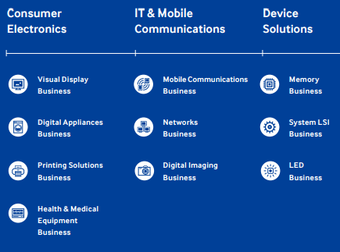
Figure 1: Business model of Samsung
(Source: Images.samsung, 2022)

Selected product for this work is “Samsung Handsets”. It has been selected for this work as there is high demand for Samsung mobiles. Even in pandemic situation of 2020, Samsung sold 62.12m smartphones to customers (Statista, 2022). Besides, handsets offered by Samsung are considered top-notch due to premium design, top-of-line specifications, and great features. The company provides both high and low range headsets. In the global smartphone market, Samsung holds a 20.8% market share (Statista, 2022). Also, it has been forecasted by the company that demand for its smartphone would increase when economy recovers from Covid-19 pandemic (Images.samsung, 2022). Thus, handset is the selected product for analysing performance of Samsung.

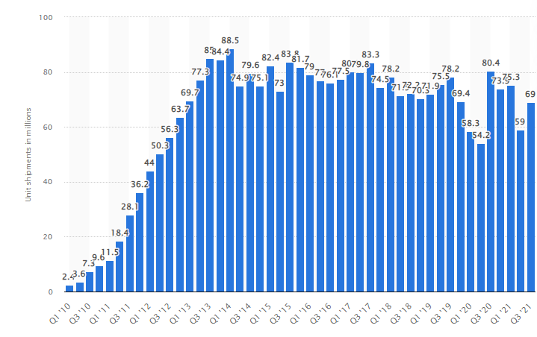
Figure 2: Global smartphone shipment of Samsung
(Source: Statista, 2022)

Demand and Market Equilibrium
In economics, demand is a quantity of goods that consumers desire to acquire at different price points during different periods. As per Samuelson and Marks (2010), a situation where economic forces i.e. demand and supply is balanced and other things remain unchanged is market equilibrium. Impact of each demand factor on Samsung handsets are discussed as under:

Substitutes’ Price
In perspective of microeconomics, two goods are substitutes if they can be used for same purpose by consumers. So, customer operations such goods similar or comparable, having more or less of one good can impact demand of the other. Similarly, price of one can affect the price of the other good (Llull, 2018). In the smartphone market, “Apple” is the biggest competitor of Samsung. Thus, smartphones offered by Apple are a substitute for Samsung handsets. Considering UK market, price of Samsung mobiles comes under price range of £197-£1,599 (Samsung, 2022). Apple offers smartphones under price range of £489-£1968. In handset market of UK, costs of average mobile phones are rising by £197 on average since 2018. Samsung Galaxy S8 cost £603.26 in 2018 that increased to £1312.98 in 2021. Apple iPhone 7 cost £762.55 in 2018 increased to £1068 in 2021 and Apple iPhone 12 Pro Max stands at £1468.72 in 2021 (Thisismoney.co.uk, 2022). So, it can be said that both prices of Samsung's handset and substitutes are increasing. However, Apple is biggest competitor of Samsung and the prices of its smartphones are higher than Samsung. Thus, it would positively affect the demand for Samsung's handset. A high number of customers would opt for Samsung mobile because prices of Apple mobiles are greater.

Complements’ Price
In economics, complementary goods are goods whose appeal enhances popularity of their complement. Such goods signify negative cross-elasticity of demand for increases when price of a complementary good decreases (Labandeira et al., 2017). For Samsung handsets, complementary goods are sim cards and Bluetooth headphone devices. Samsung is well known for offering a wide range of electronics. Samsung Galaxy Buds Live, Samsung Galaxy Buds Pro, Considering UK’s smartphone market, many individuals use mobile phones for accessing games, using social networking sites, and listening to music. In Covid-19 pandemic, higher use of mobile phones is made for online meeting and studying purposes. In global lockdown situation, price of online games was £34.13-100. Besides, Samsung Galaxy Buds are available at price range of £99-£300 (Samsung, 2022). However, cost of these items has increased in 2020 as compared to 2018. But, global lockdown situation and Covid-19 restrictions have fuelled demand for these products globally. Companies are offering their products on offer or at discounts for avoiding losses during pandemic situations. So, it can be said that prices of complementary goods positively affect the demand for Samsung headsets.

Consumer Income
It is money that consumers earn from work or investment. According to Freire-González et al. (2017), spending of consumers depends on his/her level of income. An increase in income enhances purchasing power of consumers and a decrease in income reduces purchasing power. Considering the UK economy, it has been found that consumer income was £31280 in 2021 which was £30800 in 2020, £29400 in 2019, and 35300 in 2018 (Statista, 2022). This means income level of consumers declined during the pandemic situation of 2020. However, an improvement in income level has been found in 2021 which is efficient for encouraging demand for Samsung handsets in country. Due to increasing consumer income, a high sale of Samsung smartphones has been found in 2021. The company retained the number one spot in the global smartphone market in the third quarter of 2021 as its smartphone shipment enhanced by 20% to 69.3m (Counterpointresearch, 2022).

Consumer tastes & preferences
Demand of a product is affected by taste and preference of consumers. If the taste of consumers is in favour of products, its demand will rise in the market, but if products are unavoidable for customer base, then demand will fall (Bradley et al., 2017). For UK smartphone market, Apple and Samsung are key players. UK has a high standard of living and both companies provide high-priced smartphones. So, these companies play an important role in shaping the taste and preferences of consumers. For instance, Apple is considering launching a new AirPod, HomePad mini, new variant of iPhone, updated Apple Watch (Macworld.co.uk, 2022). Such launches would certainly attract a large population and would shape the preference of customers for new technologies and innovation. On the other hand, Samsung Galaxy S21, Samsung Galaxy S21+, and Samsung Galaxy S Ultra are new offerings of Samsung in UK (Samsung, 2022). Thus, the tastes and preferences of consumers are changing which demand new offerings from Samsung.

Consumer expectations of price
Consumers thoroughly observe the prices and obtain price information from different sources for developing purchase decisions. Therefore, price expectations can alter purchase behaviour of customers in, either way, deterring from or accelerating towards current purchase. As opined by Lavieri et al. (2018), price expectations are used as reference points for making final purchase decisions. In case of electronics like smartphones, customers expect a price drop whenever a new model of mobile launches in a market. Even introduction of new technology leads to development of new products in market that lead to dropping in prices in existing models. Therefore, demand for Samsung smartphones would rise if prices drop. However, Samsung is considered as most valuable brand for future smartphone purchases in the UK (Counterpointresearch, 2022). Due to an increase in demand and significant development in offerings, consumers are expecting to increase the prices of Samsung mobiles. The survey indicates that UK customers would likely invest in Samsung mobile even when prices rise in future.
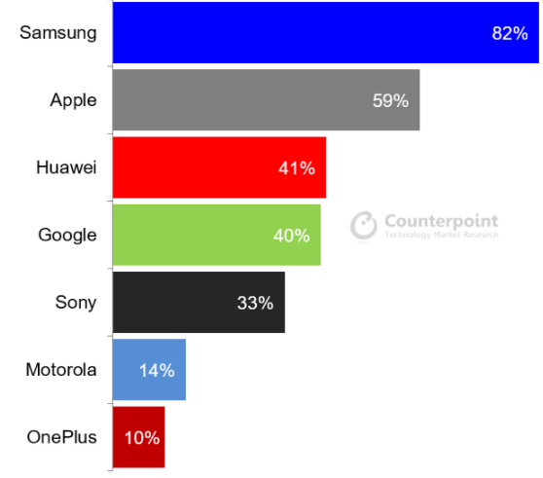
Figure 3: Samsung Top Choice for Future Smartphone Purchase in the UK
(Source: Counterpointresearch, 2022)

Demographics
Demographic data indicate socioeconomic information denoted statistically. Demographic information includes data about income, age, employment, or gender (Gagnon et al., 2021). Evaluation of demographics helps understand the customer base of Samsung. In 2020, the global smartphone sales of Samsung reached 1.38bn units which were 1.54bn units in 2019 (Statista, 2022). Besides, in 2021 company sold 59m units in first quarter and 69m units in the third quarter. This indicates that demand for Samsung mobiles was efficient before Covid-19 pandemic. However, a slight reduction in total sale quantity has taken place during pandemic. But, company was able to cope with losses during 2021. Demographic of Samsung includes both high and low-income group individuals as company offers different ranges of smartphones.

Elasticity of demand
Price elasticity of demand can be defined as measurement of change in consumption of commodity in relation with price change. Price elasticity of demand can be expressed as “percentage change in quantity demanded/percentage change in price” (Keat and Young, 2005). Besides, income elasticity of demand can be considered as “percentage change in quantity demanded/percentage change in income” (Andreyeva et al., 2010). Considering each factor of elasticity of demand, how demand of Samsung handsets is affected is discussed as under:

Substitution Effects. Luxury vs. Necessity
In economics, substitution effect can be defined as a decrease in sale of a product as consumers switch to other alternatives available in market. It is a result of an increase in price of the commodity, other things remaining same. As per Leskinen et al. (2018), products may lose market share due to the substitution effect, but the substitution effect purely reflects frugality. For Samsung mobiles, substitution effect is significantly high. Considering UK’s smartphone market, company faces competition from companies like Apple, Huawei, Google, Sony, and, OnePlus (Counterpointresearch, 2022). Considering price range of Samsung mobiles, it can be considered as a luxury item. Smartphones offered by Samsung have a high price range. For instance, Samsung Galaxy Z Fold3 5G has a price of £1599 which is significant (Samsung, 2022). However, there are other mobile phones available at lower price ranges. According to a survey in UK, Samsung is considered as top choice for future smartphone purchases in UK (Counterpointresearch, 2022). This indicates high demand for the company in handset market of UK. Apple is a leading competitor of Samsung and an increase or decrease in price of Apple smartphones can affect demand for Samsung smartphones. Thus, this substitution effect makes demand for Samsung smartphones elastic.
Price range of Samsung mobile makes it a luxury product from a consumer's perspective. Luxury versus Necessity effect indicates a product that a consumer desires to have even if its prices are higher (Zeng, 2019). Besides, necessity goods are those normal goods that are needed by customers for running their livelihood. Such types of goods include food, water, shelter, clothes, and education. As with any other goods, an increase in income of customers leads to increased demand for such goods. However, an increase in necessity products leads to a lesser rise in income level. Thus, proportion of spending on these goods declines when income rises. However, in case of luxury goods, the spending of customers rises when income rises when prices increase. Thus, Samsung mobiles can be considered luxury items from the perspective of customers. This effect makes demand for Samsung smartphones inelastic.

Income effects. Percentage of income
Income effect is part of consumer choice theory. It indicates a change in relative market price and income level’s effect on consumption patterns of consumer goods. Moreover, purchasing power of an individual has a considerable impact on the demand for goods and services. As per Griffiths and Stuart (2011), a change in income is result of increase salary or wages. Samsung offers both cheap and expensive smartphones. However, demand for expensive smartphones from Samsung is higher in UK (Counterpointresearch, 2022). It has been found that Samsung sells smartphones in a price range of £197-£1,599 (Samsung, 2022). This helps companies in catering to customers with different levels of income. So, for customers with a low-income level, a high percentage of income is invested on Samsung smartphones. So, if income level of such consumers rises, purchases would also rise. Therefore, the purchase of Samsung smartphones represents a more elastic demand.
Samsung offers smartphones to both high and low-income group customers. Even in Pandemic situation of 2020, higher demand for Samsung mobile has been found (Statista, 2022). In case of high-income group individuals, demand for Samsung mobile would increase with increase in income. However, spending on these products by high-income group customers is low. This means a low percentage of income is spent on purchase decisions of Samsung mobile. So, even if price of such goods is increased, or income of customers rises, no change would take place on demand for Samsung mobile in high-income group customers. This indicates demand is inelastic. Such income elasticity of demand indicates higher scope of future development for Samsung smartphones. The company would be able to enhance its demand in the market by offering innovative products in market and customers with a high-income group would opt for it despite the price factor.

Pricing policy
Pricing policy can be defined as a procedure used by an organisation for the setting price of goods and services. A company sets price of this offering by considering both internal and external factors. These factors are cost of making a product, demand in market, product value, and price of competitors (Bagwell, 2005). For Samsung handsets, using an adequate pricing strategy would allow them to reach a higher number of customers and gain a competitive edge in the industry. Different types of pricing policies are cost-plus pricing, penetration pricing, price skimming, and dynamic pricing. Competition-based pricing uses information of competitors’ pricing strategy or setting prices of products. This means Samsung is required to utilise pricing information of Apple for pricing its smartphones. Cost-plus pricing includes setting price by adding a profit margin on cost of product. So, Samsung can change a light amount of profit on cost of making smartphones. Dynamic pricing requires rapid changes in pricing based on factors affecting product.
As per dynamic approach, Samsung can change prices as per changes in technology, labour market, or resources. Penetration pricing requires setting prices below market level for capturing a high number of customers (Kienzler and Kowalkowski, 2017). By using such a pricing policy, Samsung would be able to attract customers of other companies like Apple, Microsoft, and Google. Price skimming policy includes setting high prices when products are launched and leveraging market demand, then lowering prices as per market (Hsieh and Dye, 2017). By using such a pricing policy, Samsung would be able to charge high prices when smartphones are launched and adjust prices at later stages. As per analysis of each pricing policy, the use of price skimming seems to be profitable for Samsung. As companies provide luxury products, price skimming would help in achieving high revenue at launching of products and offering the same product at a low price in a later stage for attracting customers. This would help Samsung increase its share in global smartphone market.

Conclusion
Managerial economics is a branch of economics that signifies performance of an organisation. As per analysis of Samsung smartphones, from a managerial economics perspective, it can be concluded that Samsung is operating well in the smartphone industry. In UK, Samsung is considered most valuable brand of smartphone. The company offers smartphones for both high and low-income group individuals. Further, Samsung can be primarily identified as a luxury item.

References
Andreyeva, T., Long, M. and Brownell, K. (2010). The Impact of Food Prices on Consumption: A Systematic Review of Research on the Price Elasticity of Demand for Food. American Journal of Public Health, 100, (2),p216-222.
Bagwell, K. (2005). The Economic Analysis of Advertising. Columbia University Discussion Papers No. : 0506-01
Bradley, J., Postel-Vinay, F. and Turon, H., (2017). Public sector wage policy and labor market equilibrium: a structural model. Journal of the European Economic Association, 15(6), pp.1214-1257.
Britannica (2022). About Samsung Company history. Available at: https://www.britannica.com/topic/Samsung-Electronics[Accessed on 1st January 2022]
Counterpointresearch (2022). About Samsung Company global smartphone market share. Available at: https://www.counterpointresearch.com/global-smartphone-share//[Accessed on 9th January 2022]
Counterpointresearch (2022). About Samsung Company survey. Available at: https://www.counterpointresearch.com/samsung-top-choice-future-smartphone-purchase-uk//[Accessed on 12th January 2022]
Freire-González, J., Decker, C. and Hall, J.W., (2017). The economic impacts of droughts: A framework for analysis. Ecological economics, 13(2), pp.196-204.
Gagnon, E., Johannsen, B.K. and Lopez-Salido, D., (2021). Understanding the new normal: The role of demographics. IMF Economic Review, 3(1), pp.1-34.
Griffiths, A., and Stuart, W., (2011). Economics for Business and Management 3rd Edition, Prentice Hall.
Hsieh, T.P. and Dye, C.Y., (2017). Optimal dynamic pricing for deteriorating items with reference price effects when inventories stimulate demand. European Journal of Operational Research, 262(1), pp.136-150.
Images.samsung (2022). About Samsung Company financial data. Available at: https://images.samsung.com/is/content/samsung/p5/global/ir/docs/2019_Business_Report.pdf/[Accessed on 13th January 2022]
Images.samsung (2022). About Samsung Company. Available at: https://images.samsung.com/is/content/samsung/p5/in/aboutsamsung/2012_E_04_0_1.pdf[Accessed on 2nd January 2022]
Images.samsung (2022). About Samsung Company. Available at: https://images.samsung.com/is/content/samsung/assets/global/ir/docs/2020_Business_Report.pdf/[Accessed on 5th January 2022]
Keat, P., and Young, P., (2005). Managerial Economics: Economic Tools for Today’s
Decision Makers, 5th Edition.
Kienzler, M. and Kowalkowski, C., (2017). Pricing strategy: A review of 22 years of marketing research. Journal of Business Research, 78, pp.101-110.
Labandeira, X., Labeaga, J.M. and López-Otero, X., (2017). A meta-analysis on the price elasticity of energy demand. Energy policy, 102, pp.549-568.
Lavieri, P.S., Dias, F.F., Juri, N.R., Kuhr, J. and Bhat, C.R., (2018). A model of ridesourcing demand generation and distribution. Transportation Research Record, 2672(46), pp.31-40.
Leskinen, P., Cardellini, G., González-García, S., Hurmekoski, E., Sathre, R., Seppälä, J., Smyth, C., Stern, T. and Verkerk, P.J., (2018). Substitution effects of wood-based products in climate change mitigation, 7(2), pp.22-25.
Llull, J., (2018). Immigration, wages, and education: A labour market equilibrium structural model. The Review of Economic Studies, 85(3), pp.1852-1896.
Macworld.co.uk (2022). About Samsung Company products. Available at: https://www.macworld.co.uk/news/new-apple-products-3510027/#:~:text=We've%20seen%20Apple%20launch,update%20to%20the%20Apple%20Watch. /[Accessed on 10th January 2022]
Samsung (2022). About Samsung Company. Available at: https://www.samsung.com/uk/smartphones/all-smartphones//[Accessed on 6th January 2022]
Samsung (2022). About Samsung Company. Available at: https://www.samsung.com/uk//[Accessed on 11th January 2022]
Samuelson, W., and Marks, S., (2010). Managerial Economics, Study Guide, London, John Wiley & Sons
Statista (2022). About Samsung Company market share. Available at: https://www.statista.com/statistics/276477/global-market-share-held-by-samsung-smartphones/[Accessed on 3rdJanuary 2022]
Statista (2022). About Samsung Company revenue. Available at: https://www.statista.com/statistics/1002964/average-full-time-annual-earnings-in-the-uk/#:~:text=The%20median%20annual%20earnings%20for,increase%20of%2013.48%20thousand%20pounds. /[Accessed on 8th January 2022]
Statista (2022). About Samsung Company sales in units. Available at: https://www.statista.com/statistics/299144/samsung-smartphone-shipments-worldwide/[Accessed on 4th January 2022]
Thisismoney.co.uk (2022). About Samsung Company. Available at: https://www.thisismoney.co.uk/money/bills/article-9732797/Popular-mobile-phones-cost-200-2018-contract-payments-increasing-8-month.html/[Accessed on 7th January 2022]
Zeng, F.B., (2019). Exploring factors affecting consumer expenditures on media. Journal of Media Studies, 29(2), pp.33-37.

