
Master of Business Administration

International Business pathway

Contemporary employability skills
Assessment 1: Individual report. Weight: 100%
Module Name: International Business Concepts
Module code: LCMB7034
Lecturer Name: Jean Wang
Title: primark’s international expansion into Japan:A strategic analysis of market entry and international business environment
Student Name: Zeel Bharatbhai Talaviya
Student ID: 2434306

Word count: 4960
Submission Date: Friday 14th August 2026
AI Use Acknowledgement
Note: One acknowledgement is needed for each used AI tool.
I acknowledge that the complete was solely done by me. I have not used any kind of generative Ai tools to complete the work. I used academic resources, reports, company information available on online resources. The sources through which I collected data have been put in reference section along with right citations throughout the report.
Table of Contents
Section 1: Introduction 4
PART 1: Organisational Classification and Global Strategy 5
PART 2: Macro-Environmental Appraisal and Market Attractiveness 8
Political Environment 8
Economic Environment 9
Legal Environment 11
Cultural Environment 13
Power Distance 13
Uncertainty Avoidance 13
Long-Term Orientation 14
Motivation Towards Achievement and Success: Masculinity 14
Dunning's Eclectic Paradigm (OLI Framework) 15
Ownership Advantages 15
Location Advantages 17
Internalisation Advantages 18
PART 3: Entry Mode Strategy and Strategic Synthesis 19
Historical Entry Modes 19
Suitability of Historical Mode for Japan 19
Alternative Entry Modes 20
Recommended Entry Strategy 20
Conclusion 22
Section 2: Reflection 23
1. Description 23
2. Feelings 24
3. Evaluation 24
4. Analysis 25
5. Conclusion 25
6. Action Plan 26
References 27

Section 1: Introduction
Primark is an international value fashion retailer established in 1969 in Dublin, Ireland and is a subsidiary of Associated British Foods (ABF) (Primark, 2026). Japan has implemented policies to support digital transformation, sustainable investment and regional economic development to increase productivity and long-term business development (OECD, 2026). This report aims to evaluate the suitability of Japan as a potential market for Primark's international expansion. It looks at the company's global strategy, analyses Japan's macro-environment, uses Dunning's Eclectic Paradigm to determine the most suitable foreign direct investment and suggests the most suitable market entry strategy for sustainable growth.

PART 1: Organisational Classification and Global Strategy
Primark is a subsidiary of ABF and is one of Europe's biggest value-fashion retailers with a network of 486 wholly owned stores across 19 countries (ABF, 2026). Its international expansion strategy shows that it has a strong commitment to operational efficiency, cost leadership and centralised decision-making (Primark, 2023). According to Bartlett and Ghoshal, a global approach is the most suitable strategy for Primark in which competitive advantage is gained by integrating and standardising operations globally instead of extensive local circumstances. Primark's strategy is more focused on global efficiency than local adaptation which makes a global strategy more suitable compared to transnational and multinational strategies.
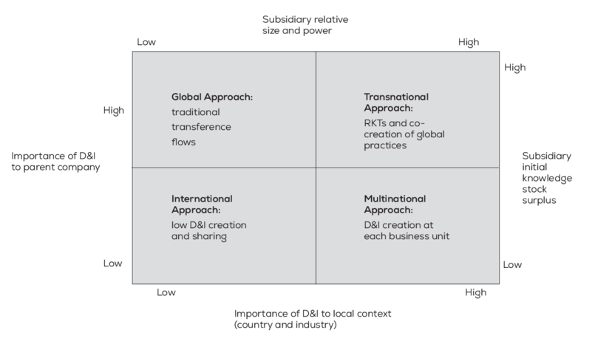
Figure 1: Bartlett and Ghoshal Framework
(Source: Da Fonseca and Kogut, 2023)
This strategic orientation is evident in Primark’s highly centralised management of sourcing, merchandising, pricing and supply chain activities from Europe-based facilities (Lu, 2023). Standardised product ranges, store layouts and procurement processes allow the company to benefit from substantial economies of scale and maintain its value proposition of fashionable clothing at affordable prices. While adaptations are made as per local legislation, climate and sizing preferences, these are limited and do not change the way the retailer runs its business internationally. Primark's approach is different from a multidomestic strategy where subsidiaries have significant autonomy but it also differs from a transnational strategy because it does not promote much knowledge sharing and adaptation of the product across markets.
The global presence of Primark also adds to the company's competitive position. The retailer has developed a high concentration in the U.K., Ireland, Spain, France, Germany, Italy, Portugal, the Netherlands, Belgium, Austria, Central and Eastern Europe and the United States and is not present in key East Asian markets such as Japan (Primark, 2026). The geographical concentration results in more efficient distribution networks, lower transport costs and better collaboration between stores and regional logistics centres. Primark's ongoing store expansion and excellent sales performance emphasise its disciplined international growth strategy which focuses on market attractiveness and operational feasibility over rapid global expansion (ABF, 2026).
The company's global business operations bring a competitive advantage because they allow it to combine international sourcing with a centralised procurement system and strategic relationships with suppliers in Asia and other industrial areas. These capabilities enhance bargaining power, reduce production costs and maintain a steady retail price which further consolidates Primark's cost leadership strategy. Moreover, the standardised retail format boosts brand visibility, streamlines inventory control and provides operational efficiencies that will benefit customers and shareholders over the long haul (Moshood, 2025). However, the growing demand from consumers for sustainability, digital retailing and culturally adapted products raises questions about the sustainability of the global approach. Thus, Primark needs to maintain the advantage of global integration while offering some local responsiveness in Japan which means that a better-balanced strategy might be needed to maintain competitive advantage in culturally diverse international markets.

Figure 2: Brand Logo of Primark
(Source: Primark, 2026)

PART 2: Macro-Environmental Appraisal and Market Attractiveness

Political Environment
The stable political climate in Japan encourages long-term foreign investment and lowers uncertainty for foreign retailers, with a response rate of 19.7% (JETRO, 2026). The country is a constitutional monarchy with a parliamentary system and had stable economic with trade policies for decades. Stable governance, effective public institutions and a transparent regulatory framework minimise the risk of sudden policy changes and enable companies to make long-term investments with confidence (Akinsola and Taofeek, 2025). These conditions are important for Primark as the company has investments in its physical stores, distribution network and long-term supplier relationships. Japan’s current policies are dedicated to digital transformation, green investment and regional economic development, with a view to boosting productivity and generating new business opportunities (ITA, 2025). Such changes will reduce administrative hurdles for foreign businesses and make it easier for retailers to operate in Japan. The trade deal between the United Kingdom and Japan enhances investment protection, facilitates greater regulatory cooperation and helps to create smoother market access for British companies (Morita-Jaeger, 2025). These measures help to remove institutional obstacles for Primark and strengthen its international expansion plan.
Political risks can be taken into account before entering the Japanese market. Demographic pressures due to an ageing population and geopolitical uncertainty in East Asia and rising energy costs could add to business uncertainty and operating costs in Japan (OECD, 2026). These problems may impact consumer confidence, supply chains and future government spending. However, continuity of policy, low corruption and an existing legal system offer foreign investors a predictable business environment. Primark has experience of operating in various international markets and can apply this experience to control external risks whilst maintaining consistent retail operations (Primark, 2026). The political climate in Japan is helpful to Primark's market entry as it has a stable political environment, investment support and a clear regulatory system which reduces country risk.

Economic Environment
Japan offers a big consumer market for Primark as it is a developed country with high household income, stable economic conditions and developed retail infrastructure. The country's nominal GDP surpassed US$ 4. 38 trillion, the fourth largest in the world (IMF, 2026). Real GDP growth is forecast to be 0.7% in 2026 and domestic demand is expected to continue as the primary driver of economic growth. Private consumption is expected to rise as wage growth will increase the disposable income of households, while business investment is expected to keep benefiting from the government's support for digital and green investment. The conditions offer a stable environment for Primark to grow its retail business and invest in stores for the long term. (OECD, 2025).
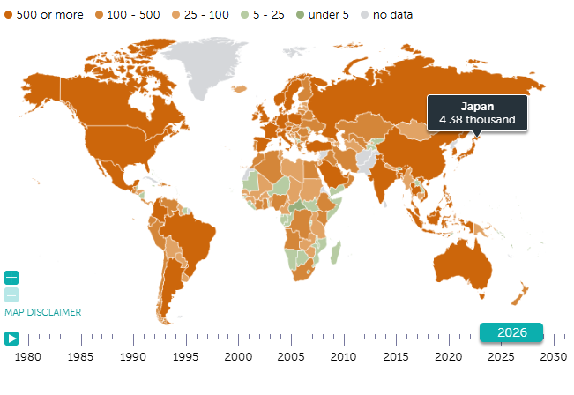
Figure 3: Japan's GDP on Map
(Source: IMF, 2021)
Japan's retail sector is being sustained by consumer spending. Consumer inflation is expected to be 2.2% and private consumption is expected to increase by 0.9% in fiscal 2026 (Yamazaki, 2026). Many consumers are now more likely to shop around for the best price due to the increasing cost of living. This change creates an opportunity for retailers offering fashionable products at affordable prices. This shift in consumer behaviour aligns with Primark's value-based pricing approach, which could help the company attract middle-income consumers without altering its business model.
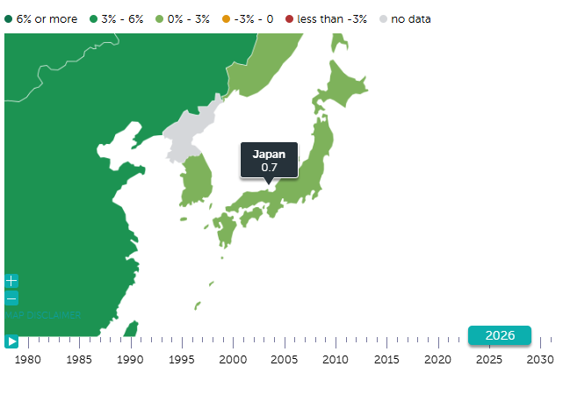
Figure 4: GDP growth in percentage
(Source: IMF, 2026)
Japan offers operational benefits to international retailers as effective transportation systems, logistics, digital infrastructure and organised retail markets facilitate the distribution of products and the management of its stocks (Jumaway, 2025). Stable corporate profits and public investment programmes are driving business investment, which is improving retail operations and the efficiency of the supply chain (JETRO, 2026). These conditions enable Primark to effectively manage its stock and ensure that they have products available in physical stores. Developed infrastructure can minimise delays and enhance customer service, which can support the company's growth plans (OECD, 2026).
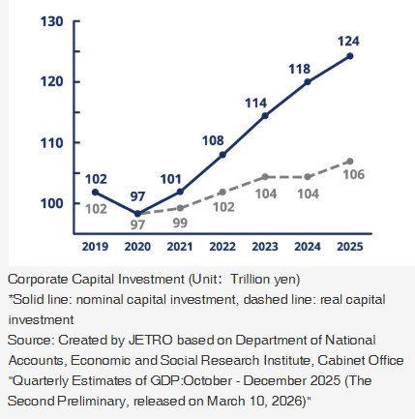
Figure 5: Trends in Ordinary Profit Across All Sectors and Industries in Japan
(Source: JETRO, 2026)
Labour shortages, an ageing population and higher operating costs may lead to higher employment and retail costs than in other Asian markets (OECD, 2026). The government's growth forecast has been cut due to higher energy prices, as household spending and business costs continue to be reduced. Despite these difficulties, stable consumer demand, increasing wages and ongoing business investment create a favourable climate for Primark's long-term growth. The size of the consumer market and the company's financial resources enable it to address these economic conditions and establish operations with average household disposable income per capita is $28,872 per year in Japan (ITA, 2024).

Legal Environment
Japan's laws provide clear standards for the operation of international retailers via consumer protection, employment regulation and intellectual property laws. Foreign companies can invest in the retail sector and open with 100% foreign direct investment, as long as they follow the national commercial and tax laws (Sekiguchi, et al., 2021). This legal certainty helps to encourage long-term investment as businesses are able to function in a clean regulatory environment and with a consistent set of rules for both domestic and foreign businesses. The clear legal procedures minimise the uncertainty of operation and enable Primark to keep the same business practices in all their retail outlets worldwide. One of the main legal aspects for fashion retailers in Japan is product compliance as the Household Goods Quality Labelling Act mandates that information on fiber content, care instructions, country of origin and business identification be provided on clothing products before they are sold (SGS, 2017). Consumer laws prohibit any misleading claims about price, quality and product performance and retailers must ensure that they give correct information during the buying process.
These regulations will help to improve transparency and consumer confidence in the retail market (Kim and Yang, 2026). Before opening its shops, Primark will have to change its product labels, packaging and promotional material to meet these legal requirements. Compliance adds to the administrative burden but decreases the risk of product recalls, customer complaints and regulatory penalties. The employment laws govern the relationship between retailers and their employees. The Labour Standards Act covers working hours, overtime pay, annual leave and workplace safety and the Equal Employment Opportunity Act mandates fair employment practices, free from discrimination (Japanese Law Translation, 2018). These regulations involve Primark having to keep its recruitment procedures, staff training and workplace policies compliant in Japan. While the employment standards may lead to higher labour costs, they also contribute to the welfare of the workers, workforce stability and a decrease in legal disputes (Chukwu, et al., 2025).
Good compliance will ensure that Primark can operate in a consistent manner and safeguard its corporate reputation in an industry that is under the spotlight for employment practices. Japan has an established intellectual property (IP) framework to protect trademarks, industrial designs and copyrights (WIPO, 2023). Such safeguards minimise the risk of product imitation and help to protect Primark's brand identity in the competitive fashion industry. National guidance on business and human rights calls on companies to improve their supply chain due diligence and monitoring of labour practices in their supply chains (Business and Human Rights Centre, 2026). These expectations align with the current ethical trade programme and supplier audits in place at Primark. The observance of the legal framework in Japan helps to ensure responsible business practices and minimise regulatory risks, which is essential for Primark's sustainable retail growth.

Cultural Environment
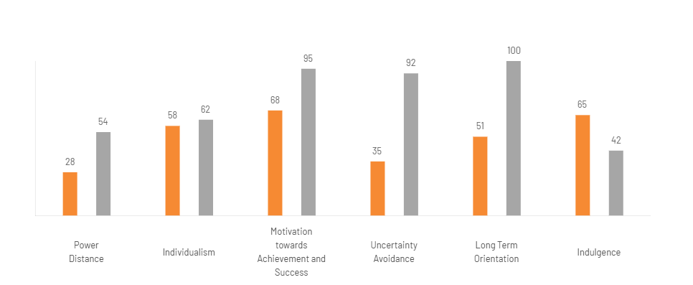
Figure 6: Country Comparison through Power-Distance
(Source: The Culture Factor Group, 2026)

Power Distance
The Power Distance score for Japan is 54, while Ireland is 28, suggesting that Japanese people are more likely to accept a hierarchy in the organisation and structured decision-making. Staff will be more likely to uphold formal authority and follow reporting structures. Primark can ensure that all stores in Japan have clear responsibilities, communication lines and leadership practices. The effectiveness of the operation can be affected as employees are waiting to be told what to do by supervisors.

Uncertainty Avoidance
The Uncertainty Avoidance score of Japan is 92 and Ireland is 35. This gap illustrates that Japanese consumers and workers value detailed planning, procedures and consistent business practices. Primark can ensure that they have proper inventory management, product information is clear and the standard operating procedures of the stores are uniform. The quality of the product, return policy and customer service procedures can be clearly stated to minimise uncertainty when making a purchase (Bozzi, et al., 2022). These practices can help to increase customer trust and enhance service uniformity in the Japanese retail sector.

Long-Term Orientation
Japan has a score of 100 for Long-Term Orientation while Ireland scores 51, which shows that Japan is more oriented towards the future, continuous improvement and long-term relationships. Product durability, reliability and consistent quality are often important factors for consumers when deciding to buy. Primark needs to concentrate on the quality of its products, sourcing responsibly and providing a consistent customer experience with short-term promotional campaigns. Building long-term relationships with suppliers and customers will help to ensure sustainable growth in Japan (Srinivas, 2026).

Motivation Towards Achievement and Success: Masculinity
Japan scores 95 and Ireland scores 68, which means that Japan is more achievement-oriented towards high standards. Consumers will carefully compare the products before buying and retailers are expected to provide a good quality product at a competitive price. If Primark can deliver on product quality and customer service in a reliable manner, then they can deliver on the valuable strategy and meet these expectations. Staff performance management and training can ensure that the level of service is consistent to satisfy customer needs and expectations in a competitive retail market (Alabi, et al., 2024). The cultural differences between Ireland and Japan necessitate Primark to make some adjustments to their management and retailing practices to ensure their global value proposition is unaffected.

Dunning's Eclectic Paradigm (OLI Framework)
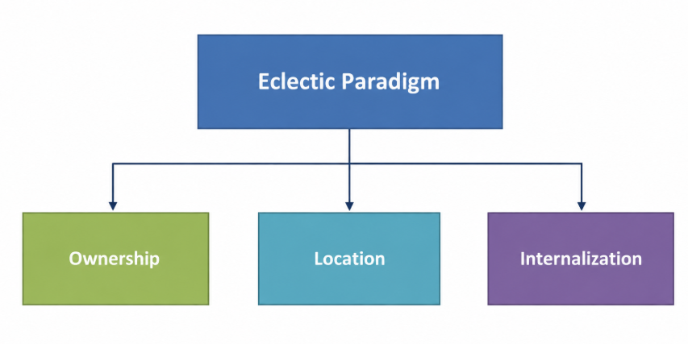
Figure 7: ODI Framework Flowchart
(Source: By Author)

Ownership Advantages
Primark's ownership advantage accounts for the fact that it is able to compete successfully in Japan, having entered a mature and competitive retail market. The company has specific assets that are hard for other firms to replicate such as its value-driven business model, international sourcing network, existing supplier relationships and brand recognition. These resources enable Primark to provide fashionable and affordable clothing at competitive prices and ensure the quality of the products is the same in all the international markets (UK Parliament, 2018). The company's purchasing scale gives it control with suppliers and allows it to purchase at a lower cost than many domestic retailers. These efficiencies help Primark to be a cost leader and provide a price edge in the Japanese apparel market.
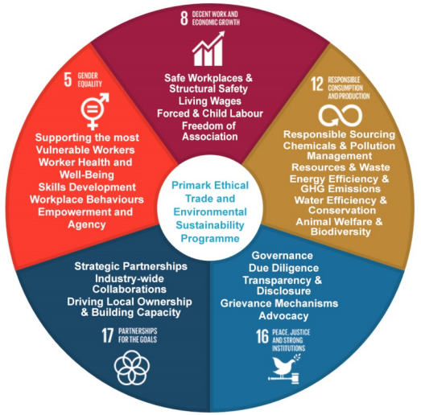
Figure 8: Sustainability programme in the company
(Source: UK Parliament, 2018)
Primark has gained experience in 19 countries and has over 480 retail stores, giving it knowledge about international retail expansion, supply-chain coordination and store management (Primark, 2025). This experience helps to minimise the uncertainties that come with entering a new market and provides a consistent level of operation across countries. The company has invested in responsible sourcing programmes, supplier monitoring and product quality management, to build customer confidence and to support the long-term development of its brand (JETRO, 2024). These are the organisational capabilities that are not easily transferable via contractual arrangements and are intangible assets. By owning these resources, Primark will be able to have full control of its retail operations while safeguarding its competitive advantage. These firm-specific capabilities are a solid basis for Foreign Direct Investment (FDI) into Japan, as opposed to using external partners.

Location Advantages
The location advantages are the reasons why Japan has suitable conditions for Primark's FDI. Japan has a huge and mature apparel market with consumers frequently buying branded fashion goods which values over ¥10 trillion (Causton, 2021). As households are more aware of the price differences and demand for affordable clothing has grown, without sacrificing quality and product reliability. This market situation is a perfect fit for Primark's value retailing approach, which enables the company to remain competitive with lower prices without altering its business model.
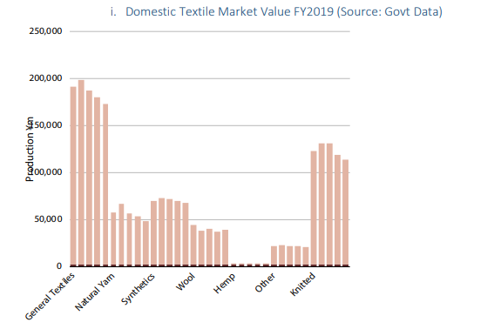
Figure 9: Japan’s apparel market valuation
(Source: Causton, 2021)
The retail market in Japan offers effective distribution channels, shopping districts and modern commercial facilities that facilitate large-scale retail. These conditions enable Primark to open stores in areas where there is a high volume of customers and connect with the global supply chain and local distribution networks. The presence of international retailers in key cities opens up possibilities to increase brand awareness and access to a wide audience. Meanwhile, existing logistics partners and sophisticated inventory management systems ensure timely replenishment, a crucial aspect of Primark's retail operations. The Japanese market is a challenging market in terms of operating in Japan, as labour and property costs are higher than in many Asian economies (Wolf, 2025). Retailers need to have a uniform level of operation because customers' expectations of product quality and customer service are high. Primark's international sourcing network, its purchasing power and experience of dealing with large retail operations enable it to deal with these conditions effectively (UK Parliament, 2018). These location-specific attributes enable Japan to be a good long-term investment destination, as they allow direct access to a mature consumer market, which is not possible with export alone.

Internalisation Advantages
The internalisation benefits make it more valuable for Primark to continue to operate in Japan. The company relies on having the same quality of products, the same inventory control and standardised store operations in all the international retail markets (Primark, 2026). By having direct ownership, the company can control sourcing, pricing, merchandising and customer service without having to rely on other partners that may have different goals (Pranta, et al., 2025). This helps to minimise coordination issues and safeguard the consistency of the Primark brand. The franchising of the company would have to deliver the running stores, brand and management techniques to others (Florea, et al., 2025). These types of agreements might lead to variations in store product presentation, pricing decisions and customer experience.
By having direct control, the company can ensure that the same operating procedures are followed, verify compliance of suppliers and uphold ethical sourcing practices throughout the supply chain (Onuma, 2025). This facilitates quicker decision-making and implementation of changes in the operation without contractual negotiations. These are appropriate in Japan as product quality, service consistency and retail standards are important to the consumer. The internalisation will lower the transaction costs of external agreements and enhance Primark's capacity to keep its competitive advantage and facilitate long-term growth in the Japanese market.

PART 3: Entry Mode Strategy and Strategic Synthesis

Historical Entry Modes
Primark has expanded internationally through wholly owned subsidiaries and organic store development rather than franchising or licensing. This enables the company to keep its stores, operations and decisions in international markets under its own control. Primark had stores across multiple countries by the end of 2025 with further expansion in Europe and the United States through direct investment (ABF, 2026). This approach has helped to ensure that pricing, store layouts, inventory management and customer experience are consistent across markets.
The international expansion of Primark is an example of a high-control entry mode which aids its cost leadership strategy. Direct ownership gives the company control over its sourcing, logistics and retail operations without the need for third-party partnership (EBSCO, 2026). This reduces the risk of inconsistent product quality, differing prices and operational disagreements that might arise from franchising and/or licensing. It has been suggested that multinational companies with standardised business models prefer a wholly owned subsidiary since it allows greater control over resources and brand management. (Matolcsy and Wakefield, 2017). Moreover, the historical entry pattern of Primark shows a long-term market commitment through direct investment. This experience provides a suitable foundation for evaluating whether the same approach should be adopted for entering Japan.

Suitability of Historical Mode for Japan
Japan is an ideal market for Primark's historical growth approach through wholly owned subsidiaries given the importance of operational control, brand consistency and long-term market development. The company adopts a cost leadership strategy which relies on centralised buying, inventory management and uniform pricing across global markets (Primark, 2023). Primark can avoid relying on external partners for these practices by having its own operations which minimises risks to customer experience or product quality due to differences in operating models. This aligns with international retailers who use standardised business models and integrated supply chains to secure a competitive edge (Cao, et al., 2018).
Product quality, convenience and presentation are important factors in the Japanese retail market (Retail Asia, 2026). A fully-owned subsidiary would enable Primark to implement its operating principles and make appropriate adjustments to some of its retail operations to meet local consumer demands. This level of control would also benefit staff training, store merchandising and inventory planning throughout the stores. However, this approach demands a significant amount of capital expenditure, extended market development time and higher operating expenses before it can be profitable. Primark has the financial means and international experience to deal with these challenges (Hardcastle, 2024) and its historical entry mode is appropriate for Japan even if it requires greater resource involvement.

Alternative Entry Modes
The alternative forms of entry that Primark might consider include a joint venture, franchising or licensing to reduce the financial commitment of entering Japan. A joint venture would give access to local market knowledge, existing distribution networks and shared investment costs (Child, et al., 2019). This approach could help Primark understand Japanese consumer preferences and retail practices more quickly. However, shared ownership can lead to loss of management control and variations in strategic decisions, pricing and standards of operation (Antón, et al., 2023). These issues may compromise Primark's standardised retail format and undermine its business efficiency.
Franchising and Licensing involve less capital investment and allow quick market penetration through partnership (Dos Santos, 2026). These entry modes also minimise financial risk as local companies operate stores and make investment decisions. However, they provide limited control over merchandising, pricing, inventory management and customer service. The competitive edge of Primark lies in its ability to ensure product quality, price control and retail management in foreign markets. Limited control can impact brand reputation and the effectiveness of the integrated supply chain. International business research indicates that retailers adopting cost leadership strategies tend to perform better in entry modes that offer improved operational control (Lim and Srai, 2018).

Recommended Entry Strategy
A wholly owned subsidiary through Greenfield investment is the most suitable entry strategy for Primark's expansion into Japan. It aligns well with the company's past internationalisation strategy and reinforces the ownership, location and internalisation benefits that can be derived from the OLI framework. It enables Primark to open up new stores that align with its retail concept, performance and cost leadership without being burdened by the operational and cultural problems of established businesses. This level of control is crucial as consistent pricing, efficient inventory management and centralised sourcing are vital to Primark's competitive edge.
Greenfield investment also offers more flexibility in choosing locations for stores, designing a distribution network and hiring staff to suit local market needs (Nguyen, et al., 2021). While it may involve significant initial capital investment and take longer time to produce a return on investment, it also lowers the risk of strategic conflict that can occur with joint ventures or franchising. Primark has the financial resources, international expansion experience and operational capacity to make this investment. Wholly-owned stores would also enable the company to have a long-term establishment in Japan and ensure the brand's consistency and operational efficiency throughout its overseas retail network.

Conclusion
The analysis shows that Japan is a good environment for Primark to expand internationally. Long-term retail investment is facilitated through political stability, a developed economy, transparent legal regulations and preferences. While differences do not delay market entry, cultural differences necessitate the need for changes in management practices, customer service and product presentation. Primark has ownership advantages as it has a value-driven business model, experience in international sourcing and retailing as per the OLI framework. Location advantages are provided through the existing apparel market and organised retail market in Japan. The internalisation advantages are provided through direct operational control to ensure brand consistency and supply-chain management. In the analysis of entry modes, it is evident that Greenfield investment will allow Primark to have the highest level of control and it fits with the international strategy of Primark. This will help to ensure stable retail activities, maintain competitiveness and build a solid base for sustainable growth in the Japanese market.

Section 2: Reflection
Gibbs' Reflective Cycle offers a framework for reflecting on experiences through describing, feelings, evaluation, analysis, conclusion and action planning (Ocampo, et al., 2025). This reflection is to assess the knowledge and understanding I gained from analysing Primark's proposed expansion into Japan.
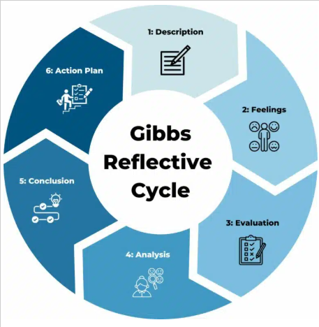
Figure 10: Gibbs Reflective Cycle
(Source: Channell, 2025)

1. Description
This report involved studying Primark's proposed expansion into Japan and using international business theories in a practical business context to evaluate the expansion. First, I analysed Primark's global strategy then I looked at the political, economic, legal and cultural environment of Japan and decided whether Japan would be a suitable place to expand. Dunning's Eclectic Paradigm was used to analyse the ownership, location and internalisation advantages of Primark and the various entry modes were analysed before recommending Greenfield investment as an entry mode to establish a wholly owned subsidiary. My challenge in completing the report was to combine academic theories with government publications, consultancy reports and company information in order to support the strategic decisions. This process enabled me to gain understanding of the impact of organisational capabilities and external environmental factors on international expansion.

2. Feelings
When I started this report, I thought that the key to successful international expansion was to choose a country that had good economic growth and consumer demand. While working through the analysis as I came to understand that business decisions involve a wider strategic evaluation internationally. I was fascinated by the interaction between political policies, legal frameworks, cultural values and organisational capabilities and their impact on the decision to enter a market. This comparison of Ireland and Japan gave me an appreciation for the cultural and institutional differences in how business is conducted, not just on the financial results. My knowledge grew and my confidence in assessing business situations objectively and providing evidence to support my arguments increased.

3. Evaluation
This report has been a learning experience in assessing international business strategy. I gained a deeper appreciation for how important it is to match a company's internal strengths with the attributes of the target market for international expansion to be successful. The study of the global strategy of Primark revealed the importance of centralised sourcing, cost leadership and operational consistency in achieving international competitiveness. The macro environment analysis indicated that political stability, economic conditions, legal compliance and cultural differences affect strategic decisions differently. The application of Dunning's Eclectic Paradigm strengthened my understanding of the reasons why MNE's prefer FDI over contractual arrangements. I struggled with applying theory to real business scenarios at first but got better as I went along and am now more confident in interpreting evidence to evaluate strategic options and making recommendations based on academic theory.

4. Analysis
While writing this report, I realised that international expansion is a strategic process and organisations need to assess their own capabilities and the market conditions before deciding to invest in international expansion. This changed my viewpoint as I had thought that the size of the market was the only factor that made an international business successful. By using the framework of Bartlett and Ghoshal, I realised that multinationals do not necessarily transfer their business models to foreign markets to a large extent. In preparing this report, I researched that most retailers adapted their business to meet local preferences. When I was analysing Primark's strategy, I realised that Primark has a centralised sourcing strategy, standardised retail operations and a cost leadership strategy with limited local adaptations. This proved that operational efficiency could be used to achieve a sustainable competitive advantage as well as local responsiveness.
The macro-environmental analysis helped me to broaden my knowledge of the factors that affect strategic decision-making. I found that government policies that promote digital transformation and sustainable investments are a good sign of foreign business development and indicators such as inflation, household consumption and wage growth give a better picture of market potential than GDP. I learned more about the legal aspects and how they affect planning for a business before entering a market and how they are more of a business obligation than a rule. The cultural analysis was especially useful as it revealed the influence of national culture on consumer behaviour and management practices. Hofstede's cultural dimensions were used to compare Ireland and Japan and the impact of uncertainty avoidance, long-term orientation and organisational hierarchy on customer expectations, leadership style and service quality. Dunning's Eclectic Paradigm strengthened my grasp of foreign direct investment as it illustrated that the ownership, location-specific and internalisation decisions all need to be in harmony to facilitate international expansion. This experience helped me to develop my skills in making strategic decisions in international business with the use of theory, evidence and practical business analysis.

5. Conclusion
This report has strengthened my knowledge of international business strategy, and has illustrated how the successful expansion of a business internationally is dependent on the interplay between the capabilities of the organisation and the conditions of the external market. I developed a greater understanding of the importance of strategic frameworks in supporting business decision-making and the impact of political, economic, legal and cultural factors on market entry. This experience enhanced my critical thinking skills in the evaluation of business situations, application of international business theories and strategic recommendations based on evidence.

6. Action Plan
This experience has inspired me to build my strategic and analytical thinking in the field of international business. In future assignments, I will enhance my comparison of alternative strategies, relating academic theory to current business evidence and evaluating business decisions from a variety of perspectives before concluding. I will keep reading peer-reviewed journal articles and international business case studies in order to expand my knowledge of multinationals. These activities will enhance my critical thinking, strategic assessment, professional decision-making skills in future academic and business situations.

References
ABF. (2026) Retail. [Online]. Available at: https://www.abf.co.uk/our-businesses/retail [Accessed on: 31 July 2026].
Akinsola, K. and Taofeek, A. (2025) The Role of Corporate Governance in Enhancing Investor Confidence and Promoting Financial Market Stability: Legal Perspectives and Practical Solutions. Article in International Journal of Accounting, 3(2), pp.1-23.
Alabi, O.A., Ajayi, F.A., Udeh, C.A. and Efunniyi, C.P. (2024) Data-driven employee engagement: A pathway to superior customer service. World Journal of Advanced Research and Reviews, 23(3), pp.923-933.
Antón, M., Ederer, F., Giné, M. and Schmalz, M. (2023) Common ownership, competition, and top management incentives. Journal of Political Economy, 131(5), pp. 1294-1355.
Bozzi, C., Neves, M. and Mont’Alvão, C. (2022) Fashion e-tail and the impact of returns: Mapping processes and the consumer journey towards more sustainable practices. Sustainability, 14(9), p.5328.
Business and Human Rights Centre. (2026) Japan: Govt. publishes HRDD guidelines, requiring all enterprises engaging in business activities in Japan to respect human rights in their supply chains, not limited to direct business partners. [Online]. Available at: https://www.business-humanrights.org/en/latest-news/japan-govt-publishes-hrdd-guidelines-requiring-all-enterprises-engaging-in-business-activities-in-japan-to-respect-human-rights-in-their-supply-chains-not-limited-to-direct-business-partners [Accessed on: 1 August 2026].
Cao, L., Navare, J. and Jin, Z. (2018) Business model innovation: How the international retailers rebuild their core business logic in a new host country. International Business Review, 27(3), pp. 543-562.
Causton, M. (2021) JAPAN’S APPAREL & TEXTILE MARKET. [Online]. Available at: https://www.eu-japan.eu/sites/default/files/2021-06-clothing-textile.pdf [Accessed on: 1 August 2026].
Channell, M. (2023) Gibbs Reflective Cycle – A Practical Guide. [Online]. Available at: https://www.tsw.co.uk/insights/gibbs-reflective-cycle/ [Accessed on 1 August 2026].
Chukwu, A.U., Emerole, B.O., Dialoke, I., Emerole, G.A. and Oko-Isu, A. (2025) Power dynamics, informal labor, and workforce management in small-scale enterprises: analyzing employment relations through regulatory and sociocultural lenses. Future Business Journal, 11(1), p.208.
Da Fonseca, L. and Kogut, C.S. (2023) Diversity and inclusion programs in multinationals: Opportunity for reverse knowledge transfer. RAE-Revista de Administração de Empresas, 63(5), pp. 1-22.
Dos Santos, J.D.W. (2026) Business Expansion: A Literature Review on Franchising and Brand Licensing. Revista Gênero e Interdisciplinaridade, 7(02), pp. 598-610.
EBSCO. (2026) Vertical Integration. [Online]. Available at: https://www.ebsco.com/research-starters/business-and-management/vertical-integration [Accessed on: 31 July 2026].
Florea, N.V., Croitoru, G., Coman, D.M. and Coman, M.D. (2025) The influence of fashion retailers on customer psychology using visual merchandising and store layout to improve shopping decision. Journal of Theoretical and Applied Electronic Commerce Research, 20(1), p.40.
Hardcastle, K. (2024) Peak Primark: Global Growth Momentum with Four Stores, Four Countries In 24 Hours. [Online]. Available at: https://www.forbes.com/sites/katehardcastle/2024/12/06/peak-primark-global-growth-momentum-with-four-stores-four-countries-in-24-hours/ [Accessed on: 31 July 2026].
IMF. (2021) IMF Database Mapper. [Online]. Available at: https://www.imf.org/external/datamapper/NGDPD@WEO/JPN/LBY [Accessed on: 31 July 2026].
ITA. (2024) Japan Country Commercial Guide. [Online]. Available at: https://www.trade.gov/country-commercial-guides/japan-market-overview [Accessed on: 1 August 2026].
ITA. (2025) Japan Country Commercial Guide. [Online]. Available at: https://www.trade.gov/country-commercial-guides/japan-digital-economy [Accessed on: 31 July 2026].
Japanese Law Translation. (2018) Labor Standards Act. [Online]. Available at: https://www.japaneselawtranslation.go.jp/en/laws/view/3567/en [Accessed on: 1 August 2026].
JETRO. (2024) Human rights due diligence: Good practices of Japanese companies. [Online] Available at: https://www.jetro.go.jp/ext_images/world/scm_hrm/JETRO_RBC_HRDD2024en.pdf [Accessed on: 1 August 2026].
JETRO. (2026) Act Now to Ride the Wave of Soaring Corporate Profits. [Online]. Available at: https://www.jetro.go.jp/en/invest/investment_environment/whyjapan/ch3.html [Accessed on: 1 August 2026].
JETRO. (2026) JETRO publishes 2025 survey on business operations of foreign-affiliated companies in Japan. [Online]. Available at: https://www.jetro.go.jp/en/news/releases/2026/4e5eb959d969f9fd.html [Accessed on: 31 July 2026].
Jumaway, J. (2025) Japan’s Logistics Sector Drives Future-Ready Supply Chain Growth. [Online]. Available at: https://icttm.org/japans-logistics-sector-drives-future-ready-supply-chain-growth/ [Accessed on: 1 August 2026].
Kim, J. and Yang, W. (2026) ESG Performance Evolution in Retail: A Systematic Review and Meta‐Analysis. Corporate Social Responsibility and Environmental Management, 33(2), pp.2254-2279.
Lim, S.F.W. and Srai, J.S. (2018) Examining the anatomy of last-mile distribution in e-commerce omnichannel retailing: A supply network configuration approach. International Journal of Operations & Production Management, 38(9), pp. 1735-1764.
Lu, S. (2023) Primark’s Global Sourcing for Apparel (Updated September 2023). [Online]. Available at: https://shenglufashion.com/2023/09/11/primarks-global-sourcing-for-apparel-updated-september-2023/ [Accessed on: 31 July 2026].
Matolcsy, Z. and Wakefield, J. (2017) Multinational headquarter control of wholly owned foreign subsidiaries. The British Accounting Review, 49(3), pp. 275–293.
Morita-Jaeger, M. (2025) THE JAPAN-UK FREE TRADE AGREEMENT - CONTINUITY OR NO CONTINUITY? HOW CAN IT STILL BE AMBITIOUS? [Online]. Available at: https://www.uktpo.org/wp-content/uploads/Publications/Briefing-Papers/UKTPO-2024-BP-46.pdf [Accessed on: 31 July 2026].
Moshood, M. (2025) Assessing brand-driven supply chain customization and its role in enhancing operational efficiency and sustained market expansion for global enterprises. Int J Adv Res Publ Rev, 2(8), pp. 32-50.
Nguyen, H.T., Luu, H.N. and Do, N.H. (2021) The dynamic relationship between greenfield investments, cross-border M&As, domestic investment and economic growth in Vietnam. Economic Change and Restructuring, 54(4), pp. 1065-1089.
Ocampo, F.A., McIntyre, B.G., Massey, D. and Saunders, R. (2025) Nursing student reflections on a research internship: A reflective discussion following the Gibbs' reflective cycle. Nurse education today, 145, p.106481.
OECD. (2026) Japan’s SME Productivity Revolution Programme. [Online]. Available at: https://www.oecd.org/en/publications/sme-technology-adoption-in-the-united-kingdom_cecfb794-en/japan-s-sme-productivity-revolution-programme_4b64c40d-en.html. [Accessed on: 31 July 2026].
OECD. (2026) OECD Economic Surveys: Japan 2026. [Online]. Available at: https://www.oecd.org/content/dam/oecd/en/publications/reports/2026/05/oecd-economic-surveys-japan-2026_9457bba4/54cc833d-en.pdf [Accessed on: 31 July 2026].
OECD. (2026) What Works for Inclusive Growth in Cities. [Online]. Available at: https://www.oecd.org/en/publications/what-works-for-inclusive-growth-in-cities_680809c3-en/full-report/policies-to-drive-inclusive-growth-in-cities_7f3eb06d.html [Accessed on: 1 August 2026].
Onuma, E.P. (2025) Multi-tier supplier visibility and ethical sourcing: leveraging blockchain for transparency in complex global supply chains. Int J Res Publ Rev, 6(3), pp.3579-93.
Pranta, A.D., Repon, M.R., Haji, A., Rahman, M. and Rahman, M.M. (2025) Sustainable merchandising for recycled textiles and apparel in the western apparel industry: Strategies, challenges and market opportunities. Journal of Engineered Fibers and Fabrics, 20.
Primark. (2023) Scaling up: Primark driving progress on its wide-ranging commitments to make more sustainable fashion affordable for everyone. [Online]. Available at: https://corporate.primark.com/en-gb/a/news/primark-cares/primark-driving-progress-on-its-wide-ranging-commitments-to-make-more-sustainable-fashion-affordable-for-everyone [Accessed on: 31July 2026].
Primark. (2026) Driving Continuous Improvement. [Online]. Available at: https://corporate.primark.com/en-gb/a/primark-cares/our-approach/partners/our-standards/driving-continuous-improvement [Accessed on: 1 August 2026].
Primark. (2026) Who we are. [Online]. Available at: https://corporate.primark.com/en-gb/a/about-us/who-we-are [Accessed on: 31 July 2026].
Retail Asia. (2026) Japanese consumers seek quality and convenience despite economic caution. [Online]. Available at: https://retailasia.com/news/japanese-consumers-seek-quality-and-convenience-despite-economic-caution [Accessed on: 31 July 2026].
Sekiguchi, K., Higashi, Y. and Oyama, H. (2021) Doing Business in Japan: Overview. [Online]. Available at: https://uk.practicallaw.thomsonreuters.com/1-519-3917?transitionType=Default&contextData=(sc.Default)&firstPage=true [Accessed on: 1 August 2026].
SGS. (2017) Japan Updates the Household Goods Quality Labeling Act. [Online]. Available at: https://www.sgs.com/en-in/news/2017/05/safeguards-07417-japan-updates-the-household-goods-quality-labelling-act [Accessed on: 1 August 2026].
Srinivas, H. (2026) Japan as a “Repeater” Economy: Implications for Sustainability. [Online]. Available at: https://www.gdrc.org/sustbiz/repeater.html [Accessed on: 1 August 2026].
The Culture Factor Group. (2026) Country Comparison tool. [Online]. Available at: https://www.theculturefactor.com/country-comparison-tool?countries=ireland%2Cjapan [Accessed on: 1 August, 2026].
UK Parliament. (2018) Written evidence submitted by Primark Ltd. [Online]. Available at: https://committees.parliament.uk/writtenevidence/93773/pdf/ [Accessed on: 1 August 2026].
WIPO. (2023) Intellectual property landscape: Japan. [Online]. Available at: https://www.wipo.int/en/web/country-profiles/JP [Accessed on: 1 August 2026].
Wolf, M. (2025) Japan Economic Outlook, April 2025. [Online]. Available at: https://www.deloitte.com/us/en/insights/topics/economy/asia-pacific/japan-economic-outlook-04-2025.html [Accessed on: 1 August 2026].
Yamazaki, M. (2026) Japan Cuts This Year’s Growth Outlook as Higher Energy Costs Weigh. [Online]. Available at: https://www.reuters.com/world/asia-pacific/japan-cuts-this-years-growth-outlook-higher-energy-costs-weigh-2026-07-30/ [Accessed on: 31 July 2026].

