Good afternoon everyone. My name is Monika and I will introduce you to our presentation:
“Workplace culture and its impact on organizational efficiency”.
The organization that we choose to explore is Admiral.
I will mention the term culture shortly and discuss why it is so important and explore its importance within our chosen organisation.

Layla, Kayleigh and Andrea will discuss the impacts on organisational efficiency, our group recommendations for the organisation and our conclusion.

For me personally, culture is our everyday lives, it’s our values and beliefs, our traditions and languages that make up culture. We develop a sense of belonging and an ability to relate to each other. Culture enhances our quality of life and increases well-being for an individual and the community in which they live/work.

So, what is culture, and why is it so important.
In this instance we are discussing Workplace and Organisational culture
Investopedia, an online reference for business users describes culture as: “The beliefs and behaviours that determine how a company's employees and management interact and handle outside business transactions. It develops organically over time from the cumulative traits of the people the company hires. A company's culture will be reflected in various factors such as:
dress code,
business hours,
employee benefits,
office setup,
turnover,
hiring decisions,
treatment of clients,
client satisfaction,
and every other aspect of operations”.

Initially it is clear to see how important Organisational and Workplace culture is to any business as it is embedded in the foundations of so may aspects of the workplace.

The organisation we chose is Admiral.
Admiral is one of the UK’s top three car insurance companies.
The company began in January 1993 when Henry Englehardt launched the company in Cardiff.
Just three years later in 1996 the company had over 250,000 policy holders.
The same year they open a new office in Swansea and turnover tops the £100 million mark.
In 2018 Admiral celebrates 25 years of business.
Now Admiral also provides home insurance, provides loans and a variety of other products to over six million customers.

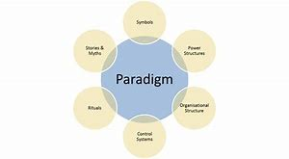
The culture web of Admiral.

My section covers power Structures, Symbols and
Organisational structure

Organisational structure.
Admiral puts efforts and investment towards making sure the Admiral Group “is a happy place to work”, as stated upon their website.

Power Structure.
The Office for Public Management states that Power structures are “pockets of real power in the organistation. Thus may involve one or two key senior directors, a whole group of senior managers or even an entire department. For Admiral two of the key players are:
Annette Court (Chairman – since 2017)
David Stevens CBE (CEO – since 2016)

Symbols.
The visual representation of the company, such as company logos, staff dress code etc; anything that the public is to observe that would be associated with the company.

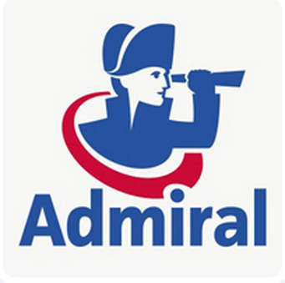
The logo, upon first impression seems to have nothing to do with insurance, yet the logo is well known amongst British car drivers.
The logo, supposed to be an Admiral, of the old traditional British Navy, perhaps representing a perceived quality that a British Naval Officer may give, or of old traditional ethics and morality, or that it simply portrays a company ‘on the lookout’, or ‘keeping a safe eye upon its policy holders’.

Methodology of Admiral.

The word Methodology, refers to a study of a method.
To imply a method.. in this instance, the method in which Admiral organises its cultural structure?
The Strategy and Business newsletter website refers to Corporate cultures as being “constantly self-renewing and slowly evolving: What people feel, think, and believe is reflected and shaped by the way they go about their business”.
The methodology (method) in implementing corporate culture.

References:

https://www.investopedia.com/terms/c/corporate-culture.asp

https://admiraljobs.co.uk/about-us/

https://en.wikipedia.org/wiki/Admiral_Group

https://www.strategy-business.com/feature/10-Principles-of-Organizational-Culture?gko=1f9d7

www.dictionary.cambridge.org

www.Ctb.Ku.edu/en

