DHL in the UAE's Dubai-based re-export and logistics ecosystem

International Business Concepts
27 April 2026

Executive Summary
This report evaluates the UAE's Dubai-based re-export and logistics ecosystem and then assesses how attractive that market is for DHL as a foreign multinational. The core finding is that the UAE, and Dubai in particular, offers strong logistics competitiveness because trade intensity, free-zone support, port-airport linkage and digital customs systems work together rather than separately (Dubai Media Office, 2025a; Jafza, 2026; Dubai Media Office, 2024). Porter's Diamond shows that factor conditions, supporting industries and state support are strong, although rivalry, cost pressure and geopolitical exposure keep that strength conditional (Porter, 1990; International Monetary Fund, 2024; Aramex, 2024). For DHL, the market is attractive because Dubai functions as a regional node inside wider global value chains, but long-run success still depends on regulatory agility, service consistency, cultural coordination and the firm's ability to turn ecosystem access into operating advantage (Dunning, 1988; Gereffi, Humphrey and Sturgeon, 2005; DHL Group, 2025b).

Table of Contents
Executive Summary 2
1. Introduction 4
2. Industry and Country Overview 5
2.1 UAE and Dubai in International Trade Context 5
2.2 Size, Scope, and Economic Importance of the Ecosystem 5
2.3 Major Domestic and Multinational Firms and Relative Positioning 7
2.4 Bridge to Competitive Analysis 8
3. Porter's Diamond Analysis of the UAE Logistics Ecosystem 10
3.0 Diamond Definition and Use 10
3.1 Factor Conditions 10
3.2 Demand Conditions 11
3.3 Related and Supporting Industries 11
3.4 Firm Strategy, Structure, and Rivalry 12
3.5 Government, Chance, and Competitiveness Judgement 12
4. DHL Evaluation in the UAE Market 15
4.1 Why DHL Is the Right Focal MNC 15
4.2 Political and Legal Factors Affecting DHL's Success 15
4.3 Economic and Infrastructure Factors Affecting DHL's Success 16
4.4 Cultural and Workforce Factors Affecting DHL's Success 17
4.5 Strategic Fit Through OLI and GVC Logic 19
4.6 Overall Market Attractiveness and Critical Success Judgement 20
5. Conclusion 22
6. Reflective Account: Gibbs' Reflective Cycle 23
6.1 Description 23
6.2 Feelings 23
6.3 Evaluation 23
6.4 Analysis 24
6.5 Conclusion 25
6.6 Action Plan 25
References 26

1. Introduction
This report examines the United Arab Emirates, specifically the Dubai-based re-export and logistics ecosystem, and evaluates how attractive that environment is for DHL as a major foreign multinational operator. The central question is twofold: first, why this ecosystem appears internationally competitive; and second, which political, economic, legal and cultural factors shape DHL's success inside it. To answer that question, the report begins with a country-industry overview, then applies Porter's Diamond to judge ecosystem competitiveness, and then evaluates DHL through a firm-level analysis supported by OLI and global value-chain logic before closing with a reflective account of the research and writing process (Dubai Media Office, 2025a; Porter, 1990; Dunning, 1988).

2. Industry and Country Overview

2.1 UAE and Dubai in International Trade Context
The United Arab Emirates is trade-led, while Dubai is its main re-export and logistics gateway. Its position between Asia, Europe and Africa gives it practical reach into Gulf, East African and South Asian markets, which is why port, airport and customs capacity matter so much in the UAE case (Dubai Media Office, 2025a; International Monetary Fund, 2024). Dubai's role rests not only on location but also on a linked system of ports, airports, free zones and digital border processes that turn geography into operating speed for shippers and multinationals (Dubai Media Office, 2024; Jafza, 2026; DP World, 2024). Compared with Singapore, Dubai's edge rests more on corridor position and state-backed connectivity than on long-built logistics reputation, which makes execution quality especially important (Fernandes and Rodrigues, 2009).
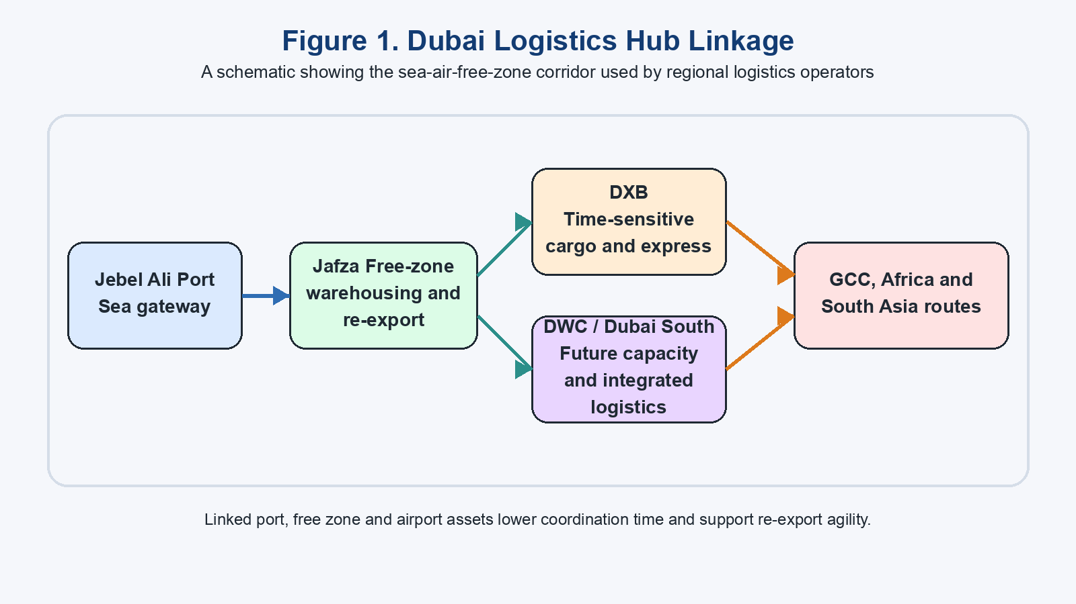
Figure 1: Dubai logistics hub linking Jebel Ali, Jafza, DXB and DWC

2.2 Size, Scope, and Economic Importance of the Ecosystem
The Dubai-based re-export and logistics ecosystem includes freight forwarding, international express, contract logistics, warehousing, customs-linked re-export activity, fulfilment, multimodal transport and value-added supply-chain services. It extends beyond cargo handling because firms also store, clear, redirect and repackage goods for onward movement. The UAE's foreign trade surpassed AED3 trillion by the end of 2024, while Dubai Chamber members alone recorded AED309.6 billion in exports and re-exports during 2024, showing how strongly the local economy depends on cross-border circulation rather than domestic production alone (Dubai Media Office, 2025a; Dubai Chambers, 2025). Free-zone trade adds further depth: DIEZ trade reached AED336 billion in 2024, while Dubai Trade processed more than 300 million transactions, linking physical flows with digital administration (Dubai Media Office, 2025b; Dubai Media Office, 2024).
Table 1: UAE and Dubai logistics ecosystem snapshot
Indicator | Evidence from the source pack | Economic relevance
National trade scale | UAE foreign trade surpassed AED3 trillion by end-2024 (Dubai Media Office, 2025a) | Large base for logistics demand
Dubai re-export depth | Chamber members' exports and re-exports reached AED309.6 billion in 2024, with 52% to GCC markets (Dubai Chambers, 2025) | Confirms regional redistribution role
Zone-based trade support | DIEZ trade reached AED336 billion in 2024 (Dubai Media Office, 2025b) | Shows strong free-zone clustering
Digital border capacity | Dubai Trade surpassed 300 million transactions (Dubai Media Office, 2024) | Points to digitised customs and trade processes
Multimodal nodes | DXB, DWC and Jafza link the airport and Jebel Ali corridor (Dubai Airports, 2026; Jafza, 2026) | Supports time-sensitive and multimodal movement
This matters to the wider UAE economy because logistics and re-export activity support diversification away from oil and attract foreign investment. Yet the ecosystem should not be reduced to trade totals. The World Bank's LPI scorecard shows that performance depends on customs, timeliness and logistics competence as well as infrastructure, so headline scale still has to be converted into dependable operating quality at firm level (World Bank, 2023). Rapid growth is strategically useful, but not self-validating: scale can still mask thin margins or uneven competence across segments (Aramex, 2024; World Bank, 2023). That point is important when comparing Dubai with a benchmark such as Singapore, because competitiveness is proved by repeatable service quality and not by throughput alone (Fernandes and Rodrigues, 2009; World Bank, 2023).

2.3 Major Domestic and Multinational Firms and Relative Positioning
The ecosystem combines UAE-rooted players with large multinationals. Aramex remains the strongest regional comparator because it combines express, forwarding and logistics services with a long-standing Gulf footprint while also reporting margin pressure in a very competitive market (Aramex, 2024). DP World and the Jafza platform are not direct substitutes for DHL in every segment, but they shape the operating base through ports, terminals, inland logistics and trade technology (DP World, 2024; Jafza, 2026). FedEx and UPS add further multinational rivalry, while DHL spans express, forwarding, warehousing and e-commerce in a way that fits Dubai's node-based trade model (FedEx, 2026; UPS, 2026; DHL Group, 2025a; DHL Group, 2025c).
Table 2: Competitor positioning matrix in the UAE logistics ecosystem
Firm | Position in the ecosystem | Core strengths | Limits or pressure points
DHL | Multinational across express, forwarding and contract logistics | Global network, recent UAE expansion (DHL Group, 2024a; DHL Group, 2024b; DHL Group, 2025a) | Must maintain strong local execution
Aramex | UAE-rooted regional competitor | Strong regional brand and product range (Aramex, 2024) | Pricing and margin pressure
DP World / Jafza | Ecosystem shaper through infrastructure and logistics services | Port access, trade technology, clustering (DP World, 2024; Jafza, 2026) | Not a direct express substitute
FedEx | Multinational express and freight competitor | International reach and Emirates Post access (FedEx, 2026) | Less evidence of broad warehousing depth
UPS | Multinational parcel and freight competitor | Recognised global network in the UAE (UPS, 2026) | Limited evidence of strong local differentiation
DHL's relative position is strong because it combines network scale with recent UAE expansion, including the Danzas AEI Emirates acquisition and contract-logistics growth, which makes it more embedded than a thin-market entrant (DHL Group, 2024a; DHL Group, 2024b; DHL Group, 2025b). Even so, the firm's advantage is not automatic. In a hub economy, customers compare reliability, customs fluency, turnaround time and digital responsiveness as much as brand reputation, so DHL still has to prove that its global system works smoothly inside Dubai's operating rhythms (Aramex, 2024; World Bank, 2023; Gereffi, Humphrey and Sturgeon, 2005).

2.4 Bridge to Competitive Analysis
The overview above shows that Dubai has scale, connectivity and a dense support base, but these features alone do not prove international competitiveness. A logistics hub can be busy without being especially strong at converting traffic into productivity or strategic value. This distinction matters in hub comparisons because throughput can rise even when value capture is weak, customer stickiness is low or rival locations offer more dependable premium service. Competitiveness therefore has to be judged through the interaction of resources, demand and rivalry rather than through cargo volume alone. The next section therefore applies Porter's Diamond to judge whether factor conditions, demand, supporting industries, rivalry and state support combine in a way that makes the UAE logistics ecosystem competitive rather than merely active (Porter, 1990; Jacobs and Hall, 2007; Fernandes and Rodrigues, 2009).

3. Porter's Diamond Analysis of the UAE Logistics Ecosystem

3.0 Diamond Definition and Use
Porter's Diamond argues that national advantage is created through the interaction of factor conditions, demand conditions, related and supporting industries, firm rivalry and state influence rather than through location alone (Porter, 1990). Here it is used to judge the international competitiveness of the UAE's Dubai-based logistics ecosystem, not simply to restate that the market is large.
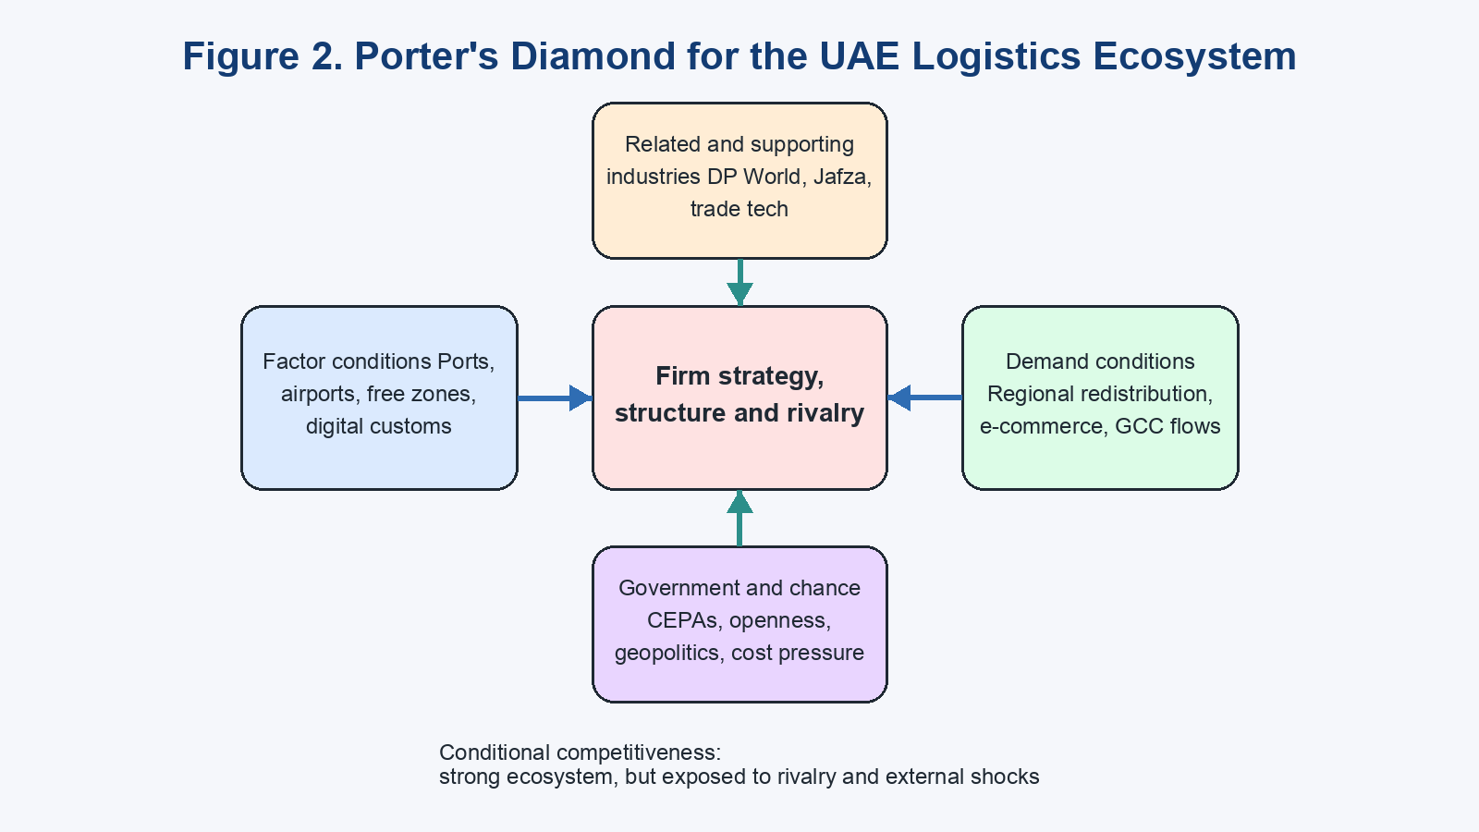
Figure 2: Porter's Diamond adapted to the UAE logistics ecosystem

3.1 Factor Conditions
Factor conditions are the UAE ecosystem's clearest strength. Dubai combines port access, airport reach, free-zone space and digital border systems in a way that lowers coordination time for logistics-intensive business, while Jafza and DP World's wider platform deepen the supply of warehousing, forwarding and trade-support capability (Jafza, 2026; DP World, 2024; Dubai Media Office, 2024). DXB and DWC strengthen the airport side of this story, so firms can move between sea, air and land with relatively little friction (Dubai Airports, 2026; Jafza, 2026). On Porter's terms, these are advanced rather than basic factors because they depend on organisation, technology and clustered infrastructure, not merely geography (Porter, 1990).
However, strong infrastructure should not be mistaken for complete operating superiority. The World Bank's scorecard breaks logistics performance into customs, competence, tracking and timeliness, which means a country can look impressive at the headline level while still leaving gaps in execution across segments (World Bank, 2023). Dubai research also warns that high operating costs and capability depth matter when a hub is compared with top-tier rivals such as Singapore, while local SME evidence shows that resilience still depends on collaboration and risk management rather than physical assets alone (Fernandes and Rodrigues, 2009; Abudaqa et al., 2023). Compared with Singapore's more mature logistics reputation in that study, Dubai's factor advantage depends more clearly on corridor integration and rapid platform development. The synthesis is that UAE factor conditions are strong, but their value lies in ecosystem usability rather than prestige.

3.2 Demand Conditions
Demand conditions are also favourable. Dubai serves cross-border business demand, regional redistribution, e-commerce fulfilment and time-sensitive delivery needs, while the large GCC share in chamber members' exports and re-exports shows that nearby markets generate steady onward movement rather than one-off domestic transactions (Dubai Chambers, 2025; DHL Group and New York University Stern School of Business, 2024). Regional buyers using Dubai as a redistribution point still impose demanding expectations around customs speed, inventory visibility and multimodal hand-off, so transit demand can generate discipline even when end consumption sits elsewhere. At the same time, part of this demand is transit-driven and may not always produce deep local innovation pressure in every segment (International Monetary Fund, 2024; Fernandes and Rodrigues, 2009). Even so, the demand profile is strong enough to support competitiveness.

3.3 Related and Supporting Industries
The strongest diamond effect may lie in related and supporting industries. Ports, airports, free zones, customs systems and digital trade platforms are tightly linked, which gives Dubai cluster depth of the sort that logistics research associates with lower coordination costs and stronger service complementarities (Jafza, 2026; Dubai Media Office, 2024; Liu et al., 2022). Jacobs and Hall (2007) show that Dubai's port success was built not only on hardware but also on the institutional relationship between the port and the free zone, while current zone and airport sources suggest that this integration remains central to the city's appeal (Jacobs and Hall, 2007; Dubai Airports, 2026). That cluster logic also explains why Dubai competes on coordination quality, not only infrastructure count: once the interfaces between port, zone and airport work well, switching costs rise for customers managing time-sensitive regional flows. The caution is that concentrated systems can also create congestion and corridor dependence. Even so, for a scale-oriented multinational such as DHL, this support base is a major source of competitiveness.

3.4 Firm Strategy, Structure, and Rivalry
Rivalry inside the ecosystem is intense, but that is mostly positive in diamond terms. DHL, Aramex, FedEx and UPS all operate in overlapping service spaces, while DP World shapes the platform on which much of the market depends, so firms compete on speed, reliability and network reach rather than on simple presence (Aramex, 2024; FedEx, 2026; UPS, 2026). Aramex's own reporting notes pricing and margin pressure, which confirms that competition can compress returns if firms fail to differentiate (Aramex, 2024). Compared with Singapore's more mature benchmark status, Dubai's rivalry is less about defending an uncontested premium hub and more about winning business inside an open regional gateway, which keeps execution and cost discipline under constant pressure (Fernandes and Rodrigues, 2009; Aramex, 2024). Even so, rivalry raises the capability threshold and rewards operators that combine global networks with local execution.

3.5 Government, Chance, and Competitiveness Judgement
Government support reinforces the diamond strongly. The UAE's CEPA programme, open investment stance, free-zone architecture and digital trade systems all show a state strategy that treats trade and logistics as central to growth (Ministry of Economy & Tourism - UAE, 2025; Dubai Media Office, 2024; UN Trade and Development (UNCTAD), 2024). Yet chance factors still matter. The IMF warns that geopolitical tension and wider geoeconomic fragmentation remain real risks, while older Dubai logistics studies remind us that hub success can still be weakened by cost pressures and regional competition (International Monetary Fund, 2024; Fernandes and Rodrigues, 2009). The best judgement is that the UAE logistics ecosystem is globally competitive overall, but not frictionless.
Table 3: Diamond summary of competitiveness drivers
Diamond element | Strongest evidence | Main constraint | Overall judgement
Factor conditions | Linked ports, airports, free zones and digital systems (Dubai Airports, 2026; Jafza, 2026; Dubai Media Office, 2024) | Cost and capability variation (World Bank, 2023; Fernandes and Rodrigues, 2009) | Strong
Demand conditions | High cross-border and GCC-linked redistribution demand (Dubai Chambers, 2025; DHL Group and New York University Stern School of Business, 2024) | Some demand is transit-led (International Monetary Fund, 2024) | Strong to moderate
Related and supporting industries | Deep cluster linking ports, zones and logistics services (DP World, 2024; Jacobs and Hall, 2007; Liu et al., 2022) | Corridor dependence | Strong
Rivalry | Regional and global competitors sharpen service quality (Aramex, 2024; FedEx, 2026; UPS, 2026) | Margin pressure | Moderate to strong
Government and chance | Clear trade-supportive state strategy (Ministry of Economy & Tourism - UAE, 2025; UN Trade and Development (UNCTAD), 2024) | Exposure to external shocks (International Monetary Fund, 2024) | Strong but conditional
This conclusion matters because it sets the base case for Section 4. Because the ecosystem is strong, the more important issue becomes whether DHL can align its capabilities with that strength better than rival operators can.

4. DHL Evaluation in the UAE Market

4.1 Why DHL Is the Right Focal MNC
DHL is the most suitable focal multinational for this report because its UAE presence matches the full breadth of Dubai's logistics ecosystem rather than only one narrow service line. The group operates across express, forwarding, warehousing, e-commerce and supply-chain services, and it has recently deepened this position through contract-logistics expansion, the Danzas AEI Emirates acquisition and new investment in Dubai South (DHL Group, 2024a; DHL Group, 2024b; DHL Group, 2025b; DHL Group, 2025c). This breadth matters because DHL shows how a foreign multinational can use Dubai as a multimodal organising node for regional and global flows. Its scale also makes OLI analysis meaningful because ownership, location and internalisation advantages can be observed in practice rather than inferred abstractly (Dunning, 1988; Dunning, 2000).

4.2 Political and Legal Factors Affecting DHL's Success
Politically and legally, the UAE gives DHL a strong operating base. The state has treated trade openness, investment attraction and customs modernisation as central economic goals, which is visible in the CEPA programme, free-zone structure and digital trade systems that support cross-border activity (Ministry of Economy & Tourism - UAE, 2025; Dubai Media Office, 2024; UN Trade and Development (UNCTAD), 2024). For DHL, this reduces entry friction and makes it easier to coordinate forwarding, warehousing and re-export activity from one hub. The customs guide also shows why free zones matter: imported goods entering a UAE free trade zone are treated differently from goods entering the mainland, which helps logistics firms hold and redirect inventory with more flexibility when they are serving multiple destinations rather than only the domestic market (International Trade Administration, 2025a).
The antithesis is that a trade-friendly legal setting does not remove legal complexity. A hub economy handling regional redistribution is exposed to sanctions risk, export-control shifts, changing documentation rules and corridor-specific compliance issues that originate outside the UAE as much as inside it. The IMF's warning on geopolitical and geoeconomic fragmentation is therefore directly relevant to DHL, because external political change can alter routing and customer risk even if UAE domestic policy remains stable (International Monetary Fund, 2024; Dunning, 2000). Broad business-environment indicators can also make a market appear uniformly easy to operate in, even though logistics firms still face sector-specific friction around customs classification and documentation accuracy (International Trade Administration, 2025a; World Bank, 2023).
The most convincing synthesis is that the UAE's political and legal environment is favourable to DHL, but only when the company treats compliance as a strategic capability. Regulatory agility should therefore be seen as part of service quality rather than as a separate legal function. DHL's deeper investment in warehousing, forwarding and innovation makes sense because scale improves its ability to standardise procedures across facilities and customer groups, yet the same scale also raises the cost of legal misalignment if rules shift quickly (DHL Group, 2025b; DHL Group, 2025c; Gereffi, Humphrey and Sturgeon, 2005).

4.3 Economic and Infrastructure Factors Affecting DHL's Success
Economically, the UAE is attractive to DHL because it combines a large trade base with a hub function that reaches beyond local demand. The country's foreign trade scale, the GCC-centred pattern of Dubai re-exports and the continued growth of zone-based trade all indicate a market where logistics value comes from connecting multiple corridors rather than from serving one national consumer base alone (Dubai Media Office, 2025a; Dubai Chambers, 2025; Dubai Media Office, 2025b). This is the type of location where a multinational operator can spread fixed systems, network planning and service-control routines across many flows. DHL's UAE contract-logistics expansion and its wider Middle East investment plan suggest that the company is positioning itself to capture demand in sectors where warehousing, forwarding and value-added services matter as much as last-mile movement (DHL Group, 2024a; DHL Group, 2025b).
Infrastructure strengthens this economic case. Dubai's airport system, Jafza platform and trade-technology base reduce transfer time and give DHL several ways to organise shipments depending on urgency, cost and destination (Dubai Airports, 2026; Jafza, 2026; Dubai Media Office, 2024). The opening of DHL's innovation centre and new warehouse in Dubai South is especially telling because it places the company near the emerging DWC corridor, showing that DHL sees value in the city's future logistics geography as well as current flows (DHL Group, 2025c; DP World, 2024). Compared with Singapore, the UAE offers DHL a less mature benchmark hub but stronger adjacency to GCC redistribution routes, which helps explain why Dubai is attractive for region-facing network control. In other words, DHL is not choosing the UAE because it is the most established logistics model; it is choosing it because it is closer to the regional flows the company wants to coordinate (Fernandes and Rodrigues, 2009; Dunning, 1988).
Yet macro attractiveness does not guarantee firm-level advantage. Aramex's reporting makes clear that competition can pressure margins, while Fernandes and Rodrigues (2009) warn that a successful hub can still be weakened by high costs and rivalry from other regional centres. The World Bank scorecard adds a methodological critique because national logistics scores do not reveal segment profitability or whether a premium operator is earning enough return to justify high fixed investment (Aramex, 2024; World Bank, 2023; Fernandes and Rodrigues, 2009). DHL also does not own the local access layer of the market outright: Aramex's regional familiarity, FedEx's Emirates Post access and UPS's standard shipping presence give customers credible alternatives if DHL's pricing or reliability slips (Aramex, 2024; FedEx, 2026; UPS, 2026). The strongest synthesis is therefore conditional: the UAE is economically attractive for DHL, but returns depend on segment choice, pricing discipline and its ability to use Dubai as a network node rather than a simple domestic sales market.

4.4 Cultural and Workforce Factors Affecting DHL's Success
Dubai's business culture generally supports globally integrated firms because the city works through a multilingual, international and commercially outward-facing workforce. The business travel guide stresses the importance of relationship-building, respect for hierarchy and sensitivity to local norms, but it also presents the UAE as a setting where foreign firms regularly operate across cultures and where English is widely used in commercial interaction (International Trade Administration, 2025b). From a light Hofstede lens, this can suit a company such as DHL because standard operating systems can coexist with a context that values coordination, formal responsibility and relationship management across organisational levels (Hofstede, Hofstede and Minkov, 2010; DHL Group, 2025c). In practice, that means Dubai can support service integration across regional customers, global headquarters and frontline operations.
The caution is that cultural diversity can complicate execution as much as it helps it. McSweeney's critique of Hofstede is useful here because it warns against treating national culture as uniform or fixed, which is especially important in Dubai where many employees and customers are expatriate and cross-border in orientation (McSweeney, 2002). DHL therefore cannot rely on broad culture scores alone to manage service quality. It has to institutionalise coordination through training, clear escalation routes and common performance routines across a varied workforce (Abudaqa et al., 2023; DHL Group, 2025c; Liu et al., 2022).
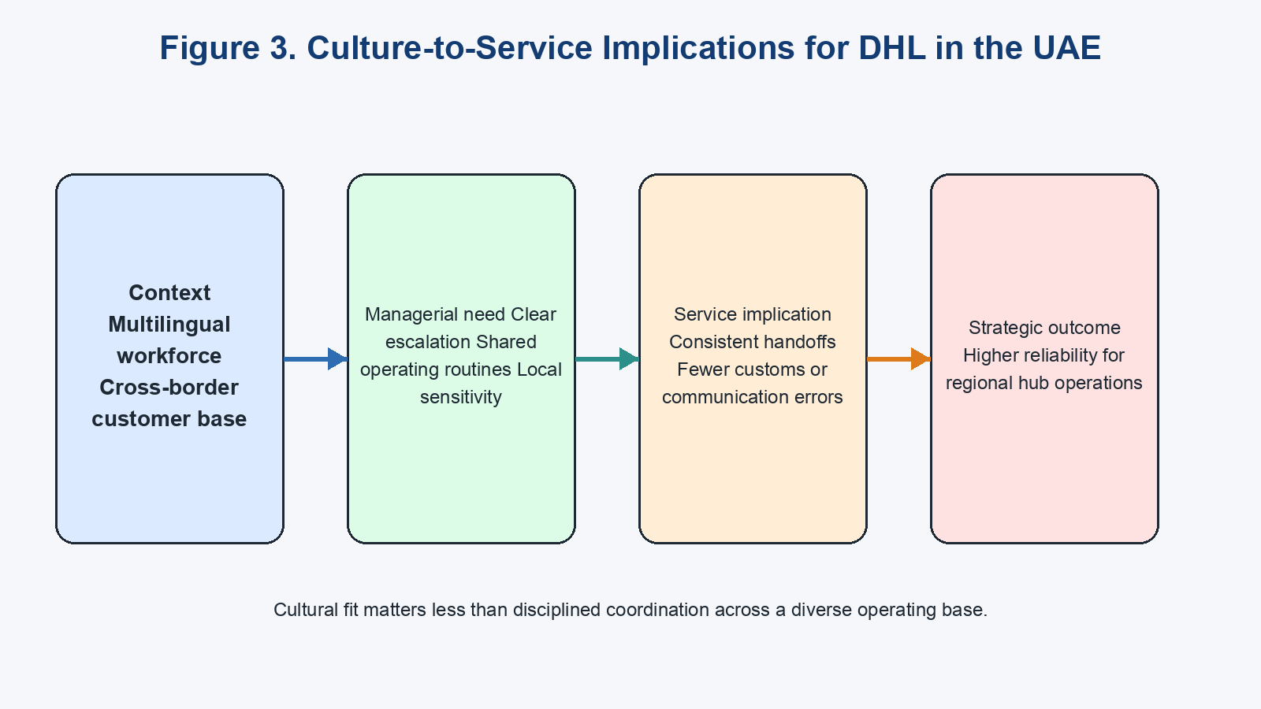
Figure 3: Culture-to-service implications for DHL in the UAE
The best synthesis is that culture in Dubai is both an advantage and a managerial test. The city gives DHL access to internationally experienced labour and customers who are comfortable with cross-border business, but it also raises the need for disciplined communication and service standard management. Success depends less on abstract cultural fit than on whether DHL can turn diversity into dependable coordination.

4.5 Strategic Fit Through OLI and GVC Logic
OLI provides the clearest explanation of why DHL should deepen its UAE operations. DHL's ownership advantages include its brand, global customer relationships, tracking systems, process know-how and integrated service portfolio. Dubai then supplies location advantages through trade scale, re-export intensity, airport and port connectivity, free-zone options and digital trade support, while internalisation advantages arise because DHL can keep control over service quality, data visibility and cross-border coordination instead of relying on loosely aligned external parties (Dunning, 1988; Dubai Media Office, 2025a; Jafza, 2026; DHL Group, 2024b). The point is not just that the UAE is open to foreign firms. It is that Dubai gives DHL a place where internal network control becomes especially valuable because many shipments, customers and corridors intersect in one operating system.
Table 4: OLI application to DHL in the UAE
OLI element | DHL-specific application | Why it matters in the UAE
Ownership advantages | Brand trust, global customer base, tracking technology, operational routines (DHL Group, 2025a; DHL Group, 2025c) | Helps DHL win high-value cross-border business and manage complex service promises
Location advantages | Dubai's trade scale, Jafza, airports, digital customs and Gulf reach (Dubai Media Office, 2025a; Jafza, 2026; Dubai Airports, 2026) | Makes the UAE a strong base for redistribution and multimodal control
Internalisation advantages | Keeping forwarding, warehousing and service control inside one network (Dunning, 1988; Dunning, 2000; DHL Group, 2024a) | Supports consistency, quality control and faster response across borders
GVC logic sharpens this further. Gereffi, Humphrey and Sturgeon (2005) argue that value in cross-border chains depends on how transactions are governed, not simply where they happen. DHL's UAE role fits this argument because the firm is not only moving cargo through Dubai; it is orchestrating sea-air-land links, warehouse decisions and customs timing across wider regional routes (Gereffi, Humphrey and Sturgeon, 2005; Jacobs and Hall, 2007). The antithesis is that OLI can understate softer institutional and execution constraints, while service outcomes still depend on rivalry, cost pressure and workforce coordination inside the hub (Dunning, 2000; Aramex, 2024; McSweeney, 2002). The synthesis is still strong: OLI plus GVC logic explains DHL's UAE fit better than either approach alone. This report's own contribution is that DHL's success rests on orchestration capability, not on presence alone.

4.6 Overall Market Attractiveness and Critical Success Judgement
Taken together, the political, legal, economic and cultural evidence suggests that the UAE is a highly attractive but conditional market for DHL. The strongest attraction comes from Dubai's role as a regional node: trade volume, free-zone support, multimodal infrastructure and digital trade systems all reinforce the logic of deeper DHL investment (Dubai Media Office, 2025a; Jafza, 2026; DHL Group, 2025b; DHL Group, 2025c). The main risks come from rivalry, cost pressure, geopolitical exposure and the difficulty of keeping service quality consistent across a varied operating base (International Monetary Fund, 2024; Aramex, 2024; Fernandes and Rodrigues, 2009). DHL's current edge should therefore be treated as contingent rather than durable, because trade fragmentation or weaker local execution would give customers several realistic alternatives. Dubai's openness is therefore double-edged: it attracts flows, but it also lowers barriers for rivals. That is the report's central strategic insight, because the same open architecture that makes Dubai valuable to DHL also makes the model easier for competitors to access and imitate. If trade routes reconfigure or nearby Gulf nodes copy the same openness with lower cost, DHL will need differentiated orchestration capability rather than hub presence alone to defend returns.
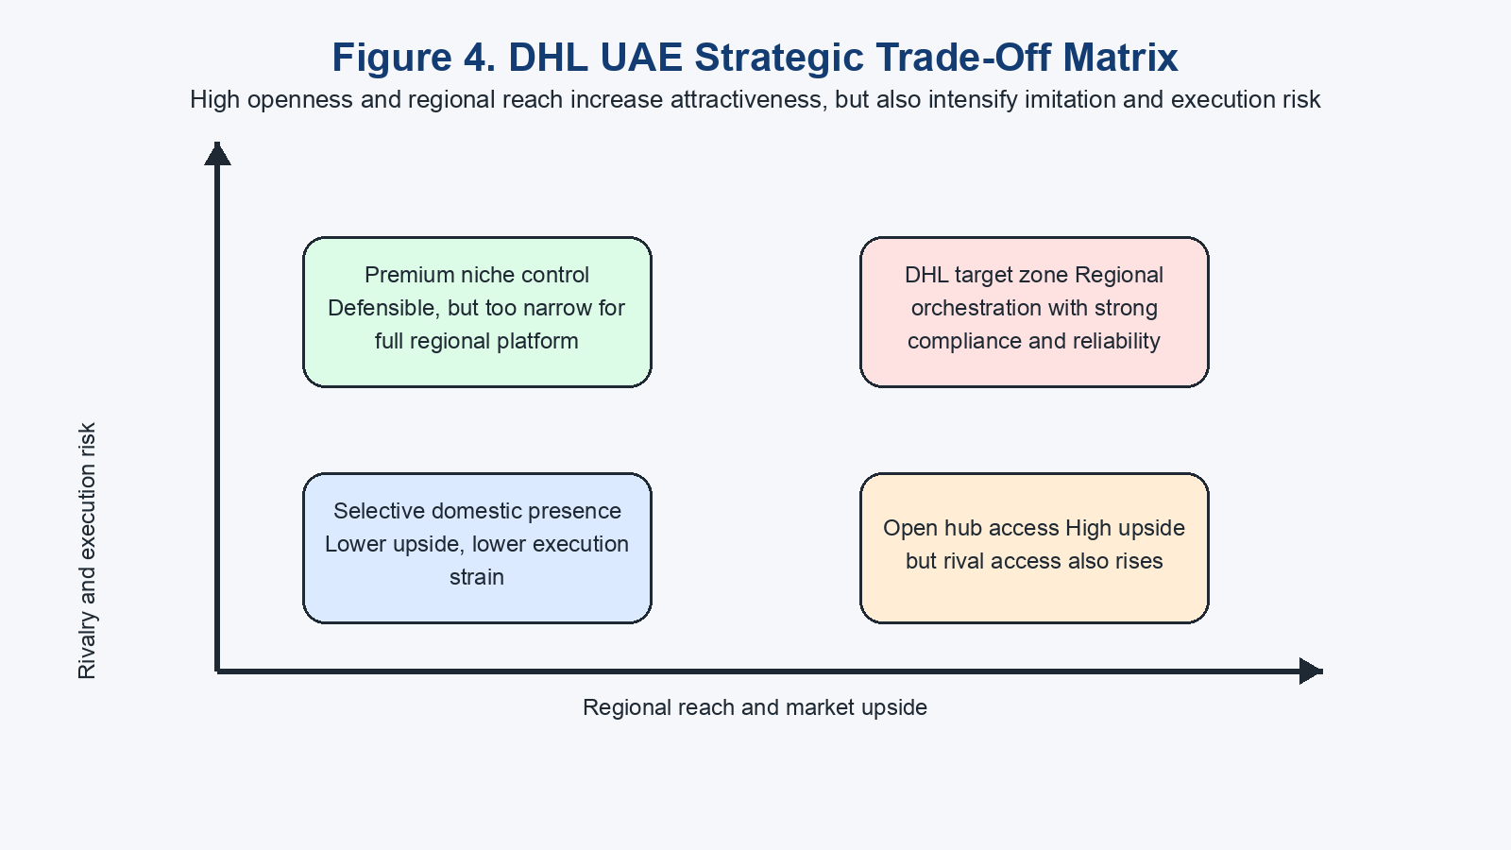
Figure 4: DHL UAE strategic trade-off matrix
Table 5: DHL UAE attractiveness matrix
Strengths | Risks | Conditions for success
Strong trade hub, good infrastructure, free zones, DHL brand and recent investment | Competition, costs, geopolitical shocks, compliance load | High service reliability, regulatory agility, strong network coordination
Access to GCC and wider regional redistribution | Margin pressure and segment variation | Focus on higher-value integrated services
Multicultural business setting and deep support industries | Coordination difficulty across diverse teams and customers | Standardised processes with locally responsive management
Overall, the UAE should be judged as strategically attractive for DHL, but the firm's advantage is temporary unless it keeps turning Dubai's hub strengths into better compliance, reliability and coordination than rivals can offer.

5. Conclusion
The report finds that the UAE's Dubai-based re-export and logistics ecosystem is internationally competitive because it combines high trade intensity, advanced infrastructure, strong free-zone support and a clear state commitment to trade connectivity. Porter's Diamond shows that the ecosystem's main strengths lie in factor conditions, related industries and government support, while its main limits arise from rivalry, cost pressure and exposure to geopolitical disruption rather than from any lack of basic logistics capacity (Porter, 1990; Ministry of Economy & Tourism - UAE, 2025; International Monetary Fund, 2024). Dubai therefore matters in international business terms not only because it is busy, but because it functions as a regional organising node linking multiple routes and markets.
For DHL, this creates a strong but conditional platform. The company's network scale, brand and recent UAE investments align well with Dubai's hub role, especially when viewed through OLI and value-chain logic, which show why location advantages are valuable when a firm can internalise service control across borders (Dunning, 1988; Gereffi, Humphrey and Sturgeon, 2005; DHL Group, 2024a; DHL Group, 2025c). Yet the report also shows that success is not guaranteed by infrastructure alone. DHL must continue to manage compliance, service quality, cultural coordination and rivalry with both regional and multinational competitors if it is to convert ecosystem access into sustained advantage (Aramex, 2024; McSweeney, 2002; Fernandes and Rodrigues, 2009). The decisive judgement is that Dubai gives DHL a real edge, but not a secure one: if the firm loses execution quality or cost discipline, the same open hub structure that helps DHL today will allow rivals to erode that advantage quickly. Because the analysis relies mainly on secondary sources, and because no DHL UAE segment margin data is available in the evidence base, this conclusion should be read as strategic rather than financial.

6. Reflective Account: Gibbs' Reflective Cycle

6.1 Description
I structured this assignment around Gibbs' Reflective Cycle so that I could move from description to evaluation and then to an action plan rather than simply listing what I had done (The University of Edinburgh, 2024). My first step was to choose a country-industry-company combination that matched the brief closely enough to support both ecosystem analysis and firm-level evaluation. I selected the UAE, focused on Dubai's re-export and logistics ecosystem, and chose DHL because the fit between the country, the industry and the company was clearer than in broader topic options. I then organised the report by moving from context, to Porter's Diamond, and then to DHL-specific analysis using OLI and value-chain logic.

6.2 Feelings
At the start, I felt confident that the UAE would provide enough material, but I was less certain about how to keep the assignment analytical rather than descriptive. Dubai is often discussed through headline claims about trade and infrastructure, so I was concerned that I might repeat positive facts without showing what they meant for competitiveness or for DHL's success. I also felt that the cultural section could become weak if I used Hofstede too heavily in a city built on expatriate labour and cross-border business.

6.3 Evaluation
Several parts of the process worked well. Choosing DHL made the assignment easier to focus because the company operates across express, forwarding and warehousing, so it could be linked directly to Dubai's multimodal trade role rather than being forced into the topic artificially (DHL Group, 2024a; DHL Group, 2024b). The decision to place Porter's Diamond before the firm analysis also helped because it created a clear ecosystem judgement that I could carry into the DHL section instead of repeating country facts in different words (Porter, 1990). Grouping sources into government, infrastructure, company and academic categories also made it easier to compare what each type of evidence could and could not show.
The main difficulty was controlling the breadth of the topic. There was a risk of spending too much time describing Dubai as a hub and not enough time explaining whether that hub structure actually improved DHL's prospects. I also found it difficult to balance positive ecosystem evidence with critical sources. Because Dubai generates many strong official figures, I had to work deliberately to retain qualifying evidence on costs, rivalry, culture and methodology rather than allowing the report to become one-sided (International Monetary Fund, 2024; Fernandes and Rodrigues, 2009; McSweeney, 2002).

6.4 Analysis
Looking back, the strongest improvement in my academic thinking came from using Porter's Diamond as a filter rather than as a checklist. Before applying it, I was tempted to treat infrastructure and trade volume as enough proof of competitiveness. Porter's model forced me to separate factor conditions from demand, supporting industries and rivalry, which showed that Dubai's success depends on interaction among these conditions rather than on a single strength (Porter, 1990; Jacobs and Hall, 2007). This made my argument more disciplined because I had to ask whether the ecosystem was genuinely competitive or simply very active.
OLI then improved the report in a different way. It shifted my thinking from describing the UAE market to explaining why DHL would choose to deepen its presence there. Ownership, location and internalisation advantages gave me a clear way to connect DHL's brand and systems to Dubai's trade role, while Dunning's later refinement reminded me that theory still needs to be adapted to service settings and institutional realities (Dunning, 1988; Dunning, 2000). I realised that the best explanation of DHL's position was not that it had entered a large market, but that it could orchestrate activity from a strategically placed node.
The cultural section taught me another important lesson. Hofstede gave me a usable starting point for thinking about hierarchy, communication and service expectations, but McSweeney's critique stopped me from treating national culture as fixed or homogeneous (Hofstede, Hofstede and Minkov, 2010; McSweeney, 2002). That was important in the Dubai case because the workforce and client base are highly international. As a result, I moved away from broad cultural labels and focused more on coordination, management systems and service consistency. This improved my practical application skills because it connected culture to managerial action rather than to stereotypes. More broadly, the process showed me that international business analysis becomes stronger when I use frameworks to test claims, not to replace judgement.

6.5 Conclusion
This assignment taught me that strong international business analysis depends on layering frameworks rather than relying on a single model. Porter's Diamond helped me judge ecosystem competitiveness, OLI helped me explain DHL's location choice, and the cultural debate reminded me to question tidy classifications when the operating setting is highly international (Porter, 1990; Dunning, 1988; McSweeney, 2002). I also learned that the quality of the report improved when I kept separating ecosystem-level evidence from firm-level conclusions instead of treating them as identical. It also showed me that persuasive writing depends on turning raw statistics into an argument about causation, trade-offs and managerial implications rather than treating citation density as proof of analysis.

6.6 Action Plan
If I were completing a similar assignment again, I would improve my process in four ways. First, I would filter sources earlier so that official statistics, company releases and academic critique were grouped from the beginning rather than sorted later. Second, I would use contradictory evidence more deliberately at the outline stage, which would make it easier to build balanced paragraphs without revising them heavily afterwards (International Monetary Fund, 2024; Liu et al., 2022). Third, I would keep a clearer distinction between ecosystem claims and firm claims in my notes, because that boundary was where drift into description was most likely. Finally, I would plan framework integration earlier by deciding exactly where Porter, OLI and culture analysis would connect, rather than allowing those links to emerge during drafting. I would also add competitor benchmarks and segment-level financial proxies earlier in the process, because those would strengthen judgements about whether a hub is merely busy or genuinely value-creating. That would make my future work more efficient and analytically consistent.

References
Anas Abudaqa, Rashed Alzahmi, Mohd Faiz Hilmi and Gouher Ahmed (2023) 'How supply chain resilience is achieved in SMEs of Dubai, UAE? Considering the flexible supply chain practices as a mediator', International Journal of Logistics Systems and Management. doi:10.1504/IJLSM.2023.131420.
Aramex (2024) Aramex 2024 Annual Report. Available at: https://www.aramex.com/cd/en/investor-relations-details/aramex-annual-integrated-report/aramex-2024-annual-report (Accessed: 27 March 2026).
Brendan McSweeney (2002) 'Hofstede's Model of National Cultural Differences and their Consequences: A Triumph of Faith - a Failure of Analysis', Human Relations. doi:10.1177/0018726702551004.
Cedwyn Fernandes and Gwendolyn Rodrigues (2009) 'Dubai's Potential As An Integrated Logistics Hub', Journal of Applied Business Research (JABR). doi:10.19030/jabr.v25i3.1028.
DHL Group (2024a) DHL expands contract logistics portfolio to the UAE to address increasing demand for specialized end-to-end supply chain services. Available at: https://group.dhl.com/en/media-relations/press-releases/2024/dhl-expands-contract-logistics-portfolio-to-the-uae.html (Accessed: 27 March 2026).
DHL Group (2024b) Acquisition approved: DHL Global Forwarding completes acquisition of Danzas AEI Emirates. Available at: https://group.dhl.com/en/media-relations/press-releases/2024/dhl-global-forwarding-completes-acquisition-of-danzas-aei-emirates.html (Accessed: 27 March 2026).
DHL Group (2025a) DHL Group: Strong fourth quarter with revenue and earnings growth. Available at: https://group.dhl.com/en/media-relations/press-releases/2025/dhl-group-annual-earnings-2024.html (Accessed: 27 March 2026).
DHL Group (2025b) DHL Group to invest more than EUR 500 million in fast-growing markets in the Middle East. Available at: https://group.dhl.com/en/media-relations/press-releases/2025/dhl-group-to-invest-more-than-eur500-million-in-fast-growing-markets-in-the-middle-east.html (Accessed: 27 March 2026).
DHL Group (2025c) DHL opens next-gen Innovation Center and builds a state-of-the-art contract logistics warehouse in Dubai, UAE. Available at: https://group.dhl.com/en/media-relations/press-releases/2025/dhl-opens-next-gen-innovation-center-in-dubai.html (Accessed: 27 March 2026).
DHL Group and New York University Stern School of Business (2024) Globalization at a record high - despite pandemic and geopolitical conflict, reveals DHL Global Connectedness Report 2024. Available at: https://group.dhl.com/en/media-relations/press-releases/2024/dhl-global-connectedness-report-2024.html (Accessed: 27 March 2026).
DP World (2024) 'Annual Report 2024', DP World. Available at: https://www.dpworld.com/en/investors/annual-report-2024 (Accessed: 27 March 2026).
Dubai Airports (2026) Dubai Airports Fact File. Available at: https://media.dubaiairports.ae/dubai-airports-main-fact-file/ (Accessed: 27 March 2026).
Dubai Chambers (2025) 'GCC markets account for 52% of Dubai Chamber of Commerce members' exports and re-exports in 2024 with combined value of AED 161 billion', Dubai Chambers. Available at: https://www.dubaichambers.com/en/w/gcc-markets-account-for-52-of-dubai-chamber-of-commerce-members-exports-and-re-exports-in-2024-with-combined-value-of-aed-161-billion (Accessed: 27 March 2026).
Dubai Media Office (2024) Dubai Trade surpasses 300 million transactions. Available at: https://mediaoffice.ae/en/news/2024/February/01-02/Dubai-Trade-surpasses-300-million-transactions (Accessed: 27 March 2026).
Dubai Media Office (2025a) Mohammed bin Rashid says UAE's Foreign Trade Surpasses AED 3 Trillion by End of 2024. Available at: https://www.mediaoffice.ae/en/news/2025/february/05-02/mohammed-bin-rashid (Accessed: 27 March 2026).
Dubai Media Office (2025b) DIEZ trade surges 19% to AED336 billion in 2024. Available at: https://mediaoffice.ae/en/news/2025/september/21-09/diez-trade-surges-19-percent-to-aed336-billion-in-2024 (Accessed: 27 March 2026).
FedEx (2026) FedEx International Shipping Services at Emirates Post | FedEx United Arab Emirates. Available at: https://www.fedex.com/en-ae/emiratespost.html (Accessed: 27 March 2026).
Gary Gereffi, John Humphrey and Timothy Sturgeon (2005) 'The governance of global value chains', Review of International Political Economy. doi:10.1080/09692290500049805.
Geert Hofstede, Gert Jan Hofstede and Michael Minkov (2010) Cultures and Organizations: Software of the Mind, Third Edition. New York: McGraw Hill Professional.
International Monetary Fund (2024) 'United Arab Emirates: 2024 Article IV Consultation-Press Release; and Staff Report', IMF Staff Country Reports. doi:10.5089/9798400293245.002.
International Trade Administration (2025a) United Arab Emirates - Customs Regulations. Available at: https://www.trade.gov/country-commercial-guides/united-arab-emirates-customs-regulations (Accessed: 27 March 2026).
International Trade Administration (2025b) United Arab Emirates - Business Travel. Available at: https://www.trade.gov/country-commercial-guides/united-arab-emirates-business-travel (Accessed: 27 March 2026).
Jafza (2026) The Logistics industry at Jafza. Available at: https://www.jafza.ae/community/industries/logistics/ (Accessed: 27 March 2026).
John H. Dunning (1988) 'The Eclectic Paradigm of International Production: A Restatement and Some Possible Extensions', Journal of International Business Studies. doi:10.1057/palgrave.jibs.8490372.
John H. Dunning (2000) 'The eclectic paradigm as an envelope for economic and business theories of MNE activity', International Business Review. doi:10.1016/S0969-5931(99)00035-9.
Michael E. Porter (1990) The Competitive Advantage of Nations. Available at: https://hbr.org/1990/03/the-competitive-advantage-of-nations (Accessed: 27 March 2026).
Ministry of Economy & Tourism - UAE (2025) Comprehensive Economic Partnership Agreements. Available at: https://www.moet.gov.ae/en/cepa (Accessed: 27 March 2026).
Sijing Liu, Nannan He, Xindan Cao, Guoqi Li and Ming Jian (2022) 'Logistics cluster and its future development: A comprehensive research review', Transportation Research Part E: Logistics and Transportation Review. doi:10.1016/j.tre.2022.102974.
The University of Edinburgh (2024) Gibbs' Reflective Cycle. Available at: https://reflection.ed.ac.uk/reflectors-toolkit/reflecting-on-experience/gibbs-reflective-cycle (Accessed: 27 March 2026).
UN Trade and Development (UNCTAD) (2024) World Investment Report 2024: Investment facilitation and digital government. Available at: https://unctad.org/publication/world-investment-report-2024 (Accessed: 27 March 2026).
UPS (2026) Shipping Services | UPS - United Arab Emirates. Available at: https://www.ups.com/ae/en/support/shipping-support/shipping-services (Accessed: 27 March 2026).
World Bank (2023) International Scorecard Page | Logistics Performance Index (LPI). Available at: https://lpi.worldbank.org/index.php/international/scorecard/radar/C/ARE/2023/lpi-only (Accessed: 27 March 2026).
Wouter Jacobs and Peter V. Hall (2007) 'What conditions supply chain strategies of ports? The case of Dubai', GeoJournal. doi:10.1007/s10708-007-9092-x.

