Module 5: BMPF7013F
Elena Atkinson-Sporle
2029941

‘Can absolute pitch be acquired by 7-10 year-olds within a 1-1 music lesson context and how might this be achieved?’
Contents

Title | Page
Overview | 3
Rationale | 4
Preparatory steps | 6
Theoretical influences | 7
Best practice influences | 8
Methodological Influences | 10
Critical reflection | 12
Part II | 14
Bibliography | 26
Appendix 1  Information on Absolute Pitch | 32
Appendix 2  Recognition Exercise: Sessions 1 & 2 | 33
Appendix 3  Song integration: Sessions 1 & 2 | 35

Part I

Artefact overview
During the course of this study, I will create and compile a set of exercises that aim to assist the acquisition of absolute pitch among students aged 7-10 in a 1-1 instrumental/singing lesson context. This project is motivated by my experience as an English as a Foreign Language (EFL) and singing/instrumental teacher, and by work undertaken in previous modules. This teaching tool will be applied within my practice with the dual objective of enhancing musicianship, and increasing each student’s aptitude for foreign language learning.

This practical artefact will combine scholarly research with best pedagogical practice. The synthesis of this work will be based on my professional experience and observations, and scientific/academic research spanning various research fields, including linguistics, neuroscience, psychology and pedagogy. There is a plethora of evidence that demonstrates the cross-domain transfer of musical and linguistic skills (Christiner et al., 2023; Kraus and Chandrasekaran, 2010; Law and Zentner, 2012; Andrianopoulou, 2020; Christiner, Bernhofs and Groß 2022; Andreeva et al., 2019; Burnham, Brooker & Reid, 2015). Absolute pitch, the ability to recognise and name a given pitch without a reference tone, is considered highly useful for musicians (Carden & Cline, 2019). New studies have found that AP possessors also have an advantage when learning a foreign language (Burnham, Brooker & Reid, 2015). Thus, this artefact was designed to aid individuals in developing absolute pitch. The literature review will assess dominant theories relating to absolute pitch, and best practices in a one-to-one skill-learning setting with children aged 7-10, as well as evaluate the efficacy of existing practices and experimental methods designed to onset absolute pitch. Careful ethical considerations will be made throughout the project, both in the artefact’s design and application phases. An information sheet will be produced to inform parents and guardians on AP, what it is and the reported advantages and disadvantages.

The artefact will contain:

- the first two weeks of materials intended to be used weekly in a one-to-one instrumental lesson for students aged 7-10
- a set of instructions for the trainer detailing how and when to implement the tasks
- instructions on how students can best practice between weekly sessions
- an information sheet detailing the current research on absolute pitch and what may have to be considered before intentionally aiming to onset absolute pitch

Rationale for the artefact’s creation (1000 words)
As a professional practitioner, I present myself as a music teacher who supports foreign language learning, most commonly English, with an academic background and training that encompasses both music and language pedagogy in the form of BA Music, CertTESOL (Teaching English to Speakers of Other Languages) and TEFL-YL (Teaching English as a Foreign Language – Young Learners). The combined approach of teaching music and foreign language takes various forms depending on the wishes and pre-existing skills of each student. Teaching takes place both in classroom and one-to-one environments, with the majority of students being aged 7-10, coming from a range of backgrounds and demonstrating a variety of native tongues. German is a common language between myself and each student. A recurring issue in my teaching practice is the perceived disengagement of children when language learning is targeted directly. Preliminary readings demonstrate evidence of cross-domain language and music learning and the targeting of specific musical skills to enhance specific linguistic skills and encourage further practical exploration into this area (Patel, 2011). Implicit development of language learning aptitude through musical activities and musical skill development is thus intended to simultaneously improve an aspect of a student’s musicality while supporting language learning and increasing engagement.

Preliminary academic readings and market research have revealed that education combining language and music training is a nascent field, which, as a teaching practitioner, means that there are few practical resources available to utilise within my practice. This presents a variety of challenges. Although evidence indicates a particular outcome, i.e. enhanced pitch perception improves novel word learning ability (Burnham, Brooker & Reid, 2015), how to apply this within a teaching practice remains untested at the time of writing. This can result in frustrating situations for students and teachers alike in which progress is slow and periodic goals hard to define. Thus this project is an opportunity to create a thoroughly researched artefact that can be tested in further research and uses currently available literature and best practices to structure educational programmes and curricula.

The artefact itself contains a set of exercises to be undertaken in lessons to aid students in developing absolute pitch (AP). AP is a highly attuned perception of pitch which allows possessors to name a given pitch without a reference tone (Burnham, Brooker & Reid, 2015). In addition to the potential for foreign language acquisition aptitude, AP has an impact on musicianship. Absolute pitch has continually been regarded as an advantageous tool for musicians (Carden & Cline, 2019). As AP involves predominantly long-term memory processes, this frees up working memory resources for other executive functions during music-making (Carden and Cline, 2019; Andreeva, 2019). As my studio focuses on the ability of students to express themselves through their instruments, AP can be an extremely useful tool for this exploration (Iusca 2017). This further justifies the creation of this artefact. Although the benefits are consistently highlighted throughout the literature, the potential negative effects of AP must be explored too. This includes reported issues with transposition (West Marvin, VanderStel & Siu, 2020) and the lack of specialised music training for those possessing AP (Carden & Cine, 2019). This data was collected and formulated into a non-biased information sheet for parents and guardians to read before undertaking training in AP development.

The cause of absolute pitch ability has long been discussed in academic literature. Previous dominant theories suggest that one must have a genetic predisposition for AP (Deutsch, Henthorn and Dolson 2004; Wong et al., 2020; Deutsch et al., 2006) and that there is a critical period for its acquisition, before the 7th year (Deutsch, Henthorn and Dolson 2004; Wong et al., 2020; Deutsch et al., 2006). Emerging evidence, however, indicates that everyone is born with the innate potential for AP development and that a form of AP is in fact learnable outside of the critical learning period (Wong et al., 2020; Gervain et al., 2013). Much of the existing research involves children in early childhood below the age of 7 and adults, thus this project addresses the little-researched gap of AP development in middle childhood.

Available findings demonstrate a plateau of AP development after age 7. In a survey with a large sample size of 600 musicians in conservatories, 40% of musicians who received their first musical training between ages 4-6 had absolute pitch ability, compared with only 8% who started aged 6-9 (Baharloo, 1998). What is not clear in this survey, is the type of music education these students received. Similarly, the popular absolute pitch acquisition method the Chord Identification Method (CIM) has been found to produce optimal results with children of 5-6 years. The method’s creator, Eguchi, even claimed that children over 8 years old could not develop AP with the CIM method (Sakakibara, 2014; Ichionkai, 2015). Thus, existing methods that are aimed at children younger than my targeted age range will have to be suitably adapted based on academic readings and pedagogical best practices.

This project is thus an opportunity to create an engaging set of exercises that benefits students both linguistically and musically grounded in best practices. This artefact will investigate and apply findings not only on how this age group learns most efficiently but how to maximise student engagement and enjoyment.

The created artefact is intended to be used primarily in one-to-one music sessions. The decision was made as the majority of my work takes place in one-to-one settings and pedagogical techniques differ greatly between one-to-one and classroom settings. A future project could focus on developing or adapting a similar artefact with an intended use within classroom settings.

Preparatory steps
To prepare my artefact, I will conduct an investigation into the current literature surrounding absolute pitch (AP) and available modern methods to acquire the skill. My study will be multi-disciplinary including literature from the fields of music pedagogy, neuroscience, linguistics and psychology. While much of the literature concerning absolute pitch will likely be rigorous academic texts, so-called ‘white literature’, I will likely also consult ‘real-world practice-oriented’ ‘grey’ literature, such as book chapters, unpublished dissertations and conference papers (Mackenzie, 2006) that can broaden the scope of research (Paez, 2017). A literature review from a previous module will prove useful in providing journals and authors within this subject area whose new works I can now easily source. I will also create inclusion and exclusion criteria for my reading.

In order to facilitate my study, I must deepen my understanding of the neurological systems and processes involved in AP by reading works by teams of neuropsychologists such as Andreeva et al; Jantzen, Hoe and Jantzen; and journals such as Quarterly Journal of Experimental Psychology and NeuroImage. This is necessary to understand how AP may be acquired and can inform methods and tasks for the artefact. From an ethical perspective, this understanding will help me assess any potential risks of AP possession or acquisition that I can use to inform legal guardians. An important ethical consideration will be to address the effect AP has or may have on one’s both on one’s experience within a musical context, and in other contexts. This can be acquired through evaluating qualitative studies collecting first-hand accounts of AP possessors, and through other research undertaken in this area.

Throughout this project, I will evaluate various existing methods of AP training, including the Chord Identification Method produced by Egochi, specifically designed to develop AP and the Yamaha Music School whose teaching incidentally produces many students with AP. I will also evaluate methods used in experimental training with adults. To produce an artefact designed to be employed within a one-to-one instrumental lesson with 7-10-year-olds, I will need to carefully consider the best practices of working with this age group in this environment. Thus, I will source literature on best pedagogical practices that address: attention, enjoyment, intensity of training and psychomotor learning.

Theoretical influences
The emerging interdisciplinary field of music-linguistics, which encompasses music, linguistics, psychology and neuroscience, has produced studies exploring the cross-domain effects of music and linguistic training. Evidence has been uncovered in recent years, that music training leads to changes in the auditory system that prime musicians for auditory challenges beyond that of music alone (Christiner et al., 2023; Kraus and Chandrasekaran, 2010; Law and Zentner, 2012; Andrianopoulou, 2020; Christiner, Bernhofs and Groß 2022; Olszewska, et al., 2021). More specific information is being uncovered in the field of neuroscience to bring to light the specific elements of music and linguistics that share neural systems and processes (Andreeva et al.; Patel, 2011). Through experimental research, it has been uncovered that enhanced pitch perception can improve one’s ability to distinguish between foreign language phonemes (Wiener & Bradley, 2023; Burnham, Brooker & Reid, 2015). Another more recent study demonstrated the correlation between refined pitch perception and novel foreign word learning abilities (Smit, Milne & Escudero, 2022). It has been hypothesized that musical training drives subcortical pitch-encoding networks to function with higher precision than is necessary for speech, thus improving speech-processing abilities (Patel, 2011). I must make clear in my artefact that the exercises provided are based on theories that are still emerging.

In a music education context, most musicians are trained to enhance their relative pitch (RP) perception skills (Gregerson et al., 2001). This is the ability to identify a given pitch in relation to a known reference pitch (Carden and Cline, 2019). In contrast, absolute pitch (AP) is defined as the ability to reflexively name a given pitch without a reference tone. The phenomenon has been researched for centuries with many hypotheses and pre-requisites for AP being posed, including genetics, tone-language exposure and some form of musical training during a critical learning period (Deutsch, Henthorn and Dolson 2004; Wong et al., 2020; Deutsch et al., 2006). Our understanding of AP has evolved rapidly in recent years alongside the development of neuroscience and its corresponding technologies. Methodological categories of electrophysiology, structural neuroimaging and functional neuroimaging have helped to separate the confounding influences of an individual’s environment in AP development (Loui, 2016).

Electrophysiological studies reveal that unlike non-AP, AP possessors do not rely on working memory to process musical tones, but rather store a template of the 12 semitone pitch chromas of the Western tempered scale in long-term memory (Loui, 2016; Rogenmoser, Elmer & Jäncke, 2015; Andreeva, 2019). AP is a bilateral ability involving long-term memory and linguistic coding (Cowan, 2008). Neuroanatomical studies found that increased left-ward asymmetry of the planum temporale (PT), was an indicator of AP ability and that the smaller right PT was a result of neural pruning in early development (Keenan et. al. 2001). This study concluded that young children with an increased leftward-PT asymmetry might have a higher likelihood of developing AP with early music exposure. This theory supports the pre-requisite of a critical learning period that is thought to span from birth to the 7th year (Baharloo et al., 2000; Rogenmoser, Elmer & Jäncke, 2015). Existing AP development training methods suggest that they are ineffective after the 7th year (Sakakibari 2014). However, studies have shown that AP can be learned in adulthood (Gervain et al., 2013; Cuddy, 1970; Wong et al, 2020; Wong et al, 2019; Grenier 2023). The success rate of these studies is very low and few provide follow-up studies to demonstrate a maintained ability. Researchers in Psychology at the University of Chicago ran an experiment in which they attempted to train adults to develop AP to the level of a “genuine” AP possessor (Hedger, Heald and Nusbaum 2019). After training, three of six previously non-AP participants were able to demonstrate an ability of the standard of those who have demonstrated AP abilities since childhood, which inspired a reconceptualization of the significance of the critical period (Hedger Heald and Nusbaum, 2019). Furthermore, this does not disprove the theory that AP gene-dependent but does suggest that working memory and attention may be more significant to AP development than a specialized mechanism. I should make it clear in my artefact that there remains a chance that, despite a student’s best effort, AP may be unattainable for them.

Best practice influences
In addition to the plethora of academic, so-called ‘white literature’, discussing the acquisition of AP, there exist many publications of a more practical position, ‘grey literature’, which present methods that lead to AP development and skills acquisition that can be applied in studio settings. I have identified best practices through my experience as a teaching practitioner, conversations with my peers, online conferences and academic texts reviewing the practices. There currently exist very few methods that are explicitly designed for AP acquisition used in studio settings similar to my own. Arguably the most popular method is the Chord Identification Method (CIM), Music pedagogue Eguchi created CIM as a method of AP acquisition that she claimed helped 90% of her students develop AP (Sakakibara, 2014). As a music teacher, much of her work was based on first-hand observations in her practice. Eguchi’s CIM highlights in practical terms a training method, the importance of particular protocols and variables including regularity of practice, how skills should be built and how AP training can be integrated into a larger curriculum (Ichionkai, 2015). While the website insists that anyone can acquire absolute pitch through this method, the information provided on this website may be biased as it is promotional copy to sell their program. Nonetheless, the CIM is a valuable tool to evaluate in the creation of this artefact, alongside a ‘white literature’ longitudinal study by Sakakibara (2014) that provides further insight into its efficacy. While the CIM involves a broad range of activities, the specific AP training focuses on identifying chords based on their ‘chroma’ (Sakikibara, 2014). This effectiveness of focusing on pitch chroma as opposed to pitch height is emphasised across much of the available literature (Cuddy, 1970; Warren et al., 2003), and is something I must take into account when designing my artefact.

Many variables affect the potential acquisition of absolute pitch. The linguistic component attached to the pitch will affect how it is stored in long-term memory. Certain pitch reception and production methods utilise ‘solfege’. Solfège is described as a method for sight-reading or vocal exercises using the French note-naming system (do for C, sol for G) (Kennedy, Kennedy & Rutherford-Johnson, 2013). Two common utilisations of solfege in music education are the ‘moveable do’ and ‘fixed do’ methods. ‘Moveable do’ refers to the use of do as the tonic, regardless of its true pitch value, whereas ‘fixed do’ maintains do as C. Learning with ‘fixed do’ has been reported to increase the likelihood of AP development (Wilson et al., 2011). I will thus need to investigate this further and decide on a logical nomenclature to be used consistently throughout my artefact.

The psychomotor domain encompasses the psychology of physical movement, coordination and the use of motor-skill areas, and is frequently used in combination with declarative knowledge learning to enhance memorisation (Moseley et al., 2005; Cozzutti et al., 2016). The BAPNE method (bio-mechanics, anatomy, psychology, neuroscience and ethnomusicology) connects musical learning with psychomotor learning (Cozzutti et al., 2016). This method employs theoretical influences of multiple intelligences (Gardner., 1983), the BAPNE method employs whole body coordination with solfege syllables and advocators for the method suggest that this method not only contributes to livelier, more engaging lessons but also facilitates internalised learning of theoretical knowledge (Cozzutti et al., 2016). Similar methods include the Kodály method which acknowledges the importance of the eye ear and hand being jointly involved in a task (Bowyer, 2015). The Kodaly method teaches hand signs with solfege vocalisation and is used in a range of educational programmes including the Full Voice Workbook Series (Loney and Adams, 2019). I thus aim to incorporate a form of psychomotor coupling to the linguistic nomenclature in the activities.

Assuming AP is an acquirable skill, this artefact aims to provide exercises that effectively engage the students while they learn. The ethos with regard to music in my practice centres around the development of musical skills for self-expression. The Yamaha School of Music is a music school for children in early and middle childhood that shares a similar philosophy and produces musicians, the majority of whom have high AP ability (Iusca 2017). This is a surprising statistic considering the perceived rarity of AP within the general population. While an exact percentage has not been determined, the figure of 1:1,500 was reported by Profita and Bidder (1988) and a recent investigation into a Brazilian conservatory found that 4% of the music students possessed AP abilities above their 85% accuracy threshold (Leite, Mota-Rolim & Queiroz, 2016). The school’s success in acquiring excellence in auditory skills is attributed to the early onset of music lessons (Iusca 2017), however, the methods employed involve learning to sing songs with solfege before playing the piano, a technique also seen in the Kodaly method (Miyazaki 2012; Bowyer 2015).

Children in middle childhood are reported to learn best through contextual learning in skill development (Smidt, 2010). Therefore, it is important to integrate AP skill training into songs and play at the piano, a practice observed in all the aforementioned methods.

Methodological Influences
This research is primarily conducted using a pragmatic paradigm, placing the ‘what’ and ‘how’ of the research problems and the centre (Creswell, 2003). A pragmatic paradigm acknowledges both singular and multiple realities (Felizer, 2020), and is considered highly useful within educational research for its lack of ontological affinity (King, 2022). This allows me to analyse data from both qualitative, quantitative and mixed-methods studies without a particular bias and orient the research around the ‘real-world’ issue itself (Mackenzie, 2006). This research must collect data from quantitative studies to ensure objective rigour is considered in concepts such as neurological information. With the objective of creating an artefact that engages individuals within an activity, subjective experiences must also be considered, thus including mixed methods and qualitative methods. By including practical experience from my professional practice in my research, the division between theory and practice is relaxed and my increased knowledge can manifest (Nelson, 2013). As the artefact is used within my professional practice, I can continue to develop and refine the artefact based on my experience.

The majority of the literature I review will be peer-reviewed published academic works, so-called ‘white literature. To gain further insight into the practical aspects of my project, I will include grey literature in my reading. Grey literature includes unpublished works that can provide more context into the researched subject and includes best practices and unpublished academic works (Benzies et al., 2006). When designing a search strategy, I should balance specificity and sensitivity to balance completeness and manageability (Paez, 2018). To fulfil this, I will consult grey literature databases like OpenGrey and WONDER. Including grey literature in such a project has led to the coining of a new term ‘state-of-the-evidence’ review, which acknowledges that available evidence exists beyond academic texts and takes into account information grounded in practice (Benzies et al., 2006). Part of the project is the undertaking of a rapid systematic literature review that clarifies the state of existing research and highlights the implications that should be drawn from this (Grant and Booth, 2009).

Gantt Chart
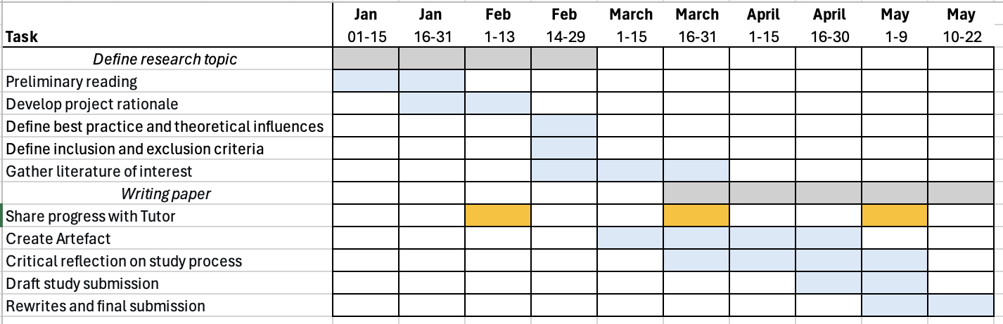

Ethical Considerations
While AP is a highly researched subject area across many academic fields, information is still being constantly uncovered on the subject. Researchers’ opinions on the usefulness of AP ability range somewhat. Some endorse AP as an instrument that allows for enhanced dictation, composition and sight-reading skills and that frees up cognitive space for other musical considerations (West Marvin, VanderStel and Siu, 2019). Others highlight the potential for some confusion in AP possessors when music is transposed and discomfort at alternative tunings (West Marvin, VanderStel and Siu, 2019). Future studies are needed to establish how and to what degree AP ability may transfer toward extramusical domains of life (Loui, 2016). There are also limited resources currently existing within music educational institutions to support and nurture AP abilities (Carden & Cline, 2019). The experiences of AP possessors are thus considered invaluable for this project. It is imperative to present a non-biased overview of what is known about AP to parents and guardians before working with the artefact and its exercises in the studio.

Learning Outcomes
Aims
- Create a study into AP acquisition in 7-10-year-olds
- Critically evaluate existing ‘white’ and ‘grey’ literature in my chosen line of enquiry
- Implement new knowledge on theoretical influences and best practice influences to produce an AP acquisition training programme suitable for my studio and clientele
- Assess how this study and artefact may impact my professional practice

Objectives
- identify significant theoretical influences and best practice influences relevant to AP development and classroom training methodologies
- to create and maintain a Reading Code Organisation Sheet (RCOS) (Shon 2018)
- identify strengths and weaknesses in the literature
- create a succinct set method that can be applied and adapted within my professional practice
- consider the implications this artefact may have on my professional practice

Critical Experience
The purpose of this project was to develop an artefact containing AP acquisition training methods suitable for students aged 7-10 with the intention of use within my teaching studio. During each stage of this project, I have utilised Kolb’s Experiential Learning Theory as a framework for reflective practice and development (Akella, 2010). The theory identifies four key stages of the learning process: concrete experience (CE), reflective observation (RO), abstract conceptualization (AC) and active experimentation (AE) (Akella, 2010). The initial CE stage of the process comprised my experiences and observations as a teacher within my professional practice and helped me establish an ‘improvement agenda’ for my practice (Ghaye, 2010:23). Through these observations, I was able to identify ‘problems’ within my practice (Nelson, 2013). The two most pertinent issues revolved around student disengagement in language tasks and frustrations with rote learning and pitch prediction to find melodies on the piano. Reflecting on my experience with the embodied knowledge collected from a previous overview study of AP, I based my further preliminary readings on the possible use of AP as a tool for both foreign language acquisition aptitude and musical activities. Through this reading, I was able to establish a line of research and intention behind the artefact. During this initial reflection stage, I designed a working title for my project, a process which is deemed vital to the success of the project (Rhoades, 2011).

Further reading into the existing theoretical knowledge and best practice facilitated ongoing reflective observation (Akella, 2010), and greatly informed the creation of my artefact (Nelson, 2013). Uncovering recent evidence that AP could be learnable past the critical period gave me the confidence to design an artefact that could be applied within my studio (Van Hedger, Heald and Nussbaum, 2019; Gervain et.al; 2013; Wong et.al, 2020). I was previously unaware of the wide array of existing best practice training techniques that had been connected to AP acquisition. As this literature was mostly ‘grey literature’, my first approach was to inform myself of the potential this type of literature has within research and how to use it to inform the creation of my artefact (Paez, 2017). I made efforts to ensure I was aware of any potential bias within the literature by determining the source and motive. I was able to identify the different variables which may have an impact on AP acquisition and how different methods adapt to these.

The lack of conclusive research on the genetic influence of AP was sometimes frustrating. I was concerned that I would produce an artefact that may be of limited use within my studio, or end up wasting students’ time on a skill that they would never be able to develop. Thus discovering the various types of AP possessors further motivated the project as I aimed to produce an artefact that would nonetheless improve one’s pitch perception and be beneficial to my students.

Working with a hermeneutic approach, which encourages perpetual research upon new discoveries, allowed me to investigate variables influencing AP acquisition that I was previously unaware of and influenced the creation of the artefact. This included ethical considerations on how AP abilities influence musical and extramusical experiences that I had not previously deeply considered and that I now deem integral to the artefact. However, the perpetual search and acquisition cycle of the hermeneutic approach extended my planned preliminary reading part of the project by weeks and at times left me feeling overloaded with information (Shon, 2018). If undertaking a project of a similar nature in the future, I will collect best practice documents first before analysing the theoretical knowledge in an attempt to limit the information intake.

The final stage of Kolb’s Experiential Learning Theory involves active experimentation (AE) (Akella, 2010). While I have not yet applied the artefact within my teaching studio, the potential impact it will have on the student experience is exciting. I predict that student pitch perception development will have a knock-on influence on their experience and the direction of their interests, maintaining a dynamic lesson environment. This artefact will act as a tool to help guide my students to further explore their musical and linguistic interests.

Part II

Introduction
Academic research is driven by a desire to address a problem, find things out and establish new insights (Nelson, 2013). Nelson’s model of Arts Praxis (2013) and Kolb’s Experiential Learning Theory both encourage reflection on experiential and embodied knowledge as a starting point for research within arts practices (Akella, 2010). Thus, the initial step in the creation of this artefact was to reflect upon recent concrete experiences within my practice and address the most pertinent issues. These unstructured observations help generate a hypothesis (Cohen, Manion & Morrison, 2018).

The two following observations were common in my sessions with 7-10-year-olds in which we combine instrumental and a foreign language learning:
- students are less engaged with language activities when language is being explicitly addressed
- students cannot easily play by rote/find melodies themselves on the piano and can become disheartened by this

Abstractly conceptualising from my experience, I imagined the potential for practical solutions in my practice that I could ground in theoretical literature and best practice resources (Akella, 2010). During a previous module, I reviewed evidence of various associations between language and music learning, and the possibility for cross-domain transfer of these skills. The reviewed literature spanned many fields of research including education, psychology, linguistics and neuroscience. Studies from these fields uncovered that enhanced pitch perception abilities appear to present many advantages in the ability to learn foreign languages (Christener et al., 2022; Hallam, 2017; Patel, 2011; Adreeva et al., 2023; Smit et al., 2022; Christiner et al., 2023; Hutka, Bidelmann & Moreno, 2015). The OPERA theory, posed by neurobiologist A. D. Patel, focuses on the overlap of brain networks that process acoustic features both in music and speech (Patel, 2011). According to the OPERA hypothesis, when certain conditions are met, neural plasticity drives the aforementioned networks to function with higher precision than is necessary for normal speech communication (Patel, 2011). Patel focuses on the acoustic features important to both speech and music, specifically periodicity. Periodicity is considered to be a waveform pattern with clear cycles that repeat regularly in time, with sounds that have stable periodicity considered to be pitched (Cook, 1999). Patel stresses that at the subcortical level in the auditory cortex, periodicity is likely processed by similar mechanisms with speech and music (2011).

Other researchers highlight that linguistic syntactic and musical harmonic processing utilise the same neural resources in bringing long-term, domain-specific knowledge into working memory (Andreeva, 2019). Additionally, linguistic alphabet phonemes’ may implicitly train musical pitch phonemes learnability in the AP function, another motivator behind the bi-directional music-language nature of this project (Andreeva, 2019). Christiner et, al. (2023) studied the association between musical capacity and foreign language intelligibility. From their findings, they hypothesized that the relationship between musical training and language may be mediated by memory capacity and thus future research should focus on how memorable languages appear and their relationship to musical variables (Christiner et al., 2023). In 2023, researchers at the MARCS Institute for Brain, Behaviour and Development studied the association between musical perception ability and novel word learning (Smit, Milne and Escudero, 2023). To determine ‘musical perception abilities’, they performed pre-tests including mistuning perception tests and melodic discrimination tests. They found that in 3 out of 4 categories, participants with enhanced musical perception skills were able to reproduce the novel words significantly more accurately than those with inferior musical abilities. Other studies have demonstrated that a refined sense of pitch perception, specifically possession of absolute pitch, has been shown to aid the distinction of foreign language phonemes (Burnham, Brooker and Reid 2014; Saito et al., 2022).

The initial question was developed as a result of my experiential observations combined with the aforementioned theoretical knowledge developed in a previous module:

‘Can absolute pitch be acquired by 7-10 year-olds within a 1-1 music lesson context and how might this be achieved?’

The phenomenon of absolute pitch
According to the methodology utilised in music psychology studies, absolute pitch (AP) is a skill or function allowing possessors to perceive isolated pitches within the equal tempered tuning system (A-440Hz), 12 chromatic semitones, without a reference tone, and rapidly label this corresponding to a relevant naming system (Andreeva et al., 2019). Despite the growing body of research and increasing interest in absolute pitch across a number of fields, the criteria to determine whether one possesses absolute pitch remains to be established (Andreeva et al., 2019; Carden and Cline 2019). Similarly, methods used to test for absolute pitch also vary between studies. The progress is thus unreliable and impeded due to variability in thresholds and testing methods. As such, it is often difficult to distinguish between the efficacy of the methods evaluated in this review.

Categorisation and types of AP
AP can be categorised as a passive skill and an active skill (Andreeva, 2019). The passive skill is the ability to recognise and name a given pitch whereas the active skill is the ability to sing a requested pitch on command. The artefact in this project is specifically designed to aid the development of passive AP skills.

AP possessors have been categorized into distinct types that vary across studies (Bachem 1937; Baharloo et al., 1998; Ross, Gore & Marks, 2005). Ross et al proposed two types of AP listeners based on physiological differences: APE (“ability to perceptually encode”) or HTM (“heightened tonal memory”) (Ross, Gore & Marks, 2005). APE listeners can encode the frequency of any auditory stimulus automatically, regardless of timbre or pitch height. HTM possessors acquire AP through early music training and recognise pitch by rapid comparison to a learned pitch template stored in the long-term memory. These two types may be associated with differences in processing mechanisms and mode of acquisition (West Marvin, VanderStel and Siu, 2019). AP tests have determined that AP abilities acquired in adulthood can perform on the same level as those with “genuine” AP (Hedger et al., 2020).

Prevalence and distribution
The prevalence of AP among the general population is a disputed statistic among researchers across various fields. For decades, researchers have frequently cited Bachem’s 1955 study which suggests AP has a prevalence of 1:10,000 in the general population (Bachem, 1955). However, the data on which this article is based is not currently available. A more recent article published by music psychologists Carden and Cline (2019) claim that AP has a prevalence of at least 4% among music students. They suggest that this level of prevalence is significant enough to consider how absolute pitch can be integrated into music education (Carden & Cline, 2019). The cases of AP are not evenly distributed among the general population. There is a significantly higher prevalence of AP among Asian populations (Gregerson et al., 1999; Deutsch et al., 2004; Miyazaki et al., 2018). Based on this finding, researchers investigated potential causes of this, breaking down the ‘nature vs nurture’ argument by focusing primarily on the potential influence of genetics and tonal language exposure.

Exposure to tonal language has often been posited as a potential cause of the increased prevalence of AP within Asian populations (Miyazaki et al., 2018). In non-tonal languages, such as English and German, words are composed only of a set of phonemes. Comparatively, within tonal languages such as Mandarin and Vietnamese, pitch and pitch changes also contribute to the semantic meaning of words. This heightened importance of pitch within the language itself heightens a speaker’s awareness of pitch and is theorised to facilitate AP development (Wong et al., 2020).

Some studies uncovered a strong familial aggregation, indicating that genetics are likely a prerequisite for absolute pitch development (Gregerson et al., 2000; Gregerson, Kolawsky and Li, 2006). Others, however, suggest that each person is born with the potential to develop absolute pitch (Keenan and Ward cited in Glasser, 2021), and that absolute pitch development is a result of a process called neural pruning. At the time of writing this paper, the role of genetics in AP ability is still unclear.

This artefact was created with the assumption that genetics may play a role in absolute pitch acquisition but that pitch perception can be nonetheless enhanced through absolute pitch training. For this reason, while the artefact has been designed first and foremost with the intention of aiding AP acquisition, should AP only occur in those with genetic predisposition, the training methods provided will nonetheless improve pitch perception and musicality.

Critical period
Dominant theories on absolute pitch suggest that musical training in early childhood is critical to the development of AP (Miyazaki, 1998; Trainor, 2005). Moreover, this critical learning period is generally considered to continue until the 7th year (Van Hedger, Heald and Nusbaum, 2019; Wong et al., 2020; Rogenmoser, Elmer and Jäncke, 2015). One investigation found that music training before the age of 6 significantly impacted the likelihood of AP abilities, however the rate of AP did not increase substantially with the onset of music training earlier than 6 years (Baharloo et al., 2000). Similarly, the increasingly popular Chord Identification Method (CIM) utilised to develop absolute pitch, Eguchi, claims a 90%+ success rate, providing children initiate training before age 8 years of age (Sakakibara, 2014).

These theories have been challenged in recent years. Numerous studies have successfully demonstrated AP acquisition in adulthood (Van Hedger, Heald and Nussbaum, 2019; Gervain et.al; 2013; Wong et.al, 2020). A 2019 study successfully trained two of six participating adults to acquire AP within an eight-week training period (Van Hedger, Heald and Nussbaum, 2019). They concluded that while it is possible to acquire AP in adulthood, this may only be limited to a certain subset of adults. However, this contained a relatively small sample size and other training methods should be tested to gather more data. A larger study similarly found AP to be a learnable skill among adults, far beyond the previously claimed critical period (Wong et.al, 2020). This study is of particular interest as the participants who successfully acquired AP after the initial training period demonstrated a maintained ability three months later. While this study is ground-breaking, compared with many methods used to train children under 6 years, the success rate is very low at 14%, with an already low sample size of 43 participants. The researchers concluded that AP is trainable in after the critical period and challenges the existence and importance of a critical period for learning AP. They call for further research into the potential differences between those who have learned AP, in adulthood for example, and those who appear to have naturally developed the skill. Regardless of whether “genuine” levels of AP were acquired, pitch perception was enhanced in the vast majority of participants through the training. This is promising data, as my method aims to enhance pitch perception if the student is unable to learn AP to the threshold.

The lack of studies conducted with participants in my target age range makes the task of designing a suitable training method challenging. There is also a lack of grey literature methods available. There is no clear musical training method most effective for AP development (Bongiovanni & Hedger, 2023); Andreeva et al., 2019). Comparing AP training methods used for children with those used for adults is also difficult as it must be identified what aspects of the training are effective and why training methods differ so much. Nonetheless, I shall evaluate existing AP training methods to refine the artefact based on my current understanding of AP acquisition and best pedagogical practice with my target age range.

The primary difference between successful AP training methods used for children and for adults is the frequency and duration of the training. The training conducted with adults is much more intensive, requiring hours of daily training over an average period of 6 weeks (Gervain et. al., 2013; Cuddy, 1970; Wong et al., 2020). The methods utilised with children, including the CIM, utilised shorter sessions of around 20 minutes per day, but skill mastery took much longer, one year minimum (Sakakibara, 2014; Ichionkai, 2015). The training exercises I have synthesized are designed to be implemented within a weekly instrumental session. This is similar to the Yamaha method and CIM (Iusca, 2017; Sakakibara, 2014; Ichionkai, 2015; Miyazaki & Ogawa, 2006). Therefore, the recognition task included in the artefact are advised to be performed for 10 minutes in a weekly lesson and once daily with a parent or guardian. A best practice help sheet is provided for parents and guardians to help their children practice and ensure they are undertaking the exercises correctly. The songs should also be played for at least 10 minutes daily to practice the skill in a musical context.
Auditory working memory and long-term memory
Working memory has been demonstrated to be an important predictor of perceptual category learning (Lewandowsky et al., 2012), including success in AP training (Van Hedger et al., 2015). Working memory is a cognitive system that provides temporary storage for the manipulation of information for complex cognitive tasks. Language comprehension and musical activity require both working and long-term memory (Andreeva et al., 2019). Studies show that both long-term memory and working memory interact when AP possessors respond to auditory stimuli (Andreeva et al., 2019; Levitin & Zatorre, 2003). The successful labelling of a pitch requires an association between a pitch stimulus and a conventional name, where both the linguistic name and representation of specific pitches are accessible within the long-term memory system and “working memory which participates in the routing of the retrieved information toward areas which will transform it into an overt manifestation” (Andreeva,et al., 2019).

One study found that the ability to hold a tone in working memory while resisting interference from other notes was crucial to the development of AP, namely because the ability to resist such interference allows memory consolidation when memory is fragile (Wong et al., 2020). This theory has been applied in the design of the ‘Recognition exercise’ contained within the artefact (see appendix. 2).

The majority of training methods evaluated, both for children and adults, implemented target note recognitions tasks. All methods gave immediate feedback on the note and each method introduced new target notes (or chords in the case of CIM) after an accuracy threshold was continuously met (Cuddy, 1970; Ichionkai, 2015). These parameters are present in the Recognition Exercise in the artefact (see appendix 2). The exact order in which target notes are introduced into training varies across training methods. The majority of methods evaluated in this review focused, at least initially, on white-note recognition (C to B), including the CIM, the Yamaha School and the school in a study lead by Miyazaki and Ogawa (2006) (Iusca, 2017; Sakakibara, 2014). Similaraly, the method in the artefact starts with C then D then E and will introduce a new white note moving up the scale every time

Recognition errors often occur when pitch chroma and pitch height are conflated (Cuddy 1970; Sakakibara 2014). Pitch chroma refers to musical pitch classes within each octave, i.e. C3 and C4 have the same pitch chroma. Pitch height refers to the linear frequency changes or how high or low a given pitch is. In a longitudinal experiment investigating CIM and the learning process, Sakakibara (2014) observed a plateau in student’s progression around the 6th new chord addition. Until this point, students had been largely focusing on pitch height to respond to the stimuli. Students eventually acquire a new strategy covering both height and chroma. In an attempt to avoid pitch height reliance, the pitch recognition exercise encourages the trainer to play pitches from C2 – C4 (See appendix 2).

Nomenclature: Fixed-do
The ability to correctly name a given pitch is part of the criteria for absolute pitch possession. Thus the selection of a suitable nomenclature system is imperative to the success of my training method. The naming system varies among the existing training methods. The Yamaha Music School, for example, uses the ‘fixed do’ system which has been accredited to its success in producing many AP musicians (Iusca, 2017). ‘Fixed do’ maintains do as C, re as D, mi as E, and so forth. In comparison, ‘moveable do’ is named such as ‘do’ is always the tonic and moves depending on the key. Learning with ‘fixed do’ has been reported to increase the likelihood of AP development (Wilson et al., 2011).

Inspired by the fixed do system, I have decided to use a combination of the English and German note-naming system for my students (see figure 1). This was selected for multiple reasons. My students are predominantly EFL learners receiving education from the Austrian school system. Thus, they will likely encounter German nomenclature. Introducing a new naming system may confuse students and interfere with their musical development. All of my current students have developed a knowledge pitch nomenclature, how this corresponds to the piano and western notation, based on the German note naming systems. Another reason for this is to keep the names monosyllabic.. The names are pronounced in English.
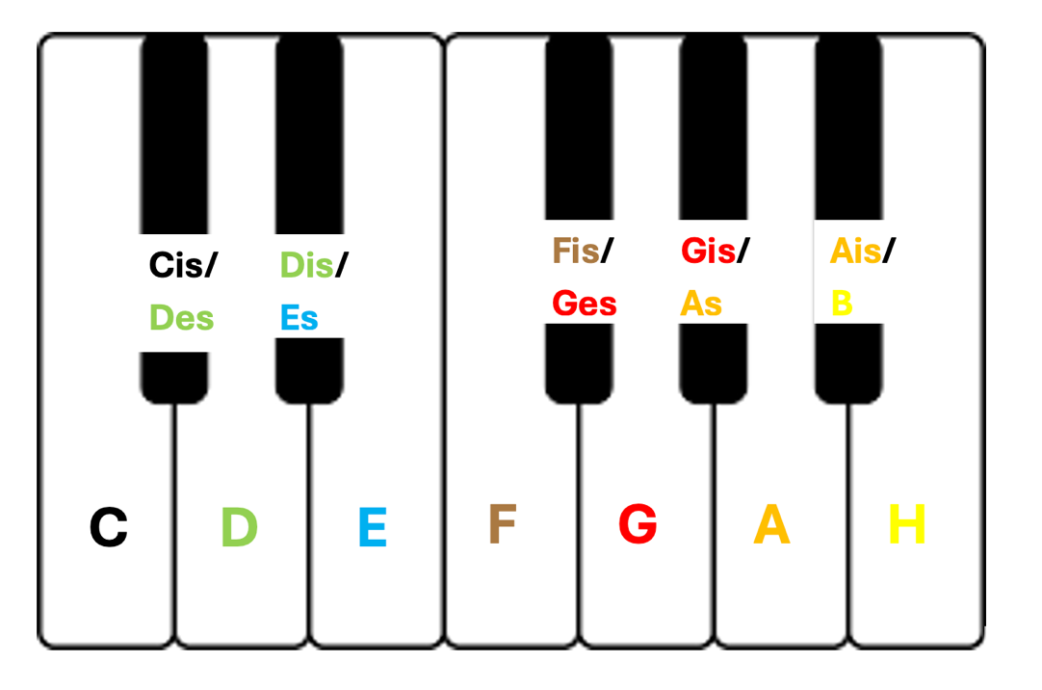
Fig. 1: Nomenclature system used within the artefact.

When sharps and flats are introduced to the music, the students will first learn to recognise notes and name them in their sharp/flat names depending on the key they are learning in the context of their lessons.

SPARC Effect
Another reason for the selection of this nomenclature is based on the SPARC effect. The SPARC effect, spatial pitch association of response codes, describes the associations between space and pitch and the effect this has on the estimation of musical intervals (Lidji, et al., 2007; Loudwin and Bannert, 2017). Inspired by the plethora of evidence within the field of mathematics connecting mental-spatial associations, Loudwin and Bannert found that training with musical notes represented visually on a vertical plane corresponding to their pitch ‘highness’ or ‘lowness’ significantly improved participants’ abilities to estimate musical intervals. The sample size was relatively large and the experiment was repeated twice to ensure validity. The participants, however, were university students. Although, we can fairly confidently assume that this phenomenon of spatial and mental connection can be applied to children aged 6-9 as numerous studies demonstrate a similar phenomenon occurring with numerical spacings (Lonnemann et, al. 2008; Young, Levine and Mix, 2018; Frick 2018). For musicians, reactions were faster when responding to a high pitch tone on the right side and low pitch on the left side. This is hypothesized as a “mental piano” map. Additionally, faster reaction times were observed in musicians and non-musicians when high notes were represented higher on a vertical plane and low notes represented lower. The objective of this experiment, however, was to test the relationship between space and intervallic recognition. Emphasizing pitch height may hinder the student’s ability to develop a strategy for pitch chroma recognition. More research should be conducted to determine whether this would be effective for AP development.

Total Physical Response (TPL)
The use of movement to enhance short and long term memory through psychomotor coordination has been used in pitch learning for centuries (Cozzutti et al, 2016; Loney and Adams, 2019). In my professional experience, I have observed variations of pitch learning combined with movement. These include body solfege and solfege matched with hand gestures. Anecdotal reports found that aural training with solfege in a static position decreased students motivation. (Cozzutti et al., 2016). Equally, Cozzutti et al. (2016) reported that students similarly became frustrated when trying to coordinate hand gestures with solfege. Where this information was sourced is unclear.

These findings prove useful to the creation of my artefact where I encourage children to play and sing the target notes on a paper piano, thus directly creating a mental-spatial association based on the piano and the position of the corresponding pitches as keys in physical space. The finger position is the middle C position, the most common for beginners. Pre-learned associations with the pitch names and the mental-spatial representations of their position on the keyboard may prove advantageous regarding AP development due to the “SPARC effect”.

Colours
Instead of having a distinct nomenclature system, CIM requires learners to identify heard chords and hold up a flag in the colour that corresponded to this chord. When a learner can correctly identify nine white chords (the first nine learned in the series), the nomenclature shifts from a colour to note names. I could not source any literature that explains why colours were selected over names, but this is could be due to the use of chords in this system as opposed to notes. It could also have been a strategic choice as colours have been proven to help learners to increase attention levels and increase the likelihood that information will be transferred to short and long term memories (Dzulkifli & Mustafar, 2013). In the AP training method I have developed in the artefact, each note will be assigned a colour in an attempt to strengthen neural connections further.

Furthermore, in a survey conducted with 30 AP musicians, 12 musicians reported colour associations with certain pitches and keys, although, the colors seemed unique to the individual and no information was provided on whether color had been part of their musical training (Marvin, VanderStel and Siu, 2019). In a study investigating colour experiences in AP individuals with synaesthesia, an anomalous blending of senses, participants reported that each note in an octave corresponded to the colours of the rainbow, starting with C as red (Itoh et al., 2017). However, behavioural studies showed that this was likely due to associations with the names of the notes and pattern superimposition, not the sound itself. Other reports suggest that colours associated with pitch listening are also influenced by the timbre of the notes (Guosheng, 2020). As there is currently little literature available of the relationship between pitch chroma and colour, the colours assigned to each pitch were selected in accordance with the piano method book used in my teaching studio in an attempt to avoid confusion and strengthen association. The children will receive a printed copy of the keyboard in figure one for the exercises in which they must correctly identify the target notes within a series.

Musicality
While these training methods may prove effective for the development of AP, they are not inherently musical. Andreeva et al emphasises the importance of constant musical activity for inducing brain plasticity, such as that required for the development of AP (Andreeva, 2019). Best pedagogical practice when working with children also stresses the importance of consolidating learning in context (Katz in Smidt, 2010). The Yamaha Music School provides an example of activities training AP being applied within a musical context. Although the programs offered at the school are not designed to train AP, absolute pitch musicians are observed to be the majority in these schools, not the minority (Miyazaki and Ogawa, 2012). The development of AP within the school has often been attributed to the critical learning period (with music lessons starting at 2 years old) and the tone-language theory, as many of its students are from East-Asian countries (Iusca, 2017).

Miyazaki and Ogawa (2012) undertook a cross-sectional study to investigate the learning process of Japanese children attending a Tokyo music school. The school’s main aim is to encourage children to develop the capability to express themselves musically, not to produce future musicians. The method in the first year of learning included the following four stages:
- sing songs with lyrics
- sing solomization of this song until memorized
- play the song on the piano
- play and sing the solfege

The second part of the artefact, Song integration: Sessions 1 & 2, includes an example of a beginner’s piano piece that will be learned using the four steps listed above (see appendix 3).
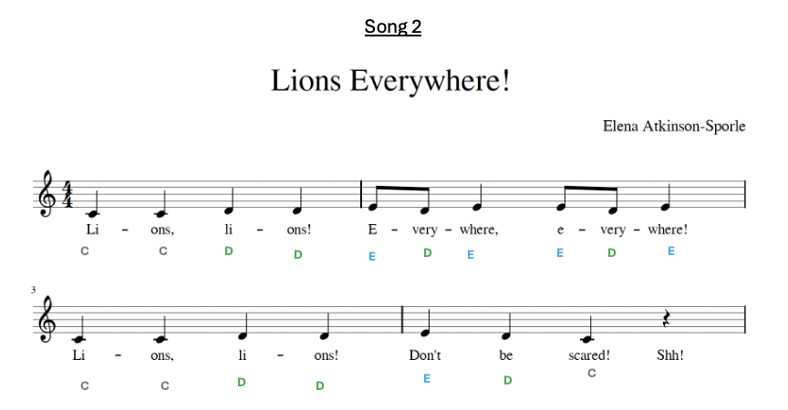
Fig. 2: Song integration: Sessions 1 & 2. Song 2, ‘Lions Everywhere!’

As a private practitioner, I have the freedom to establish the ethos of my musical instruction and not have the direction of my practice influenced by an employer or institution. Akin to the Yamaha institution, the main goal I set for myself as a practitioner is to provide my students with the tools to explore and express themselves musically. Play is considered a key part of children’s development as it relieves a sense of pressure, generates flexible, creative thinking and provides concrete experience (Moyles in Smidt, 2010). I thus consider it an integral part of my devised method that children consider the exercises in our lessons as playful and that an element of pure play is built into the sessions. To integrate play into the AP acquisition training methods, I can introduce a task which requires improvisation whilst singing note names.

Ethical considerations
To ensure ethical practice, an AP info sheet is included in the artefact to inform parents, guardians and students of the current knowledge regarding AP possessors and their experience in various environments (see appendix 1). Possession of absolute pitch has been reported to benefit musicians in many musical contexts. For example, AP musicians can undertake dictation tasks far more easily than non-AP musicians (Glasser, 2021). The efficiency with which AP musicians can recognise notes also frees up cognitive resources, making music-making more efficient (Carden and Cline, 2019; Andreeva et al). In a survey focusing on AP possessors individual experiences, four participants who were taught a fixed-do method noted that these syllables would come to mind when listening to music (West Marvin, VanderStel & Siu, 2019). While their feelings towards this were not expressed, the possible occurrence of this phenomenon should be considered before training to develop AP. Others expressed distress when asked to perform in non-A440 tunings.

In the same survey, AP possessors noted that while transcription tasks were easier for them than their non-AP peers, tasks involving chord quality identification and relative pitch were hard as they approached the tasks differently than their peers, namely by deconstructing chords or intervals and using knowledge of music theory to ascertain a response (West Marvin, VanderStel & Siu, 2019). They also indicate that AP has been learned in a HTM format, that is that a template of pitch and pitch names have been stored in long-term memory.

Participants expressed that they did not necessarily know how to utilise their AP in certain musical settings and that this was often a hinderance. One reason for this will likely be the lack of attention given to AP within music educational settings (Carden & Cline, 2019). Further research could be done into the integration of AP into music classes or programmes specifically directed at the utilisation of AP. As such educational routes are not currently available, this must be an ethical consideration before undertaking AP training.

Conclusion
The process of creating this artefact has proved an opportunity to enhance my personal practice by developing a deep understanding of the relationship between absolute pitch (AP) and music education for young learners. By critically reflecting on practical experiences and engaging with a wide range of interdisciplinary research, I was able to combine ‘modes of knowing’ to identify key methodologies and create an artefact for use in my studio (Nelson, 2013).

The primary objective was to create a study by focusing on the integration of AP training within music lessons for children aged 7-10 and create a suitable practical method to employ in my practice. Through an extensive review of current literature, a robust understanding of the variables that influence AP ability was established. This foundation was used to analyse available best practice methods being implemented in modern music education., including the Chord Identification Method (CIM), Yamaha Music School methods and the Kodaly method, as well as experimental training methods used in research with adults.

There are many potential impacts of the artefact within my studio. The potential for increasing language learning aptitude through enhanced pitch perception, supported by theories such as Patel’s OPERA theory (2011) and evidence uncovered by Smit, Milne & Escudero (2022), could be facilitated through the application of the artefact in my studio. This will need to be examined through observations. Furthermore, as detailed in first-hand accounts, the student’s musicality may improve in conjunction with their pitch perception. This would likely lead to increased student-engagement. I must constantly be aware that it may not be possible for certain students to acquire AP. I must also be aware of the potential negative effects of AP, such as problems with transposition, and investigate ways to ameliorate such issues should they arise. It is also important to be aware of the different categories of AP and the potential effects this may have for individuals (Bachem, 1937).

Bibliography

Akella, D. (2010). Learning together: Kolb’s experiential theory and its application. Journal of Management & Organization, 16(1), 100–112. https://doi.org/10.5172/jmo.16.1.100

Andreeva, I. G., Dymnikowa, M., Ogorodnikova, E. A., & Petrushin, V. I. (2019). Absolute Pitch Acquisition as Memory System with Its’ Musical Executive Function from Cognitive Neuropsychological Perspective. Asian Journal of Humanities and Social Studies, 7(5). https://doi.org/10.24203/ajhss.v7i5.5900

Bachem, A. (1937). Various types of absolute pitch. Journal of the acoustical society of America, October, 9, p.146-151.

Bachem, A. (1955). Absolute Pitch. The Journal of the Acoustical Society of America, 27(6), 1180–1185. https://doi.org/10.1121/1.1908155

Baharloo, S., Service, S. K., Risch, N., Gitschier, J., & Freimer, N. B. (2000). Familial Aggregation of Absolute Pitch. The American Journal of Human Genetics, 67(3), 755–758. https://doi.org/10.1086/303057

Benzies, K. M., Premji, S., Hayden, K. A., & Serrett, K. (2006). State‐of‐the‐Evidence Reviews: Advantages and Challenges of Including Grey Literature. Worldviews on Evidence-Based Nursing, 3(2), 55–61. https://doi.org/10.1111/j.1741-6787.2006.00051.x

Boell, S.K. and Cecez-Kecmanovic, D. (2014) ‘A Hermeneutic Approach for Conducting Literature Reviews and Literature Searches’, Communications of the Association for Information Systems, 34, pp. 12-. [Online]. Available at: https://doi.org/10.17705/1CAIS.03412

Boote, D. N., & Beile, P. (2005). Scholars Before Researchers: On the Centrality of the Dissertation Literature Review in Research Preparation. Educational Researcher, 34(6), 3–15. https://doi.org/10.3102/0013189X034006003

Bowyer, J. (2015). More than Solfège and Hand Signs: Philosophy, Tools, and Lesson Planning in the Authentic Kodály Classroom. Music Educators Journal, 102(2), 69–76. https://doi.org/10.1177/0027432115611232

Burnham, D., Brooker, R., & Reid, A. (2015). The effects of absolute pitch ability and musical training on lexical tone perception. Psychology of Music, 43(6), 881–897. https://doi.org/10.1177/0305735614546359

Campbell, P. (2011). Peirce, pragmatism, and the right way of thinking. (SAND2011-5583, 1022181; pp. SAND2011-5583, 1022181). https://doi.org/10.2172/1022181

Cook, P., R. (1999). Music, cognition, and computerized sound: An introduction to psychoacoustics. The MIT Press.

Cohen, L; Manion, L and Morrison, K. (2018). Research Methods in Education. Routledge, Oxon.

Cowan, N. (2008). Chapter 20 What are the differences between long-term, short-term, and working memory? In Progress in Brain Research (Vol. 169, pp. 323–338). Elsevier. https://doi.org/10.1016/S0079-6123(07)00020-9

Cozzutti, G., Blessano, E., De Biaggio, C., Tomasin, B., & Romero-Naranjo, F. J. (2017). Body Solfege in the BAPNE Method – Measures and Divisions. Procedia - Social and Behavioral Sciences, 237, 1572–1575. https://doi.org/10.1016/j.sbspro.2017.02.247

Cuddy, L. L. (1970). Training the absolute identification of pitch. Perception & Psychophysics, 8 (5A).

Deutsch, D., Henthorn, T., & Dolson, M. (2004). Absolute Pitch, Speech, and Tone Language: Some Experiments and a Proposed Framework. Music Perception, 21(3), 339–356. https://doi.org/10.1525/mp.2004.21.3.339

Dohn, A., Garza-Villarreal, E. A., Chakravarty, M. M., Hansen, M., Lerch, J. P., & Vuust, P. (2015). Gray- and White-Matter Anatomy of Absolute Pitch Possessors. Cerebral Cortex, 25(5), 1379–1388. https://doi.org/10.1093/cercor/bht334

Dohn, A., Garza-Villarreal, E. A., Heaton, P., & Vuust, P. (2012). Do Musicians with Perfect Pitch Have More Autism Traits than Musicians without Perfect Pitch? An Empirical Study. PLoS ONE, 7(5), e37961. https://doi.org/10.1371/journal.pone.0037961

Dzulkifli, M. A., & Mustafar, M. F. (2013). The influence of colour on memory performance: A Review. The Malaysian Journal of Medical Sciences, 20(2), 3–9.

Frick, A. (2019). Spatial transformation abilities and their relation to later mathematics performance. Psychological Research, 83(7), 1465–1484. https://doi.org/10.1007/s00426-018-1008-5

Gardner, H. (1983). Frames of mind: The theory of multiple intelligences. Basic Books (AZ).

Gervain, J., Vines, B. W., Chen, L. M., Seo, R. J., Hensch, T. K., Werker, J. F., & Young, A. H. (2013). Valproate reopens critical-period learning of absolute pitch. Frontiers in Systems Neuroscience, 7. https://doi.org/10.3389/fnsys.2013.00102

Ghaye, T. (2010). Teaching and Learning through Reflective Practice: A Practical Guide for Positive Action (2nd ed.). London: Routledge.

Glasser, S. (2021). Perceiving Music Through the Lens of Synaesthesia and Absolute Pitch. Perception, 50(8), 690–708. https://doi.org/10.1177/03010066211034439

Grant, M. J., & Booth, A. (2009). A typology of reviews: An analysis of 14 review types and associated methodologies. Health Information & Libraries Journal, 26(2), 91–108. https://doi.org/10.1111/j.1471-1842.2009.00848.x

Gregersen, P. K., Kowalsky, E., Kohn, N., & Marvin, E. W. (2001). Early childhood music education and predisposition to absolute pitch: Teasing apart genes and environment. American Journal of Medical Genetics, 98(3), 280–282. https://doi.org/10.1002/1096-8628(20010122)98:3<280::AID-AJMG1083>3.0.CO;2-6

Gregersen, P. K., Kowalsky, E., & Li, W. (2007). Reply to Henthorn and Deutsch: Ethnicity versus early environment: Comment on ‘Early Childhood Music Education and Predisposition to Absolute Pitch: Teasing Apart Genes and Environment’ by Peter K.Gregersen, Elena Kowalsky, Nina Kohn, and Elizabeth West Marvin [2000]. American Journal of Medical Genetics Part A, 143A(1), 104–105. https://doi.org/10.1002/ajmg.a.31595

Grenier, A. (2023). Assessing the Effectiveness of Different Training Paradigms in Pitch Categorisation. https://haplab.ca/pubs/2023_Grenier.pdf

Hedger, S. C. V., & Bongiovanni, N. R. (2023). Widespread but Limited in Context: Absolute Tuning Judgments are Disrupted by Relative Pitch Cues. Music & Science, 6, 20592043231208626. https://doi.org/10.1177/20592043231208626

Hu, G. (2020). Art of musical color: A synesthesia‐based mechanism of color art. Color Research & Application, 45(5), 862–870. https://doi.org/10.1002/col.22532

Ichionkai. (2015). Perfect pitch training lesson. www.ichionkai.co.jp (translated)

Itoh, K., Sakata, H., Kwee, I. L., & Nakada, T. (2017). Musical pitch classes have rainbow hues in pitch class-color synesthesia. Scientific Reports, 7(1), 17781. https://doi.org/10.1038/s41598-017-18150-y

Iușcă, D. (2017). Number 13 / Part I. Music. 7. Grounds of Absolute Pitch Development in Yamaha Music School. Review of Artistic Education, 13(1), 60–65. https://doi.org/10.1515/rae-2017-0007

Kennedy, M., & Kennedy, J. B. (2012). The Oxford dictionary of music (T. Rutherford-Johnson, Ed.; 6th ed). Oxford University Press.

King, R. (2022). The Utility of Pragmatism in Educational Research. Creative Education, 13(10), 3153–3161. https://doi.org/10.4236/ce.2022.1310199

Leite, R. B. C., Mota-Rolim, S. A., & Queiroz, C. M. T. (2016). Music Proficiency and Quantification of Absolute Pitch: A Large-Scale Study among Brazilian Musicians. Frontiers in Neuroscience, 10. https://doi.org/10.3389/fnins.2016.00447

Levitin, D. J., Zatorre, R. J. (2003). On the nature of early music training and absolute pitch: a reply to Brown, Sachs, Cammuso, and Folstein. Music perception, Fall, 21 (1), p.105-110.

Lewandowsky, S., Yang, L.-X., Newell, B. R., & Kalish, M. L. (2012). Working memory does not dissociate between different perceptual categorization tasks. Journal of Experimental Psychology: Learning, Memory, and Cognition, 38(4), 881–904. https://doi.org/10.1037/a0027298

Lidji, P., Kolinsky, R., Lochy, A., & Morais, J. (2007). Spatial associations for musical stimuli: A piano in the head? Journal of Experimental Psychology: Human Perception and Performance, 33(5), 1189–1207.

Loney, N., & Adams, M. (2019). Full Voice Workbook Series Level One (3rd ed.).

Lonnemann, J., Krinzinger, H., Knops, A., & Willmes, K. (2008). Spatial representations of numbers in children and their connection with calculation abilities. Cortex, 44(4), 420–428. https://doi.org/10.1016/j.cortex.2007.08.015

Loudwin, J., & Bannert, M. (2017). Facing pitch: Constructing associations between space and pitch leads to better estimation of musical intervals. Musicae Scientiae, 21(1), 26–40. https://doi.org/10.1177/1029864916634419

Loui, P. (2016). Absolute Pitch (S. Hallam, I. Cross, & M. Thaut, Eds.). Oxford University Press. https://doi.org/10.1093/oxfordhb/9780198722946.013.10

Mackenzie, N. and Knipe, S. (2006). ‘Research dilemmas: Paradigms, methods and methodology’, Issues in Educational Research, 16(2), pp. 193-205. Available at: https://www.iier.org.au/iier16/mackenzie.html

Miyazaki, K., Makomaska, S., & Rakowski, A. (2012). Prevalence of absolute pitch: A comparison between Japanese and Polish music students. The Journal of the Acoustical Society of America, 132(5), 3484–3493. https://doi.org/10.1121/1.4756956

Miyazaki, K., & Ogawa, Y. (2006). Learning Absolute Pitch by Children. Music Perception, 24(1), 63–78. https://doi.org/10.1525/mp.2006.24.1.63

Miyazaki, K., Rakowski, A., Makomaska, S., Jiang, C., Tsuzaki, M., Oxenham, A. J., Ellis, G., & Lipscomb, S. D. (2018). Absolute Pitch and Relative Pitch in Music Students in the East and the West. Music Perception, 36(2), 135–155. https://doi.org/10.1525/mp.2018.36.2.135

Moseley, D. (Ed.). (2005). Frameworks for thinking: A handbook for teaching and learning (1. publ). Cambridge University Press.

Nelson, R. (2013). Practice as research in the arts: Principles, protocols, pedagogies, resistances. Palgrave Macmillan.

Paez, A. (2017). Gray literature: An important resource in systematic reviews. Journal of Evidence-Based Medicine, 10(3), 233–240. https://doi.org/10.1111/jebm.12266

Paney, A. S., & Kay, A. C. (2015). Developing Singing in Third-Grade Music Classrooms: The Effect of a Concurrent-Feedback Computer Game on Pitch-Matching Skills. Update: Applications of Research in Music Education, 34(1), 42–49. https://doi.org/10.1177/8755123314548047

Profita, J., & Bidder, G. T. (1988). Perfect pitch. American Journal of Medical Genetics, 29, 763–771.

Rhoades, E. A. (2011). Literature Reviews. The Volta Review, 111(3), pp. 353-368. [Online]. Available at: https://web-s-ebscohost-com.ezproxy.uwtsd.ac.uk/ehost/pdfviewer/pdfviewer?vid=0&sid=99ee7c4f-f9c6-4533-b1e7-eda09e5f5f14%40redis

Rogenmoser, L., Elmer, S., & Jäncke, L. (2015). Absolute Pitch: Evidence for Early Cognitive Facilitation during Passive Listening as Revealed by Reduced P3a Amplitudes. Journal of Cognitive Neuroscience, 27(3), 623–637. https://doi.org/10.1162/jocn_a_00708

Ross, D. A., Gore, J. C., & Marks, L. E. (2005). Absolute pitch: Music and beyond. Epilepsy and Behavior, 7, 578-601.

Saito, K., Petrova, K., Suzukida, Y., Kachlicka, M., & Tierney, A. (2022). Training auditory processing promotes second language speech acquisition. Journal of Experimental Psychology: Human Perception and Performance, 48(12), 1410–1426. https://doi.org/10.1037/xhp0001042

Shon, P. (2018). The quick fix guide to academic writing : How to Avoid Big Mistakes and Small Errors. London: SAGE Publications Ltd

Appendix 1
Absolute Pitch

What is Absolute Pitch?
Absolute pitch, often referred to as "perfect pitch," is the ability to identify or recreate a musical note without any reference tone. Individuals with absolute pitch can hear a note and immediately know its name, such as identifying a played C note as C without a reference tone.

Who Has Absolute Pitch?
Absolute pitch is not common. Research shows that 1:1,500 people have it. It's more frequently found in people who start musical training at an early age, especially before the age of seven. The ability is also more prevalent among speakers of tonal languages like Mandarin.

Nature or Nurture?
The development of absolute pitch is influenced by both genetics and early musical training. While some people may be born with a predisposition for it, consistent and early exposure to music greatly enhances the likelihood of developing this skill. Children exposed to music and musical training from a very young age are more likely to develop absolute pitch.

Can My Child Develop Absolute Pitch?
While not every child will develop absolute pitch, you can foster their musical abilities and improve their pitch recognition with early and consistent training.

Absolute Pitch: the Pros and Cons
Pros
- Musical Precision: People with absolute pitch can tune instruments accurately and identify off-key notes with ease.
- Memory Aid: It enhances musical memory, making it easier to recall and reproduce music.
- Enhanced Listening Skills: Absolute pitch sharpens listening skills, making it easier to distinguish between different tones and pitches.

Cons
- Little Educational Support: As absolute pitch is such a rare phenomenon, there are currently few resources available to support the use of the skill.
- Still a Mystery: Some aspects of absolute pitch are still unknown, like exactly what causes AP. The potential influences of AP on extramusical abilities and experiences are also under-researched.
Appendix 2
Recognition Exercise: Sessions 1 & 2
Aim of the exercise:
Student can correctly identify the target note in a series of limited, random notes.
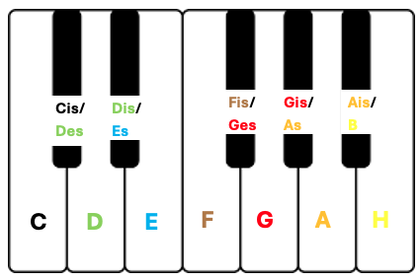
Fig.1: the student’s keyboard
Procedure
Set-up
- Both thumbs should be placed on middle C and the other fingers should fall on the neighbouring white keys, (i.e. left finger 2 on H, left finger 3 on A, etc.).
- The student should not be able to see the real piano or keyboard in the room.
- The trainer should play the target note on a piano or keyboard to familiarise the child with the target note – this is C in the first two weeks of training. Encourage the student to sing “C” and tap on the C on their paper keyboard.

Protocol
- The trainer should play a note on the piano at random once every 5 seconds – but limit this to either C or D. Randomise the octave between C2-C4
- When the student hears the target note C, the student should say “C” and tap the C on their paper keyboard with a thumb.
- Immediate feedback must be given after each note as to whether the response (or lack thereof) was correct.

Schedule and progress-tracking
- Training should last 5 minutes per music class and continue for 5 minutes per day throughout the week.
- Progress should be tracked by percentage of correct responses in each session
- When 100% accuracy is attained in 3 continuous sessions, 1 more pitch should be introduced as an interference pitch. For example, week 1 the student must correctly identify ‘C’ from C and D. After achieving 100% accuracy in 3 continuous sessions, the trainer introduces a new note on the piano - E. The target note will stay as ‘C’.
- An erasable weekly training chart will be provided to motivate the students.

Appendix 3
Song integration: Sessions 1 & 2

Song 1
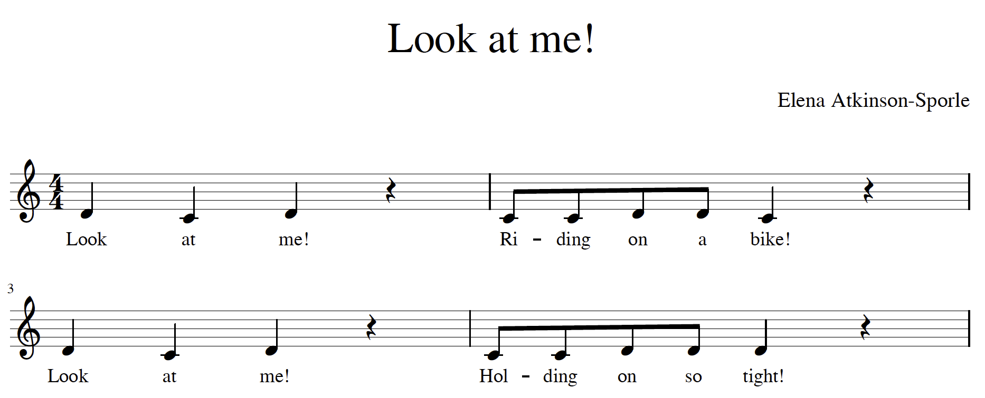
D
D
D
D
D
D
D
D
D
C
C
C
C
C
C
C

Song 2
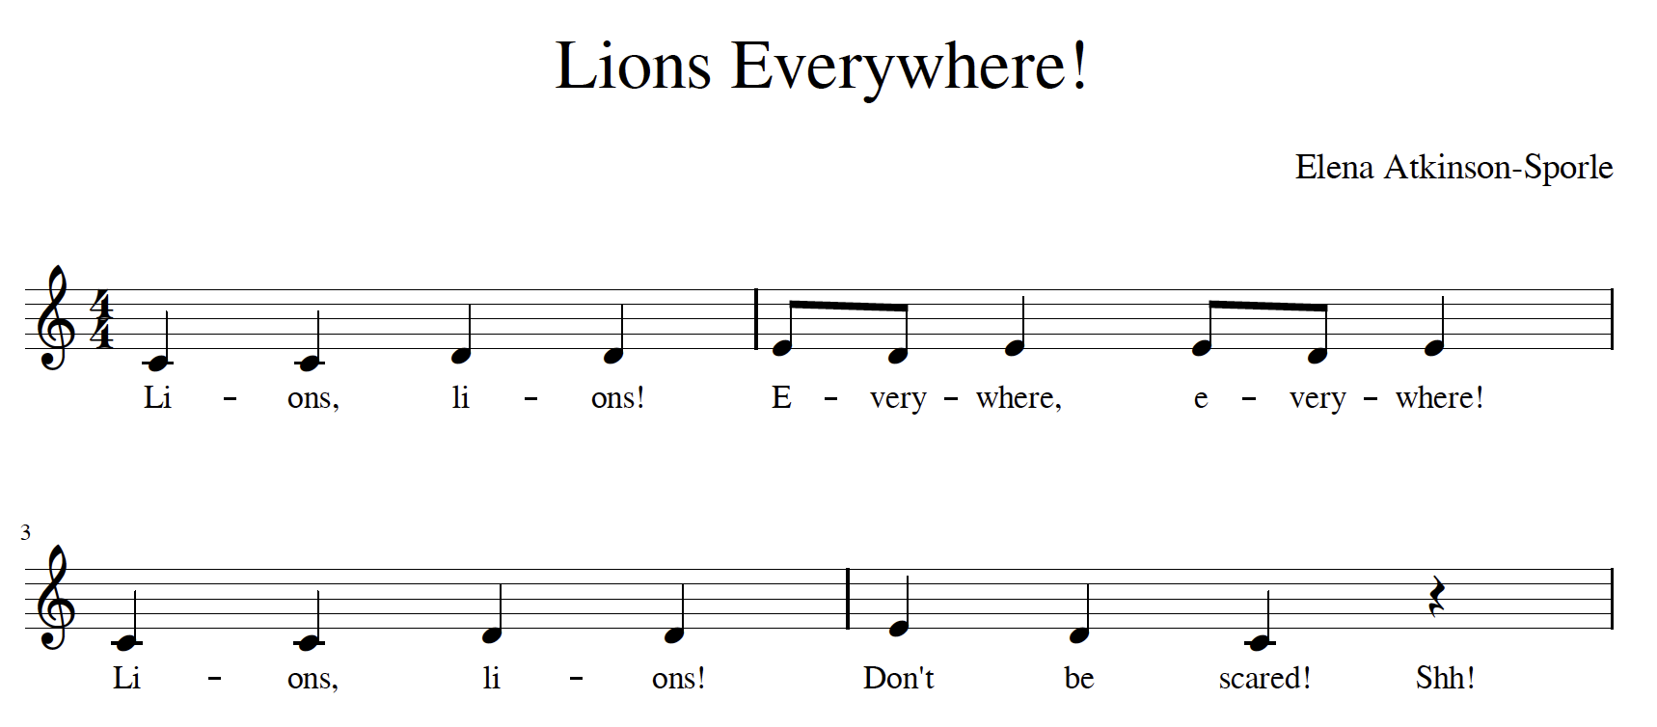
E
E
E
E
E
D
D
D
D
D
D
D
C
C
C
C
C

Protocol for learning songs
- sing song with lyrics
- replace the lyrics with note names until memorized
- play the song on the piano
- play the song on piano and sing the note names

