Marketing Plan written for Crowne Plaza
Student name
Daniela Preda
Student ID number
2208674
Marketing Essential BMIH4005
Lecturer
Gayathri Senanayake
Word count⁚1232

Table of Contents
Introduction 3
Marketing Mix 3
The marketing environment (SWOT) 5
The marketing environment (PESTLE) 6
Creating Customer Value and engagement 8
Marketing plan 10
Positioning map 11
Effective use of digital marketing 11
Conclusion 12
Gantt chart 13
References 14

Introduction
Hospitality in the United Kingdom constitutes a range of the country's hotels, pubs, restaurants, recreation as well as relaxation companies and manufactures around 4% of the country's Gross Domestic Product. Based on the current statistics, the Hospitality industry enlists around 9% of the United Kingdom's Workforce. It is the fourth-largest industry in the United Kingdom.
Contention in the hotel and hospitality industry has enhanced tremendously as customers are getting more enlightened and trendy. Clients are demanding more elegant services and products which compel organizations to concentrate on greater marketing planning. As said by Jobber and Ellis (2019). So to maintain competitive benefits and to keep customers satisfied and potential customers engrossed, a marketing strategy for Crowne Plaza is introduced that focuses on attracting consumers and clientele in the North Rhine-Westphalia, Germany region.The choice of the region is based on positive tourism trends in Germany and the apprehension of UK consumers regarding tourist related activities in mountainous regions.

Marketing Mix
Product-
Crowne Plaza Hotel offers twenty-four hours and seven days a week high-end living arrangements, ready-to-go services, layouts, and quick and fresh food that keep customers coming back, attached, and relaxed during their accommodation. Different kinds of rooms are available to customers such as regular, river view, high-end king apartments, junior suites, and one-bedroom chambers. Each room has certain amenities available such as Wi-Fi, Air conditioning, Smart TV, Laptop safe, and a Coffee machine. (Bondarenkoet al., 2019).Apart from this the region of North Rhine-Westphalia, Germany can be of great advantage for Crowne plaza in terms of product diversity. The tourist destination entails within its domain the diversities of leisure activities mountainous sports, sky jet activities as well as is a favourable spot for business meetings. The high-end accommodation and service facilities of the hotel can be optimally utilized for generating revenue for the business.
Price-
Crowne Plaza hotels utilize a dynamic pricing strategy based on supply, demand, and market forces, and the complexity of this outlook is helped by a sophisticated management system. Prices vary depending upon the accommodation a customer wants to have; for instance, the standard room is priced at 180 pounds whereas a one-bedroom suite costs 500 pounds. In addition to this, customers can earn points by staying, seasonal and family discounts are offered, and exclusive rates are provided for customers who apply for membership. The peak season is between June and the end of August while the months from November to March attract fewer customers.Moreover by adopting the differentiation in pricing the company can ensure that it is able to provide the consumers with a diverse portfolio of activities based on their interests in the mountainous region.
Place-
Location is important, especially in the case of high-end luxury hotels like Crowne Plaza which is run and managed by Intercontinental Hotel Group. The hotels are not far from the airport and the city of Germany is well connected to railways and seaport, and there are several locations within the city where the hotels are situated. The hotel has a website that can be visited for information. Crowne Plaza also owns Holiday Inn, and Regent Hotels & Resorts and at present offers four franchisees to choose from - Crowne Plaza, Crowne Plaza Suites,Crowne Plaza Hotels & Suites, and Crowne Plaza Resort. However for the current scenario the company envisages to establish its footing in North Rhine-Westphalia, Germany. The region is in close proximity to Beckum Hills and therefore has been chosen as a destination for mountainous tourist attractions. Moreover, the place is an attractive tourist destination for various sky jet activities such as safari adventure, leisure time with friends and family and business meetings.
Promotion-
Crowne Plaza hotel knows its guests better and is a leader in the upscale hospitality industry. Crowne Plaza has mainly focused to redefine its core client-the business traveller. The hotel's new blended program of mixing travel and leisure known as 'bleisure' fetches opportunities to target particular customers with a work-life blend. This component of 'bleisure' can be optimally implemented in the chosen destination because of presence of diversity in services related to leisure and business activities.Constant internal and external research is done to recognize the needs of the customers and innovations are applied for a better experience of hospitality. Crowne Plaza cooperates with franchisees and partner groups to transform travel experiences as it sponsors travel advisories and travel management websites in the United Kingdom. The target customers for the hotel are guests around the world who can pay for high-end and are inclined to luxury services. The hotel has tie-ups with many international travel agents and the rooms are also offered at lesser prices as part of the packaged tours. (Zaitsevaet al., 2018, p. 648).

The marketing environment (SWOT)
Strength | Less resource business model as in adopting franchise model and reducing owned hotels globally making more revenue and having fewer assets.  Broad physiological existence with a concentration on preference markets as in strong presence in both emerging economies and developed markets.  Good guest experience and relationship with a focus on fulfilling luxury travel experiences of clients and living arrangements.  Enhanced digital outlook and execution in this advanced age of technology and digitization of services as it attracts more customers from the new and young tech-savvy generation.
Weakness | The Intercontinental Hotel Group which runs Crowne Plaza was embroiled in controversies as it was accused of price fixing and having poor hygiene standards.  Crowne Plaza has weak IT security as it was infected with malware attacks and the names of guests, credit card numbers, and card names were stolen.  Intercontinental Hotel Group which runs Crowne Plaza has drawn a negative assessment of their rewards program as the points which were guaranteed were not offered.  According to Smith and Zook (2019). Intercontinental Hotel Group slipped to the third position worldwide which affects its brand image and brand positioning.
Opportunities | New physiological markets such as opening up hotels and services in emerging economies like India and China.  Fractured hotel market which Crowne Plaza with its franchises and sub hotels can tap to attract more business revenue and profits.  Increased International travel posts Covid owing to the demands of tourists and tourism opened a wide arena to bring in more clients to generate more revenue.  According to Patti et al.,( 2017.p 365)  Fifteen percent of the gross revenue of Intercontinental Hotel Group came from non-accommodation services with thirteen percent from food and drinks. Henceforth, launching more food elements is worth traversing.
Threats | Out-of-the-ordinary events leading to business uncertainty such as Covid-19 and subsequent lockdowns affected the hotel industry to a large extent.  Increased competition in the hotel and hospitality industry with competition from Marriott, Wyndham, Accor Hotels, Hilton, and Hyatt.  Increased reliance on intermediaries as well as the entrance of new ones challenges Crowne Plaza Hotel to find proper distribution mediums.  More sharing of the economy in the hotel and hospitality industry leads to a decrease in customers and potential customers. (Gebbelset al, 2019).

The marketing environment (PESTLE)
Factors | Description | Impact
Political | Stable political system.  Implication of Brexit on Germany and UK relations | The government in the Germany is stable, has a rule of law, and has a well-oiled administrative system which can enhance its prospects of internationalization  Brexit has created an atmosphere of uncertainty in recent times in the United Kingdom which can influence its EU membership and relations with Germany. For Crowne Plaza, political stability is better for attracting tourists and guests and for foreign investment. Post-Covid, there is an increase in the footfall of guests.
Economical | Increase in Inflation.  Decrease in unemployment. | The annual rate of inflation increased to eleven percent from nine percent.  The unemployment rate is three percent down from the earlier rate. However, staff recruitment and retention in the hospitality industry are adversely affected due to the increase in costs of doing business.
Social | Education  Income level per capital | The Germany’s education system keeps updating itself with new details and so the hospitality industry involves adequate teaching and learning.  Income levels have not gone down however owing to inflation costs are rising in the hospitality industry to do business.
Technological | Leading research and technological institutes.  AI-based technologies. | The Germany has some of the best technological research institutes that contribute to the nation’s economy.  AI-based technologies help with remote work in the post Covid age. For the hospitality industry staffing and retention is the main issue of concern.(Prasetiyo and Pertiwi, 2021, p. 610)
Legal | Employment Act 2002  Equality Act 2006. | Companies or organizations have to follow the Employment Act and the Equality Act. The former protects the rights to wages, sick pay, maternity, and paternity leaves, and the latter protects people from discrimination. Both these acts cover the entire domain of the hospitality and hotel industry.
Environmental | Pollution and other environmental issues.  Bad Weather. | Most hospitality industry businesses have given sustainability tall precedence in 2022. Crowne Plaza takes pride in respecting the environment and has taken part in initiatives such as the Green Engage system and finding Green Energy solutions. Germany’s favourable climate attracts a considerable number of tourists.(Chung, 2020, p. 729)

Creating Customer Value and engagement
Crowne plaza utilizes the capacity of human attachments to manufacture relevant experiences which means providing all the aid required to boost productivity and energize the body of the clients.

Factors | Resources used by a company | Impact on customer value and engagement
Functional value | High-end luxury apartments are offered 24 hours and 7 days in addition to food and drinks as well as other amenities. | Luxury suites attract premium customers all across the globe. No time barrier for customers as they can stay any day, any time of the week. Food and drinks as well as other amenities provide more enjoyment to the guest. Only a particular section of customers who can afford can stay in these rooms. It also can enable the company to maintain a positive brand rapport in the new region of expansion.
Monetary value | Discounts stay points and membership options for flexible guests are offered as well as seasonal and family discounts. | Fewer costs incurred during the stay provide the guest with more reason to stay. Family discounts mean more people staying, therefore more revenue. The service is not affordable to a considerable number of people. Leisure activities and interactive sky jet sports can be of monetary value for the business in the North Rhine-Westphalia, Germany region.
Social value | Values such as friendliness, politeness, and making people feel welcomed and part of the community. Investment in relationships. | As said by Kotler and Armstrong, (2018) politeness and friendliness invite a sense of belongingness for the customers making them stay on as guests and even come back to stay repeatedly. Bad social interactions make people stay away thus adversely affecting the brand image of the hotel. In the case of chosen destination for expansion it has been affirmed that the region posits a positive social atmosphere.
Psychological value | Good food quality, better service quality, better rooms, affordable price, and excellent location and privacy. | All around adequate service, finer food and drinks, economical costs, and superior location positively impacts the customer resulting in productive revenue generation for the hotel turn-in.

Marketing plan
Objectives | Specific | Measurable | Attainable | Relevant | Time-bound
To gain a diverse set of consumer base to meet its “bleisure” product plans | Required to recover from the negative external business environmental effects | Through increase in sales number in the North Rhine-Westphalia, | Through effective use of contemporary marketing practices | Required to gain prominence in tourism industry and to provide consumers with an immersive experience | 6 months
To enhance the Customer Lifetime value of consumers in the chosen region | Required to generate a cyclic flow of income and develop its business around the “bleisure”concept | Through increase in repetitive consumer base of the firm at the chosen region | By enhancing its customer service quality and building its marketing plan to posit a positive brand image | Required to enhance its revenue propositions in the region | 1 year

Positioning map
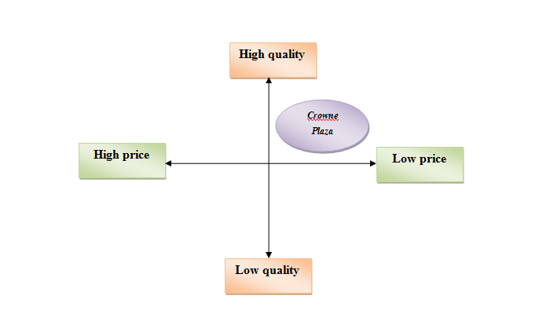
Figure 1: Positioning map
Source: Developed by the author

Effective use of digital marketing
The hospitality industry has been one of the most affected by digital trends and digitization all around. Tourists, business travelers, and digital nomads are the main customers that spend a lot of time searching for places to visit or stay, hotels to arrange, and eateries to feast on. Thus, digital marketing has become the leading way to communicate with potential clients, build a brand, and establish a pack of faithful consumers. According to Thomas and Housden, (2017), content marketing involves manufacturing content such as pictures, articles, films, and social media posts that piques the interest generally. The content needs to be appealing and charming to draw people in and at the same time quietly hint at the existence of the business.
Search engine optimization is used to improve the rankings on search engine pages to draw in potential customers from internet traffic searches. The hospitality industry utilizes this technicality to attract clients, customers, and travelers. (De Pelsmacker et al., 2018, p. 50).
Search engine advertising involves making it to the peak of search engine results. It consists of paid searches and organic searches, where paid searches appear first. Search engine advertising involves a lot of technical input and the hospitality industry employs this kind of advertising to attract customers. User experience involves drawing visitors to the business website. Good websites with fine user interface reel in more customers and bad experience deters them from visiting again, making the utilization of user experience more significant for the hospitality industry, (Parvezet al., 2018, p. 289).

Conclusion
Thus, in conclusion, the present study highlights the vital aspects that confront the Crowne Plaza as well as the hospitality industry of the United Kingdom in general in the twenty-first century. The hospitality industry cannot withstand without taking into account certain variables and in the hotel industry and services, customer satisfaction is the primary concern. Crowne Plaza has obtained a certain reputation due to the concentrated efforts that went into forging outstanding relationships with customers. Good policies including personalized services, points, superior behaviour, and addressing privacy issues have aided the hotel to increase its revenue manifold. Hotels and hospitality play a heavy part to provide a chunk to the world's economies and businesses and the most basic unit of this industry is its faithful customers. No organization can withstand the fall in the present-day market if it fails to accomplish customer retention. The hospitality industry should therefore invest in appropriate marketing strategies to secure great customer satisfaction.

Gantt chart
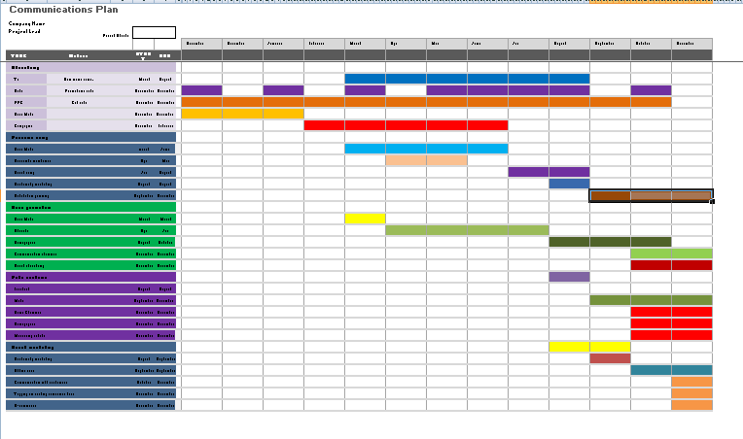
Figure 2: Gantt chart
Source: Developed by the author

References
Bondarenko, V.A., Efremenko, I.N. and Larionov, V.A. (2019). Marketing strategy for hotel and tourist complex companies.Available at⁚ https://www.um.edu.mt/library/oar/handle/123456789/45977 (Accessed⁚30 November 2022).

Chung, K.C., (2020). ‘Green marketing orientation: Achieving sustainable development in green hotel management’‚ Journal of Hospitality Marketing & Management, 29(6), pp.722-738. Available at⁚ .https://www.tandfonline.com/doi/abs/10.1080/19368623.2020.1693471 (Accessed⁚30 November 2022).

De Pelsmacker, P., Van Tilburg, S. and Holthof, C., (2018). ‘Digital marketing strategies, online reviews, and hotel performance’‚ International Journal of Hospitality Management, 72, pp.47-55.Available at⁚ https://www.sciencedirect.com/science/article/pii/S0278431917305303 (Accessed⁚28 November 2022).

Gebbels, M., Pantelidis, I.S. and Goss-Turner, S., (2019). ‘Towards a personology of hospitality professional’‚ Hospitality & Society, 9(2), pp.215-236.Available at⁚ https://www.ingentaconnect.com/content/intellect/hosp/2019/00000009/00000002/art00006 (Accessed⁚30 November 2022).

Jobber, D. and Ellis-Chadwick, F., (2019). EBOOK: Principles and Practice of Marketing, 9e. McGraw Hill.Available at⁚ https://books.google.com/books?hl=en&lr=&id=IMovEAAAQBAJ&oi=fnd&pg=PR1&dq=jobber+and+ellis+chadwick+marketing&ots=4Q3pO9w2Fg&sig=WjfoJX4IJ0HcTzsEBaD6mQDpvMM (Accessed⁚30 November 2022).

Kotler, P. and Armstrong, G., (2018). ‘Principles of Marketing (Seventeenth)’‚ United Kingdom: Pearson Education Limited.Available at⁚ https://scholar.google.com/scholar?cites=1361243844456551979&as_sdt=2005&sciodt=0,5&hl=en (Accessed⁚29 November 2022).

Parvez, S.J., Moyeenudin, H.M., Arun, S., Anandan, R. and Janahan, S.K., (2018). ‘Digital marketing in the hotel industry’‚ International Journal of Engineering & Technology, 7(2.21), pp.288-290.Available at⁚ https://www.researchgate.net/profile/Senthil-Kumar-Janahan/publication/325117493_Digital_marketing_in_hotel_industry/links/5bf647654585150b2bc8ddb9/Digital-marketing-in-hotel-industry.pdf (Accessed⁚30 November 2022).

Patti, C.H., Hartley, S.W., van Dessel, M.M. and Baack, D.W., (2017). ‘Improving integrated marketing communications practices: A comparison of objectives and results’‚ Journal of marketing communications, 23(4), pp.351-370.Available at⁚ https://www.tandfonline.com/doi/abs/10.1080/13527266.2015.1027251 (Accessed⁚28 November 2022).

Prasetiyo, B.W. and Pertiwi, I.F.P., (2021). ‘The Influence of Product Innovation, Marketing Strategy, and Entrepreneurship Orientation on Sharia Hotel Marketing Performance in the Covid-19 Pandemic Period with Competitive Advantage as an Intervening Variable’‚ Journal of Business and Management Review, 2(9), pp.605-619. Avaiable at⁚ https://profesionalmudacendekia.com/index.php/jbmr/article/view/212 (Accessed⁚30 November 2022).

Smith, P.R., and Zook, Z., (2019). Marketing communications: Integrating online and offline, customer engagement and digital technologies. Kogan Page Publishers.Available at⁚ .https://books.google.com/books?hl=en&lr=&id=gHXADwAAQBAJ&oi=fnd&pg=PP1&dq=smithc+zook+marketing+communications&ots=ArPKITK2oh&sig=PAXzRnsbtO8_ZWycXgphqB8BjRA (Accessed⁚29 November 2022).

Thomas, B. and Housden, M., (2017). Direct and digital marketing in practice. Bloomsbury Publishing..Available at⁚https://books.google.com/books?hl=en&lr=&id=PXgnDwAAQBAJ&oi=fnd&pg=PT4&dq=m+housden+marketing+research&ots=Dxe-MVruO8&sig=iOtbywQezQfLNTvP3WM6A-tlA-4(Accessed⁚30 November 2022).

Zaitseva, N.A., Larionova, A.A., Eliseeva, O.V., Katerynich, O.A., Vikhrova, N.O., Takhumova, O.V. and Zhukova, M.A., (2018). ‘The features of the marketing strategies formulation and their application in hotels (by the example of business hotels)’‚ Modern Journal of Language Teaching Methods, 8(10), pp.642-651. .Available at⁚https://elibrary.ru/item.asp?id=36373237(Accessed⁚30 November 2022).




