Name: Reema Qurban
Student Number: 2526193
Tutor Name: Helen Persons
Module: Health and Social Care
Module Code: LCHS4003

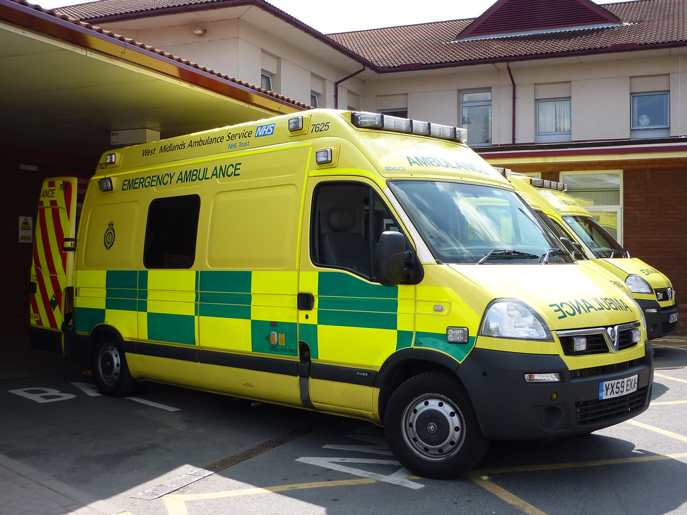 Task 1: Ambulance services

Ambulance services are the emergency and urgent care transport and response arm of the UK health system. They deliver immediate clinical care, transport patients safely to hospital or other care settings, and provide support for non-emergency health care needs (NHS England, 2024).
Uses💊: People experiencing life-threatening illness or injury, those needing urgent medical assessment, patients requiring safe transport between care settings, and people accessing specialist clinical support over the phone or via video call.
Provide🚑: Staffed by paramedics, emergency care assistants, ambulance technicians, call handlers, dispatchers, and advanced clinical practitioners. All clinical staff are regulated by the Health Care Professions Council (HCPC).

Matters🏥: It is the first point of contact for life-threatening emergencies, saves lives through early intervention, and act as a critical link between the public, primary care and hospital services. It handles over 12 million calls a year in England alone (Association of ambulance chief executives, 2025).

Delivered💉: From regional ambulance trust headquarters and local stations, via road ambulances, rapid response cars, motorcycles, and air ambulances.

Function🔦: Emergency response: Attend 999 calls for conditions like cardiac arrest, etc.; clinical triage & assessment prioritise calls, provide advice over the phone, etc. Non-emergency transport Move patient between hospitals. Specialist support provide prehospital critical care. Integrated care Work alongside GPs, pharmacists, etc.

Funding💷: In England, services are run by 11 regional NHS Ambulance Trusts. They are almost fully funded by the NHS, with small charitable contributions for air ambulances and specialist equipment. Oversight comes from NHS England, the Department of Health and Social Care, and the Care Quality Commission.

History📜: 1860s: Early voluntary and local authority ambulance services emerge, mostly for accidents and transport. 1905 Metropolitan ambulance service formed in London. 1948 Ambulance service becomes part of the NHS. 2000S Paramedics gain extended clinical roles. 2010- present Introduction of clinical triage, integrated care.



The ambulance service is a vital component of the health care system, providing rapid emergency response, prehospital care and safe transportation to medical facilities. It bridges the gap between the scene of an incident and definitive treatment, directly improving patient outcomes and saving lives. Operating 24/7 across urban and rural areas, it relies on skilled staff, well-maintained vehicles, and efficient coordination to deliver timely, reliable support. Ultimately, its role is not only to respond to crises but also to build confidence in the healthcare network.

Task 2: Community Mental Health services:
Introduction: Community mental health services are a core part of the UKSs health and social care system, providing support, treatment and care to people experiencing mental health difficulties in their local communities, rather than only in hospitals. These services aim to promote recovery, support independence and reduce the need for inpatient admission, making care more accessible and person centred (NHS England, 2023).
Function: Community mental health service delivers holistic, ongoing care across the lifespan. Their key functions include assessment and diagnosis, psychological therapies, medication management, crisis support and social rehabilitation. Multidisciplinary terms including psychiatrists, nurses, psychologists, occupational therapists and support workers work together to create tailored care plans. They also collaborate with GPs, Scholls, housing providers and charities to support recovery, reduce stigma and help people maintain their roles in family, work, and society (Royal College of Psychiatrists, 2024).Most people prefer this kind of help it keep them close to family, friend school or work, so they feel less isolated. Studies show that when these services work well, fewer people are re admitted quickly. It also save NHS money in long run.
Challenges: Workforce shortages and high demand. Demand for the community mental health support has risen sharply, accelerated by the COVID-19 pandemic and growing awareness of mental health needs. However, the sector faces critical shortages of qualified staff, with vacancy rates often above 10% in key roles. This leads to longer waiting times, higher caseloads and reduced continuity of care, which can slow recovery (NHS Digital, 2024). Fragmentation and inequalities in access. Services are often split across different organisations making it difficult for users to navigate support. There are also significant inequalities: people from ethnic minority backgrounds, rural communities and those on low incomes are less likely to access timely care. Stigma and lack of awareness further prevent many from seeking help until their condition worsens (Mind, 2023).
Conclusion: Community mental health services are vital to building a sustainable, recovery focused mental health system. They have transformed care away from institutionalisation and placed people at the centre of their own support. However, to fullfil their purpose, they must address staffing shortages and reduce barriers to access. Investing in these services is essential to improve outcomes, reduce health inequalities and ensure long term well-being for the population.

Reference
. Association of ambulance chief executives (2025) Ambulance services: Annual report 2024/25. London: AACE.
. Care quality commission (2024) Urgent and emergency care review. London: CQC.
. Department of health and social care (2023) The Ambulance service: future strategy. London: DHSC.
. Health and care professions council (2024) Regulation of paramedics. London: HCPC.
. NHS England (2024) About Ambulance services: Available at: http://www.nhs.uk/nhs-services/urgent-and medical-emergency-care-services/ambulance-services. (Accessed:20 june2026).
. Turner, J. and Williams, S. (2023) Response times and demand in pre-hospital care, emergency medicine journal, 40(3), PP. 189-194.
. Mind. (2023) State of mental health services 2023: London: Mind.
. NHS Digital. (2024). Community mental health services: Annual report. Leeds: NHS Digital.
. NHS England. (2023) Community mental health framework. London: NHS England.
. Royal college of psychiartrists. (2024). The role of community mental health teams. London: RCPsych.
. Thornicroft, G., et al. (2022). Mental health policy and practice in the UK. Cambridge: Cambridge University Press.
. Department of health and social care. (2021). Mental health Reform: the white paper. London: the stationery office.

