

CertHE in Business Skills

Module Title: Employability and Career Development

Module Code: LCLM4005

Assessment: Assessment I

Student Name: Serkalem Aylewe

Student Number: 2517705

Lecturer’s Name: Sukhpreet Grewal

Session: June 2026 Term
Submitted on: July 20, 2026
PART 1: JOB ADVERTS
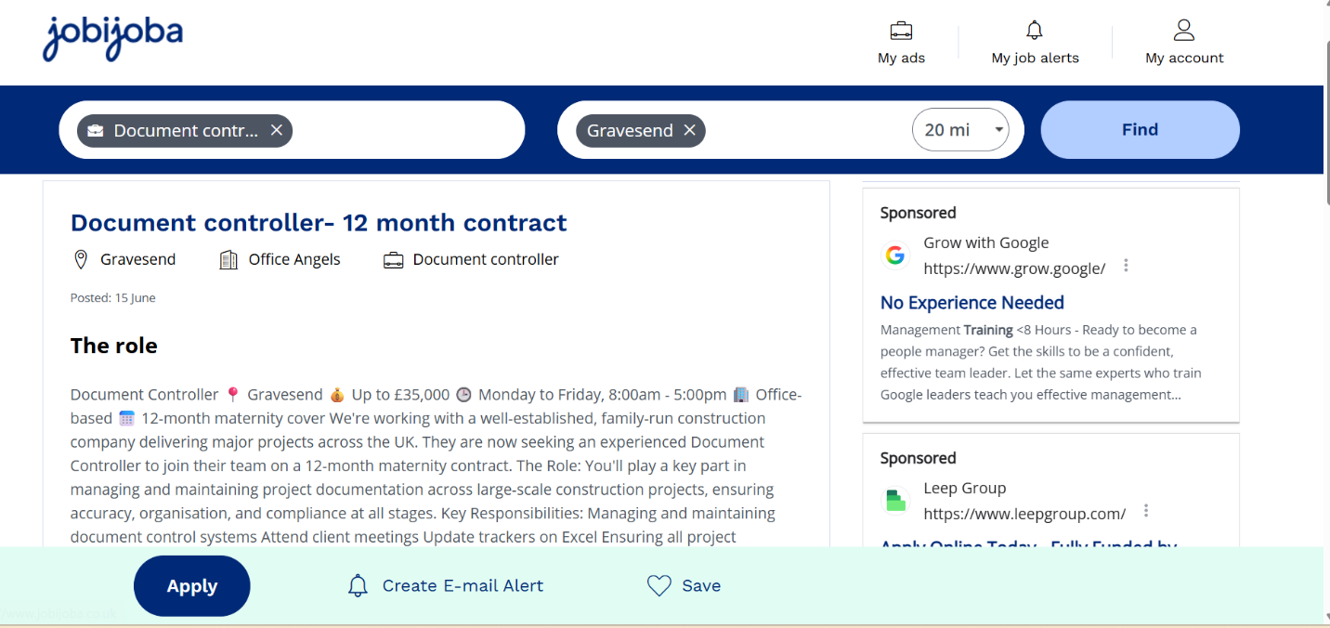
Full Vacancy Details
Role Title: Document Controller – 12 Month Maternity Cover Contract
Recruiter: Office Angels
Client: Well-established family-run construction company delivering major UK projects
Location: Gravesend (office-based)
Contract Length: 12 months (maternity cover)
Salary: Up to £35,000 per year
Working Hours: Monday to Friday, 8:00am – 5:00pm
Posted Date: 15 June

What the role involves
- You will be a key member of the project team, responsible for managing all project documentation across large construction schemes, with a focus on accuracy, organization, and compliance.

- Key Responsibilities:
- Manage and maintain the full document control system for active projects
- Attend client and project meetings as required
- Update and maintain project trackers and logs using Microsoft Excel
- Ensure all files are accurate, up to date, and follow company/industry standards
- Support teams to find, issue, and archive documents efficiently

PART 2: CV

SERKALEM AYLEWE
ID No. 2517705
Email: 2517705@student.uwtsd.ac.uk

PERSONAL PROFILE
Motivated, reliable, and detail‑oriented professional with a solid background in administration, financial record‑keeping, and construction site work. I am organized, follow strict guidelines, and carry out consistent checks to ensure work is accurate and on schedule. I work well independently and as part of a team, adapt quickly to new systems and procedures, and understand the importance of safety and compliance on site. I am now focused on growing into a qualified Document Controller while continuing my higher education.

KEY SKILLS
- Document & Records Management: Experienced in organizing, filing, and maintaining accurate records, paperwork, and data
​
- Construction & Safety Awareness: Valid CSCS Green Card; familiar with site procedures, COSHH regulations, and health & safety standards
​
- Administration & Organization: Strong ability to manage information, maintain filing systems, and prioritize tasks effectively
​
- Accuracy & Compliance: High attention to detail; follows set procedures and reports issues promptly
​
- IT Proficiency: Confident in Microsoft Office Suite (Word, Excel, Power Point, & Outlook); willing to learn specialist document control software
​
- Communication & Teamwork: Clear communicator; works well with managers, contractors, and colleagues at all levels
​
- Adaptability & Reliability: Flexible to changing work demands; consistently meets deadlines and produces quality work
EMPLOYMENT HISTORY
CSCS Welfare Operative
MSK West Management & Recycling Ltd / Knight Harwood Ltd Construction Co. | London
January 2026 – Present
- Maintain clean, safe, and organized site areas in line with health and safety regulations
​
- Handle cleaning equipment and hazardous materials safely following COSHH guidelines
​
- Ensure site walkways and work zones are clear and well‑maintained to support project progress
​
- Report any safety hazards, damaged equipment, or maintenance issues immediately
​
- Work closely with site managers and supervisors to follow schedules and meet project requirements
​
- Keep accurate daily records of work completed and materials used

CSCS Cleaner
Chris Wood Recruitment | London
July 2025 – September 2025
- Carried out site cleaning and maintenance following official safety and operational standards
​
- Managed inventory of cleaning supplies and logged usage for site records
​
- Ensured all waste and debris was removed and disposed of correctly
​
- Updated site logs and registers to confirm work was completed
​
- Collaborated with site teams to avoid disruption to ongoing construction work

Actively Seeking Employment & Professional Development
London
March 2025 – July 2025
- Searching for the appropriate Universities to continue my university degree
- Researched the construction and admin sectors to identify suitable career paths
- ​Updated professional profiles and connected with recruitment agencies and employers
- ​Completed relevant training courses to build industry knowledge and skills
- Maintained focus and consistency while preparing for the next career step

Account Clerk
MCK Trading Plc | Ethiopia
October 2021 – January 2025
- Maintained accurate financial records, ensuring all entries were correct and followed accounting standards
- Recorded daily transactions, updated ledgers, and prepared basic financial reports and statements
- ​Managed accounts payable, receivable, and payroll information with full attention to detail
- Organized and filed financial documents so they could be easily accessed and audited
- ​Used office software to input data and keep records up‑to‑date
- Administrative Assistant

Hallal Car Market | Ethiopia
March 2017 – August 2021
- Managed all administrative tasks, including filing, record‑keeping, and updating vehicle and client registers
- ​Handled incoming calls, emails, and customer inquiries professionally and efficiently
- ​Maintained clear, organized systems for storing paperwork and digital records
- ​Assisted with scheduling, data entry, and general office support to ensure smooth daily operations
EDUCATION & QUALIFICATIONS
- Certificate in Higher Education – Business Skills for the Workplace (Level 4)- University of Wealth Trinty Sent Device, London | October 2025
Currently progressing toward a Bachelor’s degree in Leadership Management​
- Vocational Diploma in Office Management- Entoto Technical & Vocational High School| Ethiopia​
- Secondary School Education- Entoto Technical & Vocational High School - Certificate in Matriculation| Ethiopia

OTHER ATTAINMENTS
- Language
  - I speak and communicate with English well
  - I speak and communicate with Amharic fluently
- Informal Training
  - Level 2 Award in Food Hygiene and Safety | London | November 202​
  - Level 1 Award in Food Hygiene and Safety | London | November 2025​
  - COSHH Awareness Training | London | November 2025​
  - CSCS Green Card – Laborer | London | June 2025​
- Leadership and Volunteer Experience
  - Class Representative of UWTSD starting from October 2025 to date
Acted as main link between students and lecturers, collecting feedback and sharing updates clearly
  - Volunteer/British Heart Foundation/ Stratford Center from May to June 2025
Assisted with sorting, organizing, and recording donated items, maintaining tidy, accurate records.
- Interests and Hobbies
  - Cooking: Enables me to follow detailed steps, keep accurate records, and stay organized under pressure.
  - Darts: Builds strong focus, attention to detail, and consistent concentration.
  - Swimming: Teaches discipline, time management, and staying focused on goals.
  - Exploring new places: Helps me adapt quickly to new environments and learn new systems easily.

REFERENCE
Reference will be available on request

PART 3: COVER LETTER
SERKALEM AYLEWE
ID No. 2517705

Email: 2517705@student.uwtsd.ac.uk
Date: 3 July 2026
Dear Sir/Madam,
I am writing to apply for the Document Controller job which I saw advertised in Total Job. I am studying Business Skills at University of Wealth Trinty Sent Devis, and I have experience in office work and keeping records. I think my skills are a good match for this role.

From my studies and past work, I have demonstrated that I am careful and accurate: I check my work so there are no mistakes. I am organized: I can set up clear filing systems, manage lots of files, and finish work on time. I am good with computers: I use Word, Excel, PowerPoint, Presentation and Outlook well, and I am learning SharePoint. I follow rules: I understand GDPR and always keep private information safe.
In my last job, I organized files, updated records, and made sure the team could find what they needed easily. I am honest, I learn new systems fast, and I am ready to follow your rules for file versions and audits.
I want to build my career as a Document Controller. I will do careful work, take responsibility, and work well with your team.
Thank you for reading my application. I hope to talk with you soon.
Yours faithfully,

Serkalem Aylewe

