

Master of Business Administration

AN E-COMMERCE BUSINESS SPECIALISING IN ETHICALLY SOURCED SOUTH ASIAN ARTISAN PRODUCTS
Student Name :- Kalani Sanjana bipinkumar
Student ID :- 2422384
Director of supervisor :- Balendran kandasamy
Table of Contents
1. Introduction 3
1.1 Business Problem and Opportunity Statement 3
1.2 Industry Background and Market Context 3
1.3 Key Trends and External Drivers 4
1.4 Initial Signals of Demand 5
1.5 Scope of the Analysis 5
1.6 Objective of the Study 6
2. Literature Review 6
2.1 Jobs-to-Be-Done (JTBD) Framework 6
2.2 PESTLE Analysis 6
2.3 Porter's Five Forces 7
2.4 Value Proposition Canvas 7
2.6 Justification and Critical Evaluation of Selected Frameworks 7
3. Methodology 8
3.1 Overall Research Approach 8
3.2 Secondary Data Collection Methods 8
3.3 Step-by-Step Application of Frameworks 8
3.4 Data Analysis Approach 9
3.5 Ethical Considerations and Limitations 9
4. Initial Market Opportunity Analysis 10
4.1 Market Size and Growth Trends 10
4.2 Key Market Segments and Customer Demographics 11
4.3 Consumer Pain Points and Unmet Needs 12
4.4 Demand Conditions and Price Sensitivity 13
4.5 Macroeconomic and Geographical Influences 14
4.6 Application of PESTLE Analysis 15
5. Limitations 18
6. Timeframe 18
7. Conclusion 18
8. Reference List 19
Reference list 19

1. Introduction

1.1 Business Problem and Opportunity Statement
In 2025, the global handicrafts market was worth approximately $880 billion and is expected to expand at a compound annual growth rate of nearly 11.8% till 2035 (Expert Market Research, 2026). With this expansion, South Asian artisans are still largely cut off from the end consumers in the west, and a large percentage of value captured by exploiting intermediaries. It is a clear opportunity to build an e-commerce site based in the UK that will be able to source handmade products directly from artisans in South Asia, provide both culturally relevant products and fair prices for artisans.
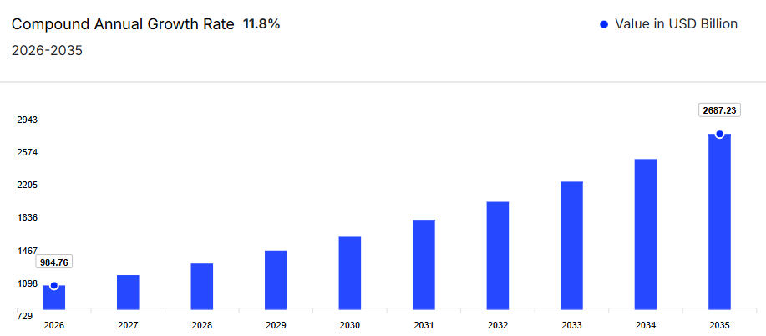
Figure 1: Global Handicraft Market
(Source: Expert Market Research, 2026)

1.2 Industry Background and Market Context
The UK ethical consumer market is estimated at around £141 billion, and sales of fair trade products have been at least £2.3bn in recent years. India is the biggest South Asian handicraft producing country with more than 744 craft clusters (with nearly 212,000 artisans and exported handicrafts valued at around $4.35 billion in 2021-22)(India Brand Equity Foundation, 2025). Asia Pacific is the leading region, accounting for more than $443 billion of the global handicraft market in 2025, contributing about 36% of the market share (Fortune Business Insights, 2025).

1.3 Key Trends and External Drivers
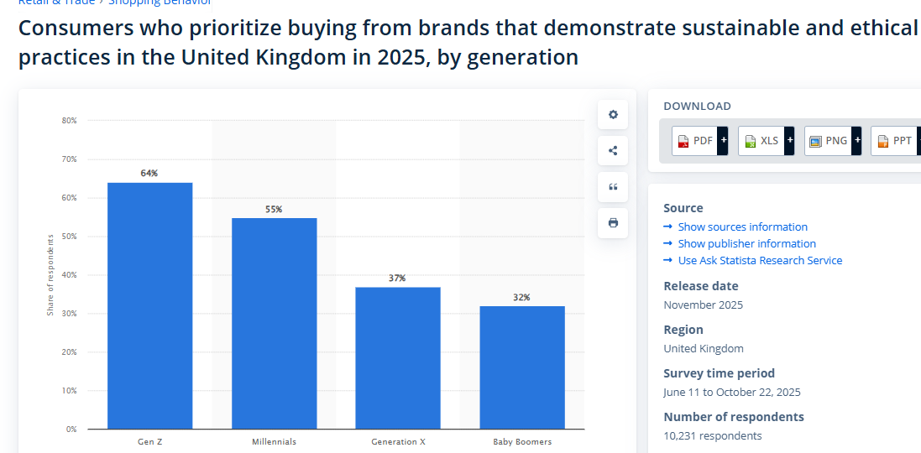
Figure 2: Consumers who prioritize Sustainibility
(Source: Watty, 2025)
Sustainable and ethical brands are a top priority for UK Gen Z consumers in 2025, with more than 64% of them preferring to buy from such brands, and there is a growing number of artisan businesses that are using online marketplaces and social commerce platforms to sell their products (Watty, 2025). The handloom and handicraft sector has also been supported by various government schemes, including the Government of India's plan to invest $120 million in the sector.

1.4 Initial Signals of Demand
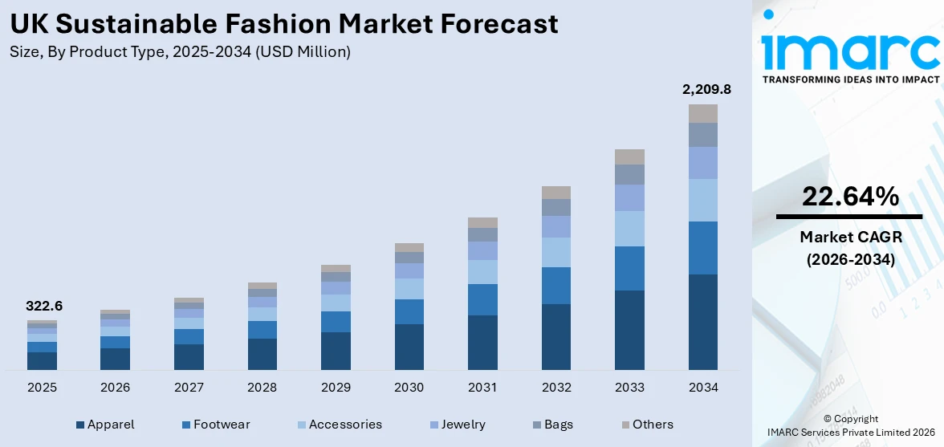
Figure 3: UK sustainable fashion market
(Source: IMARC, 2025)
There is a clear trend of personalized products with stories behind them, of which approximately 43% of consumers prefer and 39% are willing to buy handcrafted products with stories attached to them. The sustainable fashion market in the UK alone is estimated to be $322.6 million in 2025, expanding at a CAGR of 22.64% (IMARC Group, 2026).

1.5 Scope of the Analysis
This proposal is targeted specifically towards the UK / European direct to consumer clothing and home décor e-commerce markets for ethically sourced South Asian artisan goods, including textiles, pottery, jewellery and home décor. The manufacturing of mass-produced items and wholesale distribution routes are not included.

1.6 Objective of the Study
The aim is to evaluate the commercial viability of this business through market analysis, competition, and feasibility studies, and to create an evidence-based business plan that provides for fair compensation to the artisans and ensures long-term economic sustainability.

2. Literature Review

2.1 Jobs-to-Be-Done (JTBD) Framework
The Jobs-to-Be-Done approach was at first promoted by Christensen (2016), which assumes that consumers do not engage in buying a product in the first place but contract it in order to meet functional, emotional, and social demands. As per Kalbach et al. (2024) the JTBD lens uses demographic profiling but further to emphasize what is behind a choice to purchase within the framework of ethically sourced South Asian artisan goods. The application of the framework will involve defining in specific terms the jobs that UK and European consumers are trying to satisfy by making a purchase of a handcrafted or ethically sourced item, the difference between the functional job, defined as acquiring home decor or purchasing fashionable goods, the emotional job, which boils down to feeling rightly aligned morally, or the social job, which is expressing ethical self.

2.2 PESTLE Analysis
As per Citilci and Akbalik (2019), the five components of the PESTLE Analysis include political, economic, social, technological, legal as well as environmental forces influencing an industry, which is a systematic approach to industry analysis. In the case of this proposal, PESTLE is especially applicable considering that importation of artisan goods across the borders into the UK is cross-border. Lingham et al. (2025) states that some of the political factors involve post-Brexit trade laws and import taxes, and some of the economic factors involve consumer spending on non-essential products like ethical goods as a result of cost-of-living impacts. This framework will help obtain the complete picture of external forces affecting commercial viability.

2.3 Porter's Five Forces
Pangarkar and Prabhudesai (2024) states The Five Forces model has continued to be a popular instrument in evaluating competitiveness and profitability in an industry. Ndzabukelwako et al. (2024) presented a systematic review of the usage of the model to research the SME performance and established its representation as still relevant in assessing the pressure of competition that is considered to the small businesses. In this proposal, the framework will evaluate the risk of new entrants into the ethical e-commerce market, the bargaining power of South Asian crafts suppliers, the bargaining power of more knowledgeable ethical shoppers, the risk of substitutes due to mass-produced alternatives, and on-going competitive rivalry of other established fair-trade retailers like People Tree and Ten Thousand Villages.

2.4 Value Proposition Canvas
Created by Osterwalder and Pigneur (2018), the Value Proposition Canvas allows companies to visualize the value provided and the match between the needs of the customers and the value. Stojanova, Zečević and Culiberg (2023) emphasize that efficient ethical value propositions should address consumer intention and purchasing behaviour and motivation gap. There are certain customer pains (distrust of greenwashing claims) and gains (the desire to have genuine cultural products) that will be mapped with the proposed business offering using this tool.

2.6 Justification and Critical Evaluation of Selected Frameworks
The PESTLE analytical framework has been chosen to complement Porters Five Forces as the main method of analysis to be adopted in this proposal. PESTLE describes the general macro-environmental conditions that are influencing the ethical e-commerce environment (such as political trade laws, consumer spending trends, and social attitudes towards sustainability). Porter's Five Forces, in turn, shows a limited evaluation of inter-industrial behaviors of competitors, the bargaining power of suppliers, the buyers and the competitors as well as the obstacles to entry. Collectively these frameworks provide a breadth as well as depth of analysis. However, limitations exist.

3. Methodology

3.1 Overall Research Approach
The qualitative inductive approach employed in this study is a secondary research design as it is based only on the available published data to explore the viability of developing a UK-based online store to sell morally produced products of South Asian artisans. It is a commercial, systematic method, aimed at recognizing, verifying and developing the business opportunity by the systematic application of the formerly established analytical frameworks as opposed to the primary gathering of data (Locsin and Schoenhofer, 2024). This is concurring with the interpretivist school of research philosophy that aims at explaining the phenomena in the market based on existing textual and contextual evidence, as opposed to statistical quantification.

3.2 Secondary Data Collection Methods
There will be four categories of data that will be used as secondary sources. To begin with, academic databases such as Google scholar, emerald insight and scopus will be used to retrieve articles published within the last 5 years touching on ethical consumerism, the fair trade chain of supply and artisan economies (Arman and Mark‐Herbert, 2024). Market and industry reports of the Fairtrade Foundation, World Fair Trade Organization, Statista and IMARC Group will give market sizing, market growth and the data of patterns of consumer trends. The regulatory and policy environment will be informed by government and institutional publications by the UK Department of Business and Trade, International Labour Organization, and the Ministry of Textiles in India (Department of International Trade, 2022).

3.3 Step-by-Step Application of Frameworks
The secondary data obtained shall be analysed by applying step by step two major frameworks. PESTEL analysis will initially be used to create the macro environmental background of the ethical e-commerce industry, and this will be done systematically as political trade factors, economic factors, social factors, technological factors, creation of cross-border imports legislation, and environmental control factors, will be analyzed (Ran et al., 2026). This will be followed by the use of Porters Five Forces to determine competitive forces in the market of the ethically-minded artisan products.

3.4 Data Analysis Approach
Qualitative content analysis will be taken instead to analyse all the collected information, through systematic coding and categorising all the texts by themes. The patterns, contradictions and gaps in knowledge that recur will be identified throughout the source material. Results of one application of each framework will be combined to make an evidence-based evaluation of the market opportunity (Nicmanis, 2024).

3.5 Ethical Considerations and Limitations
Since the study is based solely on secondary data, no ethical justification is needed to use human participants. All the materials will be referenced according to UWTSD Harvard referencing standards. Some of the key limitations are that they use published data, which might not reflect the true situation in the market effectively, that industry sponsored reports can have a problem of bias, and the lack of primary consumer insights. These limitations will be countered by triangulation and engaging more than one type of source as well as critical assessment of source reliability.

4. Initial Market Opportunity Analysis

4.1 Market Size and Growth Trends
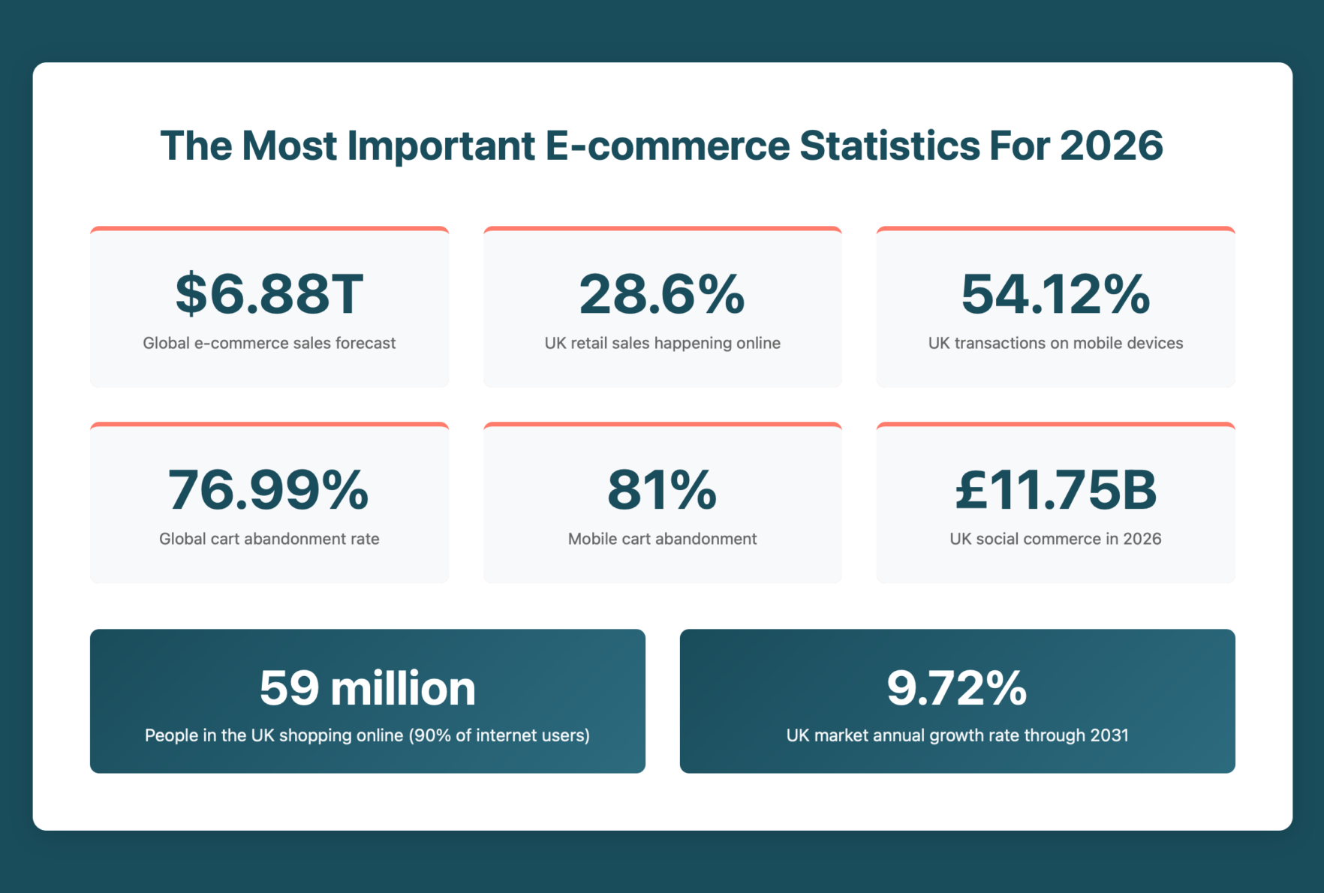
Figure 4 : E-commerce Statistics
(Source: Emrise Digital Ltd, 2026)
By the year 2025, the UK e-commerce market is expected to increase to a value of about 286 billion, and this makes the country the third biggest e-commerce web in the world after China and the United States if the industry continues to thrive. Approximately, 28% of the total retail sales in the UK are achieved through online and it is estimated that close to 59 million people are active online shoppers in the UK (Emrise Digital Ltd, 2026). In this background, the global market of handicrafts was estimated to be $880 billion by 2025 and the growth rate is estimated at 11.8 percent till 2035.

4.2 Key Market Segments and Customer Demographics
The target market is mainly ethically conscious customers aged between 18 and 44 in the UK but Gen Z and millennials are the most active in the demand. In 2025, UK Gen Z consumers (more than 64% of them) and millennials (more than 55% of them) are more likely to purchase sustainable and ethical brands. Consumers in Britain spend about £2,600 annually over the internet, with almost 30% of them spending more than 100 pounds monthly on online purchases (Hooson, 2026). Secondary segments are people who purchase gifts, interior designers, and communities in the diaspora who want products that are culturally authentic.

4.3 Consumer Pain Points and Unmet Needs
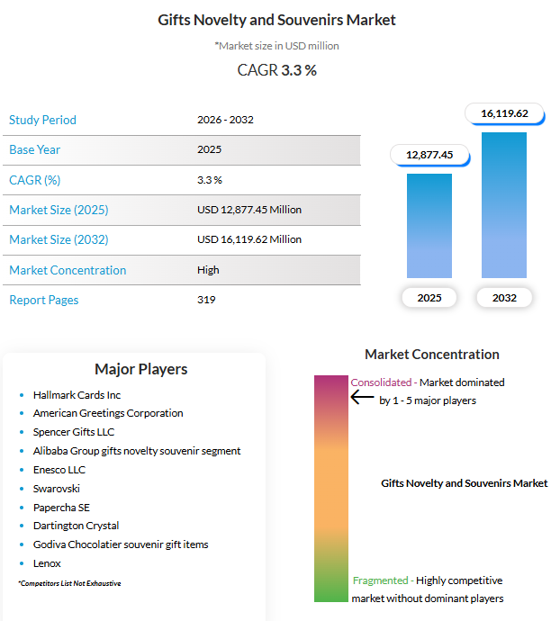
Figure 5: Gifts Novelty and Souvenirs Market
(Source: ReAnIn, 2026)
Approximately half of consumers think that brands identify with causes of ethics with the hope that it will get them publicity, signaling that there is a commonplace suspicion of greenwashing. About 43% of consumers lean towards personalised handmade gifts, 39% are proactively interested in items with a traditional regional provenance, but mainstream retailers seldom offer authenticated provenance or authentically crafted by the artisan (ReAnIn, 2026).

4.4 Demand Conditions and Price Sensitivity
Although consumers in the UK experience the pressures of cost-of-living, price alone turns out to be the primary online shopping driver with only 12% of consumers mentioning it as their primary online shopping driver; convenience, product variety and comparison capability were rated higher. The 2024 increase in the average order values increased by 7 per cent indicating a smaller but bulkier purchasing trend with preference to high quality and meaningful goods rather than bulk buying (Penagos, Encarnación and Gonzalez-Calderon, 2026).

4.5 Macroeconomic and Geographical Influences
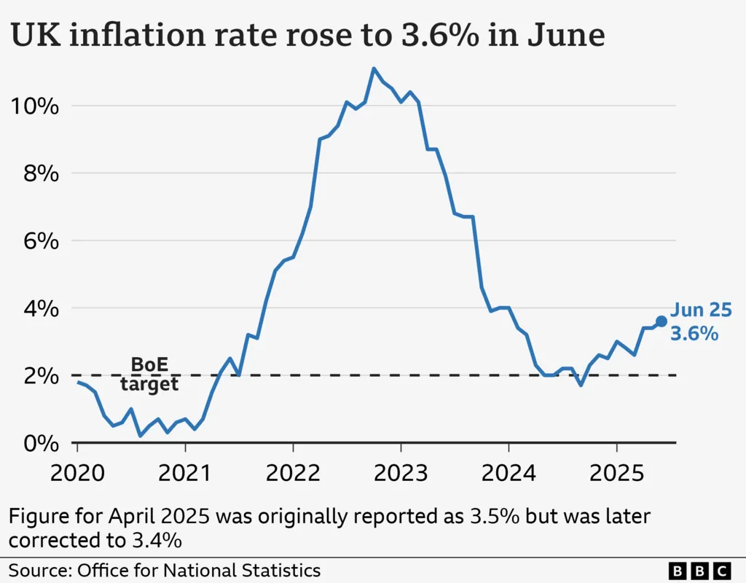
Figure 6: UK Inflation
(Source: Hooker and Bowker, 2025)
The UK inflation and cost-of-living misgivings have tamed discretionary incomes, yet the ethical segments are still performing better than mainstream retail. The greatest concentration of ethically conscious consumers with high income are London and South East, the demand further is concentrated in university cities and metropolitan areas in Europe (Hooker and Bowker, 2025).

4.6 Application of PESTLE Analysis
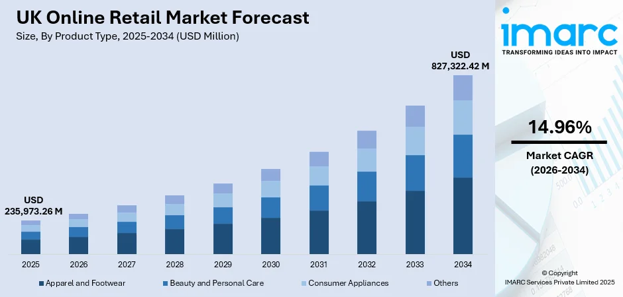
Figure 7: UK Online Retail Market Forecast
(Source: IMARC, 2025a)
Factor | Key Insight
Political | Post-Brexit trade rules affect import tariffs from South Asia; UK Modern Slavery Act compliance mandatory.
Economic | UK e-commerce projected at £286 billion in 2025; cost-of-living crisis moderates discretionary spend but ethical premiums remain viable (IMARC, 2025a).
Social | 64% of Gen Z and 55% of millennials prefer ethical brands in 2025; growing appetite for cultural authenticity.
Technological | Mobile commerce exceeds 55% of transactions; AI-driven personalisation increases conversion by 15–25% (Dunn, 2025).
Legal | GDPR compliance required; ethical labelling and Fairtrade certification standards apply.
Environmental | Rising demand for low-carbon, biodegradable materials; consumers prioritise sustainable packaging.
4.7 Application of Porter's Five Forces
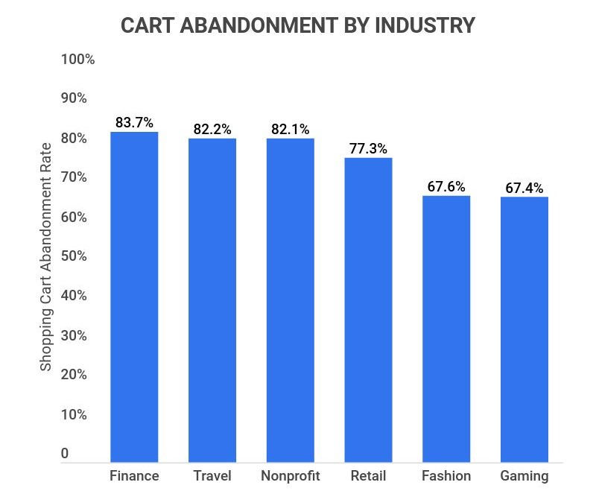
Figure 8: Cart Abandonment by Industry
(Source: McCain, 2025)
Force | Assessment | Analysis
Threat of New Entrants | Moderate | It is easy to start an e-commerce store in terms of capital outlay though developing trust and provenance networks of artisans will require time.
Bargaining Power of Suppliers | Low to Moderate | Widespread supply is supplied by more than 212,000 Indian artisans in 744 clusters, but ethical relationships demand fair compensation structures (Chettiar, 2025).
Bargaining Power of Buyers | High | There are a lot of substitutes available to consumers in the UK; the rate of cart abandonment is 70%. is easy switching world wide (SaleCycle, 2025).
Threat of Substitutes | High | There are mass-produced replication, and third-party sellers (Vinted, Depop), and the well-known fair-trade shops like People Tree and Ten Thousand Villages, who also seek the same amount of money.
Competitive Rivalry | High | Existing competition like Fabindia, Novica and Ten Thousand Villages enjoy a good market presence; competition is stiff as digital ethical retail expands (Market Data Forecast, 2025).

5. Limitations
This proposition uses only secondary qualitative data as a tool and this poses quite a number of constraints. The sentiment of consumers in real time and direct artisan point of view are unavailable, and the industry reports can be prejudiced or demonstrate outdated market situations. Lack of primary research limits the level of consumer-insight, and will not allow specific purchasing motivation to be validated. Such factors can reduce granularity of the findings and its applicability to the niche segments (Dwivedi et al., 2021). In order to counter such limitations, information will be triangulated within scholarly, government and commercial publications, where critical analysis will take place of credibility of publications, date of publication and possible commercial bias in the process of analysis.

6. Timeframe
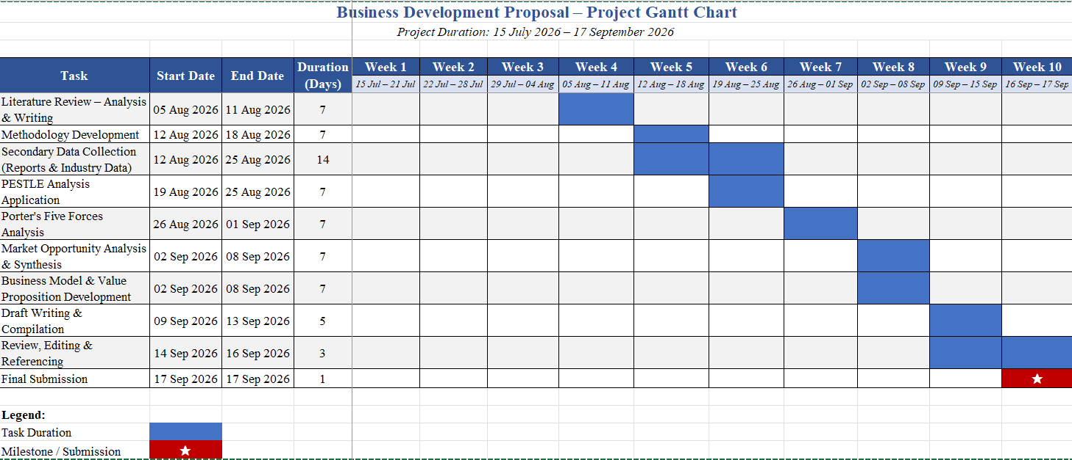
Figure 9: Gantt Chart
(Source: Self Created)

7. Conclusion
This proposal has created an opening of a UK based e-commerce business that deals in ethically sourced products of artisans in South Asia. Analysis confirms a robust demand momentum, which will be propelled by increasing ethical consumer preferences between Gen Z and millenials, online retail infrastructure development, and increased global handicraft market that is set to reach $2.6 trillion by 2035. The use of the PESTLE and Porter's Five Forces models proves that it has a favourable macro-environment that is moderated based on competitive forces that seek genuine differentiation. The proposal is viable within time, scope and secondary data dependence limits, providing a systematic channel of establishment of a commercially oriented and ethically based business model.

8. Reference List

Reference list
Arman, S.M. and Mark‐Herbert, C. (2024) “Ethical Consumption: A Review and Research Agenda,” International Journal of Consumer Studies, 48(5). Available at: https://doi.org/10.1111/ijcs.13079.
Chettiar, A. (2025) Indian Handicrafts - Major Contributor To India’s Economy. Available at: https://www.equentis.com/blog/indian-handicraft-exports-rising-steadily/
Christensen (2016) Jobs to Be Done Theory, Christensen Institute. Available at: https://www.christenseninstitute.org/theory/jobs-to-be-done/
Citilci, T. and Akbalik, M. (2019) “The Importance of PESTEL Analysis for Environmental Scanning Process,” Advances in Marketing, Customer Relationship Management, and E-Services, pp. 336–357. Available at: https://doi.org/10.4018/978-1-7998-2559-3.ch016.
Department of International Trade (2022) UK-India Free Trade Agreement The UK’s Strategic Approach. Available at: https://assets.publishing.service.gov.uk/media/61e1b75e8fa8f5058d5a76bf/uk-india-free-trade-agreement-the-uks-strategic-approach.pdf
Dunn, N. (2025) Top 33 ecommerce statistics, facts and figures you need to know in 2023., Www.charle.co.uk. Available at: https://www.charle.co.uk/articles/ecommerce-statistics/
Dwivedi, Y.K., Ismagilova, E., Hughes, D.L. and Carlson, J. (2021) “Setting the future of digital and social media marketing research: Perspectives and research propositions,” International Journal of Information Management, 59(1), pp. 1–37. Available at: https://doi.org/https://doi.org/10.1016/j.ijinfomgt.2020.102168.
Emrise Digital Ltd (2026) 100+ Useful E-commerce Statistics to Guide your Strategy in 2025 - Emrise, Emrise Digital. Available at: https://www.emrise.co.uk/blog/ecommerce-statistics-report/
Expert Market Research (2026) Global Handicrafts Market Report and Forecast 2021-2026, Www.expertmarketresearch.com. Available at: https://www.expertmarketresearch.com/reports/handicrafts-market
Hooker, L. and Bowker, C. (2025) UK inflation at highest for almost a year and a half, BBC News. BBC. Available at: https://www.bbc.com/news/articles/c3en2enpy7po
Hooson, M. (2026) “32 Top E-Commerce Statistics,” Forbes. Available at: https://www.forbes.com/advisor/uk/business/ecommerce-statistics/
IMARC (2025a) UK Online Retail Market Size, Growth and Forecast to 2033, Imarcgroup.com. Available at: https://www.imarcgroup.com/uk-online-retail-market
IMARC (2025b) UK Sustainable Fashion Market Size, Share, Growth and Industry Report, Imarcgroup.com. Available at: https://www.imarcgroup.com/uk-sustainable-fashion-market
India Brand Equity Foundation (2025) Indian Trade Portal, Indiantradeportal.in. Available at: https://indiantradeportal.in/vs.jsp?lang=0&id=0
Kalbach, J., Wermuth, Y., Duda, S. and Florin Ciontu (2024) “Jobs-to-be-done at scale: Disrupting the status quo with customer focus,” Journal of digital & social media marketing., 12(3), pp. 262–262. Available at: https://doi.org/10.69554/njqq4314.
Lingham, S., Kowalska, A., Kowalski, J., Maye, D. and Manning, L. (2025) “The Impact of Brexit on UK Food Standards and Food Security: Perspectives on the Repositioning of Neoliberal Food Policy,” Foods, 14(9), p. 1474. Available at: https://doi.org/10.3390/foods14091474.
Locsin, R.C. and Schoenhofer, S.O. (2024) “Qualitative research methods, inductive and deductive: Valuable approaches to nursing knowledge development for practice,” Nursing and health sciences/Nursing & health sciences, 26(2). Available at: https://doi.org/10.1111/nhs.13128.
Market Data Forecast (2025) Handicrafts Market Size, Share & Growth, 2033, Market Data Forecast. Available at: https://www.marketdataforecast.com/market-reports/handicrafts-marke
McCain, A. (2025) 25+ Cart Abandonment Rate Statistics [2025]: Ecommerce Industry Facts You Need To Know, Zippia. Available at: https://www.zippia.com/advice/cart-abandonment-rate-statistics/
Ndzabukelwako, Z., Mereko, O., Sambo, T. and Thango, B. (2024) “The Impact of Porter’s Five Forces Model on SMEs Performance: A Systematic Review,” The Impact of Porter’s Five Forces Model on SMEs Performance: A Systematic Review [Preprint]. Available at: https://papers.ssrn.com/sol3/papers.cfm?abstract_id=4999059
Nicmanis, M. (2024) “Reflexive Content Analysis: An Approach to Qualitative Data Analysis, Reduction, and Description,” International Journal of Qualitative Methods, 23. Available at: https://doi.org/10.1177/16094069241236603.
Osterwalder and Pigneur (2018) Value Proposition Design, Academia.edu. Available at: https://www.academia.edu/37349520/value_proposition_design?auto=download
Pangarkar, N. and Prabhudesai, R. (2024) “Using Porter’s Five Forces Analysis to Drive Strategy,” Global Business and Organizational Excellence, 43(5), pp. 1–11. Available at: https://doi.org/10.1002/joe.22250.
Penagos, P., Encarnación, T. and Gonzalez-Calderon, C.A. (2026) “Drivers of consumers’ adoption of parcel lockers as an alternative last-mile delivery solution in emerging economies,” Transportation Research Interdisciplinary Perspectives, 36, p. 101866. Available at: https://doi.org/10.1016/j.trip.2026.101866.
Ran, Y., Ali, A.S., Shen, L., Salleh, H. Bin, Zhu, M., Jiang, K. and Zhao, Z. (2026) “PESTEL Analysis of External Factors Influencing CSR Performance Toward Sustainable Development: Evidence from Small and Medium Construction Enterprises,” Sustainability, 18(4), p. 1922. Available at: https://doi.org/10.3390/su18041922.
ReAnIn (2026) Gifts Novelty and Souvenirs Market Growth & Trends, Reanin.com. Research│Analysis│Insights. Available at: https://www.reanin.com/reports/gifts-novelty-and-souvenirs-market
SaleCycle (2025) Cart Abandonment Rate in UK and European Ecommerce: Causes, Impacts, and Solutions, Salecycle.com. SaleCycle. Available at: https://www.salecycle.com/blog/cart-abandonment-rate-in-uk-and-european-ecommerce-causes-impacts-and-solutions
Stojanova, S., Zečević, M. and Culiberg, B. (2021) “From Words to Deeds: How Do Knowledge, Effectiveness, and Personal Relevance Link Environmental Concern and Buying Behavior?,” Journal of Nonprofit & Public Sector Marketing, pp. 1–25. Available at: https://doi.org/10.1080/10495142.2021.1953671.
Watty, F. (2025) Consumers who prioritize buying from sustainable and ethical brands in the UK 2025, Statista. Available at: https://www.statista.com/statistics/1626153/shoppers-who-prefer-buying-from-sustainable-brands-uk/?srsltid=afmboopa78fr_ozfxl9rp340axcfbwijscsibxr-vkknc6gaxxzkocnz

