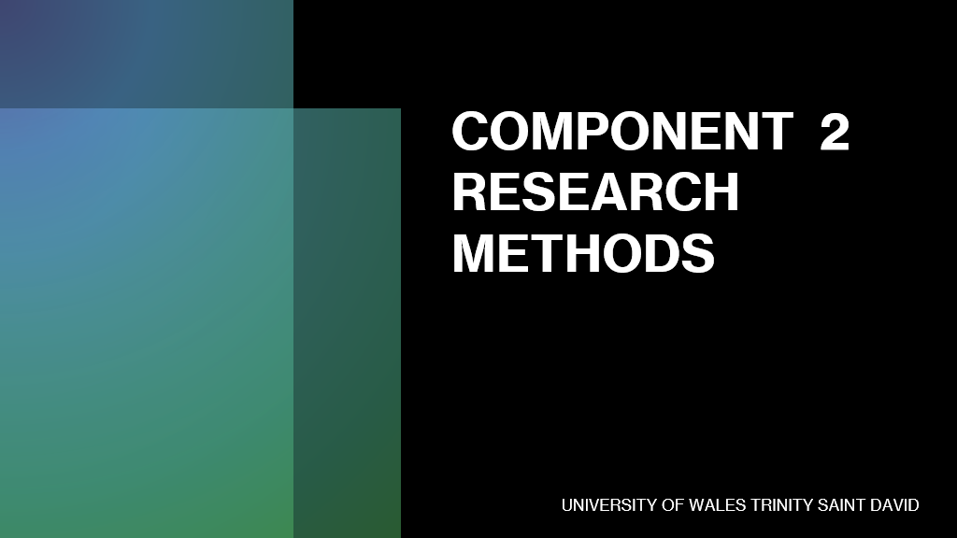

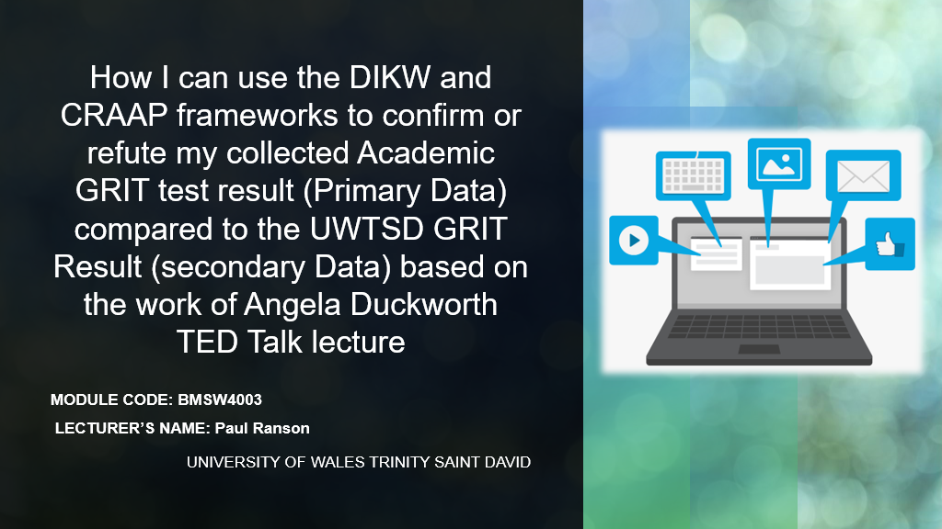

Hello!
My name is Klaus Ivan and I am student at University of Wales Trinity Saint David. The present assignment is based on the knowledge acquired during the Digital Skills and Research Method module and aims to analyse how grit impacts students’ academic path and in what way can it be used to estimate the level of success. The research follows the work of Angela Duckworth's on grit based on her assumption that grit is the key to perseverance for long term goals (Duckworth et al, 2007).
Therefore, in order to meet the assignment objective, my intent was to recreate Duckworth's experiment relying on two questions “What is your grit score?” and “What is the highest academic level you have achieved according to the British Government?”. The answers to the question were collected in an Excel document whose purpose was to turn the data collected into useful information to the research. The following step consisted in applying the CRAAP test to Angela to verify the reliability of the source. Next, the DIKW pyramid served as a framework to understand the flow of data collected and how it can be used to meet the purpose of my research (Ackoff, 1999).

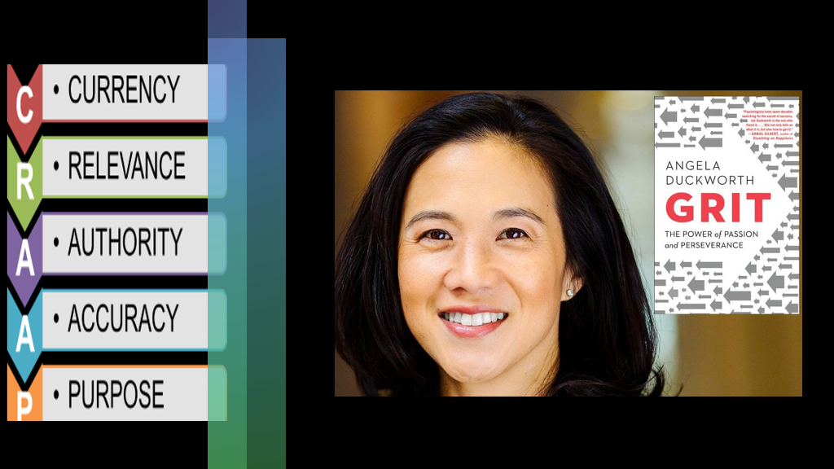

Since the entire research is based on Angela Duckworth’s work, I considered necessary to apply the CRAAP test to ensure the reliability of the source. CRAAP is the acronym for Currency, Relevance, Authority, Accuracy, and Purpose and it is a framework that helps understanding if a source is trustworthy and well-grounded (Blakeslee, 2004). Therefore, the Currency refer to the timeliness of the information, in other words Duckworth’s gave her TED Talk in 2013 (Duckworth, 2013) meaning that the information is still current almost ten years after. The Relevance, refer to the importance of the information for the research topic and thus, since the purpose of the assignment is to analyse how grit affects students, Duckworth research represents a perfect resource to support the topic. The Authority analyses the credibility of the source and of the author. Duckworth is a Professor of Psychology at the University of Pennsylvania with an impressive academic career a BA in Neurobiology at Harvard College, an M.Sc. in neuroscience at the Oxford University, and a Ph.D. in psychology at the University of Pennsylvania (McArthur Foundation, 2021). The Accuracy examines the reliability and correctness of the information, while the Purpose reason why the information was written; in this case, Duckworth’s purpose was to develop a Grit Scale to analyse the impact of grit on achieving long term goals (Duckworth et al, 2007).

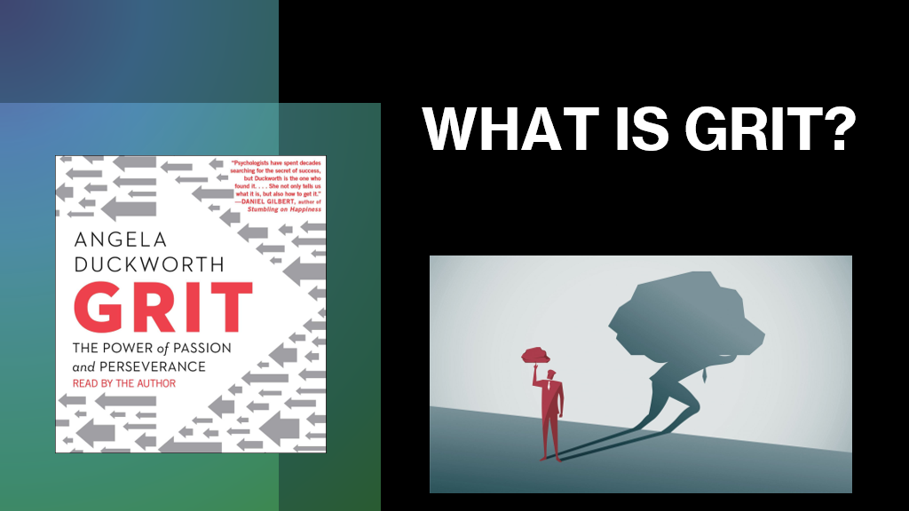

Following, after making sure that Duckworth’s work is reliable throughout the CRAAP test, I consider necessary a brief overview on the concept of girt to better understand the purpose of the research. The Oxford Dictionary (2021) defines grit as ‘the courage and strength of mind that makes it possible for somebody to continue doing something difficult or unpleasant’. In psychology, grit is considered a non-cognitive trait that gives people’s the perseverance to continue working for a goal (APA Dictionary, 2021). More specifically, Duckworth et al (2007) defined grit as the perseverance and passion for achieving long-term goals. In other words, Duckworth et al (2007) considered girt as the best predictor for success, going even beyond to intellectual talent (IQ) because grit contributes to maintain motivation high which is fundamental for successful results. In other words, although there are numerous elements that contribute to success like talent and intelligence without grit, they will lead to average results; thus, to achieve grate results grit is fundamental because encompasses both the motivation of the individual and his efforts regardless of the adversities (Duckworth, 2016). For instance, a less talented person but someone that puts effort and works hard to achieve his goals is more likely to be successful, than a high skilled person that does not work hard enough to make the most out of his talent.

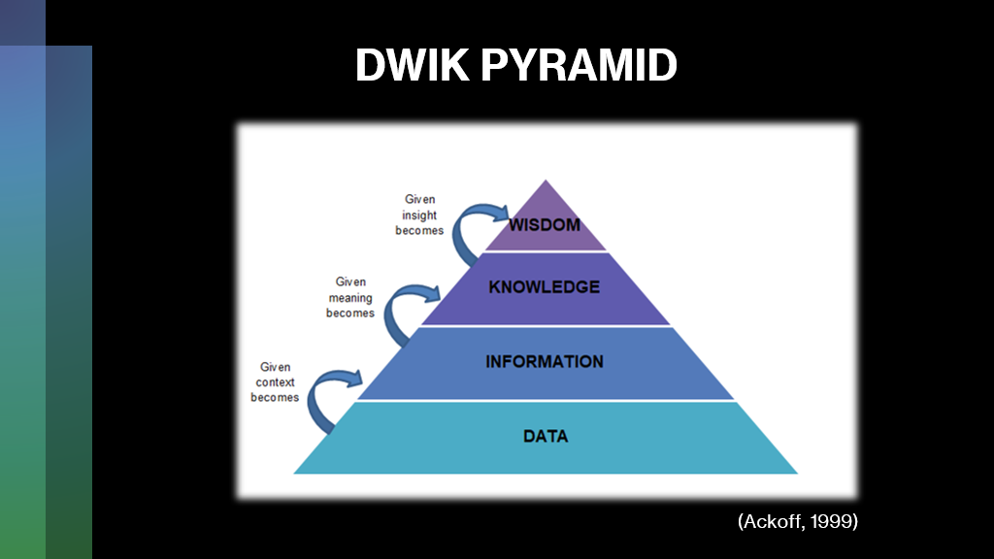

Following, the DIKW pyramid was used as a framework to recreate Duckworth’s experiment and to use the data collected according with the purpose of my research. The DIKW pyramid is the acronym of Data, Information, Knowledge and Wisdom, and it was proposed by Ackoff to emphasise the structural and functional connection between this four concepts (Ackoff, 1999). In other words, Ackoff proposed a hierarchy with data at the basis followed by information, knowledge and wisdom highlighting the fact that each of the upper category contains the one/ones that subside (Ackoff, 1989). Moreover, Ackoff (1989) considered that about 40% of the human mind is composed by data, 30% of information, 20% knowledge, and 10% understanding, thus wisdom.
To put it differently, all the data – facts, statistics, details, features – that we encounter during research has no value if not refined by information (Weinberger, 2020). Therefore, giving context to data we give it value, thus information. Yet, information has no value if not given meaning; in other words, through knowledge, we give value to the information that can be used as an asset in the research (Weinberger, 2020). Finally, by giving insight to knowledge, it becomes wisdom, otherwise said the ability to answer questions such as ‘why do something’ or ‘what is best’ (Van Meter, 2020).

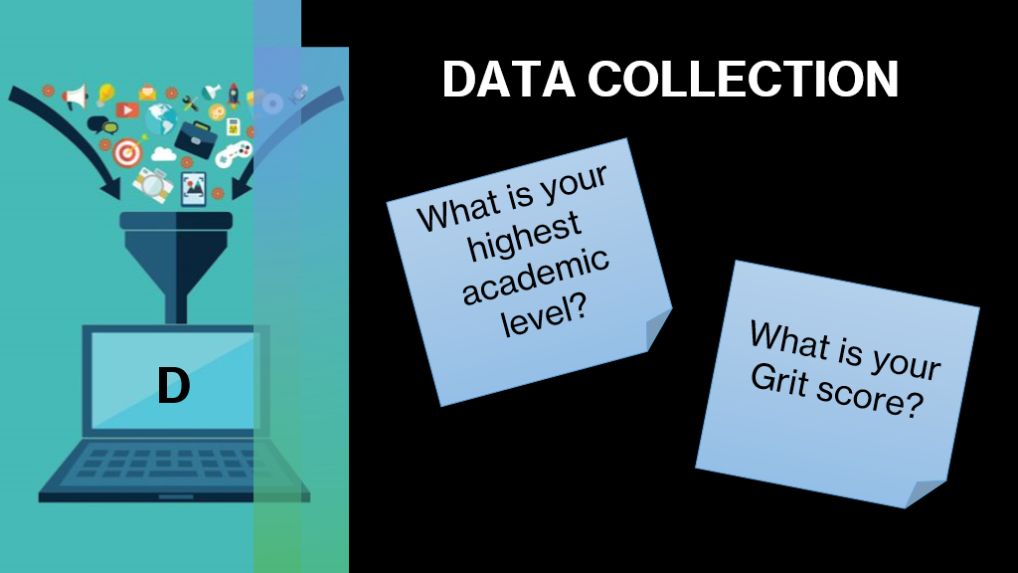

As previously stated, the first step of research consisted in collecting data. In order to do so I created a survey using Microsoft Forms on my Office 365 academic account (See Appendix 1) that was further send to my classmates. The survey was based on two questions – What is your highest academic level? and What is your grit score? The first question was a choice question with four answers from 1 to 4. To answer it, students had to check first the UK Qualification Comparison Chart (See Appendix 2) that have received when asked to answer the survey and then answer accordingly. The second question was an open question but in order to give the right answer students had to visit Angela Duckworth’s website, prior to answer the survey, and to complete the Grit questionnaire. The result, a number with two decimals had to be inserted as the answer to the second question of the survey.
The purpose of the survey was to collect two types of quantitative data that can be exported in an Excel file and transform into quantitative information that can be further examined and analysed.

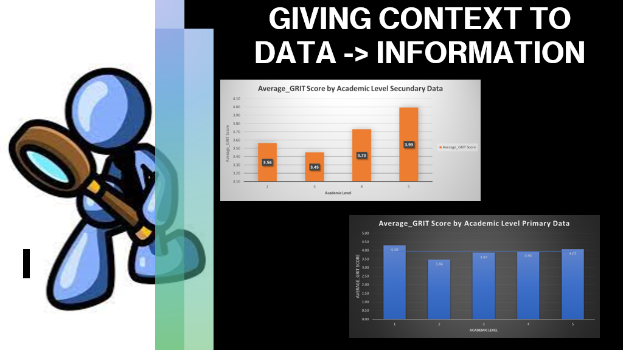

Following the DIKW pyramid the next stage of the research consists in transforming the data into information by giving it context, because without a clear context the numbers collected have no actual meaning and use. The process of understanding data is crucial in the research because through data it is possible to provide facts, statistics and details to support the research thesis as good data provides unquestionable evidence (CQL, 2021).
Therefore, to transform data into information I exported the results from the MS survey into an Excel file. Continuing, in Excel I created two different graphics based on the data collected. The first graphic showed the average score by Academic Level Secondary Data. In other words, the graphic showed the average results to the question ‘What is your highest academic level?’. The second graphic was meat to show the average score by Academic Level Primary Data, otherwise said the average results to the question ‘What is your Grit score?’ based on Angela Duckworth Grit questionnaire. Therefore, the two graphics were a useful tool to transform the data into information that can be further analysed and transformed into knowledge to support the research.

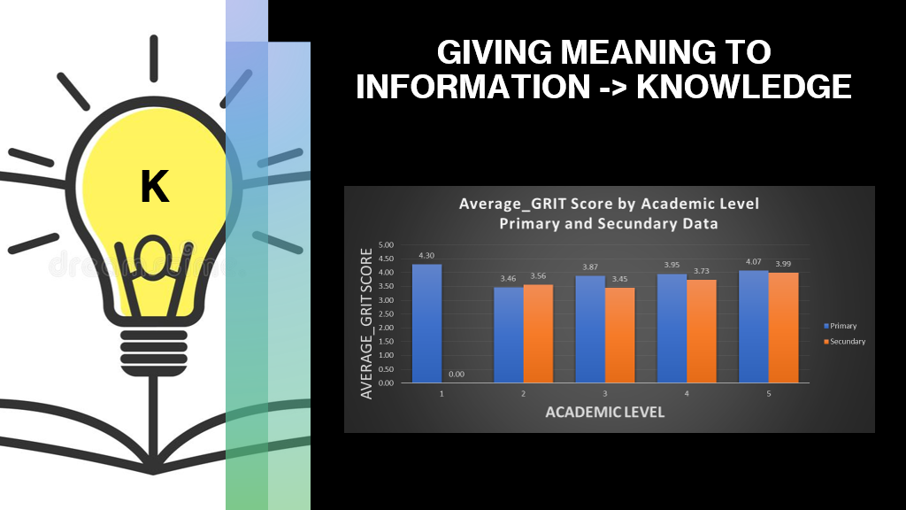

Although the two graphics created previously allowed to give data a context and to transform it into information, they were not enough to support the research. Therefore, it was necessary to give meaning to the information to create the knowledge required to support the topic of the research. In order to do so, I considered suitable to create another graphic that would combine the information collected from the first two. Hence, on the same Excel file I created a new graphic called Average_GRIT Score by Academic Level Primary and Secondary Data whose purpose was to compare the results extracted from the survey and obtain prior with the other two graphics. It was interesting to notice that the results between primary and secondary data differ slightly from academic level 2 until 5; however, now of the students who participated in the survey and had an average score of 4.30 at the grid test stopped at the first level of education. Consequently, since the higher the score the higher the grit of a person, it can be deducted that high grit has led students to purse an academic path and towards other levels of education.

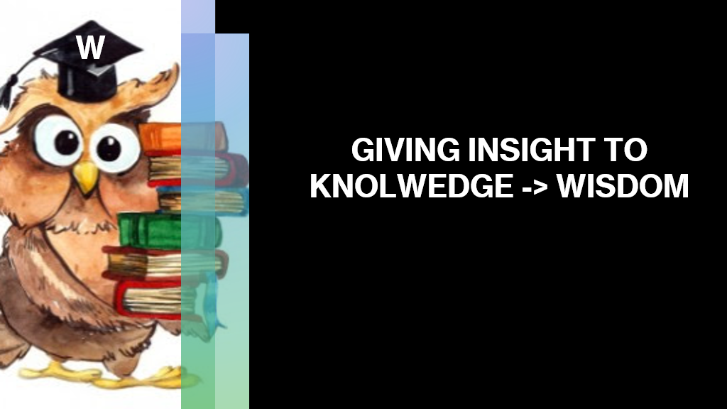

Finally, Wisdom is at the top of DIKW pyramid and encompasses all the previous levels of the model. To reach wisdom it is necessary to give insights to the knowledge; in other words, wisdom is the result of putting knowledge into action by asking questions like ‘why do something’ and ‘what is best’ (Ackoff, 1989). Therefore, while data and information offer an overview on the past offering the possibility to base the research on facts and evidence, knowledge and wisdom represent a window to the future supporting the research topic and facilitating the decision-making process related to what it is more appropriate to do in the future. Moreover, for Ackoff (1989), wisdom represents the evaluation of the understanding that was previously achieved through knowledge. Other numerous authors have considered wisdom as the ability to make effective judgements and decisions for further results (Gamble and Blackwell, 2021). Therefore, wisdom involves other elements that go beyond the knowledge achieved during the research, but there are related more with the human part of the individuals such as ethics and the capacity to choose between good and bad.

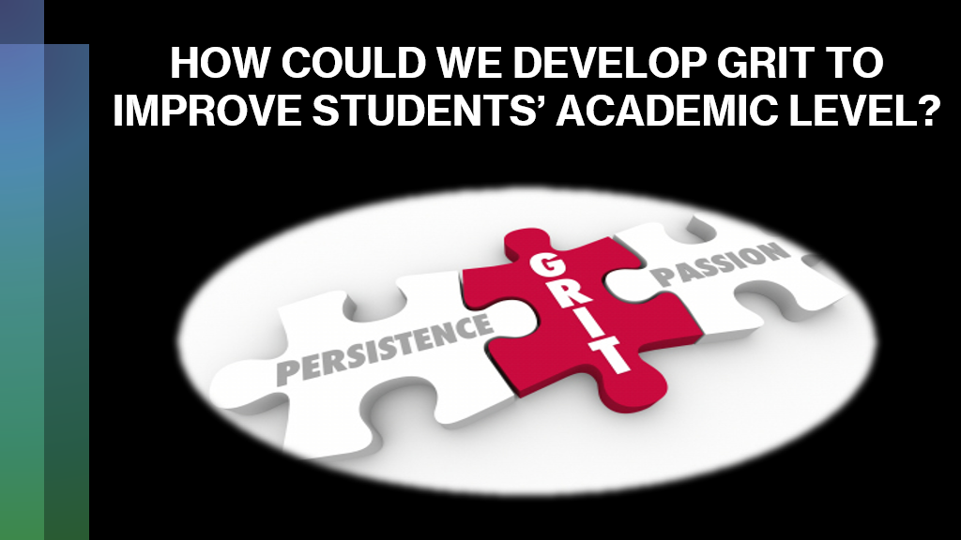

By analysing the graphic resulted from the data collected through the survey and accurately examining Angela Duckworth’s work, it is obvious that the higher the grit better the results as emphasised by the high grit score results students obtained by completing the Grit questionnaire. Hence, there is a question that naturally arises, in other words how it is possible to increment grit in individuals.
Duckworth (2016) in her book ‘Grit: The Power of Passion and Perseverance’ highlights the four steps fundamental for developing grip. First and foremost, practice is fundamental for success. In other words, practice goes hand in hand with perseverance that is the ability to continue to do something regardless of the difficulties encountered along the way or the number of failures until reaching the objective. Second, the key to practice is to set a long-term purpose that motivates enough to continue trying with perseverance and passion. Third, Duckworth emphasises the importance of hope in developing more grit; otherwise said it is important to embrace failure as a learning experience and not as a reason to give up, being aware that failure is part of the process of trying that will finally lead to the desired outcome. Finally, times contributes to fuelling grit if used effectively. Thus, it is important to be aware that achieving a goal requires time to practice and to learn from failure in order to develop the skills that lead towards the goal.



In conclusion, this research aimed to emphasise the importance of the grit and how it impacts students’ academic path, as well as how the grit can be used to estimate the level of success. The research was conducted from two perspective. On one hand, the research was based on Angela Duckworth’s assumption that grit is fundamental for achieving long term goals. On the other hand, independent research was conducted through a survey whose aim was to identify students grit score and the highest academic level they have achieved according to the British Government. After applying a DIKW framework to the data collected, it can be concluded that grit has a direct influence on students’ performance and their intent to achieve higher levels of education. Moreover, to increment students’ grit Duckworth’s framework of practice, purpose, hope, and time represents a useful model to follow to increase motivation, perseverance, and thus grip.



APA Dictionary. (2021). Grit. [Online] Available at: < https://dictionary.apa.org/grit > [Accessed 6 December 2021].
Ackoff, R. L. (1999). Ackoff’s Best. New York: John Wiley & Sons, pp 170 – 172.
Ackoff, R. L. (1989). From data to wisdom. Journal of Applied Systems Analysis, 15, pp. 3-9.
Blakeslee, S. (2004). The CRAAP Test, LOEX Quarterly, 31(3), article 4.
CQL. (2021). 12 Reasons Why Data Is Important. [Online] Available at: < https://www.c-q-l.org/resources/guides/12-reasons-why-data-is-important/ > [Accessed 6 December 2021].
Duckworth, A. (2013). Grit: The power of passion and perseverance. [Online] Available at: < https://www.ted.com/talks/angela_lee_duckworth_grit_the_power_of_passion_and_perseverance> [Accessed 6 December 2021].
Duckworth, A.L. (2016). Grit: The Power of Passion and Perseverance. New York, NY: Scribner.
Duckworth, A. (2021). Grit test. [Online] Available at: < https://angeladuckworth.com/grit-scale/ > [Accessed 6 December]
Duckworth, A.L. Peterson, C.M. Michael D. and Kelly, D.R. (2007). Grit: Perseverance and passion for long-term goals. Journal of Personality and Social Psychology. 92 (6), pp. 1087–1101.
EAL. (2021). UK Qualification Comparison Chart. [Online] Available at: < https://eal.org.uk/support/document-library/7-uk-qualifications-comparison-table/file > [Accessed 6 December 2021].
Gamble, P.R. and Blackwell, J. (2002). Knowledge Management: A State of the Art Guide. London: Kogan Page.
McArthur Foundation. (2021). Angela Duckworth. Research Psychologist – Class of 2013. [Online]. Available at: < https://www.macfound.org/fellows/class-of-2013/angela-duckworth > [Accessed 6 December 2021].
The Oxford Learners Dictionary. (2021). Grit. [Online] Available at: < https://www.oxfordlearnersdictionaries.com/definition/english/grit_1 > [Accessed 6 December 2021].
Van Meter, H.J. (2020). Revising the DIKW pyramid and the real relationship between data, information, knowledge, and wisdom. Law, Technology and Humans, 2(2), pp. 69-80.
Weinberger, D. (2020). The Problem with the Data-Information-Knowledge-Wisdom-Hierarchy. Harvard Business Review. [Online] Available from: < https://hbr.org/2010/02/data-is-to-info-as-info-is-not > [Accessed 6 December 2021]



