Name: Nwakaego Sylvia Boniface.
Student ID: 2521142.
Module code: LCHS4003.
Module: Introduction to Health and Social Care.
Lecturer: Farah Islam
Tittle: Pharmacy Services.



This Photo by Unknown Author is licensed under CC BY-NC-ND
Pharmacy Services


Pharmacy Services are services provided by Pharmacist to
promote safe and effective supply of medicines to the public. It
ensures accurate dispensing, prevents medication errors while


promoting public health and improving patient's outcome.
This Photo by Unknown Author is licensed under CC BY
This Photo by Unknown Author is licensed under CC BY
Functions of Pharmacy services
- Dispensing and screening.
- Medicines Management.
- Independent Prescribing.
- Patient counselling.

- Vaccination and Public Health

Pharmacy Services have evolved over
the years since its inception. Pharmacy
first originated during the Stone Age
using herbal and natural medicines in
the 9th -19^{th.} By the Middle Ages,
Pharmacy become a recognised
Profession different from medicine with
Pharmacists customizing medication
Tailored to a specific patient’s needs
(Anderson, 2024).
The Industrial Revolution introduced
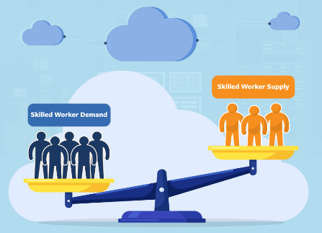
Mass-manufactured medicines and formal Regulations, transforming Pharmacy practice. In the 20th Century, Pharmacists expanded from dispensing to providing patient counselling and public health-support (Smith, 2025). Today, Pharmacy services manage chronic-diseases, clinical care, dispensing, vaccination, demonstrating evidence-based practice within modern healthcare system (WHO, 2025).

- Work force shortages and increasing
Workload: The growing demand for
medicine optimisation and public
health services have increased work
load challenges across the community
and hospital Pharmacies

(NHS England, 2024). The pressure adds to burnout, reduced service capacity, and delay in patient care (Royal Pharmaceutical Society, 2025),
- Although electronic prescribing and shared care records improve efficiency, many Pharmacy settings struggle with inconsistent digital infrastructure, limited integration and training gaps (Health Education England, 2024)
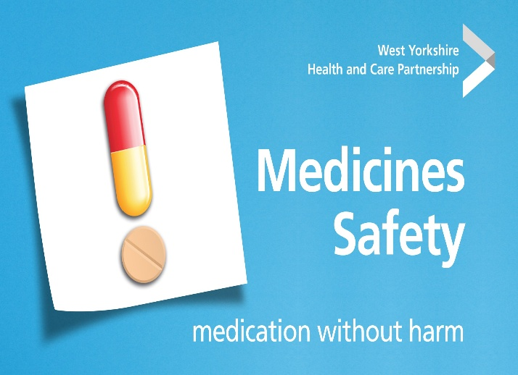
- Medicine Safety and complexity of care: The increasing usage of multiple medication by a single individual especially among older people and people with long term condition, poses a challenge. Pharmacists must manage high risk medicines, prevent errors, and ensure safe transitions of care, yet any miscommunication between healthcare providers often undermines safety (WHO, 2025). Medication errors is a persistent issue that requires stronger systems, digital integration, and Multidisciplinary collaborations (Elliot et el., 2024).

Conclusion
Pharmacy Services have evolved from traditional medicines preparation to patient-centred clinical care. Today, their role is very essential in medicines optimisation, public health delivery and supporting long-term conditions. In spite their progress, workforce pressures, digital gaps and medicine safety continued to affect service quality. Reinforcing resources, improving technology and promoting equal access are essential to ensuring Pharmacy Service remain safe, effective, and responsive to community needs.

Community Mental Health Services
Community Mental Health services have undergone great transformation over the years, refined by understanding Mental Health illness, policy and societal expectations. In the 19th and early 20th Centuries, their origin can be traced to when large Psychiatric asylums dominated Mental Health provision, it was overcrowded. Lacks the necessary staffing, equipment and funds to function effectively and associated with stigma, neglect and social exclusion (Scull, 2015). These concerns partly motivated the move towards community-based care, alongside advance in scientific study and the belief that individuals with Mental Health illness could live meaningful lives outside institutional settings.
History has it that turning point came in the mid-twentieth century with the deinstitutionalisation movement. In UK, the 1959 Mental Health Act marked a major shift by promoting treatment in the community rather than in hospitals reflecting wide international trends (Rogers and Pilgrim, 2020). In 1950s, the antipsychotic medications were introduced making it feasible for individuals to manage their symptom outside institutional environments (Healy, 2012). The NHS long term plan (2019) and Community Mental Health Frame (2021) have reinforced the need for integrated, person-centred and Multidisciplinary community services.
Morden Community Mental Health (CMHS) operate through a network of Community Mental Health Teams (CMHTs), crisis services, psychological therapy pathways, social care partnership and voluntary-sector organisations. A major strength of the current model is its alignment with recovery-oriented practice, which promotes,
1) Empowerment,
2) Shared decision making,
3) Holistic wellbeing (Slade et al. 2022)
Furthermore, research shows that community-based intervention improves continuity of care, reduce hospital admission. And supports individuals to maintain employment, relationships and independence (NHS England, 2023). The shift towards Integrated Care System has also enhanced collaboration between health, social-care and third-sector providers, enabling more coordinated responses to complex needs.
However, evaluation reveals persistent challenges. Demands for Community Health Services continues to outpace capacity with workforce shortages, long waiting times and inconsistent access to psychological therapies reported across UK (British Medical Association, 2024).
Structural inequalities. Including poverty racism and housing insecurity, continues to shape mental health outcomes, yet community services often lack the resources to address their wider determinate effectively (Marmot et al, 2020). Furthermore, although recovery-oriented practice is widely accepted, its implementation can be inconsistent, with some services adopting risk-averse or paternalistic approaches that undermine autonomy (Rose and Kalathil, 2022)
Despite these limitations, the Community Mental Health Services remain vital in enhancing the quality of life of a service user. By providing support in a familiar environment, they promote social inclusion, independence and sense of belonging, Community based care enables individuals to develop coping strategies. Maintain daily routine and engage in meaningful activities, all of which contributes to improved wellbeing and reduce relapse rate (Reper and Perkins, 2021). Peer support, culturally responsive interventions and trauma informed approaches further strengthened engagement and empower individuals to take an active role in their recovery. Importantly, Community Mental Health Services help challenge stigma by normalising mental health support as part of everyday community life.
In conclusion, the development of mental health services reflects a long historic shift from institutionalization to person-centred, recovery-oriented care. While existing services face significant pressures, they remain essential in promoting autonomy, social participation and improved quality of life for individuals experiencing mental health difficulties. Continued investment, workforce expansion and stronger integration with social support system are crucial to ensuring that Community Mental Health Services can meet the growing and diverse needs of the service users.

Anderson, J. (2024) A global history of pharmacy practice. London: Routledge.
British Medical Association (2024) Mental Health Services: Workforce and Capacity Report. London: BMA.
Elliott, R.A. et al. (2024) ‘Medication safety in primary care: reducing avoidable harm’, BMJ Quality & Safety, 33(2), pp. 89–98.
Health Education England (2024) Digital readiness in the pharmacy workforce. London: HEE.
Healy, D. (2012) Armageddon. Berkeley: University of California Press.
Marmot, M. et al. (2020) Health Equity in England: The Marmot Review 10 Years On. London: Institute of Health Equity.
NHS England (2023) Community Mental Health Transformation. Available at: https://www.england.nhs.uk (Accessed: 17 June 2026).
NHS England (2024) Community pharmacy workforce survey report. Leeds: NHS England.
Repper, J. and Perkins, R. (2012) Social Inclusion and Recovery. London: Baillière Tindall.
Rogers, A. and Pilgrim, D. (2020) A Sociology of Mental Health and Illness. 6th edn. London: Open University Press.
Rose, D. and Kalathil, J. (2022) ‘Power, participation and the recovery movement’, Social Science & Medicine, 298, pp. 1–9.
Rose, D. and Kalathil, J. (2022) ‘Power, participation and the recovery movement’, Social Science & Medicine, 298, pp. 1–9.
Royal Pharmaceutical Society (2025) Workforce wellbeing and capacity in UK pharmacy. London: RPS.
Scull, A. (2015) Madness in Civilization. Princeton: Princeton University Press.
Smith, L. (2025) ‘Evolution of community pharmacy services in modern healthcare’, Journal of Pharmacy Practice, 38(1), pp. 12–20.
World Health Organization (2025) Medication safety in high-risk populations. Geneva: WHO Press.
World Health Organization (2025) The role of pharmacists in primary healthcare. Geneva: WHO Press.

