Independent Project
Portfolio

Ellie Melvin (2206076)
ADPA600



Contents Page:

Element 1 – Research
- Introduction/proposal page 3 & 4
- Literary Review page 5-10

Element 2 – Development
- Stimulus page 11-13
- Character Creation page 14 -16
- Writing Exercises page 17
- Writing Process page 18-19
- Script Writing page 20
- Casting Process page 21- 22
- Rehearsals page 23 - 26
- Costume page 27-28
- Set Design and Props page 29-30
- Tech Week page 31-32
- Performance Evaluation page 33

- Bibliography page 34

Element 1 – Research
Introduction
Through my independent project I will be answering the question “How do toxic relationships
begin and evolve?”. Too answer my question I will be exploring this through a short play
about a woman who falls in love with a narcissistic woman. In her experience with this
relationship, she discovers herself slowly realising that it isn’t all that it seems and how she
eventually looses herself, even through therapy and being blinded by love she questions
herself did the relationship turn toxic because of her doing or was she just going insane?
In my play I will focus on the different areas which create a toxic relationship and how these
factors can cause emotional damage and evolve. I will be exploring the concept of a toxic
relationship, as well as researching into narcissistic traits, sexuality and relationships. For
the core part of the play, I will delve into what it means to be in a relationship and
demonstrate the effects of being in an emotionally abusive relationship. I will base the story
off my own personal experience, as I feel as though it’s a topic, I’m passionate about and
want to showcase this type of relationship and how it really can affect someones well being.
I want the story to start in a therapy room as she expresses the story between her loved one
and how it started and how it evolved. I’m going to create a play that will jump in and out of
the therapy room and in between have scenes of the relationship as though were seeing her
story come to life, like an insight of what’s inside her head.

My proposal
Toxic relationships are the theme I’ve decided to delve into for my independent project, to
achieve this I will create a short play that’s 20 minutes in length that contains a range of
monologues and duologues to bring the story to life. What inspired me to delve into this
theme was my own personal experience. I went through an emotionally abusive relationship
in the past and I felt as though this topic would be great to base my project on to raise
awareness on these types of relationships. I also aim to delve further into researching and
understand the underlying issues of people with narcissistic traits. The main characters
journey will take place in therapy when she discovers, she needs help, she tells her story
through a range of monologues and will also feature some duologue scenes with her
partner to give the audience a greater understanding of the relationship and the experience
she had. My main objective when writing this play is for the audience to get a better
understanding of toxic relationships, the mental effect it can cause upon someone and also
feel inspired and encouraged to tell they’re story and that they’re not alone, there is light at
the end of the tunnel. I want the audience to walk away from this play with a further
awareness of relationships such as these and the psychological toll they have on people.

Literature review
For the topic of my independent project, I have decided to base my performance on toxic/

narcissistic relationships. I will be researching narcissists and mentally abusive relationships

through finding multiple resources such as articles, news reports, statistics and books and

thoroughly evaluate. My overall question that I will be reviewing is “How do toxic/narcissistic

relationships begin and evolve?”.

After doing thorough research I came across a book called “Narcissistic abuse recovery” by Rita

Hayes. Reading through her book she expresses the start of a narcissistic relationship. It states

within the book how “At first, it’s heaven, they may shower you with attention and compliment

their way into your heart, they focus on your good points only later to use your bad points

against you”. (Hayes, R., 2023). I would completely agree with this statement, going through a

personal experience myself within this type of relationship I believe for the majority of the time

this is how narcissists tend to act at the start. Love bombing and luring someone in a massive

sign of this too.

Within this book Hayes also expresses how in the beginning “He was handsome, charming,

eccentric, interesting, and caring”. He made her believe that she had “found true love and that

we would marry and live happily ever after” (Hayes, R, 2023). Hayes goes into depth about the

beginning of dating a narcissistic person. After reading through this book, I would definitely

agree that Hayes underlines the main features of the start of a toxic relationship. As narcissistic

relationships develop and deepen, they tend to start showing they’re true self. Typically, they

start to show traits such as “sly, underhanded, selfish and controlling”. (Hayes, R, 2023).

Narcissistic people are clever and very tactical and use gaslighting as a main tactic. “Once

you’re at the stage where you wonder if you’re going crazy. The narcissist has you right where

they want you – in their condo trolling grasp” (Hayes, R, 2023). Hayes states very clearly how

this type of relationship begins and how it evolves.

Continuing on from my research I found a book called “When loving him is hurting you” by David
Hawkins that correlated well within the realm of my question. Hawkins explains where the

route of the term “Narcissism” originated from. “The term “narcissism” comes from Greek

mythology. Narcissus was a hunter, renowned for his beauty. He was exceptionally proud and

handsome, and he knew it. His enemy, Nemesis, discovered his weakness and devised a plan

to use it. Nemesis lured Narcissus to a pool where Narcissus fell in love with his own reflection

in the water. Unable to pull himself away, Narcissus fell under the spell of his own image and

drowned” (Hawkins, D., 2017). Before reading through this book, I was unaware of where the

term originated from. It’s interesting that the term dates back to Greek mythology and now

aware of this I’m able to research further into Narcissus and his story to broaden my knowledge

to enable me to write my play.

Likewise, to Hayes, Hawkins demonstrates how at first “You were captivated by his attention,

enamored with his charm, engulfed in his persistence to have a good relationship with you”

(Hawkins, D, 2017). I would agree that both Hayes and Hawkins explain clearly in their books

how dating a narcissist will be at the start. Narcissists have a tendency to act charming at the

start to make you believe that they have good intentions, knowing that this is only a trap to lure

someone right into the palm of their hands. Furthermore, Hawkins expresses how no one is

truly aware of how narcissism begins, but how many people that show signs of narcissistic

traits could potentially have an underlying mental health disorder called narcissistic

personality disorder (NPD). Hawkins explains that if you show signs of traits such as “Exhibits

an exaggerated sense of self-importance”, “Has a preoccupation with fantasies of unlimited

success, power, brilliance, beauty, or ideal love”, “requires excessive admiration”, “has a sense

of entitlement”, “Selfishly takes advantage of others to achieve his own ends”, “Lacks empathy”

(Hawkins, D, 2017) that there is a chance you could have NPD. His book states how not

everyone that can show signs of behaviours such as these will have NPD but could also be a

“Behaviour pattern that’s learnt” (Hawkins, D, 2017). Sometimes this could be learned from

parents or possibly childhood trauma and often find that people who show these traits are
something they’ve never know any different from and don’t see no wrong in their behavioural

actions. After thoroughly reading and evaluating Hawkin's book I can clearly state how I now

have a more in-depth knowledge about narcissism, the route and its possible causes.

Delving deeper into my research I came across another book by Jean Harrison and Melody

Dixton “Narcissistic abuse recovery: The ultimate guide for how to understand, cope and move

on from narcissism in toxic relationships”. Whilst reading through I’ve found all three books I’ve

read have stated very similar facts about narcissism. Harrison and Dixton delve deeper on the

route of the problem stating clearly that “Narcissists are usually those who have experienced

trauma in their childhood. When we go through experiences like these, we usually carry the

same emotional intelligence we had when we were the age of the trauma” (Harrison, J and

Dixton, M, 2019). Although NPD can sometimes be the underlying issue most of the time, you’ll

find childhood upbringing and trauma a real set off in how people with these traits brain works.

Harrison and Dixton also express how “Narcissists can get into the heads of their victims only

because they first got into their heads themselves. We think of narcissists as vain people who

only care about themselves. They usually hate themselves, which is why they are so negative

and abusive towards others” (Harrison, J and Dixton, M, 2019). Getting a real understanding of

these traits, possible causes and how they’re brain operates and thinks is great ordeal in order

for me to write a script based on around this topic. Harrison and Dixton have a great way of

doing exactly that.

Ultimately, I can definitely come to the conclusion that I have an awareness and thorough

understanding of how relationships such as toxic and narcissistic situations begin and the

underlying issue and factors that evolve the topic. I have an understanding that people who

demonstrate narcissistic traits could often be caused by childhood trauma or even NPD a

mental disorder. I have a further knowledge and now can outline traits that comes with

narcissism. People that project these traits have a lot of mental issues which can sometimes

not be helped if developed from a child.

To broaden my knowledge and understanding, and to answer my question “How do

toxic/narcissistic relationships begin and evolve?”, I will be researching into the next element of

my question and looking at how these relationships evolve.

I came across an article called “The long-term effects of narcissistic abuse” by Amanda

Lundberg. With in this article, it states clearly the top five effects it can have on someone who’s

gone through a relationship such as this. These include “low self esteem”, “relationship issues”,

“Mental health issues”, “physical health problems” and “Difficulty functioning” (Lundberg, A,

2024). This article explains clearly that not only are the narcissist deal with underlying issue but

can cause long term issue on their partner.
Being with a narcissist can cause a lot of emotional trauma which can affect people in their

everyday life and can also cause further issues in future intimate relationships due to PTSD.

Lundberg also expresses how “The constant barrage of narcissistic manipulation, criticism,

and belittlement from a narcissistic person can gradually wear down the victim’s sense of

self-worth. As the abuse continues, the victim may start to believe the hurtful things the

narcissist says, feeling worthless and flawed. In the long term, a victim may fear making

mistakes and doubt their abilities, which hampers their growth” (Lundberg, A, 2024)

The long-term damage is clearly severely from experiencing a narcissistic relationship and

Lundberg makes it clear the emotional toll it can have on someone’s well being.

I came across another article called “Narcissistic relationships: signs, impact and how to cope”
by Anna Drescher. Within this article Drescher emphasises how these relationships evolve. She
writes “They may engage in gaslighting, guilt-tripping, or triangulation, among other tactics,
to exploit your emotions and give them greater control over your life.” (Drescher, A,
2024). Ive gathered that throughout the beginning they charm there way in but eventually
we see a drastic shift in behaviour conveying how they’ve evolved. Using tactics such as
gaslighting, it’s an easy target for their victim to question themselves and their own doing
ultimately making them go crazy. Drescher also states how “Narcissistic relationships can
be emotionally draining and psychologically damaging for the partner involved. The constant
push-pull, emotional rollercoaster, and manipulation can negatively impact the partner’s self-
esteem, mental health, and overall well-being.” (Drescher, A, 2024).
She also describes at first, they have found the ideal partner, but they eventually evolve “as
the relationship progresses, the narcissist’s behavior will shift dramatically, and they may
start to criticize, belittle, or even emotionally abuse you. This devaluation can be confusing
and hurtful, leaving you wondering what you did wrong to prompt such a change.” (
Drescher, A, 2024). Throughout this article Drescher thoroughly explains how these
relationships evolve and also the mental effects it can cause upon someone.
Further into my research I found another article called “The long term consequences of
narcissistic abuse” by Manya Wakefield.I found this article extremely interesting as it
outlines health issues that can evolve from experience a relationship such as these.
Wakefield demonstrates how “Survival mode is meant to last for a short time, until the
person is able to get to safety. However, people experiencing narcissistic abuse remain in
survival mode for sustained periods of time. The long-term effects of raised adrenaline and
cortisol can have adverse health consequences as increased adrenaline and cortisol leads
to elevated heart rate, blood pressure, and blood glucose levels.” (Wakefield, M, 2023). As a
reader I found this information extremely interesting as I was unaware of toxic relationships
affecting not only emotional but also physically.

Overall, after gathering all the information I have learnt and found, I can confidently say I
have answered my question “How do toxic/narcissistic relationships begin and evolve?”. I
have learnt that within the beginning the narcissist is very tactical and will use charm, words
of affirmation and affection to lure their victim, but within time slowly their personality begins
to differ as we see a different side come to play. They also are very self centred and lack a
lot of empathy but could initially route from childhood trauma or NPD. Additionally
narcissistic are extremely clever and will use tactics such as gaslighting and manipulation to
make themselves powerful and make their victims question everything. As they evolve, I’ve
learnt that these relationships can have serious mental and physical impact on people and
can carry trauma with them for a while after.

Element 2 – Development

Stimulus:

At the beginning of this process, I knew I wanted to base my project on my own story. I felt

inspired by my experiences and because of the knowledge I had I felt I had a real great

understanding of the topic. For me personally I thoroughly enjoy watching documentaries or

shows based off true events as it has a sense of realness to them, and I find them

captivating as well as educational to watch. Because of this I felt as though I could create a

piece that’s inspirational. I personally enjoy naturalistic acting and a story that has truthiness

behind it and I felt encouraged to bring my story to life. I delved into naturalism and realism

and researched emotional memory by Stanislavski. “Emotional or Affective Memory asks

the actor to call on a memory similar in detail or sensation to their character’s situation.

Through empathy, the actor lives the character rather than simply reciting it.”
(Timoney, B,2023)

I found by using emotional memory a very useful method in writing and creating my script as
I want my play to be based off real events but also allow the actors within my play to feel
emotions naturally rather than acting out an emotion.

Originally, when brainstorming ideas, I wanted to have a cast of three actors, the lead girl,
the toxic partner and the best friend. I thought that by having a third cast member as a best
friend would break up the play as well as having something to fall back on for the narrative
of the play. I created a rough story structure of my piece:
- Three characters
- Main girl
- Toxic partner
- Best friend
- Start with a girl and girl meeting up for the first time – first date
- Charming girl, tells her all the right things, giving her gifts, too good to be true
- They start to get closer and meeting up more
- Telling her best friend all about her – different from the rest
- They get together – she’s over the moon
- Things start to change; she slowly starts making jokes about her appearance
- She starts to show narcissistic behaviours, controlling her lifestyle who she can and can’t be friends with
- Tells her best friend about her change in behaviour, advises her to leave her but she feels stuck
- Things get progressively worse with her behaviour, arguments happen
- Big dinner scene between them
- Best friend is worried as she’s shut her off/ won’t listen
- She stands her ground finally leaving him

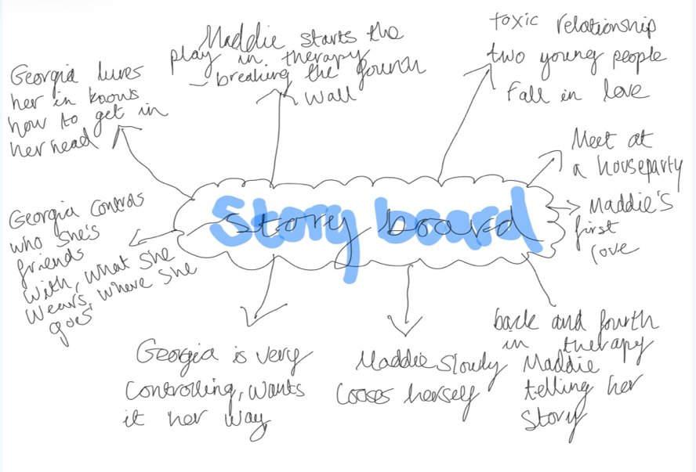
Story board mind map

I also wrote down things I wanted it to be and things
Things I want it to be:
- Powerful
- Moving
- Inspirational
- Challenging
- Captivating

Things I don’t want it to be:
- Cringy
- Unserious
- Boring
I didn’t want it to be before starting the writing
process in order for me to get a better
understanding of the layout I was aiming for.

After creating a structure plan with three cast members I found that it would be more useful
and effective to have only two cast members in my play. I did some thorough research on
Bertolt Brecht as inspiration to write my play. I liked Brecht’s method of breaking the fourth
wall where “the actors will sometimes directly address the audience with a speech,
comment or a question” (Ltd, B.CU, no date). I then came up with the idea of the lead
character starting in therapy expressing her story and addressing the audience as if they’re
all apart of the therapy group. I liked the idea of her telling her story through therapy as it
gives a narrative to fall back on too in order for the story line to have a rhythm to it and
audience members have a clear understanding of the situation. Throughout we’ll see her
breaking out of therapy and into duologue scenes with her toxic partner and how the
relationship unfolds and progressively evolves. I found by breaking into duologue it gives
the effect of us as audience members an insight of her reflecting on the relationship, like an
insight into her mind. Throughout the play we’ll see the lead character going back into
therapy to reflect on her situation, and then eventually her leaving her partner because she
becomes numb to the relationship and then will end with her finishing off back in therapy to
close her story.

Character creations
When creating characters for my piece, I based
Maddie:
- Victim of an emotionally abusive relationship
- Outgoing character, very bubbly and friendly
- Slowly looses herself within the relationship – doesn’t know who she is anymore
- The reason she’s in therapy is because she finally has the courage to tell her story – realises she needs helps
- Finally has the courage to leave Georgia – a lot of anger built up inside, explodes and tells her how she really feels
- Never would have thought she would have been the one to walk away – stakes are high
- She’s lonely, depressed
- Need to see a shift in her character from start, middle and end
- Start, her true self
- Middle, slowly loosing who she is
- End, feeling of emptiness, numb, fed up and angry
- Need to see the impact Georgias had on her mentally and physically, demonstrating how being in a toxic relationship can affects someone’s wellbeing
both of them off from my personal experience.
Maddie, who is inspired by me. And Georgia,
who’s inspired by my ex-partner. I wanted to
create characters very alike to my own story so
that I already had something to go from. I
created character profiles on each of them to
allow myself to get a better understanding to
the piece and who they are as individuals.

I found by creating character profiles it gave
me a clearer envision into my piece. When
creating characters, I started off by creating
Maddie. Maddie who represents me is the lead
character in the play. The whole story is based
off her and her experiences. She is the
backbone of the story, and the narrative of the
piece always reflects back onto her. Maddie
is a symbolisation of myself and someone who’s been through an emotionally abusive
relationship. Maddie has never been in love before or ever dated anyone until she met
Georgia, and the story demonstrates her navigating her way through the relationship.
Maddie is someone who is friendly and outgoing but slowly as the relationship unfolds, she
begins to question herself and loosing herself completely.
Georgia:
- Charming character
- Very flirty, knows all the right things to say to people
- Knows how to lure Maddie in
- At the start, the ideal partner, showering her with gifts, words and affirmations
- Only child – used to having everything
- Abusive dad growing up – doesn’t know any different
- Gets severely angry over the smallest things with Maddie
- Lashes out, rage, wants it her way all the time
- Knows how to get into Maddie head
- Very manipulative
- Compulsive liar
- Believes she’s better than everyone else
- Controlling
Georgia, who represents the toxic partner, is
somebody who has a lot of childhood trauma
which reflects on the way she treats Maddie.
Georgia is very charming and outgoing.
Georgia knows how to lure Maddie in and is
very strategic. Georgia represents someone
with narcissistic traits and truly believes that
nobody is better than her. She doesn’t believe
that she is the issue and will always blame
Maddie for her own actions.

I also created character mood boards based off of emotions and inner thoughts. I found
creating these immensely helpful for me to get a better understanding visually of the
characters: what they were going through internally and externally.
I found by creating an in-depth background extremely useful for me to proceed
and write the script as I knew exactly who the characters are thoroughly and what objective
is needed to convey for both within my script.

Character creation mood boards
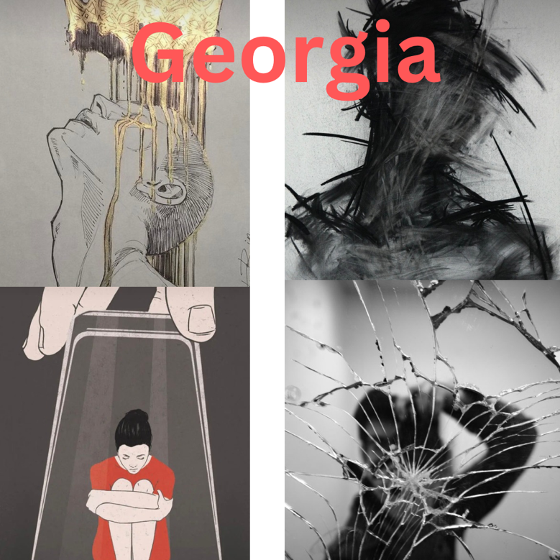
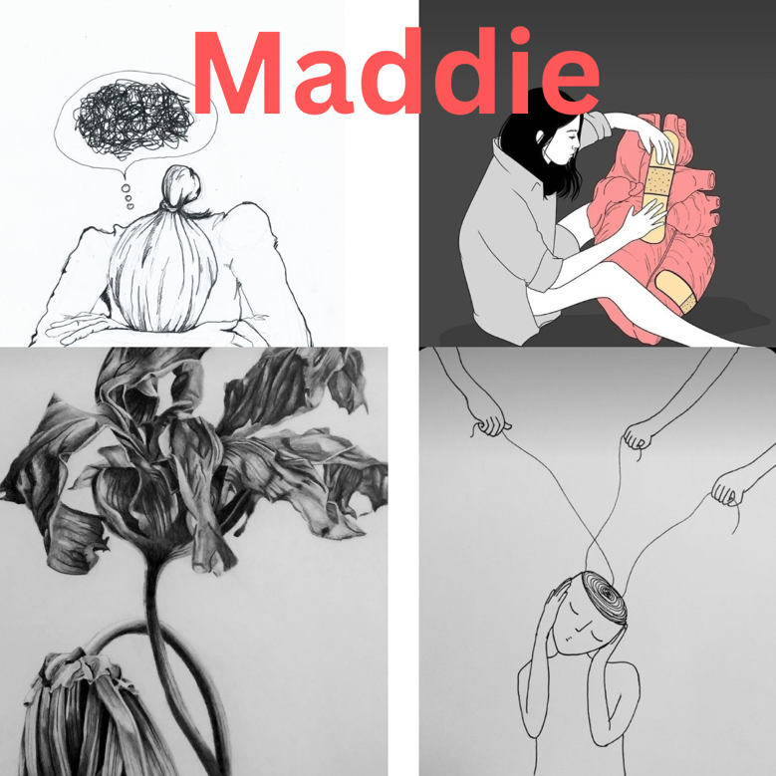

(Pictures from Pinterest)

Writing exercises
Before I started writing my script, I did some research and came across Miriam Batteye’s
writing exercises:
“Things that frighten me”
Maddie:
Things that frighten me
- Georgia
- Loosing her friends and family
- Love
- Intimacy
- Relationships
- Being alone
Things that piss me off
- Love
- Relationships
- Georgia
- Life
Things that give me hope
- Friends
- Family
- Work
- Georgia
- Love
Things I want to understand
- Love
- Life
- Georgia
- Intimacy
- Relationships
“Things that piss me off”
“Things that give me hope”
“Things I want to understand”
(Royal Court,2021)
I set a timer for two minute and wrote things for both
characters. I found this exercise very useful as it
helped me get a clearer understanding of both
characters without overthinking anything.
Georgia
Things that frighten me
- Myself
- Love
- Life
Things that piss me off
- Maddie
- Maddie's friends and family
- My family
- Love
Things I want to understand
- My family
- Maddie
- Myself
Things that give me hope
- Maddie
- Myself

Writing process
When it came to writing my script, I found it useful to start with writing the monologues first to
get a grasp and structure to my piece and then write the duologues and slot them into the
plot. I created a sequence of questions to follow to ensure that I wasn’t get off track and
kept within the realm of my topic.
Checklist
- What am I trying to say?
- Who am I speaking too?
- What’s my objective within this piece?
- Why is the character saying these words?

Whilst following my checklist I found it very beneficial to write monologues for Maddie. By not
over thinking it and making sure I reach Maddie’s goal and objective I was able to write my
few monologues. I also used emotional memory a technique by Stanislavski, as it helped
me reflect on my own personal experience and pour my own feelings within the
monologues.
First draft of opening scene monologue
Do you know what the definition of love is? Love is an intense emotion you know, that feeling of butterflies in the pit of your stomach, a deep sensation that completely takes over your body. It’s pretty fucking amazing (pause) well at least I thought it was.
I’d never been in love before until I met her, Georgia, she was my first. I’d never even glanced at a girl before her. We met at a house party and instantly just clicked. She was the ideal girl, charming, charismatic, funny, intelligent. I felt like the luckiest girl ever. I fell instantly, she lured me in, she had me right in the palm of her hands, she knew exactly what she was doing. Georgia was like a drug; an addiction and I just didn’t know how to stop. I felt trapped with no way out. It was exhausting, I lost myself completely I didn’t even know who I was anymore.
I never understood why things changed, what did I do wrong?
You know I used to blame myself for the way she treated me, I hated myself, I started to believe all of her bullshit she would say about me. I remember for a while thinking that that was what a normal relationship was, I was so out of touch with the reality of it. She scared me, I feared everyday of what she would do next. I felt stuck with no way out.

Maddie leaving Georgia Monologue
It’s exhausting this, Us. (Pause) Do you wanna know how I feel? I feel nothing. Im numb to the pain, I don’t feel anything anymore, you’ve ruined me. I don’t even know who I am anymore. I can’t keep pretending like I’m okay, putting on a brave face for everyone acting like we’re a happy couple.
This isn’t love. I don’t even know what love is anymore. If love is meant to make you feel like this, I don’t want any part of it. I’m fucking drained Georgia, I’m tired of all of this, for 2 years I’ve had to put up with the same shit day in day out and for what? “I’m worthless”, “no one will ever love me”, “you pathetic piece of shit”, do you know how damaging it is to hear them words. I thought you would have changed but clearly I’m the fucking idiot for ever thinking you would. I can’t keep doing this anymore, I’ve tried for the longest time because I love you so much it hurts, but I have to put myself first for once. I feel like I’m at the lowest point in my life because our relationship has weighed me down so much. You’ve broken me Georgia, I can’t keep going on like this. I’m done.

Final scene in therapy monologue
That night I packed my stuff and left. I never seen Georgia again. It was like a switch turned on in my head that night and I finally had the courage to leave. No one could have prepared me for heartbreak. It hit me like a truck, the easiest way to describe the process of a breakup is like you're grieving somebody that’s passed away. It’s like one minute they’re a constant in your life and then just like that they’re gone. After everything that had happened between us it still fucking hurt. Days and then weeks went by, and I just felt nothing but silence. It was weirdly peaceful. She did try and contact me multiple times and I had this massive urge to contact her back but I knew if I did I was right back to square one, I’d come this far why would I go back now. You know I can actually say I’m happy now, I’m finally happy, for the longest time I thought Georgia was my happiness, but now I’ve stepped out of the situation I feel free.
Hi, I’m Maddie and this is my story.

Script writing
In my 1st draft of my script, typically I found writing monologues effortless than writing
duologue scenes, due to the fact that I’ve found throughout this process I thrive off of
creative writing and felt I had a good flow and objective within each monologue I wrote.
Whereas when it came to writing duologues for my piece I struggled as they’re so
naturalistic sometimes I felt my scenes weren’t great, but also had to keep in mind that they
can’t be so creative as my monologues.
Once I began writing my script and I knew the narrative and path I wanted to go with it I
found it very straightforward. The only major obstacle I faced was creating a climax and
ending for my play. I knew I wanted Maddie to find the courage and leave Georgia but I
struggled with what the scene would entail and what would Georgia do for Maddie to get up
and walk away.

First draft of script: https://uowtsd-my.sharepoint.com/:w:/r/personal/2206076_student_uwtsd_ac_uk/Documents/Documents/first%20draft%20of%20script.docx?d=w0ea9356eb7414d039de0e0b717617f42&csf=1&web=1&e=gZd5BQ

My 2nd draft of the script was my final draft, I only made slight changes too the script and
created an ending for my piece as overall I was pleasantly happy and didn’t find it
necessary to create multiple drafts. Within my final draft I also added lighting and sound
cues ready for tech week. After finalising my script, I felt the name didn’t identify with my
piece. Originally, within the first draft I had named my play “Power” due to Maddie finding
the power to leave Georgia. At first, I liked the name but when finalising my script, I felt that
“The therapy room” correlated better within the realm of the piece.

Final draft of script: https://uowtsd-my.sharepoint.com/:w:/r/personal/2206076_student_uwtsd_ac_uk/Documents/Power%20script.docx?d=w9d5e2a04306b4a9bb64407ec5f5068ac&csf=1&web=1&e=fDsvk1

Casting process

For our projects we were advised to use the first years at WAVDA as apart of our cast. I then

went and sent everyone an emailing looking for two cast members as well as the synopsis:
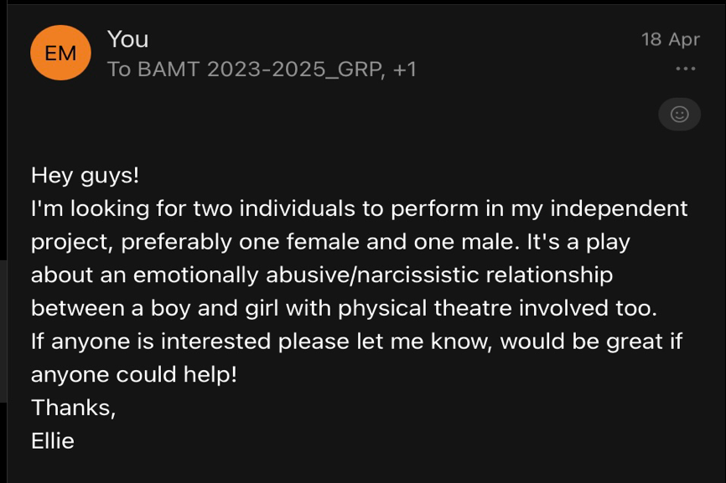

Originally, I wanted a male and female in my play, but due to the lack of males within the

first-year course as well as a lot of them already in other projects I settled on having two

females instead. It wasn’t crucial, to have a male within my play as it didn’t change the

narrative in any way. The only thing that I had to change was the male character called

George into a female character and changed the name to Georgia.

At first, I was keen to audition people for my cast as this would have allowed myself to find

the right actors that fit within my play. I created audition packs to send to anyone who

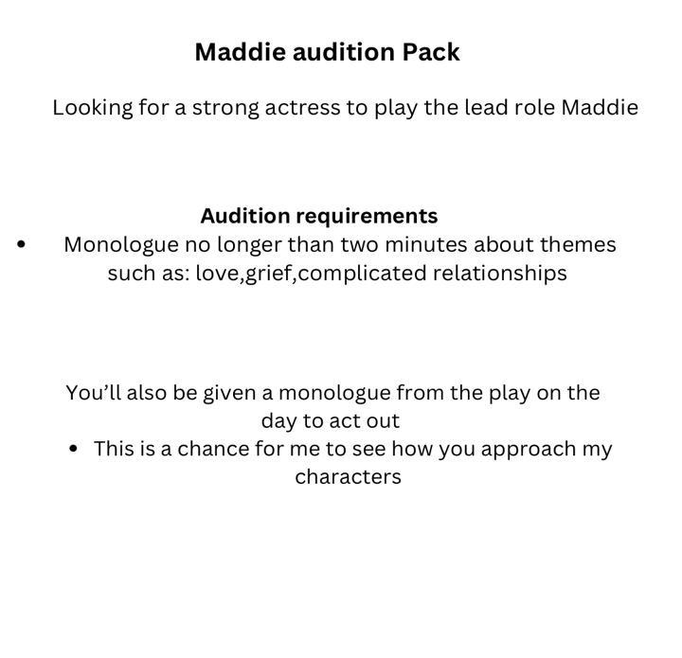
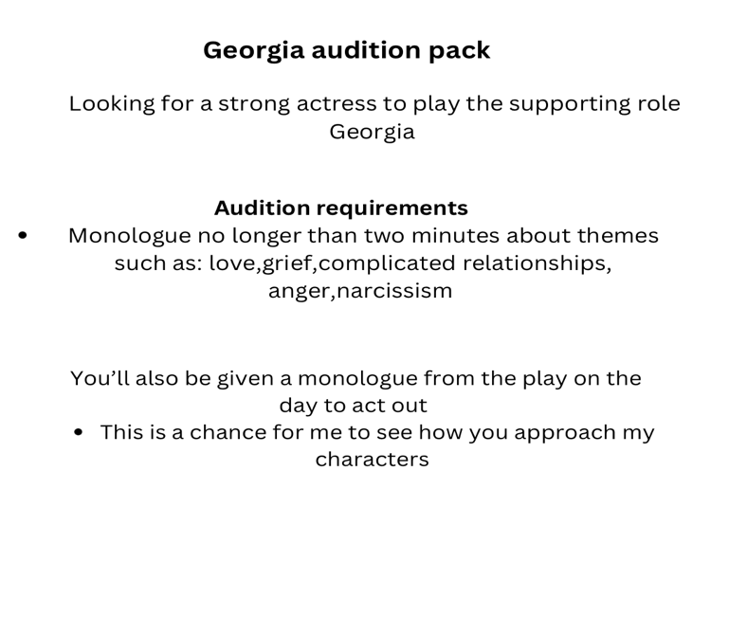
showed interest:

Unfortunately, due to lack of interest I wasn’t able to hold auditions. Instead, I asked the

people who were keen, to be apart of it as I was grateful too have anyone who wanted to be

involved within my play. My cast consisted of two people Billie Basson who will be playing

Maddie and Evangelia Dimitriou who will be playing Georgia.

Rehearsal process

I started rehearsals week commencing the 13th of May, I originally had planned on starting

rehearsals a lot earlier but due to commitments within my cast and lack of communication I

wasn’t able to see them until that week. I created a timetable for my cast with dates, times

and what would take place during each slot. I also find it beneficial to create timetables for

myself to keep on track, organised and be able to use all my rehearsals time efficiently.
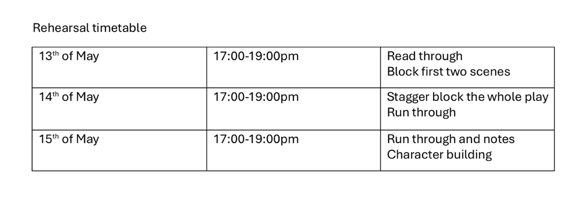
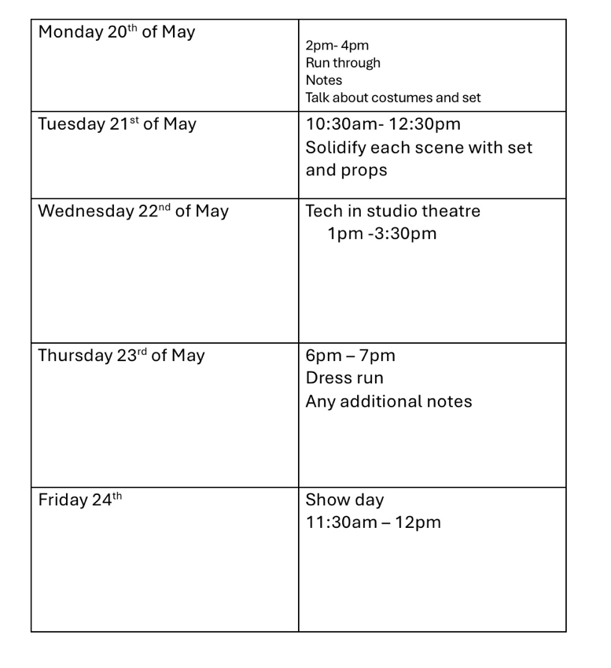

During the first rehearsal, we did a read through of the script so that Billie and Eva could get

a further understanding of the play and the route I’ve taken with it. Throughout the first read

through, Billie and Eva were already putting their own spin and acting choices within which

was great to see. Already I was thrilled to work with the both of them and to build and

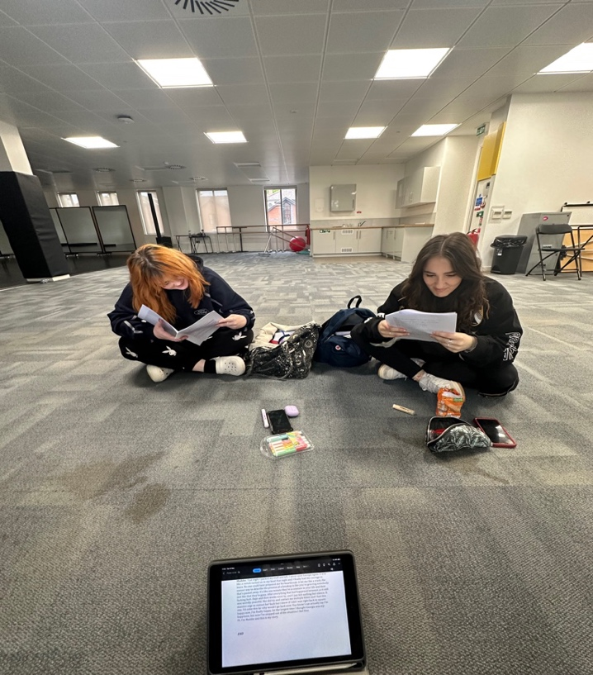
develop characters.

I was thoroughly pleased that both of them are strong actresses and they also

expressed how they enjoyed my piece and were excited to develop it. We also blocked the

first two scenes roughly. I decided that I wanted my set very minimalistic due to the nature

of my play being very extreme, I felt as though a minimal canvas would be a lot more

effective, as I felt it wouldn’t distract the audience from the movement of the story.

In the second rehearsal, we stagger blocked each scene and I made any stage direction

notes. As a whole, the blocking was fairly simple because the acting and nature of the play

is naturalistic. I also allowed both Billie and Eva to play around with blocking in scenes and

let them decide what felt best within the moment. I wanted to allow them to have this

freedom to make decisions as actors because I want my play to look as real and genuine

as possible.

In the third rehearsal, we polished each scene and did a run through. As well as this, I

worked thoroughly on character creation and development with both Billie and Eva, building

characters were vital for me as a director as I wanted them both to display a clear

progression within their characters as well as delving into every emotion.
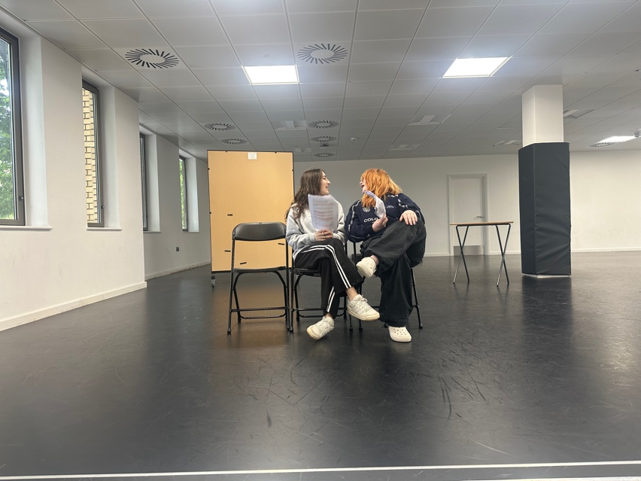

I worked continuously with Billie on “emotional memory” a technique created by Stanislavski

where an “the actor thinks back to a time when they felt the same, or a similar emotion to

their character. They remember how it felt and how that impacted on the way that they

behaved so that they could perform their character in a more believable and truthful way”

(Turton, UK, no date). Due to Maddie having various monologues throughout I wanted

Billie to delve into this technique to see every raw emotion her character is going through. I

also worked with Billie on the use of imagery, by creating images in her head, naturally pure

emotions came out due to her visually seeing what she was expressing. I found that both

these techniques worked well with Billie to amplify her character, Maddie.

During the second week of rehearsals, we developed and built characters further as well

doing many run throughs to cement every detail.

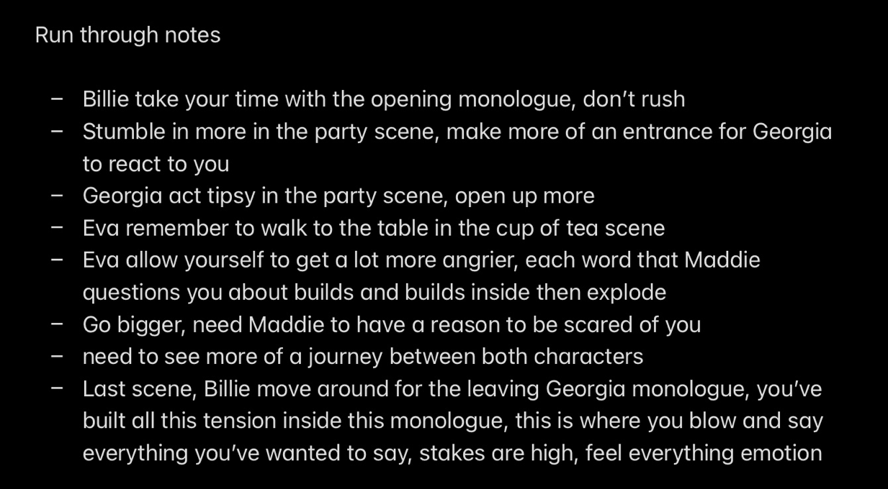
During run throughs I made notes:

My major concern initially within the run was that Eva wasn’t getting angry enough during

intense scenes which meant that they got lost and also had a knock-on effect on Billie. Due

to this, like Billie I had Eva use “emotional memory” to activate the emotions that Georgia

felt whilst talking to Maddie. By using this technique with Eva, it could definitely see a shift

within the scenes as they came cross more genuine and intense.

Costume

For costume, I decided on basic day to day clothing, due to the fact that the play is based on

real events I wanted the costume to look as normal as possible to reflect on the

performance. Not only that I didn’t want the costume to be bright and bold to take away the

intensity of the performance.

I created mood boards of costume inspiration for both characters to get a visual idea of what

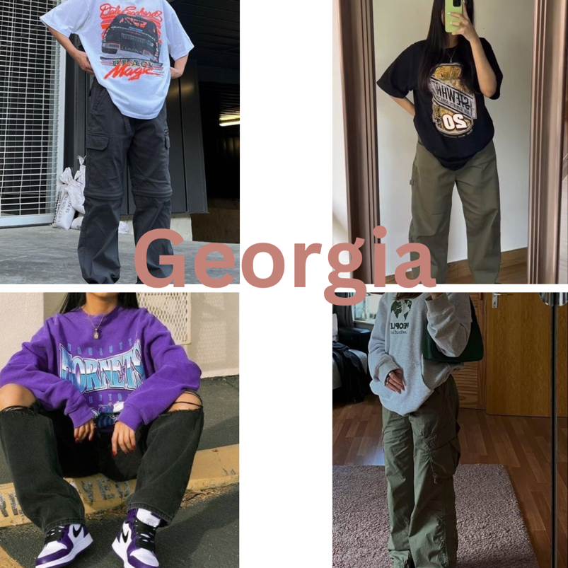
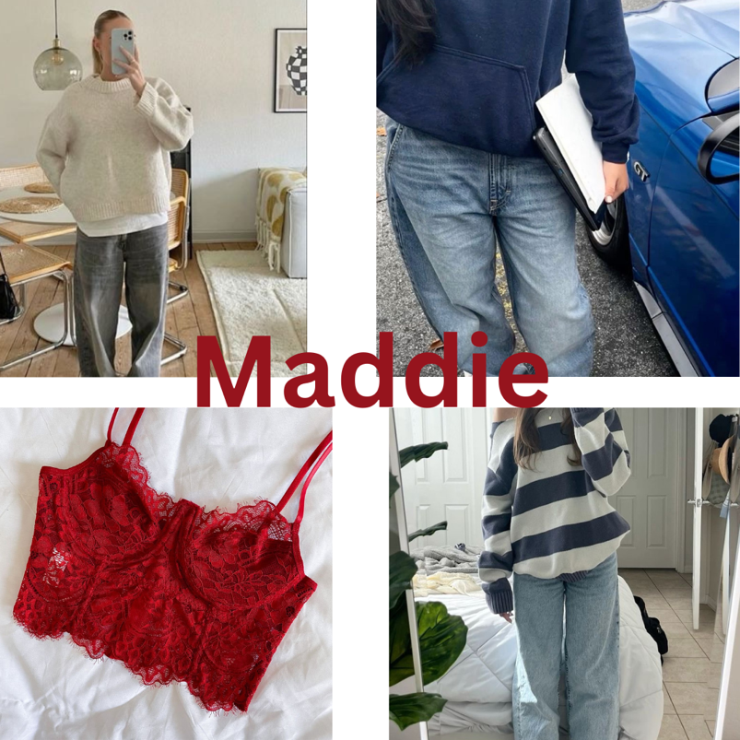
I was looking for and as well to propose my idea to my cast.

(Pictures from Pinterest)

For Maddie’s costume, I went for baggy jeans and a jumper. Underneath her jumper would

be a red corset top because Billie has a quick change into the scene of her going out with

her friends. I wanted a top that was slightly revealing to allow Georgia to react and kick off

about the situation. I felt that the colour red stuck out for me because it’s bold and suited the

intensity of the scene perfectly.

For Georgia’s costume, I went for cargos and an oversized top, likewise to Maddie’s

costume I wanted something basic and nothing drastic that would stand out. I feel like these

costume choices are perfect for the realm of my play. Luckily both of my cast members had

stuff similar already at home which meant I didn’t need to buy anything for either of them as

they provided their costumes themselves.

Set design and props

When deciding on set, I choose to keep a minimalistic canvas as I felt that the set didn’t

need to amplify the play due to nature of the show already doing that anyway. I decided on

three chairs at the front as they represent Maddie’s chair in therapy but also are used in

duologue scenes as a sofa. A table for props, but also to make the space look homely when

they’re having discussions within the living room. I also had a mirror too for when Maddie is

looking at herself in her going out outfit.

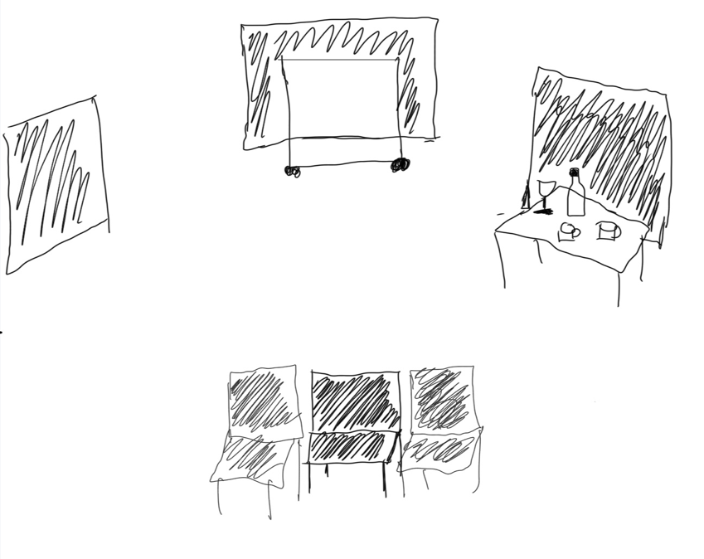
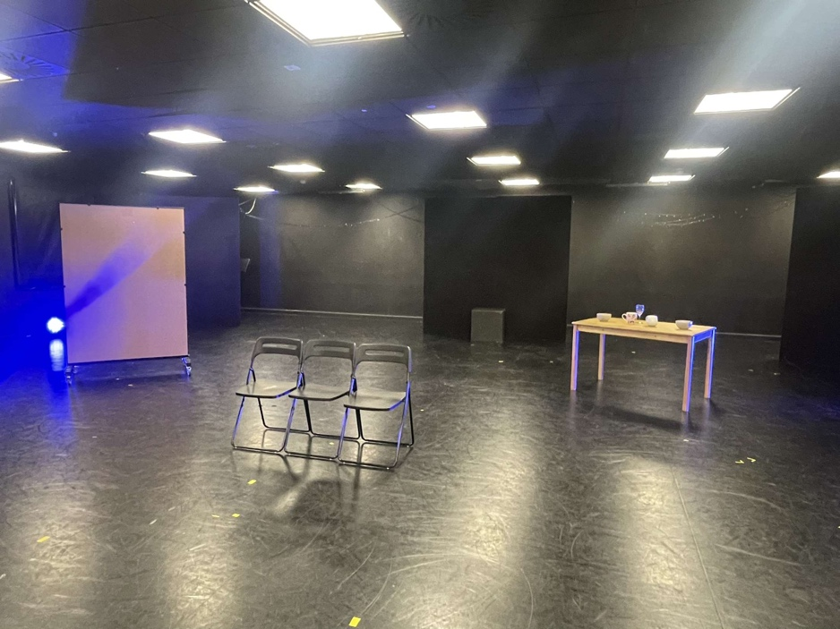

I also choose minimal props as I felt the show didn’t need much, I only used a few props to

bring scenes to life and create a more realistic scene:

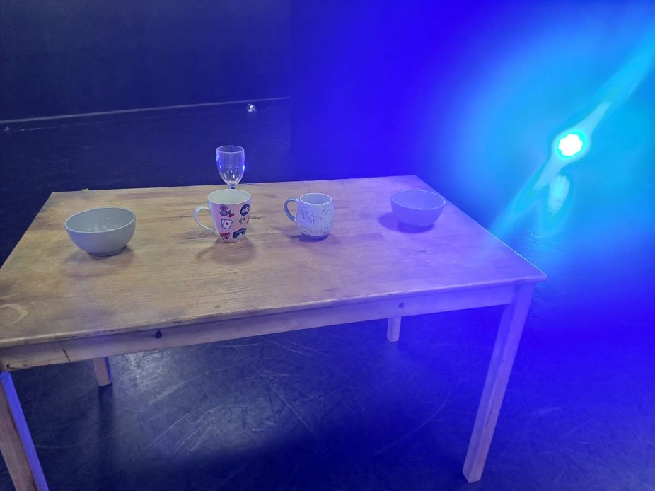
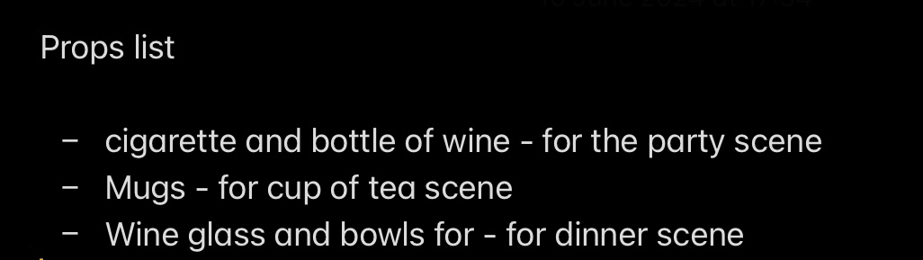

Tech week

During tech, I consulted with Nick on what lighting I wanted. For each therapy scene I went

for a spotlight, this helped to intensify the scene and have the audience’s attention solely on

Maddie. I also discussed how I wanted a blackout after each scene to demonstrate new

thoughts in Maddie’s head and also because I liked the idea of a blackout to keep the

audience’s focus due to the unknown of what’s happening next. The only scene where I

decided on a pop of colour was the party scene where both characters first meet, I decided

on purple because I felt it fitted nicely with what’s happening throughout the scene. For the

duologue scenes I went for warm lighting but eventually turning cooler. I liked the idea of

this because it foreshadowed Georgia changing and the relationship turning cold. I wanted

warm lighting to express happiness and love and the cooler lighting demonstrating the

relationship evolving negatively.
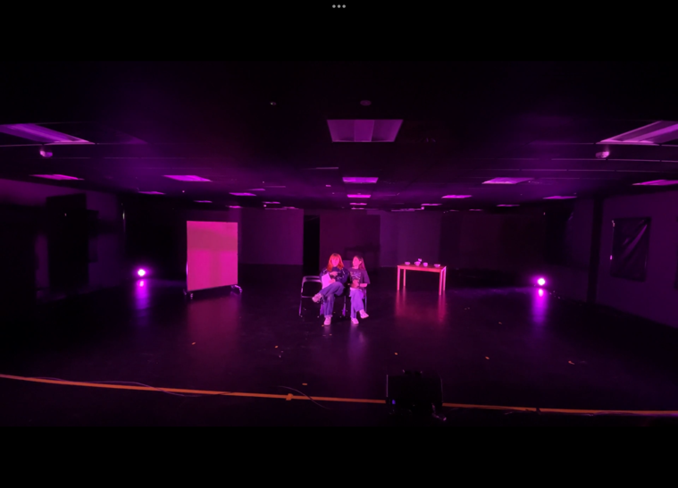
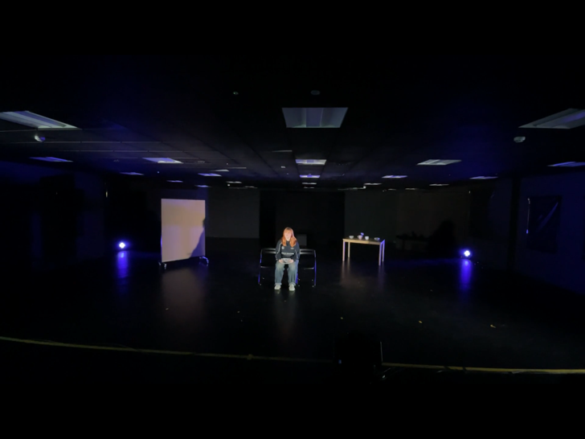
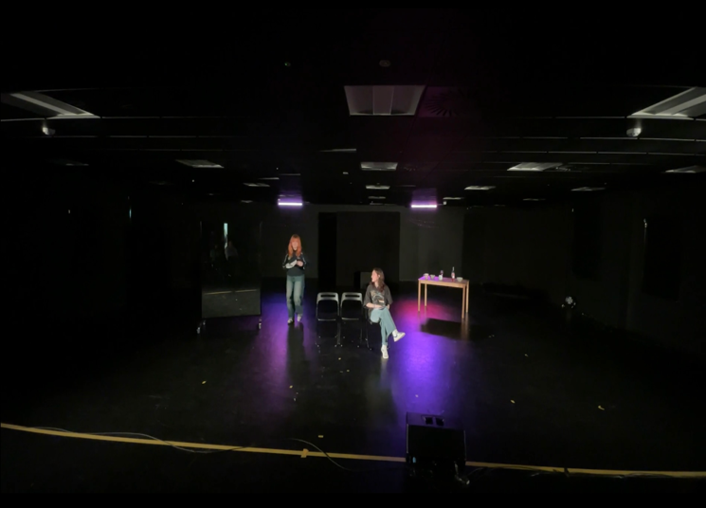
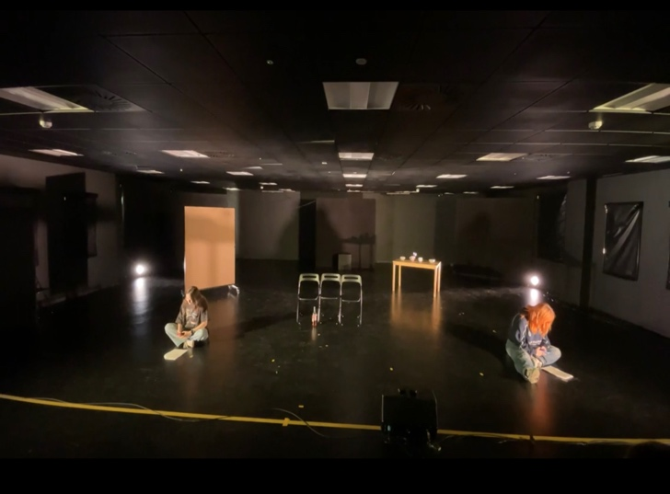
Tech went very smoothly, the only major thing I had to change was in the dinner scene was

moving the table. Due to props being on top of it and also because of a blackout it took Billie

and Eva a while to move the table to the front and to me watching it it felt awkward waiting. I

changed the blocking of the scene and got them to leave the table in its original space

and do the scene around the table upstage right and move to the chairs at the front. The

table moving was unnecessary and wasn’t essential for it to be at the front because the

scene was still executed fine without it.

On my tech team I had Elise who did my lighting and Niamh who did my sound. The only

hurdle we faced during tech was getting the timing perfect for the lighting and sound. We

ran the show a few times to allow both of them to get used to where everything slots and

eventually they both managed to do everything on time.

During the dress run, I thoroughly watched and made notes throughout:

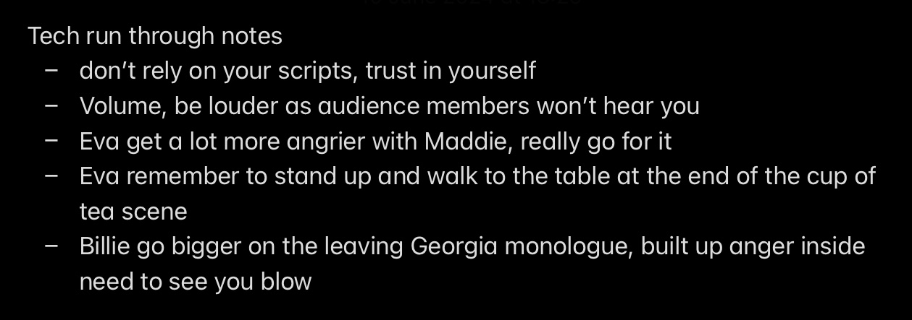

Performance

As a whole, I was thoroughly pleased with how the performance turned out. Billie excelled at

character progression throughout and her performance executed realism and whilst

watching I felt a genuine connection from her. She delivered each monologue with new

thoughts and emotions, and I felt all the character work we did within rehearsals really came

through on the show day. Eva also delivered a great performance and took on board each

note I gave her. Both of them really bounced off each other and I felt as though I wasn’t

watching actors doing my play but watching a real authentic story unfold which was

something I really wanted my piece to translate which I believe they demonstrated at a high

scale. If I were to do the show again the only major change, I would have liked to see is Eva

going even further with Georgia by getting a lot angrier and more frustrated at Maddie.

Overall, I’m very pleased with how my play went and very grateful for my cast for their

performance.

Bibliography

Hayes, R., 2023. Narcissistic Abuse Recovery: How to Spot, Overcome, and Heal From Manipulation, Gaslighting, and Codependency.

Timoney, B. (2023) Stanislavski and emotional memory - what can you learn?, Brian Timoney Acting. Available at: https://www.briantimoneyacting.co.uk/stanislavski-emotional-memory/#:~:text=This%20is%20the%20Stanislavsky%20system,rather%20than%20simply%20reciting%20it. (Accessed: 31 May 2024).
(No date) Stanislavski. Available at: https://www.turton.uk.com/wp-content/uploads/sites/2/2020/02/Drama-Theme-3-Stanislavski.pdf (Accessed: 05 June 2024).
Ltd, B.C.U. (no date) Bertolt Brecht: Techniques and facts |, Dramaclasses.biz - Drama School Directory. Available at: https://www.dramaclasses.biz/bertolt-brecht-techniques-and-factsbertolt-brecht-techniques-and-facts#:~:text=This%20is%20where%20the%20wall,question%20%2D%20breaking%20the%20fourth%20wall. (Accessed: 31 May 2024).
Miriam Battye’s writing exercise (2021) Royal Court. Available at: https://royalcourttheatre.com/playwriting/writing-exercises/miriam-battyes-writing-exercise/ (Accessed: 31 May 2024).
Hawkins, D., 2017. When Loving Him is Hurting You: Hope and Help for Women Dealing With Narcissism and Emotional Abuse.

Harrison, J. and Dixon, M., 2019. Narcissist abuse recovery: The ultimate guide for how to understand, cope, and move on from narcissism in toxic relationships.

Wakefield, M. (2023) The long-term consequences of narcissistic abuse, Narcissistic Abuse Rehab. Available at: https://www.narcissisticabuserehab.com/the-long-term-consequences-of-narcissistic-abuse/ (Accessed: 10 June 2024).
By et al. (2024) Narcissistic relationships: Signs, impact, and how to Cope, Simply Psychology. Available at: https://www.simplypsychology.org/narcissistic-relationships-signs-impact-and-how-to-cope.html#:~:text=However%2C%20as%20the%20relationship%20progresses,to%20prompt%20such%20a%20change. (Accessed: 10 June 2024).
Lundberg, A. (2024) The long-term effects of narcissistic abuse, Charlie Health. Available at: https://www.charliehealth.com/post/the-long-term-effects-of-narcissistic-abuse (Accessed: 10 June 2024).

