Part 1

Activity Plan
Activity: Chinese New Year Small World on the Tuff Tray®

Number of children: 4-6 | Age of children: 3-4 years | Number of adults: 1
Location: On a rug in the middle of the hall | Preparation time: 5 mins | Activity time: Free play
Resources:
Tuff Tray®, artificial grass, laminated cards with ordinal numbers and animals from the Chinese zodiac, variety of bridges, coloured wooden people (variety of colours, including shades of red, blue and green), several animals matching the ones on the laminated cards, wooden rainbows, wooden spoons decorated with the animals, foliage, trees, plants, numbered path made out of wooden disks.

Aim/s of activity:
To support the development of number recognition, counting and colours. Explore and investigate. Develop problem solving skills. Develop knowledge and understanding. Support, encourage and promote cultural diversity. Provide sensory experiences. Develop fine motor skills.

Links to outcomes:

- Count reliably up to 5 objects
- Recognise numbers 1-5 and relate a number, 1-5 to its respective quantity
- Understand and use the concept of one more
- Compare and order numbers to at least 5
- Demonstrate an understanding of one to one correspondence by matching pairs of objects or pictures
- Use the terms first, second, third, last and so on, in daily activities and play

Welsh Government (2015)

Differentiation:
For those children who are demonstrating good understanding,
- introduce numbers from 5-10
- introduce the ordinals
- introduce prepositions
- introduce more difficult colours, turquoise, navy etc

For those children who are demonstrating poor understanding,
- concentrate and consolidate numbers 1-3
- concentrate and consolidate one or two colours

Health and safety:

Carry out a risk assessment of the materials involved.

Role of adult/adults:

To support and encourage play. Modelling a variety of mathematical language, taking turns and sharing. Discussing the different animals. Supporting the children to count. Discuss colour. Introduce prepositions such as, on, under, behind, in front. Discuss ordinals, 1st, 2nd 3rd and so on. Ask open ended questions.

The activity:
The activity is a Chinese New Year small world scenario set out on a Tuff Tray®. There is a grass base on the bottom of the Tuff Tray®. On the grass, all of the resources are set out in an attractive and inviting way. The children can use the laminated sheets with the ordinal number and the animals to count. They can just count the animals or count the people. There are opportunities for sorting, matching, counting, one more/one less. There are also opportunities to discuss the animals and their habitats. There are also lots of opportunities to discuss prepositions, such as ‘the monkey is on the house’ or ‘the dog is going over the bridge’.

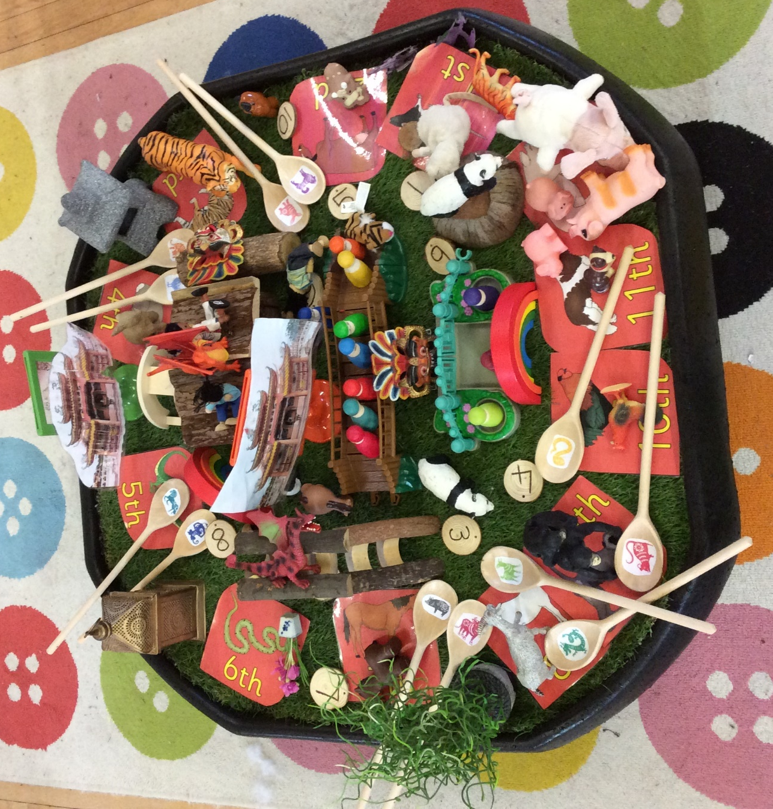

Part 2
Evaluation
The main aims of the activity were to develop and promote number and colour recognition. Overall, as the result of a well thought out, attractively presented activity, this was achieved. Practitioners have a duty to present activities in a way that is inviting and piques the curiosity of a child. For children to discover, develop, learn and direct their own learning, an environment needs to be creative, (Rees, 2016). This is supported by Zajac (2016) who states that Maria Montessori believed that making activities attractive and incorporating enticing resources it will stimulate the senses and promote development.
The activity allowed children to develop many mathematical skills and concepts. The two main concepts that form the focus of this activity were colour and number. Some of the skills being developed within this activity were colour recognition, number recognition, counting, one more/less, matching objects, problem solving, comparing and ordering numbers and use of ordinal terms (Welsh Government, 2015, p.31). Children should be given opportunities to investigate and explore mathematical concepts in a mathematically rich environment (Welsh Government, 2015, p.28).
When planning the activity, it was intended that there would be a great deal of adult involvement. However, when the activity took place, it became clear that the children were able to learn more independently than anticipated, happily allowing play to occur naturally. The small group of 4-6 children increased in number over time and the social interactions between the children were positive, allowing them to take turns and share. Vygotsky (1978) stated that a child’s development and learning is supported by the social interactions they experience (Tucker, 2014). This was an idea that Bruner shared, stating that play provides children with opportunities to learn about friendships, rules and taking turns (Tucker, 2014). If this activity was to be repeated, it would be worthwhile allowing more children to take part as there would be further opportunities for peer learning.
The activity provided a practical opportunity to interact with the resources available. Piaget (1926) and Bruner (1983) both believed that practical activities are a point from which learning could begin (Taylor, 2014, p. 6).
There was ample opportunity for children to explore and experiment with the resources in a way that was natural and instinctive to them. The children were able to pick up the animals or wooden dolls and use the laminated sheets for matching or to walk along the numbered wooden path. Many of the resources are of a tactile nature, which allows children to really use their senses. Maria Montessori’s approach to learning has allowed us to understand the importance of learning using the senses. Montessori (2010) states that developing the senses was a pre cursor to intellectual learning.
The activity contained many resources that were small in size, this promoted the development of fine motor skills. Fine motor skills play an important role in learning in the early years. Pitchford et al. (2016) believe that fine motor skills can underpin mathematical concepts, providing children with opportunities for visual representation. For children to develop mathematical minds and understand mathematical skills and concepts, they must develop fine motor skills to interact with and explore their physical surroundings (Newcombe and Frick, 2010, p.104).
This activity supported children’s physical development; it was set out on a Tuff Tray® on a rug on the floor, giving children the option to stand, bend, sit or even lie on the floor to take part, allowing them to feel physically free. A sense of well-being can be developed as a result of presenting mathematics in a way in which doesn’t restrict individuals physically (Pound and Lee, 2015). Stevens-Smith (2016) support this further by discussing the importance of practitioners understanding the holistic benefits that physical literacy can have on children.
The activity was versatile, and although it was undertaken inside the setting, it could quite easily have been taken outside. This would allow for further areas of learning to be developed. The outside environment not only has a beneficial and positive effect on a child’s well-being, but also offers alternative ways of doing things (Rodger, 2016). A risk assessment had been undertaken before the activity became available to the children, to ensure the children’s safety. However, if the activity was to be taken outside, the risk assessment would have to be amended to reflect the different risks such as the weather. Constable (2014) believes that new activities should be well prepared and risk assessed.
The role of the adult was to be involved in the children’s play, asking open ended questions to further the children’s knowledge and understanding. Stevens (2008) talks about the importance of open-ended questions, and how children are more likely to respond to open questions. Stevens goes on to talk about how closed questions can be a cause of anxiety because children often get a sense that there is a wrong or right answer which will put them off answering. Gifford argues this by stating that the use of statements as opposed to questions can provoke more discussion than questioning, and that humour should be used with younger children (2015, cited in Pound, 2006, p. 133).
Using mathematical language in a way that children can understand is a vital role of the adult in this activity, the resources available made this possible. Skinner (2005) reinforces the importance of the practitioner enhancing a child’s mathematical vocabulary by repeating key words, encouraging the use of new words and asking children to describe what they see, think or hear.
As the children found this activity so engaging, it was an excellent opportunity for the practitioner to make observations, to measure the children’s learning and how it needed to develop to further their skills and thinking. It is Vygotsky’s (1977) ‘Zone of Proximal Development’ (ZPD) theory that has led to practitioners making these constructive and beneficial observations (Smidt, 2015). Vygotsky stated that the ZPD was the gap between what a child already knows and the potential knowledge of the child, (Smidt, 2015).
During the activity the practitioner was able to scaffold the child’s learning, directing the play. This is a concept that Bruner developed as a result of Vygotky’s (1977) work on ZPD, (Smidt, 2015). When a child picked up the panda, and said “I’ve never seen a panda”, the practitioner was able to engage the child in a conversation about a panda’s natural habitat, climate, environment, nutrition etc, this allowed the child to extend their knowledge on the subject. Muhonen et al. support this by discussing the importance of both adult initiated discussions, using open questions with a clear learning objective in mind, and child-initiated discussions, using active listening and ensuring learning and understanding, both underpins the child’s learning (Muhonen et al. 2016, p. 153).
As the activity progressed the children became more and more involved, and the interactions between them were animated and meaningful. Vygotsky’s (1978) theory of ZPD led on to his theory on the “more knowledgeable other”. He firmly believed that children could learn more and develop ideas from more knowledgeable others around them. Vygotsky believed that there was potential for each child based on this idea (Abtahi, Graven and Lerman, 2017, p. 276). Bruner (1991) also believed that play allows children to learn about rules, turn taking through socialising with their peers (Tucker, 2014).
One of the strengths of this activity was that it provided enough stimulus of different types to maintain the groups interest for a long period of time. To achieve maximum engagement and exploration, activities should be presented creatively (Lamberty, 2007, p.16). Another sign that the activity was successful was that, more and more children wanted to participate.
The activity provided good opportunities for differentiation. Differentiation is important as mathematical development is individual to each child, therefore all children will have varying levels of mathematical literacy (Chigeza and Sorin, 2016, p.68). There were opportunities to explore ‘pre-number’ skills as well as the more concrete concept of counting. Piaget (1958) believed that mathematical development had a hierarchical scheme, stating the importance of these ‘pre-number’ skills, such as sorting and matching before progressing to manipulating numbers (Tucker, 2014).
Although this activity was predominantly a mathematical activity, when planning, the aim was for it to be holistic; supporting all areas of learning. The activity incorporated other areas of learning such as knowledge and understanding, personal and social, cultural diversity and language and literacy. Moyles (2013) states that in providing children with a safe and secure environment for exploring and investigating a child’s holistic development is supported.
Additional needs were considered during planning. There were no children with any physical disabilities, however there was one child with Autistic Spectrum Disorder in the group. The activity provided opportunities for tactile stimulation, which was something this child particularly enjoys. Wood (2013) states that some children with additional needs have difficulties in social interaction and imagination, therefore, more structured focused tasks may be preferable. However, Moor (2008) states that less structured activities can be beneficial if presented in a way that clearly gives choices. The activity was able to do this by using the laminated sheets to choose which animals the child wanted to explore.

Part 3
Resources
The range and diversity of resources on offer in a setting must allow children to explore and investigate in a meaningful way. Stevens (2008) states that children need the appropriate props to encourage them to use more mathematics in their play. Children should have access to resources that can inspire and motivate learning, making resources theme related can support this (Tucker, 2014).
All resources should be accessible, presented clearly and in a way that promotes independence. Resources should be easily identifiable and transportable (Stevens 2008, Wood, 2013). If children are unable to access or reach resources, then learning cannot begin. Rees (2016) supports this by adding that resources should be open ended so that they can be used, moved, combined in any way, and in any area of the setting.
It is important not to rely solely on the concrete resources. Haylock and Cockburn (2013) state that there are 4 key components in mathematical experiences, these being; concrete materials, symbols, language and pictures. It is concrete materials that help underpin abstract ideas and thinking, whether this is large or small play pieces, indoors or outdoors, (McGrath, 2010). The use of symbols provides opportunities such as mark making, sequencing, arranging, copying and splitting numbers. The use of mathematical language allows for opportunities such as reading instruction, processing instructions and interpreting problems. The use of pictures allows for opportunities to use number lines, arrow pictures and graphs (Haylock and Cockburn, 2013).
Providing children with varied and diverse resources is equally important to stimulate children’s thinking. McGrath (2010) believes that giving children access to loose play pieces and fixed structured pieces provides a diverse learning experience.
The outside environment is an excellent source of resources. Exterior resources are natural and plentiful and have many benefits. Providing children with access to the resources of the natural world allows them to become familiar with living and non-living things (Ashbrook, 2017, p. 18). Children can use items such as acorns, pinecones, twigs, grass and stones to underpin many different mathematical concepts, such as classification, ordering, counting and sizing. Resources should allow children to use all their senses to set their own challenges to learn and discover, (Rees, 2016).
Maths should be incorporated into every area of the setting, immersing children in a world of numbers, allowing them to apply their knowledge to a range of situations, both real world and imaginary. Children should be able to “practice, develop and refine their mathematical skills within all aspects of the provision, including continuous provision and through all areas of learning” (Welsh Government, 2015, p.13).
If children are allowed free access to varied and diverse resources, it allows them to develop as independent thinkers. Rees (2016) believes that providing free access to open ended resources will encourage children to set their own challenges, problem solve and find alternative ways to do things. All children should have equal access to all resources, including any children with additional needs. All children have a right to play, therefore the responsibility lies with practitioners to provide equal opportunities (Wood, 2013). Tucker (2014) supports this further by stating that if children can have access to all resources on offer, including space, time and practitioner’s attention, they will feel included.
By introducing mathematics in play, it will encourage children to follow their own ideas, think creatively and be flexible, whilst developing physically, emotionally and cognitively, all vital for brain development, (Rees, 2016).
Quality of resources is also an important point to consider in the early years setting. McGrath (2010) believes that it is good practice to rid the setting of any poor quality, damaged, or incomplete resources, such as jigsaws with pieces missing. Children should always be allowed to complete an activity, to experience the feeling of satisfaction on completion contributes to a child’s well-being. In order for children to develop successfully in mathematics they must be allowed to develop positive attitudes towards mathematics (Taylor, 2014, p. 17). It is the quality of the materials that contribute to a rich, play based environment, (McGrath, 2010).
Real world, realistic materials and resources are thought to be much more beneficial for children, than plastic, mass manufactured, unrealistic versions. Role play areas are an excellent way to introduce realistic resources, such as real hairdryers or hair straighteners (wires cut off) in the hairdressers, or real telephones (wires cut off) and clocks in the police station. McGrath (2010) believes that equipment and props should represent those that are used by adults in the real world. All settings should be rich in mathematical resources so that children can develop the ability to problem solve in a way that makes sense to them. Providing high quality, realistic props will support children to learn mathematical concepts and skills. By making resources, materials and props realistic, it allows children to associate mathematics to the real world.

Part 4
Role of the adult
Children’s development in mathematics needs to be monitored and assessed so that effective planning can be put in place. It is the practitioner’s responsibility to ensure effective planning takes place. Williams (2006) believes that effective planning will result in good quality mathematical learning. When engaging in an activity, children will already have some knowledge. Pound (2006) states that the learning requirements of the child need to be at the centre of all planning, awareness of individual needs will allow for effective learning.
Assessing children is vital to be able to plan effectively and to know what stage each individual has attained. Through assessment, practitioners can identify next steps for each child, set targets, address difficulties and report on a child’s learning and development (Taylor and Vincent, 2014). Smidt (2015) adds to this by stating that it is the role of the practitioner to ensure that children in our care are making progress, enabling them to become more independent learners. Formal assessment in England and Wales has been largely influenced by the New Zealand, Te Whariki approach, (Rodger, 2016). Learning stories/journals were developed by the Te Whariki early education curriculum in New Zealand in 2001 and these have been adopted by settings in the England and Wales. These learning journals are an excellent way to work in partnership with families, involving all adults in connection with the child to contribute to this assessment method (Rodger, 2016).
Observing children is the process that can allow for assessing children’s learning and development. It is important to observe children so that practitioners can provide activities that will extend their learning. Vygotsky believed that teachers often taught children things they already knew, as a result he theorised the Zone of Proximal Development (ZPD). This is the gap between what a child can do, and what a child can do with support (Smidt, 2015).
Individuals involved with a child’s mathematical learning can include parents, family, key workers, class teachers and specialist teachers. All of individuals should take an active role in promoting and supporting the mathematical development of the child. In order to enhance mathematical learning, adults should ensure they have the time to observe and support children (Pound, 2008)
It is important that the adults involved in teaching mathematics to children are not held back by their own lack of confidence or ability in the subject. There has been a lot of publicity in recent years about the competency of practitioners to teach mathematics. Pound (2008) states that parents and practitioners avoid exploring mathematics with children because of a lack of confidence. Pound continues, by adding that adults may sub consciously communicate their own fear of mathematics to children, therefore influencing the confidence of children. Practitioners should therefore take steps to improve their knowledge and confidence by attending training sessions or reading, but most importantly, by playing with and engaging in mathematic activities with children (Pound, 2008).
Partnership with parents is important if a child is to become successful in mathematics. Parents and guardians are usually a child’s first educator, so working together can only improve a child’s outcomes. Wood (2013) states that parent’s participation should be encouraged, building a good relationship will allow for 2-way communication.
Giving children the opportunity to revisit activities and resources over a period of time and allowing them to encounter them in a different way, allows for consolidation. Bruner (1991) believed that a ‘spiral curriculum’ was beneficial to children (Tucker, 2014). This involves giving children the opportunity to revisit activities and resources over a period of time and allowing them to encounter them in a different way, allows for consolidation. This is why enhancing provision on a regular basis is important.
The Welsh Government has developed a set of requirements for assessment as part of the Early Years Development and Assessment Framework (EYDAF), which supports assessments throughout the Foundation Phase, (Welsh Government, 2017). The introduction of the Foundation Phase Profile, in 2017 supports practitioners use of observations and formative assessments to be able to provide a holistic curriculum for all. The Foundation Phase Profile includes the Literacy and Numeracy Framework skills, (Welsh Government, 2017). The aim of this profile is to provide a nationally consistent approach.

Reference List
Abtahi, Y., Graven, M. and Lerman, S. (2017) ‘conceptualising the more knowledgeable other within a multi-directional ZPD’, Eduacational Studies in Mathematics, 96 (3), pp. 275-287. Accessed: 11th February 2019. DOI: 10.1007/s10649-017-9768-1
Ashbrook, P. (2017) ‘Taking Math Outside’, Science and Children, 54 (9), pp 18-19.
Chigeza, P. and Sorin, R. (2016) ‘Kindergarten children demonstrating numeracy concepts through drawings and explanations: international teaching within play- based learning’, Australian Journal of Teacher Education, 41 (5), pp 65-77.
Constable, K. (2014) The Outdoor Classroom in practice, age 3-7. Abingdon: Routledge.
Haylock, D. and Cockburn, A. (2013) Understanding Mathematics for Young Children. 4th Ed. London: Sage Publications Ltd.
Lamberty, K.K. (2007) Getting and keeping children engaged with a constructionist design tool for craft and math. Available at: https://smartech.gatech.edu/bitstream/handle/1853/14589/lamberty_kristin_k_200705_phd.pdf?sequence=1&isAllowed=y (Accessed: 20th February 2019).
McGrath, C. (2010) Supporting Early Mathematical Development. Abingdon: Routledge.
Montessori, M. (2010) The Montessori Method. New York: Knopf Doubleday Publishing Group.
Moor, J. (2008) Playing, laughing and learning with children on the autism spectrum. 2nd ed. London: Jessica Kingsley Publishers.
Moyles, J. (2013) Play and Early Years: Birth to Seven Years. Available at: http://www.playwales.org.uk/login/uploaded/documents/INFORMATION%20SHEETS/play%20and%20early%20years.pdf (Accessed: 17th Feb 2019)
Muhonen, H. et al. (2016) ‘Scaffolding through dialogic teaching in early school classrooms’, Teaching and Teacher Education. 55, pp. 143-154. (Accessed: 17th February, 2019). Available at: https://jyx.jyu.fi/bitstream/handle/123456789/48396/scaffolding%20through%20dialogic%20teachingmuhonen.pdf?sequence=1&isAllowed=y
Newcombe, N.S., and Frick, A. (2010) ‘Early Education for Spacial Intelligence: Why, What, and How’, Mind, Brain and Education, 4 (3), pp 102-111. Doi: 10.1111/j.1751-2288X.
Pitchford, N., Papini, C., Outhwaite, L. and Gulliford, A. (2016) ‘Fine motor skills predict maths ability better than they predict reading ability in the Early primary school years’ Frontiers in Psychology. Vol 7, pp 783.
Pound, L. (2006) Supporting Mathematical Development in the Early Years. 2nd Ed. Berkshire: Open University Press.
Pound, L. (2008) Thinking and Learning about Mathematics in the early years. Abingdon: Routledge.
Pound, L. and Lee, T. (2015) Teaching Mathematics Creatively. 2nd Ed. Abingdon: Routledge.
Rees, J. (2016) Inspiring ideas to support early maths and literacy. Abingdon: Routledge.
Rodger, R. (2016) Planning an Appropriate Curriculum in the Early years. 4th Ed. Abingdon: Routledge.
Skinner, C. (2005) Maths Outdoors. London: Beam Education.
Smidt, S. (2015) Observing Young Children. 2nd Ed. Abingdon: Routledge.
Stevens- Smith, D. (2016) ‘Physical Literacy: Getting Kids active for Life’, Strategies, 29 (5), pp.3-9. Accessed: 19th February 2019. https://search-proquest-com.ezproxy.uwtsd.ac.uk/docview/1819120592?accountid=130472&rfr_id=info%3Axri%2Fsid%3Aprimo
Stevens, J. (2008) Maths in Stories. London: Beam Education.
Taylor, H. (2014) ‘How children learn mathematics and the implications for teaching’, in Taylor, H. and Harris, A. (ed.) Learning and Teaching mathematics 0-8. London: Sage Publications Ltd.
Taylor, H. and Vincent, K. (2014) ‘Assessing children’s mathematics’, in Taylor, H. and Harris, A. (ed.) Learning and Teaching Mathematics 0-8. London: Sage Publications Ltd.
Tucker, K. (2014) Mathematics through play in the Early Years. 3rd Ed. London: Sage Publications Ltd.
Welsh Assembly Government. (2015) Foundation Phase Curriculum. Cardiff: Welsh Assembly Government.
Welsh Assembly Government. (2017) Foundation Phase Profile Handbook. Cardiff: Welsh Assembly Government.
Williams, H. (2006) Let’s pretend maths. London: Beam Education.
Wood, E. (2013) Play, Learning and the Early Childhood Curriculum. London: Sage Publications Ltd.
Zajac, A. (2016) Sensory education in the Montessori Classroom. Available at: https://www.montessori.school.nz/blog-capital-montessori-parenting-early-childhood-education/2016/10/27/learning-with-the-senses (Accessed: 11th February 2019).

