Student Number:2317365
BA course: Design Crafts
Word count: 2,374
Lecture: Julia Lockhart

Question 3: How useful are Manifestos to designers and/or design groups? Outline your discussion with reference to three key manifestos. Through careful critique, conclude your text by defining your own design values in a 10-point manifesto

List of illustrations

Figure 1: Rams, D. (1970) Ten principles of good design. Available at:Ten Principles for Good Design — R / D( Accessed: 2nd December 2024).

Figure 2: MacPherson, A. (2014) Red Alans Manefesto. Available at:T (Red Alan's Manifesto | Royal Academy of Arts ( Accessed: 1^{st: December} 2024).

Figure 3 ,Engestrom, U. (2005) On making and consuming things. Available at:
https://ullamaaria.typepad.com/hobbyprincess/2005/03/draft_craft_man.html ( (Accessed: 2nd December 2024).

Introduction
Within this essay I will be looking and discussing three different manifestos, written by a design, crafter and an artist. I will be analysing the differences and the similarities of these manifestos. During this process I will then begin to curate a ten-point manifesto of my own with the knowledge I have gained. I have looked at a variety of manifestos and have chosen three very different styles. I have included a manifesto from a designer, artist and maker as their approaches are very different and I would describe myself as a hybrid of all three disciplines.
Firstly, I will be analysing Dieter Ram “Ten principles of a good design” Written in 1970, as the design part of this essay. Secondly, is an artist’s manifesto, this manifesto is “Red Alan’s Manifesto” by Grayson Perry compiled on April 30th, 2014. This example of an artist manifesto is seen as a post-modernist view of the art community. Lastly, the final manifesto of this Easy will be a craftsperson's view of a manifesto, this will be by Ulla Engestrom, called “Draft Craft manifesto’ from March 25th, 2005.
I will be also, try to gain an understanding what a manifesto is by breaking it down to understand various ideas, with the intention of compiling a manifesto of my own. From the three examples of design, crafts and artist, I will be also breaking them down to see which one is best for my style of manifesto. This will also help to see which format be better of this easy, for example: A formal or more informative approach. I will start by analysing the term manifesto and understanding the meaning and approaches used by these difference writers.

Manifestos

Manifestos have been the property of and conceived by kings, rulers, thinkers, politicians and radical dissenters to name but a few. They have been a vehicle for an individual or group to express their aims or intentions They may be written in any format but generally are a set of concise ideas that convey a list of intentions or guidelines.

The definition of a manifesto is:” a written statement of the beliefs, aims and policies of an organisation, especially a political party”. (Cambridge dictionary, 2024)”. Some may be Prophetic or futuristic” (Danchev, 2011) whist others are a series of points or guidelines that they wish to follow. Language within the document may be emotive or flamboyant when used to inspire or encourage the viewer's or readers. Phrases may be repeated or symbolic to express the ideology of the manifesto. Many Artists, designers and makers have written manifestos to set out the principles, that they hold or as a type of blueprint/ set of recommendations to aid their own practice. Some artists manifestos are “deadly serious” and some less so, while others are totally outlandish and non- conformist in nature.
Manifestos have been written for a Varity of reasons from encouraging revolution to an art piece in their own right, “There is something of the incorrigible optimist about the manifesto. To make a manifesto is to imagine or hallucinate the promised land” (Danchev, 2011). This will be my intention and included at the end of this Essay.

In this essay will be looking at three different designers/ artists and their manifestos that influence their design principles. From manifestos the reader should be able to see their writers' beliefs and to interprets for other makers and designers. The principles of a useful design of a manifesto may include, according to Dieter Rams in “Ten principles for good design” Good Design is Innovative, this meaning that’s an designer should embrace new technology and methods to help to challenge the maker, for example, using a new way to use 3D processes and using technology to help to make there makers vision come to life. A point that is shared by some or the artist is that is a design should be either practical or aesthetically pleasing.

Manifesto one - Dieter Rams ten principles of good design (1970)
Dieter Rams, ten principles of good design, written in 1970. Is a formal ten-point check list expressing his opinion of a good design. Throughout the manifesto Rams gives of an impression that a good design needs to be in his opinion both aesthetic and it should be practical. This ideology is like that of the artist and craftsman Willam Morries born in 1834 “Have nothing in your house that you do not know to be useful or believe to be beautiful”. ‘Have nothing in your houses that you do not know to be beautiful or believe to be useful’ (Kremer, 2024) This quote links with this manifesto because of the similar ideas they both live by/ write about.

Fig. 1: Ten principles of good design.

The ten principles for good Design have many designers using the manifesto as a reference when they produce their projects, such as Bora. Bora uses the manifesto for ‘practical design knowledge, principles, design thinking frameworks, cognitive biases, and how to use design for good.’ (Bora, 2022) As a designer he breaks down Dieter Rams manifesto and wrote his vison of it, underlining which part of it is important in the 20st century. For point four of the manifestos ‘Good design makes a product understandable’ this meaning that the design should be recognised and self-explanatory. As a designer you should always make sure that the design should be understand by everyone, old or young. Having this as a point makes sure that future designers have an idea what is needed to make the project / product the best it can be. This point leads to the next one and this is point eight good design is thorough down to the last detail. This point is important because the consumer will be buying the project, meaning that the designer must have every detail and function be perfect.
Within the manifesto most of the point link up in one away, and this is the design should be for the consumer and not because the designer wants to, there should be a reason or a problem they want to fix. ‘Designers have an essential social responsibility because design is at the core of the world's largest challenges... and solutions.’ (Berman, David B, 2013) This book underlines the fact the designers are very impotent, and there should be rules for each person. The Ten principles of design are a great way to for the base line for upcoming designers, to understand the benefits of gridlines for consumers and their own morals.

Manifesto two - Grayson Perry / The Red Alan manifesto (April 30th, 2014)
Grayson Perry’s artist’s manifesto: Red Alans Manifesto is a good example of a manifesto written from the artists point of view. Red Alans Manifesto was curated by Grayson Perry on April 30th, 2014, is a post-Monden view on a manifesto. Unlike Dieter Rams manifesto that is in a more formal check list format. However, it is a point of view, that is personal, fun and informal, almost ironic in its presentation. Certainly, it could be seen is a unique piece art as well as a manifesto.

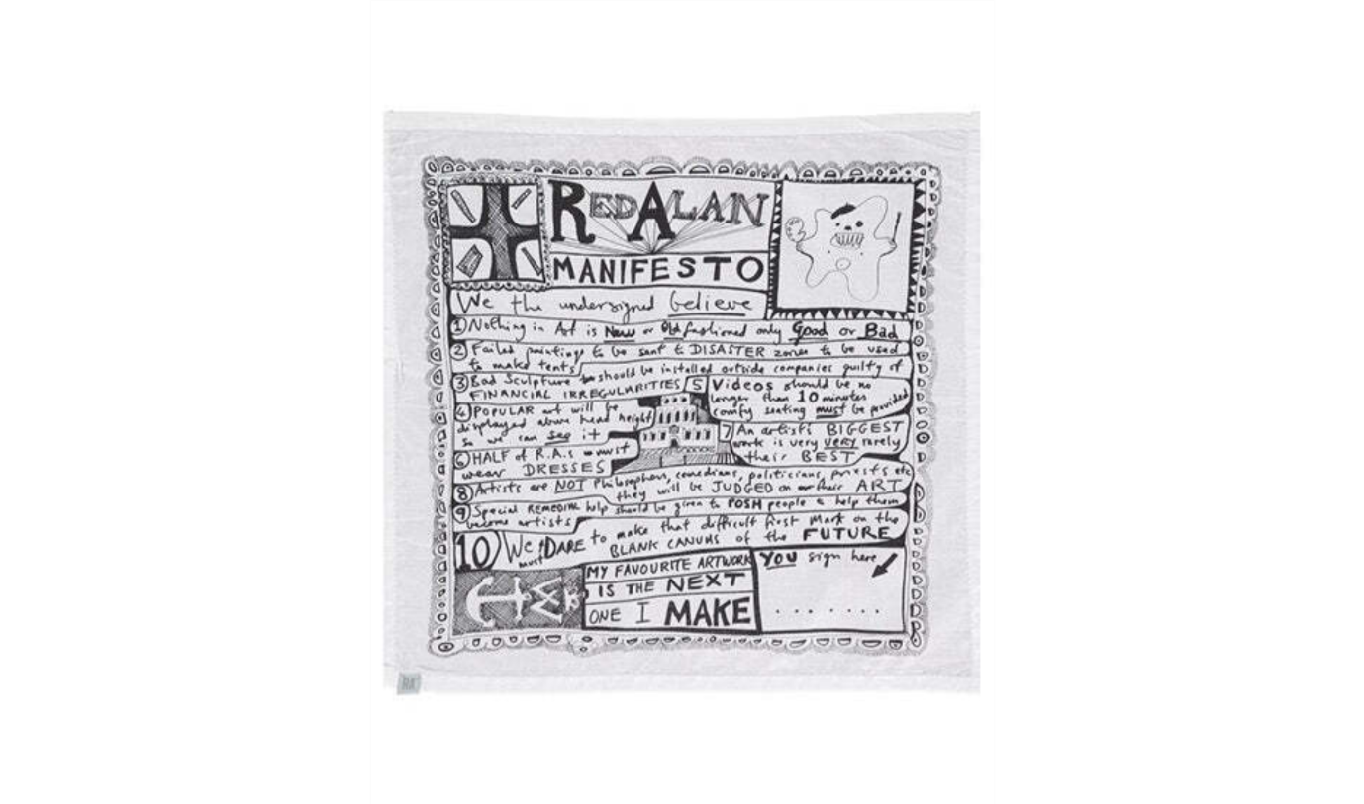
Fig.2: Red Alans Manefesto
In Red Alans Manifesto, it encourages the viewer to question what is your opion of art? an exaple of this is point one -” nothing is art is new or old fashioned only good or bad.” (MacPherson, 2014).
This encourages people to thinkof the point in art, if it is either good or bad. With in this manifersto It saids that there are good and bad art, however, we as people have different idea what is “good and bad” art. Art and deigners can have different reactions to different art. Many viwers have different opinions on the desgn and asthetics of a pices.
This leads to the next point of the fact that this manofesto is a non -comformist and a post mordernist maniferto meaning that this person dose not understand and acknowledge the fact that artist and designers can and will break the rules of the outcome. This is often seen in the modern art we appriciate today. From this manifeso you can tell that Grayson Perry wrote this as the pen name Red Alan, to see if people will agree with these outlondish points. Perry wanted to highlight and challenge viwers ways of thinking and to understand that you as a person has opions and you can say what they are.
In this sense it would be that some “art is good or bad.” But it is acknowledged that predominately art is subjective and done for its own sake. Perry uses his art to explore his identity, beliefs and his viwes on politics through is art pieces. In point seven it states, “An artists biggest work is very very rarely their best” this point can be perceived as they saying, “quality over quantity,” this tells us that even tho the work can look amazing however, the quality of the work can be less than the work of a smaller piecase.
This manifesto is usful because Grayson perry is making everyone who viwes art to understand that art ist supposed to purfeshnal and that you can make mistaleks and lurn from it. Makers should not be preshed and hold by rules. Breaking rules in art can help with the maker to express them self. ‘Art allows me to communicate, vocalize, articulate my experience” (YouTube ,2022).
From this we can see that we have to change our ways of thinking about art and designing as a whole. Grayson Perry wrote in his book “Playing to the Gallery: Helping Contemporary Art in its Struggle to be unberstod” he wrote that artist dosent need the public approvel because they are. Ot the ones making the work, the viwer should not jubge the artist or the work ‘An artist does not need the public to think his work is any good if they are not paying his wages or boosting his self-esteem. “An artist does not need the public to think his work is any good if they are not paying his wages or boosting his self-esteem.” (Perry, 2014).

Manifesto three - Draft Craft Manifesto by Ulla Engestrom. (March 25, 2005)
Ulla Engestrom, Draft Craft Manifesto was made in March the 25th ,2005. The manifesto is a maker's response and their views on the guidelines that they think is best for makers This makers manifesto is like the ten principles of design, however, not as formal. Within the manifesto it celebrates the martial you are using; it also makes the viewer to think the meaning behind the pieces and to understand it in a deeper way, it also helps makers alike to understand the work of other artist inspired others and that is celebrated in the community.

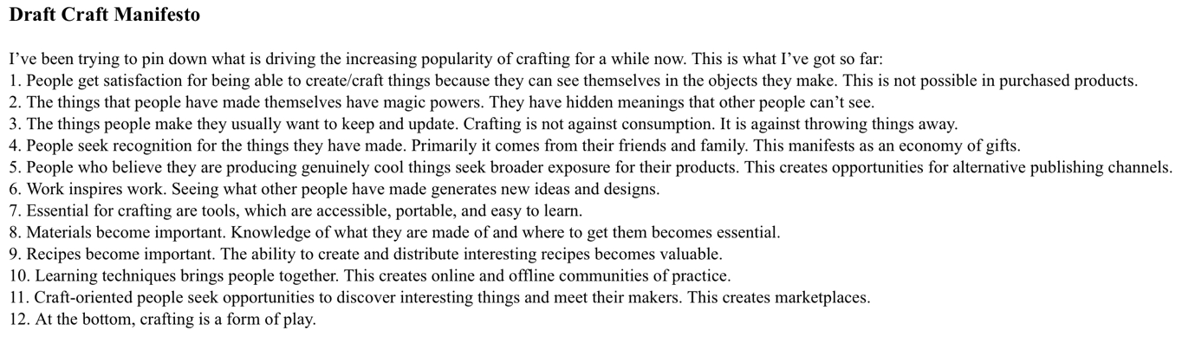
Fig.3: Engestrom -on making and consuming things

In this Draft Craft Manifesto by crafter Ulla Engestrom, it states that when a piece is made by a human hand, people can see the markers through that piece, you cannot get the same look as in a mass production. Even-though you will be paying more for that piece you can ensure that you will get character within that object. This point will lend itself to the next one, that is being that every art or design has a deeper meaning to them, meaning that, even though as a viewer you can see that story that the artist is showing there is always a deeper and meaningful message to it. A famous example of this point is “The Starry Night” by Vincent Van Gogh. ‘The deep meaning within this painting is that is a reflection of Goghs inner turmoil and his turbulent, unorganised relationships with the world’ (ETimes, 2024)
“Work inspaires work”, anything can inspaire makers to make there next pieases. Nothing can be “new” anymore, something is always a vison of what the maker saw. This making everything is unique, however, not at the same time. To make sure the crafter is not copying another makers work they will put in there own style within it. This meaning that people can express who they are as a maker and not be sceard of a method they wanted to do. The next point in this manifesto is “Crafting is a form of play,” having this has a makers rule is important becuase many people can deepen their understanding with the matrial and they will have to listen on what the matrail can do. When the maker understand the matrial they can now break the rules and play around to see what would happen.

Conclusion
From reading and analysing all three of the manifestos, Ten principles of good design by Dieter Rams as a design manifesto, Red Alans Manifesto by Grayson Perry as an artist and finally Draft Craft Manifesto by Ulla Engestrom as a maker's manifesto. As I was developing an understanding and the knowledge of all three texts, I have realized that for designers they have the consumer in mind when drafting the rules and guidelines to make sure the project is fit for them. As for the artist manifesto it tells the reader/ viewer to break rules in the art community and taking risks is important. Finally with the makers manifesto its mostly to develop an understanding with the material. To concluded from reading and evaluating the three-design manifesto I have drafted my own design manifesto with ten points that is below.

My Manifesto
- All method and processes are completed ethically where possible.
- Materials equally are ethically sourced.
- All art should have a written piece accompanying the art that references the artists ethics.
- Discourage designers that used materials or that use child labour and sweat shops for their products.
- Have an understanding that not all artist and designers are good people.
- Have ability to curate and produce anything you would like.
- Understand that processes and materials can affect the planet and take accountability for that.
- Making materials accessible for all.
- All makers and designer work towards reduce their carbon footprint.
- If an artist or maker, make a piece of art that they trying to spread awareness for a certain cause they should donate part of the money from that item.

Bibliography

Berman, David B. (2013) Do Good - How Designers Can Change the World. California: AIGA

Bora, R. (2022) Dieter Rams and 10 principles for design. Available atDieter Rams and 10 principles for good design | by Bora | UX Collective (Accessed: 4th December 2024).

Cambridge Dictionary (2024) Manifesto. Available at: MANIFESTO | English meaning - Cambridge Dictionary (Accessed: 4th December 2024).

Danchev, A. (2011) 100 Artist’s Manifestos from the Futurists to the Stuckists. London: Penguin Random House.

ETimes (2024) 6 famous paintings that have deep meanings in them. Available at:‘ (https://timesofindia.indiatimes.com/life-style/the-arts/6-famous-paintings-that-hide-deep-meanings-in-them/photostory/114610271.cms?picid=114610296 (Accessed: 3rd December 2024).

Kremer, C. (2024) William Morris gallery. Available at:‘Have nothing in your houses that you do not know to be beautiful or believe to be useful’ - William Morris - Artist's studio museum blog - Artist's Studio Museum Network(Accessed: 3rd December 2024).

Perry, G. (2014) Playing to the Gallery: Helping Contemporary Art in Its Struggle to Be Understood p. 6. London: Penguin books.

Rams, D. (1970) Ten principles of good design. Available at:Ten Principles for Good Design — R / D( Accessed: 2nd December 2024).

YouTube (2022) The art of breaking the rules. Available at: (https://youtu.be/FROUMiGmH2g?si=E8tGaY6iekL4oZvb(Accessed: 8th December 2024).

