Professional Career Development in Health and Social Care (LCHS 4009)

ASSIGNMENT 2

Name of Student: Jovanny Herrera Cortes.

I.D. Number: 2439224

Name of Tutor: Dr: Amitave Banik.

Assignment Title: Personal Development Portfolio

Acknowledgement of AI use: I confirm that I have / have not used AI to complete my work. (IF YES, ALSO WRITE I USED THIS SOURCE……. GIVE REFERENCE SUCH AS GRAMMERLY FOR EXAMPLE……TO………PROOF READ FOR EXAMPLE).

Table of Contents Page Number

Cover Page 1

Table of Contents 2

Portfolio 3

CV 3

CV 4

Personal Statement 5

Personal Statement 6

Swot Analysis 7

Personal Development Plan 9

Reflection Team Work in Health and Social Care 11

References 13

Practical Portfolio

Introduction:

In this document I attempt to demonstrate the academic knowledge plus my work experience acquired theoretically and practically in the exercise of my learning.
Job Vacancy: Adult Support worker or Learning Disabilities.

Task 1 of 4

Name: Jovanny Herrera Cortes.

Address: 11 Russell Pickering House. Clapham Road London SW4 6NH

Telephone Number: 07482322853

Email: jovanny442015@gmail.com

Professional profile A dedicated and resilient Health and Social Care student whit five years on frontline experience as a volunteer for the Colombian Red Cross. Proven track record in providing compassionate care, emergency response, and community support in high-pressure environments. Currently developing advanced knowledge of UK care standards and legislation. Committed to empowering vulnerable individuals and promoting person-centred care within the British Health system.

Core Skills and Competencies.

Emergency Care: Certified in First Aid and Basic Life Support.

Communication: Bilingual (English and Spanish); skilled in activity listening and conflict resolution.

Teamwork: Experienced in collaborating with multidisciplinary medical and social teams.

Safeguarding: Developing knowledges of the Care Act 2014 and protection of vulnerable adults.

Resilience: Capable of maintaining professional boundaries and empathy in crisis situations.

Relevant Work and Voluntary Experience

Volunteer Emergency Responder – Colombian Red Cross June 2005- January 2010 (5 years).

Provided immediate first aid and emotional support to individuals in crisis and disaster zones.

Collaborated with Healthcare professionals to deliver community health workshops and vaccination campaigns.

Assisted in the distribution of essential resources to displaced and vulnerable populations.

Maintained meticulous incident reports and adhered to strict international humanitarian ethics.

Education and Training

Health and Social Care: Currently studying at the UWTSD Relevant Modules: Working in Teams, Foundations of Social Care, Healthcare Ethics, Anatomy and Physiology.

High School Diploma/ Bachillerato Instituto Tecnico Induastrial. Colombia (1993).

Certifications and Hobbies

Certifications: Red Cross First Aid Certification; Level 2 Food Hygiene.

Interests: Community volunteering, health fitness, and learning about global social policy.

Task 2 of 4

Hello, my name is Jovanny Herrera. I've been in England since February 2015, working as a chef in various London restaurants. I've always tried to give my best and improve my living conditions and those of my family. This has led me to undertake a difficult, but perhaps not impossible, mission: to study and develop my knowledge in the community health sector. Therefore, I chose to study Health and Social Care.

This is because I have first aid knowledge from my previous experience as a volunteer with the Colombian Red Cross, where I served for over five years. This was truly fulfilling for me as a human being and instilled in me a deep love for alleviating pain and helping with situations that arise during unexpected crises such as accidents, illnesses, or natural disasters. That's why I chose to study Health and Social Care.

My experience: Being involved with the Colombian Red Cross allowed me to experience moments of brotherhood and teamwork, not only among Red Cross members but also with different medical teams with whom we shared tasks and accommodation. This fosters a high level of empathy and respect for different ways of thinking and enriches me culturally. Furthermore, teamwork in the field provides tools to improve how we understand the pain of others and find ways to offer relief from different perspectives, not only through medicine and treatments but also through cultural understanding and a genuine interest in learning about the affected person. This also enhances resilience and raises the ethical standards of those providing assistance in these difficult situations.
In my experience, it's also worth noting that I was a soldier in my country's glorious army, where I served under different commands and was a team leader in various tactical operations and tasks. These experiences instilled in me a strong sense of discipline and a profound respect for life and the individual and collective perspectives of each person, all for the benefit and importance of carrying out a mission and achieving positive results.

Skills: My experience as a volunteer has developed my ability to communicate empathetically in English and Spanish (my native language) with people in different situations, respecting and understanding their pain and what they are going through at that particular moment. I help minimize their agony and despair as much as possible through good personal support, showing them the importance of each person even in these difficult circumstances. I remind them that there is still hope, that even when life shows us its darkest side, dawn always comes, and that things can get better.
Another of my skills is that I can work under pressure and in cases where patience and empathy might disappear due to service situations, but thanks to my experiences I have very good control of my emotions, which allows me to keep situations on track even in the worst moments.

In conclusion, I believe I am a suitable and good candidate for the social work position at this company. I possess the necessary skills and knowledge to provide excellent service to our clients and staff, demonstrating respect and empathy. This service is designed to support individuals at risk or with illnesses who lack access to private care or assistance.

Furthermore, I have a strong desire to learn daily from the experience and knowledge of other team members. This, combined with my own expertise, will undoubtedly contribute to providing a high-quality and efficient service, setting an example for others and making a positive impact on those who benefit from our services.
Task 3 of 4
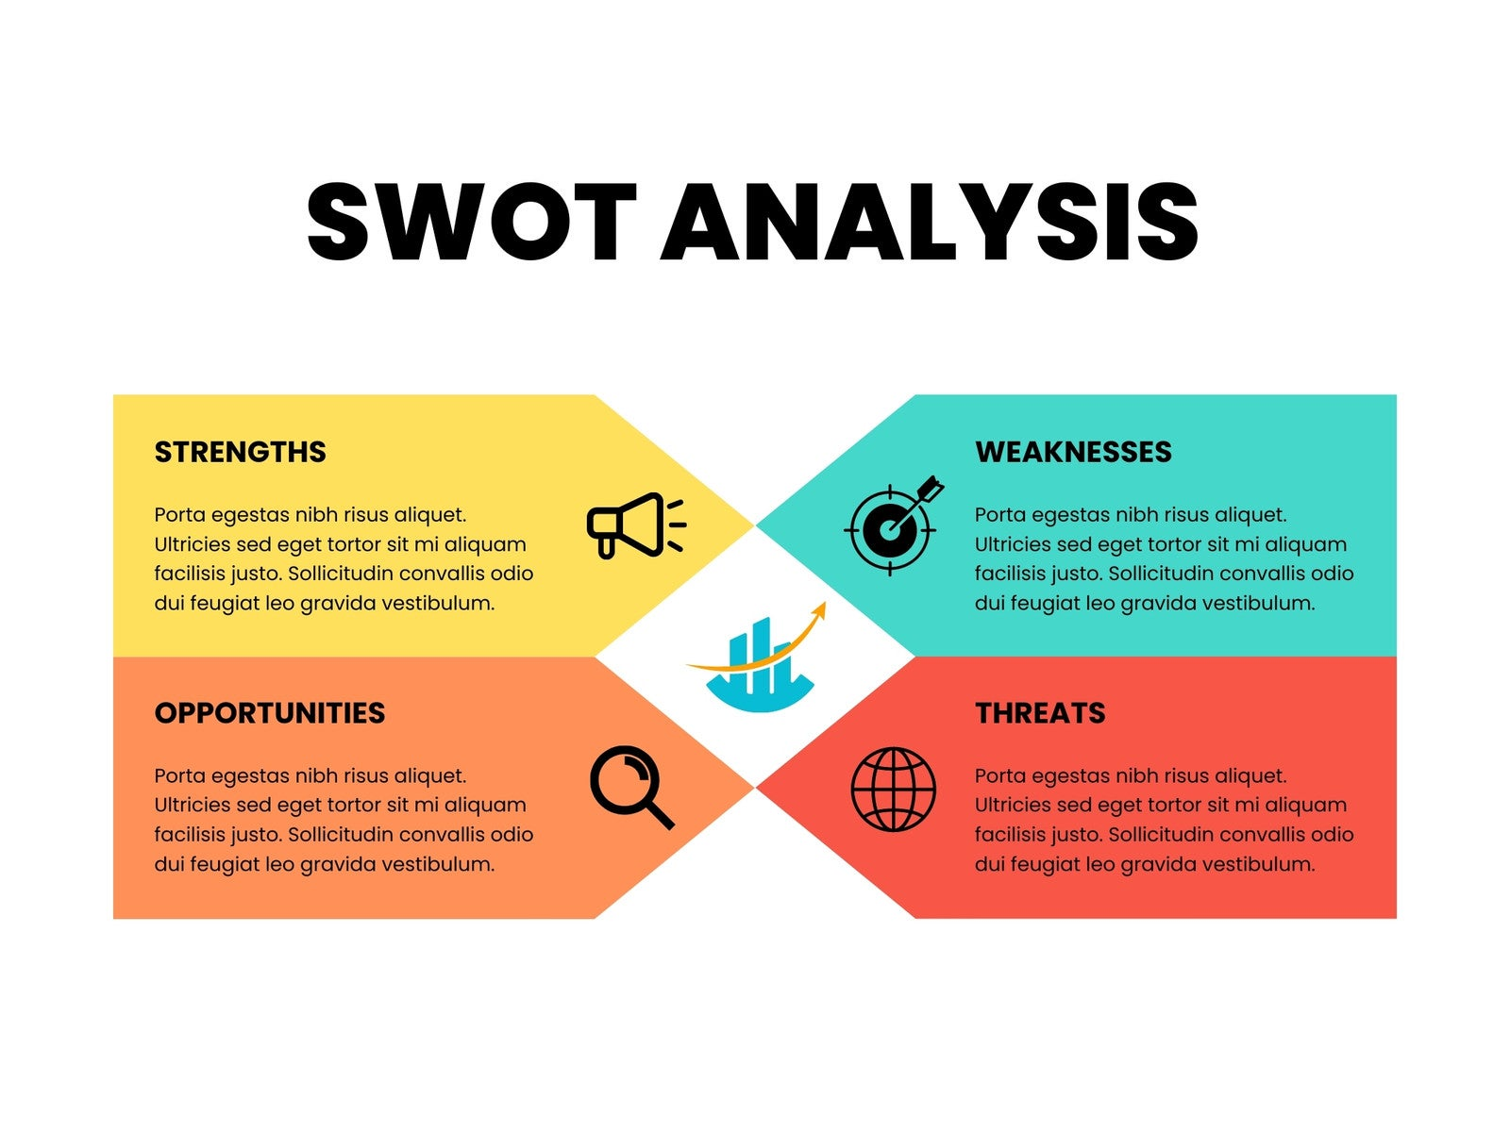
SmartDraw: Swot Analysis template

SWOT analysis is a tool designed to identify weaknesses, strengths, opportunities, and threats. It is also known as FODA and DAFO, which refer to the same thing but differ depending on the language. It is divided into four variations that address internal and external factors, helping to make better decisions and identify opportunities for improvement and growth.

In this case, the aim is to apply SWOT analysis from my own perspective and describe my own vulnerabilities, experiences, and knowledge to be applied to the development of my career and studies in Health and Social Care. This will allow me to maximize my potential and enhance all my possibilities in the profession I will pursue upon graduation. The goal is to minimize the risk of malpractice in my daily work and teamwork, with or without supervision, while handling each task with professional ethics and due respect for every client or patient I work with.

Strengths: Five years as a first responder with the Colombian Red Cross has provided me with extensive knowledge and training in first aid, crisis management of various types (anxiety, accidents, natural disasters), and emotional support.
I possess great resilience and the ability to work under medical or social supervision in emergencies, providing support and administering medical treatments specifically prescribed for each case.
Impact on Support Worker: high level of resilience and capacity for appropriate management in medical or social emergencies or natural disasters that may occur during the course of professional practice.
.

Weaknesses: In the UK legal system, each student must be guided by the laws and statutes of ethics and professionalism required for the practice of the Health and Social Care career UK laws like the Care Act 2014 or Mental Capacity Act. Despite needing more guidance and initial effort to supplement and attach the documentation and legal support that the country requires.
Impact on Support Worker: There is a possibility that at the beginning of my professional practice I will need more appropriate guidance and that it will require a greater effort to practice, since I will have to provide the necessary documentation to prove the knowledge I demonstrate. I will obtain this documentation through the university and the degree program I am currently pursuing.

Opportunities: Communication skills not only in English, since my native language is Spanish, which allows me to have a higher range of mobility and attention to a greater number of Spanish-speaking clients or patients who unfortunately do not have adequate command of the language that governs in the country.
Impact on Support Worker: The possibility of reaching a larger group of citizens or patients with linguistic diversity for better support and to personalize care and services with respect to the individual needs of each person and to be able to improve the treatment and possibilities of each one.

Threats: Currently, the UK healthcare sector is facing difficult times in terms of employment, as the economy is prioritized over the human factor. This negatively impacts the well-being of healthcare workers and contributes to the deterioration of working conditions, leading to staff burnout from long shifts with little rest and support. This situation, in turn, presents an opportunity for a new generation of students and healthcare professionals with fresh perspectives and a desire to learn to apply for these vacancies
Impact on Support Worker: The above also requires a strong capacity on the part of the health worker and a great interest in maintaining the high standards of service required in the UK, but at the same time it represents a possibility of creating new service and work support strategies to avoid the high workloads and long shifts to which workers in this field must be subjected.

TASK 3: SECTION B: Personal Development Plan (PDP)
Over the next two years, I have the opportunity to improve many aspects of my life that I currently need to refine and enhance to increase my chances of entering the competitive job market in the Health and Social Care sector. While this sector is in high demand, it also requires a high level of knowledge and experience to effectively manage the challenges and situations it presents, including a thorough understanding of the relevant laws and basic knowledge of diseases and the human body. Based on my previous experience as a volunteer with the Colombian Red Cross and my current studies, I hope this will propel me toward my goal of obtaining my professional degree in Health and Social Care.

Goal: Master Safeguarding Protocols: To fully understanding UK legislation regarding the protection of vulnerable adults.

Action Plan (how to develop): My focus is on completing my studies in Health and Social Care over the next two years, in addition to completing the Level 2 Safeguarding Adults certification and attending extra seminars and classes at university.

Monitoring and Evaluation: Successfully passing the certification and applying the knowledge in my first work placement.

Goal: Enhance Clinical Communication: To the extent possible, and in order to improve my writing, I will try to write down more of what I hear both in class and at work during lessons, and also when I watch the news and listen to the radio, trying to take notes, even if they are small, but always aiming to make longer and better-content writings, going from less to greater complexity, and in this way truly improve my professional clinical writing.

Action Plan: Part of my plan to improve my writing could also be to use an academic support person at university and ask my classmates for help with my writing so they can give me their recommendations and advice to improve my work. Another thing I could do is try asking my colleagues at work to read my writing and give me their opinion.

Monitoring and Evaluation: Weekly reports of my writings with a score from zero to ten to track their evolution and progress, obviously with the help of the aforementioned teams to increase the real possibilities of improving my practical clinical writing.

Goal: Obtain UK First Aid Certification: To complement the knowledge I gained at the Colombian Red Cross, I will explore the possibility of obtaining a first aid certificate in the UK to strengthen my skills and meet the standards established in the United Kingdom, thereby increasing my chances of working in the public or private health sector.

Action Plan: To get involved with first aid teaching groups to reinforce existing knowledge while learning new techniques and ways of practicing in any emergency situation; also to learn about hygiene and safety in all areas of practice in the health sector.

Evaluatio: Obtaining the physical certificate and being the designate First-aider in my work place.
Task 4 of 4

Reflection: Team Work in Health and Social Care
Gibbs’ Reflective Cycle.

REFLECTION TOOLKIT 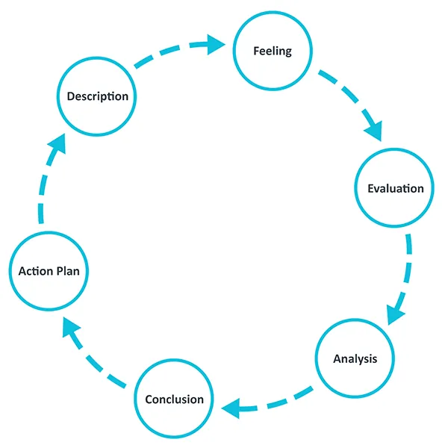

- Description: On this data, I delivered a presentation titled " team work in Health and Social Care. Multidisciplinary collaboration to ensure high-quality service user outcomes. During the delivery, I experienced significant nervousness, with manifested as hesitation and difficulties with the pronunciation of the technical terms. Also the lecture asked a specific question about Tuckman’s Model. I responded by explaining the five stages: Forming, Storming, Norming, Performing, and Adjourning.

- Feelings: Leading up to the presentation, I felt a high level of “performance anxiety” As a non-native speaker, I was hyper-aware of my accent, which a “mental block” during the more complex section of the script. I felt frustrated because I understood the core concepts-such as the importance of “shared goals” in care but I struggled to articulate them with the fluency I desired. When the professor asked about Tuckman’s Model, I initially felt a surge of panic. However, this was quickly replaced by a sense of relief when I realized I had studied the theory thoroughly. Despite my nerves, I felt a sense of accomplishment for not allowing my pronunciation errors to stop the presentation entirely.

- Evaluation: this experience showed resilience. I did not give up when I stumble over words, and I successfully demonstrated my theoretical knowledge during the session. I managed to convey the primary message: that the teams in social care must be cohesive to avoid “siloed working”
On the negative side, the affective filter caused by my nerves hindered the clarity of communication. In Health and Social Care, clear communication is a fundamental safety requirement ( Boreham,2015). If a practitioner cannot communicate clearly due to anxiety, it may lead misunderstandings in a clinical or social setting. My pronunciation issues were a “barrier to practiced” that I must address to reach professional standard in the UK.

- Analysis: Analysing this through the lens of Tuckman’s (1965) theory, I realize that even a presentation can be viewed as a “team” process between the speaker and the audience. The storming phase of my presentation occurred when my internal anxiety clashed with my desire for perfection.
Furthermore, the professor’s question about Tuckman’s is vital because “Storming” is where most Healthcare team fail. According to Lingar (2009), collective competence is only achieved when team members move past individual conflicts to reach the “Performing” stage. My difficulty in explaining this verbally suggests that while my “cognitive competence” ( what I know) is high, my “Functional competence” ( how I explain it in English) needs more development. In a real-world. Multidisciplinary team being able to explain why a team is struggling id just as important as the clinical work itself. My nervousness was a reaction to the high stakes of the environment, a common issue for international students adapting to British academic standards.

- Conclusion: I have concluded that my preparation was sufficient regarding the content, but insufficient to delivery. I focused heavily in the power point slides, but I did not spend enough time on “ vocal rehearsal” I have learned that in Health and Social Care. Even I need to automate my technical vocabulary so that it flows naturally when I am nervous.

- Action Plan: For a future performance, I will planning : Phonetic Practice: I going to create a list of the 20 more difficult words from my lesson (e.g. multidisciplinary, safeguarding, adjourning) and practice then using shadowing techniques.

Oral Drills: I will record myself and listen to the playback to identify where my fluency breaks down.
Anxiety Management: I will utilize “Box Breathing” (4-4-4-4) before my next presentation to lower my heart rate and mitigate the physical symptoms of nerves.

REFERENCES

COLLECTIVE COMPETENCES AND WORK PROCESS KNOWLEDGE: Available at:
https://www.cedefop.europa.eu/files/etv/Upload/Projects_Networks/PaperBase/BorNi04.pdf accessed: ( 01 April 2026).

LEARNING BY DOING: Available at: https://dsdweb.co.uk/wp-content/uploads/2021/10/learning-by-doing-graham-gibbs.pdf Accessed: (01 April 2026).

National Library of Medicine: What we see when we look at the competence: Available at: https://pubmed.ncbi.nlm.nih.gov/19856124/ Accessed: ( 01 April 2026).

National Library of Medicine: DEVELOPMENTAL IN SMALL GROUPS: Available at: https://pubmed.ncbi.nlm.nih.gov/14314073/ Accessed: ( 02 April 2026).

THE UNIVERSITY of EDINBURGH: REFLECTION TOOLKIT: Available at: https://reflection.ed.ac.uk/reflectors-toolkit/reflecting-on-experience/gibbs-reflective-cycle Accessed: ( 01 April 2026).

Tuckman-1965-Developmental_secuence_in_small_groups: Available at: https://web.mit.edu/curhan/www/docs/Articles/15341_Readings/Group_Dynamics/Tuckman_1965_Developmental_sequence_in_small_groups.pdf Accessed: ( 05 April 2026).

