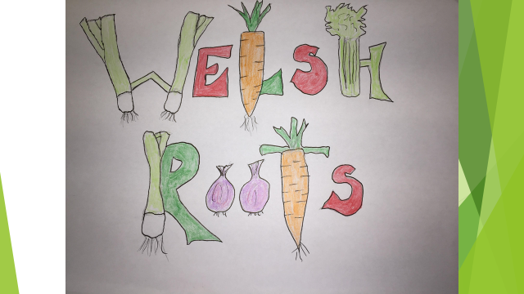
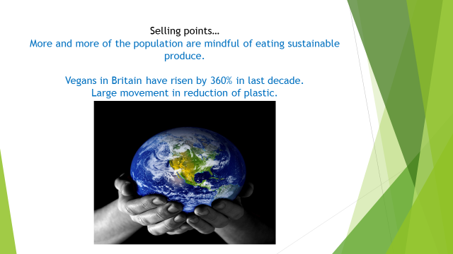
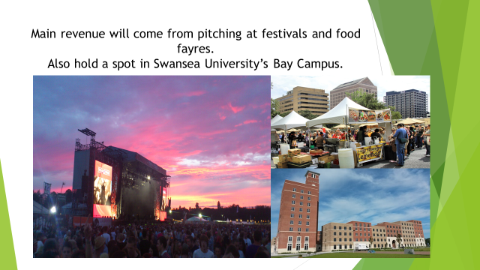
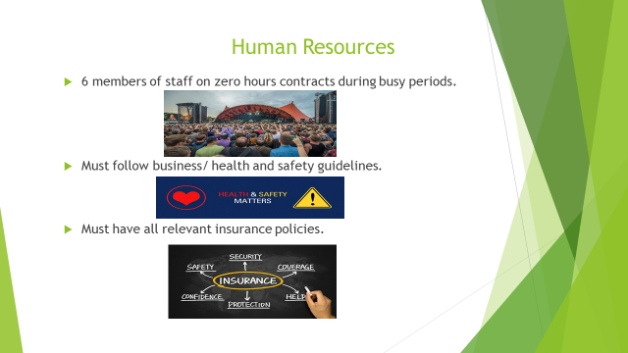
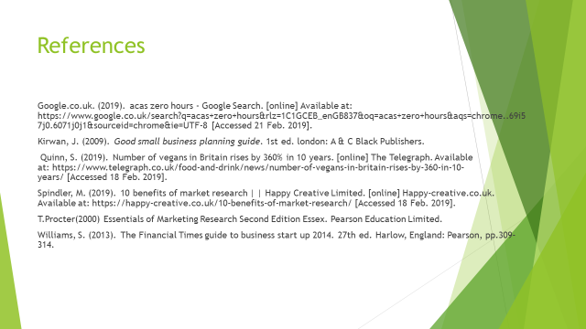
Speaker notes
Hello everyone….
My name is Jamie, this is Chris and Mo…
We are here today to pitch our exciting business idea Welsh Roots.
Welsh Roots is a vegan burger van that produces and sells high quality, vegan products using locally sourced ingredients.
We feel that this can be very successful due to the huge amount of media coverage and campaigning to look after our planet and to eat sustainable products. The number of vegans in Britain has risen by 360% in the last decade. ( Quinn, 2019)
There is also such a large green movement at the moment surrounding recycling and single use plastics, we will be very proud to not use any of this plastic on our van.
Our aim is to create a trusted brand of vegan burgers and sides that will be sold from a van.
We are looking to pitch the van at Swansea University Bay campus on a day to day basis. However we are looking for our highest revenue to be made when our van is pitched at festivals and food fayres.
We want to create a strong brand that our customers can trust and feel confident that all of our products are friendly to the planet from our ingredients to our packaging.
Chris will be telling you about our marketing campaign today, I will give some detail on the HR for the business and Mo will finish off with our financial information.
For approximately 27 weeks of the year the only employees will be the 3 of us. The other 25 weeks we are hoping to be attending festivals and events. For this we will need to employ approximately 6 members of temporary agency staff on zero hour’s contracts.
Their job roles will largely be serving customers and keeping the facility clean.

Our premises has already been approved by Swansea council and we have been granted an alcohol license.
In order to follow business guidelines we need to make sure we have all of the relevant insurances in order to trade.
This will include employer’s liability insurance, protecting against employee claims including injury or food poisoning.
We will also need public liability insurance for our customers. (Williams, 2013)
Our van will need the right insurance policy as well as contents insurance for all of the equipment within it.
We will also need in insure our stock. This will cover us in the event of any damaged or lost stock. This could occur in the event of refrigeration failure for example.
I will now pass on to Chris who will introduce the finances…

So just to summarise …
Looking to the future in the most pessimistic way….
If the stall does not make enough profit in the first year we will just concentrate on the festivals during the summer months. This will allow us to keep full time employment and run the stall between us. This will keep risk to a minimum.
Looking at it in the most optimistic way we will increase our festival attendance and become a Global brand that is present in festivals around the world. Becoming the market leader in Vegan food.
Based on our projections for the first year, I think the most realistic future for the business will be to become a trusted name within the British food industry and make enough profits from events and festivals to carry us through the winter months. Hoping that the profits will be good enough that the business will be our sole income.

References
Google.co.uk. (2019). acas zero hours - Google Search. [online] Available at: https://www.google.co.uk/search?q=acas+zero+hours&rlz=1C1GCEB_enGB837&oq=acas+zero+hours&aqs=chrome..69i57j0.6071j0j1&sourceid=chrome&ie=UTF-8 [Accessed 21 Feb. 2019].

Quinn, S. (2019). Number of vegans in Britain rises by 360% in 10 years. [online] The Telegraph. Available at: https://www.telegraph.co.uk/food-and-drink/news/number-of-vegans-in-britain-rises-by-360-in-10-years/ [Accessed 18 Feb. 2019].

Williams, S. (2013). The Financial Times guide to business start up 2014. 27th ed. Harlow, England: Pearson, pp.309-314.

