

Programme: BSc Health and Social Care
Module: Changemakers: Creativity and Value Creation
Module code: BMHP5014
Student name : Alexandra Elena Galiceanu
Student number: 2330542

Table of Contents
Task 1 – Concept Map 3
Task 2 –Self-Reflection of Group Activity 5
Task 3 –Case Study of a UK innovation 6
Task 4 –Research Task 7
Task 5–Podcast 8
Task 6–NHS Leadership Framework Analysis 9
Task 7–Self-Reflection Journal Entry 11
Reference List 12

Task 1 – Concept Map
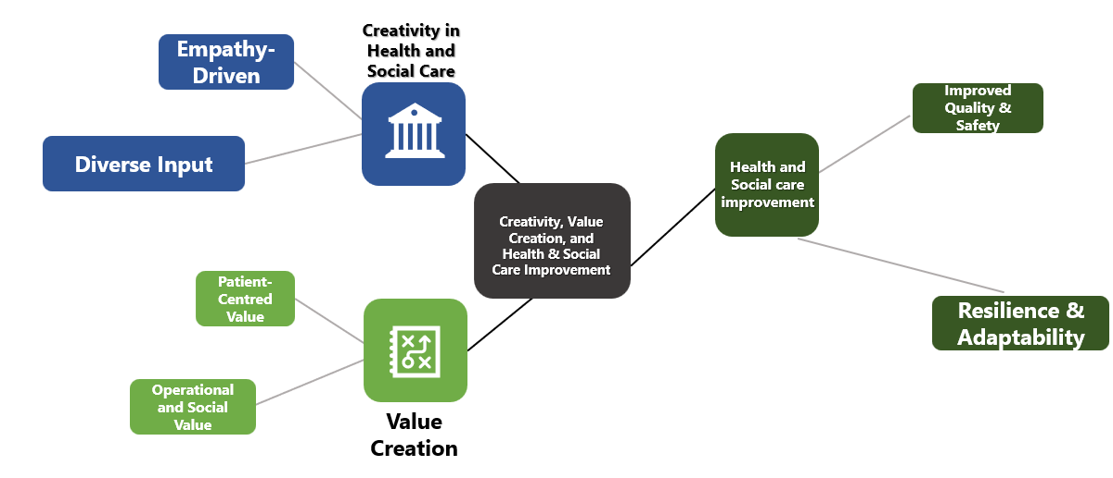
Figure 1: Concept map outlining the relationship between creativity, value creation, and health and social care improvement
(Source: Created by learner)
This concept map summarises the connection between creativity, value creation, social care, and health development, by highlighting creative thinking skills that lead to better-quality results, innovative outcomes, and through co-production practices. As discussed by Grindel et al. (2022), creativity, in this framework, is not merely about skills, but rather it is distinct as the capability to create original and beneficial concepts to solve complex, typically intractable, health complications. Being empathy-driven is about understanding the lived experience of staff and patients by engaging empathy. It permits for recognising non-understandable difficulties. As stated by Vargas et al. (2022), the diverse input is about assembling data from varied sources such as patients, caregivers and staff, leading to a more comprehensive insight. Creative skills about monotonous, ordinary, imaginative problem-solving skills executed by frontline staff are as critical as the foremost technological modernisation.
On the other hand, as the thoughts expressed by Grindell et al. (2022), value creation in healthcare has been engaged in the moving of emphasis to co-creation of value from merely delivering services and have been attributed within hospitality service users, leading to healthier experiences and consequences. The patient-centred value is about employing creative tools to comprehend patient requirements, elevating their self-esteem and quality of life. The operational value is about consuming creative, and out-of-the-box thinking skills to enhance inadequate resources, reduce waste via a lean approach, and advance efficacy. On a contradictory note, as detailed by Vargas et al. (2022), health and social care improvement is about better execution of both creativity skills and value creation that directly ignite development by renovating care design and delivery. This is about creating social value by means of building a sense of belonging, fostering community, and reducing isolation via social-creative interactions.

Task 2 –Self-Reflection of Group Activity
For group activity-based self-reflection, Gibbs’s reflective model is selected.
Description
In the Convergent/Divergent paperclip thinking class activity, while practising for the role of a supervising social worker, I had to encounter much paperwork, real-world simulation case handling and workshops. During the class lecture of week 1, at the project meeting, two team members contended, causing a halt, and the meeting finished without any clear and distinct action plan. A struggle arose between two team members as they lacked creativity skills, and during the group presentation, the group projects were divulged.
Feelings
I think it is rough and nervous, desiring I had interfered but have seemed incompetent in doing so. Initially, I felt annoyed, and wrongness was contemporary, which in advanced twisted into strain. Hindrance and apprehension about missing the deadline was a huge concern with the members giving the impression of being detached or stressed.
Evaluation
The good part was recognising the creativity skills for value creation, while the bad part was the lack of scheduling and, subsequently, missing vital deadlines. The project was done, but then again, the project quality was inferior to what was predicted, and team confidence was spoiled.
Analysis
The lack of proper communication skills and a clear outline gave rise to poor communication, by being uncreative, and emotionally in conflict (Reith‐Hall and Montgomery, 2023). The lack of a clear and honest building of milestones was permissible for the inequity to go overlooked.
Conclusion
In conclusion, I would like to highlight that by not speaking the struggle proximately, I was permitted to positively communicate with a positive influence throughout the project's process.
Action Plan
In the action plan, I would like to recommend exaggerating the team's time management skills to avoid missing deadlines and ensure project success.

Task 3 –Case Study of a UK innovation
Revolutionary AI-powered 3D scans have cut the need for invasive tests, while already saving millions of pounds (NHS, 2025). Currently rolled out across 56 NHS hospitals in England, this clever tech has enabled doctors to treat and diagnose patients with suspected heart diseases much faster through a CT scan of their heart turned into a personalised 3D image. This image has then been analysed with the help of AI-driven systems. Furthermore, this sci-fi tool has also helped offer tens of thousands of patients at risk (life-threatening heart diseases) a more accurate and rapid diagnosis, aimed at freeing up capacity at the NHS. One of the patients from the NHS who has benefited from this innovation has also stated that she was not a classic case for a threatening coronary heart disease.
However, this new system enabled the cause of the symptoms to be identified faster than ever, which became potentially life-saving. The AI-driven 3D scans also reduced the count of patients requiring invasive angiograms by about 16% in cases where it was later discovered that no treatment may have been required, and by 7% altogether. In addition, the count of second heart test patients required within a 2-year span has also been axed by 12%, with around 24,300 patients having benefited since this technology rolled out in 2021. Hundreds of patients were able to avoid invasive practices and saved an estimated value of £9.5 million for the NHS, which is equivalent to about £390 per patient. Other than this, 6,898 patients also had access to the AI-driven analysis, now known as Heartflow.
The NHS believes that this is a prime example of how technological advancements can make the organisation fit for the upcoming generations as part of its 10-year Health Plan. This tool further enabled the assessment of the location and extent of the heart blockages, then interpreted by cardiologists, while also suggesting the position of the stent, working best for particular patients. Another study analysed the use of this HeartFlow Analysis among 90,000 NHS patients over the last three years, showcasing that personalised imaging can reduce unnecessary tests while also increasing the count of individuals being treated for heart diseases with accuracy in diagnosing patients (Benn, 2025). It has been established that coronary heart diseases are the most common type of cardiovascular disease, affecting about 2.3 million individuals across England.

Task 4 –Research Task
According to the article by Ahad, Sanchez-Gonzalez and Junquera (2023), mental health stigma is categorised by prejudice, negative stereotypes, and discrimination. This has been considered to be a significant damage which has been noticed inside the psychiatric care, dispiriting timely care delivery, at the same time has been considered to be obstructive to optimum health significances. From this time, an improved understanding has been presented with the inspiration of mental health stigma across miscellaneous cultural upbringings and has been critically vivacious. This has been engaged in pointing in the direction of informed, ethnologically nuanced policies and has been articulated to diminish its consequence and contribute to a accompanying, unbiased, and vigorous psychiatric care system.
On a contradictory note, as per the article evaluation of Ma, Anderson, and Burn (2023), the more and more mounting incidence of mental health disorders among children and adolescents is a public health fear, predominantly for social, health, and economic burden amid mental health stigma and syndromes. According to the school-based interventions, the article intended to cultivate mental health literacy and decrease mental health stigma, which is probable to avoid mental disorders and encourage mental well-being. Consequently, reducing the mental disorder burden helps towards the efficacy of school-based interventions planned to progress mental health literacy and lessen mental health stigma.

Task 5–Podcast
Obsefy is the new business idea, with its tagline - Awareness today, healthier UK tomorrow, which supports creative thinking and brings out the innovation in individuals. This campaign idea has been aimed at boosting public awareness with the help of education on safety and health hazards concerning obesity. It can further help support educational workshops or programmes across communities, workplaces or schools. With the help of personalised meal plans, along with food preferences, it can encourage better-informed choices. The issue identified in this business idea informs how obesity has currently evolved as a crucial public health concern across England, as well as all across the world. This when witnessed from a different outlook, the prevalence of health concerns has been engaged in the contribution to obesity as the most preferred area. Moreover, children were stated to have been suffering the most from obesity, with the primary causes which have been witnessed to be high blood pressure, high cholesterol and lower life expectancy.
There has been an increment of sugar consumption, energy has not been used up through physical activities. Based on this, the campaign has been allocated in the targeting both adults and children in the UK. This has been essentially been aimed at reducing health inequalities, especially across underserved societies. Moreover, Obsefy has been engaged in the presentation of offers of an innovative approach towards the development of targeted education campaigns and has been motivating healthy and affordable lifestyle choices. The idea is stated to be allocated to operate through an application, which can further help track food intake and limit the nature of fat and calorie content in food. In addition, with a multi-channel strategy, the new idea has been engaged to make a belief that awareness among obese adults and children can be promoted. However, Obsefy also has been articulated to have a plan to take care of the ethical concerns associated with the use of the internet, such as data theft or cybercrimes.
Aligning with such rules, Obsefy needs to offer quality services with the help of its multi-channel communication strategy, aimed at the eradication of obesity. Furthermore, promotional platforms such as Instagram, YouTube or Facebook, with an emphasis on the development of new skill sets through integrated technological advancements. Through attractive blogs and social media channels, Obsefy can be promoted and disseminated among potential stakeholders. This campaign, Obsefy, plans to ensure the well-being of the population through a reduction in obesity and other relevant healthcare concerns in the UK.

Task 6–NHS Leadership Framework Analysis
NHS leadership is based on health and care training for staff and working in diverse hospital settings. The fundamental leadership components within the NHS are for the growth of the leadership framework as a wish to shape prevailing leadership agendas (NHS, 2026). It is to generate a single all-encompassing outline that makes available a shared purpose for value creation and hospital services and tactics for leadership growth for all staff groups, notwithstanding discipline, function or work experience in the NHS.
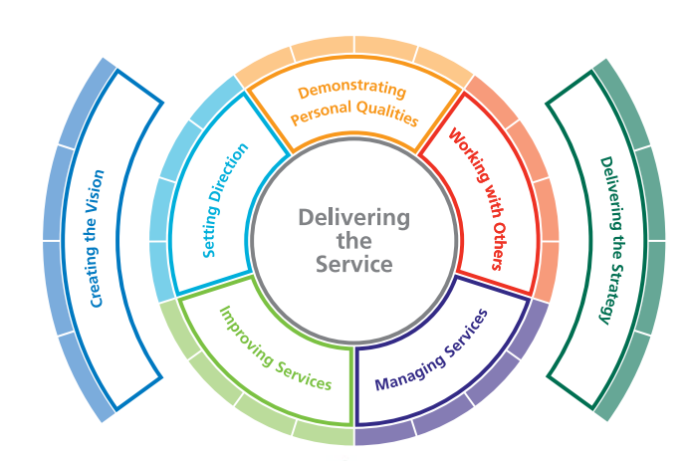
Figure 2: Crucial NHS Leadership Framework components
(Source: NHS, 2026)
In the NHS, the groundwork of leadership actions for all staff helps to understand their development as a frontrunner. The Leadership Framework by the National Leadership Council helps staff, professional bodies, patients, and academics who are consulted, comprising notions. Creating a vision, as a component, helps NHS leaders to encourage enhancing creativity skills and improve care in the hospital setting. As discussed by Kareem et al. (2023), as per transformational leadership theory, creating a leadership vision includes constructing a positive, forward-looking, and, most prominently, a depiction of the future that stimulates teams to influence their potential. On the other hand, as stated by Jerab and Mabrouk (2023), leaders create a vision, being crucial to a clear and planned determination, habitually via brainstorming, making a succinct statement and understanding essential values that attach individual help to the organisational goals.

Task 7–Self-Reflection Journal Entry
Concerning my learning of this module, I have learned about innovative concepts which helped me change my perception of technological advancements in the field of social and health care. For instance, this module made me learn of the new diagnostic systems, such as AI-powered 3D personalised heart scans, which have saved a myriad of lives till today, contributing to a reduction in traditional scan modes. Other than this, I have also come across improvements in this area based on the follow-up of my own skill sets and improvement needs. Herein, Walsh, Knott and Collins (2022) stated that the Dual Process Theory supports swift task-based problem-solving. The authors also highlighted that innovation is an essential factor in the growth and development of societies and organisations, while also being a difficult and complex phenomenon. Herein, this module has helped me learn more about the significance of innovation and its connection with value creation. Moreover, completing the podcast helped me enhance my creative skills, and I managed to elaborate further on my professional practices. However, despite being efficient in creativity and leadership, I believe that I lack time management and communication skills, which require attention in the future.

Reference List
Ahad, A.A., Sanchez-Gonzalez, M. and Junquera, P. (2023)‘Understanding and addressing mental health stigma across cultures for improving psychiatric care: A narrative review’, Cureus, 15(5).Available at: 10.7759/cureus.39549
Benn, D. (2025) Revolutionary heart scans transforming diagnosis. Available at: https://www.nationalhealthexecutive.com/articles/revolutionary-heart-scans-transforming-diagnosis (Accessed: 6 February 2026).
Grindell, C., Coates, E., Croot, L. and O’Cathain, A. (2022)‘The use of co-production, co-design and co-creation to mobilise knowledge in the management of health conditions: a systematic review’, BMC Health Services Research, 22(1), p.877. Available at: https://doi.org/10.1186/s12913-022-08079-y
Jerab, D. and Mabrouk, T. (2023)‘The role of leadership in changing organisational culture', Available at SSRN 4574324.Available at: https://ssrn.com/abstract=4574324
Kareem, J., Patrick, H.A., Prabakaran, N., B V., Tantia, V., MPM, P.K. and Mukherjee, U. (2023, May)‘Transformational educational leaders inspire school educators’ commitment’, In Frontiers in Education (Vol. 8, p. 1171513). Frontiers Media SA.Available at:https://doi.org/10.3389/feduc.2023.1171513
Ma, K.K.Y., Anderson, J.K. and Burn, A.M. (2023)‘School‐based interventions to improve mental health literacy and reduce mental health stigma–a systematic review’, Child and adolescent mental health, 28(2), pp.230-240.Available at: doi:10.1111/camh.12543
NHS (2025) News. Available at: https://www.england.nhs.uk/2025/05/futuristic-3d-heart-scans-speed-up-diagnosis-and-save-millions/ (Accessed: 6 February 2026).
NHS (2026) Leadership Framework. Available at: https://www.leadershipacademy.nhs.uk/wp-content/uploads/2012/11/NHSLeadership-Framework-LeadershipFramework.pdf(Accessed: 6February 2026).
Reith‐Hall, E. and Montgomery, P. (2023)‘Communication skills training for improving the communicative abilities of student social workers: A systematic review’, Campbell systematic reviews, 19(1), p.e1309.Available at: 10.1002/cl2.1309
Vargas, C., Whelan, J., Brimblecombe, J. and Allender, S. (2022)‘Co-creation, co-design, co-production for public health–a perspective on definitions and distinctions’, Public Health Research and Practice, 32(2), p.e3222211.Available at: https://doi.org/10.17061/phrp3222211
Walsh, C., Knott, P. and Collins, J. (2022) ‘The driving mindsets of innovation: Curiosity, creativity and clarity’, Journal of Business Strategy, 43(2), pp. 71-78. Available at: http://dx.doi.org/10.1108/JBS-08-2020-0176

