The Future Development of McDonald's Marketing

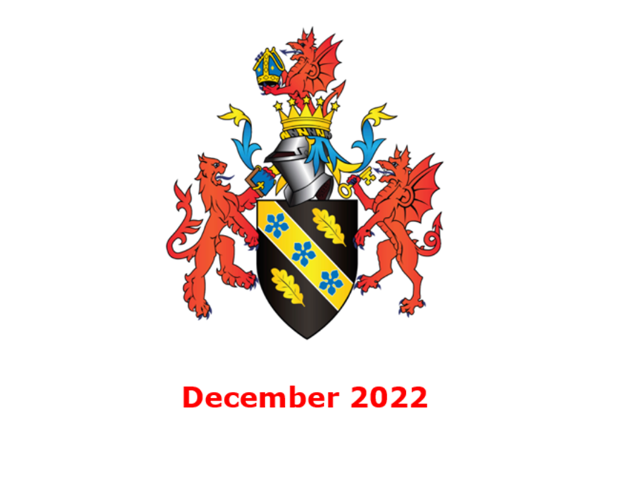
MODULE NAME：MBA Marketing Management (BMMB7012)
NAME: Li Yu
STUDENT NUMBER:2200374
Table of contents
Executive summary 3
Introduction 3
1.McDonald's marketing investment 4
1.1 Cross-border IP co-marketing 4
1.2 Green Restaurant Project 5
1.3 Young creative marketing 6
2.Analysis of Macro-environment of McDonald's Marketing 7
2.1 Political environment analysis 7
2.2 Economic environment analysis 7
2.3 Social environment analysis 9
2.4 Technical environment analysis 9
3.Micro-environment analysis: 10
3.1 Financial analysis 10
3.2 SWOT Analysis: 10
4.McDonald's Marketing Media Choices 11
4.1 online media: 11
4.2 traditional offline marketing: 12
5.McDonald's target market: 13
6.Conclusion 13
7.Recommendations: 14
7.1 Strengthen the development of McDonald's website and app 14
7.2 Minimize the construction of themed restaurants and replace them with the periphery. 15
7.3 Attach importance to the needs of customers and create a good experience. 15
7.4 Actively conduct market research and strengthen product innovation 15
References 16

Executive summary
This report analyzes the marketing situation of McDonald's. First of all, it enumerates a series of investments made by McDonald's in marketing. Then it analyzes the macro and micro environment of McDonald's marketing, and then analyzes the target market of McDonald's and the choice of marketing media. Finally, conclusions and suggestions are drawn on the content of the analysis.

Introduction
Marketing is not only a function, but also an activity, process and system in which an organization creates, communicates, spreads and transmits customer value for the benefit of itself and its stakeholders, and brings economic value to customers, customers, partners and the whole society. Mainly refers to the marketing staff for the market to carry out business activities, sales behavior process. (baike,2022)
McDonald's is a multinational catering enterprise, mainly selling hamburgers, French fries, cola and other food. Back in 1954, a man named Ray Kroc discovered a small hamburger restaurant in California and wrote the first page of McDonald's history. Starting from a humble small restaurant, McDonald's has become one of the world's leading food service brands, with more than 36000 restaurants in more than 100 countries.(McDonald's,2022) McDonald's ranks 223rd in the Forbes Global 2000(Forbes,2022), 40th in the 2022 Hurun Global 500(Hurun,2022), 152nd in the Fortune 2022(fortunechina,2022), 36th in the Brand Finance Global Brand value 500th(Brand Finance,2022), and 6th in the BrandZ Top 100 Most Valuable Global Brands (Kantar,2022). Whether it is product marketing or brand value creation, McDonald's has achieved great success. McDonald's shares are publicly traded on the New York Stock Exchange and have a long history of stable growth and stability. At the same time, the fast food culture represented by McDonald's is also sweeping the world, and more and more people are getting used to the diet of hamburgers and colas. Of course, with the continuous changes of the times, McDonald's is also constantly changing its brand image to comply with the trend of society.

1.McDonald's marketing investment

1.1 Cross-border IP co-marketing
McDonald's plan to invest $500m to develop a multi-purpose shopping mall in Oak Brook, a northwest suburb of Chicago, was finally approved. It is reported that the project is expected to cover an area of 17.5 acres and covers 250 rental apartments, 104 condominiums, a 252-room hotel, three restaurants, office areas, retail stores and parks.( Expo catering,2019) This is another major attempt by McDonald's in cross-border marketing. In fact, McDonald's has already started marketing in partnership with other ip. For example, in 2014, World of Warcraft and McDonald's officially launched cross-border cooperation, with a specially decorated World of Warcraft McDonald's restaurant in Beijing, Shanghai and Guangzhou. The points earned by customers through the purchase of designated McDonald's products can be exchanged for practical props, mounts, pets and toys in the game, and can also participate in COS shows, 3D photos, offline parties and other activities at the store, with close interaction online and offline. In 2015, Storm Hero and Fantasy Journey to the West partnered with McDonald's; in April 2017, McDonald's launched an offline "full-time master"-themed restaurant. Through the joint marketing with the hot IP at that time, it helped McDonald's improve the marketing performance of its themed restaurants through the fame bonus of these IP. But this kind of marketing method also has certain risk, cooperate with IP must pay a cooperation fee to IP, and build offline theme store need decoration cost. After the IP heat is over, it is necessary to redecorate the store, which are the costs to be considered. If the marketing growth deduction of offline theme stores is not enough to make a profit, these cross-border cooperation will fail. But in any case, these are some interesting attempts, and they are also good for raising brand awareness.

1.2 Green Restaurant Project
At the beginning of its rise, McDonald's was regarded as the representative of American fast food culture, and even aroused criticism and resistance from local food culture lovers in some countries. In order to improve its image, McDonald's has taken action under the guidance of the concept of saving environmental protection and low-carbon life. McDonald's China, the world's second-largest market, plans to open more than 1800 green restaurants from the end of 2018 to 2022, accounting for more than 95 per cent of all new restaurants. The restaurants will meet the certification standards of the "Interior Design and Construction" category of the Energy and Environmental Design Pioneer rating (Leadership in Energy and Environmental Design, "LEED") issued by the U.S. Green Building Council -from restaurant location and design, building materials and construction, to energy management, to reduce environmental impact and promote energy conservation and emission reduction. This is also the first batch certification of LEED Volume developed and applied in China, and the number of stores involved is the first in the Asia-Pacific region.(chinanews,2022)

1.3 Young creative marketing
McDonald's used to be a paradise for children because almost most McDonald's restaurants have children's entertainment areas to attract children to play. Therefore, many parents of McDonald's inevitably need to spend money at McDonald's when they enjoy parent-child time.By 2022, McDonald's has expanded from the warm image of paradise in the eyes of children in the past, focusing more on the younger consumers, and the marketing methods are getting younger and younger. After Apple added 300 emoi, McDonald's France immediately released a series of outdoor planes, using emoii to form a Big Mac, French fries, SHKP and Happy meal packaging. T Big Mac is made up of countless thumbs-up expressions. McDonald's wants to convey that it is awesome and delicious. French fries are made up of smiling faces, saying, "more choices, more laughter at McDonald's" McDonald's has also put out a set of "late Night Lights" posters, "The All Night", each poster has two lights to tell you that no matter how late, McDonald's is nearby, 24 hours a day to provide you with food and company, McDonald's is always there.(YingxiaoquanOFFER,2022)

2.Analysis of Macro-environment of McDonald's Marketing

2.1 Political environment analysis
Due to the influence of COVID-19 pandemic, the global economic growth rate is slowing down. In order to promote consumption, the US Congress passed the $2,000bn Coronavirus Assistance, Relief and Economic Security Act(CARES Act,2020) and the $900 billion bailout bill, handing out large amounts of dollars to every US citizen to stimulate consumption. Local governments in China have also launched government consumption volumes, which promote consumption by reducing the prices of goods through subsidies to businesses. To some extent, these government policies and measures have promoted the consumption of citizens and are conducive to the growth of McDonald's performance.

2.2 Economic environment analysis
According to data from the World Bank and the International Monetary Fund (IMF), global GDP shrank 3.6 per cent year-on-year in 2020, the lowest since the data were available, and economic growth in nearly 95 per cent of countries and regions was weaker than expected before the outbreak. Since 2021, with the popularity of vaccination, the thinking of countries in dealing with the epidemic has become more accurate. In the face of more contagious new variants, only some countries briefly blocked and responded to the rapid spread of the epidemic in Delta and Omicron, and most countries basically did not experience a nationwide blockade for a long time (more than a month). We also note that economic activities in major countries are no longer as sensitive to changes in the epidemic situation as they were in early 2020. Superimposed by the low base in 2020 and the support of major countries' economic rescue policies, global economic activity has recovered significantly in 2021. According to IMF, more countries are returning to the long-term growth trend, with GDP levels in 196 countries and territories shrinking by 25 per cent from pre-epidemic expectations in 2021 compared with 2020. Just like the recovery after each crisis, the economic recovery under the epidemic also reflects the resilience of human society in the crisis to some extent. In 2022, with the continuation of the COVID-19 epidemic, supply bottlenecks, high inflation in major countries and geo-conflicts intensified, superimposed and weakened fiscal support measures, weakening the prospects for global economic growth. The trend of global economic recovery has begun to slow, with IMF forecasts showing that the gap between GDP levels in 196 countries and regions in 2021-2023 and those expected before the outbreak remains around 6 per cent. (IMF,2022)The unoptimistic economic environment has brought some trouble to McDonald's marketing, and people's consumption desire and consumption strength can not be improved, which puts forward higher requirements for McDonald's marketing strategy. McDonald's must come up with more competitive marketing means in order to attract customers to spend in the current economic environment and improve McDonald's performance.

2.3 Social environment analysis
The COVID-19 pandemic once brought strict control over social distance and social behavior. Employees diagnosed with COVID-19 will be quarantined, whether in the United States or elsewhere, greatly reducing McDonald's employee attendance. In China, social behavior is strictly controlled, promoting distribution or takeout rather than dining out. This requires McDonald's to improve its distribution service capacity. In addition, food safety and hygiene has always been a topic of public concern. McDonald's excellent supply chain management and strict food production control have won a certain reputation in the society, which is undoubtedly beneficial to McDonald's marketing.

2.4 Technical environment analysis
The most important thing in the catering industry is the formula of food, the supply of raw materials and preservation. Food recipes in different countries have different characteristics, which is difficult to measure from a unified point of view. However, with the development of science and technology, food transportation technology and fresh-keeping technology have been greatly developed. McDonald's does not have a very unique recipe, and its production process and food sources are clear rather than hidden secrets. But McDonald's food supply chain is very mature and has certain advantages in this respect.

3.Micro-environment analysis:

3.1 Financial analysis
McDonald's 2022 Q3 reported revenue of $5.872 billion, with a previous value of $6.201 billion, with an expected value of $5.72 billion, exceeding market expectations of 2.66%. Earnings per share were $2.68,2.76, and the expected value was $2.60. exceeded market expectations by 3.08%. McDonald's latest financial performance has exceeded market expectations, indicating that McDonald's is doing very well in the context of the COVID-19 epidemic.( McDonald's,2022)

3.2 SWOT Analysis:
Strengths: McDonald's advantage is that it has achieved rapid expansion through the franchise model. The number of stores is far ahead of other multinational catering enterprises. At the same time, McDonald's strictly controls the quality of food and establishes a complete training system to ensure the provision of high-quality service. The high standard of food and service makes McDonald's establish a good corporate image.
Weaknesses: McDonald's disadvantage is that the speed of product development is slow, resulting in McDonald's marketing rarely take new products as the marketing focus. Secondly, McDonald's product range is limited to ingredients such as fried chicken hamburgers and colas, which can not meet the diversified dietary needs of customers.
Opportunity: McDonald's is gradually moving into second-tier and third-tier cities, which have a large number of potential customers. And the economy of the second-tier cities is developing rapidly, and there is much room for per capita income to rise. Secondly, with the operation of McDonald's for many years, overseas markets have a high degree of acceptance of McDonald's. Cultural barriers are no longer an obstacle to the development of McDonald's.
Threat: McDonald's provides foods that are high in calories, which is not in line with the concept of healthy eating advocated today. Secondly, the differentiation between McDonald's and its competitors is not obvious enough. KFC, Pizza Hut and other enterprises also maintain a certain rate of expansion and will jointly seize market share with McDonald's.

4.McDonald's Marketing Media Choices

4.1 online media:
With the development of Internet technology, people are more and more inclined to shop through online channels such as shopping websites and mobile app. McDonald's complies with this trend by placing orders for food or set meals on its website. In China, McDonald's has developed a mobile phone app, which allows users to place orders and pay by downloading McDonald's app. At the same time, for consumers who do not want to download app, McDonald's has also developed WeChat Mini Programs and Alipay Mini Program, such convenient and diverse choices to give consumers great convenience. At the same time, in order to make consumers aware of McDonald's activities and discount information, McDonald's has developed its official Wechat account, which regularly tweets to attract consumers' attention. At the same time, McDonald's is also actively placing advertisements on social media platforms such as Weibo and Xiaohongshu to attract consumers through preferential activities and new product announcements. Of course, traditional TV advertising placement is also essential. These marketing of McDonald's effectively enhance the exposure and attractiveness of the brand. Unlike some luxury brands, McDonald's food prices are relatively low. And thanks to the rapid expansion of McDonald's, McDonald's has a large number of restaurants and a wide range of distribution. After seeing the advertising marketing, people can try it at a lower price to the nearby McDonald's restaurant, which brings a good marketing effect.

4.2 traditional offline marketing:
In addition to advertising on social media platforms and television media, McDonald's also attracts consumers by placing advertisements in places such as bus stops and elevators in residential areas. There is a large flow of people in these places, and because advertisements are placed in the form of posters rather than alternately, people will not miss advertising messages, which is its advantage over online media marketing. And McDonald's advertising area is a dense area of McDonald's stores, people are easy to find nearby stores for consumption after seeing the advertisement, so that advertising marketing can be more effectively transformed into passenger traffic.

5.McDonald's target market:
McDonald's target audience is so wide that it can be considered as McDonald's target audience from children aged 5 or 6 to people in their sixties. Such a large target audience naturally requires McDonald's to provide a large number of restaurants to provide food and services. So the speed of McDonald's expansion is also surprising. McDonald's plans to open 1300 new stores worldwide, of which 800 are in China, according to McDonald's third quarter 2022 results. This surpassed the pace of opening stores in China in 2021 and reached an all-time high. After having more than 4000 stores in China in 2021, McDonald's plans to open more than 500 stores in 2021, an average of one every 17 hours-and now the company plans to speed up again. As of September 30, McDonald's had 39980 stores worldwide, of which 4905 were in the Chinese market. ( McDonald's,2022)

6.Conclusion
McDonald's marketing is undoubtedly successful. As a leading enterprise in the global catering industry, McDonald's attaches great importance to marketing investment. Through cross-border IP cooperative marketing, building a green restaurant and other ways to improve the brand awareness and improve the brand image. However, the investment of offline-themed restaurants is large and needs to be treated with caution. Macroscopically, the slowdown of global economic growth brought about by the COVID-19 epidemic is a disadvantageous factor for the marketing environment of McDonald's, but the policies introduced by governments to stimulate the economy and deal with the impact of COVID-19 's epidemic have also promoted McDonald's marketing to a certain extent. McDonald's excellent food transportation and health security have created a good reputation for McDonald's and laid a good foundation for McDonald's marketing. The financial report of McDonald's Q3 in 2022 also reflects the public's high acceptance of McDonald's recent marketing and willingness to spend at McDonald's. McDonald's has a wide target audience, and the pace of store expansion is accelerating in order to seize the market. At the same time, McDonald's has invested heavily in online social media and offline advertising platforms, which have also raised McDonald's awareness and attracted a lot of traffic. But McDonald's marketing also has disadvantages. Compared with competitors KFC and Pizza Hut, the launch speed of new McDonald's products is slower, and the combination of localization of products is at a disadvantage. As a result, McDonald's marketing seldom focuses on new products, and it is more often carried out in the way of preferential activities.

7.Recommendations:

7.1 Strengthen the development of McDonald's website and app
With the popularity of mobile communication devices, online websites and mobile phone software are becoming more and more popular. McDonald's should strengthen the development and maintenance of its website and app. Launching some interesting marketing activities on the website and app will strongly attract consumers.

7.2 Minimize the construction of themed restaurants and replace them with the periphery.
The construction cost of the offline themed restaurant is high, and it needs to be redecorated after the end of the cooperation period. By contrast, buying a McDonald's package and giving it to the surrounding area can save a lot of money.

7.3 Attach importance to the needs of customers and create a good experience.
Customer needs are varied, changeable, and more detailed. Enterprises can gather through digital technology. Member information and accumulation of historical data, and do user portraits and user behavior analysis, including user consumption preferences, consumption habits, consumption frequency, etc., so as to improve the level of service and meet the personalized needs of the new generation of consumers. For example, McDonald's can collect customer comments on Coke and consumption data on various platforms and replace large cups of Coke with appropriate size specifications. This kind of comprehensive analysis and fine management of business historical data can reduce the waste of food and improve the accuracy of predicting consumer preferences.(Chen Lei,2021)

7.4 Actively conduct market research and strengthen product innovation
Product is the root of marketing, and innovation is the soul of product. McDonald's product innovation department should actively distribute questionnaires and encourage consumers to fill in questionnaires in the form of incentives. Through the analysis of the results of the questionnaire to find the right direction of product innovation

References
1. Brand Finance(2022) BrandFinance Global 500 (100) Available at: https://www.rankingthebrands.com/The-Brand-Rankings.aspx?rankingID=83(Accessed: 9 December 2022)
2. Baike(2022)Marketing Available at: https://baike.baidu.com/item/%E5%B8%82%E5%9C%BA%E8%90%A5%E9%94%80/45718?fr=aladdin(Accessed: 9 December 2022)
3. Chen Lei (2021)Study on Localization Strategy of Multinational Catering
Enterprises in China Unpulished
4. Congress of the United States(2020) CARES Act Available at: https://www.congress.gov/116/bills/hr748/BILLS-116hr748enr.pdf(Accessed: 10 December 2022)
5. Chinanews(2022) McDonald's China CEO Zhang Jiayin: the Chinese market provides a unique development opportunity for McDonald's Available at: https://www.chinanews.com.cn/cj/2022/11-03/9886430.shtml(Accessed: 10 December 2022)
6. CHEN Ke-ke and FU Xiao-tong(2022) Analysis of Creative Design Elements
of Mcdonald’s Brand Advertising. Green Packaging Research · Design, PP 126-130, DOI: 10.19362/j.cnki.cn10-1400/tb.2022.08.028
7. Expo catering(2022) It is the most successful marketing of McDonald's. Available at: https://m.canyin88.com/zixun/2019/06/25/73679.html((Accessed: 10 December 2022)
8. Fahy, J., and Jobber, D., (2015), Foundations of Marketing, 5th edition, London: McGraw-Hill
9.Fortunechina(2022) America's top 500 enterprises Available at: http://www.fortunechina.com/america500/107/2022(Accessed: 9 December 2022)
10.Gao Hui(2020) Research on the Development Strategy of McDonald's Company,Master, Northwestern University
11. IMF(2022) World Economic Outlook, October 2022: Countering the Cost-of-Living Crisis Available at: https://www.imf.org/en/Publications/WEO/Issues/2022/10/11/world-economic-outlook-october-2022(Accessed: 10 December 2022)
12.Jobber, D., and Ellis-Chadwick, F., (2016), Principles and Practice of Marketing ,7th revised edition, Berkshire: McGraw-Hill
13.Kantar(2022) BrandZ Top 100 Most Valuable Global Brands Available at: https://www.rankingthebrands.com/The-Brand-Rankings.aspx?rankingID=6(Accessed: 9 December 2022)
14.Kotler P and Chernev, A. (2014), Strategic Marketing Management, 8th edition, Cerebellum Press
15. Lynch, R., (2015), Strategic Marketing ,7th edition, Harlow: Pearson
16.Lutgarda M. Wylengco(2020) The impact of CORONA VIRUS DISEASE 2019 to mulitinational fast food restraurants Unpulished. McDonald's(2022) Q3 Earnings Release Available at: https://corporate.mcdonalds.com/corpmcd/investors.html(Accessed: 10 December 2022)
17.Liu Chaowei(2017) the Research on the Localization ofMcDonald ’s Advertisement in China. Master, Xinan University
18.McDonald's(2022)About us Available at: https://www.mcdonalds.com/us/en-us/about-us.html(Accessed: 9 December 2022)
19. Niuniu Finance(2022)McDonald's, what is the internal asset environment, and what are the specific development advantages and disadvantages? Available at:https://baijiahao.baidu.com/s?id=1734487411636386502&wfr=spider&for=pc(Accessed: 10 December 2022)
20.Peng Cheng and Wu Qi(2003) McDonald's marketing pulisher: China Economic Publishing House
21.PENG Xin(2020) Research on Marketing Strategy of McDonald Pro APP,Master, Hunan University
22. Pride, W.M., and Ferrell, O.C. (2016), Marketing: Concepts and Strategies, 7th ed, Houghton Mifflin
23.Sun Yishan（2022）Research on chain Management Model: McDonald's VS Starbucks.SHANGYE JINGJI,56,PP44-47, DOI:10.19905/j.cnki.syjj1982.2022.12.040
24.Xinlang Finance(2020) "Boots landed"! The US Congress passes a $900 billion bailout bill Available at: https://baijiahao.baidu.com/s?id=1686758083279884304&wfr=spider&for=pc(Accessed: 10 December 2022)
25.YingxiaoquanOFFER(2022) The Marketing Road of McDonald's Available at: https://zhuanlan.zhihu.com/p/561175375(Accessed: 9 December 2022)

