

Comparing OSINT tools and creating Standard Operating Procedures for different OSINT investigations and incidents within DVLA.

by
Donna Kennett

Supervisor: Dr Nitheesh Kaliyamurthy

Project submitted as part of the requirements for the award of BSc (Hons) Computing (Computer Networks and Cybersecurity)

July 2023

DECLARATION

I, Donna Marie Rose Kennett declare that I am the sole author of this Project; that all references cited have been consulted; that I have conducted all work of which this is a record, and that the finished work lies within the prescribed word limits.

This work has not previously been accepted as part of any other degree submission.

Date: 21st July 2023

FORM OF CONSENT

I Donna Marie Rose Kennett hereby consent that my Project, submitted in candidature for the B.Sc. (Hons) Computing (Computer Networks and Cybersecurity) degree, if successful, may be made available for inter-library loan or photocopying (subject to the law of copyright), and that the title and abstract may be made available to outside organisations.

Date: 21st July 2023

Abstract
Over 2000 years ago, Aristotle wrote about humans need for knowledge [1]. Today, information is available at anytime, anywhere and at an unprecedented scale. With rapid advances in computing technology and accessibility this is expected to grow exponentially.
The cyber threat landscape is evolving and more organisations are facing the threat of cyber-attacks. In 2022, 39% of United Kingdom (UK) businesses identified a cyber-attack, 83% of those were the result of a phishing attack [2].
The aim of this project was to compare Open Source Intelligence (OSINT) tools and techniques to create a weekly OSINT process and Standard Operating Procedures for incidents and ad hoc investigations.
Tools and techniques were compared, attack surfaces created and tools mapped to the Cyber Kill Chain.
Focus groups and surveys were used to design and evaluate the new processes using quantitative and qualitative measures.
The improvement to efficiency, accuracy and confidence resulting from the new processes was beyond expectations.
This report demonstrates how OSINT can be used to improve the investigation of cyber security incidents with structured processes, the correct skills and tools.
Keywords: Open Source Intelligence, Attack Surface Mapping, Cyber Kill Chain, MITRE ATT&CK, Structured Analytic Techniques.

Table of Contents
List of Tables 10
List of Figures 11
1 Introduction 15
1.1 Current UK Threat Landscape 17
2 Background 19
3 Project Aims and Objectives 21
3.1 Aims 21
3.2 Objectives 21
4 Literature Review 22
4.1 Intelligence 22
4.1.1 Definition 22
4.1.2 Intelligence Sources 22
4.2 Cyber Threat Intelligence 23
4.2.1 Definition 23
4.3 Open-Source Intelligence 24
4.3.1 Definition 24
4.3.2 Case Study – OSINT used for good 24
4.3.3 Case Study – OSINT used for bad 24
4.4 OSINT and Cybersecurity 25
4.5 OSINT and Incident Response 25
4.5.1 The Cyber Kill Chain 26
4.5.2 MITRE ATT&CK 28
4.5.3 The Diamond Model for Intrusion Analysis 30
4.6 Types of OSINT 31
4.7 OSINT Advantages and Disadvantages 32
4.8 OSINT Requirements and Security Threats 36
4.9 Collection Sources 37
4.10 Frameworks 38
4.11 OSINT Tools 39
4.12 Intelligence Life Cycle 40
4.13 Processing and exploitation 41
4.14 Analysis and Production 42
4.15 Analytical Judgement 43
4.16 Decision Making 44
4.17 Expressing Confidence in Analytic Judgments 45
4.18 Cognitive Biases and Logical Fallacies 46
4.18.1 Cognitive Biases 46
4.18.2 Case Study 48
4.19 Logical Fallacies 48
4.20 Structured Analytic Techniques 49
4.20.1 Analysis of Competing Hypotheses 49
4.20.2 Structured Analytic Techniques Tools 50
5 Research and Development Methodology 51
5.1 Research Design 51
5.2 Research Philosophy 52
5.3 Research Approach 52
5.4 Choice 52
5.5 Research Strategy 52
5.6 Time Horizon 52
5.7 Techniques and Procedures 53
6 Design 54
6.1 Project requirements and restraints 54
6.1.1 Business requirements 54
6.1.2 User requirements 54
6.2 Selecting Cybersecurity Incidents and Investigations 54
6.3 Prioritising cybersecurity incidents and investigations that could be enhanced with OSINT 56
6.4 Comparing similar OSINT tools 56
6.5 Designing the test environment 57
6.6 Designing the OSINT Platform 57
6.7 Designing testbeds to compare and create standard operating procedures. 57
6.8 Designing confidence and usability testing 58
6.9 To create standard operating procedures based on tool comparison and user requirements, using measurable and quantitative inputs. 59
6.10 Analyse the new operating procedures and evaluate its performance. 59
7 Implementation 60
7.1 Data Source Reliability 60
7.2 Current OSINT process 60
7.3 OSINT tools for each stage of the Cyber Kill Chain 60
7.4 The new OSINT platform 61
7.5 New Weekly OSINT process 63
7.5.1 News 63
7.5.2 Social Media 64
7.5.3 Breach Data 65
7.5.4 Typo squatted domains 66
7.5.5 Infrastructure 66
7.6 Incidents and Investigations 67
7.6.1 Username Investigations 68
7.6.2 Email Address Search 69
7.7 Analytic Confidence Guide 70
7.8 Analysis and Reporting Template 71
8 Results 72
8.1 Platform testing 72
8.2 Tool testing 72
8.3 OSINT Weekly Checks 74
8.4 User testing accuracy 75
8.5 User testing time taken 77
8.6 Confidence 78
8.7 Standard Operating Procedures User Testing 79
8.8 Evaluation 80
9 Conclusion and Recommendations 81
9.1 Future Work 81
9.2 Reflection 82
10 References 83
11 Appendices 113
Appendix A: Glossary of Terms 113
Appendix B: MOSCOW Prioritisation 115
Appendix C: Full List of Tools 116
Appendix D: Confidence Assessment of Information Sources 119
Appendix E: Current OSINT Weekly Process 121
Appendix F: Current OSINT Tools 122
Appendix G: Initial OSINT Satisfaction Questionnaire 123
Appendix H: Initial Satisfaction Questionnaire Responses 124
Appendix I: OSINT Tool Survey Questionnaire 125
Appendix J: OSINT Tool Survey Results 126
Appendix K: Tool Comparison 130
Web Browsers 130
Search Engines 132
Browser Extensions 134
Harvesting Web Data 135
Language Translation 136
File Metadata Analysis 138
Reverse Image Search 139
Usernames and Avatars 139
Email Addresses 141
IP Addresses 141
Domain Lookups 143
WHOIS 144
Infrastructure 145
Website Analysis 146
Breached Data 147
Social Media Monitoring 148
OSINT Automation 149
Appendix L: Attack Surface Mapping for OSINT 150
Appendix M: Standard Operating Procedures 155

List of Tables
Table 1: Types of Attack Surface 15
Table 2: Cybersecurity attacks by attack vector 16
Table 3: Intelligence Source Categories 23
Table 4: MITRE'S definitions of TTPs 30
Table 5: Passive vs Active OSINT 31
Table 6: OSINT Advantages and Disadvantages 32
Table 7: The most common biases in CTI and OSINT 47
Table 8: Types of Logical Fallacies 48
Table 9: Focus Group Demographic 55
Table 10: Analytic Confidence Guide 70
Table 11: Platform test results 72
Table 12: Tool testing results 72
Table 13: OSINT Weekly Checks 74
Table 14: User accuracy testing results 75
Table 15: User testing time result (in minutes) 77
Table 17: User Confidence Levels Comparison 79
Table 17: Glossary of Terms 113
Table 18: Full List of Tools 116
Table 19: Confidence Assessment of Information Sources 119
Table 20: Current OSINT Tools 122
Table 20: Initial Questionnaire Responses 124
Table 22: OSINT Tool Survey Results 126
Table 23: Web Browser Comparison 130
Table 24: Search Engine Comparison 132
Table 25: Browser Extension Comparison 134
Table 26: Harvesting Web Data Tool Comparison 135
Table 27: Language Translation Tool Comparison 136
Table 28: File Metadata Analysis Tool Comparison 138
Table 29: Reverse Image Search Tool Comparison 139
Table 30: Username and Avatar Tool Comparison 139
Table 31: Email Address Tool Comparison 141
Table 32: IP Address Tool Comparison 141
Table 33: Domain Lookups Tool Comparison 143
Table 34: WHOIS Tool Comparison 144
Table 35: Infrastructure Tool Comparison 145
Table 36: Website Analysis Tool Comparison 146
Table 37: Breached Data Tool Comparison 147
Table 38: Social Media Monitoring Tool Comparison 148
Table 39: OSINT Automation Tool Comparison 149

List of Figures
Figure 1: Domain Attack Surface for OSINT 16
Figure 2: UK cybersecurity attacks in the first three months of 2023 17
Figure 3: Kevin Mitnick's Social Engineering Attack Cycle 18
Figure 4: Determining the organisations threat landscape 18
Figure 5: Cyber Incidents affecting the UK public Sector 19
Figure 6: The UK Government Cybersecurity Strategy 20
Figure 7: Data accessible by OSINT 25
Figure 8: The Cyber Kill Chain 26
Figure 9: Cyber Kill Chain Phase Detection 27
Figure 10: Courses of Action Matrix 27
Figure 11: Extract from the Enterprise MITRE ATT&CK matrix for Windows Platform [37] 29
Figure 12: Extract of MITRE ATT&CK Reconnaissance techniques for Enterprise environments 29
Figure 13: The Diamond Model for Intrusion Analysis 31
Figure 14: Hwang et. al proposed OSINT Security solution for the collection, access and storage of OSINT data 37
Figure 15: Your OSINT Graphical Analyser (YOGA) showing social media search pivot points (in purple) 39
Figure 16: The relationship of Data, information and intelligence [59] 40
Figure 17: The Intelligence Life Cycle 41
Figure 18: Sherman Kent's Analytic Principles 42
Figure 19: Heurer's Illusion 44
Figure 20: The Peterson Table of Analytic Confidence 46
Figure 21: Heuer’s ACH process 50
Figure 22: Illustration of Research Design 51
Figure 23: Saunder’s Research Onion 51
Figure 24: Potential Standard Operating Procedures 55
Figure 25: Basic OSINT process 58
Figure 26: OSINT tools for each stage of the Cyber Kill Chain 60
Figure 27: Choosing and Configuring the OSINT platform 61
Figure 28: Maltego 62
Figure 29: OSINT TweetDeck 62
Figure 30: New weekly OSINT process 63
Figure 31: Google Alerts 63
Figure 32: Social Mentions search filters 64
Figure 33: Social Searcher search filters 65
Figure 34: SOCRadar Breached Data Incident Notification 65
Figure 35: Use Dnstwister.report for possible typo squatted domains 66
Figure 36: Maltego Level One Footprint machine 67
Figure 37: Search Engine Flowchart 68
Figure 38: Username Attack Surface 68
Figure 39: Username Search Flowchart 69
Figure 40: Email Attack Surface 69
Figure 41: Email Address Search 70
Figure 42: ACH Template 71
Figure 43: Weekly OSINT Process Accuracy Comparison 76
Figure 44: Weekly Accuracy Baseline Comparison 76
Figure 45: Weekly OSINT process average time comparison 78
Figure 46: Average yearly OSINT weekly process cost comparison in pounds 78
Figure 47: MOSCOW Process Prioritisation 115
Figure 48: OSINT Satisfaction Questionnaire 123
Figure 49: OSINT Tool Survey Questionnaire 125
Figure 50: Website Attack Surface 150
Figure 51: IP Address Attack Surface 150
Figure 52: Person Attack Surface 151
Figure 53: Twitter Attack Surface 151
Figure 54: TikTok Attack Surface 152
Figure 55: Reddit Attack Surface 152
Figure 56: LinkedIn Attack Surface 153
Figure 57: Instagram Attack Surface 154
Figure 58: Dark Web Attack 154
Figure 59: Domain Investigation Flowchart 155
Figure 60: WHOis Process Flowchart 155
Figure 61: DNS Query Process Flowchart 156
Figure 62: People Search Investigation Flowchart 156
Figure 63: Web Site Investigation Flowchart 157
Figure 64: Analytic Code Flowchart 157
Figure 65: Examining HTTPS Certificate Flowchart 158
Figure 66: General Social Media Investigation Flowchart 158
Figure 67: Reverse Image Search Flowchart 159
Figure 68: Extracting File Metadata Flowchart 160

Introduction
This project looks to use Open Source Intelligence (OSINT) tooling with the Cyber Kill Chain to enhance cybersecurity incidents and investigations at Driver and Vehicle Licensing Agency (DVLA).
The Identity Theft Resource Center (ITRC) [3] reported 422.1 million victims of data breaches in the United States (US) in 2022, this was 41 percent more than in 2021. Cyber-attacks remain to be the primary source of data breaches [3].
To protect against a cyber-attack, you must understand your attack surface and attack vectors.
An attack surface are the places where an attacker can try to enter, cause an effect on, or extract data from a network or system [4]. OSINT is used in the first part of a security assessment, often called reconnaissance, to understand the attack surface.
There are three types of attack surface [3]: digital, physical and human (Table 1).
Table 1: Types of Attack Surface
Types of Attack Surface | Description
Digital | Includes the entire network and software environment of an organisation (Figure 1).
Physical | This includes all an organisation’s endpoint devices.
Human | This is the amount of authorise uses who are unprepared for or vulnerable to social engineering attacks. The most prevalent of which is a phishing attack [2].

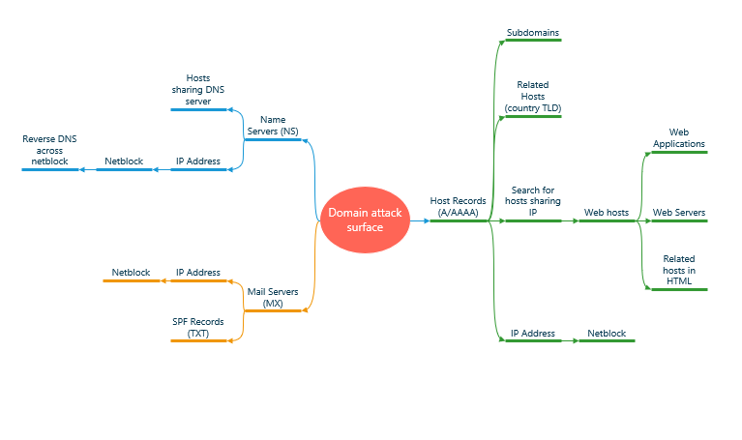
Figure 1: Domain Attack Surface for OSINT
OSINT can be used to monitor the attack surface and establish what unintended exposures may be available to an attacker.
While an attack surface is what is being attacked, an attack vector is how it is being attacked. An increasing attack vector is supply-chain attacks. There were 40 percent more supply chain attacks than malware attacks in 2022 [3]. Phishing attacks remain the leading cause of breaches [2] [3] (Table 2).
Table 2: Cybersecurity attacks by attack vector
Attack Vector | 2020 | 2021 | 2022
Phishing/Smishing | 461 | 537 | 383
Ransomware | 276 | 352 | 158
Malware | 70 | 141 | 104
Non-secured cloud environment | 9 | 24 | 50
Credential Stuffing | 18 | 14 | 17
Unpatched Software | - | 4 | 1
Zero-day attack | 8 | 4 | 1
Other | 26 | 426 | 162
Not Specified | 727 | 111 | -
Total Cyber Attacks | 1595 | 1613 | 878

Current UK Threat Landscape
The UK faces a range of national security threats. Understanding these threats will ensure the correct protective security measures are put in place. The current national UK threat level provided by MI5 is substantial [5]. Open Source and other intelligence sources are used by MI5’s Joint Terrorism Analysis Centre (JTAC) to set the threat level [6].
On 13th March 2023, MI5 launched the National Protective Security Authority (NPSA) to help businesses and organisations defend themselves against national security threats [7]. NPSA works with the National Cyber Security Centre (NCSC) [8] to develop security guidance informed by intelligence.
There were an estimated 2.39 million cyber-crimes affecting UK business in the past 12 months [2] and over 150 cyber-attacks already in the first quarter of this year [9] (Figure 2).

Figure 2: UK cybersecurity attacks in the first three months of 2023
The latest NCSC review [10] found ransomware remains to be the most serious threat with phishing emails as the successful attack vector. Research by Barracuda Networks found two-thirds of all breaches in 2022 resulted from spear phishing [11].
An expert in Social Engineering Attacks [12] [13], Kevin Mitnick [14] describes the first step of every social engineering attack is researching publicly available sources (Figure 3).
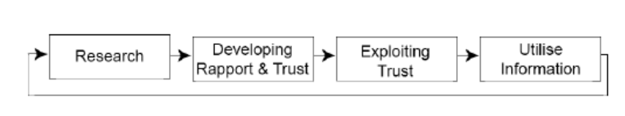
Figure 3: Kevin Mitnick's Social Engineering Attack Cycle
Understanding what threats that may potentially impact your organisation, including what type of data or system they may target, can help protect against attacks, and identify where additional resources are needed.
“Cybersecurity threat is diversifying and evolving” Sir Jeremy Fleming, Director GCHQ [10]
There are four steps for determining your organisations threat landscape [15] (Figure 4).

Figure 4: Determining the organisations threat landscape
This situational awareness not only allows you to understand the current situation it can help with forecasting [15].

Background
DVLA is an executive agency of the Department of Transport [16]. It collects over £7 billion a year in Vehicle Excise Duty (VED) and is responsible for holding more than fifty million driver records and more than forty million vehicle records [16]. ​
Between September 2020 and August 2021, 40% of all cyber incidents managed by NCSC affected the public sector [17] (Figure 5).
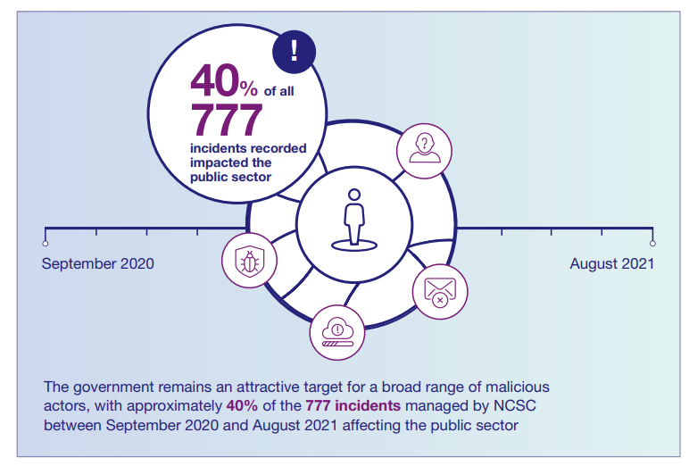
Figure 5: Cyber Incidents affecting the UK public Sector

DVLA is part of the UK’s critical national infrastructure [18]. Any loss or compromise of driver or vehicle data could have significant impact on national security, policing, defence, or the ability for the government to provide essential services. On 19th April 2023, NCSC issued an alert for heightened threat to critical national infrastructure [19] and advises organisations to check their internet footprint when national threat is heightened [20]. OSINT can be used to find an organisations technical footprint.
The first UK Government Cyber Security Strategy (GCSS) launched this year [7]. Its main aim is to harden government systems from cyber-attack (Figure 6).
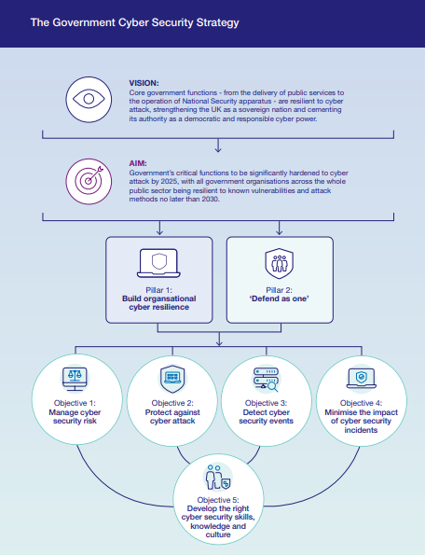
Figure 6: The UK Government Cybersecurity Strategy
Prior to the COVID pandemic cybersecurity analysts conducted a manual OSINT process weekly. Due to hybrid working a more efficient process is needed to help meet the first four objectives of the new GCSS.

Project Aims and Objectives

Aims
This project aims to improve OSINT investigations and incidents at the DVLA by comparing similar OSINT tools and techniques.
To create Standard Operating Procedures based on this comparison and user requirements.

Objectives
- To review existing literatures relating to Open-Source intelligence, tools, standards, and frameworks. ​
- To select appropriate research methods to compare similar OSINT tools.
- To design testbeds to compare and create Standard Operating Procedures. ​
- To improve usability and confidence with the OSINT process, using measurable and qualitative feedback from the end users.
- To create Standard Operating Procedures based on the comparison and user requirements, using measurable and quantitative inputs. ​
  - To improve quality of investigations with standard processes, sources, and tools. ​
  - To use available toolsets and automation. ​
- Finally, to analyse the operating procedures and evaluate its performance.

Literature Review
To understand the use of OSINT in the field of cybersecurity and incident response a review of technical and scholarly research was undertaken. This chapter seeks to answer the following questions:
- What is OSINT?
- How is OSINT used in cybersecurity?
- How is OSINT used in incident response?
- How can OSINT improve investigations?
- How to improve analytical judgements?

Intelligence
Intelligence is both the product and the process of collecting, processing, and analysing information [21].
    - Definition
Despite being 70 years old the following definition is still one of the most widely applicable definitions of intelligence today:
“Intelligence deals with all the things which should be known in advance of initiating a course of action” Clark Task Force [22].
    - Intelligence Sources
Classic Intelligence Sources can be categorised by collection and analysis, using human or technological means [23] (Table 3).

Table 3: Intelligence Source Categories
Common acronym | Description | Example
GEOINT | Geospatial intelligence collection | Geographical images from satellites
HUMINT | Human intelligence collection | Whistle blower
MASINT | Measurement and Signature intelligence collection | Nuclear detonation signatures
OSINT | Open-source intelligence collection | Public records
SIGINT | Signal intercepts | Tapping communication lines

Unlike classic intelligence, Cyber Threat Intelligence (CTI) is not split into the areas it was collected. Instead it uses various sources to meet its requirements [24].

Cyber Threat Intelligence
CTI is evidence-based, actionable knowledge used to support decision-making [23].
Matilainen’s [25] qualitative study of CTI in cyber defence found strategic and tactical CTI can enhance cyber defence if used effectively.
Within the DVLA, CTI analysts perform analysis across malware, domains, tradecraft, victimology, and open-source data.
    - Definition
There are several definitions for CTI available, however, the UK National Computer Emergency Response Team (CERT-UK) provides the most comprehensive:
“Threat Intelligence is evidence-based knowledge, including context, mechanisms, indicators, implications and actionable advice, about an existing or emerging menace or hazard to assets that can be used to inform decisions regarding the subject’s response to that menace or hazard” CERT-UK [23].

Open-Source Intelligence
OSINT is an important part of threat intelligence. It expands the knowledge about a target [26] and enables organisations to identify and mitigate risks, which otherwise would be unknown, to better protect their networks and systems from potential threats [23].
“If you know neither the enemy nor yourself, you will succumb in every battle.” Sun Tzu, The Art of War [27]
    - Definition
OSINT is simply the process of searching, gathering and analysing data in the public domain or accessible from public sources [28].
This includes media such as audio, videos, and pictures. Text from documents, blogs and articles, maps, and geolocation of data [29].
    - Case Study – OSINT used for good
In 2018, the former Russian spy Sergei Skripal and his daughter were poisoned in Salisbury, England. Bellingcat and The Insider worked together and used OSINT techniques to identify the suspects in the poisoning [30].
    - Case Study – OSINT used for bad
OSINT can also be used to identify and exploit threats. The NCSC [31] have reported Russian-based Seaborguim and Iran-based TA453 threat actors are using OSINT to conduct reconnaissance to target social engineering attacks against potential UK victims. Using the intelligence gained through reconnaissance, the attacker moulds the spear-phishing campaign to their victim.

OSINT and Cybersecurity
Also known as OSINT techniques [26], examples of some of the many data types collected during an OSINT investigation are shown below (Figure 7).
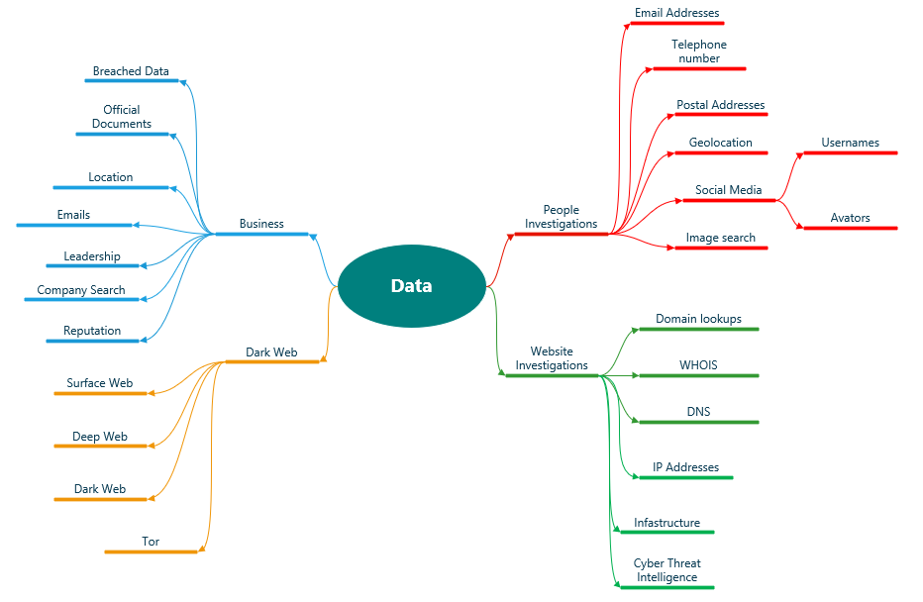
Figure 7: Data accessible by OSINT
Vulnerability assessments and OSINT are an important part of cybersecurity defence [32]. Technical Footprinting uses OSINT to discover vulnerabilities in IT systems [33]. This is the first task conducted by hackers (black and white hat) before attacking computer systems.
A 2023 systematic review by Reibe et al [29] found the primary use of OSINT was gathering CTI (74%), risk assessment and mitigation (12%), and only 4% used OSINT for both investigation and CTI purposes.

OSINT and Incident Response
There are three main models that can be used with OSINT to investigate cybersecurity incidents:
- The Cyber Kill Chain
- MITRE ATT&CK
- The Diamond Model for Intrusion Analysis
    - The Cyber Kill Chain
The Lockheed Martin Cyber Kill Chain [34] explains each stage of a cyber-attack. There are seven steps and each step must be complete for the adversary to achieve their objective [33]. At each step there is an opportunity to stop the attack (Figure 8).
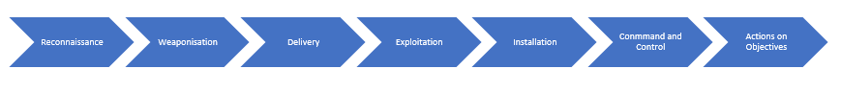
Figure 8: The Cyber Kill Chain
By knowing where along the kill chain the incident is detected (Figure 9), OSINT analysts can work with network defenders and incident responders to stop the attack using the Courses of Action Matrix (Figure 10).
OSINT analysts will then work back through the earlier stages of the Kill Chain to ensure no artefacts or attack vectors remain undetected.
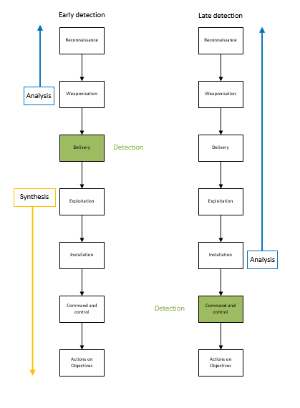
Figure 9: Cyber Kill Chain Phase Detection
The Courses of Action (COA) matrix [33] (Figure 10) is used to map actions against the stages of the Cyber Kill Chain.
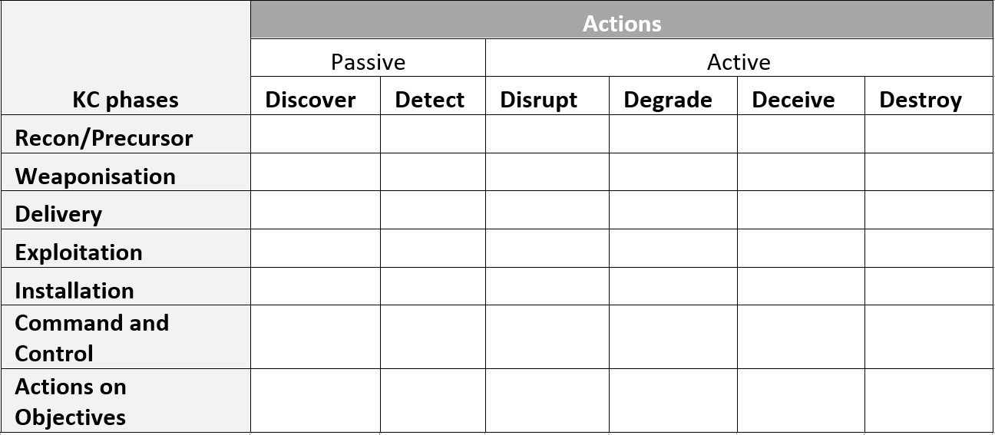
Figure 10: Courses of Action Matrix
- Discover – using an indicator or TTP (Tactics, Techniques and Procedures) to search historically and determine whether it has been seen below. For example, searching event logs for a malicious IP Address.
- Detect – identifying activity that may occur in the future. For example, creating a rule in the SIEM to alert when traffic is received from a certain domain.
- Deny – prevent an event from occurring in the first place. For example, adding an IP address to the external firewall deny list.
- Disrupt – interfere with an event so that it fails. For example, using an application sandbox.
- Degrade – interfere with an event to reduce efficacy. For example, Tom Linton’s LaBrea tar pitting approach by incrementally reducing the TCP (Transmission Control Protocol) window size to delay incoming connections [35].
- Deceive – provide misinformation to the adversary so they believe they were successful. For example, plant false email addresses on a website for future research.
- Destroy – offensive action that reduces capacity to operate. Must not be used without legal basis. For example, law enforcement arrests.
    - MITRE ATT&CK
MITRE ATT&CK [36] is an incredible framework documenting a vast amount of tactics and techniques observed in the real world (Figure 11).
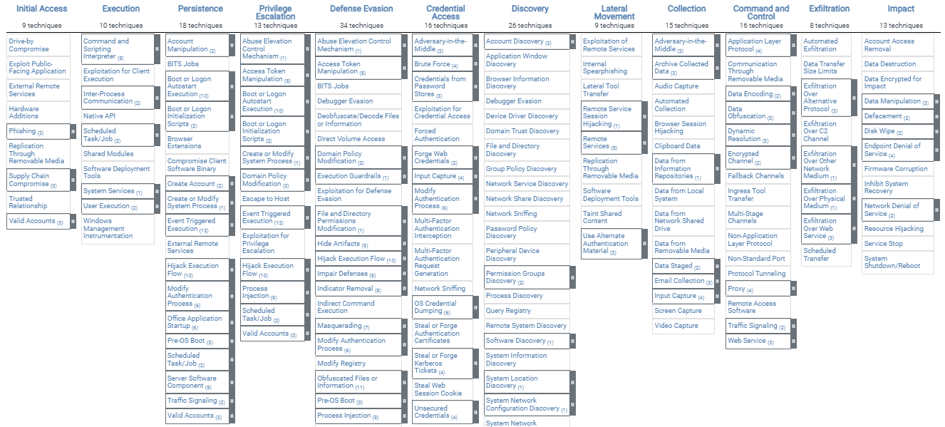
Figure 11: Extract from the Enterprise MITRE ATT&CK matrix for Windows Platform [37]
ATT&CK categories adversary goals as tactics. These tactics are broken down further into techniques and sub-techniques (Figure 12).
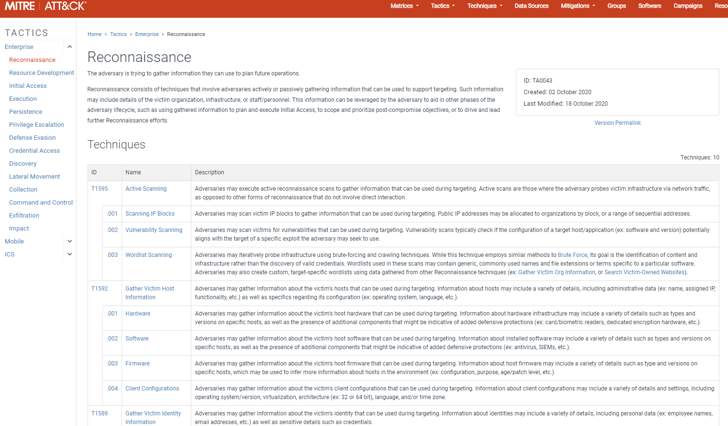
Figure 12: Extract of MITRE ATT&CK Reconnaissance techniques for Enterprise environments
There is a whole section on reconnaissance techniques which can be used for OSINT [38].
It is important to remember that ATT&CK has its limitations. It will never be complete, there will always be new TTP’s.
The framework should be used with OSINT to complement the Cyber Kill Chain. To use the frameworks effectively it is important to understand the differences in the way that MITRE defines TTPs (Table 4).
Table 4: MITRE'S definitions of TTPs
Tactics | Adversary’s technical goal.
Techniques | How the adversary achieves the goal.
Sub-techniques | More granular techniques (for example spear-phishing).
Procedures | Implementation of the technique or sub-technique.

    - The Diamond Model for Intrusion Analysis
Caltagirone et al [39] created this model whilst working for the US Department of Defence in 2014 (Figure 13). Created to analyse intrusion it can also be used to analyse a large amount of threat intelligence.
To use the model to its full capability it should be used alongside MITRE ATT&CK and the Kill Chain. Each phase of the Kill Chain will have an associated diamond model providing actionable intelligence and identifiable gaps.
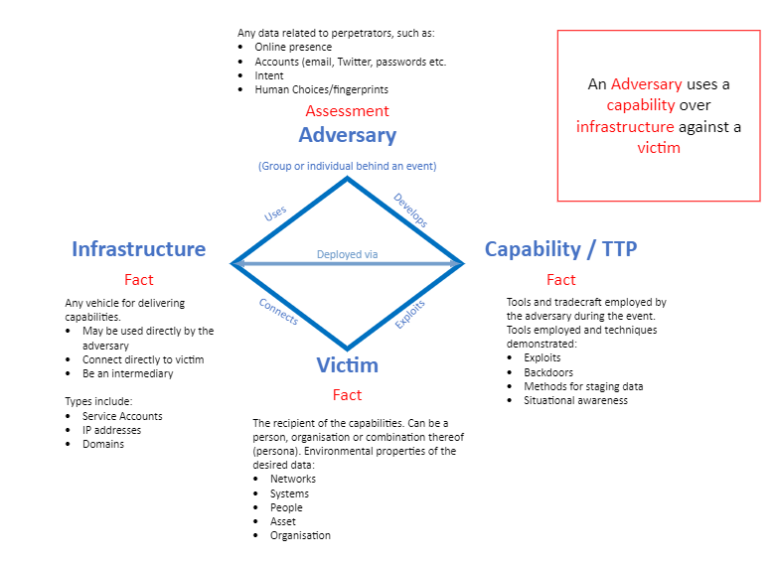
Figure 13: The Diamond Model for Intrusion Analysis

Types of OSINT
OSINT can passive or active (Table 5). Active tactics involve contact with the target and can be consider HUMINT (Chapter 4.1.2).
Table 5: Passive vs Active OSINT
Passive | Active
No engagement with the target | Engage with the target (or target’s contacts)
Slower | Faster
Minimal risk | Elevated risk
Active OSINT may have more social, legal and ethical implications [40]. A major requirement for this project is that the approach taken must be passive.

OSINT Advantages and Disadvantages
The development of Internet of Things (IoT) and Big Data has accelerated the advancement of OSINT [24] [28]. As the fields of application grows, so does the technical advantages and disadvantages (Table 6).
Table 6: OSINT Advantages and Disadvantages
Advantages | Disadvantages
Amount of available data | Data management complexity
Flexibility | Unstructured data
Cost | Vulnerable to inaccurate and misinformation
Provide real time information | Reliability
Provide actionable intelligence | Social, legal, and ethical concerns

A. OSINT Advantages
1) Amount of available data
There is a huge volume of open source data ready to be collected, analysed, and processed [26] [29] [40] [41]. This includes social networks, public documents, reports and online multimedia content on the surface web alone.
With the correct tools even more information is available on the Deep web and the Dark web [42]. There are social, ethical, and legal implications when accessing data on the deep and dark webs [40] [42].
2) Flexibility and Scope
OSINT can help a wide range of areas such as marketing, journalism, and policing [43]. This report concentrates on its uses within cybersecurity:
- Footprinting
- CTI
- Social Engineering/phishing attack prevention
- Forensics analysis
- Incident response
3) Cost savings
OSINT is less expensive compared to traditional information collection methods. Because OSINT uses open sources, information is always available, accessible and current. Traditional intelligence needs expensive equipment, is complex, specialist and very resource intensive.
4) Real time data
Real-time data is important for OSINT because it allows security teams to get critical insights faster. Giving organisations a better chance of mitigating threats and stay up-to-date on current events and emerging trends. Processing real-time data can also be challenging.
- Provides actionable intelligence
This is the main purpose of OSINT. OSINT is produced by collecting, evaluating and analysing raw data with the aim to answer a specific intelligence question. This intelligence can be used to support national security by identifying potential terrorist threats, law enforcement by tracking criminal activity or business intelligence by monitoring social media for public opinions or trends.
B. OSINT Disadvantages
1) Complexity of Data Management
The amount of data available for OSINT is vast, making it difficult to manage. Whilst it is important to consider as much information as possible, it is also important to have relevant tools and techniques in place to help collection, processing, analysis and storage.
2) Unstructured Information
The public information available on the Internet is often disorganised and unrelated [44]. This makes classifying, linking and analysing data difficult.
Techniques such as data mining [45], Natural Language Process (NLP) [46] and text analytics [47] have been shown to help standardise unstructured data [24]. Structured analytic techniques are used to put data into buckets for analysis [48] (Chapter 4.21).
3) Misinformation
The amount of open-source information on the internet is growing exponentially, there is an increasing probability that information is inaccurate, and intentionally or unintentionally misleading.
Misinformation and fake news tactics have been used for thousands of years [1]. The main difference now is the volume, speed and spread of information due to the internet.
“People by nature desire knowledge, we are also political and
social animals by nature.” Aristotle [1]

Social media networks contain subjective opinions, untruths and fake news [49]. The likelihood of inaccurate information must be taken into consideration. OSINT activities should always consider the reliability of the information, the source and credibility of the author [26].
Another type of misinformation to consider is counterintelligence. Counterintelligence identifies, assesses and counteracts adversary intelligence activities. CTI overlaps with counterintelligence but it is defensive, not offensive in nature.
Operation Bodyguard is an excellent example of counterintelligence [50]. Conducted by allied forces during World War II to confuse German forces and cause faulty strategic choices.
4) Data Sources Reliability
The trustworthiness and authority of the information are key for successful OSINT investigations. To guarantee data reliability it is necessary to validate data integrity and data sources [51]. However, in practice, OSINT will often need to use subjective sources, such as social media content. While these sources may be more prone to misinformation, they can also provide valuable insights into people, groups or companies.
The Blakeslee CRAAP test [52] can evaluate the reliability of information sources:
- Currency – is the information up-to-date and reflect current research?
- Relevance – is the information relevant?
- Authority – is this a respected publication? Examine the authors credibility and experience on the subject.
- Accuracy – can other sources verify this?
- Purpose – what is the purpose of the information, is it biased or objective?
Most OSINT investigations are conducted over a discrete period. To maximise the work performed in the time given, start by focusing on sites known to provide solid, trustworthy information and move to less trustworthy sites as the investigation proceeds. If the data gathered is inaccurate or less trustworthy, time is lost and the risk of missing vital intelligence increases.
Creating and using Standard Operating Procedures will provide consistency needed to both stay safe online whilst getting excellent results.
5) Ethical, Social and Legal Considerations
Numerous scholars [53] [54] [55] [56] have expressed ethical and social concerns about privacy, respect and personal data in relation to OSINT. Although the data is freely available users’ privacy must be respected [57].
The General Data Protection Regulation (GDPR) [58] is also relevant to the collection and storage of any OSINT data containing personal information [59] [60]. According to the GDPR act, personal data is information that relates to an identified or identifiable individual [58]. Identifiers such as an IP address is personal data if it can identify the individual [58]. Any breaches of collected personal data must be reported to the ICO (Information Commissioner’s Office) within 72 hours [58].
Organisational data protection and retention policies must also be adhered. If not correctly protected the data collected during the OSINT be used by an attacker.
These advantages and disadvantages were considered when designing the OSINT processes.

OSINT Requirements and Security Threats
Hwang et al [28] points out the “double-edge sword” of OSINT. It is vital to put in place good cybersecurity hygiene to keep confidentiality, integrity and availability of the data with adequate controls in place to mitigate the risk of security threats from misused OSINT data collections.
The collection and storage of the data collected should be careful managed with relevant access controls to prevent handing the preverbal “keys to the castle” to a would-be attacker. Hwang et al [28] proposed the following solution (Figure 14) which supplies the starting point for this project’s OSINT Platform requirements.
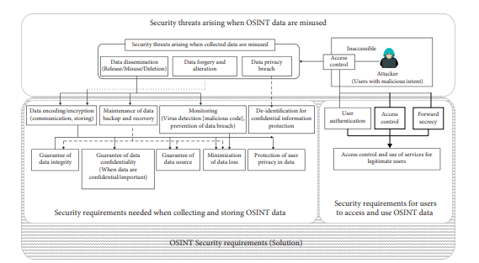
Figure 14: Hwang et. al proposed OSINT Security solution for the collection, access and storage of OSINT data

Collection Sources
Although OSINT can supply real time information. Data may not be truthful or correct. It is important to use trustworthy sources and distinguish valid and verifiable data from false or misleading data (Chapter 4.7).
Main sources of data [29] includes:
- Social media
- Threat advisories
- Blogs, Forums and Websites
- CTI-Feeds
- Commercial Datasets
- Dark Web Forums and Markets
It is important to consider the ethical, social and legal implications of each data sources along with its trustworthiness (Chapter 4.7).

Frameworks
There are a vast number of tools and sources which makes finding the correct tool confusing. Abdullah et al [61] presented a framework to find tools and information sources.
The online companion framework [62] to Hassan’s guide to Open-Source Intelligence Methods and Tools [63] supplies a categorised list of tools.
Peers from the OSINT community also recommend the following frameworks:
• Bruno Mortier’s OSINT Framework [64]
• The Ultimate OSINT Collection [65]
• Yoga.osint.ninja [66]
• Bellingcat’s Online Investigation Toolkit [67]
These frameworks provide a good starting point for OSINT investigations and were used to investigate data sources for use within the project.
The Yoga OSINT Ninja (Figure 15) is a particularly useful resource as it shows clear pivot points for different data types which will improve investigations.
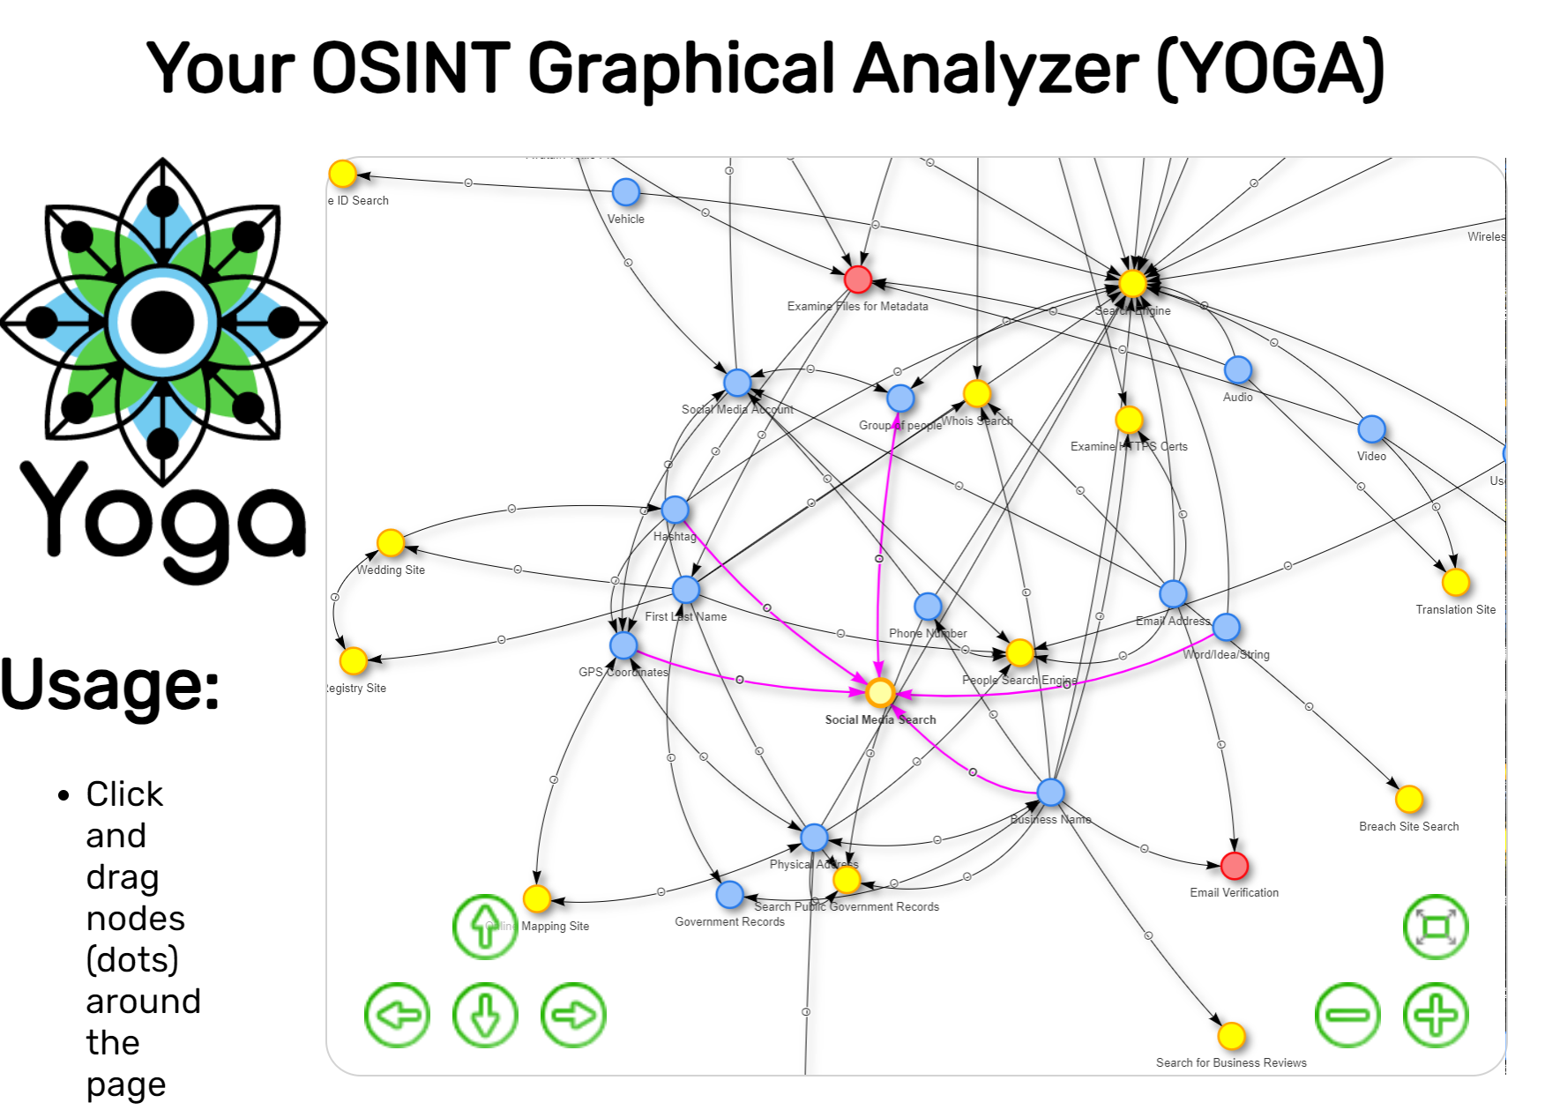
Figure 15: Your OSINT Graphical Analyser (YOGA) showing social media search pivot points (in purple)

OSINT Tools
OSINT tools are used to gather information from different publicly available sources [28] [40] [68] [69]. There are number of OSINT tools available which can be categorised as follows:
- Search Engines
- Harvesting Web Data
- Image Analysis
- Language Translation
- File Metadata Analysis
- Reverse Image Searching
Each organisation will have its own OSINT requirements; this project compares the tools needed for OSINT within the DVLA.
Yasmin et al [69] successfully identified and mapped OSINT tools to each stage of the Cyber Kill Chain [34] (Chapter 4.5.1). This project takes that report one stage further to create different Standard Operating Procedures for incidents and investigations along the Cyber Kill Chain using OSINT tools and techniques.

Intelligence Life Cycle
Data is just data until it has analysed (Figure 16). The collection, organisation and analysis of that data is important. This “intelligence” part of OSINT is key.
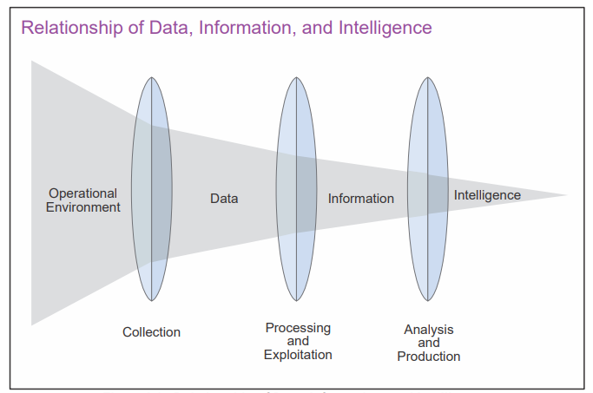
Figure 16: The relationship of Data, information and intelligence [59]
Based on the US Military Intelligence Lifecycle [21] the OSINT lifecycle (Figure 17) consists of five parts:
- Planning and direction stage, intelligence gaps are prioritised and methods for filling those gaps developed.
- Collection stage, data is collected to fill the intelligence gap.
- Processing and exploitation stage, data can be in different languages or formats, it is important to convert and normalise the data for analysis.
- Analysis and production stage involves using structured analytic techniques (Chapter 4.21) to evaluate processed information to fill information gaps and meet the requirements.
- Reporting stage. Findings are reported to allow strategic, technical and operational decisions. Indicators of Compromise (IOCs) are issued for implementation.
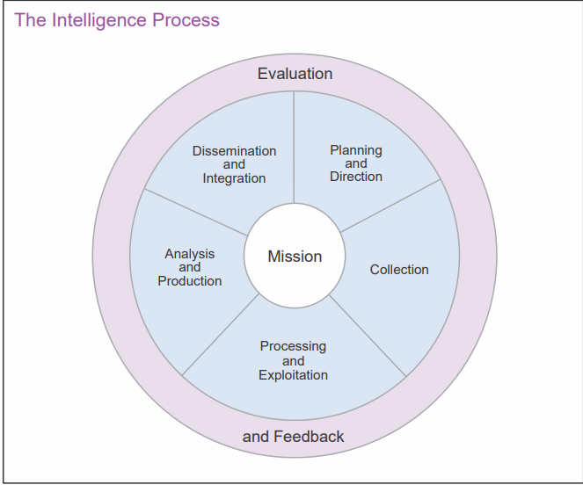
Figure 17: The Intelligence Life Cycle

Processing and exploitation
As discussed previously, unstructured data will need preparation to make the raw data easier to be used. This includes filtering, changing the format of the data or extracting key indicators.

Analysis and Production
Derived from Greek “ana” (up) and “luein” (loosen), analysis involves the understanding of the subject being analysed so that it can be broken down into parts for detailed examination. As it is at the core of any intelligence work, including OSINT [24], analysis makes up a large part of this project. The confidence level of sources is important to mitigate attempts of manipulation or misinformation.
Sherman Kent, the author of “Strategic Intelligence for American World Policy” [70], is often considered the father of intelligence analysis. During World War II While working for the Central Intelligence Agency (CIA) he created nine analytic principles [71] (Figure 18):
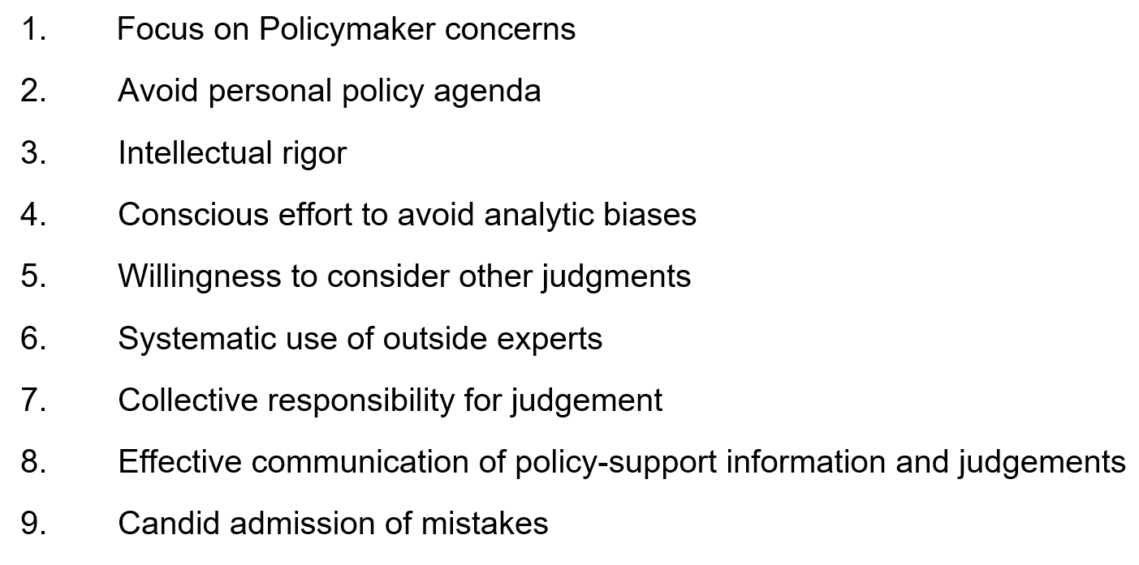
Figure 18: Sherman Kent's Analytic Principles
Everyone has a preferred type of analysis (visual, link or temporal), using several types of analysis can help identify patterns.
A fundamental analytical method for OSINT is link analysis. Maltego [72] is a link analysis tool already in use by the Security Operations Centre (SOC) to help find and visualise the relationships between data points.
Data analysis includes the cleaning, transforming and modelling data to reveal patterns and new insights into the data. There are many ways to analyse data, including using structured and unstructured models, and machine learning. Temporal data analysis looks at data over time to reveal patterns. This is particularly useful in CTI for trending adversarial activity.
After analysis breaks something down, synthesis is used to pull in data from other sources, aside from the event or incident being analysed, to enhance our understanding. Analysis-synthesis duality forms the basis of the Cyber Kill Chain (Chapter 4.5.1) and the Diamond Model for Intrusion Analysis (Chapter 4.5.3).

Analytical Judgement
The role of an intelligence analyst is to assess what the information signifies and its potential impact [33]. This form of analytic judgement is used to meet a specific intelligence requirement using available data and information while acknowledging information gaps or remaining uncertainties.
Judgements can be made about things that have already happened, such as arbitrating the goal and impact of an adversary responsible for an intrusion, or about something in the future, such as the impact of blocking communication to and from a command-and-control domain.
Analytical judgements have room for human error, so it is important to understand why a judgement was made and follow a repeatable process. There are two main types of analysis that lead to analytic judgments:
- Data-driven analysis is enabled by pre-existing or previously developed analytic models. The reliability of this analysis technique relies on complete and correct data sets and applying the right models. This analysis is logical and easily replicated.
- Conceptually driven analysis is used more often in CTI and OSINT. There are often unknowns and undefined variables and relationships which prevents exact modelling of a situation. Accuracy in this type of analysis is driven by mental models and feedback over time.
All people view the world differently, when making analytic judgements perception should be an active process. Heurer [73] created a simple expectation for analysts:
“Think about how we arrive at a conclusion instead of presuming what others would see, or else we will miss important things at critical times” Heurer [73].
The following illustration from Heurer [73] shows that we tend to perceive what we expect to perceive, this is because the human brain takes shortcuts (Figure 19).

Figure 19: Heurer's Illusion
Studies have shown that during analysis, the brain uses working memory, pattern recognition, template matching, prototype matching and top-down pattern matching which are critical to the analytic process [74]. Cognitive bias (Chapter 4.18) is always present and may hinder analysis if not addressed.

Decision Making
A prominent theory of human decision-making is called the dual-process theory which says that decision making process follows one of two methods [75].
System one thinking is initiative; it is often an unconscious decision-making process. It is fast, effective and often right. It uses available knowledge, experience and existing mental models. Mental models are experience-based assumptions and expectations [76]. These link different concepts together into a cohesive model of the world used to interpret events and information. Analysts need to have a good understanding of their own mental models and take care not to use cognitive biases (Chapter 4.18).
System two thinking is analytical, it is slow, methodical and conscious. It involves following scientific methods, operating instructions or structured analytic techniques (Chapter 4.21).

Expressing Confidence in Analytic Judgments
It has been reported that in 2003, the then director of the CIA, George Tenet told President George W. Bush that it was a “slam dunk” that Hussain possessed weapons of mass destruction [77] [78]. The confidence expressed in this assessment likely led to the war in Iraq.
Just like the example above, studies show that people are overconfident that their judgements are correct [79]. Psychologists [80] have attributed this to biases (Chapter 4.18).
Confidence of judgement is based on the number of key assumptions made, the credibility of the source, expertise on the subject and the strength of the argument [81].
The Peterson Table of Analytic Confidence Assessment [81] is a tool to calculate the level of analytic confidence. Peterson’s technique (Figure 20) works with intelligence lifecycle and Structured Analytic Techniques.
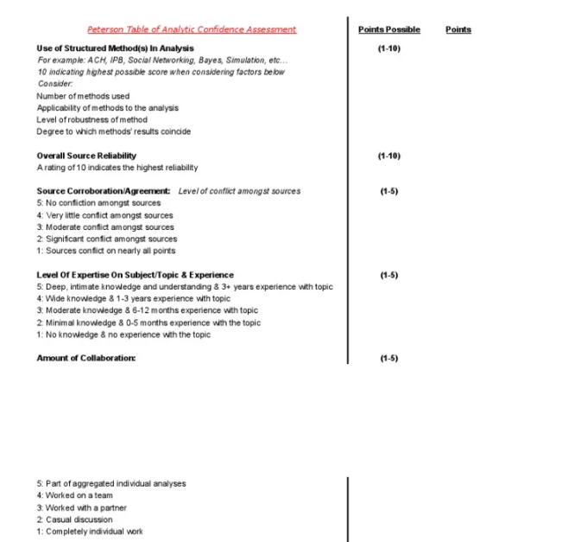
Figure 20: The Peterson Table of Analytic Confidence
Confidence levels can be descriptive or given numeric value on a sliding scale [81]. For the purposes of this project, Low, Moderate and High confidence levels will be used.

Cognitive Biases and Logical Fallacies
    - Cognitive Biases
In the 1974, two psychologists Amos Tversky and Daniel Kahneman, used the term cognitive biases to describe peoples “flawed patterns of thinking in response to judgment and decision making” [80].
Everyone has biases, they can be conscious and intentional or unconscious [82]. Unconscious biases are automatic processes that are impossible to eliminate, however we must understand, and counter act our own biases when doing analysis. Croskerry [83] suggested the following strategies to help unbiased decision making:
- Acknowledge the limitations of memory
- Seek different perspectives while making decisions
- Be able to self-critique
- Use strategies to prevent cognitive errors.
Several studies [80] [84] show the human brain tries to simplify the world around us, these shortcuts and simplicity can cause mistakes. Psychologist and social researcher Bobby Duffy called these psychological biases [85]. The most common biases to be aware whilst carrying out CTI and OSINT are shown below (Table 7).
Table 7: The most common biases in CTI and OSINT
Bias | Description
Anchoring | Overvalues initial information for assessment and adjusts these assessments as new evidence is found.
Confirmation | Selectivity supporting one hypothesis and only includes evidence that supports hypothesis.
Congruence | Does not test competing hypotheses and only selects data that supports the existing hypothesis.
Causal and Correlative Confusion | Confusing the correlation of two events with a causal relationship.
Hindsight | Tendency to see an unpredictable event as an obvious result of a set of conditions.
Illusory correlation | Observe correlation when none exists.
Mirror Image | Forms when you analyse a situation, person or entity with your context, background and experience instead of theirs.

Intelligence teams must also strive to limit bias through structured analytical approaches (Chapter 4.20) and diversity on the team. In addition to sex, age, ethnicity, background, diversity should also include speciality. For example, a group of analysts specialising in malware analysis will view the world of intelligence focused on malware.
    - Case Study
In 2020, Ransomware activity increased ahead of the US Presidential Election. In September, one ransomware attack hit Tyler Technologies, a company making software used by countries to preserve records of election results [86]. Reports soon appeared blaming Russia for using ransomware to affect elections like the attacks in 2016 [87] . Although this assessment should have been only one of several hypotheses, no other hypothesis was considered despite the lack of evidence and the fact that state and local agencies had been targeted by ransomware since 2015 [88].
This was a case where a mental model of “election hacking” was used to assess a large amount of information, resulting in confirmation bias, anchoring and appeal to authority.
In 2021, an unclassified report by the National Intelligence Council [89] found no evidence that any foreign actor tried to alter any technical aspect of the 2020 US Presidential Election.

Logical Fallacies
Logical fallacies are flaws in reason and often appear in CTI assessments. There are many types of logical fallacies that analysts must be aware of (Table 8).
Table 8: Types of Logical Fallacies
Fallacy | Description
Anecdotal | Occurs when personal experience is used over compelling evidence.
Appeal to Probability | Accepting the most probable case instead of following the evidence.
Appeal to the Stone | Naming a claim as absurd without any proof to dismiss it.
Argument from Silence | Accepting a conclusion due to lack of evidence against it.
Argument from Repetition | Arguing so much that eventually people accept the conclusion.

Good intelligence analysts think about how they think (metacognition) which supplies an opportunity to defeat bias and fallacies [73].

Structured Analytic Techniques
Peterson [81] found that the quality of analysis improves when using a structured method.
Structured Analytic Techniques (SATs) allow analysts to better evaluate available information and find trends and gaps while reducing the impact of bias.
    - Analysis of Competing Hypotheses
Richards J Heuer Jr. is one the most well-known intelligence analysts [48] [73] and creator of the Analysis of Competing Hypotheses (ACH) [90].
Predominately used for threat hunting at DVLA, ACH is used to evaluate hypotheses against a range of evidence (Figure 21). It is designed to reduce biases (Chapter 4.18) by requiring the consideration of alternative hypotheses and use evidence found to rate the likelihood of each hypothesis [90].
“For an unproven hypothesis, there is no evidence that it is correct. For a disproven hypothesis, there is positive evidence that it is wrong” Richards J Heuer Jr. [90].

Figure 21: Heuer’s ACH process
Studies [40] [68] show ACH can also be used during OSINT investigations for incident response. However, it is important to remember that evidence may change in time which may affect the outcome.
“Analytical conclusion should always be regarded as tentative”
Richards J. Heuer Jr. [90]

    - Structured Analytic Techniques Tools
There are two main types of tools used for SATs: brainstorming tools and sorting tools.
Brainstorming tools help capture and sort information quickly. There are many software tools available along with pen and paper.
Sorting tools, for example spreadsheets or similar software, help analysts find trends. Many studies [91] [92] [93] [94] recommend using Microsoft Excel [95] for structured analytics. This tool is already used by the SOC.

Research and Development Methodology

Research Design

Figure 22: Illustration of Research Design

Saunder’s Research Onion [96] (Figure 23) was used to identify research and development methods.
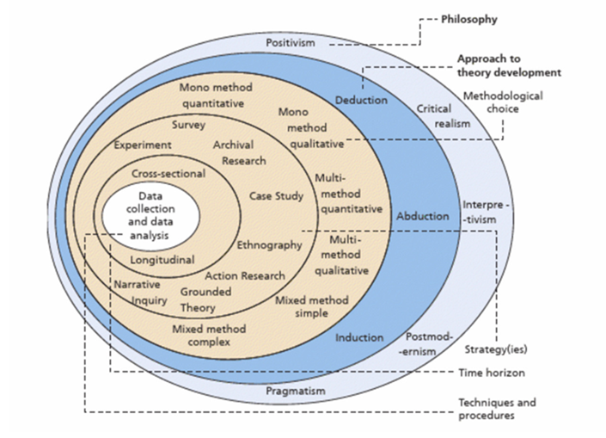
Figure 23: Saunder’s Research Onion

Research Philosophy
Interpretation approach was used to identify requirements, compare tools and develop operating procedures.

Research Approach
A deductive approach was chosen to assess Yamin et al. [69] theory that OSINT investigations can improve cybersecurity incidents and investigations.
Firstly, conduct a literature review to understand current knowledge, relevant theories, methods, and potential gaps in existing research (Chapter 4).
Using knowledge gained by critically reviewing the literature to analyse OSINT tools and create Standard Operating Procedures (Chapter 7).

Choice
Mixed-methods methodology was used to supply a more holistic understanding of the current issue.
With the small focus group available, the mixed methods approach used both qualitative and qualitative methods to enhance analysis and prevent research bias.

Research Strategy
Action research was used to evaluate and critically analyse current practices and introduce and evaluate new Standard Operating Procedures based on user needs.

Time Horizon
Cross-sectional as data needed to be collected at set points for analysis and evaluation.

Techniques and Procedures
Both quantitative and qualitative data analytic techniques will be used. Each type will be analysed separately before being integrated to supply a complete result.

Design

Project requirements and restraints
    - Business requirements
The following technological, reporting and budgetary requirements were agreed by the lead SOC specialist at the outset of the project:
- Reintroduce a weekly OSINT process with reporting function
- Common cybersecurity investigations and incidents which could be enhanced using OSINT must be considered first.
- OSINT platform will be created on Virtual Machines (VMs) on standalone devices only. Azure native VMs will be considered once the project has been implemented and processes finalised.
- No additional budget available this financial year.
    - User requirements
From focus groups users made their requirements clear:
- No programming
- No command line tools
- Graphical User Interfaces needed
- Easy to follow flowcharts

Selecting Cybersecurity Incidents and Investigations
Using the main objective of the project the first action was to hold a focus group with the cybersecurity analysts and incident responders to brainstorm and compile a list of incidents and investigations where OSINT techniques could be used to enhance the current process (Figure 24).
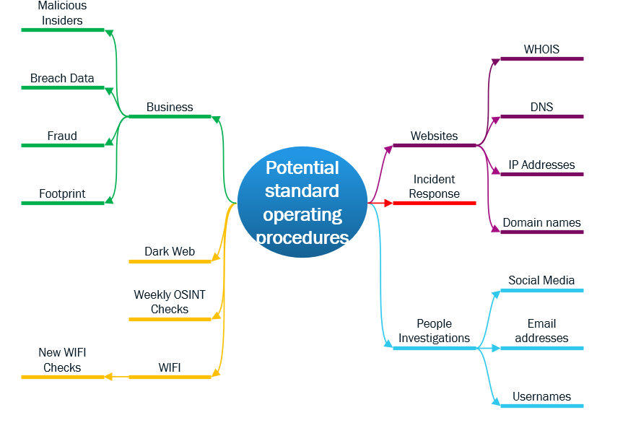
Figure 24: Potential Standard Operating Procedures
This primary focus group was chosen to include a range of experience, specialities, ages and genders to ensure results were unbiased, complete and as accurate as possible (Table 9).
Table 9: Focus Group Demographic
Experience level | 6 months – 25+ years
Gender | Male and female
Specialities | OSINT, Threat Intelligence, Incident Response, Malware and Forensic analysis, Ethical hacking, Help Desk Specialist, System Administration.
Focus group size | Analysts = 8  Specialists = 3  Senior Specialists = 3

Prioritising cybersecurity incidents and investigations that could be enhanced with OSINT
The next step was to meet with senior SOC personnel and lead Incident Responders to prioritise the types of incidents and investigations using the MoSCoW prioritisation approach [97] (Appendix B). “Must have” and “Should have” were considered first. “Won’t have” will not be considered during this project but will be looked at again at a future date.

Comparing similar OSINT tools
OSINT tools which could be used meeting the key requirements were identified from frameworks, user experience, previous academic research and industry whitepapers.
Map and imagery, image analysis and wireless were not considered priority requirements at this time and will not be considered as part of the scope of this project.
Comparison testing was chosen to compare the strengths and weaknesses of the tools based on business and user requirements to ensure the correct tool is chosen for that process. To enable comparison testing tools were categorised according to its main function (Appendix C).
To ensure compliance with all data protection and computer misuse laws tests, testing was carried out in a controlled environment using only cybersecurity testing websites.
A weighting schema was created to use quantitative data such as features and attributes (including usability, reliability, cost, security and privacy) to directly compare tools from each category.

Designing the test environment
Comparable tools were evaluated in a standalone testing environment based on a DVLA gold standard Virtual Machine (VM) image with internet connectivity through the guest VPN to maintain segregation.

Designing the OSINT Platform
Design considerations:
- Users requested a Graphical user interface (GUI).
- Affordable to use and maintain. There is no additional budget available.
- Trustworthy, must be free of viruses, uncompromised and easily updatable.
- Cleanable, need to remove previous data and objects.
- Accessible on standalone devices via a VM to maintain host system security and isolation during investigations.
- Use Oracle Virtual Box Virtualisation (already have current licensing). Disabling shared folders, drag and drop, copy and paste and clipboard sharing.
- Internet access required but totally isolated from the corporate networks.
- Always on VPN for each VM

Designing testbeds to compare and create standard operating procedures.
A high-level process based on the intelligence cycle was created to allow flexibility with several types of investigations and incidents (Figure 25).
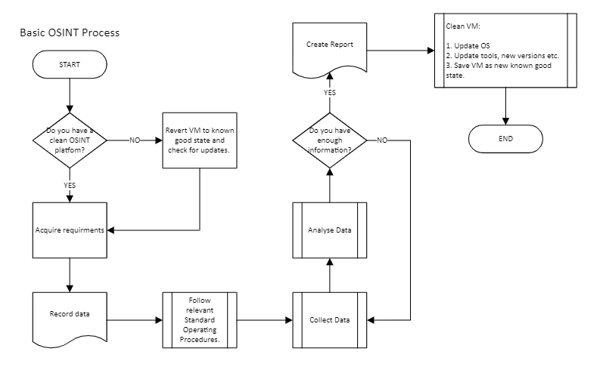
Figure 25: Basic OSINT process

TTPs used will change depending on the type of investigation or incident being investigated. Each investigation and incident were looked at separately and appropriate TTPs mapped accordingly.
Investigations were conducted to find intelligence about the DVLA for the seven days prior to week commencing 12th June 2023 using the current OSINT process. This was repeated using the new process for comparison and to be used as a baseline for user testing.
The testing environment used to compare the tools was cleaned and used as a testbed to create, compare and assess the Standard Operating Procedures.

Designing confidence and usability testing
To evaluate the confidence and to establish any improvements in the process a snapshot was taken at the start of the project using a simple questionnaire (Appendix G) and repeated after implementation. The questionnaires were sent via Microsoft Forms to maintain anonymity.
The questions were chosen to establish the user’s confidence level and understanding of the current process.
To establish usability requirements a second questionnaire (again using Microsoft Forms for anonymity) was issued to the primary focus group (Appendix I).

To create standard operating procedures based on tool comparison and user requirements, using measurable and quantitative inputs.
Analysts specifically requested no programming or command-line tools. They would prefer instructions to be in a flowchart whenever possible.
Draft Standard Operating Procedures were created with input from Incident response handlers and two senior analysts. The current process and new processes were tested by the remaining six analysts (test group) to ensure impartiality and testing by analysts with different experience levels. The results were compared for accuracy (was the result correct), reliability (was the result obtained from a reliable source) and timely (how long did the process take).
The time taken was compared to find out which process was the most effective.

Analyse the new operating procedures and evaluate its performance.
The test subjects were asked to find the information following the old processes. The subjects were asked to record the information found, where it was found and how long it took.
Next the test subjects were given the new operating instructions and was asked to repeat the test following the instructions only.
The subjects were then asked to record the same things. They were then asked to compare the two processes, what went well, what could be removed etc.
The results were compared for accuracy, reliability and efficiency.

Implementation

Data Source Reliability
OSINT can produce a vast amount of data, not all of which is true. Using the CRAAP method (Chapter 4.7), information sources were checked and rated for reliability. Please see Appendix D.

Current OSINT process
Please see Appendix E and F for the current process and tools.

OSINT tools for each stage of the Cyber Kill Chain

Figure 26: OSINT tools for each stage of the Cyber Kill Chain

The new OSINT platform
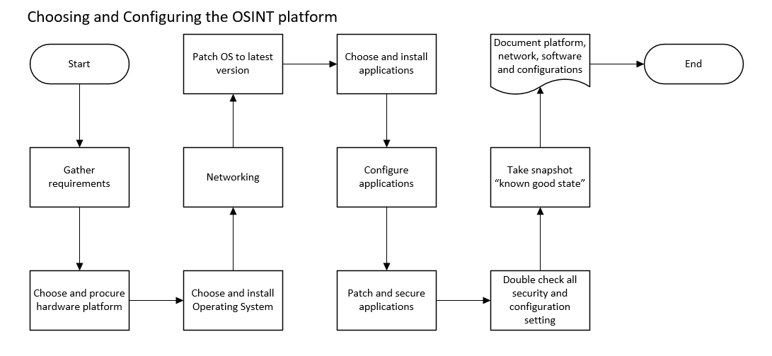
Figure 27: Choosing and Configuring the OSINT platform

Each category of tools was tested separately to compare reliability and accuracy of search results of each tool (Appendix K). User experience and recommendations were also considered (Appendix J).
The search engines and browsers were tested first to create the platform to test the remaining tools (Appendix K).
The platform was then tested to ensure the Startpage search engine worked as expected with the Firefox browser (Chapter 8.1).
Next the browser extensions Web Scraper, Privacy Badger, TinEye was added and tested (Chapter 8.2).
Maltego was installed and licence key registered (Figure 28).
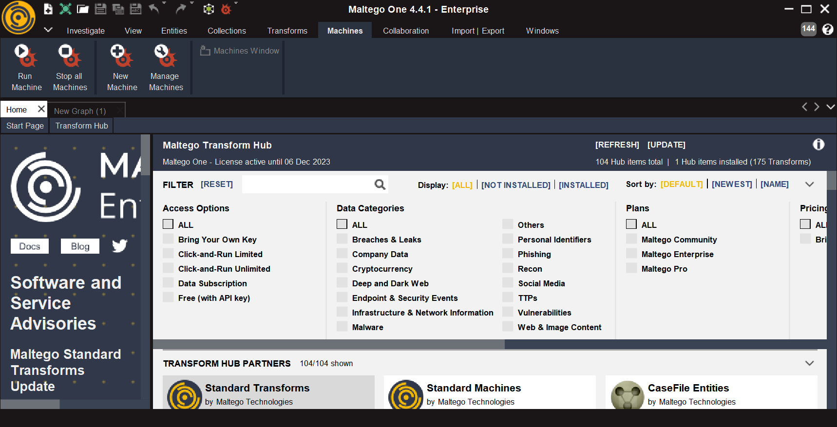
Figure 28: Maltego
A new email address was allocated and used to create the necessary user accounts.
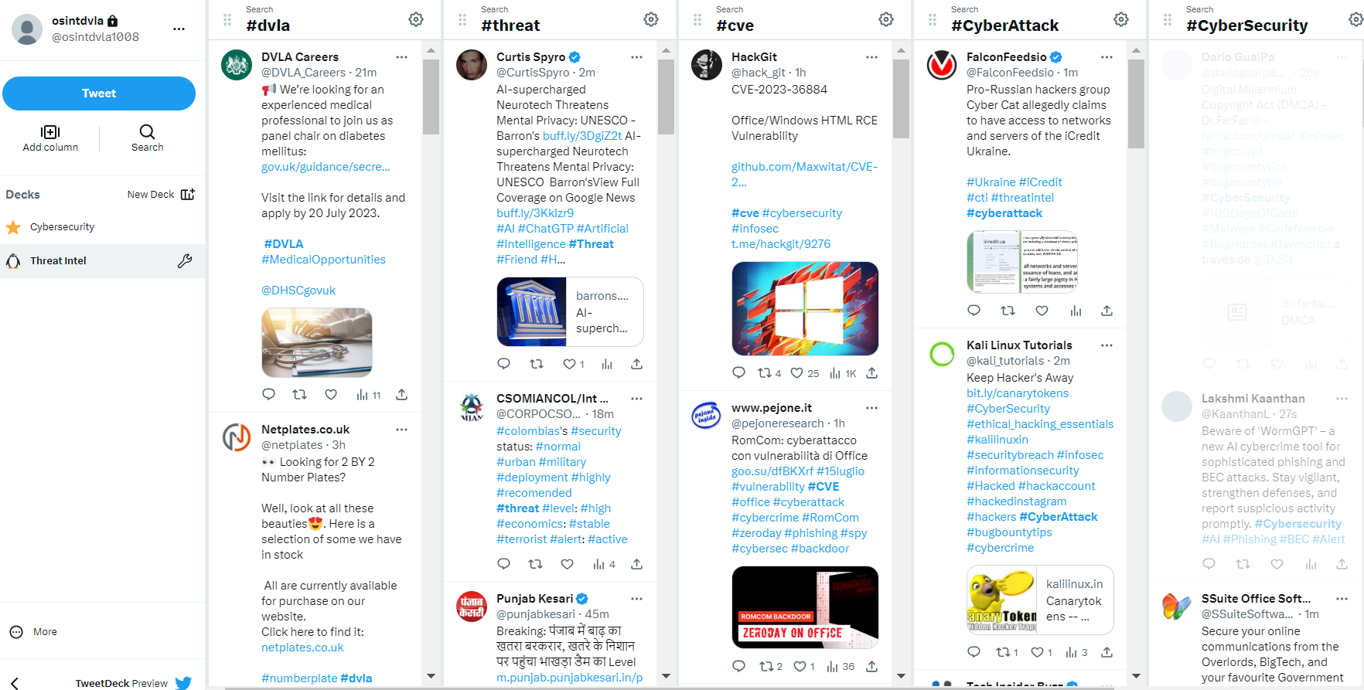
Figure 29: OSINT TweetDeck
Shortcuts for the remaining tools were added.

New Weekly OSINT process
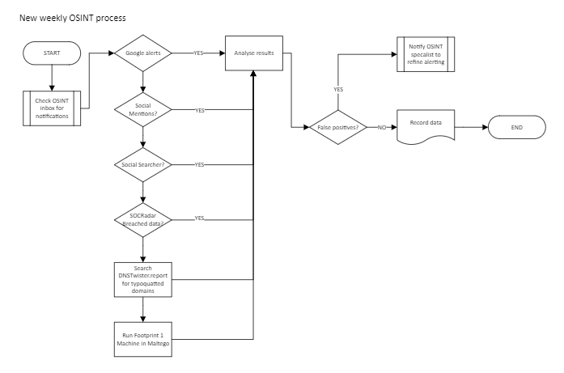
Figure 30: New weekly OSINT process
    - News
The following google alerts were created (Figure 31) and Social Mention filters (Figure 32) to maintain situational awareness. Email alerting was set up for weekly notifications to be sent to the dedicated OSINT inbox.
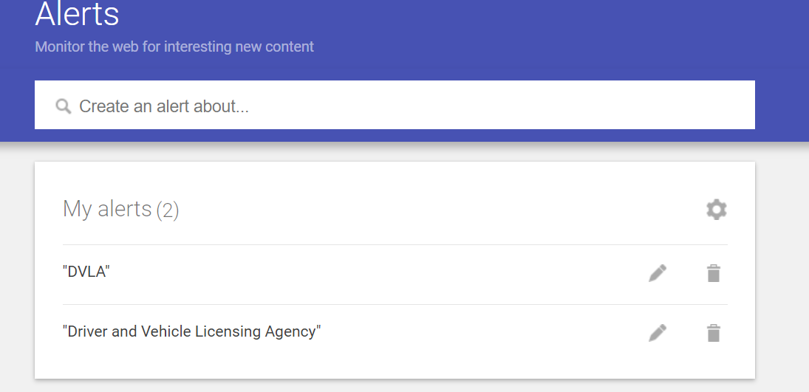
Figure 31: Google Alerts

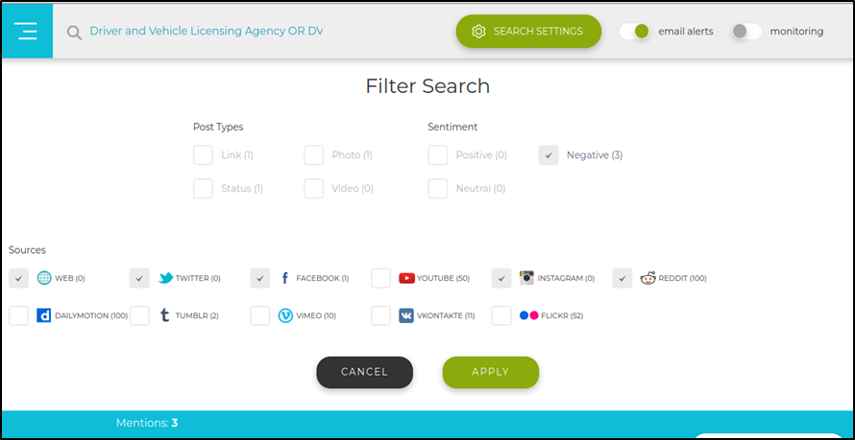
Figure 32: Social Mentions search filters

    - Social Media
According to Similarweb [98] the top three most visited Social Media Networks in the UK for June 2023 were:
- Facebook.com
- Twitter.com
- Instagram.com
The following filters (Figure 33) were added on Social Searcher to look for evidence of fraud on six social platforms (including the UK top three). This is four more than the previous process. Email alerting was set up for weekly notifications to be sent to the dedicated OSINT inbox.
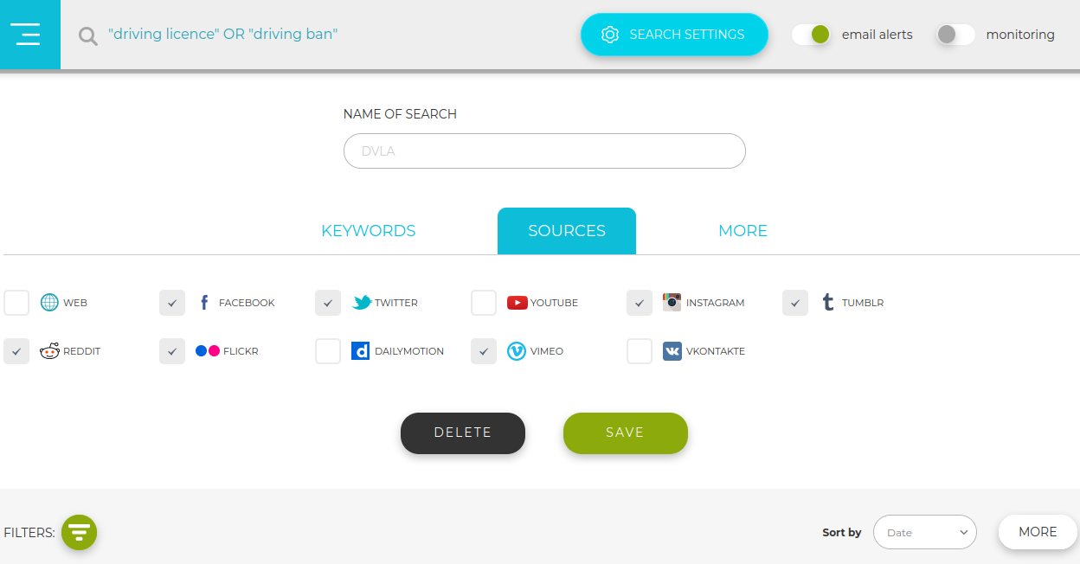
Figure 33: Social Searcher search filters
    - Breach Data
SOCRadar [99] is a multi-purpose platform that combines attack surface management, risk protection and CTI. The platform provides instant phishing domain identification, compromised credentials and breached data. SOCRadar is being trialled by the SOC for twelve months. The compromised credentials and breached data module will be used for this section of the new weekly OSINT process. An example alert is shown in the figure below (Figure 34), which was a false positive.
-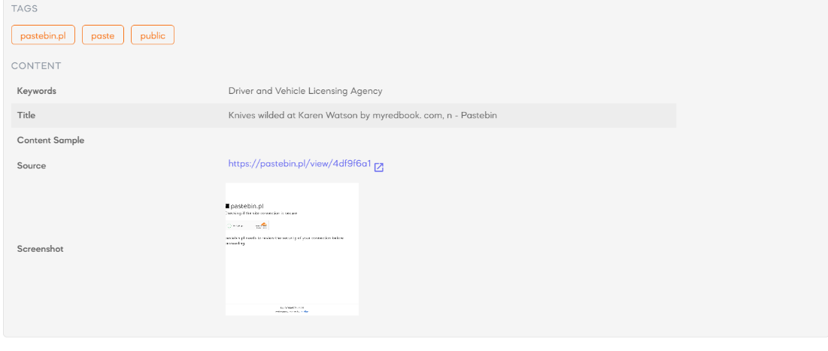
Figure 34: SOCRadar Breached Data Incident Notification
    - Typo squatted domains
This is a new process added to the weekly checks to look for typo squatted domains which could be used against our customers or in phishing attacks against ourselves.
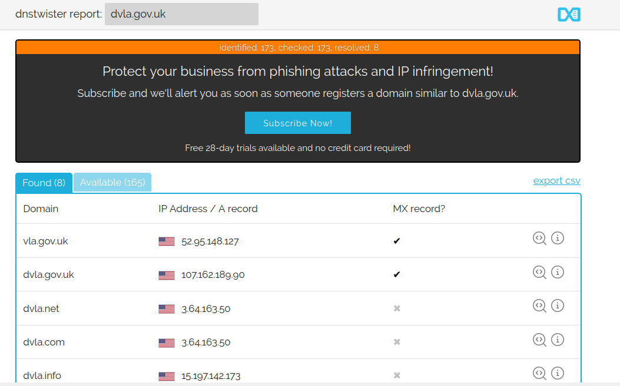
Figure 35: Use Dnstwister.report for possible typo squatted domains
    - Infrastructure
Instead of manually searching Maltego using separate entities the footprint level One Machine [100] can automatically provide results on the following:
- Website
- AS
- Domain
- Company
- Netblock
- NS Record
- DNS Name
- IPv4 Address
- Email Addresses
- Location
After the results are plotted on the graph (Figure 36), results can be saved as a csv file for comparison with known infrastructure, map the attack surface and identify previously unknown attack vectors.
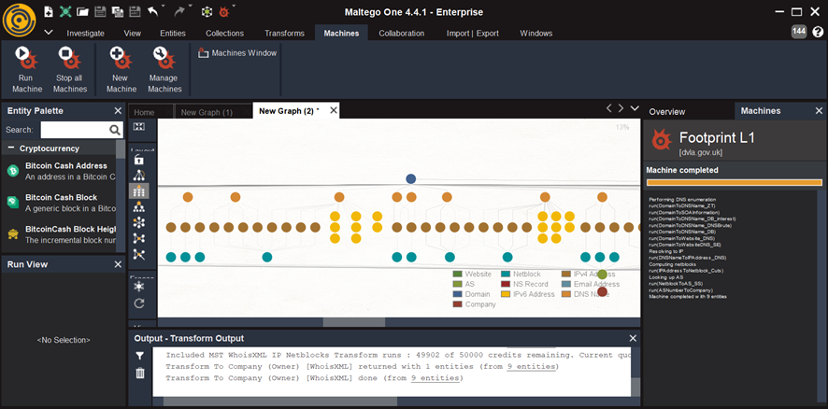
Figure 36: Maltego Level One Footprint machine

Incidents and Investigations
A core OSINT skill is the ability to collect and document information. The following flowchart (Figure 37) was designed to help the analyst think about what they need to look for and structuring the approach.
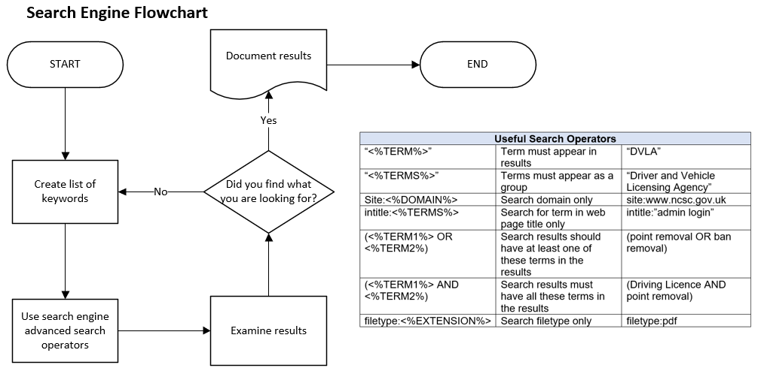
Figure 37: Search Engine Flowchart
As previously discussed, OSINT can be used to monitor the organisation’s attack surface, to do this, potential attack surfaces were mapped to establish where to look for any unintended exposures.
    - Username Investigations
This attack surface (Figure 38) was used to understand what tooling and information sources were required to create the Standard Operating Procedure (Figure 39) to investigate usernames.
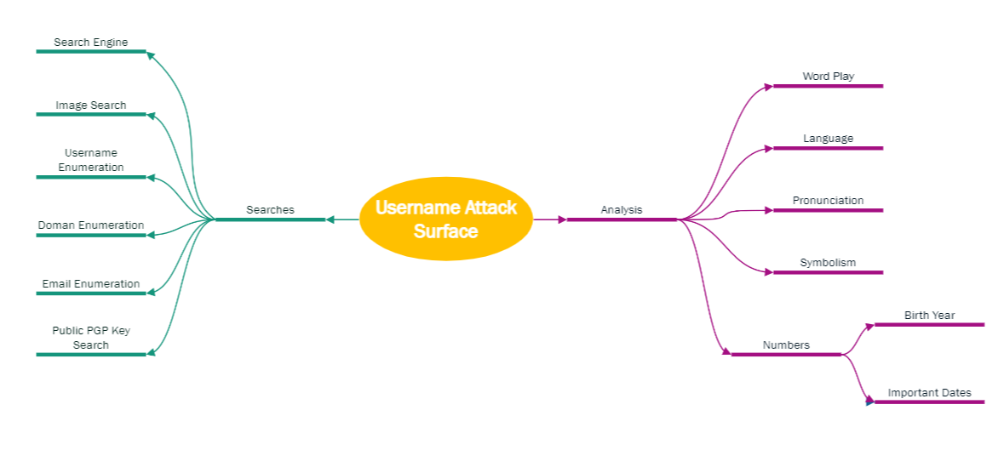
Figure 38: Username Attack Surface

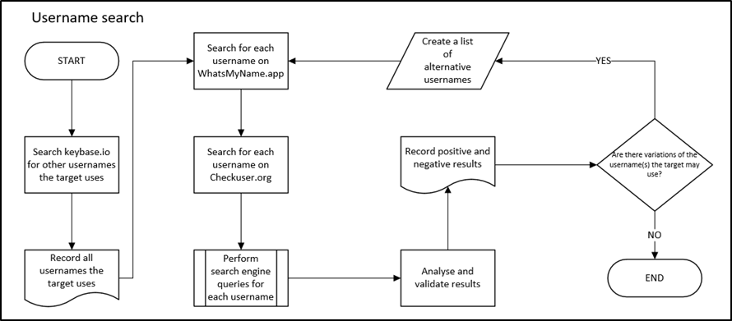
Figure 39: Username Search Flowchart

    - Email Address Search
The process was repeated to created Standard Operating Procedures for Email Addresses.
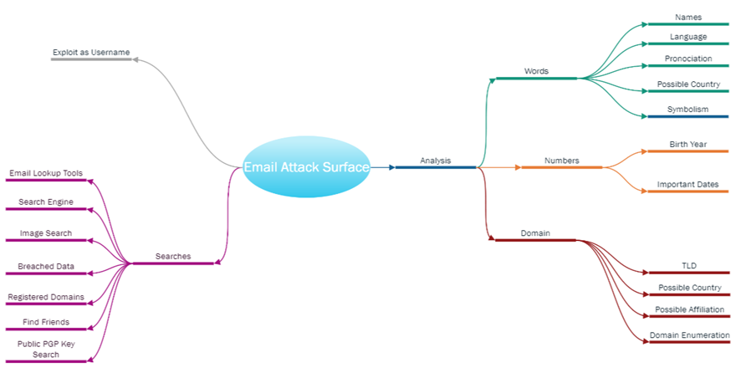
Figure 40: Email Attack Surface

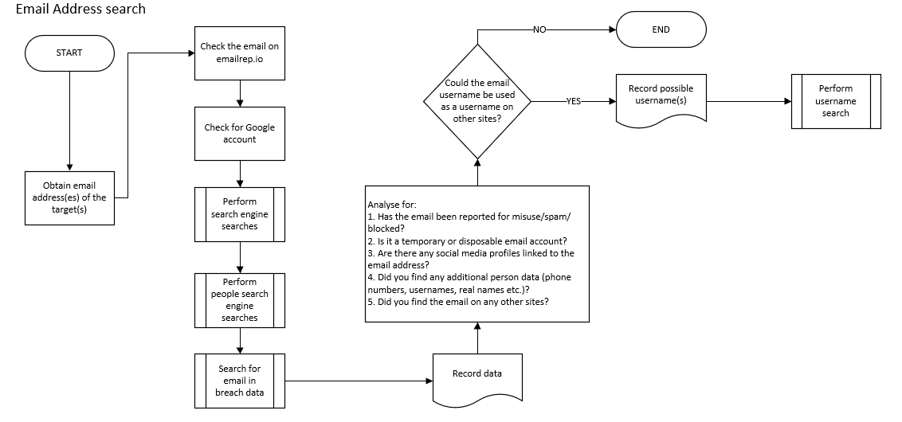
Figure 41: Email Address Search
Please see Appendix L for further Attack Surfaces and Appendix M for further Standard Operating Procedures.

Analytic Confidence Guide
The following confidence guide was created to help structure analytic confidence levels based on the type of source, assumptions made and any remaining intelligence gaps.
Table 10: Analytic Confidence Guide
Low confidence | Uncorroborated information from good or marginal sources. Many assumptions made due to considerable intelligence gaps.
Moderate confidence | Partially corroborated information from good sources. Several assumptions were made, and some intelligence gaps remain.
High confidence | Well corroborated information from proven sources. Minimum assumptions were made. No or minor intelligence gaps remain.

Analysis and Reporting Template
This structured analysis and reporting template outlines each step of the ACH process to identify, evidence and compare hypotheses to answer a specific intelligence question and take relevant actions.
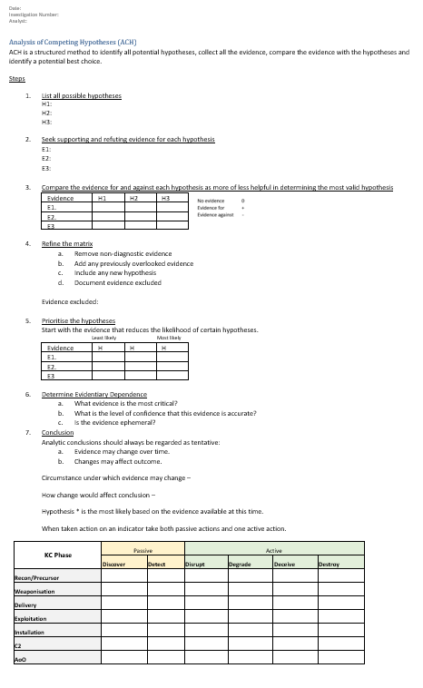
Figure 42: ACH Template

Results

Platform testing
The following table shows the results of the platform testing where surprisingly Google did not meet the requirements. Firefox Browser and Startpage Search Engine provided the best results and were chosen.
Table 11: Platform test results
Tool | Usability | Reliability | Cost | Security | Privacy
Edge | ✓ | ✓ | ✓ | X | X
Opera | X | X | ✓ | ✓ | ✓
Chrome | ✓ | ✓ | ✓ | X | X
Tor Browser | X | X | ✓ | ✓ | ✓
Firefox | ✓ | ✓ | ✓ | ✓ | ✓
Google | ✓ | ✓ | ✓ | X | X
Bing | ✓ | ✓ | ✓ | X | X
DuckDuckGo | X | X | ✓ | ✓ | ✓
Startpage | ✓ | ✓ | ✓ | ✓ | ✓
Yandex | ✓ | X | ✓ | X | X

Tool testing
The following table shows the results for the tool testing. TinEye was recommended by a user, met all requirements and fared better than comparison tools.
Unsurprisingly VirusTotal and URLscan fared very well. Although Maltego is not favoured by the analysts it does provide the best functionality and offers different machines which makes using it easier and faster.
Table 12: Tool testing results
Tool | Usability | Reliability | Cost | Security | Privacy
Hunchly | X | X | X | ✓ | ✓
Instant Data Scraper | X | X | ✓ | ✓ | ✓
Web Scraper | ✓ | ✓ | ✓ | ✓ | ✓
Privacy Badger | ✓ | ✓ | ✓ | ✓ | ✓
Search by image | X | X | ✓ | ✓ | ✓
TinEye | ✓ | ✓ | ✓ | ✓ | ✓
Mobile-Friendly Test | X | X | ✓ | ✓ | ✓
URLscan.io | ✓ | ✓ | ✓ | ✓ | ✓
Virus Total | ✓ | ✓ | ✓ | ✓ | ✓
Bing Translate | ✓ | X | ✓ | ✓ | ✓
DeepL Translator | ✓ | X | ✓ | X | X
Google Translator | ✓ | ✓ | ✓ | ✓ | ✓
Yandex Translate | ✓ | ✓ | ✓ | X | X
ExifInfo | ✓ | ✓ | ✓ | ✓ | ✓
FotoForensics | ✓ | X | ✓ | X | X
Bing Image Search | X | ✓ | ✓ | ✓ | ✓
Google Images | ✓ | ✓ | ✓ | X | X
Yandex Image Search | ✓ | ✓ | ✓ | X | X
Checkuser | ✓ | ✓ | ✓ | ✓ | X
Gravatar | ✓ | ✓ | ✓ | X | X
Keybase | X | ✓ | ✓ | ✓ | ✓
WhatsMyName | ✓ | ✓ | ✓ | ✓ | ✓
Emailrep | ✓ | ✓ | ✓ | ✓ | ✓
Epieos | ✓ | ✓ | ✓ | ✓ | X
HaveIbeenpwned? | ✓ | ✓ | ✓ | ✓ | ✓
Hunter | ✓ | ✓ | X | ✓ | X
Infosniper | ✓ | ✓ | X | X | X
IP Chicken | ✓ | ✓ | ✓ | ✓ | ✓
WhatisMyIPAddress | ✓ | ✓ | ✓ | ✓ | ✓
Whatu.info | ✓ | ✓ | ✓ | ✓ | X
SecurityTrails | ✓ | ✓ | X | ✓ | X
DNSdumpster | ✓ | ✓ | ✓ | ✓ | X
Host.io | ✓ | ✓ | ✓ | ✓ | X
DNSTwister | ✓ | ✓ | ✓ | ✓ | X
ViewDNS | ✓ | ✓ | ✓ | ✓ | X
Whoxy | X | ✓ | ✓ | ✓ | ✓
Shodan | ✓ | ✓ | X | ✓ | X
Censys.io | ✓ | ✓ | ✓ | ✓ | X
Maltego | X | ✓ | ✓ | ✓ | ✓
Archive.is | ✓ | X | ✓ | ✓ | ✓
BuiltWith | ✓ | ✓ | X | ✓ | ✓
Netcraft | ✓ | ✓ | X | ✓ | ✓
Dehashed | ✓ | ✓ | X | ✓ | ✓
Intelx.io | ✓ | ✓ | X | ✓ | ✓
PasteBin | ✓ | ✓ | ✓ | ✓ | ✓
SOCRadar | ✓ | ✓ | ✓ | ✓ | X
Social Search | ✓ | ✓ | ✓ | ✓ | X
TweetDeck | ✓ | ✓ | ✓ | ✓ | ✓
Social Mentions | ✓ | ✓ | ✓ | ✓ | X
Google Alerts | ✓ | ✓ | ✓ | ✓ | X
Power Automate | X | ✓ | ✓ | ✓ | ✓
Python scripts | X | ✓ | ✓ | ✓ | ✓
VisualPing.io | X | ✓ | ✓ | ✓ | ✓

OSINT Weekly Checks
The following table compares the parts of the old OSINT weekly Checks with the new process. This table shows there are an extra two parts to the new process. This table is also used to identify the processes being compared for accuracy and efficiency in Tables 14 and 16.
Table 13: OSINT Weekly Checks
Number | Description | Old | New
P1 | Manual Search Engine checks | ✓
P2 | Google Alert email notifications |  | ✓
P3 | Social Mentions email notifications |  | ✓
P4 | Manual Social Media Checks (twitter only) | ✓
P5 | Social Search email notifications |  | ✓
P6 | Manual Data Breach Checks | ✓
P7 | SOCRadar Data Breach notifications |  | ✓
P8 | Registered Typo squatted domains |  | ✓
P9 | Maltego Infrastructure Search | ✓
P10 | Automated Maltego footprint machine |  | ✓

User testing accuracy
This table shows the total number of indicators discoverable for each process (baseline), the results for each user is anonymised and averaged for each process. Even disregarding the results for P10 (new Maltego process) the new process has improved accuracy as no indicators were missed.
Table 14: User accuracy testing results
User | P1 | P2 | P3 | P4 | P5 | P6 | P7 | P8 | P9 | P10
Baseline | 16 | 12 | 4 | 2 | 5 | 0 | 0 | 4 | 20 | 90
User1 | 11 | 12 | 4 | 2 | 5 | 0 | 0 | 4 | 19 | 90
User2 | 12 | 12 | 4 | 2 | 5 | 0 | 0 | 4 | 19 | 90
User3 | 12 | 12 | 4 | 2 | 5 | 0 | 0 | 4 | 20 | 90
User4 | 11 | 12 | 4 | 2 | 5 | 0 | 0 | 4 | 19 | 90
User5 | 12 | 12 | 4 | 2 | 5 | 0 | 0 | 4 | 20 | 90
User6 | 12 | 12 | 4 | 2 | 5 | 0 | 0 | 4 | 20 | 90
Average | 11.6 | 12 | 4 | 2 | 5 | 0 | 0 | 4 | 19.5 | 90

Figure 43: Weekly OSINT Process Accuracy Comparison

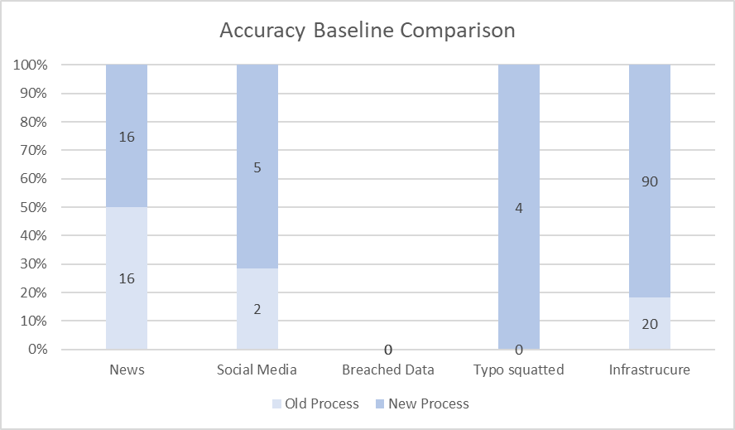
Figure 44: Weekly Accuracy Baseline Comparison
The new process found an additional 77 indicators requiring further investigation. This is an increase in 202.63%.
User accuracy was improved by 187.28%.

User testing time taken
This table shows the time taken it took for each user to find the indicators (Table 15) again the data has been anonymised. Results show the new process is quicker.
Table 15: User testing time result (in minutes)
User | P1 | P2 | P3 | P4 | P5 | P6 | P7 | P8 | P9 | P10
User1 | 30 | 10 | 4 | 25 | 5 | 35 | 20 | 5 | 20 | 10
User2 | 25 | 8 | 3 | 20 | 4 | 35 | 21 | 7 | 20 | 12
User3 | 30 | 9 | 5 | 26 | 4 | 34 | 20 | 6 | 30 | 12
User4 | 33 | 12 | 5 | 24 | 5 | 33 | 18 | 5 | 35 | 10
User5 | 30 | 9 | 4 | 22 | 4 | 34 | 20 | 5 | 30 | 11
User6 | 28 | 8 | 4 | 20 | 5 | 33 | 18 | 6 | 30 | 12
Average | 29.3 | 9.3 | 4.2 | 22.8 | 4.5 | 34 | 19.5 | 5.7 | 27.5 | 11.2

Figure 45: Weekly OSINT process average time comparison

The average analyst salary is £25,915 (£13.84 per hour). Average time taken for old process is 1.91 hours. The average time taken for the new process (minus the new typo squatting checks for fair comparison) is 1.04 hours.

Figure 46: Average yearly OSINT weekly process cost comparison in pounds

The new process will save DVLA and the UK public an average of £626.31 a year with no added expense

Confidence
The initial confidence level of the weekly OSINT process and Maltego was very low (36.7%). After four weeks of following the process confidence had improved by 54.3%.

Table 17: User Confidence Levels Comparison
Confidence  Level (1-5) | User 1 | User 2 | User 3 | User 4 | User 5 | User 6
Before | 2 | 1 | 2 | 3 | 2 | 1
After | 3 | 3 | 3 | 4 | 3 | 1

Apart from one user, confidence levels have increased.
Anonymous feedback from users include:
“The flowcharts are clear and easy to follow.”
“It’s so much easier to just go into the inbox that trying to search for the intelligence.”
“The machines in Maltego make is so much easier and quicker!”

Standard Operating Procedures User Testing
As there were no previous processes to test against users were asked to trial the new process and provide feedback. Feedback included:
“The new process helped me find a lot more pivot points faster.”
“It helped me finish the investigation much quicker and I am confident nothing has been missed.”
“The new HTTPS Certificate process has been very useful.”
“The flowcharts and nice and easy to follow.”
Accuracy and reliability are much more difficult to quantify due to the lack of anything to compare with. Further testing over a longer period against a wider array of incidents and investigations would be beneficial.

Evaluation
The results show unequivocally that OSINT can aid investigations. This was expected from research in the literature review, however with far greater results than anticipated. The survey size and time scale for testing which would have a greater impact on the results. Even with recalculating without the extra Maltego indicators accuracy improved by 47%.
All aims and objectives have been met. OSINT tools have been compared and appropriate tools used to create Standard Operating Procedures for the priority incidents and investigations.
Results show an improvement in both accuracy and efficiency by automating most of the weekly OSINT process.
Confidence in both the OSINT process and tools have improved beyond expectations.

Conclusion and Recommendations
Deriving a conclusion in an OSINT investigation should be like a forensic process. Considering how the conclusions are reached is as vital as the conclusions themselves.
Following Standard Operating Procedures has improved investigations and confidence levels. It has made the process defensible, repeatable and understandable to others. Although the project itself is complete, further testing, reassessing and perfecting the processes will continue as a business-as-usual process.
The attack surface mapping has also become an unexpected addition to the SOC’s Threat Hunting toolkit.

Future Work
Evaluate using Robotic Process Automation (RPA) [24] [101] for weekly OSINT checks. RPA will be suitable to automate repetitive tasks which may be suitable to enhance the weekly OSINT checks to allow more persistent monitoring and free up analysts to do more complex OSINT investigations.
Create a process using Facebook’s Rosetta Text Extraction System [102] to find images of fraudulent driving licences and conduct reverse image searches to find where else that image is being used for fraud investigations.
On 5th July 2023, Meta launched its new social networking platform Threads. Meta describes Threads as a “open social network for sharing text” [103]. Within less than one week of its launch it already had over 100 million users [104] and could be a valuable source for OSINT. As it is linked to Instagram the attack surface should be similar. The Instagram attack surface (Appendix L) will be used as a starting point to find out what information can be harvested from Threads to create a new OSINT process.

Reflection
This was a very enjoyable project not only from the OSINT aspect but also learning about metacognition, mental models and biases, and how they affect investigations and decision making.
Mapping tools to each section of the Kill Chain was difficult at times but the frameworks found during the Literature Review helped.
The world of OSINT is far greater than initially imagined, the aims and objectives set at the beginning of the project along with a clear project plan helped keep the project going in the right direction.
With hybrid working it was challenging to get everyone together for focus groups and it would have been easier if we had all been in the office together.
The most difficult part of the whole project was getting timely responses from the target group, after sending reminders they had to be told to do it by their line managers. This was disappointing as the process was being created for their benefit, and their views and ideas were needed.
Pastor-Galindo et al [26] wrote about the unexploited goldmine of OSINT and it is true. It is exciting to imagine where it can go next. As available open source information continues to grow so does the possibilities for OSINT.

References

[1] | Aristotle, “Metaphysics,” 350 B.C.E. [Online]. Available: http://classics.mit.edu/Aristotle/metaphysics.1.i.html. [Accessed 20 July 2023].
[2] | “Cyber Security Breaches Survey 2022,” HMG Department for Digital, Culture, Media and Sport, 2022.
[3] | Identity Theft Resource Center (ITRC), “Identity Theft Resource Center’s 2022 Annual Data Breach Report Reveals Near-Record Number of Compromises,” 25 January 2023. [Online]. Available: https://www.idtheftcenter.org/post/2022-annual-data-breach-report-reveals-near-record-number-compromises/. [Accessed 20 February 2023].
[4] | “Attack Surface Anaylsis Cheat Sheet,” OSWAP, 2021. [Online]. Available: https://cheatsheetseries.owasp.org/cheatsheets/Attack_Surface_Analysis_Cheat_Sheet.html. [Accessed 30 May 2023].
[5] | “Threat Levels,” Security Service MI5, [Online]. Available: https://www.mi5.gov.uk/threat-levels#:~:text=Current%20national%20threat%20level%20The%20threat%20to%20the,Scotland%20and%20Northern%20Ireland%29%20from%20terrorism%20is%20SUBSTANTIAL.. [Accessed 4 July 2023].
[6] | “Joint Terrorism Analysis Centre,” Secret Service MI5, [Online]. Available: https://www.mi5.gov.uk/joint-terrorism-analysis-centre. [Accessed 7 July 2023].
[7] | “Government launches new cyber security measures to tackle ever growing threats,” GOV.UK, 20 April 2023. [Online]. Available: https://www.gov.uk/government/news/government-launches-new-cyber-security-measures-to-tackle-ever-growing-threats--2. [Accessed 21 April 2023].
[8] | “The National Cyber Security Centre. Helping to make the UK the safest place to live and work online,” National Cyber Security Centre (NCSC), [Online]. Available: https://www.ncsc.gov.uk/. [Accessed 7 March 2023].
[9] | L. Irwin, “Data Breaches and Cyber Attacks Quarterly Review: Q1 2023,” IT Governance UK. Blog, 13 April 2023. [Online]. Available: https://www.itgovernance.co.uk/blog/data-breaches-and-cyber-attacks-quarterly-review-q1-2023. [Accessed 21 April 2023].
[10] | “NCSC Annual Review 2022,” National Cyber Security Centre (NCSC), [Online]. Available: https://www.ncsc.gov.uk/collection/annual-review-2022/threats-risks-and-vulnerabilities (accesses Feb. 14, 2023).. [Accessed 14 February 2023].
[11] | Barracuda, “2023 spear-phishing trends,” Barracuda, 24 May 2023. [Online]. Available: https://www.barracuda.com/reports/spear-phishing-trends-2023. [Accessed 25 June 2023].
[12] | “The History of Social Engineering & How to Stay Safe Today,” Mitnick Security, [Online]. Available: https://www.mitnicksecurity.com/the-history-of-social-engineering. [Accessed 14 March 2023].
[13] | D. Korinchak, “Kevin Mitnick – The Most Infamous Hacker of All Time,” Cyber Experts, [Online]. Available: https://cyberexperts.com/kevin-mitnick-the-most-infamous-hacker-of-all-time/?utm_content=cmp-true. [Accessed 10 March 2023].
[14] | K. D. M. a. W. L. Simon, The Art of Deception. Controlling the Human Element of Security, Wiley, 2003.
[15] | R. Dartnall, “Intelligence Preparation of the Cyber Environment,” in SANS Cyber Threat Intelligence Summit, Maryland, 2018.
[16] | “DVLA annual report and accounts 2021 to 2022,” 14 July 2022. [Online]. Available: https://www.gov.uk/government/publications/dvla-annual-report-and-accounts-2021-to-2022. [Accessed 2022 September 7].
[17] | H. G. C. Office, “Government Cyber Security Strategy 2022-2030. Building a cyber resilient public sector,” January 2022. [Online]. Available: https://assets.publishing.service.gov.uk/government/uploads/system/uploads/attachment_data/file/1049825/government-cyber-security-strategy.pdf. [Accessed 1 March 2023].
[18] | “Critical National Infrastructure,” National Protective Security Authority (NPSA), 25 April 2023. [Online]. Available: https://www.npsa.gov.uk/critical-national-infrastructure-0. [Accessed 30 April 2023].
[19] | “Heightened threat of state-aligned groups against western critical national infrastructure,” National Cyber Security Centre (NCSC), 19 April 2023. [Online]. Available: https://www.ncsc.gov.uk/news/heightened-threat-of-state-aligned-groups. [Accessed 23 April 2023].
[20] | “Actions to take when the cyber threat is heightened,” National Cyber Security Centre (NCSC), 17 January 2022. [Online]. Available: https://www.ncsc.gov.uk/guidance/actions-to-take-when-the-cyber-threat-is-heightened. [Accessed 8 March 2023].
[21] | Joint Chiefs of Staff, “Dictionary of Military and Associated Terms, Joint Publication 1-02,” Department of Defense, 2001.
[22] | Clark Task Force, “Intelligence Activities,” Hoover Commission, 1955.
[23] | CERT-UK, “An introduction to threat intelligence,” 2015. [Online]. Available: https://www.ncsc.gov.uk/files/An-introduction-to-threat-intelligence.pdf. [Accessed 22 February 2023].
[24] | G. Ungureanu, “OPEN SOURCE INTELLIGENCE (OSINT). THE WAY AHEAD,” Journal of Defense Resources Management, vol. 12, no. 1, pp. 177-200, 2021.
[25] | J. Matilainen, “Using Cyber Threat Intelligence as a part of organisational cybersecurity,” University of Jyvaskyla, Jyanakyla, 2021.
[26] | P. N. F. G. M. a. G. M. P. J. Pastor-Galindo, “The Not Yet Exploited Goldmine of OSINT: Oportunities, Open Challenges and Future Trends,” IEEE Access, vol. 8, pp. 10282-10304, 2020.
[27] | S. Tzu, The Art of War, Aegitas, 2017.
[28] | H. e. al, “Current Status and Security Trend of OSINT,” Hindawi, Wireless Communications and Mobile Computing, vol. 2022, pp. 1-14, 2022.
[29] | J. B. M.-A. K. a. C. R. Thea Reibe, “Values and Value Conflicts in the Context of OSINT Technologies for Cybersecurity Incident Response: A Value Sensitive Design Perspective,” Computer Supported Cooperative Work (CSCW), 2023.
[30] | M. Rakuszitsky, “Third Suspect in Skripal Poisoning Identified as Denis Sergeev, High-Ranking GRU Officer,” Bellingcat, 14 February 2019. [Online]. Available: https://www.bellingcat.com/news/uk-and-europe/2019/02/14/third-suspect-in-skripal-poisoning-identified-as-denis-sergeev-high-ranking-gru-officer/. [Accessed 19 March 2023].
[31] | National Cyber Security Centre (NCSC), “Advisory. SEABORGIUM and TA453 continue their respective spear-phishing campaigns against targets of interest,” 26 January 2023. [Online]. Available: https://www.ncsc.gov.uk/files/NCSC_Advisory-SEABORGIUM-and-TA453.pdf. [Accessed 10 February 2023].
[32] | S. J. B. a. A. Karmel, “Detecting Vulnerabilities Using Open-Source Intelligence,” in International Conference on Hybrid Intelligent Systems, 2022.
[33] | M. J. C. R. M. A. P. E. M. Hutchins, “Intelligence-Driven Computer Network Defense,” [Online]. Available: https://www.lockheedmartin.com/content/dam/lockheed-martin/rms/documents/cyber/LM-White-Paper-Intel-Driven-Defense.pdf. [Accessed 8 March 2023].
[34] | “The Cyber Kill Chain®,” Lockheed Martin, [Online]. Available: https://www.lockheedmartin.com/en-us/capabilities/cyber/cyber-kill-chain.html. [Accessed 8 March 2023].
[35] | “LaBrea - The Tarpit,” LaBrea, [Online]. Available: https://labrea.sourceforge.io/README. [Accessed 11 July 2023].
[36] | “MITRE ATT&CK,” MITRE, [Online]. Available: https://attack.mitre.org/. [Accessed 1 May 2023].
[37] | “MITRE ATT&CK Windows Matrix,” MITRE, [Online]. Available: https://attack.mitre.org/matrices/enterprise/windows/. [Accessed 1 May 2023].
[38] | “MITRE ATT&CK Reconnaissance,” MITRE, 18 October 2022. [Online]. Available: https://attack.mitre.org/tactics/TA0043/. [Accessed 1 May 2023].
[39] | A. P. a. C. B. S. Caltagirone, “The Diamond Model of Intrusion Analysis,” [Online]. Available: https://www.activeresponse.org/wp-content/uploads/2013/07/diamond.pdf. [Accessed 1 May 2023].
[40] | I. B. a. S. Lolagar, “Open souce intelligence. Introduction, legal, and ethical considerations,” International Cybersecurity Law Review, vol. 2, pp. 317-337, 2021.
[41] | B. L. W. Wong, “Fluidity and rigour: Addressing the design considerations for osint tools and processes,” in Open Source Intelligence Investigation: From Strategy to Implementation, Switzerland, Springer, 2016, pp. 167-185.
[42] | G. K. e. al, in OSINT and the Dark Web, Cham, Springer, 2016, pp. 111-132.
[43] | E. Beffa, “WHAT IS OSINT?,” Facts & Findings, pp. 62-64, 2022.
[44] | H. Gibson, “Acquisition and Preparation of Data for OSINT Investigations,” in Open Source Intelligence Investigation. Advanced Sciences and Technologies for Security Applications, Cham, Springer, 2016.
[45] | M. D. a. F. M. V. Plotnikova, “Adaptations of data mining methodologies: a systematic literature review,” PeerJ Computer Science, vol. 6, 2020.
[46] | B. S. a. E. Kotze, “Open source intelligence (OSINT) for conflict monitoring in contemporary South Africa: Challenges and opportunities in a big data context,” African Security Review, vol. 28, no. 1, pp. 19-37, 2019.
[47] | F. D. a. R. Maitra, “Practical Text Analytics: Maximising the Value of Text Data,” Technometrics, vol. 62, no. 2, pp. 1-286, 2018.
[48] | R. J. H. J. Randolph H Pherson, Structured Analytic Techniques for Intelligence Analysis, 3rd ed., CQ Press, 2019.
[49] | M. A. a. M. Fernandes, “Social media networks, fake news and polarisation,” European Journal of Political Economy, vol. 76, 2023.
[50] | M. J. A. Reed, “Know Thy Team, Know Thy Enemy: Using Deception Teams to Achieve Air Superiority,” Air Univeristy, Maxwell Air Force Base, Alabama, 2016.
[51] | R. V. a. S. T. B. Rai, “Using Open Source Intelligence as a Tool for Reliable Web Searching,” SN Computer Science, vol. 2, 2021.
[52] | A. J. Esparrago-Kalidas, “The Effectiveness of CRAAP Test in Evaluating Credibility of Sources,” International Journal of TESOL & Education, vol. 1, no. 2, 2021.
[53] | I. B. a. S. Lolagar, “Open souce intelligence,” International Cybersecurity Law Review, vol. 2, pp. 317-337, 2021.
[54] | P. Casanovas, “Cyber Warfare and Organised Crime. A Regulatory Model and Meta-Model for Open Source Intelligence (OSINT),” Philosophical Studies Series, vol. 124, 2016.
[55] | H. Bean, “Is open source intelligence an ethical issue?,” Research in Social Problems and Public Policy,, vol. 19, pp. 385-402, 2011.
[56] | J. Simola, “Privacy issues and critical infrastructure protection,” Emerging Cyber Threats and Cognitive Vulnerabilities, pp. 197-226, 2020.
[57] | L. M. V. S. a. D. G. M. Kandias, “Which side are you on? A new Panopticon vs. privacy,” International Conference on Security and Cryptography (SECRYPT), pp. 1-13, 2013.
[58] | “UK GDPR guidance and resources,” Information Commissioner's Office: ico, [Online]. Available: https://ico.org.uk/for-organisations/uk-gdpr-guidance-and-resources/. [Accessed 30 March 2023].
[59] | A. R. K. Shere, “Now you (don't) see me: how have new legislation and changing public awareness of the UK surveillance state impacted OSINT investigations?,” Journal of Cyber Policy, vol. 5, no. 3, pp. 429-448, 2020.
[60] | L. Block, “GDPR essentials for OSINT research,” 28 July 2021. [Online]. Available: https://www.blockint.nl/methods/gdpr-essentials-for-OSINT-research. [Accessed 30 March 2023].
[61] | S. A. L. A. J. a. S. K. A. Abdullah, “OSINT Explorer: A Tool Recommender Framework for OSINT Sources,” Advances in Cyber Security, vol. 1487, pp. 389-400, 2021.
[62] | “Open Source Intelligence (OSINT) Tools & Resources,” OSINT.Link, 2023. [Online]. Available: https://osint.link/. [Accessed 3 May 2023].
[63] | N. A. H. a. R. Hijazi, Open Source Intelligence Methods and Tools. A Practical Guide to Online Intelligence, Berkeley: Apress, 2018.
[64] | B. Mortier, “OSINT,” start.me, [Online]. Available: https://start.me/p/ZME8nR/osint. [Accessed 5 March 2023].
[65] | Hatless1der, “The Ultimate OSINT Collection,” start.me, [Online]. Available: https://start.me/p/DPYPMz/the-ultimate-osint-collection. [Accessed March5 2023].
[66] | “My OSINT Training: YOGA,” yoga.myosint.training, [Online]. Available: https://yoga.myosint.training/. [Accessed 7 March 2023].
[67] | Bellingcat, “Bellingcat’s Online Investigation Toolkit,” 2023. [Online]. Available: https://docs.google.com/spreadsheets/d/18rtqh8EG2q1xBo2cLNyhIDuK9jrPGwYr9DI2UncoqJQ/edit#gid=930747607. [Accessed 7 March 2023].
[68] | J. E. e. al, “Systematic Literature Review to Investigate the Application of Open Source Intellience (OSINT) with Artificial Intelligence,” Journal of Applied Security Research, vol. 16, no. 3, pp. 345-369, 2021.
[69] | M. M. Y. e. al, “Mapping Tools for Open Source Intellience with Cyber Kill Chain for Adversarial Aware Security,” Journal of Open Innovation: Technology, Market, and Complexity, vol. 10, no. 12, pp. 1-20, 2022.
[70] | S. Kent, Strategic Intelligence for American World Policy, Princeton University Press, 1966.
[71] | S. Kent, “Strategic Intelligence for American Foreign Policy,” Princeton University Press, Princeton, 1949.
[72] | “Maltego: Mine Data,” Paterva, [Online]. Available: https://www.maltego.com/. [Accessed 10 March 2023].
[73] | R. J. H. Jr., Psychology of Intelligence Analysis, Center for the Study of Intelligence, 1999.
[74] | W. G. H. Stacey T. Lutz, “Information Processing and Memory: Theory and Applications,” 2003. [Online]. Available: http://www.edpsycinteractive.org/papers/infoproc.pdf. [Accessed 2023 2 May].
[75] | F. L. T. L. G. Smithia Milli, “A rational reinterpretaion of dual-process theories,” Cognition, vol. 217, pp. 1-16, 2021.
[76] | S. S. K. P.N. Johnson-Laird, “Chapter 10: Mental Models and Causation,” in The Oxford Handbook of Causal Reasonin, Oxford, Oxford University Press, 2017, pp. 169-188.
[77] | B. Woodward, “Chapter 23,” in Plan of Attack, New York, Simon & Schuster Paperbacks, 2004, p. 558.
[78] | “CIA Director Geoge J. Tenet,” The Wishington Post, 3 June 2004. [Online]. Available: https://www.washingtonpost.com/archive/business/technology/2004/06/03/cia-director-george-j-tenet/. [Accessed 15 April 2023].
[79] | N. Harvey, “Confidence in Judgment,” Trends in Cognitive Sciences, vol. 1, no. 2, pp. 78-82, 1997.
[80] | A. T. a. D. Kahneman, “Judgment under Uncertainty: Heuristics and Biases,” Science, New Series, vol. 185, no. 4157, pp. 1124-1131, 1974.
[81] | J. J. Peterson, “Appropriate Factors to Consider When Accessing Analytic Confidence in Intelligence Analysis. A Thesis,” Department of Intelligence Studies, Mercyhurst College, Erie, 2008.
[82] | D. R. S. Ben R. Newell, “Unconscious influences on decision making: A critical review,” Behavioral and Brain Sciences, vol. 37, no. 1, pp. 1-19, 2014.
[83] | P. Croskerry, “The importance of cognitive errors in diagnosis and strategies to minimize them,” Academic Medicine, vol. 78(8), pp. 775-780, 2003.
[84] | A. W. a. R. Mata, “Cognitive bias,” Encyclopedia of human behavior, Vols. 1. A-D, pp. 531-535, 2012.
[85] | B. Duffy, The Perils of Perception, why we're wrong about nearly everything, Atlantic Books, 2018.
[86] | O. Johnson, “Tyler Technologies: Ransomware Locked Our Network, But Election Info Not At Risk,” CPN, 25 September 2020. [Online]. Available: https://www.crn.com/news/channel-programs/tyler-technologies-ransomware-locked-our-network-but-election-info-not-at-risk#:~:text=In%20a%20late%20Friday%20afternoon%20update%20to%20the,the%20company%E2%80%99s%20phone%20lines%20and%20website%20off%20line.. [Accessed 5 March 2023].
[87] | D. E. S. Nicole Perlroth, “Ransomware Attacks Take On New Urgency Ahead of Vote,” The New York Times, 27 September 2020. [Online]. Available: https://www.nytimes.com/2020/09/27/technology/2020-election-security-threats.html. [Accessed 5 March 2023].
[88] | GCN Staff, “Malware, ransomware twice as likely to hit state, local networks,” GCN, 1 December 2015. [Online]. Available: https://gcn.com/cybersecurity/2015/12/malware-ransomware-twice-as-likely-to-hit-state-local-networks/292264/. [Accessed 5 March 2023].
[89] | National Intelligence Council, “Foreign Threats to the 2020 US Federal Elections - DECLASSIFLIED,” 16 March 2021. [Online]. Available: https://www.dni.gov/files/ODNI/documents/assessments/ICA-declass-16MAR21.pdf. [Accessed 5 March 2023].
[90] | R. J. H. Jr., “Chapter 8: Analysis of Competing Hypotheses,” in Psychology of Intelligence Analysis, Washington, Center for the Study of Intelligence, 1999, pp. 95-110.
[91] | K. W. B. a. K. H. Woo, “Data Organisation in Spreadsheets,” The American Statistician, vol. 72, no. 1, pp. 2-10, 2018.
[92] | D. Z. M. a. L. M. Avery, “Excel as a Qualitative Data Analysis Tool,” Sage , vol. 21, no. 1, 2008.
[93] | D. D. e. al, “Basic statistics with Microsoft Excel: a review,” Journal of Thoracic Disease, vol. 9, no. 6, pp. 1734-1740, 2017.
[94] | C. O. e. al, “Selection of Statistical Software for Solving Big Data Problems: A Guide for Businesses, Students, and Universities,” Sage Open, vol. 5, no. 2, 2014.
[95] | “Excel,” Microsoft, [Online]. Available: https://www.microsoft.com/en-gb/microsoft-365/p/excel. [Accessed 1 March 2023].
[96] | P. L. a. A. T. M. Saunders, “Chapter 4,” in Research Methods for Business students., 8th ed., New Delhi, Pearson, 2019.
[97] | T. B. a. T. S. T. Kravchenko, “Ranking Requirements Using MoSCoW Methodology in Practice,” in Cybernetic Perspectives in Systems, 2022.
[98] | “Similarweb Top Websites Ranking. Most Visited Social Media Networks Websites in United Kingdom. June 2023,” Similarweb, 1 July 2023. [Online]. Available: https://www.similarweb.com/top-websites/united-kingdom/computers-electronics-and-technology/social-networks-and-online-communities/. [Accessed 2 July 2023].
[99] | “Extended Threat Intelligence,” SOCRadar, [Online]. Available: https://socradar.io/. [Accessed 1 May 2023].
[100] | “Maltego Beginners' Guide, Mapping a Basic (Level 1) Network Footprint – Part 1,” Maltego, 8 June 2020. [Online]. Available: https://www.maltego.com/blog/beginners-guide-to-maltego-mapping-a-basic-level-1-network-footprint-part-1. [Accessed 2 April 2023].
[101] | “What is robotic process automation (RPA),” IBM Cloud, [Online]. Available: https://www.ibm.com/topics/rpa. [Accessed 1 July 2023].
[102] | “Rosetta: Understanding text in images and videos with machine learning,” Meta AI, 2018 September 2018. [Online]. Available: https://ai.meta.com/blog/rosetta-understanding-text-in-images-and-videos-with-machine-learning/. [Accessed 20 July 2023].
[103] | “Introducing Threads: A New Way to Share With Text,” Meta, 5 July 2023. [Online]. Available: https://about.fb.com/news/2023/07/introducing-threads-new-app-text-sharing/. [Accessed 15 July 2023].
[104] | K. P. a. A. Sriram, “Meta's Twitter rival Threads surges to 100 million users faster than ChatGPT,” Reuters, 10 July 2023. [Online]. Available: https://www.reuters.com/technology/metas-twitter-rival-threads-hits-100-mln-users-record-five-days-2023-07-10/. [Accessed 15 July 2023].
[105] | “Google,” [Online]. Available: https://www.google.com/. [Accessed 8 March 2023].
[106] | “Bing,” Microsoft, [Online]. Available: https://www.bing.com/. [Accessed 8 March 2023].
[107] | “DuckDuckGo,” [Online]. Available: https://duckduckgo.com/. [Accessed 8 March 2023].
[108] | “Yandex,” [Online]. Available: https://yandex.com/. [Accessed 8 March 2023].
[109] | “The Web Capture Tool Designed For Online Investigations,” HUNCHLY, [Online]. Available: https://www.hunch.ly/. [Accessed 8 March 2023].
[110] | “Instant Data Scraper,” Chrome Web Store, [Online]. Available: https://chrome.google.com/webstore/detail/instant-data-scraper/ofaokhiedipichpaobibbnahnkdoiiah. [Accessed 8 March 2023].
[111] | “Privacy Badger,” EFF, [Online]. Available: https://privacybadger.org/. [Accessed 8 March 2023].
[112] | Dessant, “Search-by-image,” Github, [Online]. Available: https://github.com/dessant/search-by-image. [Accessed 8 March 2023].
[113] | “Mobile-Friendly Test,” Google, [Online]. Available: https://search.google.com/test/mobile-friendly. [Accessed 9 March 2023].
[114] | “urlscan.io,” Security Trails, [Online]. Available: https://urlscan.io/. [Accessed 9 March 2023].
[115] | “MoonCalc,” [Online]. Available: https://www.mooncalc.org/. [Accessed 9 March 2023].
[116] | “SunCalc,” [Online]. Available: https://www.suncalc.org/. [Accessed 9 March 2023].
[117] | Microsoft Bing, [Online]. Available: https://www.bing.com/translator/. [Accessed 8 March 2023].
[118] | DeepL, [Online]. Available: https://www.deepl.com/translator. [Accessed 8 March 2023].
[119] | “Translate,” Google, [Online]. Available: https://translate.google.com/. [Accessed 8 March 2023].
[120] | “Yandex Translate,” Yandex, [Online]. Available: https://translate.yandex.com/. [Accessed 8 March 2023].
[121] | “An online tool to analyze and display the metadata in images and other media files.,” Exifinfo.org, [Online]. Available: https://exifinfo.org/. [Accessed 10 March 2023].
[122] | “FotoForensics,” [Online]. Available: https://fotoforensics.com/. [Accessed 10 March 2023].
[123] | “Images,” Yandex, [Online]. Available: https://yandex.com/images/. [Accessed 11 March 2023].
[124] | “BBBike,” [Online]. Available: https://www.bbbike.org/. [Accessed 12 March 2023].
[125] | “Local Guide,” Microsoft Bing, [Online]. Available: https://www.bing.com/maps/. [Accessed 12 March 2023].
[126] | “Search Google Maps,” Google, [Online]. Available: https://www.google.co.uk/maps/@51.6685824,-4.0402944,14z?entry=ttu. [Accessed 13 March 2023].
[127] | “Google Earth,” Google, [Online]. Available: https://earth.google.com/. [Accessed 13 March 2023].
[128] | “Live cameras directory,” Insecam, [Online]. Available: http://insecam.org/. [Accessed 14 March 2023].
[129] | WorldCam, [Online]. Available: https://worldcam.eu/. [Accessed 15 March 2023].
[130] | “Check Your Desired Usernames Across 70+ Popular Social Network Sites,” CheckUser, [Online]. Available: https://www.checkuser.org/. [Accessed 15 March 2023].
[131] | “One avatar for everything, everywhere.,” Gravatar, [Online]. Available: https://en.gravatar.com/. [Accessed 15 March 2023].
[132] | “Search Keybase,” Keybase, [Online]. Available: https://keybase.io/. [Accessed 15 March 2023].
[133] | “Welcome to WhatsMyName,” WhatsMyName, [Online]. Available: https://whatsmyname.app/. [Accessed 15 March 2023].
[134] | “Simple Email Reputation,” emailrep, [Online]. Available: https://emailrep.io/. [Accessed 17 March 2023].
[135] | “Retrieve information linked to an email address, without notifying its user,” EPIEOS, [Online]. Available: https://epieos.com/. [Accessed 17 March 2023].
[136] | “have i been pwned?,” HIBP, [Online]. Available: https://haveibeenpwned.com/. [Accessed 9 March 2023].
[137] | “Email Finder,” Hunter, [Online]. Available: https://hunter.io/email-finder. [Accessed 18 March 2023].
[138] | INFO SNIPER, [Online]. Available: https://infosniper.net/. [Accessed 18 March 2023].
[139] | “Current IP Address,” IP Chicken, [Online]. Available: https://ipchicken.com/. [Accessed 18 March 2023].
[140] | “My IP Address is:,” WhatIsMyIPAddress, [Online]. Available: https://whatismyipaddress.com/. [Accessed 18 March 2023].
[141] | M. Hoffman, “This is how your browser appears to other sites.,” What U Info, [Online]. Available: https://whatu.info/. [Accessed 18 March 2023].
[142] | “VirusTotal,” VirusTotal, [Online]. Available: https://www.virustotal.com/gui/home/upload. [Accessed 15 April 2023].
[143] | “DNS, IP, and Domain Intel for Security Teams,” SecurityTrails, [Online]. Available: https://securitytrails.com/. [Accessed 20 March 2023].
[144] | “dns recon & research, find & lookup dns records,” DNSdumpster, [Online]. Available: https://dnsdumpster.com/. [Accessed 20 March 2023].
[145] | “A Powerful and Fast Domain Name Data API.,” host.io, [Online]. Available: https://host.io/. [Accessed 20 March 2023].
[146] | “The anti-phishing domain name search engine and DNS monitoring service,” DNSTwister, [Online]. Available: https://dnstwister.report/. [Accessed 25 March 2023].
[147] | “Tools,” ViewDNS.info, [Online]. Available: https://viewdns.info/. [Accessed 25 March 2023].
[148] | “Domain Search Engine,” WHOXY, [Online]. Available: https://www.whoxy.com/. [Accessed 25 March 2023].
[149] | “Wireless Network Mapping,” WiGLE, [Online]. Available: https://www.wigle.net/. [Accessed 25 March 2023].
[150] | “Shodan,” [Online]. Available: https://www.shodan.io/search?query=cam. [Accessed 24 March 2023].
[151] | “The Leading Internet Intelligence Platform for Threat Hunting and Exposure Management.,” Censys, [Online]. Available: https://censys.io/. [Accessed 25 March 2023].
[152] | “Webpage capture,” Archive.today, [Online]. Available: https://archive.is/. [Accessed 25 March 2023].
[153] | “Find out what websites are Built With,” BuiltWith, [Online]. Available: https://builtwith.com/. [Accessed 9 March 2023].
[154] | “We protect the world's leading brands from cybercrime and fraud,” Netcraft, [Online]. Available: https://www.netcraft.com/. [Accessed 9 March 2023].
[155] | “TAKE YOUR ENTERPRISE SECURITY TO THE NEXT LEVEL,” Dehashed, [Online]. Available: https://dehashed.com/. [Accessed 10 March 2023].
[156] | Intelligence_X, [Online]. Available: https://intelx.io/. [Accessed 9 March 2023].
[157] | “PasteBin,” [Online]. Available: https://pastebin.com/. [Accessed 10 March 2023].
[158] | “Let's find the right SOCRadar solution.,” SOCRadar, [Online]. Available: https://socradar.io/free-access/. [Accessed 10 March 2023].
[159] | “Social Searcher. Free Social Media Search Engine,” Social Searcher, [Online]. Available: https://www.social-searcher.com/. [Accessed 1 May 2023].
[160] | “Log into TweetDeck,” TweetDeck, [Online]. Available: https://tweetdeck.twitter.com/. [Accessed 1 May 2023].
[161] | “Securing our world with intelligence,” Recorded Future, [Online]. Available: https://www.recordedfuture.com/. [Accessed 5 March 2023].
[162] | “Alerts,” Google, [Online]. Available: https://www.google.co.uk/alerts. [Accessed 30 March 2023].
[163] | “Python 3.11.4 documentation,” Python, 20 June 2023. [Online]. Available: https://docs.python.org/3/. [Accessed 21 June 2023].
[164] | “Power Automate,” Microsoft, [Online]. Available: https://powerautomate.microsoft.com/. [Accessed 30 March 2023].
[165] | “We monitor website changes,” Viusalping, [Online]. Available: https://visualping.io/. [Accessed 30 March 2023].
[166] | “Turning internet noise into intelligence.,” Greynoise, [Online]. Available: https://www.greynoise.io/. [Accessed 2 March 2023].
[167] | “Facebook Login,” Meta, [Online]. Available: https://www.facebook.com/. [Accessed 10 March 2023].
[168] | “Twitter Log in,” Twitter, [Online]. Available: https://twitter.com/. [Accessed 10 March 2023].
[169] | “File,” VIRUSTOTAL, [Online]. Available: https://www.virustotal.com/gui/home/upload. [Accessed 10 March 2023].
[170] | “Microsoft,” Microsoft Edge, [Online]. Available: https://www.microsoft.com/en-us/edge?exp=e00&form=MY01BV&OCID=MY01BV. [Accessed 20 March 2023].
[171] | “Microsoft Edge, browsing data, and privacy,” Microsoft, [Online]. Available: https://support.microsoft.com/en-us/windows/microsoft-edge-browsing-data-and-privacy-bb8174ba-9d73-dcf2-9b4a-c582b4e640dd. [Accessed 20 March 2023].
[172] | C. Cowan, “Windows Blogs. Strengthening the Microsoft Edge Sandbox,” Microsoft, 23 March 2017. [Online]. Available: https://blogs.windows.com/msedgedev/2017/03/23/strengthening-microsoft-edge-sandbox/. [Accessed 20 March 2023].
[173] | “Microsoft Edge release schedule,” Microsoft, 13 June 2023. [Online]. Available: https://learn.microsoft.com/en-us/deployedge/microsoft-edge-release-schedule. [Accessed 7 July 2023].
[174] | “Opera. Your personal browser,” Opera, [Online]. Available: https://www.opera.com/. [Accessed 15 April 2023].
[175] | “Get to know Opera’s features,” Opera, [Online]. Available: https://www.opera.com/features. [Accessed 15 April 2023].
[176] | “Opera Privacy Statement,” Opera, 27 June 2023. [Online]. Available: https://legal.opera.com/privacy/. [Accessed 7 July 2023].
[177] | “Connect to the world on the browser built by Google,” Google Chrome, [Online]. Available: https://www.google.com/intl/en_uk/chrome/browser-tools/. [Accessed 18 March 2023].
[178] | “Google Chrome Privacy Notice,” Google Chrome, 11 August 2022. [Online]. Available: https://www.google.com/intl/en_uk/chrome/privacy/. [Accessed 5 April 2023].
[179] | “Browse Privately. Explore Freely,” Tor, [Online]. Available: https://www.torproject.org/. [Accessed 15 April 2023].
[180] | “Firefox Browser. Get the browser that protects what's important,” Mozilla, [Online]. Available: https://www.mozila.org/en-GB/firefox/new/. [Accessed 15 April 2023].
[181] | “Google Search Engine,” Google, [Online]. Available: https://www.google.co.uk/. [Accessed 20 March 2023].
[182] | “Google Search,” Google, [Online]. Available: https://www.google.com/search/howsearchworks/how-search-works/organizing-information/. [Accessed 20 March 2023].
[183] | “Privacy Policy,” Google, 15 December 2022. [Online]. Available: https://policies.google.com/privacy?hl=en. [Accessed 20 March 2023].
[184] | “Microsoft Bing Search Engine,” Microsoft, [Online]. Available: https://www.bing.com/?=UK&toWww=1&redig=B2A50A9C90EA426B9C2DF8BB80FE4672. [Accessed 8 March 2023].
[185] | “Security and Privacy for Microsoft Search in Bing,” Microsoft, 29 June 2023. [Online]. Available: https://learn.microsoft.com/en-us/microsoftsearch/security-for-search. [Accessed 7 July 2023].
[186] | “Microsoft Privacy Statement,” Microsoft, February 2023. [Online]. Available: https://privacy.microsoft.com/en-gb/privacystatement. [Accessed 8 March 2023].
[187] | “Startpage Search Engine,” Startpage, [Online]. Available: https://www.startpage.com/. [Accessed 20 March 2023].
[188] | “Our Privacy Policy,” Startpage, [Online]. Available: https://www.startpage.com/en/privacy-policy. [Accessed 25 March 2023].
[189] | “Yandex Blog / Yandex Browser Pioneers Built-in DNS Security,” Yandex, 21 April 2016. [Online]. Available: https://yandex.com/company/blog/5717ab47abbdf29c0212e7d4/. [Accessed 25 March 2023].
[190] | “Our Commitment to Users’ Privacy,” Yandex, [Online]. Available: https://yandex.com/company/privacy. [Accessed 24 March 2023].
[191] | “Russia tightens grip on internet as Yandex sells assets to state-run VK,” Reuters, 23 August 2022. [Online]. Available: https://www.reuters.com/markets/europe/russia-tightens-grip-media-yandex-sells-homepage-news-rival-vk-2022-08-23/. [Accessed 25 March 2023].
[192] | “Yandex agrees restructuring with Kremlin,” Financial Times, 18 November 2019. [Online]. Available: https://www.ft.com/content/999e3ca6-09db-11ea-bb52-34c8d9dc6d84. [Accessed 25 March 2023].
[193] | Foreign, Commonwealth & Development Office, “Guidance. The UK Sanctions List,” 6 July 20. [Online]. Available: https://www.gov.uk/government/publications/the-uk-sanctions-list. [Accessed 7 July 2023].
[194] | “Yandex Legal Documents. Privacy Policy,” Yandex, 19 May 2022. [Online]. Available: https://yandex.com/legal/confidential/. [Accessed 25 March 2023].
[195] | “Firefox Brower add-ons,” web-scraper, [Online]. Available: https://addons.mozilla.org/en-US/firefox/addon/web-scraper/. [Accessed 15 March 2023].
[196] | “The fastest way to search for web images is right from your browser,” TinEye, [Online]. Available: https://tineye.com/extensions. [Accessed 4 July 2023].
[197] | “Frequently Asked Questions,” Fotoforencis, [Online]. Available: https://fotoforensics.com/faq.php?show=General&c=guidelines#What%20is%20the%20privacy%20policy. [Accessed 15 March 2023].
[198] | “Visual Search,” Microsoft Bing, [Online]. Available: https://www.bing.com/visualsearch. [Accessed 11 March 2023].
[199] | “Google Images,” Google, [Online]. Available: https://images.google.co.uk/. [Accessed 11 March 2023].
[200] | “CheckUser Privacy Statement,” CheckUser, [Online]. Available: https://www.checkuser.org/privacy/. [Accessed 15 March 2023].
[201] | “Gravatar Email Checker,” Gravatar, [Online]. Available: https://en.gravatar.com/site/check/. [Accessed 15 March 2023].
[202] | “Gravatar Web Site Breach,” Firefox Monitor, 5 December 2021. [Online]. Available: https://monitor.firefox.com/breach-details/Gravatar#what-is-this-breach. [Accessed 15 April 2023].
[203] | TURROCKS, “Maltego_WhatsMyName,” Github, [Online]. Available: https://github.com/TURROKS/Maltego_WhatsMyName. [Accessed 15 April 2024].
[204] | Megadose, “holehe,” Github, [Online]. Available: https://github.com/megadose/holehe. [Accessed 15 April 2023].
[205] | “Info Sniper Privacy Policy,” Info Sniper, [Online]. Available: https://infosniper.net/privacy-policy.php?lang=1. [Accessed 15 April 2023].
[206] | “IP Chicken Privacy Policy,” IP Chicken, [Online]. Available: https://www.ipchicken.com/privacy.html. [Accessed 15 April 2023].
[207] | “WhatIsMyIPAdress. Our Privacy Policy: Protecting Your Information,” WhatIsMyIPAdress, [Online]. Available: https://whatismyipaddress.com/privacy-policy. [Accessed 15 Apri 2023].
[208] | Office of Public Affairs, “A Consumer's Guide to Intelligence,” Central Intelligence Agency, Washington, 1999.
[209] | V. Walters, “Silent Missions,” Doubleday, Garden City, 1978.
[210] | J. H. Flavell, “Metacognition and cognitive monitoring: A new area of cognitive-development inquiry,” American Psychologist, vol. 34, no. 10, pp. 906-911, 1979.
[211] | US Joint Chiefs of Staff, “Joint Publication - Joint Intelligence,” 22 October 2013. [Online]. Available: https://www.jcs.mil/Portals/36/Documents/Doctrine/pubs/jp2_0.pdf. [Accessed 1 March 2023].
[212] | Office Of The Director of National Intelligence, “Intelligence Community Directive 203. Analytic Standards,” 20 January 2015. [Online]. Available: https://irp.fas.org/dni/icd/icd-203.pdf#:~:text=Analysts%27%20confidence%20in%20an%20assessment%20or%20judgment%20may,source%20material%2C%20and%20their%20understanding%20of%20the%20topic.. [Accessed 30 June 2023].
[213] | “New body will help the UK combat national security threats,” Security Service MI5, 13 March 2023. [Online]. Available: https://www.mi5.gov.uk/news/new-body-will-help-the-uk-combat-national-security-threats. [Accessed 7 July 2023].
[214] | “Government launches new cyber security measures to tackle ever growing threats,” Cabinet Office, 20 April 2023. [Online]. Available: https://www.gov.uk/government/news/government-launches-new-cyber-security-measures-to-tackle-ever-growing-threats--2. [Accessed 25 April 2023].
[215] | E. P. C. N. e. a. S. Roy, “SoK: The MITRE ATT&CK Framework in Research and Practice (preprint),” April 2023. [Online]. Available: https://www.researchgate.net/publication/370070213_SoK_The_MITRE_ATTCK_Framework_in_Research_and_Practice. [Accessed 7 July 2023].

Appendices

Appendix A: Glossary of Terms
Table 17: Glossary of Terms
Term | Description
Adversary | Initiate intrusions that may lead to a compromise when they have the opportunity, intent and capability.
Campaign | Is the adversary’s mission focus.
Data Mining | The process of discovering patterns in large data sets.
Enumeration | Finding information about something, for example all the devices on a network.
Fake News | News that is spread online that is not true.
Incident | An event that may have negative impact on a system, network or information.
Indicator | Data plus context describing an aspect of an intrusion.
Intelligence Requirement | Objectives that analysts look to satisfy through the intelligence process.
Intrusion | Any attempt, regardless of success, to enter a computer or network.
Misinformation | Information which is not 100% accurate and crafted to influence the recipient.
MITRE ATT&CK | Focuses on specific tactics and techniques.
Natural Language Processing (NLP) | Allows computers to understand and generate human language.
Persona | A fake name or identifier used by an adversary.
Pivot | Using one data point or indicator to find other relevant data points. Often one pivot leads to more pivots, but they must be validated to ensure they are meaningful.
Procedures | Granular view into the steps taken to achieve a goal.
Risk | An event or action that could cause harm to a computer system, network or the data it contains.
Tactics | High-level approach to achieving the goal.
Target | The intended victim of an intrusion.
Techniques | How the goal will be achieved.
Threat | A negative action caused by a vulnerability that results in an unwanted impact.
Threat Actor | Person or organisation that is responsible for intrusions and can be uniquely tracked across different intrusions.
TLP | Traffic Light Protocol used for information sharing. Uses White, Green, Amber and Red to show who information can be shared with.
Tradecraft | A combination of methods, capabilities and resources used by an adversary to achieve their goal.
TTP | Tactic, Technique and Procedure.
VERIS | Vocabulary for Event Recoding and Incident Sharing is a framework that supplies a common language for describing security incidents in a structured and repeatable manner.
Victim | Is an individual, network or system compromised during an adversary achieving its goal.
Virtual Machine (VM) | An application run on a host operating system which supplies a virtual interface allowing complete operating systems to run.

Appendix B: MOSCOW Prioritisation

Figure 47: MOSCOW Process Prioritisation

Appendix C: Full List of Tools
Table 18: Full List of Tools
Category | Tool
Web Browsers | - Microsoft Edge [105]  - Opera [106]  - Google Chrome [107]  - Tor Browser [108]  - Mozilla Firefox [109]
Search Engines | - Google.com [110]  - Bing.com [111]  - Duckduckgo.com [112]  - Yandex.com [113]
Browser extensions | - Hunchly [114]  - Instant Data Scraper [115]  - Privacy Badger [116]  - Dessant Search by Image [117]
Harvesting Web Data | - Google Mobile-Friendly Test [118]  - URLscan.io [119]  - Virus Total [120]
Image Analysis | - MoonCalc [121]  - SunCalc [122]
Language Translation | - Bing Translate [123]  - DeepL Translator [124]  - Google Translate [125]  - Yandex Translate [126]
File Metadata Analysis | - ExifTool [127]  - FotoForensics [128]
Reverse Image Search | - Yandex Image Search [129]  - TinEye [130]
Imagery and Maps | - BBBike.org [131]  - Bing Maps [132]  - Google Maps [133]  - Google Earth [134]  - Insecam [135]  - WorldCam [136]
Usernames/Avatars | - Checkuser.org [137]  - Gravatar [138]  - Keybase.io [139]  - WhatsMyName Web [140]
Email Addresses | - Emailrep.io [141]  - Epieos [142]  - HaveIbeenpwned? [143]  - Hunter.io [144]
IP Address | - Infosniper.net [145]  - IP Chicken [146]  - WhatisMyIPAddress [147]  - Whatu.info [148]  - Virus Total [120]
Domain Lookups | - SecurityTrails [149]  - DNSdumpster [150]  - Host.io [151]  - Dnstwister.report [152]
WHOIS | - ViewDNS.info [153]  - Whoxy [154]
Wireless | - WiGLE [155]
Infrastructure | - Shodan.io [156]  - Censys.io [157]  - Maltego [72]
Website Analysis | - Archive.is [158]  - BuiltWith [159]  - Netcraft [160]  - Virus Total [120]  - URLscan.io [119]
Breached Data | - Haveibeenpwned.com [143]  - Dehashed.com [161]  - Intelx.io [162]  - PasteBin [163]  - SOCRadar – Extended Threat Intelligence (XTI) [164]
Social Media Monitoring | - Social Searcher [165]  - TweetDeck [166]  - Social Mention [165]
Dark Web | - SOCRadar – Extended Threat Intelligence (XTI) [164]  - Recorded Future [167]
OSINT Automation | - Google Alerts [168]  - Python Scripts [169]  - Microsoft Power Automate [170]  - VisualPing.io [171]
Vulnerability Search Engines | - Shodan [156]  - Censys [157]  - Greynoise [172]

Appendix D: Confidence Assessment of Information Sources
Table 19: Confidence Assessment of Information Sources
Category | Source | Confidence level
News | - BBC News  - CNN  - Reuters | - Moderate
Social Media | - Twitter  - Facebook  - Instagram  - LinkedIn  - Reddit | - Low
Threat intelligence | - URLhaus  - Pulsedive  - GreyNoise  - Fire Eye  - MITRE  - CISP  - Alien Vault | - High
Vulnerability Database | - National Vulnerability Database (NVD)  - Common Vulnerabilities and Exposures (CVE)  - Open Web Application Security Project (OWASP) | - High
Exploit Database | - Exploit Database  - Packet Storm  - 0day.today | - High
Default Passwords | - Default Passwords  - RouterPasswords  - CIRT.net | - High
Web site content | - Pages  - Text  - Images  - Videos  - Blogs | - Low/Moderate depending on source credibility
Web site content | - Archiving websites  - Robots.txt. file  - Sitemap.xml  - URLscan.io  - HTML source code  - Web Analytics Codes | - High

Appendix E: Current OSINT Weekly Process
- Conduct search engine searches for set terms from the previous 7 days using www.google.com and www.bing.com.
- Conduct search on Facebook and Twitter for evidence of fraud and significant news stories.
- Search Pastebin for DVLA data.
- Use Maltego transform to find public facing IP information.

Appendix F: Current OSINT Tools
Table 20: Current OSINT Tools
Tool | Purpose
Google [107] | Fraud and current threat landscape.
Bing [111] | Fraud and current threat landscape.
Facebook (non-sock puppet account needed) [173] | Fraud and current threat landscape.
Twitter (non-sock puppet account needed) [174] | Fraud and current threat landscape.
Pastebin (account needed) [163] | Find breached data.
Maltego [72] | Fraud and public IP footprint.
URLscan.io [119] | View websites via proxy.
WhatisMyIPAddress [147] | Find IP geolocation
Virus Total [175] | Check IP address, domain, URL or hash for cyber security threats.

Appendix G: Initial OSINT Satisfaction Questionnaire
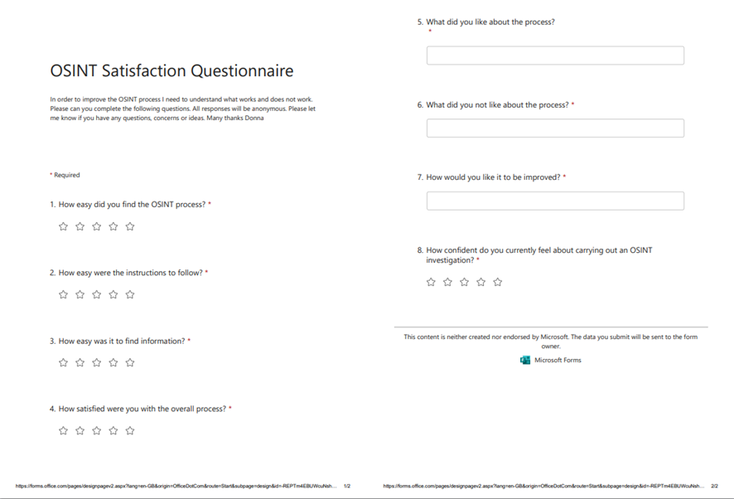
Figure 48: OSINT Satisfaction Questionnaire

Appendix H: Initial Satisfaction Questionnaire Responses
The answers to the questionnaire were collated, average scores are shown below along with the comments received.
Table 20: Initial Questionnaire Responses
Question | Response
How easy did you find the OSINT process? | 2/5
How easy were the instructions to follow? | 1.5/5
How easy was it to find information? | 2/5
How satisfied were you with the overall process? | 1.5/5
What did you like about the process? | “Some of the findings could be quite interesting.”
What did you not like about the process? | “The instructions weren’t easy to follow and took a long time to get through the process.”  “Very time consuming!”  “Felt very repetitive”  “Not enough cyber”
How would you like it to be improved? | “I think it could be quicker, easier, and more targeted to cyber security – providing more valuable results to the team.”  “Can some of it be automated?”  “Clearer instructions, perhaps a flowchart.”
How confident do you currently feel about conducting an OSINT investigation? | 1.83/5

Appendix I: OSINT Tool Survey Questionnaire
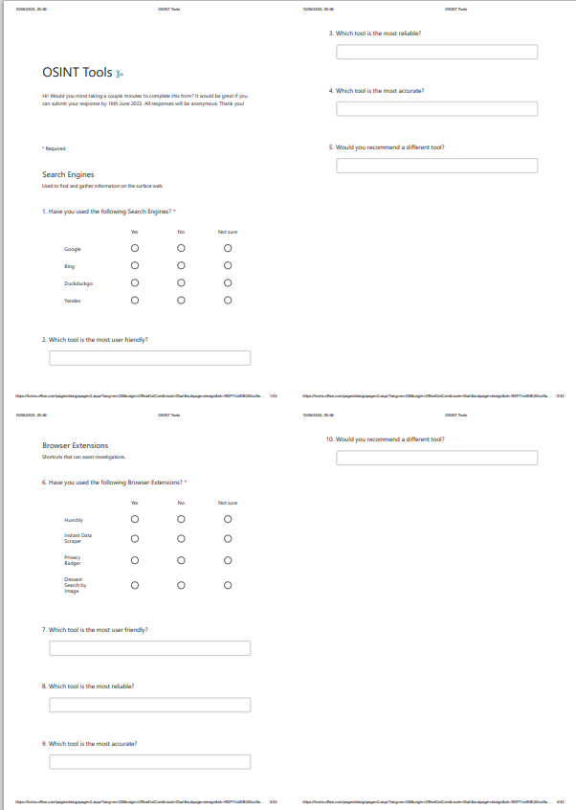
Figure 49: OSINT Tool Survey Questionnaire

Appendix J: OSINT Tool Survey Results
Table 22: OSINT Tool Survey Results
Category | Tool | Yes | No | Not Sure | Most user friendly | Most reliable | Most accurate | Positive Totals
Search Engines | Google | 14 | 0 | 0 | 10 | 10 | 10 | 44
Search Engines | Bing | 14 | 0 | 0 | 4 | 4 | 4 | 26
Search Engines | DuckDuckGo | 8 | 3 | 3 | 0 | 0 | 0 | 8
Search Engines | Yandex | 2 | 12 | 0 | 0 | 0 | 0 | 2
Browser Extensions | Hunchly | 1 | 13 | 0 | 0 | 0 | 0 | 1
Browser Extensions | Instant Data Scraper | 1 | 13 | 0 | 1 | 1 | 1 | 3
Browser Extensions | Privacy Badger | 6 | 8 | 0 | 6 | 6 | 6 | 24
Browser Extensions | Dessant Search By Image | 3 | 10 | 1 | 3 | 3 | 3 | 12
Harvesting web data | Google Mobile-friendly Test | 1 | 13 | 0 | 0 | 0 | 0 | 1
Harvesting web data | URLscan.io | 14 | 0 | 0 | 14 | 14 | 14 | 56
Image analysis | SunCalc | 1 | 13 | 0 | 1 | 1 | 1 | 4
Image analysis | MoonCalc | 1 | 13 | 0 | 1 | 1 | 1 | 4
Language translation | Bing Translate | 14 | 0 | 0 | 2 | 2 | 2 | 20
Language translation | DeepL | 4 | 10 | 0 | 0 | 0 | 0 | 4
Language translation | Google Translate | 14 | 0 | 0 | 12 | 12 | 12 | 50
Language translation | Yandex Translate | 3 | 9 | 2 | 0 | 0 | 0 | 3
File metadata analysis | ExifTool | 7 | 0 | 0 | 7 | 7 | 7 | 28
File metadata analysis | FotoForensics | 4 | 0 | 0 | 4 | 4 | 4 | 12
Reverse Image search | Bing Image Search | 14 | 0 | 0 | 7 | 7 | 7 | 35
Reverse Image search | Google Images | 14 | 0 | 0 | 7 | 7 | 7 | 35
Reverse Image search | Yandex Image Search | 5 | 8 | 1 | 0 | 0 | 0 | 5
Imagery and map analysis | BBBike | 2 | 0 | 0 | 0 | 0 | 0 | 2
Imagery and map analysis | Bing Maps | 14 | 0 | 0 | 4 | 4 | 4 | 26
Imagery and map analysis | Google Maps | 14 | 0 | 0 | 10 | 10 | 10 | 44
Imagery and map analysis | Insecam | 1 | 0 | 0 | 1 | 1 | 1 | 4
Imagery and map analysis | WorldCam | 2 | 0 | 0 | 2 | 2 | 2 | 8
Usernames and Avatars | CheckUser | 6 | 8 | 0 | 0 | 0 | 0 | 6
Usernames and Avatars | Gravata | 1 | 0 | 0 | 0 | 0 | 0 | 1
Usernames and Avatars | Keybase | 1 | 0 | 0 | 0 | 0 | 0 | 1
Usernames and Avatars | WhatIsMyName | 7 | 5 | 2 | 7 | 7 | 7 | 28
Email Addresses | EmailRep | 8 | 4 | 2 | 8 | 8 | 8 | 32
Email Addresses | Epieos | 1 | 13 | 0 | 0 | 0 | 0 | 1
Email Addresses | Email Format | 1 | 13 | 0 | 0 | 0 | 0 | 1
Email Addresses | Hunter | 8 | 6 | 0 | 4 | 4 | 4 | 20
Email Addresses | InfoSniper | 6 | 8 | 0 | 5 | 5 | 5 | 21
IP Addresses | IP Chicken | 1 | 13 | 0 | 1 | 1 | 1 | 4
IP Addresses | WhatIsMyIPAddress | 14 | 0 | 0 | 14 | 14 | 14 | 56
IP Addresses | Whatu.info | 1 | 13 | 0 | 0 | 0 | 0 | 1
Domain lookups | Security Trails | 8 | 4 | 2 | 8 | 8 | 8 | 32
Domain lookups | Dnsdumpster | 3 | 11 | 0 | 3 | 3 | 3 | 12
Domain lookups | Host.io | 6 | 8 | 0 | 6 | 6 | 6 | 24
Domain lookups | Dnstwister | 4 | 12 | 0 | 4 | 4 | 4 | 12
WHOIS | ViewDNS | 8 | 6 | 0 | 8 | 8 | 8 | 32
WHOIS | Whoxy | 4 | 4 | 6 | 3 | 3 | 3 | 16
Infrastructure | Shodan | 7 | 7 | 0 | 5 | 5 | 5 | 22
Infrastructure | Censys | 5 | 9 | 0 | 3 | 3 | 3 | 17
Infrastructure | Maltego | 12 | 1 | 1 | 3 | 3 | 3 | 31
Wireless | WiGLE | 2 | 12 | 0 | 2 | 2 | 2 | 8
Wireless | CiscoDNS | 1 | 14 | 0 | 1 | 1 | 1 | 4
Website Analysis | Archive.is | 4 | 10 | 0 | 3 | 3 | 3 | 13
Website Analysis | BuiltWith | 2 | 12 | 0 | 2 | 2 | 2 | 8
Website Analysis | Internet archive | 4 | 10 | 0 | 1 | 1 | 1 | 7
Website Analysis | Netcraft | 5 | 9 | 0 | 5 | 5 | 5 | 20
Breached Data | HaveIbeenpwned | 10 | 4 | 0 | 10 | 10 | 10 | 40
Breached Data | Dehashed | 3 | 11 | 0 | 3 | 3 | 3 | 12
Breached Data | Intelligence X | 2 | 11 | 1 | 0 | 0 | 0 | 2
Breached Data | SOCRadar | 1 | 13 | 0 | 1 | 1 | 1 | 4
OSINT Automation | Google Alerts | 2 | 12 | 0 | 2 | 2 | 2 | 8
OSINT Automation | Python Scripts | 6 | 7 | 0 | 5 | 5 | 5 | 21
OSINT Automation | Power Automate | 2 | 12 | 0 | 1 | 1 | 1 | 5
OSINT Automation | Visualping | 1 | 13 | 0 | 0 | 0 | 0 | 1

Appendix K: Tool Comparison

Web Browsers
Table 23: Web Browser Comparison
Tool | Advantages | Disadvantages
Microsoft Edge [170] | - Already used by DVLA.  - Block pop-ups [171].  - Block tracking [171] .  - Runs in a sandbox [172].  - Users already confident using it.  - As already in use, privacy and security risk assessment would already have been conducted by Information Assurance Group (IAG). | - Updated every four to 8 weeks [173].  - Limited extension support  - No advanced privacy and security features [171].  - Not suitable for OSINT purposes due to missing security features and update frequency.
Opera [174] | - Recommended by user.  - Nice user interface.  - Cypto mining protection [175].  - Tracker blocker [175].  - Ad blocker [175].  - Built in VPN (unneeded) [175]. | - Slow  - Stores Browsing data by default, can remove by clearing data [176].  - No update schedule found.  - Not suitable for OSINT activities due to speed and unknown update frequency.
Google Chrome [177] | - Already used at DVLA.  - Full updates released every six weeks. Minor patches released every two to three weeks [177].  - Browser extensions available to improve security and privacy  - As already in use, privacy and security risk assessment would already have been conducted by IAG. | - Lacking privacy [178].  - Collect user data [178].  - Uses user profiling as a source of revenue for ad targeting [178].  - Not suitable for OSINT activities due to its data collection policy.
Tor Browser [179] | - Prevents unauthorised snooping with its hidden relay services [179] .  - Pre-configured security features [179]  - Can run from USB  - Encrypts internet traffic three times for three different nodes. | - Slow  - Does not support many plug-ins.  - Settings are complicated.  - No anti-malware.  - Illegal in some countries.  - Not suitable for OSINT investigations
Mozilla Firefox [180] | - Fast  - Only mainstream open-source browser.  - Secure [180].  - Tracking, malware and phishing protection [180] .  - Pop-up blocking [180]  - Anti-fingerprint protection [180] .  - Extensive customisation possibilities.  - Collection of security add-ons.  - Standard updates released every four weeks (not including any urgent patch updates) [180] . | - Has Pocket, Telemetry and startup profiling by default but can be disabled [180] .

Search Engines
Table 24: Search Engine Comparison
Tools | Advantages | Disadvantages
Google [181] | - Already used by DVLA.  - Largest index size [182].  - Text, video and image search [181].  - Simple user interface  - As already in use, privacy and security risk assessment would already have been conducted by IAG. | - Creates user profiles [183].  - Tracks search history [183].  - Track location [183].  - Unsuitable for general OSINT activities due to privacy concerns.
Bing [184] | - Already used by DVLA  - Text Search [184]  - Video Search, supplies grid view of large thumbnails.  - Better Image Search, search by image size, colour or type.  - Simple User Interface  - Uses HTTPS [185].  - Uses single-sign-on [185]  - As already in use, privacy and security risk assessment would already have been conducted by IAG. | - Creates user profiles [186].  - Tracks search history [186].  - Tracks location [186].  - Unsuitable for general OSINT activities due to privacy concerns.
DuckDuckGo [107] | - Currently used for OSINT at DVLA.  - Does not store IP addresses [107].  - Does not store search history [107].  - Does not save user agent strings [107].  - Does not build user profiles [107].  - Blocks trackers [107]  - SSL encryption [107].  - Search shortcuts (!bang) [107]. | - Limited customisation options  - Unattractive search results  - Unfavourable feedback from analysts.
Startpage [187] | - Does not track IP addresses [188].  - Does not store search history [188].  - Does not save user agent strings [188] .  - Does not build user profiles [188].  - Does not use price trackers [188].  - Does not share ISP [188].  - Does not store cookies [188].  - Does not store cache [188].  - Does not share browser type [188].  - Does not share location information [188].  - Blocks trackers [188].  - Includes an anonymous view feature [188].  - Uses Google’s search algorithm [187].  - Combines results from lxquick and Google [188]. | - Owned by advertising company.
Yandex [108] | - Good image search and facial recognition  - Customisable layout.  - Fast results.  - DNS Spoofing protection [189].  - DNSCrypt [189].  - Automatic HTTPS [190]. | - Allegedly associated with the Russian Government [191] [192]. Ex-executives of Yandex are on the UK Sanctions List for allegedly supporting the Russian Government [193]  - Privacy and User data concerns [194].  - Maps default to Europe  - Search results default to non-English at times.  - Unsuitable for OSINT activities due to privacy concerns.

Browser Extensions
Table 25: Browser Extension Comparison
Extension | Advantages | Disadvantages
Hunchly [109] | - Casefile documenting application.  - Records data  - Extract and store image metadata  - Automatically harvests Google Analytics code | - Does not work with Firefox.  - 30 free trials but then $129.99 a year for one user subscription.
Instant Data Scraper [110] | - Extracts table data on a web site and saves it as a CSV or XLSX file.  - Free | - Does not work with Firefox. Firefox alternative is Web Scraper [195]
Privacy Badger [111] | - Ad and tracker blocker.  - Works with Chrome, Firefox, Edge and Opera.  - Free | - Will need added ad-blocking.
Dessant Search by Image [112] | - Sends images to different image search engines. | - Does not work with Firefox. Alternative is Tineye.com [196]
Tineye.com [196] | - Does not save images | - Can only search one image at a time

Harvesting Web Data
Table 26: Harvesting Web Data Tool Comparison
Tool | Advantage | Disadvantage
Google Mobile-Friendly Test [113] | - Retrieves a web page and bypass authentication and access controls. | - Author has ethical concerns using this tool for a government agency.
URLscan.io [114] | - Proxy Web applications, scans web sites from the server and not your browser.  - Prevents browsing related malware infections.  - Supplies historical searching of earlier web site scans.  - Well used and liked by analysts.  - Free  - As already in use, privacy and security risk assessment would already have been conducted by IAG. | - None found for OSINT.
Web Scraper [195] | - See Browser extensions | - See Browser Extensions.
VirusTotal [142] | - Analyse suspicious files, domains, IP addresses and URLs.  - Well used and liked by analysts.  - As already in use, privacy and security risk assessment would already have been conducted by IAG. | - Have to be careful no sensitive data is included in any files scanned.

Language Translation
Table 27: Language Translation Tool Comparison
Tool | Advantages | Disadvantages
Bing Translate [117] | - Nicest user interface.  - Good for conversation translation.  - Split-screen conversation mode.  - Fast.  - Accurate.  - Offline mode.  - Free | - Only translates 60 languages
DeepL Translator [118] | - Uses AI when translating documents which provides more natural translations.  - Free version available | - Privacy concerns with the free version as DeepL stores and uses texts to improve and update their algorithm.  - Can only translate 11 languages.
Google Translate [119] | - Most recommended by analysts.  - Nice user interface.  - Fast.  - 109 languages.  - Translate web pages, text and documents.  - Offline mode.  - Available as an extension for Chrome, Edge and Firefox.  - Free | - Singe direction translation only.
Yandex Translate [120] | - Supports 102 languages.  - Also translates text from images and videos.  - Very fast. | - Data privacy concerns.

File Metadata Analysis
Table 28: File Metadata Analysis Tool Comparison
Tool | Advantages | Disadvantages
ExifInfo [121] | - Analysts have requested no command-line tool.  - This is the online version of Exiftool.  - Analyse a file or an URL.  - Easy to use  - Fast  - Clear results  - Works with JPEG, PNF, DOC, RAF, ARW, DNG, TIFF, JP2, CR2, NEF, PEF and ORF.  - Original files are immediately deleted after processing. Exif metadata is stored for 3 days for viewing and then purged.  - Results are only accessible via unique URL.  - Free | - None found for OSINT.
FotoForensics [122] | - Easy to use  - Check image using URL or by uploading a file.  - Free | - Pictures uploaded will not be kept private [197]  - Supports JPEG, PNG, WebP, HEIC or AVIF.  - Needs JavaScript enabled.  - Uploads are limited to 12 megabytes per file. Pictures should be at least 100x100 pixels.

Reverse Image Search
Table 29: Reverse Image Search Tool Comparison
Tool | Advantages | Disadvantages
Bing Image Search [198] | - Well used and liked by analysts  - Found to provide the most accurate and relevant results by analysts.  - High quality images  - Does not save images | - Slow
Google Images [199] | - Well used and liked by analysts  - Fast  - Sort by size, colour, image type. | - Accuracy  - Stores image for up to seven days to improve products and services
Yandex Image Search [123] | - Exceptionally good for facial recognition  - Can search by collection. | - Privacy concerns [194]
TinEye | - See extensions

Usernames and Avatars
Table 30: Username and Avatar Tool Comparison
Tool | Advantages | Disadvantages
CheckUser.org [130] | - Can check what usernames are used on each platform  - Checks over 70 social network sites including the most popular.  - Can check available domain names  - Free  - Does not need any personal data or registration. | - Collects IP and device type [200].  - Usage and activity [200].  - Uses cookies [200].
Gravatar [131] | - Gravatar allows users to use the same avatar and user data across multiple sites. Can be used to find new accounts for the target.  - Email checker [201] | - Need an account  - Suffered a data breach in 2020 [202]
Keybase.io [132] | - Ties social media accounts together.  - Does not need an account to search | - Small user base
WhatsMyName Web [133] | - Finds usernames across websites  - Automatically searches documents (PDF, Spreadsheets, Word documents, PowerPoint, Text file, Python code and JavaScript Code.  - Automatically searches Google and Google Images.  - Can be used with Maltego [203]  - Hides false positives | - Doesn’t search as many sites as alternative paid for tools.

Email Addresses
Table 31: Email Address Tool Comparison
Tool | Advantages | Disadvantages
Emailrep.io [134] | - Finds reputation of email address. | - No other functions.
Epieos [135] | - Search email address and phone number.  - Automatically checks HaveIbeenpwned?  - Automatically uses holehe [204] to check for registered accounts  - Lists accounts linked to email address  - Free tier gives full google, holeha an skype results. | - Need to sign up to see some details.  - “Osinter” tier gives all modules including LinkedIn and 30 full-access request per month for 29.99 euros.
HaveIbeenpwned? [136] | - See breached data
Hunter.io [137] | - Domain search  - Email finder  - Email verifier | - Free account five 25 searches a month.  - Business plan is £3516 a year for 50,000 searches a month.  - Did not find or verify email address.

IP Addresses
Table 32: IP Address Tool Comparison
Tool | Advantages | Disadvantages
Infosniper.net [128] | - Provides geolocation | - Need to purchase credits after trial period. Minimum credits 10,000 queries for $19  - Stores IP address, browser type, browser version, pages visited, time, date and length of visit [205].
IP Chicken [139] | - Displays current IP address  - Displays remote port number  - Displays browser  - No information is stored [206].  - No cookies used [206]. | - No other function
WhatisMyIPAddress [140] | - Well used and liked by analysts.  - Displays own IP address  - Search IP address for hostname, ASN, ISP, Services, Assignment, Country, City, Latitude and Longitude.  - Blacklist check  - Breach check  - Proxy check  - VPN Leak check  - Trace email  - Speed test  - Reverse DNS Lookup  - Free  - As already in use, privacy and security risk assessment would already have been conducted by IAG. | - Adverts are annoying.  - Track IP address [207]
Whatu.info [141] | - Find geolocation from IP address  - Shows your how your browser appears to other sites | - No privacy policy found.

Domain Lookups
Table 33: Domain Lookups Tool Comparison
Tool | Advantages | Disadvantages
SecurityTrails [143] | - Free tier offers 50 queries a month, current DNS records, historical DNS records, subdomains and IP address research. | - Paid for professional, business and enterprise versions.  - Uses cookies
DNSdumpster [144] | - Discover hosts for domains  - DNS lookups and WHOIS searches  - Free  - Available as a browser extension | - No privacy policy found.
Host.io [145] | - DNS lookups and WHOIS searches  - Scraped website content  - Hosing details for domains  - Free plan | - Need account
Dnstwister.report [146] | - Enumerates typo squatted domains | - Uses cookies

WHOIS
Table 34: WHOIS Tool Comparison
Tool | Advantages | Disadvantages
ViewDNS.info [147] | - Domain/IP WHOIS  - Reverse IP and WHOIS lookup  - IP History  - DNS Report  - Reverse MX and NS Lookup  - IP Location Finder  - DNS Propagation Checker  - DNS Report and record lookup  - IP Location Finder  - Get HTTP Headers  - Traceroute and Ping  - DNS Record Lookup  - Get HTTP Headers  - DNS Record Lookup  - Port Scanner  - Traceroute and Ping  - SPAM Database Lookup  - Reverse DNS Lookup  - ASN Lookup  - DNSSEC Test  - URL/String Decode  - Abuse Contact Lookup  - MAC Address Lookup  - Free Email Lookup | - Uses cookies
Whoxy [148] | - Web WHOIS tool  - Historical WHOIS searches | - Less functions that ViewDNS

Infrastructure
Table 35: Infrastructure Tool Comparison
Tool | Advantages | Disadvantages
Shodan.io [150] | - Search engine for internet connected devices  - Monitor internet connected devices | - Limited data available without a paid for plan ($69/month to $1099/month).  - Collect IP addresses, device type, Operating Systems, Open Ports.
Censys.io [151] | - Constantly scans the internet and collects certificates from servers which can be searched.  - Scans the internet and catalogues the results for searching  - Works with Maltego | - Uses cookies  - Collects IP address  - Logs search queries
Maltego [72] | - Already used for OSINT.  - Link and relationship analysis tool  - Many available transforms and machines to conduct searches  - As already in use, privacy and security risk assessment would already have been conducted by IAG. | - Confidence level is low amongst analysts.

Website Analysis
Table 36: Website Analysis Tool Comparison
Tool | Advantages | Disadvantages
Archive.is [152] | - Cached content of websites. Allows analysts to go back in time to see what the site looked like and how it has changed.  - Recover deleted tweets | - Relies on the site needed already being cached.
BuiltWith [153] | - Shows relationships between different web sites using similar tracking codes.  - Browser extensions  - Free to use for individual site lookups | - Paid for plans available (£232/year to £784/year)
Netcraft [154] | - Examines web server platforms and contents.  - Different services available  - Reveals technology, users, DNS, IP, hosting histories, tracker and vulnerabilities.  - Browser extension | - No free version  - No free trail

Breached Data
Table 37: Breached Data Tool Comparison
Tool | Advantages | Disadvantages
Haveibeenpwned.com [136] | - Already used  - Check if email address or phone number is in a data breach  - Search across your own domain  - Find latest breaches | - Doesn’t provide granular details.
Dehashed.com [155] | - Real time asset monitoring  - Monitor multiple accounts  - Asset searching | - $179.99 a year.
Intelx.io [156] | - Search for breach data, IP, domain registration content and emails.  - Search Google Analytics code to find other websites with the same ID. | - Paid for API version for companies ($5000/year).
PasteBin | - Already used for OSINT  - Does not track  - Browser extensions  - As already in use, privacy and security risk assessment would already have been conducted by IAG. | - Now needs an account to conduct searches.  - Uses cookies  - Collects IP address
SOCRadar – Extended Threat Intelligence (XTI) [158] | - Phishing Detection  - Data Leak Detection  - Dark Web Monitoring  - Vulnerability scanning  - Free access for 12 months | - Need subscription

Social Media Monitoring
Table 38: Social Media Monitoring Tool Comparison
Tool | Advantages | Disadvantages
Social Searcher [159] | - Real-time social mentions search tool  - Free provides 100 real-time searches/day and 2 email alerts.  - Filter by general, sentiment, users, links, types and keyword.  - Export report to CSV | - Needs an account for real-time monitoring and email notification.  - Paid for versions
TweetDeck [160] | - Already used by the SOC  - Customisable Twitter interface to monitor different users, search terms and hashtags  - Browser extension  - As already in use, privacy and security risk assessment would already have been conducted by IAG. | - Need Twitter account  - Browser extension will not be used as it requires access to data for the following sites:  - Tenor.com  - Giphy.com  - Twimg.com  - Tweetdeck.twitter.com
Social Mentions [159] | - Searches user generated contents such as blogs, comments, news, events and videos  - Part of Social Searcher. | - See Social Searcher

OSINT Automation
Table 39: OSINT Automation Tool Comparison
Tool | Advantages | Disadvantages
Google Alerts [162] | - Email or RSS alert when Google indexes a keyword.  - Very easy to set up and amend.  - Choose frequency of alerts, type of sources, language, regions, best results or all results. | - Need a Google Account
Python Scripts [163] | - Scripts to automate data collection. | - Analysts not confident with Python
Microsoft Power Automate [164] | - Data collection and social media flows  - Powerful | - More complicated to set up.
VisualPing.io [165] | - Visually examines a section of a web page or examine text for changes. | - May not be required for general use

Appendix L: Attack Surface Mapping for OSINT
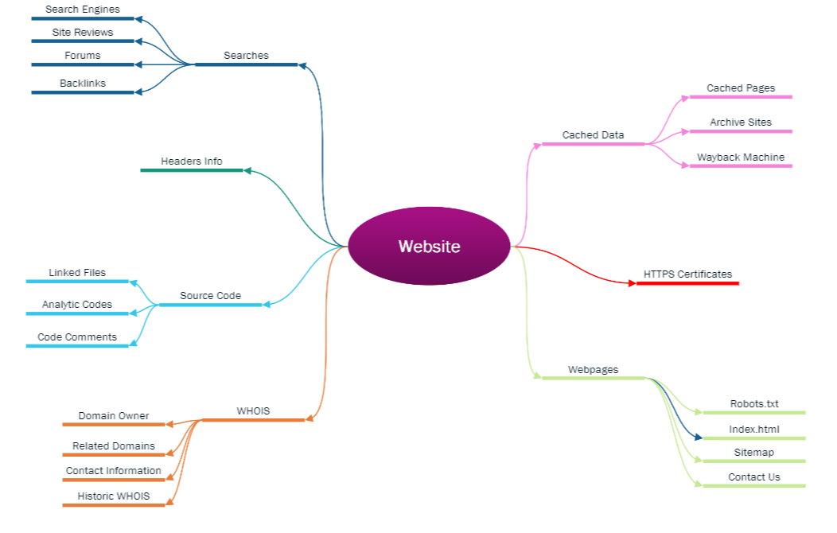
Figure 50: Website Attack Surface

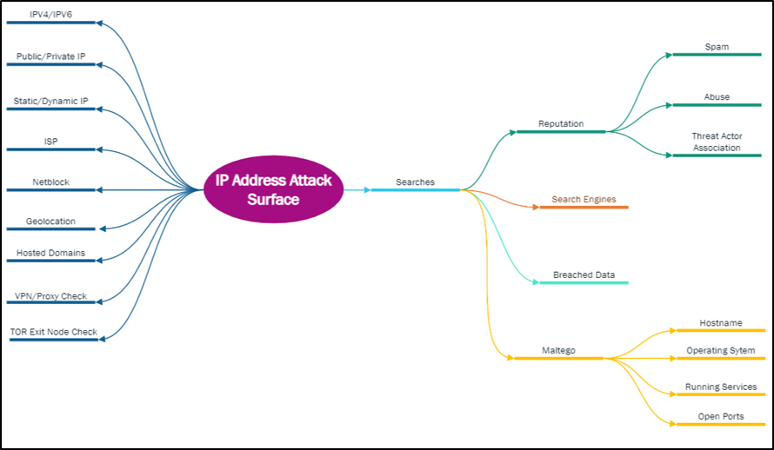
Figure 51: IP Address Attack Surface
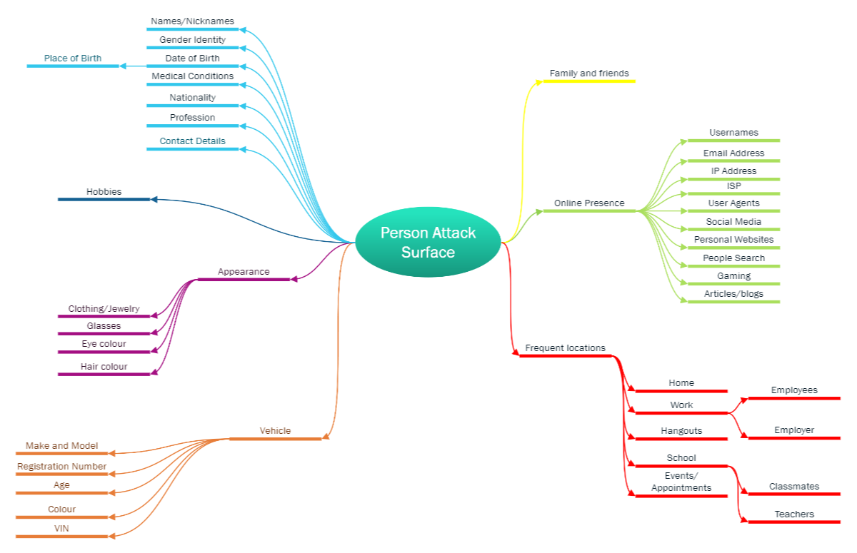
Figure 52: Person Attack Surface
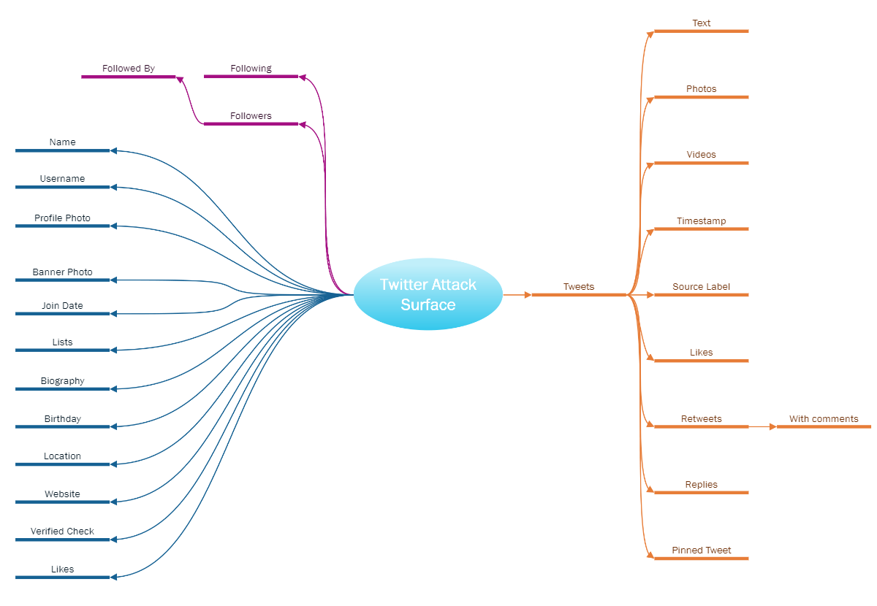
Figure 53: Twitter Attack Surface
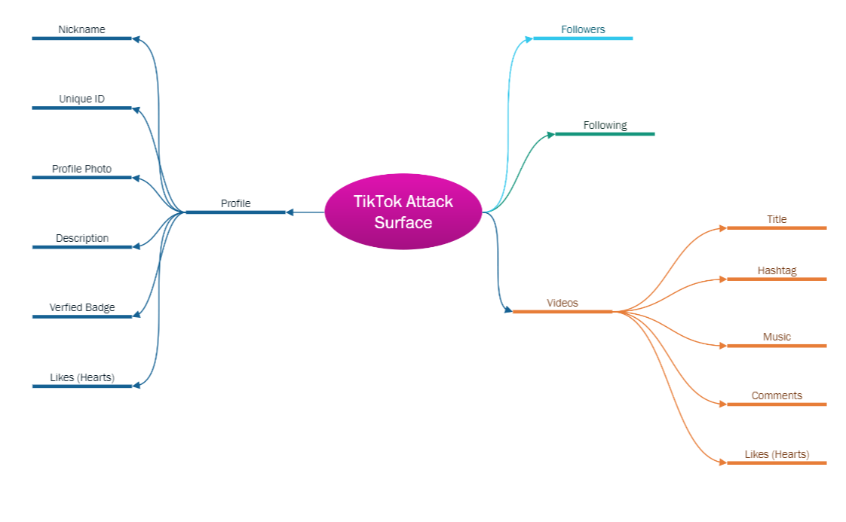
Figure 54: TikTok Attack Surface
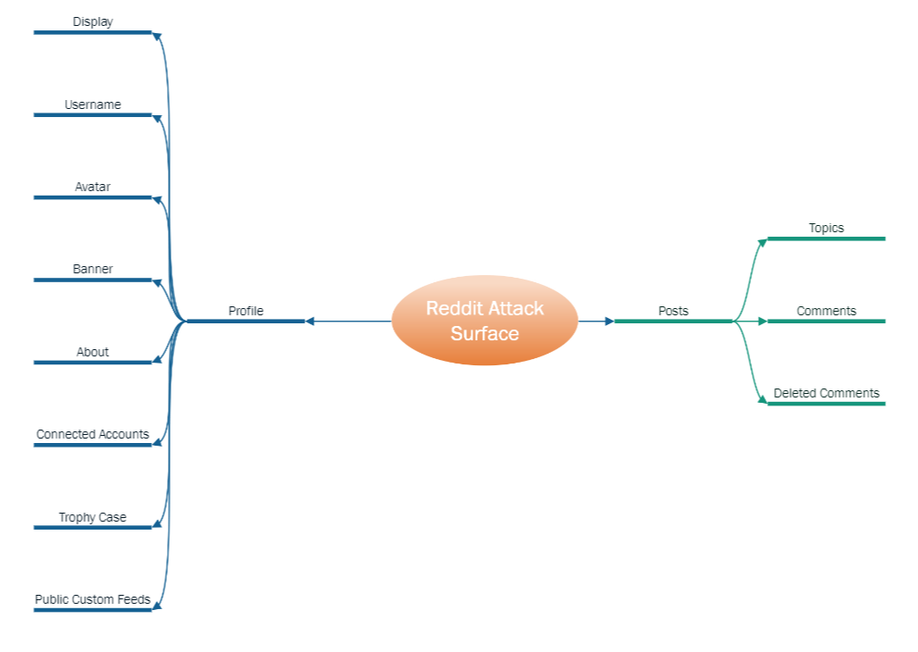
Figure 55: Reddit Attack Surface
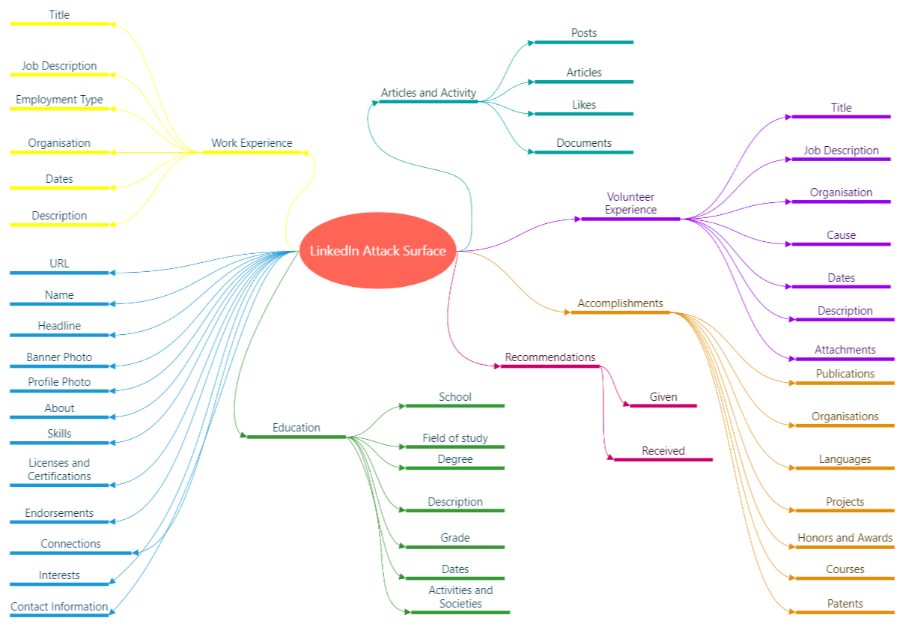
Figure 56: LinkedIn Attack Surface
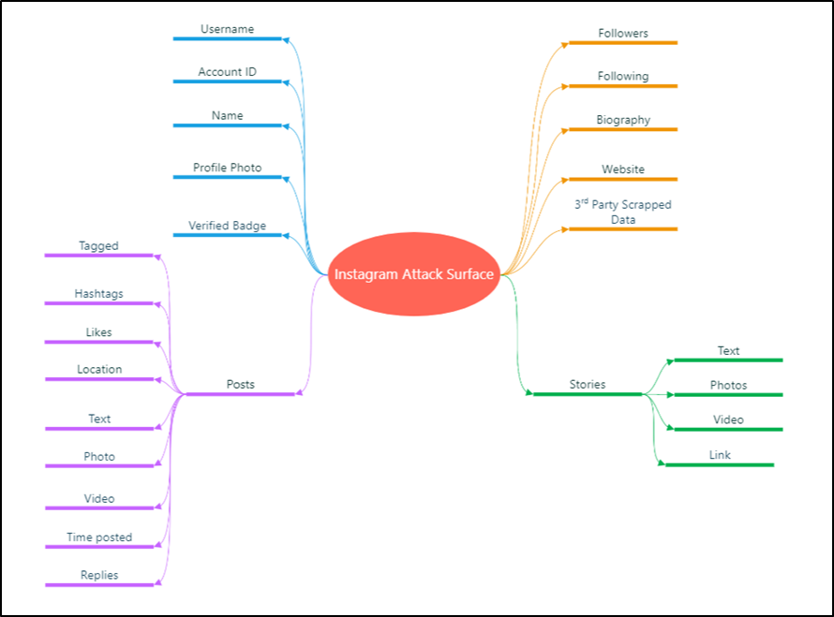
Figure 57: Instagram Attack Surface
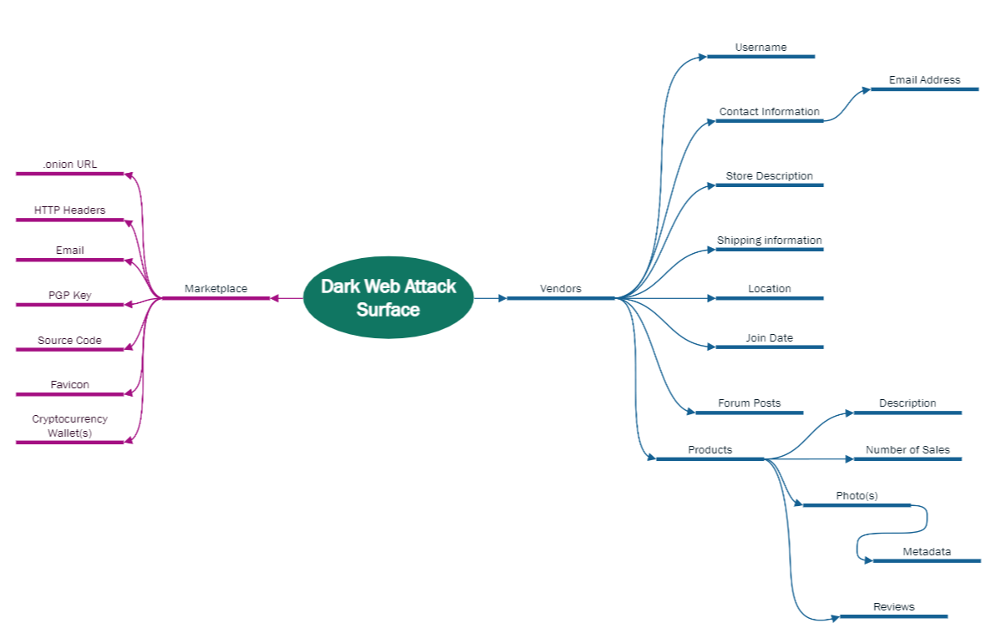
Figure 58: Dark Web Attack

Appendix M: Standard Operating Procedures
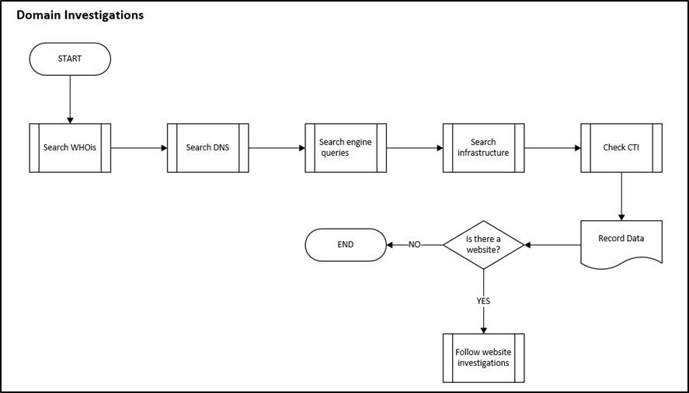
Figure 59: Domain Investigation Flowchart

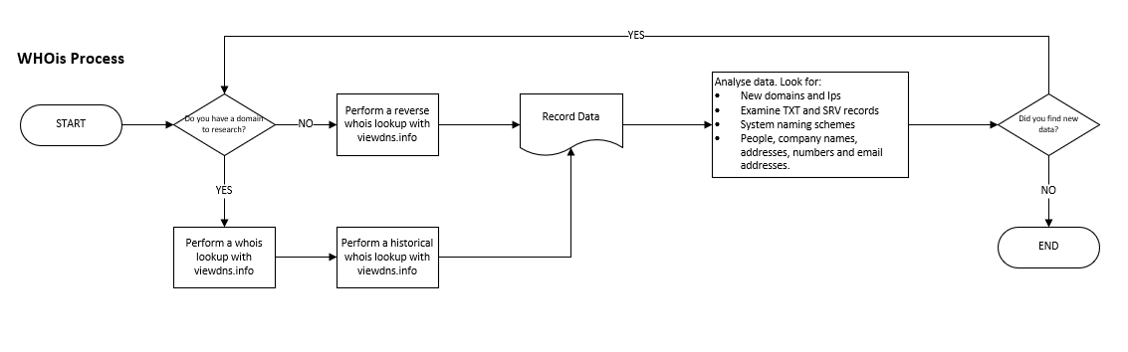
Figure 60: WHOis Process Flowchart
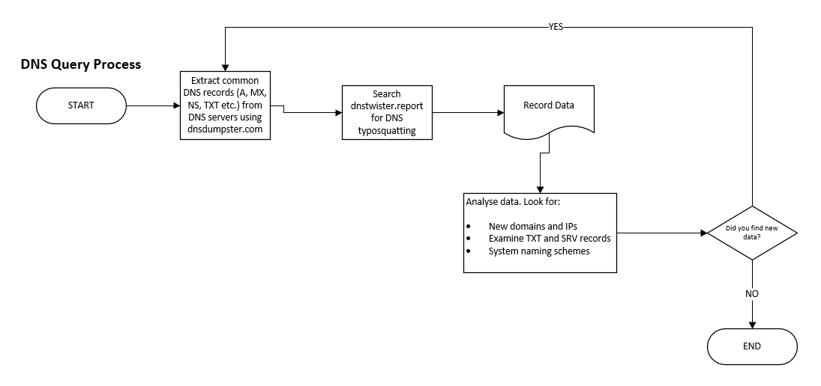
Figure 61: DNS Query Process Flowchart

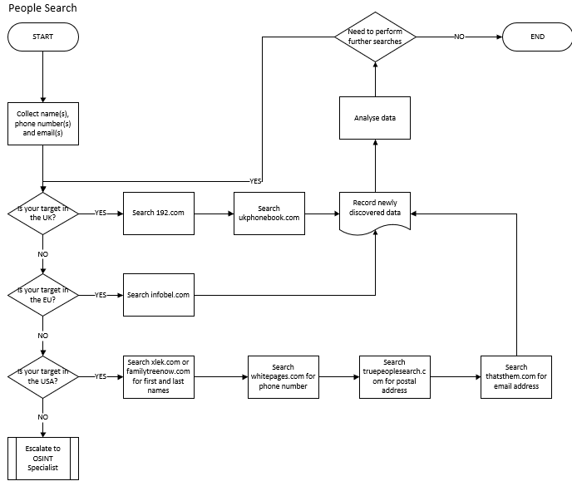
Figure 62: People Search Investigation Flowchart
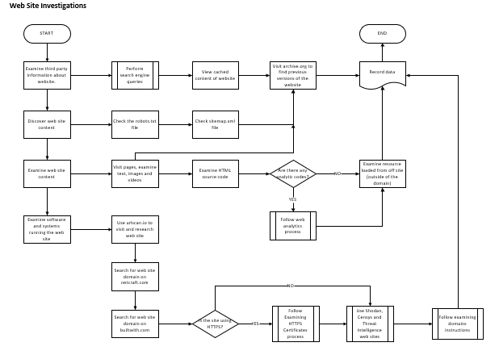
Figure 63: Web Site Investigation Flowchart
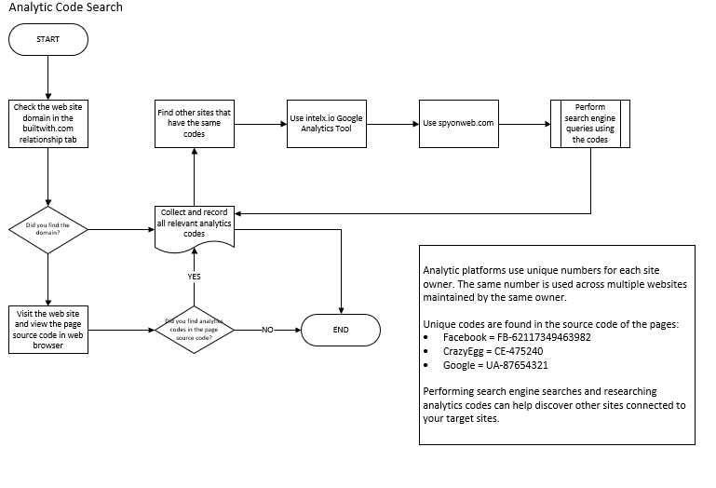
Figure 64: Analytic Code Flowchart
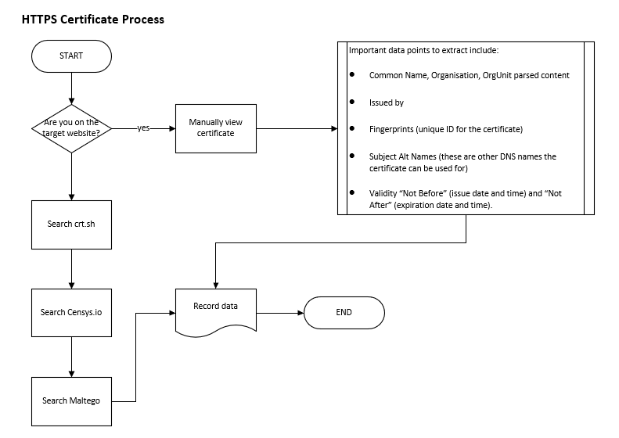
Figure 65: Examining HTTPS Certificate Flowchart

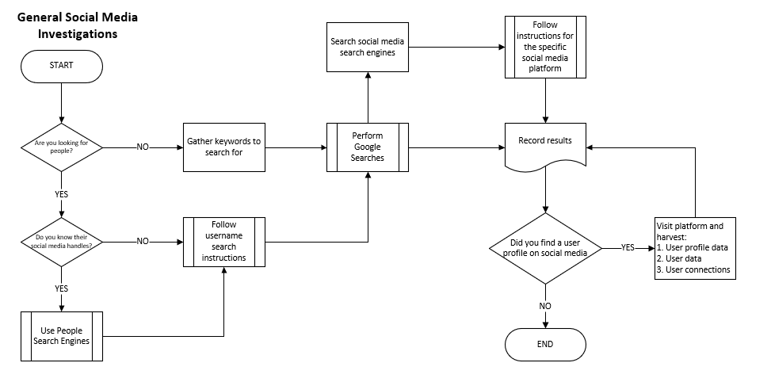
Figure 66: General Social Media Investigation Flowchart
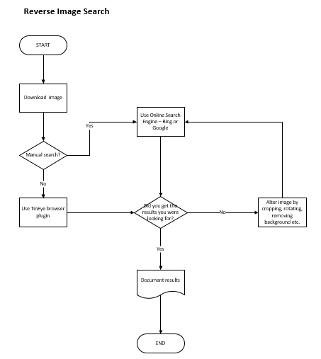
Figure 67: Reverse Image Search Flowchart

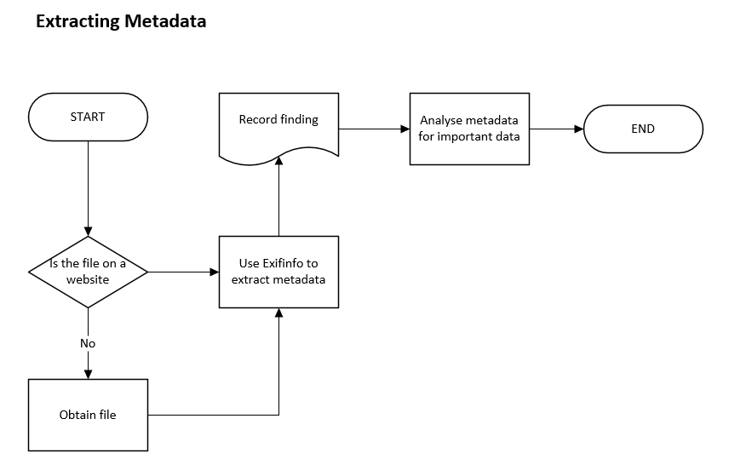
Figure 68: Extracting File Metadata Flowchart

