https://learntransformation.com/types-of-leadership/

Types Of Leadership In The VUCA Environment
Although leadership can take many different forms, its fundamental purpose is to encourage and direct people to success.
By MANISHSeptember 11, 2021Updated:November 4, 2023No Comments16 Mins Read
FacebookTwitterPinterest

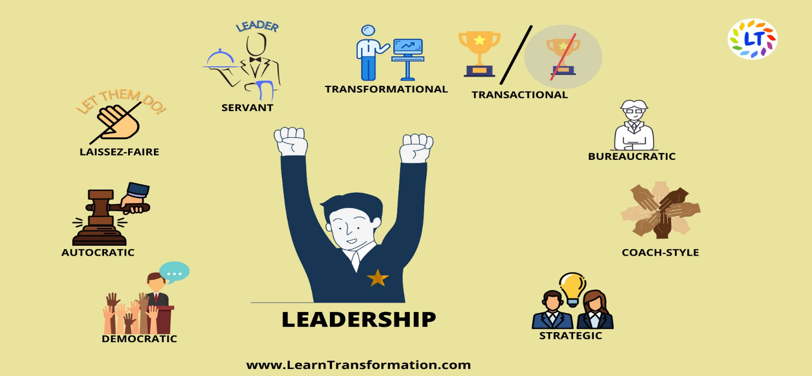
types-of-leadership
SHARE
You manage things; you lead people.
GRACE MURRAY HOPPE

Types of Leadership: Understanding Different Leadership Styles
Leadership is a power relationship among leaders & followers who plan real changes & consider their mutual purpose. It’s necessary to acknowledge that anybody can be a leader. Yes, that means you, too. There are many types of leaders and leadership. A good leader can enter any given situation & give an insight for a better future, brainstorm strategies for realizing that future & implement a plan to see it to fulfilment during transformation process.
But great leaders take it a step further by understanding their strengths & flaws and learning to practice the leadership styles that best suit them and their team, allowing them to achieve more, force bigger change & create a legacy that extends beyond their lifetime. Leadership as a supervisory function was previously not allowed to the top officers. But now even if you’re not managing a team on a daily basis, you might still have to step into a leadership role from time to time.
- Leadership is a process.
- Leadership is not only influence, yet it includes influencing others through the leadership.
- Between the leader & followers, the influence is mutual, together, they influence the environment around them in some way.
- Leadership goes beyond goals. There is a motive a source which a wide enough to generate a vision that links followers who might have distinct individual aim.

Why Is it Necessary to Acknowledge Your Leadership Style?
Our leadership style is a whirl of our values, our natural strengths & abilities, our faith & experiences.
Acknowledging the best leadership style felicitous for your particular personality will not only make you a more effective leader, it will help you better understand & expertise yourself. You’ll learn about your powerful qualities so you can escalate them, while also becoming more aware of what to work on so you can be the best version of yourself. Your leadership style influences how you connect & communicate with your team, relate to your team’s working style, sort out disputes & more. Whether a Leader is autocratic or democratic? Is he or she charismatic or reserved, confident or humble?
The answer is: It depends.
Also Read: 26 Best Leadership Books Of All Time
Table Of Contents:
- Types of Leadership: Understanding Different Leadership Styles
- Why Is it Necessary to Acknowledge Your Leadership Style?
- Types of Leadership
  - Frequently Asked Questions
  - Key Takeaways:

Types of Leadership

1. Democratic or Participative Leadership
Impact: Commonly Effective.
Democratic type of leadership style is also a Participative style. It is a leadership style which says that leader should take the input of each team member while making final decision. Though leader takes the final decision, but every employee has an equal chance on a project’s direction.
Democratic leadership is one of the most effective leadership types because in this leader has cooperation of its employees & leader always welcome any creative & fruit- bearing input from employees. It is similar to how decisions can be made in company business meetings.
Example: In a company business meeting, leader might give the team a few decision-related choices. Then they start a discussion about each option. After a discussion, this leader might take the board’s thoughts & feedback into reflection, or they might open this decision up to a vote.
Pro: Innovation or Creativity is encourage, which also enhances job satisfaction among employees & team members. When changes occur during organizational transformation, the democratic leadership style helps employee’s welcome changes easily because they possessed a good role in the process.
Con: Continually trying to obtain agreement among a group can be ineffective and, in some cases, costly.
You Can be a Participative Leader If-
- You can’t remember the last time you made an important decision without getting input from at least one other person.
- You think the best meetings are those where each employee has an equal opportunity to comment.
FAQs for Blogs- Leadership in Digital World
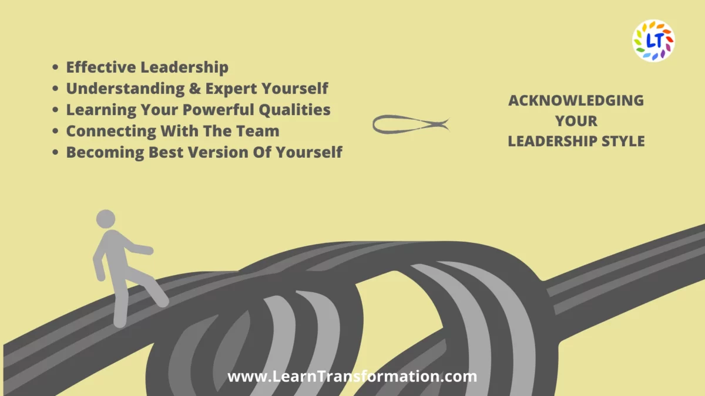

2. Autocratic or Authoritarian Leadership
Impact: Rarely Effective.
Autocratic leadership is also the authoritarian type of leadership. It is the reverse of democratic leadership. In this leadership type, the leader don’t take inputs from their employees in making decisions. They order not only what needs to be done, but also how those tasks should be attained. An autocratic leader own high level of power & authority and imposes its will on its employees. You can think of this as a “my way or the highway” approach.
Candidly, this type of leadership style reeks. This type is more a traditionally enforced one than logically applied. The concepts of ‘power’ and ‘order’ are embedded in this style’s foundation. An example of this: When a manager alters the work hours shifts for many employees without discussing anyone.
This leadership types finds to be useful where the level of management is close. This type of leader is someone who gives attention almost completely on results & efficiency. We can think these types of leaders as military commanders.
Example: Before an operation, the doctor cautiously narrates the rules & processes of the operation room with each & every team member who will be helping during the surgery. He wants to make sure everyone is understandable on the expectations & follows every procedure cautiously, so the surgery goes as smoothly as possible.
Pro: Decisions are often made swiftly & strategically. And teams are kept on track, resulting in better leadership transformation.
Con: Employees can feel ignored, restricted, and in the absolute worst of cases even abused. Creative employee’s confidence goes down because they take their output as unnecessary. It results in job dissatisfaction & staff turnover.
You can Be an Autocratic Leader If-
- You think group discussions & brainstorming only slow things down, and it’s better if you make important decisions alone.
- You dislike it when employees question your decisions—when you’ve said something, that’s final.
Also Read: Leadership Challenges in 2023 – Ignore At Your Own Risk

3. Laissez-Faire or Hands- off Leadership
Impact: Sometimes Effective.
The French term “laissez faire” actually translates to “let them do”. This leadership type is the opposite of the autocratic leadership type, concentrates mostly on assigning many tasks to team members & offering little to no supervision. Laissez-faire leadership provides complete freedom to its team members. In this leaders don’t engage in the process of decision-making & hardly give suggestions. This style can work well if the group is highly experienced, highly inspiring, well trained & competent. But it can also decrease productivity if employees are unclear about their leader’s expectations.
It is important when adopting this style that the top management has belief in the workforce & its capabilities.
Example: In a new startup, you may see a laissez-faire company founder who does no big office policies around work hours. They may put full belief into their employees while they focus on the complete workings of running the company. It can limit their development & miss essential company growth opportunities. Consequently, it’s necessary that this type of leadership style is in check everytime.
Pro: This level of trust & independence is empowering for teams that are self-motivated & creative.
Con: Chaos and confusion can swiftly follow—especially if a team isn’t organized well. It is one of those leadership types which failed to provide continuous feedback resulting in high costs, failure to meet deadlines, bad service, lack of control & poor production.
You May Be a Laissez-Faire Leader If-
- You’re really only involved in most tasks & projects at two key points: the starting & the end.
- You hardly do any of the talking in project status update meetings. Instead, your team members are the ones filling you in on where things are.\

Leader’s Tip:

Set a good example for your team by acting in the manner that you would like them to.

4. Servant Leadership
Impact: Most Effective.
Servant leaders work with this standard motto: Serve first & lead second.
Servant leadership is the most effective & powerful way to lead. It is the universal leadership style types that you must be expert at – because servant leaders are inspiring leaders. They have a vision so transparent, others see it, too. They prioritize the needs of other people above their own. Servant leaders live by a people-first mindset & believe that when team members feel personally and professionally satisfied, they’re more effective & more likely to produce great work constantly in VUCA.
To truly be a servant leader, you must find your motive & combine it into everything you do. It can mean working to benefit your workplace, community, the world. Having a purpose is essential in business: It indicates your company’s culture, values, and its success or failure. As Simon Sinek explains in his book, Leaders Eat Last: Why Some Teams Pull Together And Others Don’t, When it needs, leaders choose to eat last.”
Example: Product manager throws monthly one-on-one coffee meetings with everyone that has questions, concerns, or thoughts about enhancing the product. This time is meant for her to address the needs of and help those who are using the product in any capacity.
Pro: This leadership style in management stimulates morale & leads to a high level of trust, which results in better employee performance and a more positive company culture overall.
Con: It’s challenging. Constantly pushing your own needs & priorities to the backburner isn’t something that comes as second nature for most of us.
You Might Be a Servant Leader If-
- You’ve to ask for, “What can I do to help?” at least three times a day.
- You place a high priority on removing roadblocks & helping others get things complete.
- You never think twice about helping out when you’re asked—because you know that your own to-do list will still be there when you return.

5. Transformational Leadership
Impact: Sometimes Effective.
Transformational leadership is always “transforming” & improving upon the company’s conventions. It concentrates on clear communication, goal setting & employee motivation during transformation. These leadership types are all about making improvements & finding better ways to get things complete. And as a result, they motivate & empower other people to own their work & boom in with their opinions about how things could be well-organized or upgraded.
Under the transformational leader types, people have enough breathing room to innovate & think outside the box. When starting a job with this type of leader, all employees might get a list of goals to reach, as well as deadlines for reaching them. While the goals might seem simple at first, this manager might pick up the pace of deadlines or give you more and more challenging goals as you grow with the company.
Example: Sayra is hired to drive a marketing department. The CEO asks her to set new goals & organize teams to reach those objectives. She spends the first months in her new role getting to know the company & the marketing employees. She gains a strong understanding of current trends & organizational strengths. After a few months, she has set clear targets for each of the teams which will report to her & asked individuals to define goals for themselves that align with those.
Pro: Leaders are able to establish a high level of trust with employees and rally them around a shared vision or end goal, eventually leading to effective leadership transformation.
Con: In environments where existing processes are valued, this desire to change things up can ruffle some feathers.
You May Be a Transformational Leader If-
- You’re always encouraging others to get outside their comfort zones & push their own limits.
- You burst with pride whenever you see a team member achieve something that was previously seems impossible.
Check out the Video- https://youtu.be/4O6_0jq5wTs

6. Transactional Leadership
Impact: Sometimes Effective.
A transactional leader concentrates on performance of his team members during lean transformation. Transactional leaders types issue instructions to their team members & then use various rewards & penalties to either recognize or punish what they do in response.
Under this leadership style, the manager set up predetermined incentives—generally in the form of financial rewards for success & disciplinary action for failure.
For example, a marketing team gets a scheduled bonus for helping execute a certain number of tasks like sending 15 marketing emails. While transformational leader may give you a bonus only if your work outcomes are a big amount of newsletter subscriptions. Unnecessary to say, this approach is highly directive and is a “telling” leadership style.
This type of leader is great for organizations assigned with beating specific goals, such as revenue & sales, but it’s not the best leadership style for leading creativity.
Example: A bank branch manager meets with each member of the team bi-weekly to discuss ways they can meet & exceed monthly company goals to get their bonus. Each of the top 10 performers in the district receives a financial reward.
Pro: Confusion and guesswork are eliminated, because the leader in VUCA organization clearly maps out tasks and expectations.
Con: Due to the rigid environment & expectations, creativity, and innovation may be stifled.
You May Be a Transactional Leader If-
- You regularly use the threat of having to stay late when you need to motivate your team.
- You’re constantly brainstorming clever ways to recognize solid work—your team can’t wait to see what you come up with after last month’s taco party.

7. Bureaucratic Leadership
Impact: Rarely Effective.
Under this, a leadership types believes in structured procedures & make sure that his or her employees follow procedures correctly. This style of leadership might listen & consider the input of employees – not like an autocratic leadership – but the leader can reject an employee’s input if it clashes with company policy. Bureaucratic leaders get their power from a formal position, in place of distinct quality that they possess.
They have a list of responsibilities & also rules for how they’ll manage others. They just need to follow that blueprint. This type of leadership is highly effective in hospitals, universities, government organizations, banks.
Example: Managers at a Department of Motor Vehicles office instruct their employees to work within a specific, defined framework. They must take many steps to complete a task with strict order & rules.
Pro: There’s enough stability. Since this is a systematized approach to leadership, things remain constant even through personnel changes & other shifts that threaten to rock the boat.
Con: It’s appealing to come into the “we’ve always done it this way” trap. This leadership style in management can be inflexible & neglect to leave room for creativity or ideas from employees.
You May Be a Bureaucratic Leader If–
- You regularly find yourself asking how your predecessor managed particular scenarios.
- You always request confirmation that you’re doing things right whenever you work with something new.

8. Coach-Style Leadership
Impact: Commonly Effective.
A coaching type leadership is someone who can swiftly acknowledge their team members’ strengths, weaknesses & motivations to help each individual improve. This type of leader often help team members in defining smart goals & then gives regular feedback with challenging projects to stimulate growth. They’re accomplished in setting clear expectations & generating a positive, encouraging environment during leadership transformation.
This is one of the most advantageous leadership types. But it’s often one of the most unused styles—widely because it can be more time-consuming.
Similarly, to a sports team’s coach, this leader focuses on identifying & nourishing the individual strengths of each member on his or her team. They also concentrate on strategies that will enable their team work better together. It is strongly similar to democratic leadership but puts more emphasis on the growth & success of individual employees.
It doesn’t push all employees to focus on same skills, but this leader may build a team where each employee has mastered in different skills, which they contribute in transformation process. In the long run, this leader focuses on creating strong teams. That can communicate well & embrace each other’s unique skill sets in order to complete the work.
Example: Let say a sales manager conducts a meeting with their team of account executives to discuss learnings from the previous quarter. They begin the meeting by completing an assessment together of weaknesses, strengths, opportunities & threats regarding the team’s performance. The manager then recognizes particular team members for exceptional performance & goes over the goals achieved by the team. Finally, the manager closes the meeting by announcing a contest to start the next quarter, motivating the salespeople to achieve their goals.
Hand-picked for you- Performance Accountability & The Talent Pipeline

9. Strategic Leadership
Impact: Commonly Effective.
Strategic leadership types leaders sit at the intersection between a company’s main operations & its growth opportunities in VUCA.
Strategic thinking supports various types of employees at once. It is employed in situations when the company faces hard competition. In such scenarios, leaders need to remain alert to take decisions & bring about changes in minimal time with the least resources consumed.

Leader’s Tip:

Effective communication Trust, alignment, and collaboration among team members are fostered via open, transparent communication.

Final Thought
By acknowledging each of these leadership types, you can choose the right leadership style for your present situation. Most leaders choose from various styles to achieve many goals at different times in their careers. While you may have shine in a role using one type of leadership, but other position may require another set of habits to make sure your team is working most effectively.

Frequently Asked Questions
How do different leadership styles impact organizations and individuals?
Different leadership styles have varying impacts on organizations and individuals:
- Autocratic leadership may lead to decreased employee morale and creativity due to limited employee involvement and decision-making power.
- Democratic leadership can foster a sense of ownership, engagement, and collaboration among employees, leading to increased job satisfaction and innovative ideas.
- Laissez-Faire leadership can result in lack of structure and direction, potentially leading to decreased productivity and accountability among employees.
- Transformational leadership promotes high performance, employee growth, and a positive work environment, enhancing overall organizational success.
- Transactional leadership provides clear expectations and rewards for achieving goals, but may limit creativity and intrinsic motivation among employees.
- Servant leadership promotes trust, loyalty, and employee well-being, leading to increased job satisfaction and organizational commitment.
- Charismatic leadership can inspire and motivate employees, but it may also rely heavily on the leader’s personality and charisma, which could be challenging to sustain long-term.
Can a leader use multiple leadership styles?
Yes, leaders can use a combination of leadership styles based on the situation and the needs of their team or organization. This approach is known as a situational or contingency leadership style, where leaders adapt their style to fit the specific circumstances. Effective leaders often exhibit flexibility and may employ different leadership styles depending on factors such as the task at hand, team dynamics, and individual capabilities.

Key Takeaways:
- Individuals are inspired and motivated to realise their greatest potential by transformational leadership.
- Serving others’ needs and fostering their personal development are key components of servant leadership.
- Adaptive leadership welcomes change, promotes creativity, and handles difficulties with adaptability and resiliency.

