User Experience Design

Critical Analysis & Design

Alexander Jenkins (2103347)
Contents
User Experience Design 1
Critical Analysis & Design 1
Alexander Jenkins (2103347) 1
Product Selection – Pokémon GO 1
Initial Review 1
UX Design Principles 4
UX Analysis 4
Accessibility [3] 4
Usability [5] 5
Consistency 5
Performance 5
Aesthetics 5
Recommendations for improvement 5
Product Selection – Pokémon Sleep 6
Initial Review 6
UX Analysis 6
Accessibility 6
Usability 6
Consistency 7
Performance 7
Aesthetics 7
Recommendations for improvement 8
Conclusion 8
References 9

Product Selection – Pokémon GO
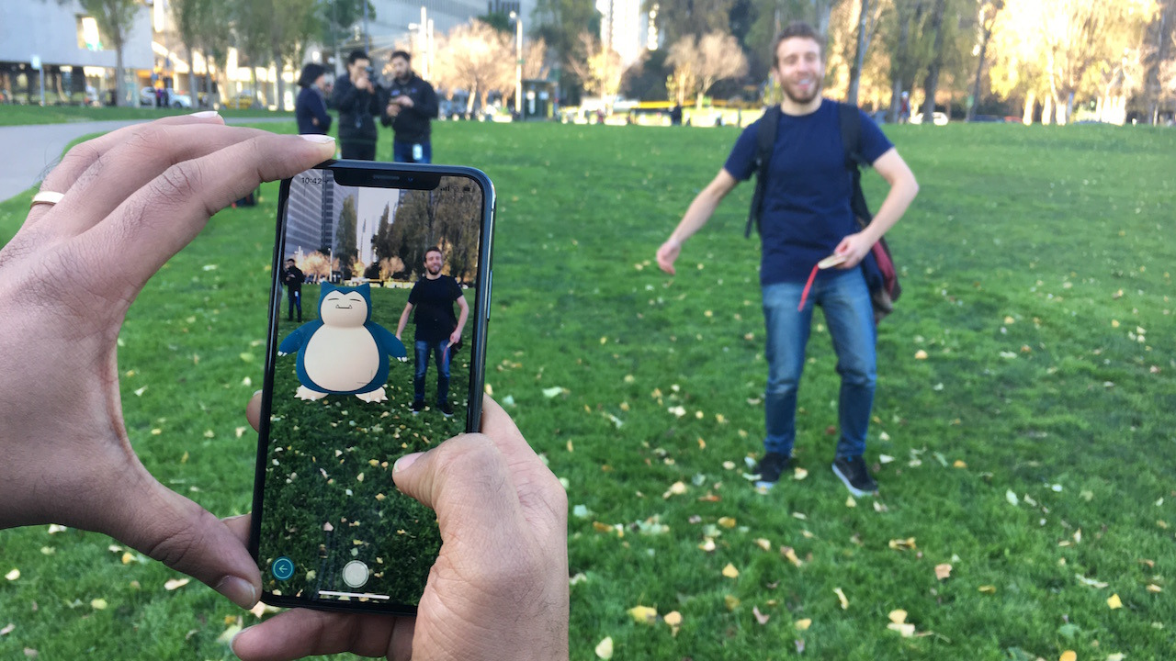
The first digital product I have chosen to analyse is the mobile AR (augmented reality) game Pokémon GO, developed by Niantic Labs. Pokémon GO brings Pokémon into the real life with the smart phone app using AR. The game is about catching Pokémon by walking in the real world and collecting Pokéballs via spinning Pokéstops which are found at real life positions of interest. Pokémon GO uses AR+ to allow you to bring the Pokémon you catch into the real world. Pokémon GO is a live service game, meaning that there are constant updates so there’s always something to look forward to.
[1]

Initial Review
One of the first noticeable things about Pokémon GO when you play the game is how user friendly and easy the game is to play, anyone can pick up the game and instantly start playing as the game’s core is simple. Pokémon GO has a large target audience, being people that are fans of the franchise, and it even goes beyond that, being mobile gamers looking for a new game to try out. Pokémon GO has less drought stages than most of your regular games due to it being a live service game, there are constant events, with there being monthly updates as well. Pokémon GO is designed to keep the player playing for as long as possible. Below is an example of a monthly update post that Pokémon GO post to get their playerbase excited for the next month and to give a sneak peak of what’s to come.

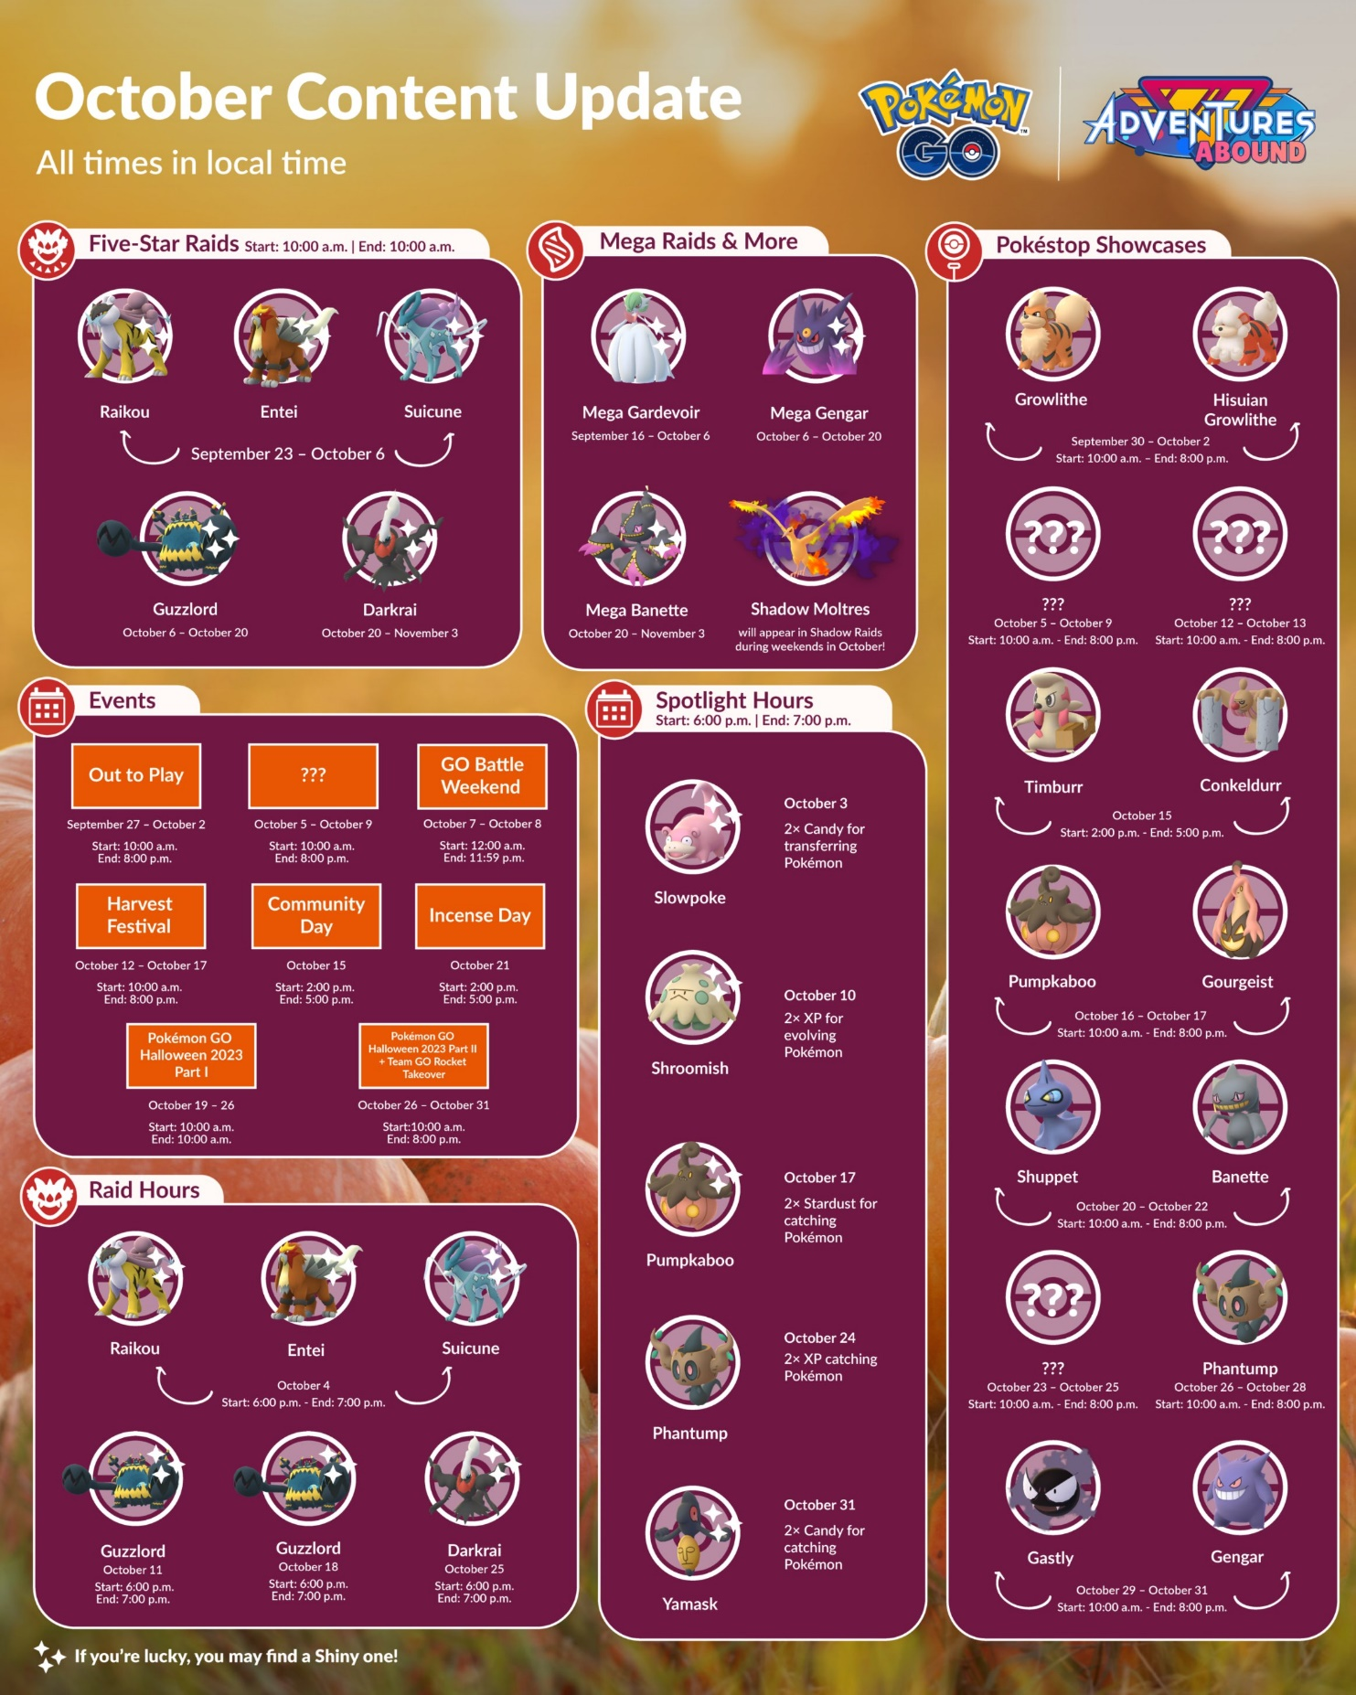
[2]

UX Design Principles
Accessibility design principle is to design the product in mind of thinking of accessibility options for users that use the product that may be disabled, such as having colour blind options for people that are colour blind and people that may be deaf.
Usability design principle focuses on how easy information is to find within the game. This is important to get right as game’s with confusing menus can frustrate the player.
Consistency design principle is making the product consistent in its layout and design, so the user knows what to expect, consistency helps the user navigate the product more easily as they can expect to know where everything should be.
Performance in design principle is how well does the product work, fast and responsive menus is what the user wants and expects, if the performance is slow this can cause frustration for the user.
Aesthetics design principle is more subjective to each person, although generally well-made graphics for the product can please the user, it’s important to make sure though that the graphics aren’t too complex, so they start to affect the usability of the product.

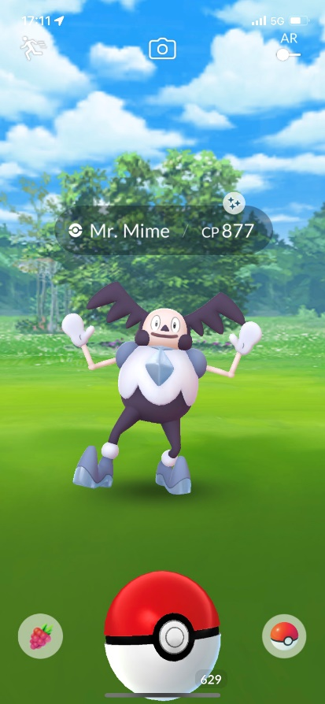

UX Analysis

Accessibility [3]
Pokémon GO has a lot of flaws when it comes to accessibility, for users with various kinds of disabilities, there’s almost nothing in place to help them, one being colour-blind players. At the beginning, some colour-blind players couldn’t tell if a Pokémon was shiny (1/512 chance of having an altered colour) which made playing the game frustrated, although they helped this by adding an icon to shiny Pokémon (the sparkle above the cp number). Another large region of players that are affected is people that struggle to go outside or walk [4]. Although, this is a core issue with the gameplay as the whole game is revolved around travelling outside. There are certain features that can help players play from indoors such as many of the bonuses put in place during the Covid-19 era. Since then though, most of the bonuses have either been removed or heavily nerfed.

Usability [5]
The usability for Pokémon GO is simple, allowing anyone to pick up and play the game. Although, for certain sections of the game some mechanics aren’t explained and, in some cases, misled. One example being is that you would always think having the highest power is the most efficient, but for some activities, you want to have lower power attributes, the game does not tell you this. Another case is that there is a Pokémon type called “shadow” Pokémon. Once caught you can purify them to gain some bonuses, what the game doesn’t tell you is that shadow Pokémon are more powerful and more often preferred over their purified state, but the game encourages you to purify them.

Consistency
Pokémon GO’s design stays very consistent, whether you log in a few years apart you can expect the app to look relatively the same and get straight back into playing the game.

Performance
Pokémon GO runs smoothly using your device’s native frames per second, with the menus being quick and responsive. Although, there are some mechanics that are painfully slow. One of the most egregious ones being the animation screen when evolving a Pokémon, it takes roughly 30 seconds to evolve a Pokémon. Another one is opening and sending gifts, which takes minutes to do. These are especially bad as there are tasks given out requiring you to perform these objectives while actively playing the game. This can happen during small time gated events where you want to spend the time playing, but you’re made to do what feels like waste time completing these tasks.

Aesthetics
Pokémon GO’s aesthetics design is simple and pleasing, finding what you need is easy and the basic design of the user interface compliments how casual the game is to play.

Recommendations for improvement
The first improvements made should be to help colour-blind players, this can be done be adding various colour-blind settings in the options to change the colour of different UI. Another improvement for accessibility would be to bring back some of the covid-19 bonuses to give a bit more help to players that cannot go outside to play the game.

Product Selection – Pokémon Sleep
Pokémon Sleep is a mobile game developed by The Pokémon Company. The gameplay is very unique, as the game requires you to sleep in order to play. The longer you sleep for during a session, the more score you get, resulting in more and higher rarity Pokémon spawning. There is also some gameplay to be had while awake, as you can collect berries from your team of Pokémon and feed your Snorlax (which results in your overall score increasing).

Initial Review
Pokémon Sleep is a well-made game, and is unique enough to be its own unique selling point to fans of the Pokémon franchise. The game has a toon graphics style, which hasn’t been seen in a Pokémon game before. This makes the art style of the game more appealing and a breath of fresh air for fans of the Pokémon franchise. The gameplay is simple enough that anyone can play it, as the core gameplay is done by sleeping, which can be tracked either by your smartphone or a separate device you can purchase. The ease of use to play this game is a great factor for appealing for all types of people, especially fans of Pokémon.

UX Analysis

Accessibility
Pokémon Sleep is a very accessible game to play, as it’s extremely casual and all you need to do to really play the game is sleep. As well as this, the game has easy to look at visuals, casual laid-back gameplay, subtitles, easy to use UI just to name a few. One problem although is unlike Pokémon GO, shiny Pokémon have no symbols to indicate they are shiny, so if you miss the initial sparkle, you may not realise that the Pokémon is even shiny, this can be even worse for colour blind people [6]. Another issue is that the game is better played with the Pokémon GO Plus +, which is a device you can buy that costs £50. This doesn’t change the gameplay; however, it allows you to use your phone while the device is tracking your sleep, making it far more convenient for people that are willing to pay the price for the device.

Usability
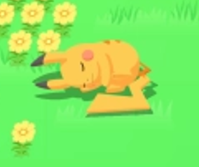
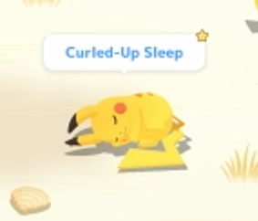
The core mechanics are explained when you first play the game. Although, your Pokémon get different random traits once you catch them, it can be hard to know which are the best ones, which requires looking for a guide, as well as other various tips and tricks. Shiny Pokémon (rare 1 in 450 chance colour variant) are never mentioned in the game, leaving the player to figure their existence out by either finding out from an external source or by finding and noticing one. As well as this, if you miss the initial sparkle and don’t notice the colour change (some can have very subtle changes) you can easily not realise a shiny Pokémon is there, which could result in the user completely missing it.

Consistency
Pokémon Sleep has a consistent design and UI, the art style fits the game, the menus compliment the simplicity of the game, and everything is where you would expect it to be.

Performance
Pokémon Sleep’s performance is very good in the way that the game never experiences any lag or framerate issues. Although lots of the animation can be painfully slow, and there are a lot of them and they are common. As well as this there are a lot mini loading screens in between each of the different menus. The long animation could make the user not want to bother playing the game, as it feels like doing something on the game takes twice as long as you’re made to sit through some tedious animation.

Aesthetics
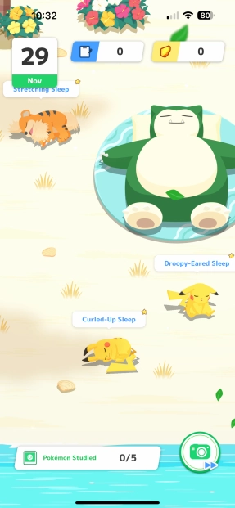
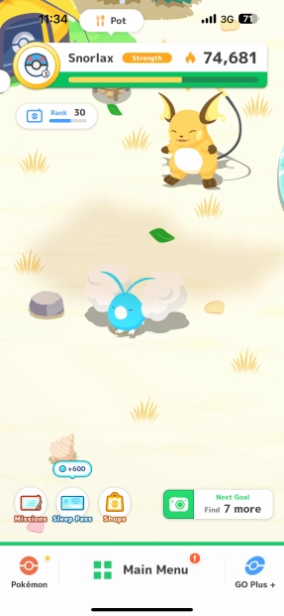
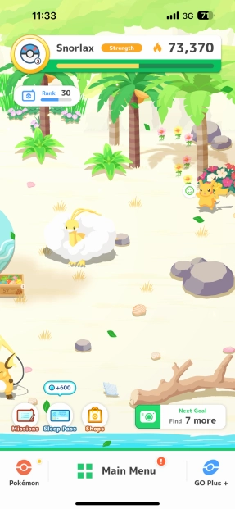
The aesthetics to Pokémon Sleep is very appealing, the game has simple 2D graphics, but the art style is very well done and all of the graphics look great.

Recommendations for improvement
The biggest issue with Pokémon Sleep is the tedious animations as well as the loading screens are plentiful. The animations are easy to solve, by allowing the play to still play the game while some animation is playing instead of locking the camera. For some other animation, allow the player to tap the screen to speed up/skip the animation. Another improvement could be telling the player what shiny Pokémon are and how to find them, as the game never mentions their existence. If a player was to miss a shiny Pokémon and find out later on, they could get annoyed and may quit the game. If possible, Select Button (the developers of Pokémon Sleep) should change how your phone always needs to be on the app while tracking your sleep. It should be more convenient as people may not want to leave their phone on all night. The fact that you need to spend £50 on a device to have a better playing experience may leave a bitter taste in some player’s mouths.

Conclusion
In conclusion, both games have good UX design but also have some room for improvement. Both games can be slow at time with lengthy animations. Pokémon Sleep is the bigger offender here as it has far more tedious animations, where as Pokémon go is only really slow to play when performing certain activities. Making both games faster to play will help keep the player engaged as they’re not stuck waiting around at any points. Neither game explains what shiny Pokémon are in game, but Pokémon GO has the better UX design here as you can always tell if a Pokémon is shiny by the symbol. Whereas in Pokémon Sleep, if you miss the sparkle, there’s nothing telling you whether a Pokémon is shiny if you don’t notice the colour change. This may be hard for people with visual problems such as colour blindness

References
All in-game screenshots were taken with my phone.
[1] K. Plagge, “Pokemon go is getting a better AR mode,” GameSpot, https://www.gamespot.com/articles/pokemon-go-is-getting-a-better-ar-mode/1100-6455762/ (accessed Nov. 12, 2023).
[2] Pokémon GO, “Spooky season has arrived! 🎃see what a ghoulishly good time awaits you this October! Twitter, https://twitter.com/PokemonGoApp/status/1704903376029274204 (accessed Nov. 12, 2023).
[3] “7 fundamental ux design principles all designers should know,” UX Design Institute, https://www.uxdesigninstitute.com/blog/ux-design-principles/ (accessed Nov. 15, 2023).
[4] Kittypokemonsalot, “Let’s talk about accessibility and pokémon go,” Pokémon GO Hub, https://pokemongohub.net/post/article/opinion/lets-talk-about-accessibility-and-pokemon-go/ (accessed Nov. 24, 2023).
[5] 10 usability heuristics for user interface design,” Nielsen Norman Group, https://www.nngroup.com/articles/ten-usability-heuristics/ (accessed Nov. 19, 2023).
[6] “Pokémon sleep accessibility report,” Android and iOS - Family Gaming Database, https://www.familygamingdatabase.com/en-us/accessibility/Pokmon+Sleep (accessed Dec. 6, 2023).

