Name: Swetha Baske
Student No: 2130060
Module: LCMB7000
Lecturer: Gladius Kulothungan
Course: Masters in Marketing Management
Submission date: 10/09/2022
Assignment – 1 (50%)

This report evaluates the administrative managerial and commercial business environment analysis of an organization and how resourcing affected by the internal or inside the organization and external factors that influence the procedures and policies and its processes that are adopted by the organization.
- Current state of the labour market at UK:

Definition:
Labour market is well-defined as the market for hiring or bringing together the people and supplying labour to utilize their skills to perform certain jobs at a wage rate (by Simplinotesadmin, June 22, 2019).

Description:
Labour marketplace is an area wherein employers meet employees (with right talents required to do the job). Labour marketplace evaluation is an imperative a part of an organization's recruitment manner as it allows in finding the maximum certified workers (with the proper talent set) for the roles that it gives and additionally guarantees that it presents a aggressive reimbursement bundle to its workers. (CFI team, January 22, 2022)
Understanding nearby labour marketplace records is becoming an increasing number of critical as the arena of labour keeps to extrude at a speedy pace because of globalisation and technological advances. Individuals want to be aware of the talents and know-how which are wanted with the aid of using employers. (The Appleton School)
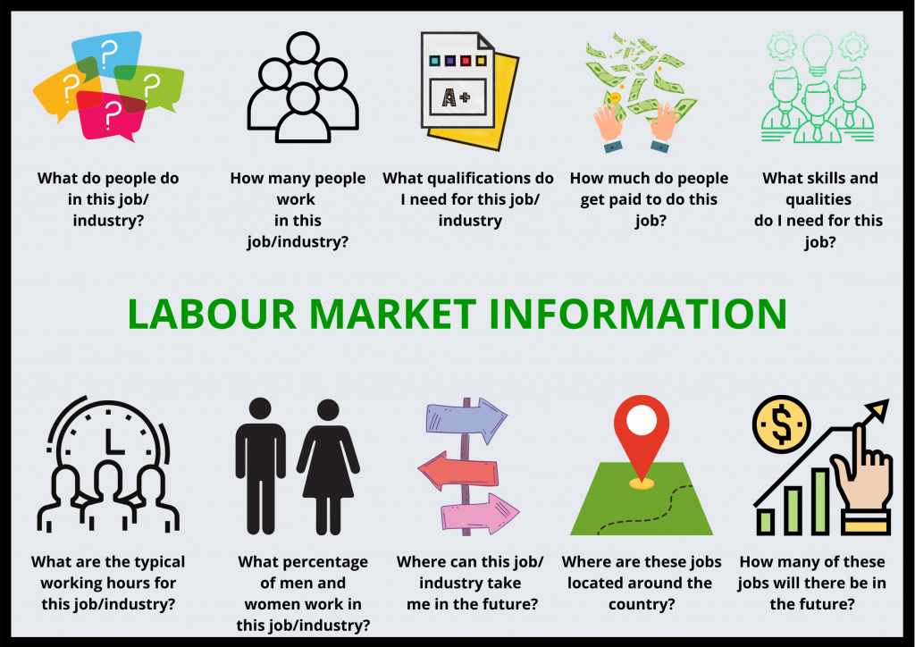
Source: The Appleton School
The UK’s labour marketplace overall performance has been remarkably sturdy during the last seven years, unemployment price fell to 4%, the lowest for the reason was in midst of 1970s, whilst the employment or the labour price for 16 year to 64 year olds reached highs of above 75%. (https://www.pwc.uk/monetary-services/ /ukeo-labour-marketplace.pdf)
According to Financial Times, Delphine Strauss, JUNE 14 2022 “UK labour marketplace stays warm no matter stalling economy” Number of full-time personnel at all-time is excessive however hiring is sluggish and unemployment is edging up.
Stalling monetary increase has now no longer but taken the warmth out of the United Kingdom labour marketplace, consistent with legitimate facts on Tuesday that confirmed the variety of full-time personnel at an all-time excessive, whilst the variety of vacancies rose to a file 1.3mn (Financial Times, Delphine Strauss, JUNE 14 2022).
However, the facts contained a few early symptoms and symptoms that the jobs marketplace may be at the turn, with hiring slowing and unemployment edging up (Financial Times, Delphine Strauss, JUNE 14 2022).
All areas withinside the UK noticed a lower withinside the unemployment price as compared with the equal length remaining year, the East Midlands noticed the biggest lower, of 1.9 percent factors, whilst the smallest lower became in Wales, down via way of means of 0.3 percent factors (August 2022 - workplace for National Statistics - Data and Analysis from Census).
For the 3 months finishing June 2022, the very best monetary inactiveness price estimate withinside the UK became in Northern Ireland (28.3%) and the lowest became withinside the East of England (18.9%) (August 2022 - workplace for National Statistics - Data and Analysis from Census).
Compared with the equal length remaining year, the biggest change withinside the monetary inactiveness price became in Wales, with a boom of 1.7 percent factors, whilst the biggest lower became in Yorkshire and The Humber, which became down via way of means of 1.3% factors (August 2022 - workplace for National Statistics - Data and Analysis from Census).
Between June and July 2022, the variety of payrolled personnel withinside the UK persevered to boom in all areas, with the biggest percent will increase in London and Northern Ireland, and the smallest withinside the East Midlands and Wales (August 2022 - workplace for National Statistics - Data and Analysis from Census).
Economists stated that whilst the figures supported the case for the Bank of England to elevate hobby charges once more at its assembly on Thursday, they may reduce the argument for a large boom or for persevered competitive coverage tightening (Financial Times, Delphine Strauss, JUNE 14 2022).
The figures, launched via way of means of the Office for National Statistics, confirmed the employment price rose to 75.6 in step with cent withinside the 3 months to April, up 0.2 percent factors at the sector and a larger upward push than economists had anticipated. This became pushed via way of means of full-time employment, with part-time paintings and self-employment nevertheless underneath pre-pandemic levels (Financial Times, Delphine Strauss, JUNE 14 2022).
Sandra Horsfield, economist at Investec, stated “stable labour demand, withinside the context of red-warm customer fee inflation” could affirm the case for similarly financial coverage tightening, whilst Hugh Gimber, strategist at JPMorgan Asset Management, stated the facts confirmed the “conundrum” dealing with the BoE, as “vital banks are being compelled to tighten at a time whilst there are already clean symptoms and symptoms that increase is slowing” (Financial Times, Delphine Strauss, JUNE 14 2022).
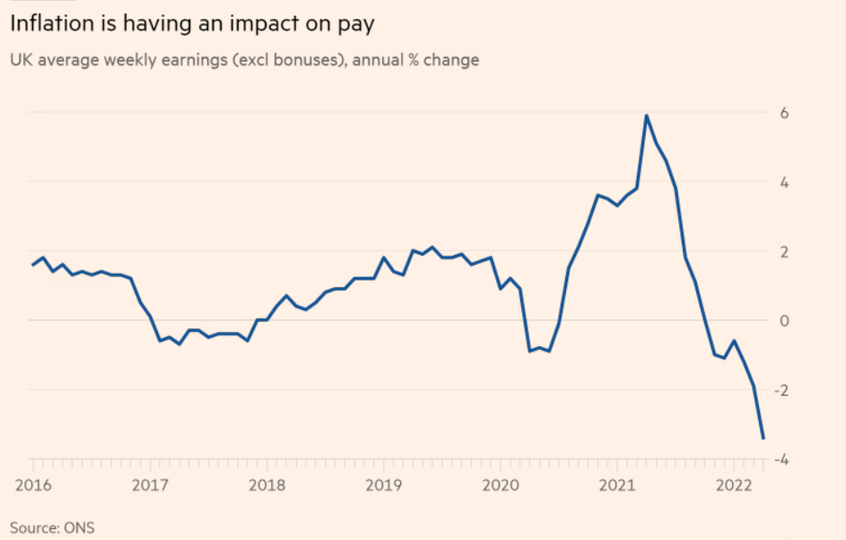
However, the data showed that the breakneck pace of hiring in recent months has slowed. Vacancies, although at a record, were only slightly higher than the previous month. Unemployment rose in April, taking the jobless rate over the three months to 3.8 per cent — slightly above the 50-year low recorded a month earlier (Financial Times, Delphine Strauss, JUNE 14 2022).
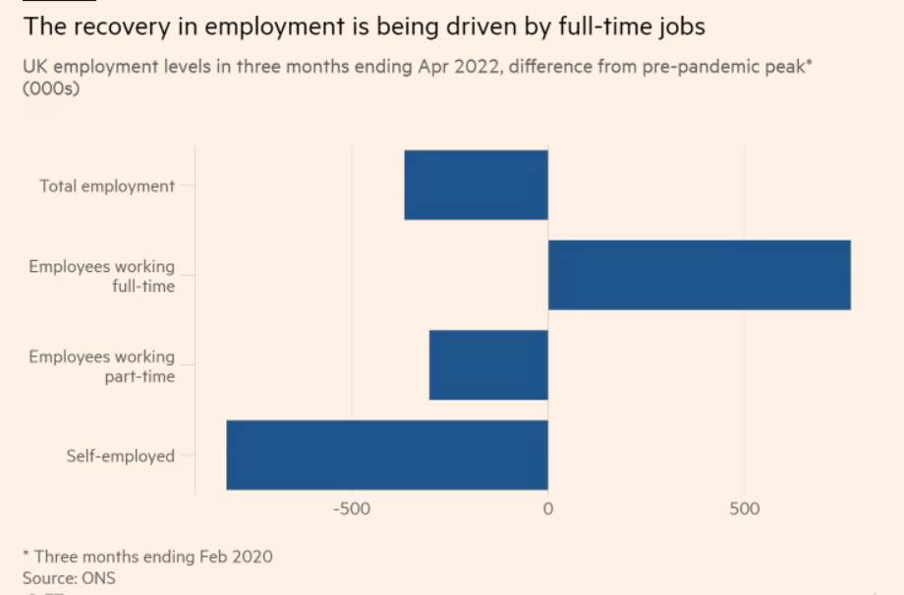
The range of task vacancies in March to May 2022 rose to a brand-new file of 1,300,000. However, the price of boom in vacancies persevered to sluggish down (workplace for National Statistics, Data and Analysis from Census August 2022).
Chancellor Rishi Sunak stated the figures confirmed the jobs marketplace remained robust, including that supporting human beings into higher jobs turned into the first-class manner to guide them withinside the lengthy term, even though the authorities turned into also providing “instantaneously assist with growing prices” (Financial Times, Delphine Strauss, JUNE 14 2022).
However, inflation is now beginning to hit pay packets hard. Although pay boom remains sturdy with the aid of using historic standards, common weekly profits have been 3.4 in keeping with cent decrease in actual phrases than a year in advance in April, the month whilst the cap on family power payments changed (Financial Times, Delphine Strauss, JUNE 14 2022).
The statistics will toughen the case for the Monetary Policy Committee to elevate hobby costs once more whilst it meets this week. The BoE made it clean in its May forecasts it believed nominal salary boom turned into walking at an unsustainable tempo and unemployment could want to upward thrust if inflation turned into to go back to its 2 in keeping with cent goal withinside the medium term.

- Emerging changes in human resourcing strategies in the post covid, post Brexit external environment
The final years have had a long-lasting effect at the destiny of work. It’s vital that HR leaders compare the on the spot and longer-term effect of those developments and the diploma to which they'll alternate strategic goals and plans.
“Chief human useful resource officers (CHROs) are going through historic demanding situations from an exhausted staff and a enormously aggressive exertions market,” says Brian Kropp, Distinguished Vice President at Gartner. “At the identical time, this surroundings creates a thrilling possibility for CHROs to guide expertise into the destiny and differentiate their businesses as employers of choice.” (June 16, 2022, Contributor: Jordan Turner and Mary Baker)
Changes in human resourcing strategies in the post covid - Redefining the organisation post covid:

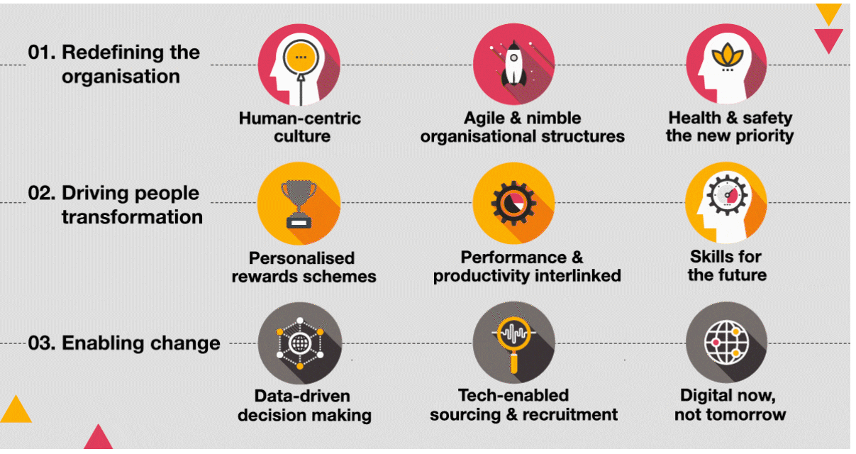
Organizational structure is redefined into a culture by making the workplace people-centric:
Restoring organizational tradition becomes a priority for Human resources departments or divisions as a company to make company agreements more flexible. There are a major shift towards hybrid career models that take advantage of both remote and workplace careers. While this is a fantastic change, the implications of this transition from threaten the current organizational tradition. Social dynamics among employees will not be the same due to different operating conditions coupled with less face-to-face interaction and an increasingly spread workforce.
Organizing ordinary checks solely for work, social interaction, or emotional support is an exceptional way to achieve a desirable balanced manner establish to deal with a distant group of workers and strengthen relationships. Fostering open conversations and establishing direct lines of communication between all levels within a company helps keep management informed of workers' concerns. Finally, adopting diversity, equality and inclusion policies and programs will help strengthen the company's heritage and create an environment that fosters trust, unity, empathy and engagement. As organizations seek to accelerate the operational pace well into the foreseeable future, it is critical that they consciously try to maintain their mean values ​​and emphasize building a centre of governance that puts people at the heart of every decision. (June 16, 2022, Contributor: Jordan Turner and Mary Baker).

Foster employee transformation, personalized reward systems, align rewards with market realities through customizable and customizable compensation structures.
The impact of COVID-19 has left many groups with high levels of debt, rising fees, little or no revenue and weakened balance sheets. As such, they have been pressured to take action to lower rates by quickly deferring or reducing workers' reimbursements and benefits. While this may dictate the short-term strategies of many companies, the pandemic has also opened the round of dialogue to reconsider employee rewards and benefits in the long-term.
Many companies may seek to attract and compete for the best skills to bring delivery of a speedy and successful post-COVID recovery closer. Since many employers will not be able to offer better wages, they must follow an example of constant wage reduction, even if the variable wage increase is directly related to the employee's performance and overall productivity. In this way, employees can be stimulated to work at a higher level while maintaining a healthy and aggressive environment. On the other hand, some companies may not forget to take advantage of the opportunity to offer flexible reimbursement and benefits programs that can give them an aggressive advantage. Another option is to introduce personalized compensation structures that allow employees to design their own programs that better suit their desires and preferences (Jordan Turner and Mary Baker, June 16, 2022).

Enabling change, data-driven decision-making, leveraging people analytics to drive data-driven decision-making:
Over the past decade We've seen an uptick in data-driven choices across every industry, business and corporate sector, and HR is no different. Workforce Analytics enables HR. HH. Rate employee experience, engagement and satisfaction. In an attempt to live aggressively in today's complicated business landscape, particularly as a result of COVID-19, companies must continue to use analytics to predict employee needs, optimize revenue and reduce costs. They should also rely more on analytics to measure and show overall team performance and productivity. MR. (Jordan Turner and Mary Baker, June 16, 2022).
Conclusion: The world is evolving and HR with it Due to the impact of the pandemic on the economy, businesses were quickly forced to switch and adapt to the new standard in order to survive. It is important that HR evolves and transforms in every detail of the HR lifecycle to meet a new set of organizational needs. In short, HR will increasingly want to find approaches to support leaders in restructuring during and after the pandemic, taking measures to streamline staff while managing the hazards associated with such interventions and affecting productivity and that increase employee engagement. Finally, the COVID-19 pandemic will very likely be with us well into 2021, so we want to know how to manage it. It's important to act now: the further HR falls behind, the longer it will take for real estate to adapt and thrive in the post-COVID era. Jordan Turner and Mary Baker, 16. June 2022.

2. Emerging changes in human resourcing strategies post Brexit external environment

Brexit is not an easy task. It's been relatively estimated for years, and while we recognize that organizations on two sides of the pond have done their best to organize it, there will be a choice of different constraints and challenging situations to contend with. through the true way. The UK officially left the EU on 31 January 2020, after which residents’ resident in the UK will have until 30 June 2021 to reside in the UK. According to the Home Office, the total number of packages as of June 30, 2021 was 6,015,400 and more than half of the 1,000,000 packages had already been unsealed at the time of writing. Uncertainty causes confusions and we recognize the weight you carry as HR professionals on behalf of the company, wanting to balance the sensitive issue of Brexit and also inspiring a great perspective across the business for certain employees to know be encouraged and sought. Commitment to raising awareness of the existing and the future at the same time.

HOW Brexit affects recruitment:
- How HR be able to organise globally if the company is UK-primarily based totally?
- If the firm is US-based with a UK office, how to navigate the post-Brexit landscape to make sure the people overseas are looked after and
  - getting the support they need? (September 2, 2021 — By Lattice Team)
Overseas Recruitment into the United Kingdom
According to Anna Stobart, Founder and Director of Hafton Consultancy Ltd, “The maximum critical issue in order to do is make certain humans have the right office work to be dwelling and running withinside the UK”. The first level of this entailed helping nationals withinside the UK with making use of for settled or pre-settled repute under the European Settlement Scheme with the aid of using 30 June 2021. As we're now beyond this date, the post-Brexit immigration machine is in place. Employees running in a regulated profession requiring set qualifications will want to ensure those are “officially recognised”, and HR specialists ought to assist incoming skills with securing acclaim for those qualifications from regulators previous to their arrival withinside the UK (September 2, 2021 — By Lattice Team).

Acknowledge income variations.
“In addition to the office work aspect, with the upcoming shift to hybrid running due to the pandemic, and running from everywhere now a possibility, want to be cautious approximately using humans on a UK income if they stay in a rustic with a one-of-a-kind price of dwelling. This can be an ambiguous vicinity and demands for commercial enterprise to have a clean, thought-through philosophy round rewards”, says Anna Stobart at Hafton Consultancy Ltd. If a worker’s settlement says they may be hired withinside the UK however they may be running from remote places, this wishes to be re-negotiated after organising the local marketplace pay facts in which the worker is primarily based totally, and figuring out what's reasonable for each the commercial enterprise as an entire and its personnel (September 2, 2021 — By Lattice Team).
Be obvious with personnel.
Not most effective is Brexit developing a selection of recent policies and rules for organizations to be conscious of, it's also critical to take into account the effect it is having on worker intellectual health. As we know, matters are in flux throughout organizations for some of reasons, however the pressure surrounding Brexit for those who're affected wishes to be understood and managed. One manner this could be mitigated is thru growing a clean know-how of how Brexit is impacting one-of-a-kind elements of the commercial enterprise, after which communicating this actually together along with humans in conjunction with a plan of the way the effect can be managed. The firm ought to inspect the variety of assets available, for example, the Chartered Institute of Personnel and Development’s comprehensive Brexit Hub, and tap into their community of peers to proportion knowledge. This ought to then relay this again to personnel in order that they have the records in hand and sense like they’re being added alongside at the journey. This will also broaden their agree with withinside the commercial enterprise and ensure they see organisational leaders as actively navigating them right into a post-Brexit world (September 2, 2021 — By Lattice Team).
New strategies to adapt in the post covid:
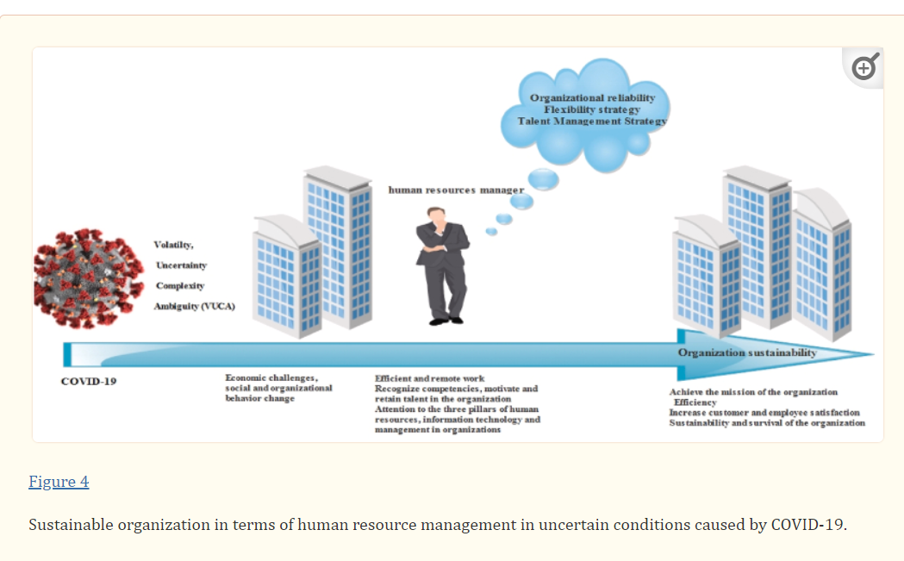
Flexibility and personnel' digital lifestyles cycle:
This includes, the Flexibility of contracts, encourage personnel to paintings from domestic. Floating hours and flexibility, Distance running and running from domestic, Open workspaces, Virtual paintings cycle of personnel from arrival to departure and undertaking digital interviews and Knowledge of personnel on a way to paintings or supply paintings in tough situations (David Collings, Nyberg,Patrick M.,John McMackin,Anthony Wright, 02 March 2021).

Ensuring the provision of good enough assets for personnel' domestic office
Provide complete logistical aid for the transportation of IT infrastructure to new candidates or personnel, Connect the client community to the organisation community withinside the personnel' domestic in the course of the contemporary disaster in order to maintain running the business, create a digital processing application for conversation, offer enough assets together with IT belongings to fulfil the needs of personnel to assist them paintings efficiently (David Collings, Nyberg,Patrick M.,John McMackin,Anthony Wright, 02 March 2021).
Providing personnel with education publications to advantage new capabilities
This involves, Virtual schooling of fitness care methods, develop personnel' capabilities with the aid of using developing a user-pleasant digital platform. For example; encouraging personnel and executives to take part in numerous conferences, so that primarily based totally at the conferences attended, initiatives are assigned to personnel (David Collings, Nyberg,Patrick M.,John McMackin,Anthony Wright, 02 March 2021).
Providing progressive a laugh sports for the personnel
Use of innovative worker engagement techniques together with interactive digital crew conferences (in which personnel are advised to excursion their domestic/introduce their family), celebrations together with birthdays, anniversaries, or non-public talents, create a marketing campaign called: "Let's do it together" wherein personnel proportion memories approximately a way to spend time in quarantine, a way to assist with day-by-day chores (David Collings, Nyberg,Patrick M.,John McMackin,Anthony Wright, 02 March 2021).
Strengthening inner performance and expertise acquisition
Strengthen the inner crew to draw and collect expertise. Because hiring a representative expense more. Instead of paying a representative, pay the personnel. Hiring new individuals and now no longer suspending gives Outsourcing service (David Collings, Nyberg,Patrick M.,John McMackin,Anthony Wright, 02 March 2021).
Strengthening brotherly love and sharing experiences
The COVID-19 pandemic has created pressure and common frustration withinside the world. Currently, education and imparting revel in assist to lessen ambiguity in unique societies and cultures, together with a way to use statistics era in a complete manner or the regulations of conversation and workflow (David Collings, Nyberg,Patrick M.,John McMackin,Anthony Wright, 02 March 2021).

New strategies to adapt in the post Brexit:

Source: FEBRUARY 25 2016 - Richard Milne and Peter Spiegel

Workforce Planning – Improve Employee Retention:
Staff perks make contributions to a fantastic, dynamic place of business surroundings that facilitates all personnel thrive at paintings. Creating a fantastic operating tradition includes encouraging group of workers to paintings collectively and aid each different, in addition to trusting and empowering group of workers to make modifications and decisions. Freedom and autonomy permit personnel the time and area to clear up troubles and innovate new ideas, and facilitates people sense proper approximately themselves and the future in their area withinside the organisation. A fantastic business enterprise tradition can hastily and sustainably growth worker retention, in addition to appeal to new group of workers thru referrals, tips and a fantastic logo image (On: 30, Oct 2019 by: Ryan Abbot).
Work With Partners, Experts and International Recruitment Agencies
collabration with different groups and thru alternate institutions and enterprise establishments to become aware of what your area has to provide capacity recruits, and paintings with nearby faculties and schools to focus on examples of personnel who experience their roles and examples of development that started in low-talent roles (On: 30, Oct 2019 by: Ryan Abbot).
.

Attract Diverse Talent Pools
Reassessing necessities will faucet into unused skills swimming pools that are to be had proper now withinside the UK. Candidates without a diploma however a long time of revel in will be simply as treasured in your organisation, and older generations missing technical talents however a wealth of understanding in addition to various skills swimming pools without revel in withinside the marketplace ought to show treasured long-time period personnel if given the preliminary education investment.
Re-onboarding and re-induction programmes are essential to hold personnel returning to paintings after maternity go away, paternity go away and time away for caring obligations or illness. Employees returning to the workplace or worksite need extra time to settle lower back in and adapt to the needs in their role. Analysing and enhancing the candidate revel in for individuals who are much less assured in making use of for roles will assist recruit candidates with much latest revel in or getting to know difficulties, a appreciably untapped labour marketplace. Business leaders can attain out to recruiters and not-for-earnings establishments for first-rate practice recommendation on appropriate roles and communique for brand spanking new personnel from minority, various and excluded groups (On: 30, Oct 2019 by: Ryan Abbot).
Take a Different Approach to Attracting orkers
Job and profession possibilities may be really communicated from the primary process ad visible with the aid of using a capacity applicant, and continuously reinforced and tailor-made to the employee for the duration of years of employment. HR departments and hiring managers can use process ads to really define sensible routes for profession development inside roles to draw EU jobseekers trying to construct a profession and live withinside the UK, and offer an perception into long-time period profession and incomes potentialities for EU people beginning out in low-pay, low-professional roles.
An inclusive place of business tradition may be accomplished with the aid of using introducing measures to enhance place of business tradition and operating family members among group of workers from throughout the UK, EU and different nations globally. Successful combined places of work are constructed and maintained with the aid of using making sure control prioritises and addresses xenophobia and all kinds of discrimination, offering voluntary English classes and unique and ordinary communique outlining control and HR aid for people of all background (On: 30, Oct 2019 by: Ryan Abbot).
Attract Young UK Workers
Business leaders and recruiters can associate with schools and faculties to without delay engage with college students and display them the style of a success careers open to them throughout UK industries. (On: 30, Oct 2019 by: Ryan Abbot).

Reference:

- https://commonslibrary.parliament.uk/research-briefings/cbp-9366/ https://www.theappletonschool.org/careers/labour-market-informationhttp://www.simplinotes.com/labor-market/
- https://corporatefinanceinstitute.com/resources/knowledge/economics/labor-market/
- Nation postpones putting date for ratifying Brexit change deal. The Guardian. four March 2021. Retrieved 15 March 2021.
- Blenkinsop, Philip (22 April 2021). "Parliament has the same opinion to April 27-UK change deal". Reuters. Retrieved 28 April 2021.
- Brexit: European Parliament backs UK change deal". BBC News. 28 April 2021. Retrieved 28 April 2021.
- https://economictimes.indiatimes.com/definition/labour-market
- https://www.economy-ni.gov.uk/news/labour-market-statistics-43
- https://www.ft.com/saveConsentPreferences-success
- Rankin, Jennifer; O'Carroll, Lisa (12 June 2020). "Brexit: complete controls on items getting into UK will now no longer follow till July 2021". The Guardian. Retrieved 1 May 2021.
- Partridge, Joanna (eleven March 2021). "UK compelled to postpone exams on imports through six months". The Guardian. Retrieved 22 June 2021.
- Holton, Kate (14 September 2021). "Britain delays post-Brexit import change controls again". Reuters. Retrieved 25 September 2021.
European Union Bill 2017–19 – UK Parliament". Parliament of the United Kingdom. Archived from the authentic on 25 July 2019. Retrieved 23 July 2017.
- Repeal invoice wins first Commons vote". BBC News. 12 September 2017. Archived from the authentic on 27 July 2019. Retrieved 1 November 2017.
- Authors: Matthias Dütscs - The labour market and COVID-19: What are the working environments in critical jobs?
- Original Article26 July 2022, Jobcenters’ strategies to promoting the inclusion of immigrant and native job seekers
- Authors: René Lehwess-Litzmann and Janina Söhn - Article11 July 2022
- Understanding Brexit: Taylor, Graham. Reasons Why Britain Voted to Leave the European Union Group Published by Emerald, 2017. Quote: "to secure Brexit, the coalition that came together however, included a diverse range of people or individuals, groups and interests
- Significance: Tarran, Brian (8 April 2016). "The Economy: a Brexit vote winner?".
- "Theresa May rejects Nicola Sturgeon's referendum demand". Stewart, Heather (16 March 2017). The Guardian Retrieved 15 May 2017. Archived from the original on 31 May 2017.
- Brexit: What is the Northern Ireland Protocol and why are there checks?". BBC News. 15 March 2021. Retrieved 21 April 2021.
- Retrieved 3 April 2018, Herald Scotland, 2018. "Whitehall lawyers drawing up plans to challenge Continuity Bill in courts" from the original on 3 April 2018.
- European Union (Withdrawal) Act 2018", www.legislation.uk. Archived on 6 August 2019. Retrieved on 6 August 2019.

