University of Wales
Trinity Saint David - London

Strategic Management and Sustainability – LCBB6004

Diageo – strategic choices and capabilities of the company
ASSIGNMENT 1

Teodora Georgieva
Student ID: 2111818
Date of submission: ……..
Word Count: …… words
Tutor’s Name: Piyumika Gamage

1.Introduction
In conditions of global competition, constantly changing consumer preferences and technological progress, the stability of the business built by the company's capabilities and the strategic approaches taken determines further development and success. This report examines the Diageo company, a major representative of the alcoholic beverage industry, emphasizing current and future strategic planning and business strategies viewed through the lens of economic theory, along with the company's organizational capabilities.
Diageo is a British company founded in 1997 through the merger of Guinness and Grand Metropolitan. It is one of the leading producers and suppliers of alcoholic beverages in more than 180 countries, with more than 130 production sites worldwide (Diageo,2024) and a staff of about 27.99 thousand people in 2022 (Statista, 2024). The portfolio of this conglomerate includes 200 brands, including Johnnie Walker, Smirnoff, Captain Morgan, Bailey's and Guinness. Operating profit for 2023 is approximately GBP 4.6 billion (Statista, 2023). Compared to previous years, it has grown, which speaks of a good allocation of resources and successful strategies.

2.Business and Corporate Strategies of the company
Strategic planning serves to navigate the organization on the path to sustainability and competitive advantage. According to Michael Porter (1980), the aim of companies should be to build a strategy in which the choice of a precisely defined market position, differentiation and creation of company value are of primary importance.
The main strategies that Diageo focuses on are innovative solutions, brand diversification, responding to changes in customer preferences and expanding the market and its portfolio. Confirmation of the latter is the acquisition of George Clooney's premium tequila brand and Casamigos Tequila (Diageo, 2024).
2.1. Porter’s Generic strategies
There are three Porters' strategies that would distinguish any company from the competition. Evaluating your capacity and strengths, the options for strategic development are:
Cost leadership, where the focus is on the lowest costs in the industry, to obtain a competitive advantage (Porter, 1987);
Differentiation, where a company offers consumers unique services or products (Porter, 1987);
A focus strategy for which companies focus on a specific marketing niche serving a specific target group (Porter, 1996).
Diageo's approach to standing out in the spirits industry as a whole is focused on the differentiation approach. With a wide range of 200 internationally renowned brands in its portfolio, including Tanqueray, Guinness, Johnnie Walker and Don Julio, Diageo embodies a methodical approach to brand development that connects with customers on a personal and social level. This commitment goes beyond the calibre of products to include sustainability campaigns and responsible drinking, as demonstrated by the ESG Action Plan Society 2030: The Spirit of Progress (Diageo, 2023). The company is hard at work improving supply chain skills, entrepreneurship, enabling culture and brand excellence.
Diageo's comprehensive understanding of consumer behaviour and preferences, enhanced by advanced technologies such as Catalyst, Sensor and CreativeX, underpins its capacity to create and predict consumer trends. In the name of its brand and the quality of the products offered, Diageo creates strategic alliances with suppliers in its wide supply chain in different geographies. This in turn saves money which is then invested back into brand image building projects. An entrepreneurial attitude mixed with this culture of productivity and efficiency creates an atmosphere where new ideas are embraced and market problems are solved quickly and nimbly.
Ultimately, Diageo's differentiating approach is underpinned by its unwavering focus on customers and trading partners, which drives sustainable growth and establishes the business as a global leader in consumer engagement and brand innovation.
2.2. Ansoff Matrix
By looking at Ansoff's matrix and its four strategies, we determine the feasible directions for growth and development of a given company (Ansoff,1980). From the analysis of Diageo Ltd, it can be said that multiple strategies from the Ansoff matrix are used. The company is taking these steps to maintain its strong position as a leader in the production of alcoholic beverages worldwide and to further stimulate its growth.
Market penetration
Market penetration means increasing market share in existing markets through existing products (Hussain, 2013). For Diageo, this is achieved with an enhanced marketing strategy, through advertising and promotional campaigns. According to the 2023 Annual Report (Diageo, 2023), the company invested in key markets such as Europe and the United States, and also in the "Join the Pact" campaign for Johnnie Walker, which aims to promote responsible alcohol consumption.
Product development
Product development involves introducing new products or variations of existing products into current markets. In this direction, Diageo is constantly updating its product portfolio. To the standard Smirnoff brand vodka option, the company added new flavoured options also and Captain Morgan rum (Diageo, 2024) to satisfy the preferences of, for example, women or younger consumers. In addition, the company also produces temporary limited bottles that differ from the standard design, which further attract the attention of connoisseurs.
Market development
In Market Development we have research into new markets and entering them with existing products. Following this strategy, Diageo has its current positions as the world leader in sales of alcoholic beverages. For large companies, conquering new markets is a matter of necessity. A notable example is India, the vast growth market that the company targeted with localized products and tailored marketing strategies. Geographical expansion of companies requires extensive research into preferences and cultural differences, but are an inevitable part of future development…..
Diversification
Diversification involves entering new markets with new products. Diageo relies on the traditional spirits trade, but is trying to capture opportunities in neighbouring industries through partnerships and acquisitions. An example is premium tequila brand Casamigos, which the company has been promoting for a while and is new to the brand, but gives the company an opportunity to tap into the fast-growing tequila market and target consumers looking for luxury spirits. Diageo is exploring emerging markets such as Africa and India. The company makes investments and already owns 21 facilities and trades in 16 countries on the African continent. In India, production is at 37 production bases (Diageo, 2024). The company's focus is to satisfy the needs of customers by emphasizing the production of mass-market spirits at affordable prices.
3.Resources and Capability of the company
The adaptation and success of the company in the dynamics of the industry is largely determined by the resources and their adequate management. According to Teece, Pisano and Shuen (1997), it is the ability of the company to arrange its policy and activities so that there is a proper distribution of forces in building, integrating and reconfiguring all resources. In addition, the assimilation and use of external information that Cohen and Levinthal (1990) share also contributes to management flexibility.
3.1. Value Chain Analysis
All activities including the phases from the conception of a product or service, through production, distribution and its receipt by the end user, were described by Porter in 1985 under the name "value chain" (Dubey at al, 2020).
To establish Diageo's competitive advantages and core competencies, looking at how the company carefully monitors and controls all of its value chain activities. They are divided into primary, which have a direct impact on value, as the firm transforms inputs into outputs, and other ancillary, which add value indirectly – Fig 2 (Medium, 2020)

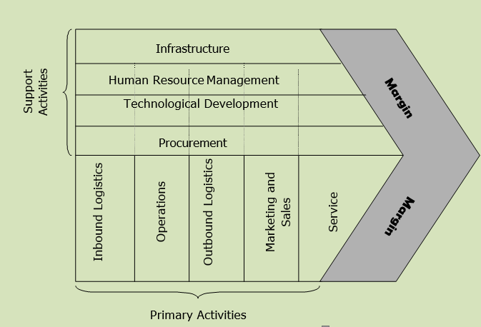
Fig 2. Porter’s Value chain 1985 (Medium, 2020)
3.1.1 Primary Activities
Inbound Logistics - for the high quality of its final products, the company uses basic raw materials such as sugar, water, barley, corn, anise and agave, which are supplied from over 100 countries (Diageo, 2022). They are of very good quality and sourced to sustainable and ethical standards (Diageo, 2024). Diageo maintains robust inbound logistics, ensuring timely and efficient supply of raw materials.
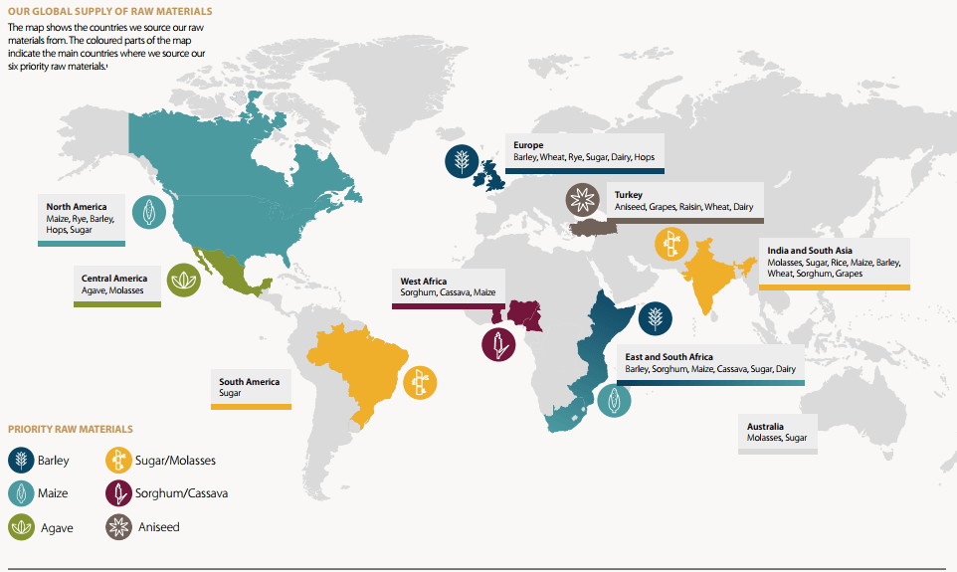
Source: (Diageo, 2024) Building Sustainable Supply Chains: Our Strategy for Sustainable Agriculture

Operations: As one of the leaders in the production of alcoholic beverages, the company has built its production facilities on state-of-the-art technologies, enabling the production of the diverse product portfolio in short terms and on a large scale. Still other facilities, such as those for making and aging the Scotch whiskey, adhere to strict standards of quality and tradition (Diageo, 2024). The company operates over 140 production sites such as distilleries, maturation warehouses, breweries, coopers, packaging plants, as well as distribution warehouses (Spirits Europe,2024).
Outbound logistics: Diageo distinguishes itself from its competitors with a very good distribution network worldwide. Partnerships with global distributors in 180 countries from Asia, Europe, Africa, Latin and North America, the Caribbean ensure the wide availability of their products for many markets (Diageo, 2024). Diageo has five ways of distributing its products, all of which are used in most countries, namely: wholesalers and distributors, eMarketplace, modern trade, direct to consumer and store (Diageo, 2023). In the work with more than 40 carriers, the company uses a logistics platform, the Luminate Control Tower (LCT), through which it tracks all its operations in real time, anticipates transportation challenges and better plans its inventory levels (Diageo, 2022).
Marketing and Sales:
In the UK, the products are marketed and sold through Diageo GB - for spirits and beer, and through Justerini & Brooks Fine Wines for wines. Products are distributed through wholesalers, to retailers and consumers. In the Republic of Ireland and Northern Ireland they sell direct to wholesalers and the mass market. In France, they are distributed through an agreement with Moët Hennessy. In Europe, they use their own companies and distributors, and in Turkey, the products reach the market through their subsidiary Mey İçki (Duarte, 2019).
Almost all of the company's products are recognizable worldwide. The company implements innovative promotional strategies and campaigns to increase the commercial power of its brands. Partnership and sponsorship of famous events and sporting events is one of the strategies through which the brand gains consumer engagement and loyalty Johnie Valker's advertisements are everywhere and are emblematic of the brand. In addition, the company created a song and video with famous South Korean singer and actor SUHO, carrying the message of responsible alcohol consumption (Diageo, 2024).
Service: Attention to customer service is strongly advocated in Diageo's policy. They are aware that consumer loyalty is earned with price, quality and, last but not least, satisfaction with the consumption or shopping process itself. For this reason, the company trains its sales representatives and bartenders on quality service to partners and customers (Diageo, 2024). Another strategy implemented by the company is Johnnie Walker My Edition, offering personal customization of the bottle (Duarte, 2019).
3.1.2. Support Activities
Company infrastructure: Management bodies maintain stability in the organizational structure of the company involved in global operations worldwide. The scale of the company can be determined by the regions in which it operates actively and successfully, namely over 180 countries and over 30,000 employees (Duarte, 2019). In addition to a strong financial profile, Diageo is committed to corporate social responsibility and sustainability initiatives that further strengthen its reputation and the trust of its stakeholders.
Human resource management: To drive organizational performance, apart from financial incentives, the company promotes and prioritizes the development of the capabilities of its employees all over the world by organizing various initiatives and programs for innovation, flexible working, support woman working, inclusion, additional training (Diageo, 2023). According to the Diageo Careers company website, they offer courses for their employees on presentations, people management development, project management. (Diageo, 2024) Also, the management of the company wants to create confidence, trust and a sense of accessibility in the employees through their non-hierarchical structure (You Tube, 2014).
Technological development: Diageo is characterized by the use of cutting-edge technologies to improve production and develop new recipes through investment in research and development. Thus, the company turns to new packaging solutions - the grain-to-glass sustainability system, which reduces waste and cares for the environment (Diageo, 2024).
Procurement: Diageo closely monitors its level of sourcing, which ensures reliability and quality of the raw materials required for its extensive portfolio. To maintain good and stable relations with its suppliers, the company engages in strategic initiatives to maintain stable prices and protect against unexpected risks. Most of Diageo's global shipping and supply chain operations are in Europe. There are manufacturing facilities in Italy, the United Kingdom and Ireland. The business owns 30 distilleries in Scotland, a distillery, maturation and packaging facilities in England, Scotland, Ireland and Italy, and a brewery located in Dublin. Producing whisky, gin, vodka, beer, rum, liqueurs and other spirits that are sold in around 180 countries, the team is responsible for all supply chain operations for Europe. (Diageo, 2024).

3.2. VRIO analysis
VRIO analysis is used to clarify an organization's strengths and weaknesses, and specifically which resources or capabilities are particularly important for economic competitiveness and success (Wernerfelt, 1984; Barney, 1991).
According to Barney (1991), the use of the four criteria - valuable, rare, inimitable and organized, would give an idea to the company, what are the resources that distinguish them from the competition and give them an advantage.

Recourse of Capability | Valuable | Rare | Inimitable | Organized | Impact on Competitive Advantage
Brand image and recognition | ✔️ | ✔️ | ✔️ | ✔️ | Sustainable competitive advantage
Effective distribution network | ✔️ | ❌ | ❌ | ✔️ | Unused competitive advantage
leadership and innovative ability | ✔️ | ❌ | ❌ | ✔️ | Unused competitive advantage
Relationship with suppliers | ✔️ | ❌ | ❌ | ✔️ | Competitive parity
Plant Facilities | ✔️ | ❌ | ❌ | ✔️ | Competitive parity
Innovation | ✔️ | ❌ | ❌ | ✔️ | Competitive parity
Ability to raise capital | ✔️ | ❌ | ❌ | ✔️ | Competitive parity
International presence | ✔️ | ✔️ | ❌ | ✔️ | Unused competitive advantage
Adaptability | ✔️ | ✔️ | ❌ | ✔️ | Unused competitive advantage
Quality product offering | ✔️ | ❌ | ✔️ | ✔️ | Unused competitive advantage
Marketing communications | ✔️ | ❌ | ❌ | ✔️ | Competitive parity
Competitive pricing | ✔️ | ❌ | ❌ | ✔️ | Competitive parity
Customer experience | ✔️ | ❌ | ❌ | ✔️ | Competitive parity
Financial strength | ✔️ | ❌ | ❌ | ✔️ | Competitive parity
Technological integration and advancement | ✔️ | ❌ | ❌ | ✔️ | Competitive parity
Employee training | ✔️ | ❌ | ❌ | ✔️ | Competitive parity
Investment in research and development | ✔️ | ❌ | ❌ | ✔️ | Competitive parity
Corporate leadership and vision | ✔️ | ❌ | ❌ | ✔️ | Competitive parity
Production capacity | ✔️ | ❌ | ❌ | ✔️ | Competitive parity
Raw materials | ✔️ | ❌ | ❌ | ✔️ | Competitive parity
Organizational culture | ✔️ | ❌ | ❌ | ✔️ | Competitive parity
Marketing strategy | ✔️ | ❌ | ❌ | ✔️ | Competitive parity

According to the analysis, it is clear that Brand image and recognition is the strongest points of the company and fall into the group of Sustainable competitive advantages. The brand has been created for a long time and is a symbol of a stable and sustainable policy that includes a strategy for responsible drinking and protection of natural sources. The company's portfolio includes 200 brands such as Johnnie Walker, Smirnoff, Captain Morgan, Bailey's and Guinness, which are recognizable, unique and protected by patents.
The group of Unused competitive advantages includes Adaptability due to the company's ability to respond to constantly changing customer preferences. This makes Diageo competitive through innovation, market knowledge and flexible management, also thanks to the good coverage of production capabilities relying on own factories. In addition, the quality of the products is also an advantage that the company holds and can rely on, strictly following the production processes and unique traditions. At the same time, international presence also falls here, due to the presence of over 180 countries from Asia, Europe, Africa, Latin and North America, the Caribbean (Diageo, 2024). All the advantages listed so far are well developed, but the company has additional potential to perfect them.
The remaining strengths listed above such as leadership and innovative ability, Relationship with suppliers, Plant Facilities, Competitive pricing, Customer experience, Investment in research and development, Technological integration and advancement or Competitive parity of the Diageo should not be underestimated but should be systematically monitored and improved to avoid potential risks of competitive interference and dominance.
4. Diageo – Strategy in Action
Diageo's core objectives of driving growth, fostering innovation and increasing shareholder value are based on its strategy, structure and systems. The company's decentralized organizational structure places a strong emphasis on portfolio management and brand growth, while allowing for flexibility and responsiveness to market conditions. Diageo's corporate strategy includes its commitment to supporting sustainable practices and responsible drinking. In addition, the company's investment in data-driven decision-making and digital skills improves efficiency and enables the implementation of marketing strategies that increase customer engagement and brand loyalty. Diageo's well-coordinated approach to strategy, structure and processes emphasizes the ability to adapt and thrive in a rapidly changing market environment.
According to the company's 2023 annual report, a key commitment is driving growth and generating shareholder value, fending off headwinds such as inflationary pressures, geopolitical concerns and continued post-Covid-19 uncertainty.
Premiumization and innovation: Diageo's focus on these two areas is in line with both consumer tastes for premium drinks and long-term sector developments. The company responded strategically by expanding into the ready-to-drink market and introducing limited editions. Illustrating the effectiveness of its premiumisation approach, Diageo recorded robust growth in several key categories in FY23. For example, net sales of tequila increased by 19% and scotch by 12%. (Diageo Annual Report, 2023).
Diversification and portfolio management: Diageo has proactively expanded its portfolio by acquiring brands such as Balcones Distilling and Don Papa Rum to capitalize on new market trends and consumer preferences. In addition, the sale of non-core assets such as Archers and Guinness Cameroun S.A. demonstrates a systematic commitment to resource allocation and portfolio optimization. For example, the company's growth in the US whiskey and rum categories was aided by the acquisition of Balcones Distilling and Don Papa Rum respectively, while Diageo was able to focus on more efficient models to support brand growth in Cameroon through the sale of Guinness Cameroun S.A. (Diageo Annual Report, 2023).
Financial Performance and Shareholder Value: Diageo's fiscal 2023 results, which include growing organic net sales, higher earnings per share and a progressive dividend policy, demonstrate the effectiveness of the company's business and corporate initiatives. Despite short-term market swings, the company's emphasis on long-term shareholder wealth generation, along with careful capital allocation and brand awareness investments, has helped preserve shareholder returns. For example, Diageo increased its final dividend by 5% to recognize its sustained good performance and achieved organic net sales growth of 6.5%, with strong price/mix performance offsetting a slight decline in volume (Diageo Annual Report 2023).
SAF Framework:
Suitability: In light of the company's industry positioning, market dynamics and long-term growth prospects, Diageo's initiatives appear appropriate. While diversification through partnerships and acquisitions strengthens Diageo's competitive advantage and market presence, the company's emphasis on premiumization and innovation is in line with consumer trends and sector growth prospects.
Acceptability: A wide range of stakeholders, including shareholders, employees and customers, find Diageo's plans acceptable. The company's commitment to sustainability, employee involvement and responsible drinking is a reflection of its corporate social responsibility and wider societal impact. The approval of both internal and external stakeholders is demonstrated by a high level of staff engagement and a positive brand attitude.
Feasibility: Given Diageo's assets, skills and operational efficiency, its plans appear feasible. The company's strong financial results, diverse portfolio and global presence offer a strong platform to execute strategic plans and effectively address market obstacles. A commitment to long-term growth and value generation is evident through continued investment in technology, supply chain optimization and sustainability efforts.

Duarte, A.M.B.(2019) Equity Research: Diageo Plc (Doctoral dissertation, Universidad de Lisboa (Portugal)).

Ansoff, H. I. (1980). Strategic issue management. Strategic management journal, 1(2), 131-148.

Hussain, S., Khattak, J., Rizwan, A., & Latif, M. A. (2013). ANSOFF matrix, environment, and growth-an interactive triangle. Management and Administrative Sciences Review, 2(2), 196-206.
Barney, J. (1991). Firm resources and sustained competitive advantage. Journal of Management, 17(1), 99-120.

Cohen, W. M., & Levinthal, D. A. (1990). Absorptive Capacity: A New Perspective on Learning and Innovation. Administrative Science Quarterly, 35(1), 128–152.
Diageo (2024) Diagio - Our Business.
Available at: https://www.diageo.com/en/our-business
(Accessed: 01 April 2024).

Dubey, S., Singh, R., Singh, S.P., Mishra, A. and Singh, N.V., 2020. A brief study of value chain and supply chain. Agriculture Development and Economic Transformation in Global Scenario, pp.177-183.
Teece, D. J., Pisano, G., & Shuen, A. (1997). Dynamic Capabilities and Strategic Management. Strategic Management Journal, 18(7), 509–533.
Statista (2023) Operating profit of Diageo worldwide from 2013 to 2023 (in million GBP)*.
Available at: https://www.statista.com/statistics/398449/operating-profit-of-diageo-worldwide/
(Accessed: 01 April 2024).
Porter, M. E. (1980). Competitive Strategy: Techniques for Analysing Industries and Competitors. Free Press.
Porter, M. E. (1996). What is Strategy? Harvard Business Review, 74(6), 61-78.
Porter, M. (1987). “From Competitive Advantage to Corporate Strategy.” Harvard Business Review, May-June: 43-59.

Wernerfelt, B. (1984). A resource‐based view of the firm. Strategic Management Journal,
5(2), pp.171-180.

