BMMB7013D

Strategic Management
The strategic analysis and development of Jingdong Group

Executive Summary
Jingdong Group (as JD) is the Chinese enterprises specializing in business-to-customer e-commerce. Found in 2004, JD has leaped and forwarded into the largest e-commerce platforms in China with a market share of over 50%. However, the previous comparative advantage acquired from pricing war through offering the cheapest prices are no longer sustainable given the competition within the industry is getting every dynamic and fierce.
The purpose of the present report is to, by the leverage of a wide range strategic management techniques, to study the competitive environment of JD tentatively. PEST is used to investigate the macro environment; Porter’s five forces is used to evaluate the meso environment; SWOT is used to access the internal environment. Based on the comprehensive scanning on the internal and external environment, the reports concludes that that JD should seizes the opportunities presented by the favorable polities, the technological advances, and the demographical changes ( such as the emergence of young generation consumers with distinct consumption preferences) , as well as the covid-19 social distancing, and eliminates the treats posed by the intensified industrial competition, and the high industrial attractiveness, the low bargaining power against buyers and suppliers. The report indicates the differentiation route on the Bowman’s strategy clock as a more sustainable approach to secure future comparative advantage in the long-term. Specifically, the differentiation should be enabled by more aggressively integrating information and communication technologies in every node of service delivery chain, such as marketing, pricing, logistics to afford more superior and personalized services for consumers in China.

Table of Contents
Executive Summary 2
1. Introduction 1
2. The scanning on the envrionment 2
2.1 Macro-level environment analysis 3
2.2 Meso-level environment analysis 6
2.3 Micro-level environment analysis 9
3. The strategic management of Jingdong 12
3.1 The existing strategy of Jingdong 12
3.2 The future strategic orientation of Jingdong 13
4. Conclusion 15
Reference List 17

Introduction
Jingdong Group (hereinafter as JD) is the largest e-commerce platform in China driven by leading supply chain-based technology. Officially founded in 2004, JD was listed in NASDAQ in 2014 and secondary listed in the HKSE in 2020. It believes that the competitive edge of it has been built upon on the delivery of superior customer experience and the acquisition of high operational efficiency, as well as its continuous commitment to the logistics infrastructure and e-commerce-related technologies (JD, 2021a). Offering Chinese consumers with a wide variety of authentic products/services at a highly competitive prices have been at the center of its e-commerce business, which has been supported by its nationwide fulfillment infrastructure and integrated supply chain. The e-commerce service is mainly provided through its content-rich and user-friendly mobile applications and websites. In the fiscal year ended in 2020, JD reports an astonishing revenue of RMB746 billion even under the business uncertainties resulted from covid-19 pandemic, marking a sharp increase from the RMB577 billion in 2019 (JD, 2021a).
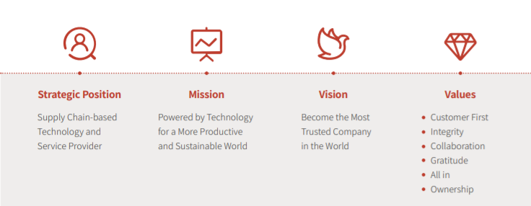
Figure 1: Strategic position, mission, vision and values of JD
Source: (JD, 2021b)
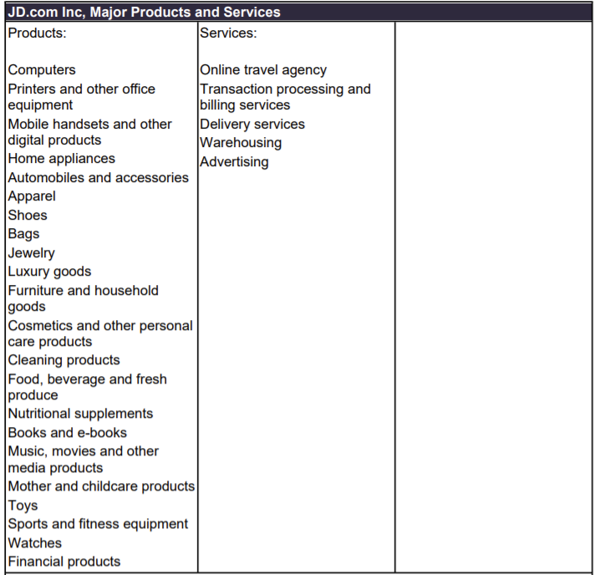
Figure 2. Major products and service of JD
Source: (MarketLine, 2021)

The scanning on the envrionment
The competitive situation in this industry environment will have a direct impact on JD's production and operation activities. The analysis of the strategic environment of JD therefore includes aspects of the external macro-environment and micro-environment faced by the company. The external macro environment usually acts and influences the company indirectly and potentially. In this section, PEST analysis will be used to explore the macro environment of JD from the dimensions of Politics, Economy, Society, and Technology. The micro-environment refers to the overall industry environment in which JD's business is located. The competition between the major forces in the environment and their combined intensity have a decisive impact on the intensity of competition within the industry and the ultimate profitability of the industry. In this section, Porter's five forces model is used to analyses the external industry structure of JD, starting with the five basic forces of industry competitors, suppliers and buyers, potential entrants and substitutes. Ultimately, the last section will use the SWOT analysis method, to conduct a comprehensive matrix analysis of JD's internal environment, so as to propose a more complete competitive strategy.
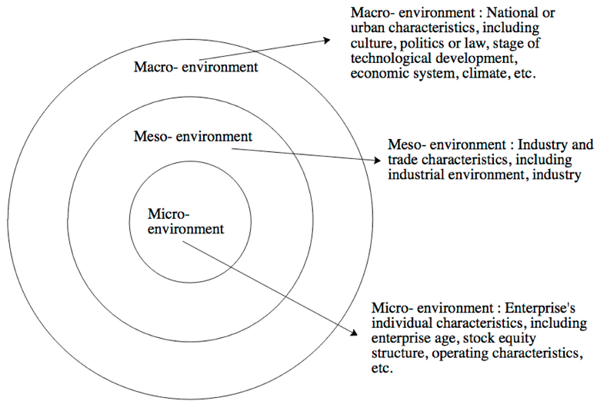
Figure 3: the environment analysis framework
Source: (Han et al., 2019)

Macro-level environment analysis
Political factors: the e-commerce industry in China has gained momentum for further development on the basis of constant supports from the state (Liang Li et al., 2019). In recent years, the state has recognized the importance attached to the industry, and actively attempting to construct a favorable environment to coordinate a wide range of necessary resources for the industry to thrive, such as improving the logistics infrastructure, safeguarding network security, enhancing the level of openness, etc. (Hongfei, 2017; Tang & Zhu, 2020). In particular, the State has recently announced through the Opinions on Vigorously Developing E-Commerce to Accelerate the Cultivation of New Economic Dynamics that it will continue to enhance the strategic industrial positioning of e-commerce in the future and increase its support for this industrial form of e-commerce, and that the State will take the initiative to adapt to the new normal of economic development, further solve the major problems and deep-rooted conflicts that hinder the development of e-commerce in China (Qin et al., 2014). Besides the effort in encouraging e-commerce development, the state also places a great amount of attention on e-commerce market regulation with an overate aim to create a fair and open competitive environment by putting forth more completed regulations in terms of intellectual property protection, consumer data protection, faire competition, etc. (Leong et al., 2016).
Economic factors: the economic development, so called as ‘new normal model’ indicates a transition from rapid growth to sustainable growth, with attention being placed on optimizing economic structure and changing growth dynamics (Riedel et al., 2020). The state has been actively boosting the domestic demand and stimulating domestic consumption. With the income per capital increased in a y-o-y growth of 6.9, the e-commerce industry will continue to gain growth momentum (Guan et al., 2018). At the same time, the on-going covid-19 pandemic creates unprecedented opportunities for online-ecommerce, as brick-and-mortar retail stores featured by people and interaction intensive are not longer welcomed by the public (W. Xu et al., 2020). Although the economy in China has been disrupted by the covid-19, China's economic growth rate has returned to roughly the pre-epidemic trend level, and we expect the Chinese economy to grow by around 8.0% in 2021 (BBC News, 2021). As China is at the forefront of the world's recovery, it is natural that it will be one of the first countries to return to normality in macroeconomic policy. However, in the first half of this year, China's fiscal policy contracted much faster and more sharply than expected, which weighed on economic growth. A number of other temporary factors also slowed growth, including natural disasters; the tightening of policy in a number of sectors (reflecting a variety of policy priorities); and the repeated recurrence of the new crown epidemic - an epidemic that continues to cast a shadow over the economy (BBC News, 2021). The economic uncertainties resulted from on-going and other related contributive factors can be both challenges but opportunities for JD.
Social Factors: the number of internet users in China has reached 86 million till the end of 2019, and the internet penetration rate has reached 67% at the same time point (Luo et al., 2019). The rapid growth of internet users will cultivate a wide range of internet-based habits, such as information acquisition, social networking, online shopping, mobile payment, etc. The number of domestic Internet users has been increasing, and the number of e-commerce application groups has been growing steadily. As of 2019, the number of domestic online shopping users was nearly 5.14 billion, an increase of 10.2 percentage points over the same period in 2018, and online shopping consumption has become the social norm (Qin et al., 2014). At the same time, the spending power of online shopping users is increasingly strong. Specifically, the total revenues of domestic consumer goods in 2018 was estimated to be around 37 trillion yuan, of which online consumption accounted for 7.2 trillion yuan and around 20 per cent (BBC News, 2021). Thus, the pulling effect of the online retail market on consumption is further evident and the prospect is very broad. With the youthfulness of China's online shopping group, the concept of quality consumption is also gradually gaining popularity. According to (Couture et al. (2018), the current domestic e-commerce consumer population is topped by the post-80s and post-90s age groups with more than 50% of the consumers, who are the main group of online shoppers. Most of these two generations have a high level of education, have been in contact with the Internet for a long time, are prone to accept online shopping habits, and use online shopping more frequently, and as most of these people already have income and thus have the ability to spend independently, they are relatively well-off. Therefore, despite the attractiveness of various kinds of product promotions, these groups are more interested in the quality of products and consumer services than the price factor. As a result, the characteristics of consumer upgrading will result in profound influence on the e-commerce industry, brining unprecedented opportunities for the e-commerce industry in terms of product/service personalization and diversification, category expansion, experiential marketing, value-added logistics and after-sales services.
Technology Factors: The joint promotion of ‘Internet Plus’ in China has assisted in the promotion of the internet information infrastructure, resulting in wide and deep integration of a wide range of cutting-edge information and communication technologies being applied in the e-commerce industry and significantly improving the overall level of the current e-commerce service in terms of scale, technical means and service levels. Specifically, the overall progress of the infrastructure has resulted in highly diversified mobile payment services, either through online banking or third-party payment (Alipay, WeChat, JD pay, etc.) (Jun et al., 2021). The prevalence of mobile payments enables customers to freely realize the cash flows between their own accounts and e-commerce platforms anytime and anywhere. Also, the emergence of internet of things technology enhances the overall intelligence of e-commerce supply chain. Interest of things, in the form of specific technologies such as intelligent sensing, identification technologies and pervasive computers, is widely used in the e-commerce industry to ensure intelligence management of logistics and delivery (Fedorko et al., 2018). Meanwhile, the application of cutting-edge technologies, such as cloud computing, machine learning, blockchain, etc., by the virtue of their ultra-large scale computing power, has significantly improved the information flow between the e-commerce eco-systems, and allow business intelligence to be developed based on real-time collection and analysis of customer data, and therefore to generate proactive prediction and personalization on service delivery.

Meso-level environment analysis
Threats of potential entrants : Each of potential entrants would bring new pressure on the competition and would have the potential power to alter the business landscape. The inflow of new competitors could result in lower prices for products in the B2C market, thus reducing the profit margin of the industry as a whole. It would therefore hope that the fewer new entrants the better, so as to ensure that the current position of vested interest and relative competitive advantage in the market is maintained. The current e-commerce B2C product market has seen the formation of giant companies such as JD and Tmall, who have already harvest the benefits of economies of scales, which is a huge obstacle for new entrants to face (Luo et al., 2019). As it stands, potential entrants seeking to enter the B2C market will not only have to cross the market entry barrier, but also face a backlash from existing players in the B2C market against new entrants. The current potential entrants of the e-commerce industry can be categorized into two groups, respectively internet giants that have been successfully in other relevant areas, as well as the traditional brick and mortar retailers who are seeking for a digital transformation. On the one hand, the internet giants in China, such as Baidu and Tencent, have inherent advantages, such as brand recognition, financial strengths, accumulated experience, in exploiting their current ecosystems to march into the e-commerce sector (Couture et al., 2018). On the other hand, the digitalization to realize onmi-channel integration has been a mainstream trend reshaping the retailing industry, and this trend has been accelerated by the outbreak of covid-19 pandemic. As a result, increasing traditional retailers are actively deploying their digital presence and developing their digital capabilities. The threats from traditional retailers cannot be neglected as they have innate resources accumulated from their previous operation, such as the huge customer base, the in-depth brand influence, the integrated supply chain, etc. (Couture et al., 2018) However, crossing the barriers to entry in the e-commerce B2C industry is no easy task for potential entrants. In terms of economies of scale, JD, after 14 years of capital accumulation, has built up the JD brand effect while also accumulating rich operational experience and technical capabilities (Chen et al., 2020). In terms of differentiated products, JD is an e-commerce platform that has focused on 3C products since the beginning of the enterprise and has developed into a business model such as a giant in the book market and department store market at a later stage, which is the first path in China (S. Li et al., 2020). In addition, JD's brand positioning of focusing on the 3C products market and the quality of its products has formed a brand effect that is deeply rooted in people's hearts and is difficult for other newcomers to replicate and surpass (Zhao, 2020). The threats of potential entrants are evaluated to be high.
Industry rivalry: In the e-commerce B2C industry, the level of competition between major competitors for market activities has a direct impact on the overall industry profitability. JD's current competitors in the e-commerce B2C market are mainly platforms such as Tmall , Suning, Vipshop, Dangdang, and Gome. According to Qin et al. (2014), Tmall, with the advantageous resources accumulated by Taobao, steadily ranked first with a market share of 60.4%, making it the first major competitor of Jingdong Mall. The second category of competitors of JD is the e-commerce platform established by large offline electrical stores such as Suning and Gome, which also poses a certain threat to JD. Sunning and Gome has relied on their offline accumulation of the logistics, after-sales experiences as the fundamental support to convert offline customers into online customers (Qin et al., 2014). Especially, both of them have physical stores as support, allowing direct interaction with customers, and that is something missing from JD’s business model. The level of industrial competition is evaluated to be high.
Threats of substitutes: the biggest substitute of JD comes from the traditional retailing chain and the new retailing players (represented by unmanned convenience stores and social e-commerce, etc.) Although e-commerce has gained more momentum in recent years, traditional shopping methods still have many incomparable advantages over internet e-commerce, such as products being accessible, more direct transactions, taking less risk, being able to bargain directly, etc. (Fan, 2019) With traditional shopping, consumers can avoid losses caused by product descriptions and pictures that differ from the actual product. Especially for high-end products or digital goods, consumers would prefer to go to traditional shopping centers or other end-users due to habit or concerns about the quality of the products (Zhang, 2019). The underlying reason can be attributed to the lower frequency of products updates in the traditional retail models relying on physical stores. The prices of goods are relatively not comparable horizontally, it is more time consuming for consumers to shop, and it is also limited by the physical retail shops, which are relatively fixed geographically and cannot achieve the convenience of home delivery services of online retail platforms like JD (Couture et al., 2018). As the physical network system of convenience stores driven by new technologies such as unmanned convenience stores and vending machines is rolled out, a piece of the retail market will also be carved away from the retail market (Seo et al., 2018). This new retail model has a smaller shop area and fewer stock keeping units, and the "convenience store" mode of operation is replicated in bulk in other formats, making it simple to manage, easy to choose a location, controlled rent and easy to replicate in bulk, to a certain extent making up for the shortcomings of traditional retail (Lee & Lee, 2018). The threats of substitutes are evaluated to be moderate.
Bargaining power of buyers: with the full availability of product and service information online, and the wide alternatives of e-commerce providers, it has become increasingly accessible and convenient for consumers to gather information and acquire services (Couture et al., 2018). The low switch costs between different platforms, and the comprehensive understanding towards pricing afford Chinese buyers with higher bargaining power against e-commerce platforms. Also, due the fair competition regulation, the domestic e-commerce providers do not enjoy any specific privilege in procurement from upstream suppliers (Tang & Zhu, 2020). Also, due to the prevalence of parallel imports, it is extremely hard for e-commerce platforms to gain bargaining power over Chinese customers through providing differentiated products via exclusive access to supplies (Hongfei, 2017). In the meantime, as competition between major e-commerce platforms is fierce, internet users are diversifying their consumer choices, and they can make detailed comparisons between major e-commerce platforms on the basis of a full understanding of the content of the product information, the actual price level, the level of after-sales service, logistics efficiency and comprehensive evaluation, thus increasing the bargaining power of consumers themselves. In recent years, major e-commerce companies have been competing to reduce prices in order to capture a larger market share and attract consumers. In particular, several price wars conducted by JD, Gome and Suning in recent years have seized the market with exceptionally fierce low-price competition, but while gaining market share, they have also created the impression that e-merchants must ship at low prices (Hsieh, 2019). However, because online retail has not yet completely replaced the offline market, online shopping is not the only channel available to consumers; coupled with the fact that many suppliers have invested in the operation and promotion of their own e-commerce systems, such as the official websites of some specific brands, or brands focusing on niche consumer market., the platform advantages occupied by comprehensive e-commerce channels have received relative restrictions, so JD and other major e-commerce players are competing against each other through pricing war. In this sense, the bargaining power of customers is evaluated to be high (Wei et al., 2020).
Bargaining power of suppliers: Couture et al., (2018) argued that the competitive dynamics of the e-tailing market are not yet set in stone. Even e-commerce companies such as JD and Tmall have not yet grown to the point where they can take the proactivity when negotiating with suppliers, so the absolute say in the procurement linkage remains in the hands of the suppliers. In recent years, major suppliers have gradually started to build their own e-commerce systems to develop their e-commerce business. If these entities can find their own e-commerce development direction and model, they will no longer have a great dependence on platform-based e-commerce enterprises, and the bargaining power of such enterprises as JD will be further reduced (Tang & Zhu, 2020). Therefore, the bargaining power of suppliers are evaluated to be high.

2.3 Micro-level environment analysis
Strengths | Weaknesses
- Superior customer experience: JD has always pursued a customer-first service philosophy, creating a service concept of "more speed, more savings", improving service levels in terms of product price, quality, logistics and delivery, and after-sales service (JD, 2021a). For instance, JD has established distinctive logistics services such as limited-time delivery, next-day delivery and overnight delivery, bringing users quality products while meeting the individual logistics needs of different consumers and gaining increasing recognition from consumers (JD, 2021a).  - Business authenticity and integrity: JD always insists on direct supply from a large number of brand manufacturers, conducts strict examination of merchants' qualifications, and also guarantees genuine products by building its own logistics to ensure product safety during the delivery process (JD, 2021a). JD spends a great deal of money to strictly control counterfeit goods, and consumers trust that the JD will not sell such products, and that the brand value it represents is genuine, making it more worthwhile for consumers to buy. JD's principle of winning corporate success through legal means not only protects the legitimate rights and interests of consumers, but also plays an important role in creating a fairer and more orderly competitive market environment.  - Integrated logistic system: JD has been committed to building its own warehouses and logistics systems rather than relying on third-party logistics service. Currently, among all domestic e-commerce platforms, JD is the only one with five major logistics networks, including small item logistics, large item logistic, cold chain for fresh goods, business-to-business logistics, and cross-broader logistic (Wu, 2019). | - High reliance on low pricing strategy: As online consumers are very concerned about price, JD has long relied on a low-price strategy, especially several large-scale "price wars" that have successfully captured a large market share, which to a certain extent has compressed its own profit margin and created the impression of low-priced goods to consumers  - High operational cost: a large amount of costs has been invested in the previous decade to quickly penetrate into the market. As a result of JD's long-term low-price strategy, product margins are low, and the existing asset-heavy costs can easily put JD in a passive position once it becomes difficult to support the quality shopping experience it prides itself on.
Opportunities | Threats
- The promising outlooking on e-commerce: the e-ecommerce market in China is expected to grow in the future as a direct result of the stable economic growth. The consumption power of new generation will continue to be realized as their increasingly per capita income. The younger generation, who are more willing to pay price premium for heterogeneous services, will be the major growth engine  - The favorable political support: The state has supported the industry through the introduction of several policies and regulations, providing support in the areas of finance, credit, logistics and taxation. The "Internet Plus" policy has promoted deeper integration between e-commerce and other areas such as manufacturing and has facilitated the development of the retail industry towards omnichannel.  - The advances in technologies: With the accelerated pace of development of China's Internet information infrastructure and the deepening application of cutting-edge technologies (such as machine learning, internet of things, etc.), the current level of development of the scale, technical means and service methods of the domestic Internet continues to rise, providing an information technology guarantee for the development of e-commerce platforms.  - The uncertainties brought by covid-19: the social distancing intervention imposed by the covid-19 will accelerate people’s reliance and preference on e-commerce platforms | - The intense competition: The homogenization of domestic e-commerce players directly intensifies the competition. For instance, T-mall with the resource advantages brought by Alibaba, including e-commerce, Internet finance, logistics and cultural creation, has occupied the majority of the online retail B2C market for years, becoming JD’s biggest threat (Couture et al., 2018).  - The bargain power of upstream and downstream partners: despite the rapid development, the domestic e-commerce platforms has not yet raised enough power to bargain against suppliers and buyers as indicated above. The national "Internet Plus" policy has promoted more suppliers to develop their e-commerce platforms. As a result, the bargaining power of the upstream suppliers on the JD platform has furthered increased. The market entry of international retailers, such as Tesco, Sam, etc. has provided buyers with more choices. The zero cost of switching brings buyers even more bargaining power.

3. The strategic management of Jingdong

3.1 The existing strategy of Jingdong
E-commerce enterprises have a relatively short history of development and lack of innovation, and have not formed a unique core competitiveness. In this case, many e-commerce enterprises in the early stage of development mainly took the "imitation" or even "copy" business approach, which led to many e-commerce enterprises in the customer, supply channels, marketing methods, business management there is a serious homogeneity (Couture et al., 2018). Through price wars, e-commerce enterprises can attract more consumers, thus grasping the first-mover advantage, occupying more market share faster and achieving the so-called survival of the fittest. E-commerce is mainly used for the sale of goods and services through online platforms. In the development of the real economy, it is often characterised by information asymmetry, in which product and service providers always occupy an information dominant position, while customers are always at an information disadvantage (Hsieh, 2019). The online economy effectively solves this problem by enabling greater market transparency and better information provision, which facilitates search and price comparison between e-commerce enterprises and consumers, but also leads to a greater preference for price wars among e-commerce enterprises. However, price wars are detrimental to the entire supply chain (Shang, 2020). For manufacturers and channel operators, price wars squeeze the normal profitability of goods and are detrimental to the subsequent production operations of enterprises (Dou et al., 2019). For consumers, manufacturers and channel operators may cut back on manufacturing costs and labour service costs in response to price wars, and consumers may not get the value they expect for their goods (Dou et al., 2019). Therefore, price wars are a primary form of competition, an undesirable competitive behavior that is detrimental to the interests of the entire market. However, JD has adhered to the price war strategy since 2012, JD even employ thousands of employees to perform cross-sectional monitor on the price of same items provided by its competitive peers and adjust the price to the industrial lowest level on a real-time manner (Couture et al., 2018). On the one hand, price wars have rapidly contributed to the development and growth of JD. Through price wars, JD's business revenue has been increasing and its market size has been expanding rapidly. On the other hand, JD's price wars have been plagued by long periods of time and a lack of customer loyalty, which can easily lead to numerous adverse effects, with JD investing huge sums of money in price wars every year, often in the tens of millions of dollars or even hundreds of millions of dollars, leading to a decline in corporate profits.

3.2 The future strategic orientation of Jingdong
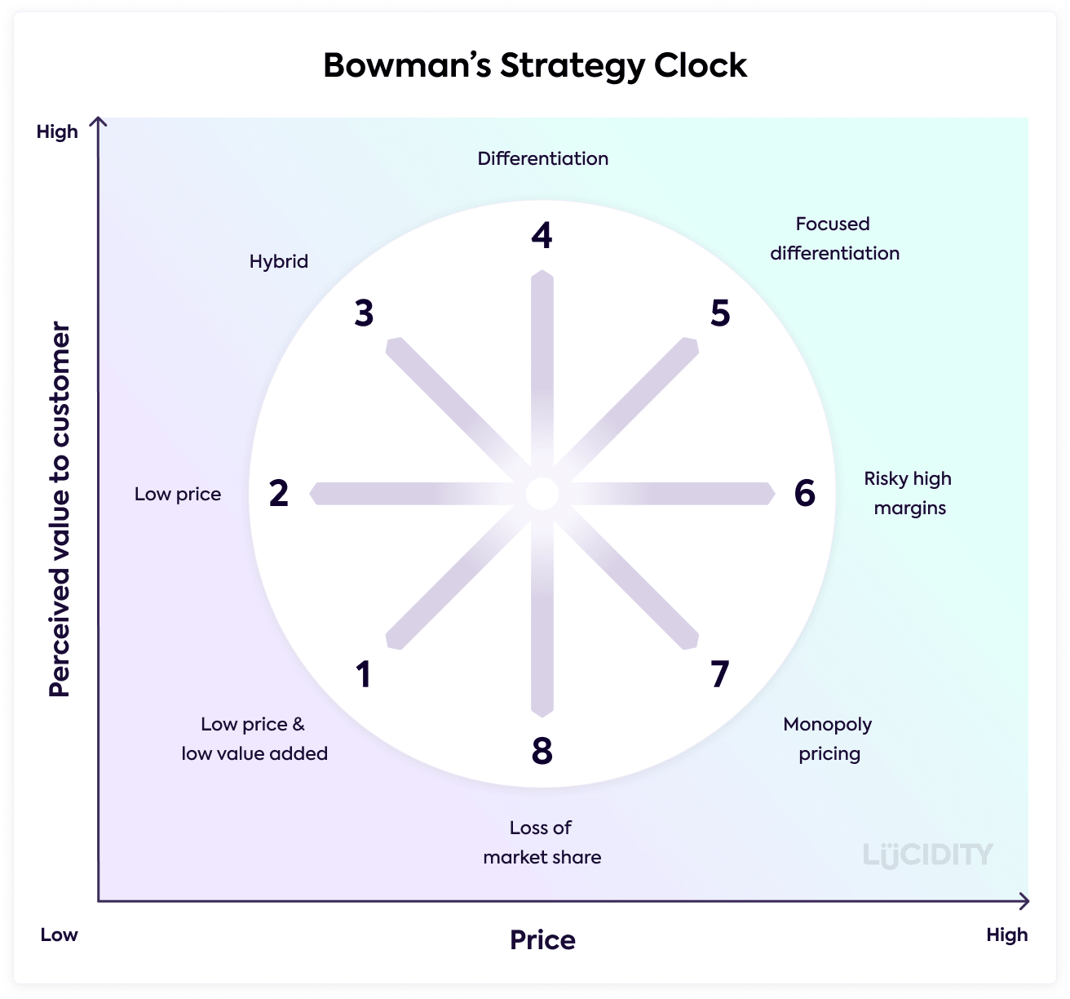
Figure 4: Bowman’s strategy clock
Source: (Faulkner & Bowman, 1996)
Bowman’s strategic clock is a classic strategic model widely used in the industrial practices to explore the possible alternative options for strategic positioning. Two dimensions, respectively price, and perceived value, collectively determines the eight possible strategic options a specific business could follow giving a comprehensive consideration and evaluation on the internal and external environment (see Figure X). The external environment on the macro level, featured by the emergence of technological advancements, the sharp rise of young consumers, the favorable political environment, together with the external environment on the meso level, featured by high bargaining power of consumers and suppliers, fierce industrial competition indicates the fact that the previous price war strategy (which is the route 2 in Bowman’s strategy clock) is not sustainable for JD over the long term. Under such circumstance, more personalized e-commerce experience and customer care, especially during the covid-19 pandemic and during the post-covid-19 era is a more sustainable path for JD to sustain its current competitive position and its future comparative advantage. That is to say, differentiation (which is at the route 4 in Bowman’s strategy clock) through personalization in service delivery should be considered by JD in its future strategic orientation. Specifically, achieving highly responsive customer service requires an effective combination of people, processes and technology to deliver a superior service experience at a lower cost. However, in the covid-19 and post-covid-19era, the rules of the game are changing. As social distance increases, the need for empathy and trustworthiness increases, and brands that fail to trust, or fail to perceive customer needs, are being phased out (Bhatti et al., 2020). Increasing competition is driving brands to increase customer engagement and sales by using the right messages in the right channels, while effectively reducing costs (Purba et al., 2021). Conversely, they will lose customer base, reduce revenue and fail to compete in the marketplace. To adapt and seize the opportunities, JD must rethink their customer service strategies. On the one hand, the whole service-delivery chain of JD should be more customer-centered. Chinese consumers have an ever diverse and concrete demand for distinct the overall experiences. Consumer profiling is the core content of consumer profiles, which are built by analyzing consumers' basic information and shopping behavior to paint a portrait of their characteristics. The insights generated from customers can be used not only to guide marketing, but also to match capacity and customize the logistics experience (Akter & Wamba, 2016). In terms of marketing, the highlight personalized marketing contents can be generated according to customer profiles and a holistic, full-line brand assortment based on customer insight data can be developed to meet forecasted potential customer needs (Linze Li & Zhang, 2021). For instance, through personalized displays and services, JD can understand customers' shopping habits and establish the most effective offline and web/mobile product displays to stimulate customers' desire to spending. In terms of pricing, pricing strategies, based on real-time monitor of supply and demand, and the pricing offer from competitors, can be developed to encourage customer purchase. In terms of logistics, JD can design logistics services (e.g., choice of delivery time) and delivery methods (door-to-door, courier locker, self-pick-up, etc.) based on their understanding of customers to enhance the customer experience (Zheng et al., 2020). Also, the insights generated from customers can enhance the reverse logistics and after-sale services. Reverse business refers to the logistics business from the consumer to the seller/vendor and mainly covers the return of goods and the return of repair parts (J. Xu & Jiang, 2009). As the scale of online shopping increases and the rate of electronic product replacement increases, reverse logistics and after-sales service are new demands for the superior and personalized customer service delivery within the e-commerce industry. Therefore, JD needs to build up reverse business and after-sales logistics capabilities to enhance customer service superiority. Lastly, the integration of technological advancements such as Internet of Things, Artificial Intelligence, are transformation the linear supply chain and information chain to collapse into a dynamic network, thus bringing more opportunities for JD to implement differentiation strategies. With an integrated information and supply ecosystems, JD can choose some specific differentiating factors (such as the speed of delivery, the accuracy on demand prediction, etc.) it wants to compete on against other e-commerce players. Overall, the differentiation concept should be embedded in every node of service delivery chain to ensure a more personalized customer experience. This is the most possible approach for JD to get rid of its current pricing war dilemma and secure its long-term comparative advantage.

Conclusion
The present report sheds light on the strategic status of JD. Despite the fact that JD is the largest e-commerce service provider in China, it has been trapped by the price war strategy it has insisted for years. The external environment on the macro level indicates the advances in e-commerce related technologies, the penetration and prevalence of e-commerce, the favorable environment of the state should be perceived as opportunities seized by JD in the future. The external environmental on the meso level indicates its current challenges of low bargaining power against buyers and suppliers, the intense industrial competition, the strong threats from entrants and substitutes. Indicated by strategy clock, a more sustainable strategy featured by higher level of differentiation throughout the service delivery, supported by the integration of cutting technologies to deliver more personalized and more superior services to Chinese customers should be pursued by JD.

Reference List
Akter, S., & Wamba, S. F. (2016). Big data analytics in E-commerce: a systematic review and agenda for future research. Electronic Markets, 26(2), 173–194.
BBC News. (2021). China’s economy grows 18.3% in post-Covid comeback. https://www.bbc.com/news/business-56768663
Bhatti, A., Akram, H., Basit, H. M., Khan, A. U., Raza, S. M., & Naqvi, M. B. (2020). E-commerce trends during COVID-19 Pandemic. International Journal of Future Generation Communication and Networking, 13(2), 1449–1452.
Chen, C.-M., Zhang, K.-S., & Li, H. (2020). Research on the Relationship Among Electronic Word-of-Mouth, Trust and Purchase Intention-Take JingDong Shopping E-commerce Platform as an Example. International Conference on Computer Engineering and Networks, 100–104.
Couture, V., Faber, B., Gu, Y., & Liu, L. (2018). E-commerce integration and economic development: Evidence from China (Vol. 24383). National Bureau of Economic Research Cambridge, MA.
Dou, W. W., Ji, Y., & Wu, W. (2019). Equilibrium Asset Pricing with Price War Risks. Rodney L. White Center for Financial Research.
Fan, Q. (2019). An exploratory study of cross border e-commerce (CBEC) in China: opportunities and challenges for small to medium size enterprises (SMEs). International Journal of E-Entrepreneurship and Innovation (IJEEI), 9(1), 23–29.
Faulkner, D., & Bowman, C. (1996). Competitive and Corporate Strategy. Irwin: The Strategy Clock: Competitive Strategy Options.
Fedorko, I., Bacik, R., & Gavurova, B. (2018). Technology acceptance model in e-commerce segment. Management & Marketing, 13(4), 1242–1256.
Guan, X., Wei, H., Lu, S., Dai, Q., & Su, H. (2018). Assessment on the urbanization strategy in China: Achievements, challenges and reflections. Habitat International, 71, 97–109.
Han, S., Cui, W., Chen, J., & Fu, Y. (2019). Why Do Companies Choose Female CEOs? Sustainability, 11(15), 4070.
Hongfei, Y. (2017). National report on e-commerce development in China. Inclusive and Sustainable Industrial Development Working Paper Series WP17.
Hsieh, P.-H. (2019). A study of models for forecasting E-commerce sales during a price war in the medical product industry. International Conference on Human-Computer Interaction, 3–21.
JD. (2021a). Annual report 2020.
JD. (2021b). Environmental,social and governance report.
Jun, Y., Xiao-Hui, S., & Yan, G. (2021). The" competition" for training cross border E-commerce talents in China on the background of" internet plus". Journal of Higher Education Theory and Practice, 21(6), 219–231.
Lee, S.-H., & Lee, D.-W. (2018). A study on ICT technology leading change of unmanned store. Journal of Convergence for Information Technology, 8(4), 109–114.
Leong, C. M. L., Pan, S.-L., Newell, S., & Cui, L. (2016). The Emergence of Self-Organizing E-Commerce Ecosystems in Remote Villages of China: A Tale of Digital Empowerment for Rural Development. MIS Q., 40(2), 475–484.
Li, Liang, Du, K., Zhang, W., & Mao, J. (2019). Poverty alleviation through government-led e-commerce development in rural China: An activity theory perspective. Information Systems Journal, 29(4), 914–952.
Li, Linze, & Zhang, J. (2021). Research and analysis of an enterprise E-commerce marketing system under the big data environment. Journal of Organizational and End User Computing (JOEUC), 33(6), 1–19.
Li, S., Jiang, C., & Li, L. (2020). Research on Chinese well-known e-commerce enterprises’ innovation ability based on real comment. International Journal of Computing Science and Mathematics, 11(1), 54–62.
Luo, X., Wang, Y., & Zhang, X. (2019). E-Commerce development and household consumption growth in China. The World Bank.
MarketLine. (2021). JD.com Inc - Profile JD.com Inc. https://advantage-marketline-com.uoelibrary.idm.oclc.org/Company/Profile/jdcom_2276839?companyprofile
Purba, M., Simanjutak, D., Malau, Y., Sholihat, W., & Ahmadi, E. (2021). The effect of digital marketing and e-commerce on financial performance and business sustaina-bility of MSMEs during COVID-19 pandemic in Indonesia. International Journal of Data and Network Science, 5(3), 275–282.
Qin, Z., Chang, Y., Li, S., & Li, F. (2014). E-commerce strategy. Springer.
Riedel, J., Jin, J., & Gao, J. (2020). How China Grows. Princeton University Press.
Seo, J.-H., Yang, H.-C., Park, C.-J., & Youn, M.-K. (2018). A Study on the Unmanned convenience Store Operation System from the Viewpoint of Visual Merchandising. The Journal of Industrial Distribution & Business, 9(12), 45–53.
Shang, L. (2020). Innovative ideas for promoting information management in e-commerce enterprises. 2020 5th International Conference on Mechanical, Control and Computer Engineering (ICMCCE), 1791–1793.
Tang, W., & Zhu, J. (2020). Informality and rural industry: Rethinking the impacts of E-Commerce on rural development in China. Journal of Rural Studies, 75, 20–29.
Wei, Y. D., Lin, J., & Zhang, L. (2020). E-commerce, taobao villages and regional development in China. Geographical Review, 110(3), 380–405.
Wu, A. (2019). Logistics Cost Control of Jingdong Mall Under E-Commerce Mode. International Conference on Applications and Techniques in Cyber Security and Intelligence, 592–599.
Xu, J., & Jiang, Y. (2009). Study of reverse logistics in the E-commerce environment. International Business Research, 2(1), 128–130.
Xu, W., Wu, J., & Cao, L. (2020). COVID-19 pandemic in China: Context, experience and lessons. Health Policy and Technology, 9(4), 639–648.
Zhang, X. (2019). Investigation of e-commerce in China in a geographical perspective. Growth and Change, 50(3), 1062–1084.
Zhao, C. (2020). A Survey Report on the Trend of E-commerce Consumption in Jingdong from 2016 to 2018. 2019 International Conference on Education Science and Economic Development (ICESED 2019), 269–272.
Zheng, K., Zhang, Z., & Song, B. (2020). E-commerce logistics distribution mode in big-data context: A case analysis of JD. COM. Industrial Marketing Management, 86, 154–162.

