The Potential of YouTube Monetization and Daily Forex Trading as Replacing 9-5 Jobs
(Individual Proposal)

Module code: LCBB6000
Lecturer: Dr Dudley Ofori
Supervisor: Dr. Richard Olusoyi Ashaye
Stefan Vasilev Zamfirov University of Wales Trinity Saint David, London Campus, BA Business and Management, London, United Kingdom 2024063@student.uwtsd.ac.uk

Contents
CHAPTER 1 2
1.1 Introduction 2
1.2 Significance of topic 2
1.3 Purpose 2
1.4 Proposed Aim 3
1.5 Proposed Objectives 3
1.6 Proposed Research Questions: 3
CHAPTER 2 Literature Review 4
2.1 Introduction 4
2.2 Definition and Characteristics 4
2.3 Importance 4
2.4 Models and Theories 4
2.5 Advantages 5
2.6 Disadvantages 5
2.7 Challenges 5
CHAPTER 3 Method and Methodology 6
3.1 Research philosophy 6
3.2 Paradigm 6
3.3 Approach 6
3.4 Methodology 6
3.5 Strategy 6
3.6 Sampling 7
3.7 Data collection 7
3.8 Data Interpreting 7
3.9 Data analysis tool 7
3.10 Ethical considerations 7
3.11 Ghantt Chart for the period 8
Conclusion 9
References 10

CHAPTER 1

1.1 Introduction
In recent years, the rise of digital platforms and the increasing accessibility of online income opportunities have sparked a growing interest among individuals seeking alternatives to traditional 9-5 jobs. Two prominent avenues that have gained significant attention are YouTube monetization and daily forex trading. YouTube, as one of the largest video-sharing platforms, offers content creators the potential to generate substantial income through advertisements, sponsorships, and other monetization strategies.
Similarly, the foreign exchange market, known as forex, offers individuals the opportunity to trade currencies and potentially profit from price fluctuations. Forex trading has gained significant popularity due to its accessibility, liquidity, and potential for substantial returns. Traders can engage in daily trading activities, taking advantage of market volatility to generate income.
Because of the traditional “rat race” people are so focused on their 9-5 jobs that they forget there are other, better things to explore and try. With more free time more flexibility more profit and better conditions.

1.2 Significance of topic
The significance of the topic lies in addressing the changing landscape of employment and income generation in the digital age.
Understanding the viability and potential of these alternative avenues is crucial for individuals who wish to explore non-traditional career paths. This research provides insights into the income generation potential, strategies, challenges, and risks associated with YouTube monetization and daily forex trading. By examining these aspects, individuals can make informed decisions about their career choices and assess whether pursuing these avenues aligns with their goals and aspirations.

1.3 Purpose
By exploring these alternatives, the purpose is to empower individuals to make informed decisions about their career paths, assess the feasibility of transitioning from traditional employment models, and explore alternative avenues for financial independence and professional fulfilment in the digital age. The importance of getting freedom and flexibility of the standard 9-5 job. Give people the courage to explore and try something new.

1.4 Proposed Aim
The aim of this dissertation is to explore the potential of YouTube monetization and daily forex trading as alternative income streams that could potentially replace traditional 9-5 jobs.

1.5 Proposed Objectives
These are some of the proposed objectives to be achieved:
- To examine the income generation potential of YouTube monetization and daily forex trading, compared to traditional employment models.
- To explore the skills, knowledge, and resources required for individuals to pursue YouTube monetization and daily forex trading effectively.
- To provide practical recommendations for individuals interested in pursuing YouTube monetization or daily forex trading as alternative income streams.

1.6 Proposed Research Questions:
These are some of the proposed questions to be asked and answered:
- What is the income generation potential of YouTube monetization and daily forex trading, compared to traditional 9-5 jobs?
- What are the required skills, knowledge, and resources for individuals to pursue YouTube monetization and daily forex trading effectively?
- What practical recommendations can be provided for individuals interested in pursuing YouTube monetization or daily forex trading as alternative income streams?

CHAPTER 2 Literature Review

2.1 Introduction
The literature review provides an overview of the existing research and scholarly work related to YouTube monetization and daily forex trading as alternative income streams to traditional 9-5 jobs. This section explores the definition, characteristics, importance, models, theories, advantages, disadvantages, and challenges associated with these avenues.

2.2 Definition and Characteristic of YouTube monetization and Forex trading
YouTube monetization refers to the process by which content creators earn income through advertisements, sponsorships, merchandise sales, and other monetization strategies on the YouTube platform. It allows individuals to share their content, engage with an audience, and generate revenue based on views, engagement, and partnerships(Chu et al., 2022). Daily forex trading, on the other hand, involves buying and selling currencies within the global foreign exchange market on a daily basis, aiming to profit from price fluctuations. It requires analysing market trends, utilizing technical analysis tools, and making informed trading decisions(Hua et al., 2022).

2.3 Importance of looking at them as alternatives
YouTube monetization and daily forex trading have gained significance due to the changing dynamics of employment and the rise of digital entrepreneurship(Drakopoulou, 2016). They offer individuals opportunities to pursue their passions, achieve financial independence, and work on their own terms. These alternative income streams provide flexibility, creativity, and potential for substantial returns, challenging the traditional notion of employment(Halim et al., 2023).

2.4 Models and Theories of YouTube monetization and Forex trading
Several models and theories are relevant to understanding the dynamics of YouTube monetization and daily forex trading. For YouTube monetization, the Business Model Canvas can be employed to analyse the key elements such as value proposition, revenue streams, and customer segments(Ailon, 2015). The Theory of Planned Behaviour can explain the motivations and intentions of content creators to engage in YouTube monetization. In the context of daily forex trading, the Efficient Market Hypothesis and Technical Analysis theories are often explored to understand the pricing patterns and trading strategies employed by traders(Ajzen, 2020).

2.5 Advantages of YouTube monetization and Forex trading
YouTube monetization offers a range of advantages, including low barriers to entry, global reach, potential for passive income, and the ability to build a personal brand. It provides opportunities for content creators to generate revenue through diverse channels, such as advertising, sponsorships, and merchandise sales (Halim et al., 2023). Daily forex trading offers advantages such as potential high returns, 24-hour market access, and the ability to trade from anywhere with an internet connection.

2.6 Disadvantages of YouTube monetization and Forex trading
While YouTube monetization and daily forex trading offer attractive prospects, they also come with certain disadvantages. For YouTube monetization, challenges include intense competition, fluctuating ad revenue, changing platform policies, and the need for consistent content creation(Carter, 2015). Daily forex trading involves risks such as market volatility, financial losses, psychological stress, and the requirement for continuous learning and adaptation.

CHAPTER 3 Method and Methodology

3.1 Research philosophy
By employing an interpretive approach, the research would contribute to a deeper understanding of the lived experiences and subjective realities of individuals engaged in YouTube monetization and daily forex trading. It would provide insights into the motivations, challenges, and perceptions of these alternative income streams, shedding light on their potential to replace or supplement traditional 9-5 jobs from the participants' perspectives.

3.2 Paradigm
By adopting the interpretivist paradigm for this topic, the researcher would primarily use qualitative methods, such as in-depth interviews, focus groups, participant observation, and content analysis, to explore and interpret the perspectives of individuals involved in YouTube monetization and daily forex trading. Using both Primary and Secondary data.
3.3 Approach
In this research inductive reasoning will be adopted, the specific observations from the interviews are used to derive a general conclusion. While inductive reasoning does not guarantee absolute certainty like deductive reasoning, it allows for the development of hypotheses and generalizations based on empirical evidence. After conducting in-depth interviews with 10 content creators engaged in YouTube monetization and daily forex traders, several common themes emerge:
Participants emphasize the potential to earn substantial income from these activities. They highlight the flexibility to work on their own terms and manage their schedules.
Based on these specific observations, it can be inferred that for some individuals, YouTube monetization and daily forex trading offer opportunities to replace or supplement traditional 9-5 jobs. The potential for income generation and flexible working arrangements are consistent themes among the participants.

3.4 Research Method
A qualitative research methodology focuses on understanding and interpreting subjective experiences, perceptions, and behaviours, which aligns well with exploring the motivations, challenges, and perceived advantages of engaging in YouTube monetization and daily forex trading.

3.5 Strategy
A case study research strategy involves an in-depth examination of a specific phenomenon or a small number of cases to gain comprehensive insights and understanding. Going for netnographic approach due to online interviews, in this context, conducting case studies would allow me to explore the potential of YouTube monetization and daily forex trading in replacing or supplementing traditional 9-5 jobs in a focused and detailed manner.

3.6 Sampling method /technique and sample size
Purposive sampling is a non-probability sampling technique in which researchers intentionally select specific participants who possess the characteristics or experiences relevant to the research objectives. This method will allow me to target individuals who have expertise and direct involvement in YouTube monetization and daily forex trading, providing rich and relevant data to address the research questions effectively. With a population of millions of people. A sample size of 15 participants can yield valuable qualitative insights into the potential of YouTube monetization and daily forex trading as replacements for 9-5 jobs. While the findings may not be statistically representative of the entire population, they can provide depth, context, and a more comprehensive understanding of the experiences and perspectives within your chosen sample.

3.7 Data collection
Conducting in-depth semi-structured netnographic interviews allows researchers to explore participants' experiences, motivations, strategies, and challenges in-depth. These interviews are flexible and permit follow-up questions to probe deeper into specific aspects of YouTube monetization and daily forex trading.

3.8 Data Interpreting
Interview: The data was collected through interviews and the first step is to transcribe the audio recordings into written text. This process involves carefully listening to the recordings and accurately transcribing the participants' responses.
Themes: Researchers interpret the identified themes and patterns to make sense of the data. They look for underlying meanings, connections, and explanations for the phenomena being studied.

3.9 Data analytical tool
I will be interpreting the data using traditional pie chart tool.

3.10 Ethical considerations
Participants should be fully informed about the purpose of the research, the data collection methods, potential risks, and their right to withdraw from the study at any time without penalty.
If the study involves collaboration with influencers, content creators, or forex traders, researchers should acknowledge their contributions appropriately and respect their intellectual property rights.
Researchers should implement appropriate measures to safeguard the security and confidentiality of the data collected. Online data collection platforms should be secure and comply with data protection regulations.
Obtaining ethical approval form the university after permission has been given by the respondents.

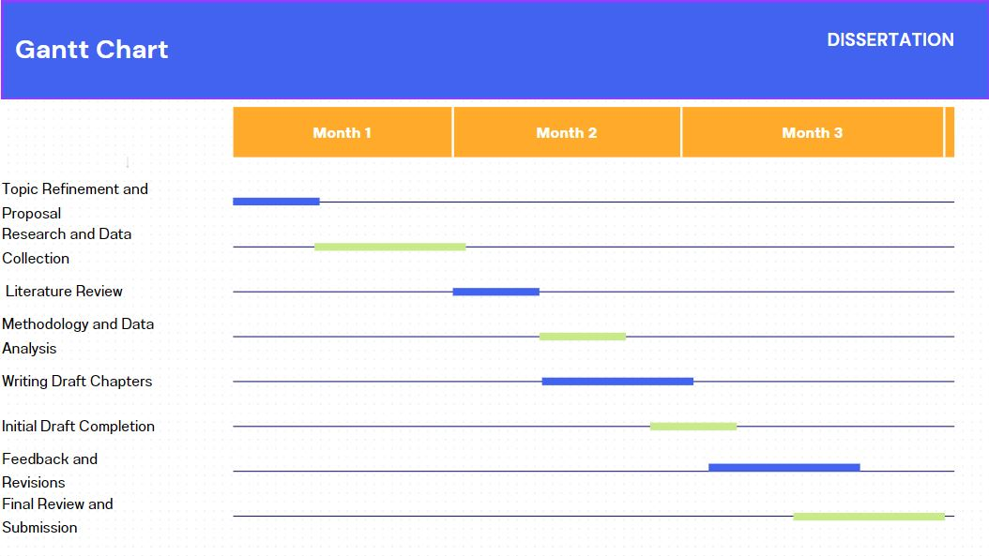
3.11 Ghantt Chart for the period

Conclusion
In conclusion, exploring "The Potential of YouTube Monetization and Daily Forex Trading as Replacing 9-5 Jobs" through qualitative research is a valuable endeavour. Adopting an interpretivist paradigm, mixed-methods research strategy, and purposive sampling, the study aims to gain in-depth insights into the subjective experiences and motivations of content creators and forex traders. Ethical considerations are essential throughout the research process to ensure participant rights, confidentiality, and respect. By delving into the complexities of these alternative income streams, this research offers a comprehensive understanding of their viability as alternatives to traditional employment, contributing to informed decision-making and practical recommendations for individuals seeking alternative career paths.

References
Ailon, G., 2015. Rethinking calculation: the popularization of financial trading outside the global centres of finance. Economy and Society, 44(4), pp.592-615.
Ajzen, I., 2020. The theory of planned behavior: Frequently asked questions. Human Behavior and Emerging Technologies, 2(4), pp.314-324.
Ben-David, I., Birru, J. and Prokopenya, V., 2018. Uninformative feedback and risk taking: Evidence from retail forex trading. Review of Finance, 22(6), pp.2009-2036.
Carter, P., 2015. Virtual ethnography: Placing emotional geographies via YouTube. In Social memory and heritage tourism methodologies (pp. 48-67). Routledge.
Chu, A., Arunasalam, A., Ozmen, M.O. and Celik, Z.B., 2022. Behind the Tube: Exploitative Monetization of Content on {YouTube}. In 31st USENIX Security Symposium (USENIX Security 22) (pp. 2171-2188).
Drakopoulou, V., 2016. A review of fundamental and technical stock analysis techniques. Journal of Stock & Forex Trading, 5.
Halim, U., Febriyanti, M. and Hidayat, N., 2023. Advertisement Exposure and Investment Interest: Study on Octafx Advertising Trading Platform Among Students. Jurnal Lensa Mutiara Komunikasi, 7(1), pp.132-143.
Hua, Y., Horta Ribeiro, M., Ristenpart, T., West, R. and Naaman, M., 2022. Characterizing alternative monetization strategies on YouTube. Proceedings of the ACM on Human-Computer Interaction, 6(CSCW2), pp.1-30.
Ørmen, J. and Gregersen, A., 2023. Institutional polymorphism: Diversification of content and monetization strategies on YouTube. Television & New Media, 24(4), pp.432-451.

.

