RESEARCH METHODS

Research Proposal:
Implementation of IoT in Planet Organic

Thomas Molner
1804565
Joy Botu

Table of Contents
1. Introduction/ background to the proposed research 1
Title- Implementation of Inter of Things (IoT) in Planet Organic 1
Background of the research area 1
Aim of the study 3
The objectives of the study are as follows: 3
2. Research and development method 4
Research strategy 4
Data collection methods 4
Identification and justification of development method and techniques that will used 5
Identification of risks 6
Data analysis 6
3. Resource and planning 7
Identification of resources required 7
Gantt chart based on project planning 7
References 10

1. Introduction/ background to the proposed research

Title- Implementation of Inter of Things (IoT) in Planet Organic

Background of the research area
In this new era of technology whenever questions arise related to demand aware fulfillment all of the businesses and organizations are found moving towards advanced technical excellences. The proposed project reflects the role play by Internet of Things (IoT) in Planet Organic a supermarket chain located in Westbourne Grove, West London. The project proposed for the nominated store Planet Organic will help the store to monitor their sales opportunities all over West London in the real time. Not only this but also the warehouse automation and robotics will help the store to track the missing in the store sales by implementing advanced supply demand planning in to a next level of advancement. In addition to this for accurate service level optimization and inventory management of the company another part of IoT in terms of RFID is also proposed to implement. Based on a fixed schematic, a typical distribution center is proposed to implement by the company to process the supply chain easily. However, in the coming future also the concept of traditional warehouse will become obsolete and related by self-organized automated pallets.
Stated that, in order to monitor all the activities of warehouse the three main components of IoT that play the most vital roles are sensors, actuators and a microcontroller. For supervising, monitoring and tracking the warehouse activities this proposed project is absolutely justified for Planet Organic. Again, in order to overcome warehouse storage related issues IoT monitoring system is very helpful because it helps to control all storage parameters. The proposed IoT based warehouse automation system uses intelligent management as well as fixes bins that are with high storage racks for storing the products. From the system and development perspective it can be said IoT gives economic viability to the companies than any other technical approaches and mechanism. In order to give security to the warehouses and to the store itself also the other devices that are to be connected together include build in WI-FI, cameras, line sensors, sharp sensor, limit switched etc. Beside the system automation and business efficiency the other important aspects that is successfully offered by the IoT system is high level security.
The company for which the IoT Implementation project is proposed in Planet Organic, an industry supermarket chain headquartered in London. Nowadays the company is one of the largest certified organic supermarket chains of United Kingdom (UK). The company sells more than approximately 8000 products in almost 8 stores in West London. Storing the organic products in proper environment is very essential. The temperature of London fluctuates a lot and therefore, managing the organic materials properly is very essential. The IoT sensors will control the heat, humidity, cold inside the warehouse storage area to keep the organic products secure. It is identified that the company is facing major challenges due to lack of technical supports.

Aim of the study
There are many large organizations those have already started using the IOT in their warehouse activities. It is important to identify the potential issues that the Planet Organic is facing due to the absence of advanced technology in the warehouse storage. The aim of the study is to focus on demand aware warehouse fulfillment by warehouse automation system and inventory management based on a completely fixed schematic through RFD tags. If the research conducted for the IOT application and the project proposed for the company is successfully implemented then Planet Organic will improve the forecasting accuracy, collect and process inventory data, decrease the over work pressure, seamless workflow and a n enhanced scalability as well. AT will also give a better real time product tracking opportunities to the company leads.

The objectives of the study are as follows:
- To study the current issues with inventory management in Planet organic
- To analyze AI based algorithm stores as well for demand forecasting
- To evaluate the advancement can be used after the implementation IoT
- To design and develop the project within a specific time of 8 months and budget of $200,000
At the end of the study, a project proposal will be submitted based on issues in current warehouse management and the how the inventory management system will be improved after the implemented of the IOT application in the warehouse of Planet Organic. IoT enabled warehouse will give solutions in terms of space allocation optimization, automatic navigation to the inventory storage, IoT enabled smart shipping, inventory control and management and advanced end to end inventory level visibility opportunities.

2. Research and development method

Research strategy
In order to conduct the research on IoT enabled smart warehouse automation system the strategy that will be used are survey and detail experiments. It has been found that if all the approaches are successfully followed and maintained throughout the research then the hidden facts of use of IOT in warehouse automation will become clearer. Survey research is referred to as quantitative as well as qualitative methods that are also with two different features. With the use of self-reports, the variables of interests are measured. The survey will be conducted with the help of some respondents, their thoughts, feelings reported directly for the research area. The survey will be conducted online, and the data will be collected online as well. However, in this specific research study major attention should be paid to the sampling process to avoid any possible issues. Random sampling will be used as a part of this research strategy. The online will be filled up by the participants though internet. Survey research quantitative approach features the usage of self-reporting measurements on careful sample selection. This approach is completely flexible in nature and applicable to study wider variety of research questions.
The research strategy will be initiated with selection of survey participants. After that, an online survey will be conducted to collect their opinion about IOT enabled warehouse automation system and different security level applications.

Data collection methods
As a part of the warehouse automation system development project the data collection method for each of the objectives set at the project initiation stage will be used is observation and document review. The warehouse automation system is a very advanced and new approach but already there are some companies those have started using the process. Therefore, whether the application will be suitable for Planet Organic Company or not can be measured with the help of observation and document reviews and questionnaire. The documents will be studied to identify the potential benefits that the company can get with the advanced warehouse automation system. The questionnaires will be used to survey the participants to get their opinion about the advancement.

Identification and justification of development method and techniques that will used
In order to design and implement warehouse automation system for planet Organic the development method and technique which is suggested to apply as a part of the system is prototyping. It has been identified that the process of developing as well as evolving complex data warehouse system is extremely exploratory by nature. IoT based warehouse automation is a complex project and may fail to meet all the objectives if not completed followed by proper development model.
Prototyping is the best possible model applicable for the warehouse automation system. It is a first and foremost full scale as well as functional format of the new product that will be designed. In order to demonstrate to the investors this particular model is used which is accepted after unit testing and final user acceptance testing. Prototype gives a rough idea to the project developer about the product and its functionalities. Alpha testing, beta testing, user test, integrated testing are the different testing approaches used before the final delivery of the model or system in the real time applications. Prototype model always eliminated the risks of innovation failure. It will help to gather all useful data from different sources and assist the project tam to understand the possible technical problems. It gives conflict resolving opportunities and easy funding as well.

Identification of risks
There can be some limitations or risks with which the proposed project development team may need to deal with. Lack of time for the research can be major concern or limitation to the project. The project is complex therefore needs enough of time to evaluate and execute the supporting applications.
During the research the other risk with which the team needs to deal with is ethical issues. The participants must not be manipulated or externally forced while taking part in the survey and questionnaires.

Data analysis
In order to analyze the data those have been collected during the survey, from documents and observations compare with user requirements and aims, and objectives is the best possible approach should be used. It will help to make sure that the data collected and analyzed are will help the company to implement the proposed project. For this research project at the initiation stage the objectives are set. The purpose of the research is to meet the objectives. Therefore, data those have been collected should be compared successfully with the objectives to make sure that these data are useful for the implementation of an IoT based warehouse automation system for Planet Organic.

3. Resource and planning

Identification of resources required
Resource Name | Type | Max. Units | Std. Rate | Ovt. Rate | Base Calendar
Project manager | Work | 100% | $28.00/hr | $0.00/hr | Standard
Operation manager | Work | 100% | $29.00/hr | $0.00/hr | Standard
System developer | Work | 100% | $24.00/hr | $0.00/hr | Standard
Technical expert team | Work | 100% | $18.00/hr | $0.00/hr | Standard
system designers | Work | 100% | $22.00/hr | $0.00/hr | Standard
tester | Work | 100% | $20.00/hr | $0.00/hr | Standard
Functional and non functional item cost | Material |  | $30,000.00
Technical and non technical item cost | Material |  | $48,192.00
DBA | Work | 100% | $24.00/hr | $0.00/hr | Standard
Researcher 1 | Work | 100% | $23.00/hr | $0.00/hr | Standard
Researcher 2 | Work | 100% | $24.00/hr | $0.00/hr | Standard

Gantt chart based on project planning
WBS | Task Name | Duration | Start | Finish | Resource Names | Cost
0 | Project planning and management schedule | 240 days | 14/05/20 | 14/04/21 |  | $125,000.00
1 | Phase 1- Project initiation | 29 days | 14/05/20 | 23/06/20 |  | $6,080.00
1.1 | Identification of research area | 6 days | 14/05/20 | 21/05/20 | Technical expert team | $864.00
1.2 | Analyzing current status of Planet Organic | 8 days | 22/05/20 | 02/06/20 | Operation manager | $1,856.00
1.3 | Research problem identification | 7 days | 03/06/20 | 11/06/20 | Project manager | $1,568.00
1.4 | Identification of diverse sources | 8 days | 12/06/20 | 23/06/20 | Project manager | $1,792.00
2 | Phase 2- Project planning | 61 days | 24/06/20 | 16/09/20 |  | $83,824.00
2.1 | Identification of data sources | 10 days | 24/06/20 | 07/07/20 | Operation manager | $2,320.00
2.2 | Analyzing collected data | 18 days | 08/07/20 | 31/07/20 | Researcher 1 | $3,312.00
2.3 | Developing project scope document | 15 days | 08/07/20 | 28/07/20 |  | $0.00
2.4 | Identify functional and non functional requirements | 11 days | 03/08/20 | 17/08/20 | Functional and non functional item cost[1] | $30,000.00
2.5 | Identify technical and non technical requirements | 12 days | 18/08/20 | 02/09/20 | Technical and non technical item cost[1] | $48,192.00
2.6 | Developing project team | 10 days | 03/09/20 | 16/09/20 |  | $0.00
3 | Phase 3- Design and development | 109 days | 17/09/20 | 16/02/21 |  | $26,120.00
3.1 | Discovering the right fit IOT based system prototype | 30 days | 17/09/20 | 28/10/20 | System developer | $5,760.00
3.2 | UML design and modeling | 22 days | 29/10/20 | 27/11/20 | system designers | $3,872.00
3.3 | Process Integration | 15 days | 30/11/20 | 18/12/20 | System developer | $2,880.00
3.4 | data migration | 21 days | 21/12/20 | 18/01/21 | Project manager, DBA | $8,736.00
3.5 | Installing all applications | 21 days | 19/01/21 | 16/02/21 | Operation manager | $4,872.00
4 | Phase 4- Project Testing | 37 days | 17/02/21 | 08/04/21 |  | $8,080.00
4.1 | Unit testing | 15 days | 17/02/21 | 09/03/21 | tester, Technical expert team | $4,560.00
4.2 | Integrated testing | 12 days | 10/03/21 | 25/03/21 | tester | $1,920.00
4.3 | User acceptance testing | 10 days | 26/03/21 | 08/04/21 | tester | $1,600.00
5 | Phase 5- Project closeout | 4 days | 09/04/21 | 14/04/21 |  | $896.00
5.1 | Stakeholders signoff | 2 days | 09/04/21 | 12/04/21 | Project manager | $448.00
5.2 | Post maintenance planning | 2 days | 13/04/21 | 14/04/21 | Project manager | $448.00

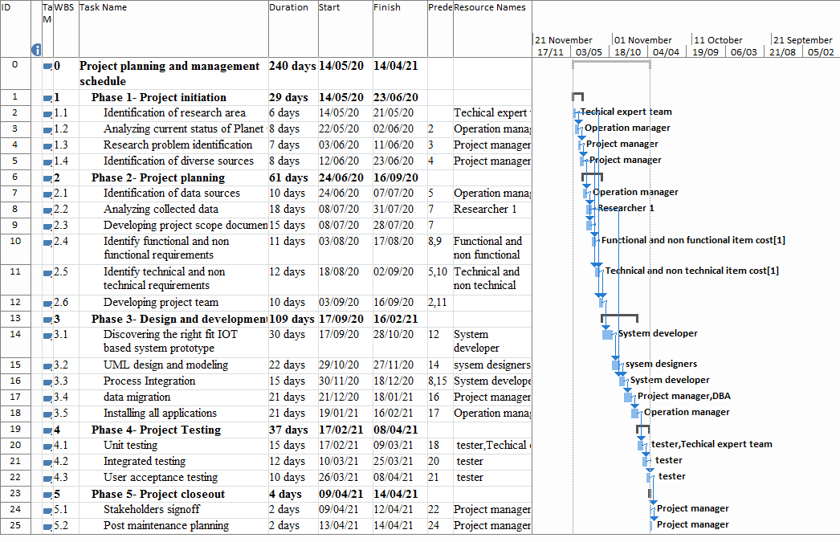
Figure 1: Gantt hart for the project
(Source: created by author)

References
Ichimiya, R., Jokinen, A., Marqueta, A. and Bolzon, B., 2018. Software-based discharge suppressor using an EPICS data acquisition system as a rapid prototype at the LIPAc beam extraction system. arXiv preprint arXiv:1803.08742.
Kasemsap, K. 2018. The roles of information technology and knowledge management in project management metrics. In Global Business Expansion: Concepts, Methodologies, Tools, and Applications (pp. 1191-1221). IGI Global.
Kerzner, H. 2017. Project management: a systems approach to planning, scheduling, and controlling. John Wiley and Sons.
Kerzner, H. 2019. Using the project management maturity model: strategic planning for project management. John Wiley and Sons.
Khan, R., Bhujbal, A. and Goudar, M., 2017. IoT enabled Automated Robotic Service for Warehouses.
Kivilä, J., Martinsuo, M., and Vuorinen, L. 2017. Sustainable project management through project control in infrastructure projects. International Journal of Project Management, 35(6), 1167-1183.
Kurnia, Y. and Sie, J.L., 2019. Prototype of Warehouse Automation System Using Arduino Mega 2560 Microcontroller Based on Internet of Things. bit-Tech, 1(3), pp.124-130.
La Rosa, M. 2016. Interview with Michael Rosemann on “The Role of Business Process Management in Modern Organizations”. Business and Information Systems Engineering, 58(1), 89-91.
Lai, T. 2019. The Rise of Legal Project Management: Importance of project management to law firms.
Melecio, J.I., Mohammed, A., Schofield, N. and Djurović, S., 2019, May. 3D-printed rapid prototype rigs for surface mounted PM rotor controlled segment magnetisation and assembly. In 2019 IEEE International Electric Machines & Drives Conference (IEMDC) (pp. 1830-1836). IEEE.
Meredith, J. R., Mantel Jr, S. J., and Shafer, S. M. 2017. Project management: a managerial approach. John Wiley and Sons.
Nicholas, J. M., and Steyn, H. 2017. Project management for engineering, business and technology. Taylor and Francis.
Patil, T.S., Khedkar, S.R. and Jadhav, M.S., 2019. Internet of Things (IoT) based Warehouse Monitoring and Control Interface Implementation.
Sigurdsson, G.A., Varol, G., Wang, X., Farhadi, A., Laptev, I. and Gupta, A., 2016, October. Hollywood in homes: Crowdsourcing data collection for activity understanding. In European Conference on Computer Vision (pp. 510-526). Springer, Cham.
Teknomo, K., 2016. Microscopic pedestrian flow characteristics: Development of an image processing data collection and simulation model. arXiv preprint arXiv:1610.00029.

