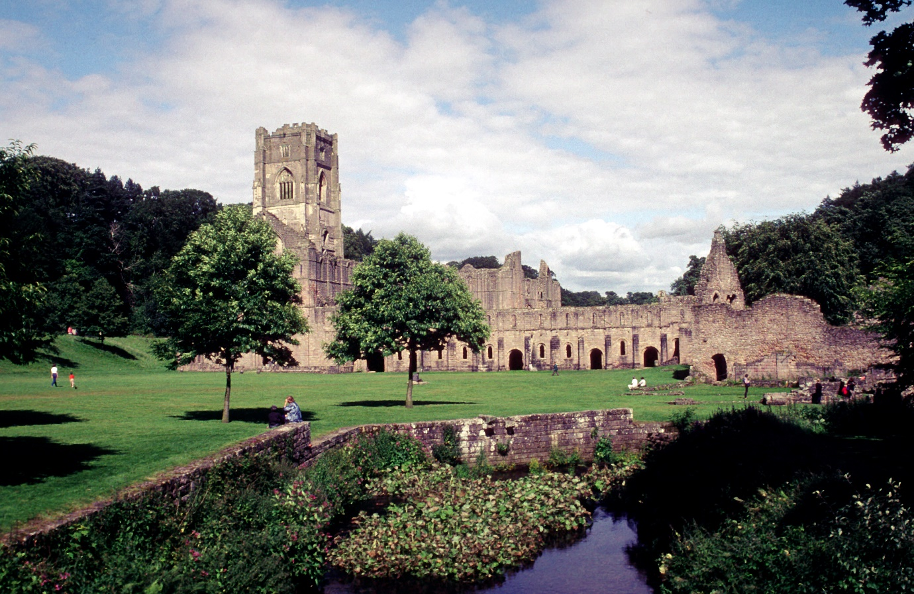
Fountains Abbey from the South West
Fountains abbey was a daughter house of Clairvaux. It was founded in 1132 by a group of monks that left the Benedictine abbey of St Mary’s after some Cistercian monks stayed on their way to found Reivalux. It is likely that there was already discord in St Mary’s, and the arrival of the Cistercians merely inspired those who felt St Mary’s was no longer following the Rule of St. Benedict to act. The foundation documents suggest that the monks did not leave to become Cistercian, merely to follow a stricter adherence to the Rule; however, after the first winter of them leaving, they decided that “The holy simplicity and the perfection of the life of salvation of the Cistercian Order was pleasing to all of them” and requested advice and guidance from Abbot Bernard of Clairvaux. Fountains Abbey was built in the valley of the River Skell in North Yorkshire. Flowing water is of paramount importance to a monastery and can affect orientation and construction. Fountains is not on an East-West alignment due to the area’s geography and the position of the river. The marshy ground necessitated additional buttresses on the extended High Altar in the Fourteenth and Fifteenth Centuries.
While Fountains Abbey follows the general layout of a Cistercian monastery, a notable addition is the bell tower. The ringing of the bells ordered the liturgical day, calling the monks to the Hours. In 1157 the General Chapter prohibited the contraction of stone bell towers as they were deemed excessive; however, by the late 13th century, a president had been set for “stone towers in stormy climates”, and stone towers became gradually accepted. Marmaduke Huby, the abbot of Fountains (1495-1526), built the 48-metre bell tower at Fountains. While bell towers are commonly found in the centre of the church, at Fountains, the central crossing piers were too weak to support a tower; therefore, it was built adjoining the north transept. The inscriptions on Fountains’ bell tower relate to the Sunday offices, the most important for the Cistercians. While there has been much debate over the hubris of Huby’s tower, the inscriptions clearly show reverence to the growing Cult of Jesus Christ and God. The addition of Huby’s arms and motto is merely a reflection of the cultural norms of commissioning a building in the fifteenth century.
The photo of the abbey shows the huge Western range that housed the lay-brethren, or conversi. The western range originally built by Henry Murdac was pulled down in the 1160s for the construction of a more extensive range to accommodate the increasing number of conversi, making it the largest of its kind in 12th century Europe. The conversi were an essential aspect of Cistercian monastic life. While monks were expected to do physical labour, most of the agricultural work required to run a large monastery was performed by the conversi. Despite differences in literacy and daily routine, the conversi were considered equal to monks as they all performed “work” in the name of God. The recent discovery of the largest monastic tannery at Fountains shows how industrial a monastery could be. The conversi would have been essential for the noisy, smelly work of tanning, and it was equally essential for producing the manuscripts studied and copied by the monks. During the twelfth century, Fountains Abbey had more than 500 conversi that lived and worked in the monastery and in the granges that supplied Fountains with food, building materials and wool.
The photo of Fountains was taken close to the lanaria, identified initially as the monastic bakehouse by Sir William St John Hope. Despite its location close to the monastery in the Outer Court of Fountains Abbey, the lanaria would have been a noisy, bustling building managed by conversi, much like the tannery. Wool was a crucial aspect of Fountains’ economy and of many Cistercian monasteries in England and Wales. In the fourteenth century, Francesco Balducci Pegolotti’s list of wool-producing monasteries was dominated by Cistercian houses. The Cistercians developed complex systems of grading wool, which required spaces to sort the wool before it was exported and sold. This grading system, along with their exemption from tithes and tolls, enabled the Cistercians of England and Wales to dominate the wool trade of the twelfth and thirteenth centuries. The lanaria was an essential space for wool to be gathered from all the granges owned by Fountains and possibly from other monastic houses or local communities. The practice of collecting wool from other sources to be sold for profit was initially frowned upon, but, like the building of stone towers, the rules were relaxed over the centuries. Here it could be washed, sorted and sold in bulk to merchants in Flanders and Italy who were willing to embark on 5, 10, even 20-year contracts with the Cistercian monasteries for their wool. These contracts enabled the substantial building projects, such as the expanded West range at Fountains, but also put the White monks on a dangerous knife-edge of debt and dispersal if disease ravaged the flocks year after year, a fate that befell the monks of Pipewell.

Bibliography
Bell, A. R., Brooks, C. and Dryburgh, P. R. ‘Leger est aprendre mes fort est arendre’: wool, debt, and the dispersal of Pipewell Abbey (1280-1330). Journal of Medieval History, 32:3 (2006). pp. 187-211.
Bilson, F. ‘The Architecture of the Cistercians, with Special Reference to Some of Their Earlier Churches in England’ https://archaeologydataservice.ac.uk/archiveDS/archiveDownload?t=arch-1132-1/dissemination/pdf/066/066_185_280.pdf [Accessed on 19 December 2021]
Bucher, F. ‘A Failure of Architectural Purism’ Perspecta; Vol. 6 (MIT Press, 1960) pp. 4-15
Carter, M. ‘The Tower of Abbot Marmaduke Huby of Fountains Abbey: Hubris or Piety?’, Yorkshire Archaeological Journal, 82:1 (2010) 269-286
Coppack, G. ‘The Excavation of an Outer Court Building, Perhaps the Woolhouse, at Fountains Abbey, North Yorkshire’, Medieval Archaeology, 30:1, (1986) 46-87
Donkin, R. A. ‘Bercaria and Lanaria’, Yorkshire Archaeological Journal Vol. 39 (1958a) 447-450
Donkin, R. A. ‘Cistercian Sheep-Farming and Wool-Sales in the Thirteenth Century Agricultural History Review, Volume 6 (1958b) 2-8
Hawks, K (Unpublished) Narratio de fundatione Fontanis Monasterii, (email correspondence) D. Mercer, 3 December 2021.
Hodges, G. Fountains Abbey: The Story of a Medieval Monastery [e-book] https://www.gutenberg.org/files/52581/52581-h/52581-h.htm [Accessed on 19 December 2021]
National Trust, ‘Discovery of medieval tannery at Fountains Abbey surprises archaeologists and reveals remarkable new evidence of community that lived there’ https://www.nationaltrust.org.uk/press-release/discovery-of-medieval-tannery-at-fountains-abbey-surprises-archaeologists-and-reveals-remarkable-new-evidence-of-community-that-lived-there [Accessed on 19 December 2021]
The Cistercians in Yorkshire, ‘The Western Range’ https://www.dhi.ac.uk/cistercians/fountains/buildings/range/ [Accessed on 19 December 2021]
Whitwell, R. J. ‘English Monasteries and the Wool Trade in the 13th Centuary’, Vierteljahrschrift für Sozial- und Wirtschaftsgeschichte, 2:1 (1904) 1-33

K, Hawks, (unpublished) Narratio de fundatione Fontanis Monasterii,
ibid.
G, Coppack, ‘The Excavation of an Outer Court Building, Perhaps the Woolhouse, at Fountains Abbey, North Yorkshire’, Medieval Archaeology, 30:1, (1986) 46-87 (p. 46)
G. Hodges, Fountains Abbey: The Story of a Medieval Monastery [e-book] https://www.gutenberg.org/files/52581/52581-h/52581-h.htm [Accessed on 19 December 2021] (p. 133)
F. Bilson, ‘The Architecture of the Cistercians, with Special Reference to Some of Their Earlier Churches in England’ https://archaeologydataservice.ac.uk/archiveDS/archiveDownload?t=arch-1132-1/dissemination/pdf/066/066_185_280.pdf [Accessed on 19 December 2021] (p. 192)
F. Bucher, ‘A Failure of Architectural Purism’ Perspecta; Vol. 6 (MIT Press, 1960) pp. 4-15 (p. 15)
M. Carter, ‘The Tower of Abbot Marmaduke Huby of Fountains Abbey: Hubris or Piety?’, Yorkshire Archaeological Journal, 82:1 (2010) 269-286 (p. 273)
ibid. p. 276
Ibid. p. 279
Ibid. pp. 272-273
The Cistercians in Yorkshire, ‘The Western Range’ https://www.dhi.ac.uk/cistercians/fountains/buildings/range/ [Accessed on 19 December 2021]
K, Hawks, (unpublished) Narratio de fundatione Fontanis Monasterii,
National Trust, ‘Discovery of medieval tannery at Fountains Abbey surprises archaeologists and reveals remarkable new evidence of community that lived there’ https://www.nationaltrust.org.uk/press-release/discovery-of-medieval-tannery-at-fountains-abbey-surprises-archaeologists-and-reveals-remarkable-new-evidence-of-community-that-lived-there [Accessed om 19 December 2021]
Woolhouse
Coppack, ‘The Excavation of an Outer Building’ pp. 46
R. A. Donkin, ‘Bercaria and Lanaria’, Yorkshire Archaeological Journal Vol. 39 (1958a) 447-450 (p. 449); Coppack, ‘The Excavation of an Outer Building’ pp. 48
R. A. Donkin, ‘Cistercian Sheep-Farming and Wool-Sales in the Thirteenth Centuary’ Agricultural History Review, Volume 6 (1958b) 2-8 (p. 2)
ibid. p.6
R. J. Whitwell, ‘English Monasteries and the Wool Trade in the 13th Centuary’, Vierteljahrschrift für Sozial- und Wirtschaftsgeschichte, 2:1 (1904) 1-33 (p.8)
ibid. p. 10-13
A. R. Bell, C. Brooks, and P. R. Dryburgh, ‘Leger est aprendre mes fort est arendre’: wool, debt, and the dispersal of Pipewell Abbey (1280-1330). Journal of Medieval History, 32:3 (2006). pp. 187-211. (p. 189)
ibid. p. 188

