2011835 Lloyd Andrew Jones
Additional Needs in Context (ECIE4003)

Contents Page

- Introduction
- Element 1 (Poster)
- References for Poster
- Element 2
- Element3
- Element 4
- Conclusion
- References
- Appendices

Introduction

In this portfolio the author will be writing about the differences between the Medical Model and the Social Model of disability. Also, throughout the portfolio they will taking you through the support methods that are currently within the education environment in the settings that the author currently works. Within this section of the portfolio, we will be taking you through the current policies and legislations that learning environments around the county must link with the models of disability.

The Different Models of Disability

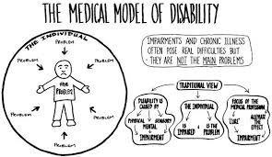
The Social Model of Disability is about looking through the eyes of the disability and for some this is viewing the world in a different way.

According to (Scope) “The model says that people are disabled by barriers in society, not by their impairment or difference. Barriers can be physical like buildings not having accessible toilets.”
The Social model looks at:
- The Environment
- Attitudes
- Stereotyping
- Discrimination
This model looks at the barriers that are easily overcome for the people with disabilities. This can be built up from the barriers put in front of people but they are able to find ways of breaking them down for example:
Someone who is deaf can communicate with people via sign language. Giving them empowerment over their own lives.

Social Model
The Medical Model of Disability looks at the consequences of the long term trauma, health conditions and diseases to which of them have an impact on everyday life.

The medical model looks at the following disabilities:
- Hearing impairment
- Eyesight
- Speech
- Or other genetic defects.
Looking at the medical model of disability, this often makes people believe there is ways of fixing the health problems with interventions such as medication or surgery. From the research that the author has done this model looks at the impairments of those with disabilities and deems them as helpless to do anything about their impairment.
Medical Model

Definition of Disability
Looking at the word disability it has various meanings to every single person. But a disability according to (Centers of Disease, 2020) ”is any condition of the body or mind (Impairment) that makes it more difficult for a person with the condition to do certain activities and interact with the world around them.”

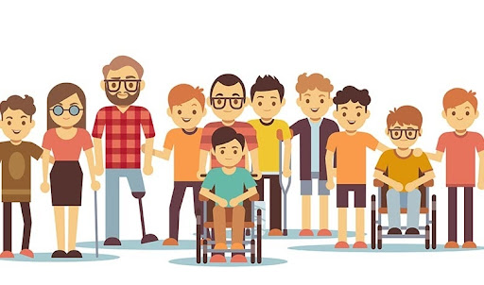

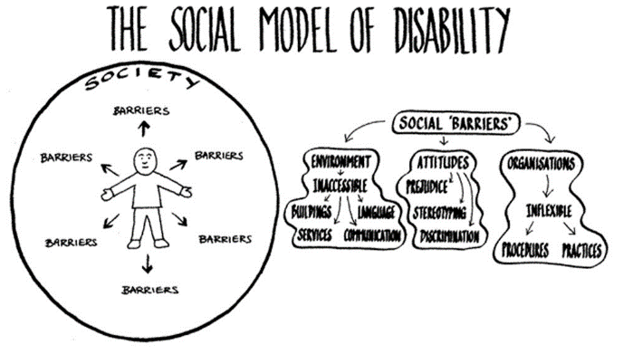

References for Poster

- ( Definition of Disability)Centres for Disease Control and Prevention. 2021. Disability and Health Overview | CDC. [online] Available at: <https://www.cdc.gov/ncbddd/disabilityandhealth/disability.html> [Accessed 10 August 2021].
- (Social Model Information) Ddsg.org.uk. 2021. Social Model of Disability - Taxi Driver Training Pack - Democracy Disability and Society Group. [online] Available at: <http://ddsg.org.uk/taxi/social-model.html> [Accessed 9 August 2021].
- (Medical Model Information) Wecanandmustdobetter.org. 2021. [online] Available at: <http://www.wecanandmustdobetter.org/files/5914/2626/5339/Models_of_disability.pdf> [Accessed 9 August 2021].
- Medical Model Image, Ddsg.org.uk. 2021. Medical Model of Disability - Taxi Driver Training Pack - Democracy Disability and Society Group. [online] Available at: <http://ddsg.org.uk/taxi/medical-model.html> [Accessed 10 August 2021].
- Image of Disability, Eurodoc.net. 2021. Disability as an evolving concept: paving the way for more inclusive working environments for ERCs | Eurodoc. [online] Available at: <http://eurodoc.net/news/2020/disability-as-an-evolving-concept-paving-the-way-for-more-inclusive-working-environments> [Accessed 12 August 2021].

How do current policies, legislation, and framework link to the theoretical approaches?
From the poster you can see that we have looked at the different models of disability, throughout the research there are more models, but we have concentrated on the Social and Medical models. Whilst looking at these models these factors come into our everyday life and not just within the public, we see but also within the children that we see in our education sectors. So that we can help those who are classed as ‘Disabled’ we as a country have policies and legislations in place for them to make them more independent. Through the research form the Medical Model of Disability it follows those who are classed as disabled because of their impairments and looks at what is wrong with the person rather than the needs of the person in question. Looking at the medical model in a classroom-based approach, an example of this could be the case of a teacher giving a child with dyslexia a handout not on coloured paper. Another example of this could also be not providing a deaf pupil with a one-to-one who is their designated interpreter.
According to (Nicola John, Head of Inclusion for Pembrokeshire, 2013) “The fundamental aim of making an inclusive education system is to promote achievement and wellbeing for all” from this we know using the medical model that we will not be promoting achievement or wellbeing if we are not helping them to the best of our ability. The medical model is just the start of the models of disability because whilst looking at the social model this is the one where we look at the way that society restricts them. The social model helps society consider the differences that some children or young people have physically or psychological and looks at the different barriers that can be put in their way. An example of this is wheelchair bound person not having the necessary steps to get to a higher floor in a building i.e. disabled lift.
Whilst doing research about the additional learning needs transformation programme, which was passed on 12th December 2017, this covers the range of additional learning needs within the children/young people that we work with aged 0-25 years old. Whilst the bill was passed it was not until 24th January 2018 that the Additional Learning Needs (ALN) Bill gained the Royal Assent. Throughout the ALN Bill the Welsh Government have come up with 11 aims that they wanted to push with the education services and workforces to help the children/ young people gain the most out of their education and their future work placements. The main point they come up with is making sure that they have High Aspirations and improved outcomes through an Individual Development Plan (IDP) to which they can look at the strengths and weaknesses of a pupil or worker to help them go further.
From looking at the ALN Bill and the Education Policy for Pembrokeshire County Council, we can see how they both tie to the Models of disability. This has come about because they are both wanting the best for the young people, we work with but also, they both look at the strengths of the child/ young person in question. The frameworks and legislations have evolved with the times and for the better of the young people today. Since the Salamanca Statement which was originated in June 1994 where 92 governments and 25 international organisations gathered to put together the first statement for SEN (Special Educational Needs).

Identify how your setting supports the development of a pupil or a group of pupils with an additional learning need/additional learning needs.

In this section of the portfolio, I will be taking you through the different ways that my provision and settings alike support the development of those young people we teach with ALN. We all know that throughout the last few years the level of ALN’s within children have become a wider problem that what it used to be. This is where the education side must develop more ALN settings within mainstream schools and speciality provisions throughout each county. Within this I will be talking to you about a couple of the pupils in my provision and how we have helped them through their needs.
For the instance of this portfolio, I will be referring to the child in question as “Child A”. Child A has been with us in our provision for some time now and he has grown so much since the first time we met him. He came to us at the age of 7 with a troubling background following him around, from the time he started to settle in he was a nervous and shy child after a couple of weeks we started to see the additional learning needs come to the surface. Child A lives at home with his mum and two siblings, and dad is not on the scene anymore. Since dad left the family home the behaviours and social interactions from the child has become very disturbing and likes to have something over on another child.
We as a unit believe that this child feels that having this certain aspect over another child makes him feel superior to the others. This aspect could be something to do with the work, how to use a computer or even if another child tells him about a game or toy that they want he will buy it and then bring it into school. We believe that this is down to the home life as he is currently going through a diagnosis of childhood depression with the CAMHS team (Child and Adolescent Mental Health Services). According to (Local Government Association 2021) “at least one in eight children and young people have a diagnosable mental health condition”. This is having a greater impact in the children and young people we see these days because there are more anxieties kicking in and socialites to keep up with.
Whilst Child A is with us in our provision, we try to help him through his depression by using ELSA (Emotional Literacy Support). When he has these sessions with our ELSA, they work on the in-depth reasons to why he is feeling like this and look at who he feels close to at home, in school and friendships. Child A has an ELSA session at least twice a week to maintain the support and guidance he needs to help him grow into a confident pupil. With the ELSA work we also offer him a Lego Therapy course but to the pupils we call it “Construction Crew”. This has become a new session within our provision, this is a kind of therapy to help them with their social skills and build on their friendships. Whilst having these therapies in place for the child in question he has come on leaps and bounds. Child A is currently going into year 6 but is also going through a change in school placement too. We are hoping that this new school placement will help him not just get back on track with his schoolwork but also to give him the head start that he needs to make it through secondary school. Whilst tackling his depression he also has been diagnosed with ADHD to which he has taken in his stride during school time.
Child A has shown a great deal of emotions with us since he joined at the age of 7, when he started, he was unable to recognise his emotions or know how to talk about them and regulate himself. Through the years he has slowly been able to start regulating himself to which now he is able to see when he needs time our or even needs time to talk to one of our members of staff. For a child that has depression and ADHD this is a big step, and a massive achievement. At the beginning of when he was settling into his emotions, he chose one member of staff to talk to about the way he was feeling, and this would normally be the class teacher. But since time has gone on, he is able to convey how he is feeling to a wider selection of staff throughout our provision which is much easier as there are more people there to help him. Since coming back in from the summer holidays he has been a breath of fresh air and is ready to start his new chapter in year 6 but to also make it back into mainstream full time.
Now that Child A is in year 6, we are going to help him take this year in his stride to develop him into the year 6 pupil that we know he can be. We will do this by continuing the ELSA sessions and going into a bit more depth about working on the school relations and friendships.

Discuss the support provided to your chosen pupil or a group of pupils and compare the key principles/approaches and policies that guide inclusive practice.
As stated, previous in this portfolio, we have seen a mass growth in childhood and adolescent additional learning needs. This could be down to their homelife or even the way they came into the world. But since the Salamanca Statement came into practice in 1994 the support within school has become more defined to those specific needs. Within schools there are more staff who are qualified in certain aspects and with the ongoing adult training to better us we have the knowledge to help the young people that we work with in each sector. In the behaviour sector of education, you will tend to see more LSA’s in a classroom, than in a mainstream class and this is because there are more children or adolescents with needs to be looked after.
As well as the support and guidance they get within the school environment, there are also outside agencies that can help them. These outside agencies can come into their learning environments, in the behavioural sector that the author works in they have used and outside agency that deals with play therapy. Within this they would be able to have one to one time with a supplier and be able to speak about how they are feeling whilst having fun and not knowing that they are helping the supplier gain more information on how to help them. On the other side of outside agencies, they also have a pet therapy which is a very good tool for those pupils who feel that they are not able to connect with a member of staff.
We have used this particular outside agency within the behaviour sector because it is a great way for the child or adolescent to start opening up about their emotions or even their worries without them even knowing. This is because is it a calming environment due to having a dog in the class, in our education setting we tend to get the child to read a book to the dog and then once they have finished this they are able to speak freely or even smooth and give the dog a treat. Not only is there support for the children or adolescents that we work with but also for the families and carers. Within the agencies and education settings there are different parent forums that can help those parents who need any extra help within their homelife. The support that is given to the families and carers of the children we work with has become greater just like the needs of the children and adolescents. As mental health is growing within our pupils it is also grows within the family members around them. Looking at Maslow’s hierarchy of needs, it is the basis of a strong homelife. Without this not only the children suffer but also the adults because we learn from what we once had in our lives and if we have had a bad upbringing as adults, we look to give the children and adolescents a better one than ourselves.
Conclusion
Throughout this portfolio we have looked at the different models of disability and in particular looking at the Social and Medical models. To which we found that these are the two main models that we see through our teachings and also our lives. The models of disability have been around since 1976 and has evolved with the times, this has been the same for the different policies and statements that have come into the additional learning system. These can be viewed all over the internet or even in the libraries that are around.
I believe that within the sectors of additional learning needs in education these statements and bills come in very helpful. Whilst doing the research for this portfolio I found that the Salamanca Statement was a very good insight of the first ALN/SEN statement that came into play in 1994. The Salamanca Statement is a great progression step into helping those children and adolescents that we today need to help. But we know that not only do the young people get the help that they need or want for their additional learning needs but also the parents/carers or people alike. This is a massive step for those households that have multiple members with mental or physical health needs.
In conclusion to this, we see varied behavioural, social and medical needs coming through our school environments and without these Statements or Bills we would not be able to help them to the best of our abilities.

References
- Pembrokeshire Inclusion Service. 2021. Education Policy and Strategy. [online] Available at: <https://supportandprovision.pembsinclusionservice.wales/wp-content/uploads/2019/04/SP6-Education-Inclusion-Policy-and-Strategy-August-2013.2.pdf> [Accessed 17 August 2021].
- Gov.wales. 2021. [online] Available at: <https://gov.wales/sites/default/files/publications/2018-09/additional-learning-needs-aln-transformation-programme-v2.pdf> [Accessed 30 August 2021].
- Mayor, F., 2021. [online] Unesdoc.unesco.org. Available at: <https://unesdoc.unesco.org/ark:/48223/pf0000098427> [Accessed 31 August 2021].
- Local.gov.uk. 2021. CAMHS – facts and figures. [online] Available at: <https://www.local.gov.uk/about/campaigns/bright-futures/bright-futures-camhs/child-and-adolescent-mental-health-and> [Accessed 4 September 2021].

