

Master of Business Administration
Marketing Management
Module Code: LCMB7024
Assessment Component 1: Marketing Environment Analysis
Marketing Environment Analysis and Strategic Growth:
Tata Steel’s Transition towards Lower-Carbon Products
Lecturer Name: Taonga Kaonga Sobere-Snithers
Name: Nensi Vipulbhai Kachhadiya
ID: 2535707
Word Count: 3615 (total)
Submission Date: 22/10/26

Contents

1. Task 1: Marketing Environment Analysis — Tata Steel 3
1.1 Company Context 3
1.2 Environment Actor 3
1.3 Political and Legal Actor 6
1.4 Technological Actor 7
2. Task 2: Strategic Growth and Competitive Positioning 9
2.1 Applying the Ansoff Matrix 9
2.2 Recommended Strategic Growth Approach 11
2.3 Competitive Advantage and Positioning 12
3. Task 3: Managerial and Professional Reflection 13
3.1 Reflection on Key Managerial Decisions 13
3.2 Limitations and Additional Information Required 14
3.3 Professional Learning and Development 16
4. References 16

1. Task 1: Marketing Environment Analysis — Tata Steel

1.1 Company Context
Tata Steel offers an interesting case to consider the marketing impact of industrial de-carbonisation in markets. It has a number of transition conditions in India, the UK and the Netherlands, and has an ambition of being a net zero company by 2045 (Tata Steel, 2026a). The company needs to ensure that the environmental improvements they make bring value to the customer but does not affect the product quality, affordability or reliability of supply. This analysis is on three actors of the external marketing environment – Environment, Political/legal forces, Technology. The thrust is overall on environment, with the pressure of climate change and resource constraints demanding lower carbon steel and the market place viability of steel.

1.2 Environment Actor
Environmental actor is an opponent to the traditional steel industry. Today, the Blast Furnace-Basic Oxygen Furnace (BF-BOF) sector represents approximately 70% of the total steel production and further reductions are required to achieve the pathway of IEA (IEA, 2025a). As purchasing expectations change and even assets become obsolete, for Tata Steel the continued dependence on emissions-intensive production is a risk. This becomes not only a corporate responsibility matter, but also a sustainability situation in order to cater to the needs of industrial buyers.
The changeover can also be a significant marketing opportunity. Automotive manufacturers and the construction industry have started to make commitments to buy near - zero emissions materials, with some willing to pay a premium (IEA, 2025b). Lower-carbon steel helps Tata Steel customers meet emissions from purchased materials, building their relationship with buyers focusing on their own carbon reduction targets. The IEA (IEA, 2024), however, sees no lack of interest in buying, but there are significant price considerations. There is no direct link between environmental interest and regular business demand. Marketing research needs to differentiate those customers who prefer sustainability from those who are willing to enter into contracts at commercially viable prices.
The credibility of the measurement of environmental benefits is important to credibility. The IEA differentiates steel that is low emission (which is moving towards de-carbonization) from steel that is near-zero emission and will be suitable for the eventual net-zero system (IEA, 2024). The difference is important as changing a production process does not necessarily imply that all products produced as a consequence of the change will have the same environmental standards. The communications from Tata Steel must clearly state the boundaries of emissions, as well as the production routes and the baselines that are compared. In terms of marketing, the idea is that if you have a precise, verifiable piece of product information, you'll have less uncertainty in the buyer's mind; broad sustainability language will give rise to expectations that are unfulfilled by operations.
This is highlighted in the Port Talbot transition. The UK government is expecting the electric arc furnace project to cut the site's carbon emissions by around 90% (Department for Business and Trade, 2025). This offers good potential product differentiation. However, the number was for projected emissions on the site and should not be counted as a realised reduction in the Tata Steel group and/or for every product's life cycle. When communicating environmental performance, electricity purchased, materials and transportation up stream still need to be considered (IEA, 2024). People should have similar evidence which shows the specific steel that they are buying.
But this opportunity isn't made easy by resource limitations. Limited clean electricity and end-of-life scrap and carbon storage are the two key limitations to decarbonize global steel, cited by Watari and McLellan (2024). They are addressing the systems perspective, which puts doubt on the idea that technology investments will suffice to enable unlimited production increases. For Tata Steel, therefore, environmental positioning needs to be based on having access to the appropriate inputs, rather than just announced equipment upgrades. Reliability of delivery and costs may be compromised due to competition for these resources. The circularity brings value to the customer but if it is not possible to garner sufficient, consistent scrap, there is potential business risk.
Carbon is not the only aspect of environmental responsibility. ResponsibleSteel have developed a production standard, which also includes the topics of water stewardship, Biodiversity and Pollution and responsible sourcing (ResponsibleSteel, 2024). A narrow focus on GHGs may thus lead to missing community and stakeholder impacts. Some of the material physical climate risks identified by Tata Steel are extreme heat, flooding and water stress (Tata Steel, 2026a). These risks mean there may be disruptions in operation and problems to uphold the guaranteed delivery dates. Marketing should be coordinated with Operations and Procurement that will ensure a match between the environmental claims and reliable service.
Finally, there is the element of caring with respect to certification. The scheme of steel products' availability as certified is divided into core sites and further progress requirements (ResponsibleSteel, 2024). So, a Tata Steel should not imply, from a site level qualification (in this case a certificate) that the carbon footprint of a particular product is as they claim. The marketing department supports by collecting customer’s needs, clarifying established features and openly broadcasting restrictions. Environment is a place to differentiate and enhance customer relations overall, but this relies on measurable improvements and good use of resources and if customers remain willing to pay for it.

1.3 Political and Legal Actor
Political/Legal Forces have impact on both economics and market acceptance of Tata Steel's transition. The total investment into the Port Talbot transformation is £1.25 billion, with £500 million being provided by the UK government to support the investment, highlighting how public intervention can help to facilitate investment that may otherwise have been faced with significant financial hurdles (Department for Business and Trade, 2025; Tata Steel, 2025). The support can boost confidence in future supply. But subsidized investment will also draw the attention of the public to its value, job and execution. Therefore, communication needs to be directed at the concerns of the stakeholders as well as anticipated production services. The commitments demand the involvement of governments, of employees and of affected local communities.
The buying environment is altered when there are changes in trade regulation. The EU's Carbon Border Adjustment Mechanism will come into effect in January 2026, and will apply to specific iron and steel imports, with embedded emissions commitments (European Commission, 2026). Tata Steel exports covered goods to the EU, impacting the exposure of their customers. Reduced emissions would enhance the relative attractiveness, but lack of data could make it more difficult to manage customer relationships. However, the competition effect is dependent on the rules applicable, costs of carbon and the performance of other suppliers competing; regulation alone does not lead to an increase of sales.
Principles relating to communication about the environment should also be respected in the same way. The Competition and Markets Authority's (CMA's) Green Claims Code (2021) suggests a set of principles that includes substance and comparison in marketing, the product's entire life cycle and sustainability in marketing claims. These principles, when interpreted for marketing and legal purposes, provide guidance for Tata Steel's marketing about the environment. Legal and marketing departments will need to carefully consider and implement the distinction between actual and aspirational targets to avoid misrepresentation and liability. Increasingly restrictive laws regarding climate change and global emissions and carbon budgets will require even greater accuracy in reporting and communicating benefits of lower carbon goods.

1.4 Technological Actor
Which lower-carbon promises are commercially deliverable products is decided by the technological actor. In March 2026, Tata Steel opened its electric arc furnace (EAF) facility for processing scrap, the cost of which is estimated at around ₹3,200 crore (Tata Steel, 2026b). While it shows a real step towards alternative production, one plant is not able to achieve de-carbonization for the group. Adopting technology should also keep the specifications that customers need. Innovation is indeed valuable in the marketing process if it is accompanied by environmental improvements, but is not considered in the light of equipment announcements alone, but is dependent on reliability of quality and supply.
Technological potential is related to environmental constraints through scrap availability. In a European preprint study, Klimek et al. (2024) link growth in the capacity of electric arc furnaces with increased competition for scrap. They have concluded that the provision of recycling infrastructure and supply chains are valuable complements to furnace investment. This makes it a challenge for Tata Steel to translate technical capacity into regular products. Product commitments and marketing forecasts should reflect procurement realities or they can fall short of the customer, despite being technically viable, due to higher prices or limited availability.
Another option is hydrogen, but this can only be applied for certain situations. Jordan et al. (2025) conclude that direct reduction (DR) using hydrogen is not the lowest cost option for steel de-carbonisation in most scenarios in their model for the United States. This is not something that can be merely copied in its entirety to the operating countries of Tata Steel, but it is an assumption that could be challenged: that one technology is better than the other. The selection of technology must consider energy infrastructure, input cost and customer requirements taking into account realistic operating conditions in the local area. The three actors demonstrate that the positioning towards lower carbon emissions needs alignment between environmental evidence and regulatory expectations and technically feasible production.

2. Task 2: Strategic Growth and Competitive Positioning

2.1 Applying the Ansoff Matrix
Ansoff Matrix is a four quadrant matrix that outlines four directions of growth – market penetration, market development, product development and diversification (Ansoff, 1957). In Tata Steel's case, penetration is to expand the sales of steel products in the existing product markets. Market development would be the expansion of the current product mix, into new geographical or application markets. Product development would mean new or significantly improved steel products to current customers, diversification would be new products and markets that are unknown.
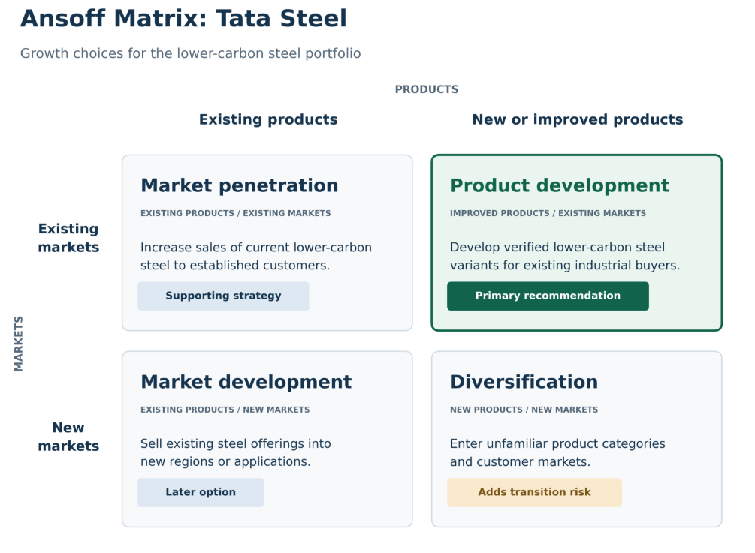
Figure 1: Ansoff Matrix Applied to Tata Steel’s Lower-Carbon Transition
Product development is suggested as the main strategy as it links the pressures identified through Task 1 with Tata Steel's industrial relations. The company should create a number of steel types with proven emission reductions in the production process, but with the same technical performance. This represents an enhanced customer proposition, rather than simply replacing equipment. Complementary market penetration would be an increase in sales of lower carbon products that are already manufactured. Unrelated diversification is less appealing, as the new competencies and the customers will pose an additional challenge in a challenging and capital-intensive industrial transition programme.
Table 1: Application of the Ansoff Matrix to Tata Steel’s Lower-Carbon Transition
Growth strategy | Products / markets | Application to Tata Steel | Assessment
Market penetration | Existing products / existing markets | Increase sales of existing lower-carbon steel to established customers. | Supporting strategy.
Market development | Existing products / new markets | Introduce existing steel offerings into new regions or applications. | Consider after validating demand and supply capacity.
Product development | New or improved products / existing markets | Develop verified lower-carbon steel variants for existing industrial buyers. | Primary recommended strategy.
Diversification | New products / new markets | Enter unfamiliar product categories and customer markets. | Adds uncertainty during the industrial transition.

2.2 Recommended Strategic Growth Approach
Tata Steel should start with existing customers who have automotive and construction, and have a clear agenda on emissions, and a credible purchasing program in place. But having sustainability goals does not mean the demand will be there. IEA (2025a) identifies firm offtake agreements as a drivers that will support investment decisions. Thus, before a serious effort is made to produce a product in a dedicated facility, it is important to determine that there is a willingness to pay from the customer.
The development of products should be based on the existing capabilities. Construction steel (Tata Steel, 2026b) is being produced as a foundation of Tata Steel's new electric arc furnace at Ludhiana, which uses scrap. There is room for further development to increase recycled content and independently verified carbon performance. Automotive grades must be qualified separately, with environmental benefits evaluated in addition to strength, formability, durability and manufacturability.
Information should be transparent and should be used to back the offer. With stable emission boundaries and auditable data, it is possible to make comparisons between material with lower emissions (IEA, 2024). Product declarations should provide information about production routes, electricity assumptions and emissions covered. Accounting allocations must not be the same as products' physical footprints. Technical sales teams need to share documented benefits to procurement teams, covering the credibility risk and reporting requirements of customers.
Implementation should build from the ground up starting with a pilot, customer acceptance and controlled scaling. Investment should be based on the availability of local energy, availability and quality of scrap and infrastructure, as transition conditions differ in each country in which Tata Steel operates (Tata Steel, 2026a). Procurement alliances should ensure procurement of appropriate scraps and cleaner electricity. Volumes, delivery terms, verification and pricing should be covered in contracts; and commitments should be made subject to proof of capability and capacity. Further expansion should be approved only with the joint review of engineering, marketing as well as finance with regard to customer evidence, production readiness and margins.
Financial sensitivity should be done around energy costs, prices for price premiums and lower demand. Measuring success will be by contracted lower carbon sales, contribution margins, customer retention and verified emissions performance. Coordinating commercial growth with Tata Steel's ambition to transition would be facilitated by monitoring absolute emissions as well as product intensity; evidence-based review should be used to inform future investment.

2.3 Competitive Advantage and Positioning
Porter (1985) suggests that there are three ways of achieving competitive advantage: cost leadership, differentiation and focus. Whereas, differentiation focus might be appropriate for the proposed lower carbon portfolio, Tata Steel should target buyers with a need for reliable technical performance and reliable carbon information. The offer should include proven environmental characteristics, application assistance and guaranteed delivery. This positioning is in response to a specific purchase need and offers more foundation for the customer's preference than simply sustainability promotion. It also does not make an assumption that the transition investments will automatically make Tata Steel the lowest cost producer of the industry.
The advantage should be substantiated by activities that are difficult for the competitors to do in combination. Relationships can be strengthened and responsiveness enhanced through joint product development, a traceable supply chain, and customised technical support. While site certification should build trust, it should not be seen as being the same as product certification (ResponsibleSteel, 2024). The desired benefit is then based on the customer experience and evidence being provided for the product, not on the furnace technology being used that is comparable to that which can be bought by a competitor. The customer should evaluate these differences and determine if he or she values them, and if competitors can provide the same level of assurance, product quality, service and delivery in an economic manner.
The need for cost discipline continues to be the key. Porter (1985) states that differentiation can lead to better returns only if the premium price is greater than the extra costs. Cost barriers to the early use of near zero emission materials are also noted by the IEA (2025b). Tata Steel should therefore be able to negotiate realistic premiums, have a better efficiency and safeguard margins. This would link growth to customer value and recognize that actions to improve the environment would not ensure profitability or long-term competitive advantage.

3. Task 3: Managerial and Professional Reflection

3.1 Reflection on Key Managerial Decisions
I chose Tata Steel because it has operations in various countries, and would be a good case to look at the effect of environmental pressures on marketing decisions. Its geographically diverse pathways to transition highlight that decarbonisation can't be done in the same way in all places (Tata Steel, 2026a). To the senior leadership, I would highlight that environmental performance is of a commercial nature for customer acceptance, supply reliability and product claims credibility.
The Environment actor was chosen as the highest priority as it underlies the reason for a reduction in carbon steel. Political/legal forces and technology have been chosen because they have an impact on the financial support for that transition, its credible communication and its technical feasibility. I was able to understand how they relate to the external pressures and how that relates to their decision making on products and markets, when looking at their interaction.
For my highest level decision in strategy, I recommended a strategy of product development alongside market penetration. The Ansoff Matrix breaks down a company's options between new products in existing markets vs. new products in new markets (Ansoff, 1957). Another strategy option of diversification didn't feel right because there would be even more uncertainty for the company to explore new, unfamiliar markets. In order to distinguish products from competition, I recommended Porter's strategy (Porter, 1985). This strategy is built on customers believing that performance and verifiable sustainability are what they're going to get. Leadership shouldn't believe in using investments in sustainability to show how commercially successful a company is going to be.
The recommendation that I believe would work best for the company is a combination of product development and market penetration. As laid out in Ansoff's Matrix (Ansoff, 1957), product development is a strategy that focuses on adding value to an existing product in an existing market, whereas market penetration focuses on increasing sales for a product within an existing market. I feel that these strategies complement one another as the organization looks to diversify its current portfolio by offering a low-carbon option for its product offering. With sustainability and performance becoming key differentiators for the products that the company offers, there will be more customer confidence, and with that comes more market share.

3.2 Limitations and Additional Information Required
The analysis is based on the published company reports, policy documents and industry research. These give relevant evidence but not evidence of profitability of individual products or customers. Any stated aims and promised emission reductions must be verified independently as they are included in corporate disclosures, which are based on management's expectations. A more robust assessment would make a comparison between the company claims and measured outcomes and external assurance findings.
Other limitations include demand uncertainty. The IEA lists the barriers to firm purchase commitments and cost barriers in emerging markets for materials with lower emissions (IEA, 2025b). I was thus able to determine the potential value to my customers without having to demonstrate what they are willing to pay for Tata Steel's products. Prior to making final recommendations, a consultant should conduct customer interviews, forecast customer buying, and glean test results and evidence of acceptable price premiums.
Further details should include investment needs at the plant, operating costs, the quality of the scraps generated, electricity needs and independently calculated product emissions. The consultant must also review competition and costs of not producing or not having as strong demand as other competitors. Moreover, data from other countries cannot be directly transferred: Jordan, et al. (2025), for instance, model hydrogen economics in the U.S. Additionally, data from other countries cannot be directly transferred: Jordan, et al. (2025) model hydrogen economics in the U.S., for instance. I would experiment with alternative electric, solar etc. costs, alternative technology results and demand scenarios before laying any big bets. Such checks would strengthen the defensibility of the recommendation and uncover assumptions which would need to be explored.

3.3 Professional Learning and Development
This assignment helped me to understand how to analyze and integrate evidence, customer needs and operational feasibility into the decision-making process. I gained an understanding about measurable environmental benefits and effective communication. Going forward, I will record assumptions made, work with technical and financial colleagues and further develop customer research and financial analysis to make informed recommendations.

4. References
Ansoff, H.I. (1957) ‘Strategies for diversification’, Harvard Business Review, 35(5), pp. 113–124. Available at: https://www.casrilanka.com/casl/images/stories/2017/2017_pdfs/sab_portal/course_material/strategies_for_diversification.pdf
Competition and Markets Authority (CMA) (2021) Making environmental claims on goods and services. 20 September. Available at: https://www.gov.uk/government/publications/green-claims-code-making-environmental-claims/environmental-claims-on-goods-and-services
Department for Business and Trade (2025) 5,000 jobs secured as construction starts on Port Talbot green steel project. 14 July. Available at: https://www.gov.uk/government/news/5000-jobs-secured-as-construction-starts-on-port-talbot-green-steel-project
European Commission (2026) CBAM successfully entered into force on 1 January 2026. 14 January. Available at: https://taxation-customs.ec.europa.eu/news/cbam-successfully-entered-force-1-january-2026-2026-01-14_en
International Energy Agency (IEA) (2024) Definitions for near-zero and low-emissions steel and cement, and underlying emissions measurement methodologies. Available at: https://www.iea.org/reports/definitions-for-near-zero-and-low-emissions-steel-and-cement-and-underlying-emissions-measurement-methodologies
International Energy Agency (IEA) (2025a) Breakthrough Agenda Report 2025. ‘Steel’ section. Available at: https://www.iea.org/reports/breakthrough-agenda-report-2025/steel
International Energy Agency (IEA) (2025b) Demand and supply measures for the steel and cement transition: the case for international co-ordination. Available at: https://www.iea.org/reports/demand-and-supply-measures-for-the-steel-and-cement-transition
Jordan, K.H., Jaramillo, P., Karplus, V.J., Adams, P.J. and Muller, N.Z. (2025) ‘The role of hydrogen in decarbonizing U.S. iron and steel production’, Environmental Science & Technology, 59(10), pp. 4915–4925. Available at: https://doi.org/10.1021/acs.est.4c05756.
Klimek, P., Hess, M., Gerschberger, M. and Thurner, S. (2024) Circular transformation of the European steel industry renders scrap metal a strategic resource [Preprint]. arXiv. Available at: https://doi.org/10.48550/arXiv.2406.12098.
Porter, M.E. (1985) Competitive advantage: creating and sustaining superior performance. Free Press.
ResponsibleSteel (2024) ResponsibleSteel international production standard. Version 2.1.1. Available at: https://www.responsiblesteel.org/resources/responsiblesteel-international-production-standard
Tata Steel (2025) Tata Group Chairman N. Chandrasekaran marks groundbreaking of new Electric Arc Furnace at Port Talbot. 14 July. Available at: https://www.tatasteel.com/newsroom/press-releases/india/2025/tata-group-chairman-n-chandrasekaran-marks-groundbreaking-of-new-electric-arc-furnace-at-port-talbot/
Tata Steel (2026a) ‘Climate change report’, Integrated report & annual accounts 2025–26. Available at: https://www.tatasteel.com/investors/integrated-report-2025-26/climate-change-report.html
Tata Steel (2026b) Tata Steel inaugurates its first scrap-based Electric Arc Furnace in India. 20 March. Available at: https://www.tatasteel.com/newsroom/press-releases/india/2026/tata-steel-inaugurates-its-first-scrap-based-electric-arc-furnace-in-india/
Watari, T. and McLellan, B. (2024) ‘Decarbonizing the global steel industry in a resource-constrained future—a systems perspective’, Philosophical Transactions of the Royal Society A: Mathematical, Physical and Engineering Sciences, 382(2284), article 20230233. Available at: https://doi.org/10.1098/rsta.2023.0233.

