

Student: Antoaneta Vazova

ID number: 2123847

Module: Introducing the Modern Workplace

Module code: LCBB4003

Assignment 2

Lecturer: Aparna Venkatesan

TABLE OF CONTENTS

- INTRODUCTION…………………………………………………………………………………page 3

- KOLB’S THEORY OF LEARNING STYLES……………………………………………….page 3

- MAIN BODY……………………………………………………………………………………….page 3

- CONCLUSION……………………………………………………………………………………..page 4

- REFERENCE…………………………………………………………………………………………page 5

- INTRODUCTION

This report aims to explain the entire creation stage and process of making our presentation. And above all, my participation in the preparation and presentation. Adhering to Kolb’s model of learning, I will describe my experience, what I learned and what I felt during the whole process.
The learning styles model was a discovery by the American psychologist David Kolb, who published his theory on the subject in 1984. Kolb believed that learning involves the acquisition of abstract concepts that can be flexibly applied in a variety of practical situations.
Adhering to Kolb’s theory I will describe my feelings and sensation during the whole process. What I learned and understood about my capabilities.

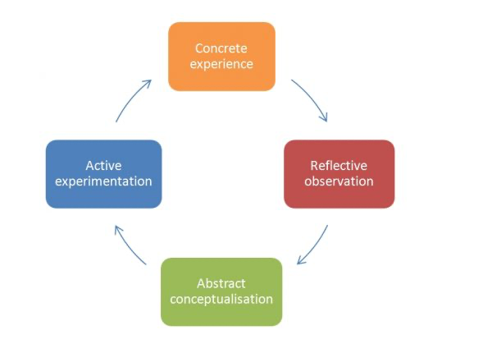

- MAIN BODY

- Concrete experience
I define myself with a diverse learning style person. I’m one of those people who wish to observe and get involved at a later stage. I feel more comfortable working in a group.
I don’t consider myself a genius, so I let the leaders in the group decide first, and then I give opinion or idea. Wanting to learn something new, I am aware that I must systematically practice and improve my skills. That’s how our presentation started.
- Reflective observation
Giving a presentation is something new for me, I kept thinking about it because I was afraid of failing. However, I found it interesting that I would challenge myself, even if I didn’t succeed, I still tried. I know there are many ways to motivate myself- quotes, affirmations, mirror practice, training, but nothing beats action itself. It helps me look at the true power that lies within me and understand what I am capable of. When I overcome a difficult challenge, I prove to myself that I am better than I thought. It gives me a sense of accomplishment, which boost my confidence.

- Abstract conceptualisation
Our group had very good communication from the beginning, this motivated me and made me feel calm and confident in what we were doing. Starting to work my slides I had a bit of hard time because I wasn’t sure how to start. I needed to talk to someone, organize the thoughts in my head and then on the screen. Therefore, I had to follow a well- planned plan. I started researching for the company we had decided to present. There was a lot of information, the most important had to be taken to be clear and understandable for the audience. This was one of the challenges for me, I had to determinate what was important and interesting. Analysing each point very carefully, I would extract the consistency, try to understand why it was so, and then decided whether to present it in the presentation. During this research, I paid attention to small details, defined key points, created short and clear sentence. This requires a lot of time and patience, which I don’t have, but eventually I learned to be patient and calm.
- Active experimentation
We often have plan A, B, C…and then life decides to check how we’re doing with our plan B. It is possible that you have prepared your topic perfectly, made an extremely harmonious and visually engaging presentation, and again be surprised by unexpected situations. One of the most valuable qualities a person can develop is the ability to adapt to change. If you are confident and calm enough, you will be able to move away from the tense situation and look at things from a new angle. This way you will find a solution to the problem more easily and you will present yourself excellently.
According to one statistic, the fear of speaking in front of people is before the fear of death.
I knew from the beginning that presenting would be a challenge for me. During the entire process of creating the presentation, I was convinced that I could do it, that I was able to challenge myself and overcome my fears. I was very well prepared and confident and had the support of my colleagues when we did the MOCK exam.
When the day of the presentation came and the moment I had to go out and present my part I panicked and forgot what I wanted to say, my hands started sweating one of the worst effects of anxiety is that it impairs the ability to concentrate. When we are overwhelmed with anxiety, the mind wanders, and we lose the ability to make decisions.

- CONCLUSION

Self assessment is one of the main skills one should posses and apply. Self assessment means exactly what the word itself defines – your evaluation or opinion about yourself, supported by solid arguments and evidence. You should know what you can do and what you are capable of, and of course these claims of yours should be mirrored in practice, not just in theory. Therefore, I can safely say that I have learned to challenge myself and feel full of confidence and self esteem.
Every situation in life is a lesson and it changes us as individuals. The more situations we have in our lives, the more choices we will have to make, and this is how we gain experience. We begin to have a much clearer view of the world and ourselves – who you are, what you want to happen to you and what you want to be. When we don’t run away from challenges, but instead bravely face them, we learn how to take care of ourselves and take responsibility for our lives.

REFERENCE:

Kolb, D.A. (1984). Experiential learning: experience as the source of learning and development. Englewood Cliffs, NJ: Prentice Hall.

