Lecturer: Dr Azura Hurd

Module: Changemakers: Creativity and Value Creation

Module code: BMHP5014_BIRM

PROJECT OUTCOMES WRITTEN ASSIGNMENT

NAME: Madiha Yousuf
STUDENT NO: 1911360

Table of Contents

Introduction 2
Who are Changemakers? 2
Unit 1: Ideas and Values 2
Innovation and Society 2
Unit 2: Creative Solutions 3
Creative Solution Tool Cards 3
My Creative Solution Tool Card 4
My Tool Card 4
Unit 3: Mobilsing Support 5
Stakeholders 5
Unit 4: Evaluation 6
Career aspiration 7
Unit 1 and 2 7
Unit 3 and 4 7
Conclusion 8
References 8

Introduction
In this report, I will self-reflect my knowledge, and I will identify the aspects of all four units in the module. I will discuss the key learning points in the topics such as ideas and values, creative solutions, and mobilising support and evaluation in e-learning. Furthermore, I will evaluate my knowledge and the critical understanding of innovation, creativity and mindset. I will also discuss the values and influence on creativity, advantages, disadvantages, and effects on the environment.

Who are Changemakers?
A Changemaker is referred to a person who takes creative action to resolve a common problem. Most of the time, they learned and shaped their thoughts from their own experience. Represent their strengths from the hardships, and their difficulties lead them to think big. It is a difficult task for them to challenge the prominence and encourage others to do the same. Changemakers resolve the errors and transfer the world in better shape, and their skills and confidence mentors the next generation to think big and challenge their knowledge to bring new ideas into the world (Gray, Brown, and Macanufo, 2010).

Unit 1: Ideas and Values
This unit taught me about how innovation changes the world and how I can make a difference as an individual. Influencers can develop a significant role in people’s lives, and they give inspirations and influence new ideas in people. This unit helps me understand the resources required to be a changemaker and generate new ideas.

Innovation and Society
In this session, I learnt how daily life requirements can enhance my capability to innovate and how human life has changed after innovations. It benefits the countries economically by sharing digital information for vital projects innovations (Van den Bosch and Taanman, 2006). If I looked a few decades back, it was different when there were no smartphones or digital technology. The innovations have benefited humans in almost every field, like technology impacted us, such as internet connectivity, smartwatch, smartphone, intelligent electricity lights, intelligent washing machines. Innovation makes our life easier, but every invention has its pros and cons; it saves our time but makes us lazy and affects global warming with the excess usage of electricity. In the TED Talk video, Steven Pinker identified that the progression is problem-solving but not having all the solutions for everything. As with progression, the more we invent new things, the more we damage our planet. We face a threat as climate change, air pollution, causing numerous deaths because of diseases, facing upraising crimes rates because of extreme poverty, which are the side effects of the progression in civilisation (Pinker, 2018).
Hans Rosling analysed in his global health report that from 1810, 200 years ago, 200 countries were suffering from poverty and diseases. Their lifespan was 25-40 years old because of poverty and sickness compared to wealthy lifespans who were 25-75 years old. After the industrial revolution, this historical gap finished, and the world becomes an entirely new converging world. Comparing 200 years ago to now, it had shown remarkable progress, and in future, with more innovations and technology, everyone can have a healthy and wealthy life in society (Rosling, 2010). In my opinion, we progressed with technology’s help, increased everyone’s lifespan, medical facilities and innovations in the medical field, and helped the poor with jobs and charity funds. As a society, we are better and resilient now.

Unit 2: Creative Solutions
In this unit, I learned how to develop ideas, create solutions, or invent something with my creativity. I find out how I can get inspirations from others, how their stories impacted me and encouraged me to mobilise and value my ideas and creativity. I can generate ideas with creative solution tools to change my or others’ lives and become influencers in the future.

Creative Solution Tool Cards
According to organisational psychologist Adam Grant, it is not necessary people who look perfect and are punctual can always be successful. In his video, he said people who do have a habit of doing a task at the last minute have more creativity and a better success chance than those (procrastinators) who delay or finish their task late. He refers to them as ‘Originals’. They speak their ideas and do not worry about failure as 85% of people do not share their views because of despair and embarrassment. He said the original feels fear and doubts about their ideas and themselves, which is a good thing because they do not get satisfied until they bring out the best of their ideas (Grant, 2016). I agree with Adam statements, when I become panic about doing my assignments and tasks, I feel more motivated, and I give my best.
As Adam described the original with last-minute ideas in creativity, Janet Echelman story comes. She was rejected by seven art schools and never been to any sculpture, engineering or architecture college. She started her journey from India by an incident of her painting exhibition where she could not show her paintings. One morning, only walking on the beach, seeing the fishermen making a fishnet, she got an idea of making a voluptuous fishnet scale as an art piece. After her first art piece, she was offered to show her art pieces in different countries, and she said with collaboration with others, she improved her idea (Echelman, 2011). Janet’s story taught me never to give up on my dreams as she was rejected from seven art schools but still made the best unique art piece only by observing and speaking her idea.

My Creative Solution Tool Card
After watching their stories about how they got the best creative ideas, I made my tool card to generate new ideas. This section helped me create my Tool Card, which can help me develop new ideas and get more creative in the future.

My Tool Card
- Sit alone in peace with tea
- Observe my surroundings
- Use my imagination
- Collaborate with others (feedback)
- Experimental
- watch inspiring videos for not giving up
- seek out online materials
- believe in my self
- listen to some music
- Go for a walk

Unit 3: Mobilsing Support
In this unit, I understood collaborating and getting support from my family and friends and other local connections with the community to generate my idea. It taught me how to find valuable sources for my innovations. I studied that it is vital to have a network to make any project successful in a financial issue. I learned how my social circle could help me find stakeholders and open numerous opportunities for my project. Moreover, it taught me valuable points about giving a presentation for my pitch and using social media to promote and market my idea professionally.

Stakeholders
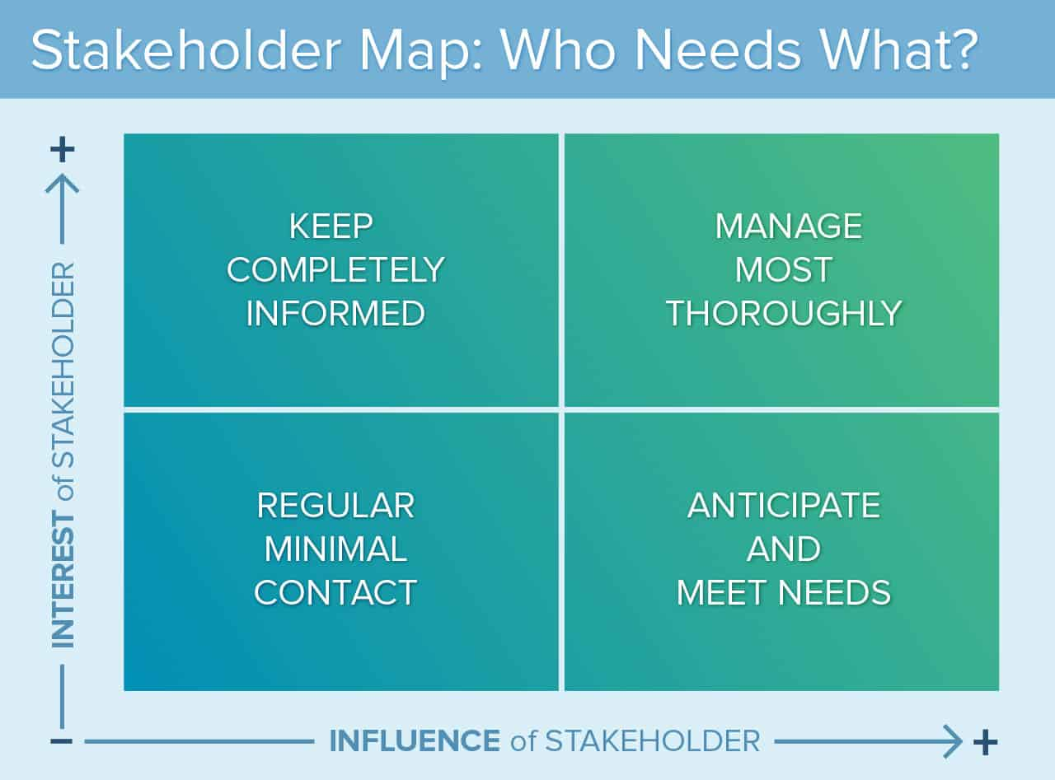
According to Freeman, the people who can help build a successful project with any help are ‘Stakeholders’. They have the same interest in an idea, which can benefit both sides (Freeman, 2015). The main stakeholders can be investors, employees, customers and suppliers. They can be my relatives, friends or other professional contacts. However, if they could not help me, they can still help me by providing indirect contacts as potential resources for my project from their circle. To find my stakeholder, I can create a map that can help me identify the stakeholders and stay focused on the most important and less central stakeholders. The map can help me prioritise them by those who have power or money but less interest. I can win their interest and confidence by finding what will motivate them to put their interest in my project (Freeman, 2010, p.54). The more I will engage and include my stakeholders in my projects and involve them in future next steps, the more they will show interest in the project. They will play a significant role in defining the future of my project.
(Smartsheet, 2016)

Unit 4: Evaluation
In this unit, I learn about success is not about getting famous; it is about making a difference, but it is also about changing the world for others to make it a better place. It is about accomplishing the progression I did. Furthermore, It showed me how to measure my failure and success from a personal and social perspective. I learned how I could evaluate my project’s aspects to make it successful and how my success will impact others in a good or bad way. It defines failure as a part of learning and how I can channel my disappointments into my strength. Moving forward, myself from bad experience can open another learning opportunity and generate improved and fresh ideas for my project. It taught me new skills and how important it is to succeed in my projects, and how significant my well-being impact is on my success. It allowed me to see my inner potentials from the self-identity quiz, such as ocean personality tests and other quizzes. I analysed my strengths and weaknesses with these quizzes. It also gave me ideas about identifying my stakeholders and getting more successful for my project by evaluating my team’s potential by these quizzes and showing me their faults and powers.
Your project and success
In this session, I learned about putting success criteria for my project how my success criteria will help me reach successful results. A success criterion is a list of elements I expect to put in my project, and it is the best way to be aware of what I want and need from myself to achieve my goals. It can encourage me to extend myself during my project, good feedback for my project, the measurements of cost, finding the resources to improve the quality of my work,100% satisfaction with my final results, and how to promote my idea and motivating stakeholders (Atkinson, 1999). I would be successful if my innovation can help our planet when people use solar lights worldwide. It will reduce global warming by cutting the harmful gasses caused by electricity.

Career aspiration
This module has inspired me and encouraged me to have creativity, and taught me how to make a difference in the world by taking simple action. As a visual learner, I have learned a lot from the units’ videos; they gave me so much knowledge, and I found them valuable and exciting. As a health and social care student, I chose to become an occupational therapist in the future. These units will help me a lot in the future as I learned how to reflect on myself from the self-assessment quizzes like the personality test. They helped me analyse the weakness I had and the strengths I have. These learning tools helped me develop various skills about managing teams, recovering after failure, giving presentations and pitch, generating new ideas, and evaluating the projects I have. These skills, which I learnt from these units, will be aspects of my successful career.

Unit 1 and 2
These units will guide me if I have any difficulties on my job, team, or problems. I know how to measure the issues and get their solutions. Now I know how to make a difference if something is not correct or if something needs to change, generate new ideas and what resources can help me develop that idea. Moreover, it taught me how to show creativity in the future for my projects and innovate something with nothing. I learned how to make my tool cards to develop new creative ideas to benefit my users’ service.

Unit 3 and 4
In my chosen career, its central aspect is working with a team; as for occupational therapist, I will need my team to help the service users; these units taught me how to engage with my team and learn about their weaknesses and strengths. I can find the stakeholders to develop new ideas for investing and helping with my projects. Moreover, I did not know about giving presentations with confidence; it taught me how to deliver better and strong presentations.
It taught me when I would have disappointments, and things will always not go in my favour, I should not give up; I have to believe in myself. I always fear being a failure, but I learned failure is just a process and part of success. I learned my weakness, such as impatience, critical about myself, doubtful about myself, inability to say no to things, feeling shy to ask for help, and not believing in myself. My strengths can benefit me in my careers, such as listening to others, comforting others, focused, flexible, and creative, and I will focus on my weakness, and this analysation of my potential will help me improve in future.

Conclusion
It was a self-reflected and deep analysation report about the units we learn; it discussed the skills we developed. It defines the value of creativity and motivation, and it had shown the tools about self-assessment and tools for conducting new creative ideas. I discussed my success criteria and how to overcome a failure and channel my disappointments into my strength. I discussed how these units and the materials will help me with my chosen career, how these units positively impacted me and gave me confidence myself.

References

Atkinson, R. (1999) ‘Project management: cost, time and quality, two best guesses and a phenomenon, it’s time to accept other success criteria’, International journal of project management, 17(6), pp.337-342. URL: https://doi.org/10.1016/S0263-7863(98)00069-6 (Accessed: 07 April 2021).
Echelman, J. (2011) Janet Echelman: Taking imagination seriously [video]. Available at: https://www.youtube.com/watch?v=9YekkGz1E2k (Accessed: 05 April 2021).
Freeman, R.E. (2010) Strategic management: A stakeholder approach. Cambridge: Cambridge University Press.
Freeman, R.E. (2015) ‘Stakeholder theory’, Wiley encyclopedia of management, pp.1-6. URL: https://doi.org/10.1002/9781118785317.weom020179 (Accessed: 05 April 2021).
Grant, A. (2016) The surprising habits of original thinkers | Adam Grant [video]. Available at: https://www.youtube.com/watch?v=fxbCHn6gE3U (Accessed: 05 April 2021).
Gray, D. Brown, S. and Macanufo, J. (2010) Game storming: A playbook for innovators, rulebreakers, and changemakers. Sebastopol: O’Reilly Media Inc.
Pinker, S. (2018) Is the world getting better or worse? A look at the numbers | Steven Pinker [video]. Available at: https://www.youtube.com/watch?v=yCm9Ng0bbEQ&t=779s (Accessed: 03 April 2021).
Rosling, H. (2010) Hans Rosling’s 200 Countries, 200 Years, 4 Minutes - The Joy of Stats - BBC Four [video]. Available at: https://www.youtube.com/watch?v=jbkSRLYSojo&t=76s (Accessed: 03 April 2021).
Smartsheet (2016) What Is Stakeholder Analysis and Mapping and How Do You Do It Effectively?. Available at: https://www.smartsheet.com/what-stakeholder-analysis-and-mapping-and-how-do-you-do-it-effectively (Accessed: 07 April 2021).
Van den Bosch, S. and Taanman, M. (2006) ‘How Innovation Impacts Society, Patterns and mechanisms through which innovation projects contribute to transitions’, Innovation Pressure Conference, 15th-17th March, Tampere, Finland. URL: https://www.researchgate.net/profile/Suzanne-Van-Den-Bosch/publication/237427252_HOW_INNOVATION_IMPACTS_SOCIETY_Patterns_and_mechanisms_through_which_innovation_projects_contribute_to_transitions/links/574c06bd08ae9f0023e2230c/HOW-INNOVATION-IMPACTS-SOCIETY-Patterns-and-mechanisms-through-which-innovation-projects-contribute-to-transitions.pdf (Accessed: 03 April 2021).

