
Williams, Matthew
BEng, Yr. 1 - 2023
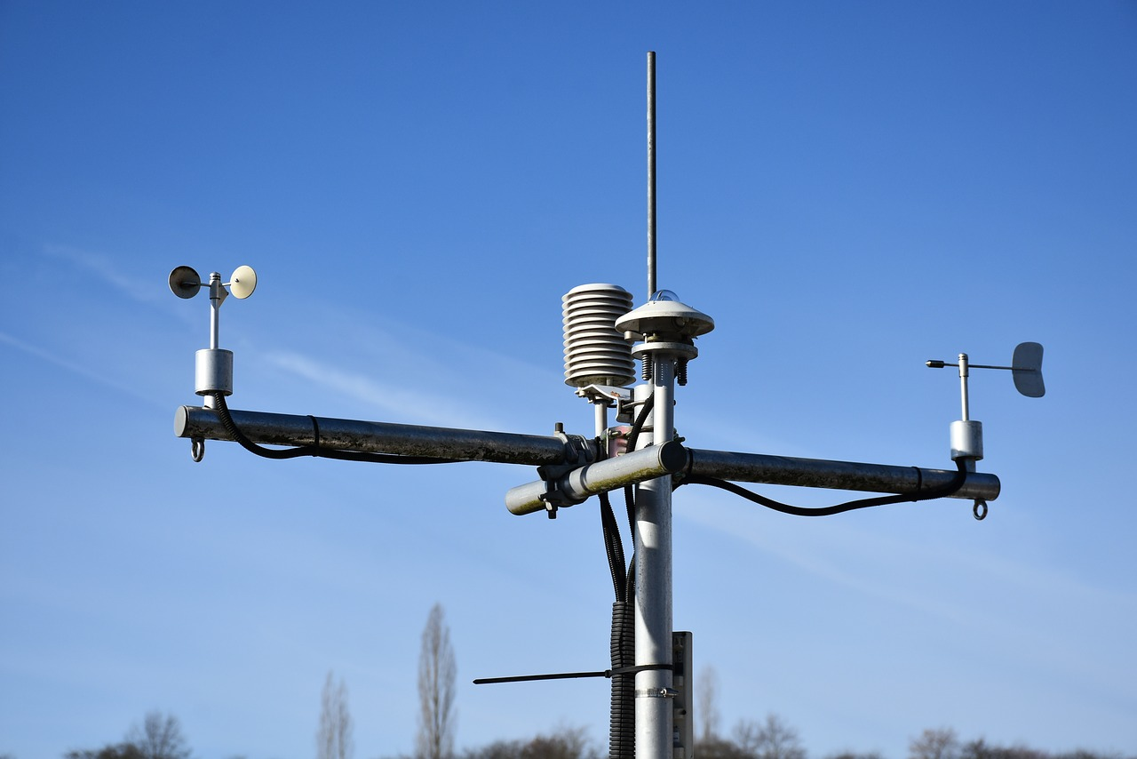
electronic systems design
BEng Electrical & Electronic Engineering
14 Day Weather and Air Quality Measurement Logging System

Table of Contents
Abstract 3
Design Specification 3
Output Requirements 3
Existing Systems 4
The Design 5
Design Parameters 6
Equipment Requirements 6
Sensors 7
Temperature 7
Humidity 8
Wind Speed 9
Wind Direction 10
Airborne Particle Count 11
Sunlight Brightness 12
UV Level 13
GPS Position 14
VOC Levels 15
Microcontroller Selection 17
Storage 21
USB & SD Card Modules 28
Batteries 29
Enclosure 31
The Hardware Layout 32
Connectors (Panel Mounted to Casing) 36
Connectors (PCB Mounted) 37
ASSUMPTION 37
Circuit and PCB Design 38
Power Supply Schematic 40
12v Supply Schematic 41
5v Supply Schematic 41
3.3v Supply Schematic 42
LED Flashing Indicator Schematic 43
Temperature & Humidity Sensor Schematic 45
Wind Speed & Wind Direction Sensor Schematic 46
GPS Sensor Schematic 47
Air Quality & VOC Sensor Schematic 48
UV Sensor Schematic 49
Sunlight Sensor Schematic 50
SD Card Circuit Schematic 51
USB Circuit Schematic 52
PIC Microcontroller Schematic 53
PIC Decoupler & PIC MCLR Schematic 53
PCB Schematic 56
PCB Schematic (with Copper Pour) 57
PCB Schematic 3D View (Top) 58
PCB Schematic 3D View (Bottom) 59
The Software 62
Costs and Figures 66
Summary 69
Conclusions 69
Recommendations for Improvements 69
References 70
Appendix 77
Appendix 1 – yEd Software File 77
Appendix 2 – Links to all Components 77

Abstract
The requirement of this assignment is to design a microcontroller based Weather and Air Quality Logger. The Data logger is designed to be fully portable and adaptable for any site, and is intended for the amateur weather forecasters market.

Design Specification
Our Weather and Air Quality Logger needs to be powered by an independent power supply, and designed to withstand the varied environmental forces that this type of system needs to endure, e.g. Heat & Cold, Water & Dust Ingress etc. As well as this, it needs to be capable of recording data for a 14 day period.
Our Weather and Air Quality Logger needs to be capable of obtaining the following data:
- Temperature (°C)
- Humidity (%)
- Wind Speed (mph)
- Wind Direction (°)
- Airborne Particle Count (f³/min)
- Sunlight Brightness (W/m²)
- UV Levels (0 to 11)
- GPS Position (NMEA) - National Marine Electronics Association
- Volatile Organic Compound (VOC) Level (μg/m³)

Output Requirements
To achieve the design specification, the Weather and Air Quality Logger must be powered by an independent power supply, be portable and adaptable. This is to ensure it will continue monitoring even when the site is remote and unpowered.
The microcontroller will need to be capable of not only connecting to a variety of sensors and measuring tools, but will need the capacity to store the data during the 14 day cycle on non-volatile memory and also have the capability of connecting to an external computer via USB to process the information gathered. An LED will need to be programmed to Blink every 10 seconds for one second to indicate operation.
How the microcontroller and sensors are housed and the connectors used will be a major consideration. IP Rating (also known as Ingress Protection Rating) will need to be adequate.

Existing Systems
Before we start designing our Weather and Air Quality Logger, we need to look at what is already on the market, and how we can improve on the existing systems available. After extensive research, the following systems have been identified:
- Davies Wireless VP2 Station 6152 from https://shop.weatherstations.co.uk/
- SEN-15901 from https://cpc.farnell.com/
- Sencorp Weather Station from https://www.marketplace.farm/
- BRESSER MeteoChamp 7-in-1 HD Wi-Fi Weather Station from https://www.bresseruk.com/en/home/
- Davies Vantage Vue 6250 from https://shop.weatherstations.co.uk/

Below is a detailed tabulated comparison of three of the existing systems that are on the market:

Existing Data Acquisition Systems
System: | SEN-15901 | Davies Vantage Vue 6250 | Sencorp Weather Station
Company: | Spark Fun | Davies Instruments | Sencorp
Photo: | 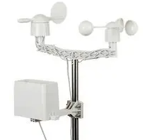 | 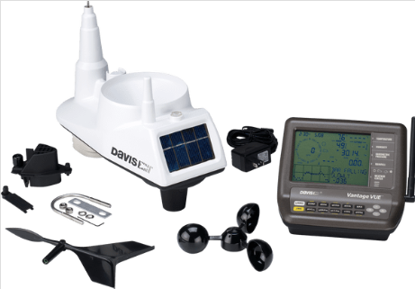 | 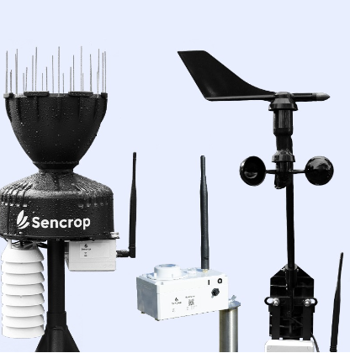
Input Voltage Range: | 5v | 3v | 3.6 v
Power: | Battery | Battery & Solar | 19Ah Battery
Data Logging: | N/A | 1 Minute | Every 15 minutes
Memory: | N/A | Real Time | Real Time to Application
Measures: | Wind Speed,  Wind Direction,  Rainfall, | Wind Speed,  Wind Direction, Temperature, Humidity, Pressure, Rainfall, Dew Point | Rainfall, Temperature, Humidity, Dew Point, Wind Speed, Wind Direction, Gusts, Solar Irradiance
GPS: | No | No | Yes
Communication: | Wired | Wi-Fi | Sigfox LPWAN
Other Connections: | RJ11 | N/A | N/A
USB: | No | No | No
Rainfall
Measurement Range: | - | - | 0 to 1039 mm/h
Resolution: | 0.2794 mm | 0.2 mm | 0.254 mm/h
Wind Speed
Measurement Range: | - | 0 to 320 km/h  (0 to 200 mph) | 0 to 160 km/h
Resolution: | 2.4 km/h | - | 0.5 km/h
Wind Direction
Measurement Range: | Compass Baring | Compass Baring | 0° to 359°
Resolution: | 16 Point | 8 Point | 1°
Temperature
Temperature Range: | N/A | -40 to 65 °C | -40 to 125 °C
Temperature Accuracy: | N/A | - | ± 0.2°C
Humidity
Humidity Range: | N/A | 1% to 100% | 0% to 100%
Humidity Accuracy: | N/A | - | ± 2%
Differences
Advantages: | Sensors can be used by other logging systems  Much cheaper than the competition | Solar panel included in the design which extends battery life  Logging rate of every 1 second gives accurate data | The Sencorp Weather Station measures many more parameters compared to its competitors on the list  GPS
Disadvantages: | Limited amount of parameters measured | Needs to be within Wi-Fi range | It’s one the most expensive on the market
Price: | £69.77 | £515.00 | £1,042.80
Referencing: | [1] | [2] | [3]
Table 1: Existing Systems Comparison

The SEN-15901 is an example of a very basic weather station. It measures Wind Speed, Direction and Rainfall only. This would require a microprocessor or logging device in order to record the readings. Compared to the SEN-15901, the Davies Vantage Vue 6250 is a big upgrade, as it measures Wind Speed, Wind Direction and Rainfall like the above, but also measures Temperature, Humidity, Pressure and Dew Point onto a logging device. For someone who is looking for instant access to sensor readings, the Sencorp Weather Station is the ideal solution. It measures Wind Speed, Wind Direction, Rainfall, Temperature, Humidity, Dew Point like the Davies Vantage, and also logs Gusts & Solar Irradiance. All this comes at double the cost however. This can be justified due to the facility to read real time results on a mobile phone app.

The Design
Below is the information required to build our Weather and Air Quality Logger. The starting point is to work out the parameters we are working with. From the information we already know, i.e. what parameters we need to be able to measure, we can work through in a methodical way to build the required information required to choose our Microcontroller. Starting with the number of Analogue/Digital Inputs required to connect our sensors and working through to the memory required to store our data.

Design Parameters

Parameters
Temperature
Humidity
Wind Speed
Wind Direction
Air Borne Particle Count
Sunlight Brightness
UV Levels
GPS Position
VOC Level
Table 2: Parameters to Measure
Table 2 shows the parameters to be measured by our Weather Station as set out in the brief.

Equipment Requirements
The equipment that will be required to create our Weather Station will be:
- 8bit PIC Microcontroller
- Sensors:
  - Temperature Sensor
  - Humidity Sensor
  - Wind Speed Sensor
  - Wind Direction Sensor
  - Airborne Particle Count Sensor
  - Sunlight Brightness Sensor
  - UV Levels Sensor
  - GPS Sensor
  - VOC Sensor
- Enclosure
- PCB
- USB Module
- SD Card Module
- LED Indicator Light
- Battery
- Panel Connectors
- PCB Connectors
- SD Card

Sensors

Temperature
Temperature Sensors
Model: | BME280 Breakout Board | HPP809A031 Temperature & Humidity Sensor | HX93BC
Company: | SB Components | TE Connectivity | OMEGA
Photo: | 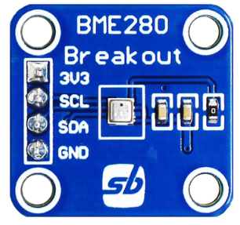 | 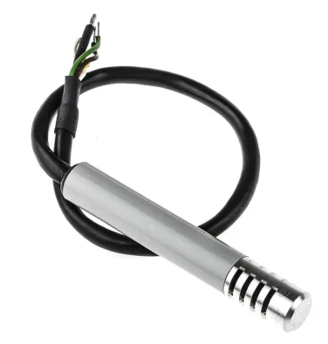 | 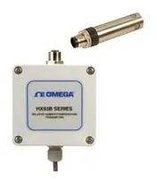
Interface: | I²C / SPI | Analogue | Analogue
Temperature Measurement: | -40 to 85 °C | -40 to 85 °C | -30 to 75°C
Operating Voltage: | 3.3 v | 5 v | 9 v to 30 v
Current: | 1.8 μA | 1.2 mA | 4 - 20 mA
Dimensions: | 22 mm x 23 mm | 11.6 mm x 76.3 mm | 3.15 inch x 3.24 inch x 2.19 inch
Weight: | 2g | - | 352 g
Price: | £7.99 | £99.23 | £491.52
Pros: | Cheap | Low Current Draw,  Can record Humidity | Highly Accurate
Cons: | Difficult to adapt to a “Mobile” Unit. Needs separate enclosure to rec. air temperature and keep dry etc. and difficult to integrate. | Will require bracket to mount. | Expensive
Chosen Sensor:
Website: | https://shop.sb-components.co.uk/ | https://uk.rs-online.com/web/p/temperature-humidity-sensor-ics/8937373?gb=s | https://uk.farnell.com/
Referencing: | [4] | [5] | [6]
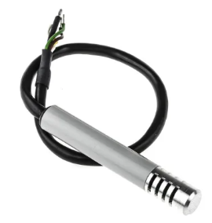
Table 3: Temperature Sensors Comparison

Figure 1: Chosen Temperature Sensor
Datasheet - https://docs.rs-online.com/fcd5/0900766b8142cdce.pdf

Humidity
Humidity Sensors
Model: | HPP809A031 Temperature & Humidity Sensor | TM1SHC4  Sensor | DHT20 Sensor
Company: | TE Connectivity | Schneider | Grove
Photo: |  | 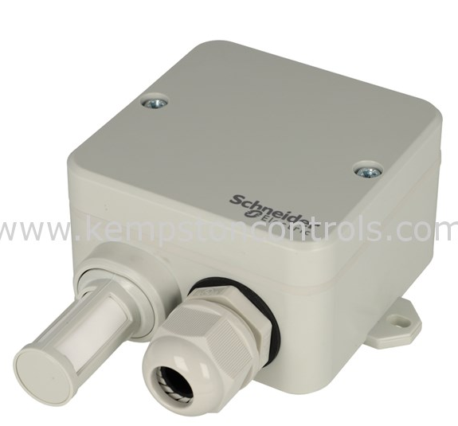 | 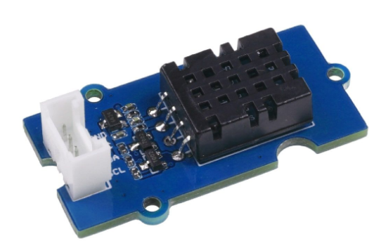
Interface: | Analogue | Analogue | I²C
Humidity Measurement: | -40 to 85 °C | 0% to 100% | 0% to 100%
Operating Voltage: | 5 v | 28 v | 2.3 v to 5.5 v
Current: | 1.2 mA | 4 - 20 mA | 980 μA
Dimensions: | 11.6 mm x 76.3 mm | 20 mm x 40 mm | 20 mm x 40 mm
Weight: | - | 24 g | 10 g
Price: | £99.23 | £99.60 | £5:16
Pros: | Low Current Draw,  Can also record Temperature |  | Cheap
Cons: | Will require bracket to mount. | High Voltage Requirements | Difficult to adapt to a “Mobile” Unit. Would need separate enclosure to access air temperature and keep dry etc. and difficult to integrate.
Chosen Sensor:
Website: | https://uk.rs-online.com/web/p/temperature-humidity-sensor-ics/8937373?gb=s | https://www.kempstoncontrols.com/ | https://www.seeedstudio.com/
Referencing: | [5] | [7] | [8]
Table 4: Humidity Sensors Comparison

Figure 2: Chosen Humidity Sensor
Datasheet - https://docs.rs-online.com/fcd5/0900766b8142cdce.pdf

Wind Speed
Wind Speed Sensors
System: | A100L2 | WindMaster 3D | Gill
Company: | Vector Instruments | Omni Instruments | WindSonic 75 Anemometer
Photo: | 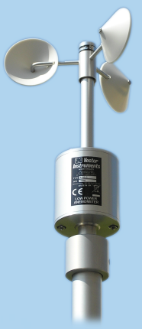 | 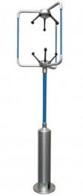 | 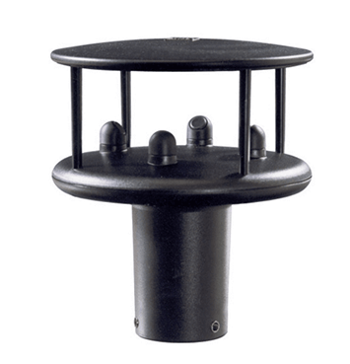
Wind Speed Range: | 0.2 to 75 m/s | 0 to 50 m/s | 0 to 146 knots  (146 Knots = 168 MPH)
Resolution: | 0.15 m/s | 0.01 m/s | 1
Operating Temperature Range: | -30 to 70 °C | -40 to 70 °C | -35 to 70 °C
Interface: | Analogue | RS232, 422, 485, Binary | RS232
Operating Voltage: | 6.5 v to 28 v | 9 v to 30 v | 12v or 30v
Current: | 2 mA | 55 mA | 44mA
Dimensions: | 195 mm x 152 mm | 750 mm x 240 mm | 142 mm x160 mm
Weight: | 500 g | 1 kg | 500 g
Price: | £537.70 | £2,413.00 | £1,443.00
Pros: | - | Also Measures Direction | Also Measures Wind Direction
Cons: | Limited Speed Measuring | Expensive | -
Chosen Sensor:
Website: | https://www.windspeed.co.uk/ws/index.php?Itemid=1 | https://www.omniinstruments.co.uk/ | https://r-p-r.co.uk/product/gill-windsonic-75-anemometer/
Referencing: | [9] | [10] | [11]
Table 5: Wind Speed Sensors Comparison

Figure 3: Chosen Wind Speed Sensor
Datasheet - https://r-p-r.co.uk/app/uploads/2019/01/WindSonic75-1405-0035-Iss-5.pdf

Wind Direction

Wind Direction Sensors
System: | Gill | S200 | W200P
Company: | WindSonic 75 Anemometer | SenseCAP | Vector Instruments
Photo: |  | 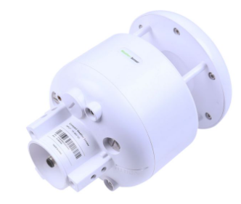 | 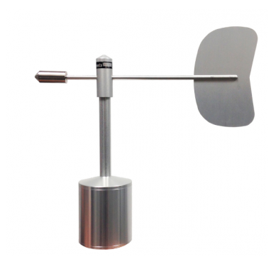
Measurement Range: | 0° to 360° | 0° to 360° | 1.15° to 358.85°
Resolution: | 1° | 0.1° | 0.2°
Operating Temperature Range: | -35 to 70 °C | -40 to 85 °C | -50 to 70 °C
Interface: | RS232 | RS485 / SDI | Analogue
Operating Voltage: | 12v or 30v | 24v | 1 v to 5 v
Current: | 44mA | - | 20 mA
Dimensions: | 142 mm x160 mm | - | 225 mm x 219 mm
Weight: | 500 g | 2 kg | 500 g
Price: | £1,443.00 | £287.26 | £587.93
Pros: | Also Measures Wind Speed | Accurate | Accurate
Cons: | - | High Operating Voltage | -
Chosen Sensor:
Website: | https://r-p-r.co.uk/product/gill-windsonic-75-anemometer/ | https://www.distrelec.be/en/ | https://www.windspeed.co.uk/ws/index.php
Referencing: | [11] | [12] | [13]
Table 6: Wind Direction Sensors Comparison

Figure 4: Chosen Wind Direction Sensor

Datasheet - https://r-p-r.co.uk/app/uploads/2019/01/WindSonic75-1405-0035-Iss-5.pdf

Airborne Particle Count

Airborne Particle Count Sensors
System: | Pro-Plus | Next PM Sensor | SEN54-SDN-T
Company: | ISOAir | Tera | Sensirion
Photo: | 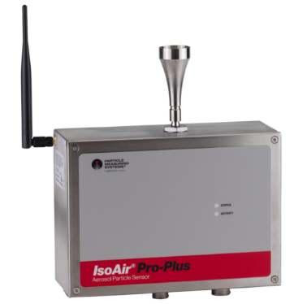 | 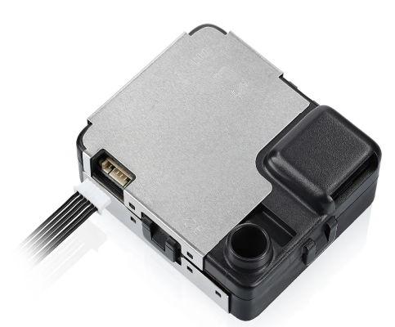 | 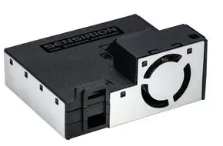
Sampling Interval: | 1 s | 1 s | 1 s
Mass Concentration Range: | From 1μm | 1 to 1,000 μg/m³ | 0 to 1,000 μg/m³
Operating Temperature: | 0 to 50 °C | -10 to 60 °C | -10 to 50 °C
Operating Voltage: | 100 - 240v AC | 5v | 4.5v to 5.5v
Current: | 4 - 20 mA | 80 - 300 mA | 100mA
Interface: | Digital | UART | I²C
Weight: | 4 Kg | - | 36.4 g
Price: | £949.00 | £68.24 | £27.32
Pros: | Accurate | - | Also measures VOC,  Cheap
Cons: | Expensive,  High Operational Voltage | Only measures Particle Count | Difficult to integrate
Chosen Sensor:
Website: | https://www.alphacontrols.com/ | https://uk.rs-online.com/web/ | https://uk.farnell.com/sensirion/sen54-sdn-t/particle-sensor-dust-digital-5v/dp/3924519
Referencing: | [14] | [15] | [16]
Table 7: Airborne Particle Count Sensors Comparison

Figure 5: Chosen Airborne Particle Count Sensor

Datasheet - https://www.farnell.com/datasheets/3689381.pdf

Sunlight Brightness

Sunlight Brightness
Model: | SP Lite2 | MPY54C569 | CS320
Company: | Omni Instruments | Photonix | Campbell Scientific
Photo: | 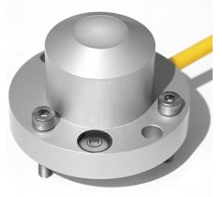 | 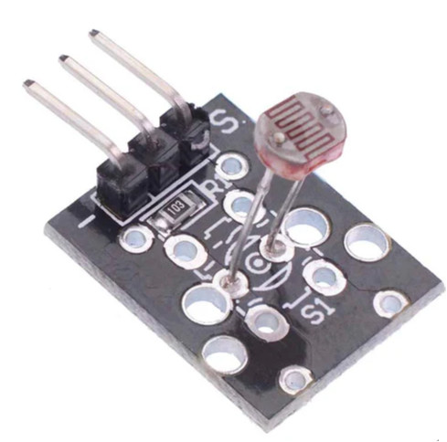 | 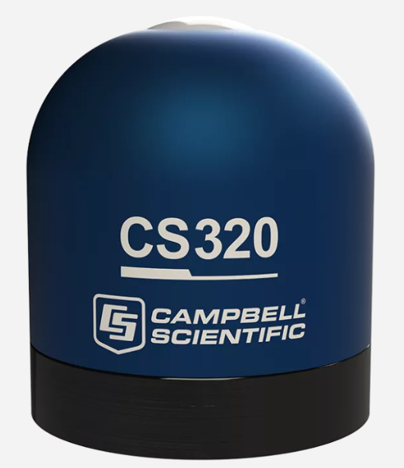
Interface: | Digital | Analogue | Digital
Operating Temperature: | -30 to 70 °C | -30 to 75 °C | -30 to 75 °C
Operating Range: | 0 to 2000 W/m² | - | 0 to 2000 W/m²
Operating Voltage: | - | 3v to 5v | 6 - 24 Vdc
Current: | - | 75mA | 25 mA
Price: | £405.00 | £0.61 | £265.00
Pros: | - | Cheap | Operates at the correct Voltage
Cons: | Expensive | Inaccurate | -
Chosen Sensor:
Website: | https://www.omniinstruments.co.uk/ | https://www.switchelectronics.co.uk/ | https://www.campbellsci.com/cs320
Referencing: | [17] | [18] | [19]
Table 8: Sunlight Brightness Sensors Comparison

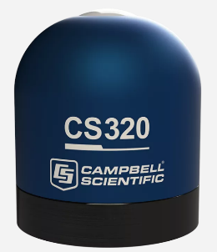

Figure 6: Chosen Sunlight Brightness Sensor

Datasheet - https://s.campbellsci.com/documents/us/manuals/cs320.pdf

UV Level

UV Level Sensors
Model: | VEML6075 | PMA1107 Analog Non-Weighted UVA+B Sensor | MS - 212W
Company: | Adafruit | Solar Light | Atmos
Photo: | 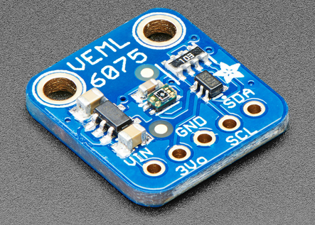 | 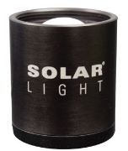 | 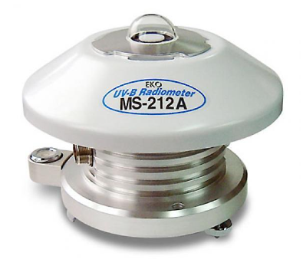
Interface: | I²C | Analogue | Analogue
Operating Range: | 0 - 11 | 280-400nm | 1
Operating Voltage: | 3v or 5v | 5 - 12 Vdc | 100 to 249 v AC
Current: | 100 mA | 30 mA
Dimensions: | 17 mm x 16 mm | 343 mm x 396 mm | 120 mm x 160 mm
Weight: | 0.8 g | 200g | 1.1 kg
Price: | £4.74 | £425.00 | £583.00
Pros: | Cheap | Measures UV A & B | -
Cons: | Not suitable for external use | - | High Operating Voltage
Chosen Sensor:
Website: | https://www.adafruit.com/ | https://solarlight.com/product/uvauvbsensorpma1107/ | www.atmos-meteo.com/sensors/precision-uv-radiometer.html
Referencing: | [20] | [21] | [22]
Table 9: UV Level Sensors Comparison

Figure 7: Chosen UV Level Sensor
Datasheet - https://solarlight.com/wp-content/uploads/AnalogSensors_PMA1107.pdf
Wiring Diagram - https://solarlight.com/wp-content/uploads/2013/04/Wiring-Diagram-for-Analog-PMA11XX-Detectors.pdf

GPS Position

GPS Position Sensors
Model: | PA1010D Breakout | M10Q-5883 GNSS | GPS Logger
Company: | Pimoroni | MATEKSYS | MAV Sense
Photo: | 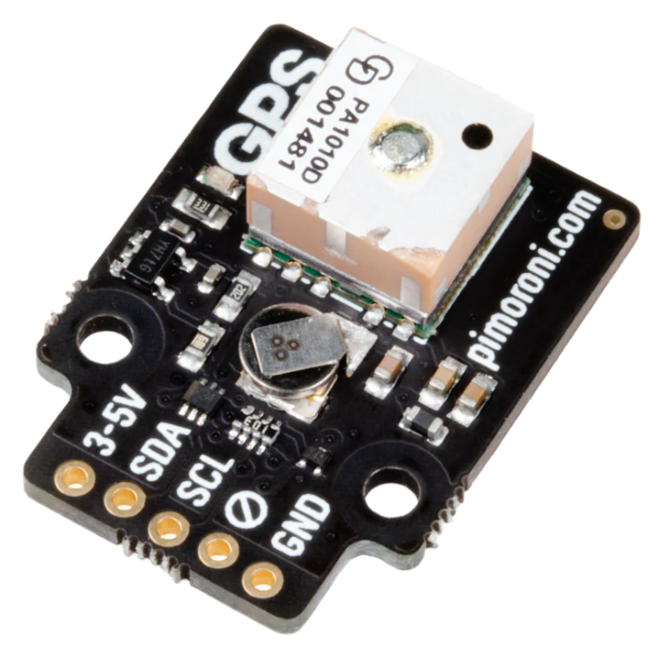 | 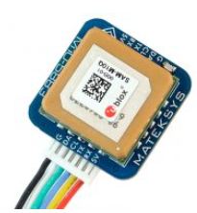 | 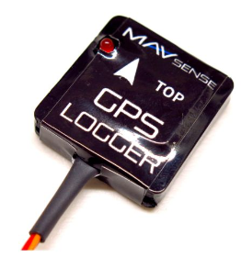
Interface: | I²C / UART | UART | GPS Logger
Operating Range: | GPS / GLONASS / GALILEO | GPS / GLONASS / GALILEO / BeiDou | GPS / GLONASS / GALILEO
Operating Voltage: | 3v to 5v | 4v to 9v | 3.5v to 8.4v
Current: | 36 mA | 13 mA | 50 mA
Dimensions: | 10 mm x 10 mm | 20 mm x 20 mm | 28 mm x 29.5 mm
Weight: | - | 8 g | 15 g
Price: | £29.70 | £31.10 | £98.27
Pros: | Cheap | Cheap | -
Cons: | - | - | Expensive
Chosen Sensor:
Website: | https://shop.pimoroni.com/ | www.yourfpv.co.uk/product/mateksys-m10q-5883-gnss-compass/ | https://esoaringgadgets.co.uk/
Referencing: | [23] | [24] | [25]
Table 10: GPS Sensors Comparison

Figure 8: Chosen GPS Sensor

VOC Levels

VOC Levels Sensors
System: | AQDTF Duct Air Quality VOC Sensor | SEN54-SDN-T | SEN0134
Company: | MSI | Sensirion | DF Robot
Photo: | 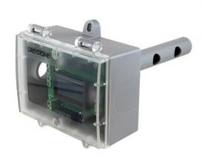 |  | 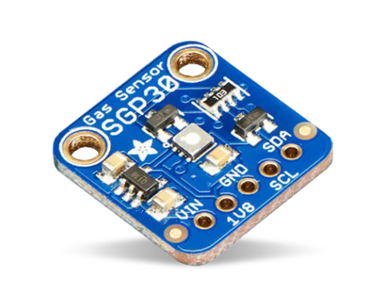
Sampling Interval: | 1 s | 1 s | -
Mass Concentration Range: | 450 to 2,000 ppm | 0 to 1,000 μg/m³ | 10 to 1,000 ppm
Operating Temperature: | 0 to 50 °C | -10 to 50 °C | -40 to 85 °C
Operating Voltage: | 20v to 28v | 4.5v to 5.5v | 0.3 - 2.16 Vdc
Current: | 35 mA | 100mA | 100mA
Interface: | Analog | I²C | I²C
Weight: | 290 g | 36.4 g | 1.1g
Price: | £310.00 | £28.54 | £22.99
Pros: | High Operating Voltage | Also measures Particle Count | Cheap
Cons: | Expensive | Difficult to integrate | -
Chosen Sensor:
Website: | www.measurementsystems.co.uk/sensors_and_meters/air_quality_and_gas_sensors/aqdtf-duct-air-quality-voc-sensor | https://uk.farnell.com/sensirion/sen54-sdn-t/particle-sensor-dust-digital-5v/dp/3924519 | https://coolcomponents.co.uk/products/sgp30-air-quality-sensor-breakout-voc-and-eco2
Referencing: | [26] | [16] | [27]
Table 11: VOC Levels Sensors Comparison

Figure 9: Chosen VOC Levels Sensor

Datasheet - https://www.farnell.com/datasheets/3689381.pdf

Review of Sensors to be Used
SENSOR | MAKE & MODEL | PARAMETER MEASURED
 | TE Connectivity  HPP809A031 Temperature & Humidity Sensor | Temperature  &  Humidity
 | Gill  WindSonic 75 Anemometer | Wind Speed  &  Wind Direction
 | Sensirion  SEN54-SDN-T | VOC Levels  &  Airborne Particle Count
 | Campbell Scientific  CS320 | Sunlight Brightness
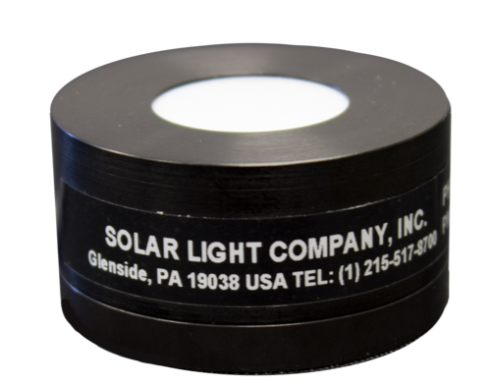 | Solar Light  PMA1107 Analog Non-Weighted UVA+B Sensor | UV Level
 | MATEKSYS  M10Q-5883 GNSS | GPS
Table 12: Review of Sensors to be used

Table 12 above shows that even though the design requirement is to measure 9 different parameters, by careful selection of sensors, we actually only need to incorporate 6 different devices into our design build.

Microcontroller Selection

Parameters | Type of Output from Sensor
Temperature  Humidity | Analogue
Wind Speed  Wind Direction | Analogue
Air Borne Particle Count  VOC Level | I²C
Sunlight Brightness | Analogue
UV Levels | Analogue
GPS Position | UART
Table 13: Type of signal from sensor

Table 13 shows the type of output signal our sensors will produce. This complete with the tabulated view below in Table 14 of how many Analogue / Digital IO pins, Communication Devices and peripherals our Microcontroller will need will give us the information we need to select our PIC.
Parameters | Type of Input Pin required on our Microcontroller
Temperature &  Humidity | 2x Analogue Pins
Wind Speed  Wind Direction | 2x Analogue Pins
Air Borne Particle Count &  VOC Level | 1x I²C
Sunlight Brightness | 1x Analogue Pin
UV Levels | 1x Analogue Pin
GPS Position | 1x UART
USB Module | 1x USB
SD Card Module | 1x SPI
LED On Indicator | 1x Digital Output

Table 14: Number of IO Pins required for PIC Microcontroller

From the above tables, we see that at a minimum, the microcontroller requirements are as follows:
- 8 Bit
- Minimum 17 Pins
- 6x Analogue Inputs
- 1x Digital Output
- 1x UART
- 1x SPI (4 I/O pins)
- 1x I²C (2 I/O pins)
- 1x USB (2 I/O pins)
- 1x Real Time Clock

We took this list of requirements for our Microcontroller, and went to the Microchip parametric part selector website tool, and used the parameter search to shortlist suitable Microcontrollers. [28]

When the above criteria was used to filter Microchip products, 19 suitable Pic18 Microcontrollers were identified as suitable. These were as follows:
- PIC18F97J94
- PIC18F87J94
- PIC18F67J94
- PIC18F47J53
- PIC18F27J53
- PIC18F96J94
- PIC18F86J94
- PIC18F66J94
- PIC18F46J50
- PIC18F46J53
- PIC18F26J50
- PIC18F26J53
- PIC18F95J94
- PIC18F85J94
- PIC18F65J94
- PIC18F45J50
- PIC18F25J50
- PIC18F44J50
- PIC18F24J50

Table 15 on the next page is a tabulated comparison of the 5 shortlisted Microcontrollers…

 | PIC18  F47J53 | PIC18  F26J50 | PIC18  F26J53 | PIC18  F25J50 | PIC18  F24J50
Family | 8-bit MCU | 8-bit MCU | 8-bit MCU | 8-bit MCU | 8-bit MCU
CPU Type | PIC | PIC | PIC | PIC | PIC
Max CPU Speed (MHz) | 48 MHz | 48 MHz | 48 MHz | 48 MHz | 48 MHz
Operation Voltage | (2V-3.6V) | (2V-3.6V) | (2V-3.6V) | (2V-3.6V) | (2V-3.6V)
Temp Range | (-40 to 85) | (-40 to 85) | (-40 to 85) | (-40 to 85) | (-40 to 85)
Pin count | 28 / 44 | 28 | 28 | 28 | 28
Program Memory Size (KB) | 128 Flash | 64 Flash | 64 Flash | 32 Flash | 16 Flash
SRAM | 3.7109 KB | 3.7109 KB | 3.7109 KB | 3.7109 KB | 3.7109 KB
Low Power | Yes | Yes | Yes | Yes | Yes
ADC Input | 13 | 10 | 13 | 10 | 10
Max ADC Resolution (Bits) | 12 | 10 | 12 | 10 | 10
UART | 2 | 2 | 2 | 2 | 2
SPI | 2 | 2 | 2 | 2 | 2
I2C | 2 | 2 | 2 | 2 | 2
Number of USB Modules | 1 | 1 | 1 | 1 | 1
USB Interface | FS Device | FS Device | FS Device | FS Device | FS Device
Max 8-Bit Digital Timers | 4 | 2 | 4 | 2 | 2
Max 16-Bit Digital Timers | 4 | 3 | 4 | 3 | 3
Hardware RTCC/RTC | Yes | Yes | Yes | Yes | Yes
Integrated full-Speed USB 2.0 | Yes | Yes | Yes | Yes | Yes
High memory density for more complex application | Yes | No | Yes | No | No
Peripheral Pin Select for design flexibility | Yes | Yes | Yes | Yes | Yes
Features nanoWatt XLP Technology, for battery applications | Yes | Yes | Yes | Yes | Yes
Deep Sleep mode for low power application | 9nA | 9nA | 9nA | 15nA | 15nA
Sleep mode (RAM retention) | 200nA | 60nA | 200nA | 60nA | 60nA
Real Time Clock & Calendar operation in Sleep modes | 700nA | 830nA | 700nA | 700nA | 830nA
Watch Dog Timer operation in Sleep modes | 330na | 780na | 330na | 830na | 780na
Integrated full speed USB 2.0 | Yes | Yes | Yes | Yes | Yes
Deep Sleep mode ideal for battery applications | Yes | Yes | Yes | Yes | Yes
Peripheral Pin Select for mapping digital peripherals | Yes | Yes | Yes | Yes | Yes
RTCC provides clock, calendar & alarm functions | Yes | Yes | Yes | Yes | Yes
Charge Time Measurement Unit (CTMU) | Yes | Yes | Yes | Yes | Yes
Enhanced Capture / Compare / PWM modules | 3 | 2 | 3 | 2 | 2
MSSP serial ports for SPI or I2C™ communication | 2 | 2 | 2 | 2 | 2
Enhanced USART modules | 2 | 2 | 2 | 2 | 2
8-bit Parallel port | Yes | No | Yes | No | No
Analog comparators | 3 | 2 | 3 | 2 | 2
ADC | 13ch,  12-bit | 10ch,  10-bit | 10ch,  12-bit | 10ch,  10-bit | 10ch,  10-bit
Self-programming Flash supports 10k erase/write cycles & 20 years retention | Yes | Yes | Yes | Yes | Yes
Operating voltage 2.0 - 3.6V, 5.5V tolerant digital inputs | Yes | Yes | Yes | Yes | Yes
Chosen Microcontroller:
Table 15: PIC Microcontroller Comparison


PIC Microcontroller selected is the PIC18F47J53
Figure 10: Chosen PIC Microcontroller

Datasheet - https://ww1.microchip.com/downloads/aemDocuments/documents/OTH/ProductDocuments/DataSheets/30009964C.pdf

Storage

Memory Requirements
In order to store the data collected from our sensors, we need to calculate the required Non-Volatile memory. Non- Volatile memory will be data stored even when the device is powered down, this opposed to the Volatile memory which can only be stored when the device is powered up.

Parameters | Possible Values
Temperature | -40° C --> +55° C
Humidity | 0% --> 100%
Wind Speed | 0 --> 155 MPH
Wind Direction | 0° --> 360°
Air Borne Particle Count | 0 --> 1,000 μg/m³
Sunlight Brightness | 0 --> 1120 W/m²
UV Levels | 280 --> 400nm
GPS Position | ≤ 65536
VOC Level | 1 --> 500
Table 16: Sensor Value Ranges

Table 16 shows the ranges that each of the sensors will measure. These ranges need to be as such that any possible value is recorded.
Temperature - The lowest point of -40° C has been chosen as this is the average winter temperature in the Russian territory of Siberia according to ClimatesToTravel.com. [29]
The highest point of +55° C has been chosen as 56.7° C is the highest temperature recorded on earth. This was at Death Valley, California according to Arizona State University. [30]
Humidity - It was decided to measure the full spectrum from 0 to 100% humidity, as according to MostPopulationReview.com the humidity in Singapore ranges between 60% and 90%. This is classed as a very humid city. Therefore we can expect the lower figure to be considerably lower in Western Europe. [31]
Wind Speed - It was decided to measure only up to 155 MPH, as anything above this is classed as Category 5 hurricane. This would cause catastrophic damage to buildings to occur, and certainly damage a Weather Station, according to the National Hurricane Centre. [32]
Wind Direction The full spectrum from 0° to 360° will be needed in order to detect wind direction. Shifts in degrees will determine the direction of the wind. This is explained in Figure 11.

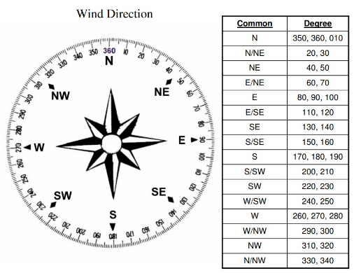

Figure 11: Compass rose with 16 wind directions

Airborne Particle Count - The full spectrum of the sensor, 0 --> 1,000 μg/m³ is to be read. This is due to the fact that a conversion formula would then be needed to be applied in order to convert into ppb (Parts per Billion) which is the standard Air Particle Count Unit. [33]
Sunlight Brightness - The maximum recorded solar radiation recorded according to SynergyFiles.com is 1120 W/m². [34]
UV Levels - As our UV Level sensor measures across UVA & UVB we need to record values between 280 --> 400nm. Wavelength can be calculated into UV Index. [35]
GPS - A GPS signal is received in a NEMA message structure of numbers and letters of up to 82 characters. [36]
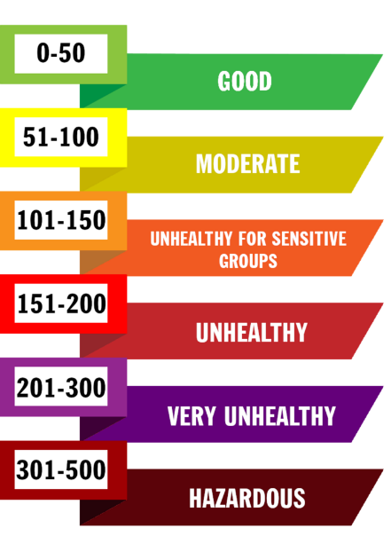
VOC Level - According to Lane Regional Air Protection Agency, VOC levels can be grouped into 6 different categories. Figure 12 shows how these are broken down. This is the reason for measuring between 1 & 500. [37]

Figure 12: The Air Quality Index (AQI) categories and colours
Parameters | Maximum Value | Resolution | Number of Possible Values | No. Bits Required
Temperature | -40° C --> +55° C | 0.1° C | 950 | 10
Humidity | 0% --> 100% | 1% | 100 | 7
Wind Speed | 0 --> 155 MPH | 1 MPH | 155 | 7
Wind Direction | 0° --> 360° | 1° | 360 | 9
Air Borne Particle Count | 0 --> 1,000 μg/m³ | 10 μg/m³ | 100 | 7
Sunlight Brightness | 0 --> 1120 W/m² | 10 W/m² | 112 | 7
UV Levels | 280 --> 400nm | 1 nm | 120 | 7
GPS Position | ≤ 65,536 | 1 | ≤ 65,536 | 16
VOC Level | 1 --> 500 | 1 | 500 | 9
Table 17: Sensor Resolution, Number of Possible Values and No. Bits Required

Table 17 is showing what Resolution we are measuring in, that is in what increments. Also it breaks down the resolution to display the possible Number of Possible Values or increments we will be measuring. The final column then shows No of Bits Required in order to accurately measure our sensors data output.

 | 1 Byte |  |  |  |  |  |  |  |  | 1 Byte
Temperature | 1 | 2 | 3 | 4 | 5 | 6 | 7 | 8 |  | 1 | 2 | 3 | 4 | 5 | 6 | 7 | 8
Humidity | 1 | 2 | 3 | 4 | 5 | 6 | 7 | 8
Wind Speed | 1 | 2 | 3 | 4 | 5 | 6 | 7 | 8
Wind Direction | 1 | 2 | 3 | 4 | 5 | 6 | 7 | 8 |  | 1 | 2 | 3 | 4 | 5 | 6 | 7 | 8
Airborne Particle Count | 1 | 2 | 3 | 4 | 5 | 6 | 7 | 8
Sunlight Brightness | 1 | 2 | 3 | 4 | 5 | 6 | 7 | 8
UV Levels | 1 | 2 | 3 | 4 | 5 | 6 | 7 | 8
GPS | 1 | 2 | 3 | 4 | 5 | 6 | 7 | 8 |  | 1 | 2 | 3 | 4 | 5 | 6 | 7 | 8
VOC Level | 1 | 2 | 3 | 4 | 5 | 6 | 7 | 8 |  | 1 | 2 | 3 | 4 | 5 | 6 | 7 | 8
Figure 13: No of 8 Bit Bytes Required

The Microcontroller I have selected is from the 8 Bit Pic family range, so to calculate the no of bytes required for our Non-Volatile Memory we need to convert the Bit requirement to a Bytes. We can do this by using the image in Figure 13. By drawing out 8 B Bits next to each of the sensors, we can understand the process better.

Parameters | Number of Possible Values | No. Bits Required | No. Bytes Required
Temperature | 950 | 10 | 2
Humidity | 100 | 7 | 1
Wind Speed | 155 | 7 | 1
Wind Direction | 360 | 9 | 2
Air Borne Particle Count | 100 | 7 | 2
Sunlight Brightness | 112 | 7 | 2
UV Levels | 120 | 7 | 2
GPS Position | ≤ 65,536 | 16 | 2
VOC Level | 500 | 9 | 2
 |  |  | Total 16 Bytes
Table 18: No of Bytes Required

Table 18 shows the result of how many Bytes of data that could be required every time our weather station records data from our sensors.

Parameters | Frequency of Measurement
Wind Speed | ½ second
Temperature | 1 second
Sunlight Brightness | 1 second
Wind Direction | 1 second
Humidity | 5 seconds
UV Levels | 5 seconds
Air Borne Particle Count | 5 seconds
VOC Level | 5 seconds
GPS Position | 60 seconds
Table 19: Frequency of Measurement
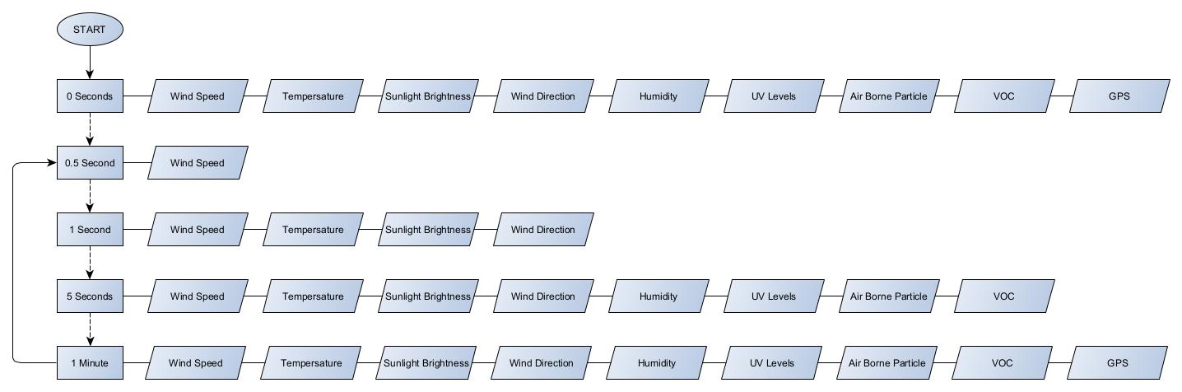
Table 19 shows the frequency we will be collecting data from each of our sensors. This is visually easier to understand from Figure 14 below.
Figure 14: Frequency of measurement (Visual Representation)
Below are the Memory Requirements calculations:
Temperature
$$2 Bytes/cycle*1 (Frequency of Measurement)=2 Bytes/Second$$
$$2 Bytes/Second*60=120 Bytes/Minute$$
$$120 Bytes/Minute*60=7,200 Bytes/Hour$$
$$7,200 Bytes/Hour*24=172,800 Bytes/Day$$
$$172,800 Bytes/Day*14 \left(Days Operation\right)=2,419,200 Bytes/ 14 Days Operation$$

Humidity
$$1 Bytes/cycle*0.2 (Frequency of Measurement)=0.2 Bytes/Second$$
$$0.2 Bytes/Second*60=12 Bytes/Minute$$
$$12 Bytes/Minute*60=720 Bytes/Hour$$
$$7,200 Bytes/Hour*24=17,280 Bytes/Day$$
$$172,800 Bytes/Day*14 \left(Days Operation\right)=241,920 Bytes/ 14 Days Operation$$

Wind Speed
$$2 Bytes/cycle*1 (Frequency of Measurement)=2 Bytes/Second$$
$$2 Bytes/Second*60=120 Bytes/Minute$$
$$120 Bytes/Minute*60=7,200 Bytes/Hour$$
$$7,200 Bytes/Hour*24=172,800 Bytes/Day$$
$$172,800 Bytes/Day*14 \left(Days Operation\right)=2,419,200 Bytes/ 14 Days Operation$$

Wind Direction
$$2 Bytes/cycle*1 (Frequency of Measurement)=2 Bytes/Second$$
$$2 Bytes/Second*60=120 Bytes/Minute$$
$$120 Bytes/Minute*60=7,200 Bytes/Hour$$
$$7,200 Bytes/Hour*24=172,800 Bytes/Day$$
$$172,800 Bytes/Day*14 \left(Days Operation\right)=2,419,200 Bytes/ 14 Days Operation$$

Air Borne Particle Count
$$2 Bytes/cycle*0.2 (Frequency of Measurement)=0.4 Bytes/Second$$
$$0.4 Bytes/Second*60=24 Bytes/Minute$$
$$24 Bytes/Minute*60=1,440 Bytes/Hour$$
$$1,440 Bytes/Hour*24=34,560 Bytes/Day$$
$$34,560 Bytes/Day*14 \left(Days Operation\right)=483,840 Bytes/ 14 Days Operation$$

Sunlight Brightness
$$2 Bytes/cycle*1 (Frequency of Measurement)=2 Bytes/Second$$
$$2 Bytes/Second*60=120 Bytes/Minute$$
$$120 Bytes/Minute*60=7,200 Bytes/Hour$$
$$7,200 Bytes/Hour*24=172,800 Bytes/Day$$
$$172,800 Bytes/Day*14 \left(Days Operation\right)=2,419,200 Bytes/ 14 Days Operation$$

UV Levels
$$1 Bytes/cycle*0.2 (Frequency of Measurement)=0.2 Bytes/Second$$
$$0.2 Bytes/Second*60=12 Bytes/Minute$$
$$12 Bytes/Minute*60=720 Bytes/Hour$$
$$7,200 Bytes/Hour*24=17,280 Bytes/Day$$
$$172,800 Bytes/Day*14 \left(Days Operation\right)=241,920 Bytes/ 14 Days Operation$$

GPS Position
$$2 Bytes/cycle*0.01666667 (Frequency of Measurement)=0.03333333 Bytes/Second$$
$$0.03333333 Bytes/Second*60=2 Bytes/Minute$$
$$2 Bytes/Minute*60=120 Bytes/Hour$$
$$120 Bytes/Hour*24=2,880 Bytes/Day$$
$$2,880 Bytes/Day*14 \left(Days Operation\right)=40,320 Bytes/ 14 Days Operation$$

VOC Level
$$1 Bytes/cycle*0.2 (Frequency of Measurement)=0.2 Bytes/Second$$
$$0.2 Bytes/Second*60=12 Bytes/Minute$$
$$12 Bytes/Minute*60=720 Bytes/Hour$$
$$7,200 Bytes/Hour*24=17,280 Bytes/Day$$
$$172,800 Bytes/Day*14 \left(Days Operation\right)=241,920 Bytes/ 14 Days Operation$$

Parameters | No. Bytes Required/Cycle | No. Bytes Required/Second | No. Bytes Required/Min | No. Bytes Required/Day | No. Bytes Required/14 Days
Temperature | 2 | 2 | 120 | 172,800 | 2,419,200
Humidity | 1 | - | 12 | 17,280 | 241,920
Wind Speed | 1 | 2 | 120 | 172,800 | 2,419,200
Wind Direction | 2 | 2 | 120 | 172,800 | 2,419,200
Air Borne Particle Count | 2 | - | 24 | 34,560 | 483,840
Sunlight Brightness | 2 | 2 | 120 | 172,800 | 2,419,200
UV Levels | 2 | - | 12 | 17,280 | 241,920
GPS Position | 2 | - | 2 | 2,880 | 40,320
VOC Level | 2 | - | 12 | 17,280 | 241,920
 | Total 16 Bytes | Total 8 Bytes | Total 542 Bytes | Total 780,480 Bytes  (781 kilobyte) | Total 10,926,720 Bytes  (10.93MB)
Table 20: Non-Volatile Memory required for 14 day Operation of Weather Station

Table 20 tabulates the calculated maximum Non-Volatile memory required for the operation of our Weather Station for a 14 day period as per our Output Requirements.
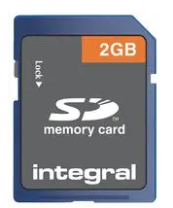
Although larger memory solutions are available. A 2GB card will be sufficient for approximately 180 x 14 day Operating Cycles of the completed Weather Station. This keeps the card below 4GB which can cause problems with addressing on some FAT32 file systems.

Datasheet - https://www.farnell.com/datasheets/3110845.pdf

USB & SD Card Modules

LED Indicators, USB Module & SD Card Module
System: | 130-1096 | CH340 | Diligent 410-380 | PELR0233
Company: | RS Pro | Everything Smart | Components 101 | Pro Elec
Photo: | 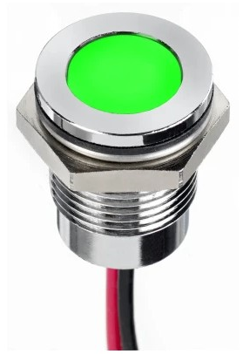 | 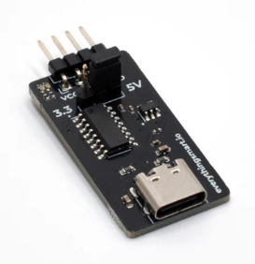 | 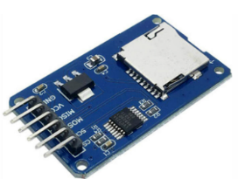 | 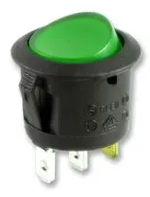
Type: | Green Panel Mount Indicator | USB-C to UART Serial Adapter | SD Card Module | Switch
Operating Voltage: | 1.8 – 3.3 Vdc | Selectable 3.3 or 5V | 4.5 – 5.5 Vdc | <125 V
Current: | 20 mA | 200 mA | 200 mA | 250 V
Weight:
Price: | £15.36 | £5.00 | £6.96 | £0.86
Website: | https://uk.rs-online.com/web/p/panel-mount-indicators/1301096?gb=s | https://shop.everythingsmart.io/products/usb-c-to-serial-adapter | https://uk.rs-online.com/web/p/memory-development-tools/1840482?gb=s | https://cpc.farnell.com/unbranded/abrr016/switch-rocker-spst-green-250vac/dp/SW02923?ost=pelr0233
Referencing: | [38] | [39] | [40] | [41]
Table 21: Miscellaneous Parts 1

LED Datasheet - https://docs.rs-online.com/8bc8/A700000009334440.pdf
USB Datasheet - https://shop.everythingsmart.io/products/usb-c-to-serial-adapter
SD Datasheet - https://docs.rs-online.com/9265/A700000006690481.pdf
Switch Datasheet - https://www.farnell.com/datasheets/1564449.pdf

Batteries

Before deciding on a battery, we must calculate the required capacity.

POWER CONSUMING COMPONENT: | CURRENT DRAW:
Microcontroller | 25 mA
Temperature & Humidity Sensor | 1.2 mA
Wind Speed & Wind Direction Sensor | 44 mA
VOC Levels & Airborne Particle Count Sensor | 100 mA
Sunlight Brightness Sensor | 25 mA
UV Level Sensor | 30 mA
GPS Sensor | 13 mA
USB Module | 200 mA
SD Card Module | 200 mA
LED Indicator Light | 20 mA
TOTAL CURRENT DRAW: | 658.20 mA
Table 22: Battery Power Requirement

The information found in Table 22 has been taken from Datasheets
Reference Numbers: [5] , [11] , [16] , [19] , [21] , [24] , [38] , [39] , [40]

Current (I) = 658.20 mA
Discharge Time (T) = 336 hours (24 hours x 14 days)

$$Amp hour \left(Ah\right)=Current \left(I\right)*Discharge Time \left(T\right)$$
$$658.20 *336=221155.20$$
$$221155.20=221.1552 A$$

$$Minimum Battery Size Required for 14 day Weather Station=222 Ah$$

Battery Systems
System: | LED240 | 24-230SMART3 | EXP12-250C
Company: | Varta | Roamer | Expedition Plus
Photo: | 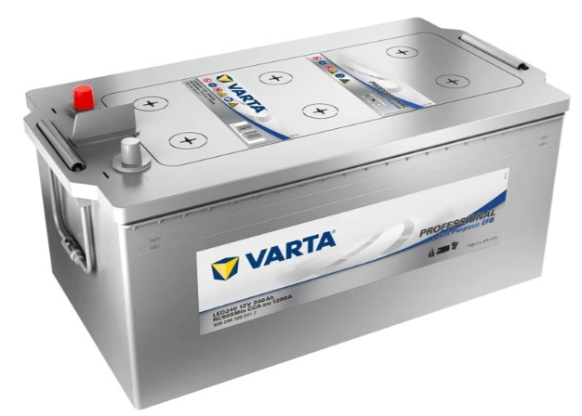 | 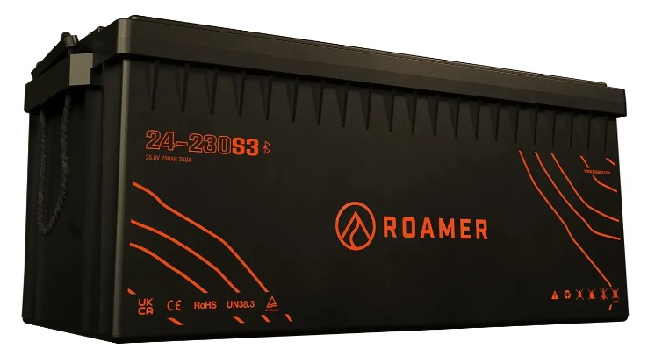 | 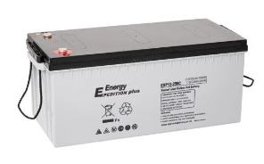
Type: | Deep Cycle  Leisure Battery | Leisure Battery | Lead Carbon Gel
Voltage: | 12 Volt | 24 Volt | 12 Volt
Current: | 240 Ah | 230 Ah | 250 Ah
Cycles: | 1,000 | 3,500 | 1,500
Weight: | 56.8 Kg | 38 Kg | 63 Kg
Length x Width x Height: | 513 mm x 276 mm x 242 mm | 521 mm x 268 mm x 218 mm | 532 mm x 240 mm x 219 mm
Pros: | Cheapest | Large Cycle Lifespan | -
Cons: | Least Cycle Lifespan | Expensive | Heavy & Bigger
Price: | £262.29 | £1,800.00 | £389.98
Chosen Battery:
Website: | https://www.powerland.co.uk/collections/marine-batteries/products/varta-led240-professional-dual-purpose-efb-leisure-battery-240ah-lfd230-930240120-1 | https://roamer.com/products/24-230smart?_pos=1&_sid=a28ebb3eb&_ss=r | https://www.alpha-batteries.co.uk/12v-250ah-expedition-plus-lead-carbon-gel-ultra-deep-cycle-battery-exp12-250c/
Referencing: | [42] | [43] | [44]
Table 23: Battery Comparison

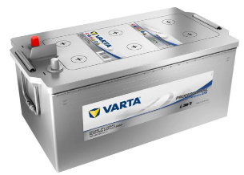
Figure 15: Chosen Battery

Datasheet - https://www.alpha-batteries.co.uk/wp-content/uploads/K087-EXP12-250C-.pdf

Enclosure

Enclosures
System: | 960 Case | M14 Mini Screen | 3I-2424-10B-C
Company: | NANUK | MetSpec | SKB
Photo: | 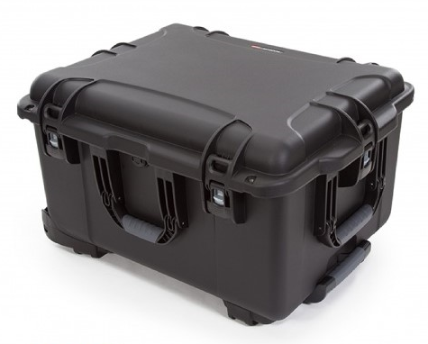 | 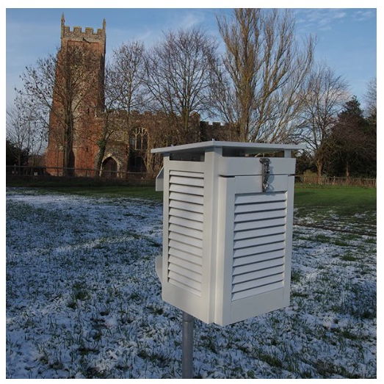 | 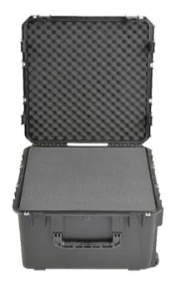
Material: | Synthetic Rubber | PVC Plastic | Moulded Plastic
Protection: | IP6X | - | -
No. of Sizes: | 34 | 1 | 40
Length x Width x Height: | 559 mm x 432 mm x 328 mm | 275 mm x 315 mm x 405 mm | 610 mm x 610 mm x 254 mm
Weight: | 8.7 Kg | 7.2 Kg | -
Price: | £332.43 | SOLD OUT | £525.68
Pros: | Cheapest | Ideal for Sensors | Large
Cons: | - | Sold Out | Expensive
Chosen Battery:
Website: | https://www.casesuk.com/nanuk-cases/nanuk-960-case.html | https://www.metcheck.co.uk/products/metspec-m14-mini-polycarbonate-stevenson-screen | https://www.protective-cases.co.uk/product/skb-3i-2424-10b-c-case-with-cubed-foam_3901
Referencing: | [45] | [46] | [47]
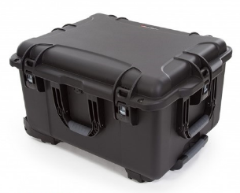
Table 24: Enclosure Comparison:

Figure 16: Chosen Enclosure

The Hardware Layout
The enclosure will be adapted to house and create a mobile power supply.

The battery will be housed within the enclosure, which will then be fitted with a terminal fuse block c/w terminal fuse.
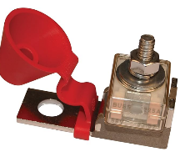
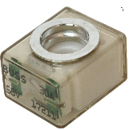

4 Gauge wire will then be connected to the terminals, and then to a battery power cut-off switch, which the enclosure will be adapted to house.
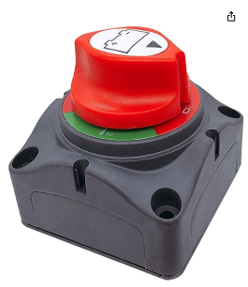
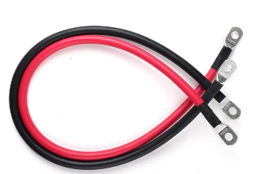

Another 4 Gauge wire will then be connected to the output of the switch to the Fuse Block.
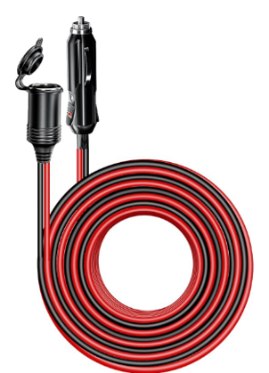
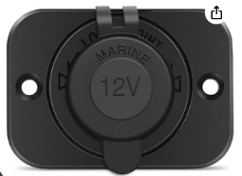
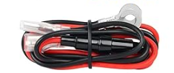
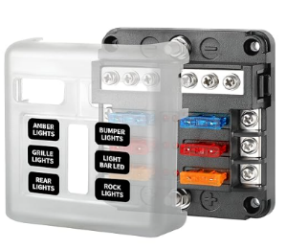

The enclosure will then be further adapted to house a 12 Volt Socket. This will be wired into the Fuse Block via the supplied cable. The Weather Station will then be able to be powered from the 12 Volt socket via a 12V cord. This method would also future proof the design by giving a direct 12v supply to any upgraded equipment.

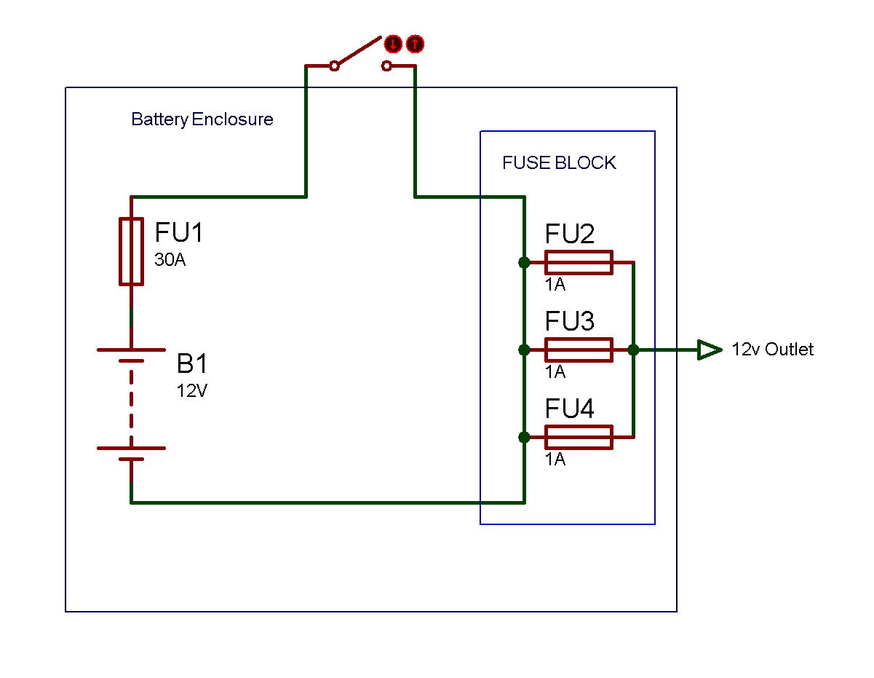
Figure 17: Battery Enclosure Schematic

Figure 17 shows the schematic of the battery hardware pack.

Terminal Block, Terminal Fuse & 4 Gauge Wire
System: | Terminal Fuse Block | BATTERY TERMINAL FUSE 30-AMP | 3M-9MQF-X7LI
Company: | Blue Sea Systems | Blue Sea Systems | LotFancy
Photo:
Seller: | Amazon | Amazon | Amazon
Weight: | 227g | 45g | 390g
Price: | £34.99 | £22.60 | £31.67
Website: | https://www.amazon.co.uk/ | https://www.amazon.co.uk/ | https://www.amazon.co.uk/
Referencing: | [48] | [49] | [50]
Table 25: Miscellaneous Parts 2

Battery Cut Off Switch, Fuse Block, 12V Socket & Lead
System: | ‎Am-CBS01 | Fuse Block | 12 Volt Socket | IR-EC-A08
Company: | ‎Ampper | Huazu | Nilight | ‎Irzaki
Photo:
Seller: | Amazon | Amazon | Amazon | Amazon
Weight: | 264g | 181g | 159g | 310g
Price: | £12.99 | £19.60 | £9.99 | £15.99
Website: | https://www.amazon.co.uk/ | https://www.amazon.co.uk/ | https://www.amazon.co.uk/ | https://www.amazon.co.uk/
Referencing: | [51] | [52] | [53] | [54]
Table 26: Miscellaneous Parts 3

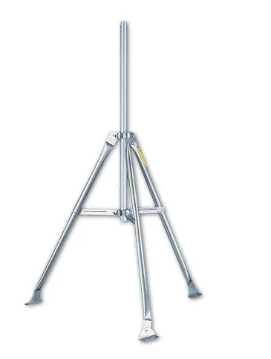
As well as an enclosure, we need a stand to hold the external sensors. This one can be secured down if necessary. And a mounting pole to ensure adequate mounting space. A plastic enclosure will also be fitted to the tripod to house the electronics via a pole mounting kit.

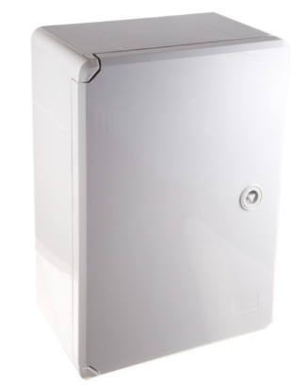
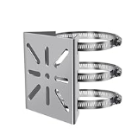
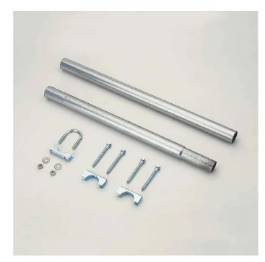

Battery Cut Off Switch, Fuse Block, 12V Socket & Lead
System: | Tripod | Mounting Pole Kit | Cabinet Enclosure | Pole Bracket
Company: | Davis | Davis | Evatron | SHENZHEN TECHNOLOGIES
Photo: | 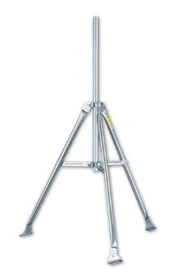 | 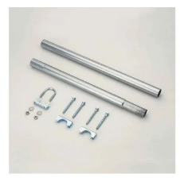
Seller: | Weather Shop | Weather Shop | Evatron | Amazon
Weight: | - | - | - | 460g
Price: | £172.30 | £60.00 | £31.13 | £26.99
Website: | https://www.weathershop.co.uk/ | https://www.weathershop.co.uk/ | https://evatron.com/ | https://www.amazon.co.uk/
Referencing: | [55] | [56] | [57] | [58]
Table 27: Miscellaneous Parts 4

Connectors (Panel Mounted to Casing)

Case Mounted Connectors Systems
System: | SP2912 | PSG08744 | SP 13 Series
Company: | In2Connect | Pro - Signal | Pro - Elec
Photo: | 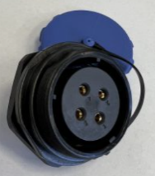  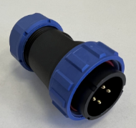 | 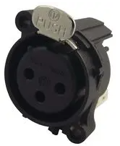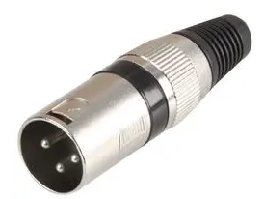 | 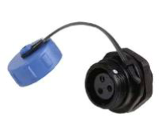  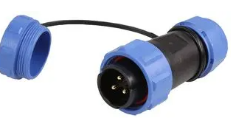
Material: | Plastic | Nickel | Nylon
Protection: | IP68 | - | IP68
Cap Fitted: | Yes | No | Yes
No. of Poles Available: | 2, 3, 4, 7, 8, 9, 10, 12, 16, 17, 20, 24, 26, 35 | 2, 3, 4, 5, 7, 9, 12 | 2, 3, 4, 5, 7, 9, 12
Rated Voltage: | 500 V | 50 V | 250 V
Pros: | Lots of Variations | - | Cheaper than alternative
Cons: | - | Not IP Rated | Expensive
Price: (Plug & Socket – 3 Pole) | £9.00 / pair | £3.89 / pair | £8.28 / pair
Chosen Connector:
Website: | https://componentbuddy.com/product/sp29-panel-mount-connectors-female/ | https://cpc.farnell.com/neutrik/nc3faav2/xlr-socket-3p-pcb-vert/dp/AV15739?st=3%20pole%20xlr%20socket | https://cpc.farnell.com/mbs-connect/sp2112-s3-1c/circular-panel-socket-3-pole/dp/CN21385?st=pro%20elec%20sp%2013%20series
Referencing: | [59] | [60] | [61]
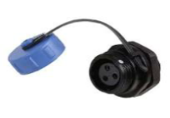
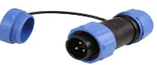
Table 28: Panel Mounted Connectors Comparison

Figure 18: Chosen Panel Mounted Connectors

Connectors (PCB Mounted)

PCB Mounted Connectors Systems
System: | PCB Connector | Pin Header | Fixed Terminal Block
Company: | Reichelt | Molex | TE Connectivity
Photo: | 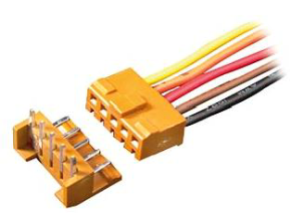 | 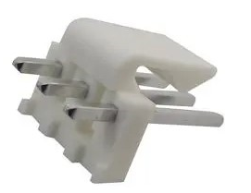 | 
Type: | Angled | Vertical | Screw
Max Voltage: | 250 V | 500 V | 150 V
Fixing: | Push Together | Locking Tang | Screw Clamp
Material: | Nylon | Nylon | Polyamide
No. of Poles Available: | 2, 3, 4, 7, 8, 9, 10, 12 | 2, 3, 4, 7, 8, 10, 12 | 2, 3, 4, 7, 8, 9, 10, 12
Pros: | - | - | Good Mechanical Connection
Cons: | - | - | -
Price: | £0.34p | £0.83p | £1.44p
Chosen Connector:
Website: | https://www.reichelt.com/at/en/pcb-connector-angled-brown-10-pin-ps-25-10w-br-p47229.html?&trstct=pos_2&nbc=1 | https://uk.farnell.com/molex/26-60-4043/connector-header-4pos-1row-3-96mm/dp/3049003?st=molex%20pin%20header | https://www.mouser.co.uk/ProductDetail/TE-Connectivity/282851-4?qs=qTrdGJE%2F%252BQz%252BSpIukU4Srg%3D%3D
Referencing: | [62] | [63] | [64]
Table 29: PCB Mounted Connectors Comparison

Figure 19: Chosen PCB Mounted Connectors

ASSUMPTION
An assumption has been made here that the factory connected cables on the sensors are adequate and long enough to get back to the Weather Station from the sensor.

Circuit and PCB Design
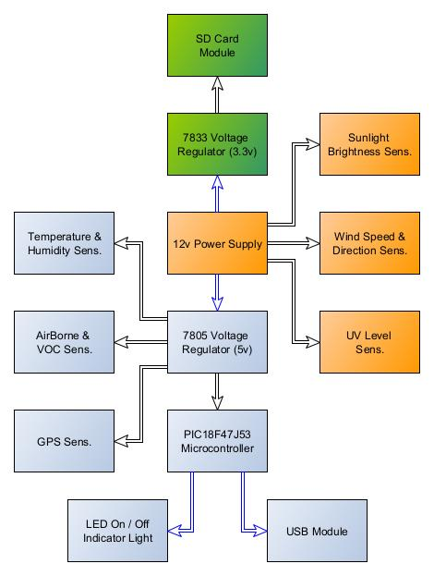
Figure 20: Power Supply Block Diagram

The Block diagram in Figure 20 shows that the Weather Station three different voltages. That is 12V, 3.3V and 5V. The diagram also shows what voltages are required for which peripheral and sensor.

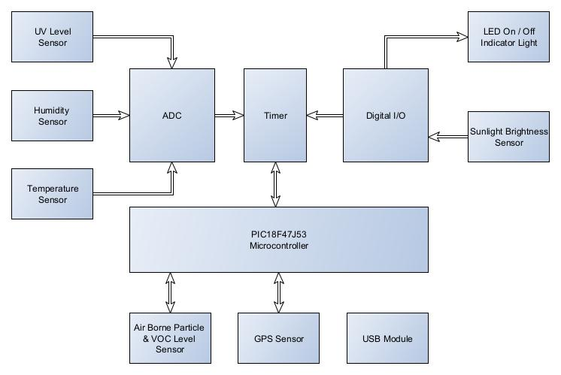
Figure 21: System Block Diagram

The Block diagram in Figure 21 shows how the sensors and peripherals in our Weather Station communicate with each other. We need to understand these paths before we design our sensor network.

Power Supply Schematic
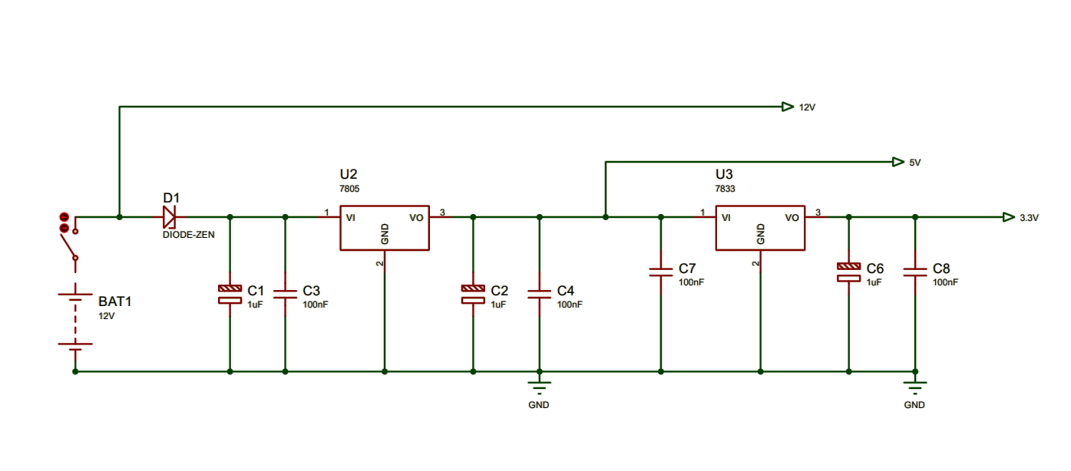
Figure 22: Proteus Power Supply Schematic

Figure 23: Easy PC Power Supply Schematic

The Proteus design in Figure 22 and the Easy PC Schematic in Figure 23 shows the step down from the 12 Volt Battery to 5V via a T7805 voltage regulator, and from 5V to 3.3V via a 7833 voltage regulator. This integrated circuit regulators maintain a constant output even if the input fluctuates. Note a Schottky Diode to protect against cross polarity of supply.

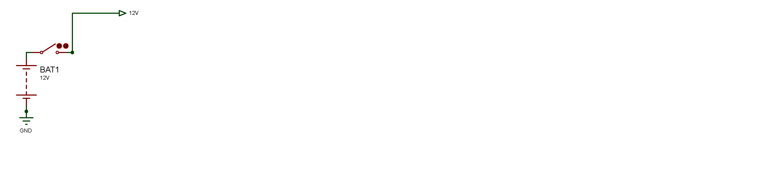12v Supply Schematic

Figure 24: Proteus 12V Schematic

5v Supply Schematic
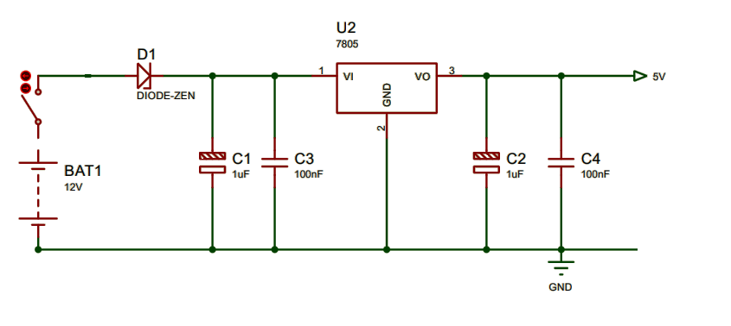
Figure 25: Proteus 5V Schematic

3.3v Supply Schematic
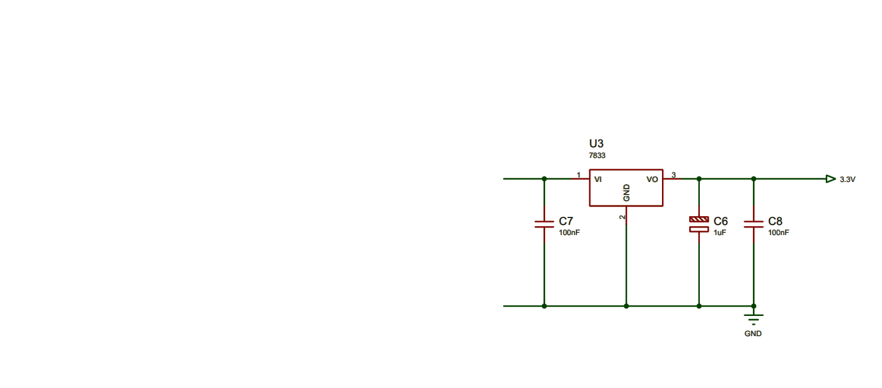

Figure 26: Proteus 3.3V Schematic

LED Flashing Indicator Schematic

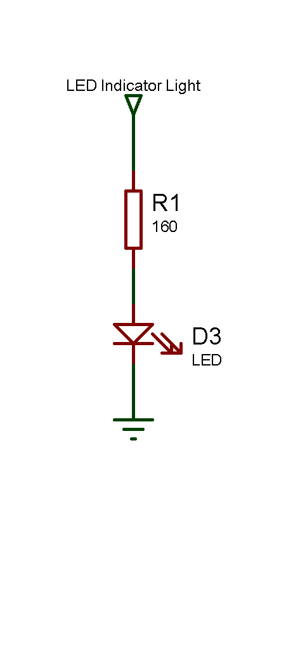

Figure 27: Easy PC LED Indicator
Figure 28: Proteus LED Indicator

$$R=\frac{Vs-Vf}{If}$$

$$R=\frac{5V-1.8V}{20mA}$$

$$R=\frac{3.2V}{20mA}$$

$$R=160 Ω$$

In order to interface the sensors to our Microcontroller, a low pass filter must be designed into our circuit. The low pass filter only allows low frequency signals from 0Hz to its cut-off frequency, ƒc, to pass while blocking those any higher.

$$fc=\frac{1}{2 R C}$$

If we choose a cut off frequency of 1.5 MHz, and a resistor value of 100Ω, then we can determine the capacitor size by rearranging the equation:
$$C=\frac{1}{2 R f}$$

$$C=\frac{1}{(2) () (100) (1.5*{10}^{6})}=1.061*{10}^{-9}$$

$$C=1.061*{10}^{-9}$$

$$\frac{1}{(2) () (100) (1*{10}^{-9})}=1.5 MHz$$

Temperature & Humidity Sensor Schematic
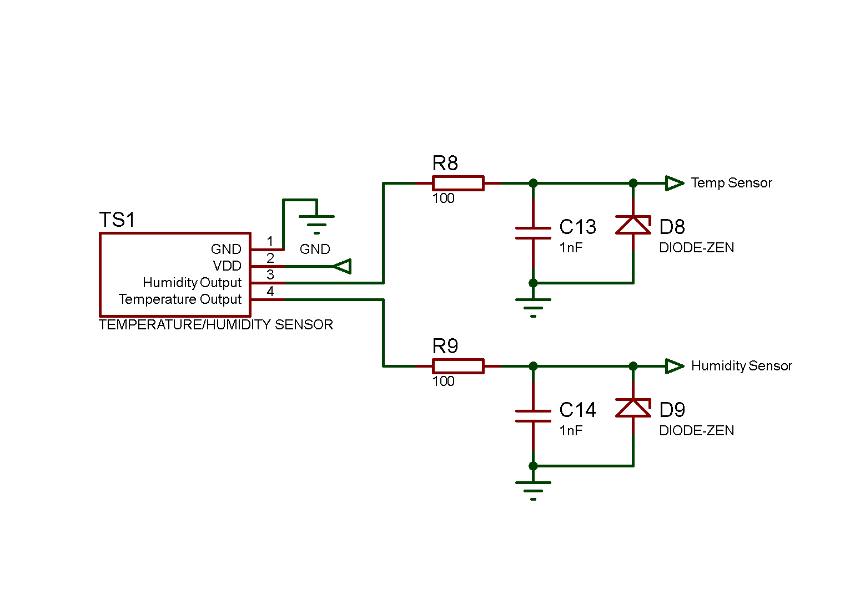
Figure 29: Proteus Temperature & Humidity Sensor Schematic

Figure 30: Easy PC Temperature & Humidity Sensor Schematic

The Proteus design in Figure 29 and the Easy PC Schematic in Figure 30 shows how the Temperature & Humidity Sensor will interface with the PIC Microcontroller.

Wind Speed & Wind Direction Sensor Schematic
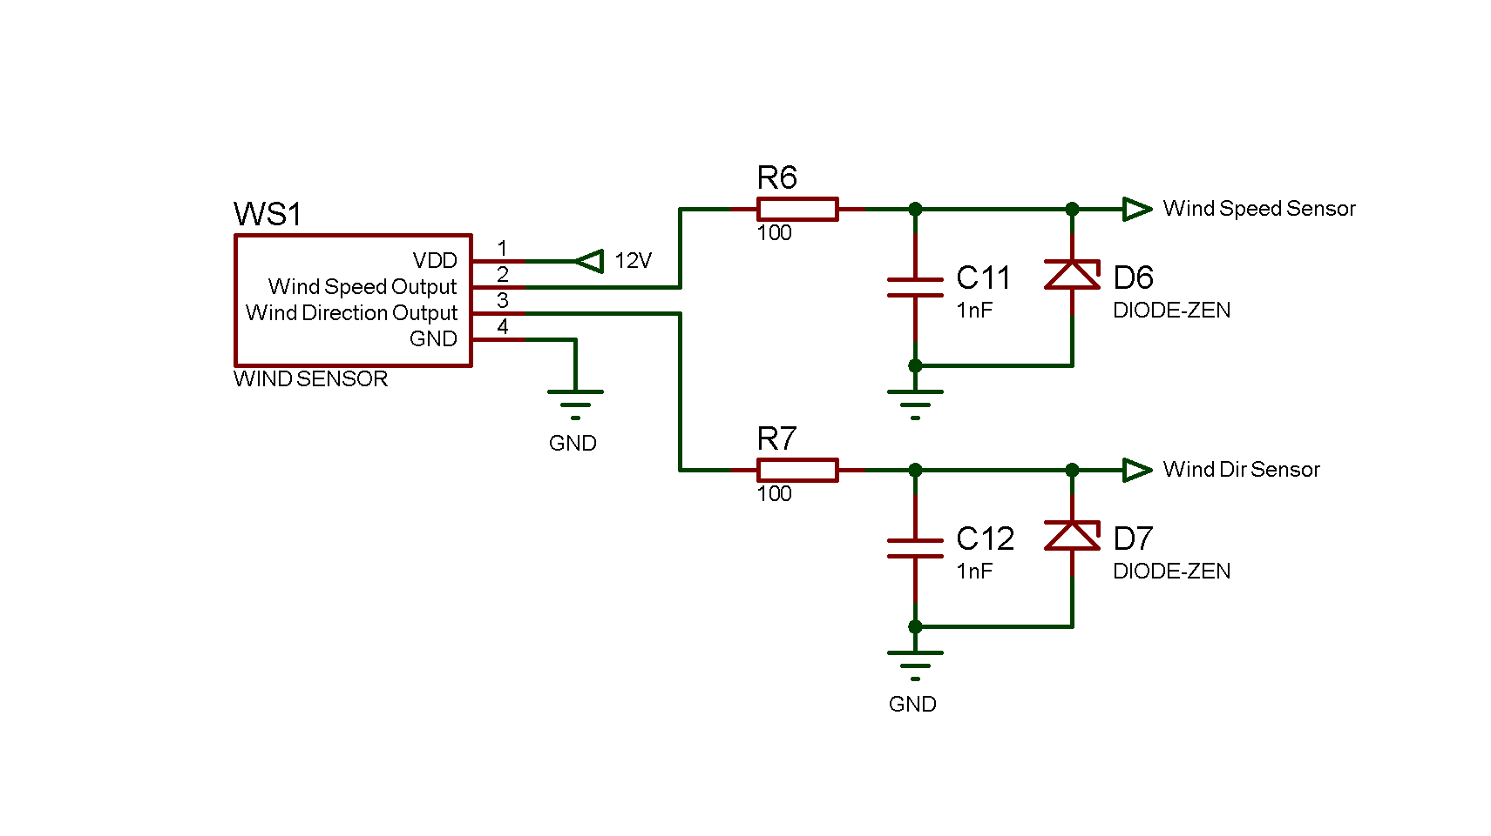
Figure 31: Proteus Wind Speed & Direction Sensor Schematic
Figure 32: Easy PC Wind Speed & Direction Sensor Schematic

The Proteus design in Figure 31 and the Easy PC Schematic in Figure 32 shows how the Wind Speed & Wind Direction Sensor will interface with the PIC Microcontroller.

GPS Sensor Schematic
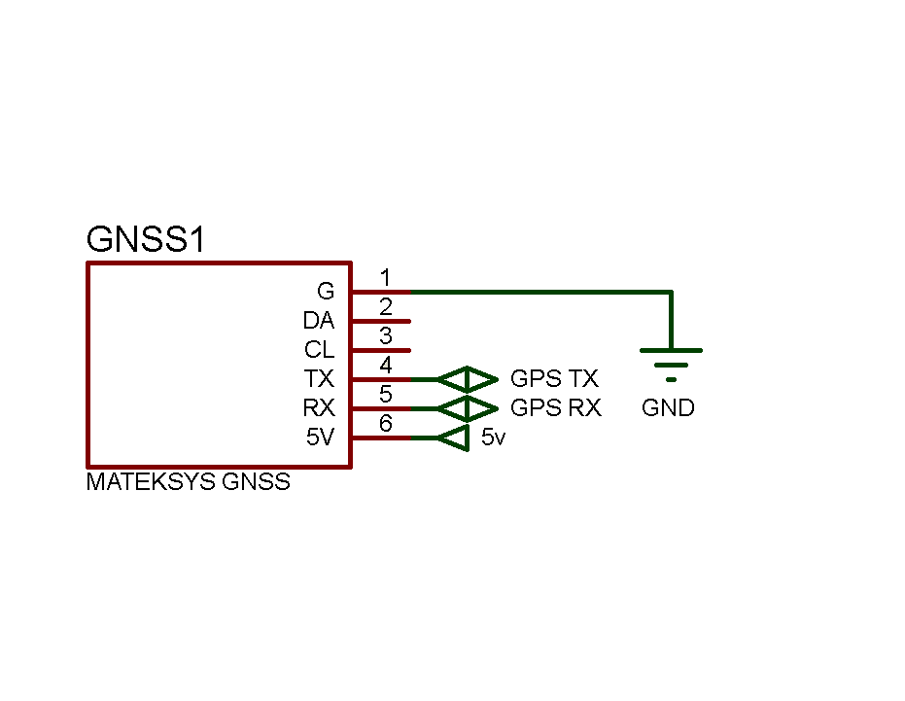

Figure 33: Proteus GPS Unit Schematic

Figure 34: Easy PC GPS Unit Schematic

The Proteus design in Figure 33 and the Easy PC Schematic in Figure 34 shows how the GPS Unit will interface with the PIC Microcontroller.

Air Quality & VOC Sensor Schematic
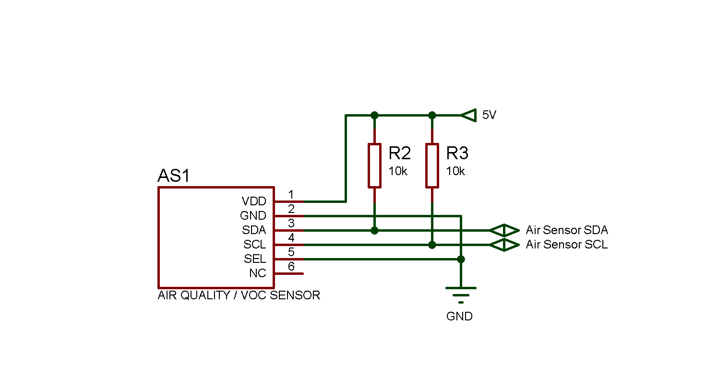

Figure 35: Proteus Air Quality & VOC Sensor Schematic

Figure 36: Easy PC Air Quality & VOC Sensor Schematic

The Proteus design in Figure 35 and the Easy PC Schematic in Figure 36 shows how the Air Quality & VOC Sensor will interface with the PIC Microcontroller. Note the pull up resistor, values are as per datasheet.

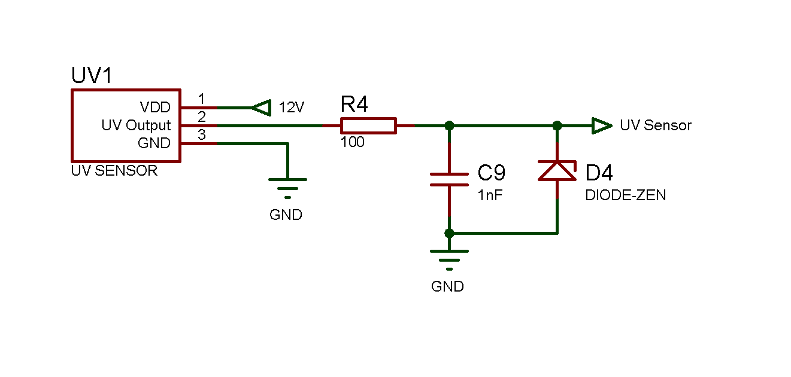UV Sensor Schematic

Figure 37: Proteus UV Sensor Schematic
Figure 38: Easy PC UV Sensor Schematic

The Proteus design in Figure 37 and the Easy PC Schematic in Figure 38 shows how the UV Sensor will interface with the PIC Microcontroller.

Sunlight Sensor Schematic
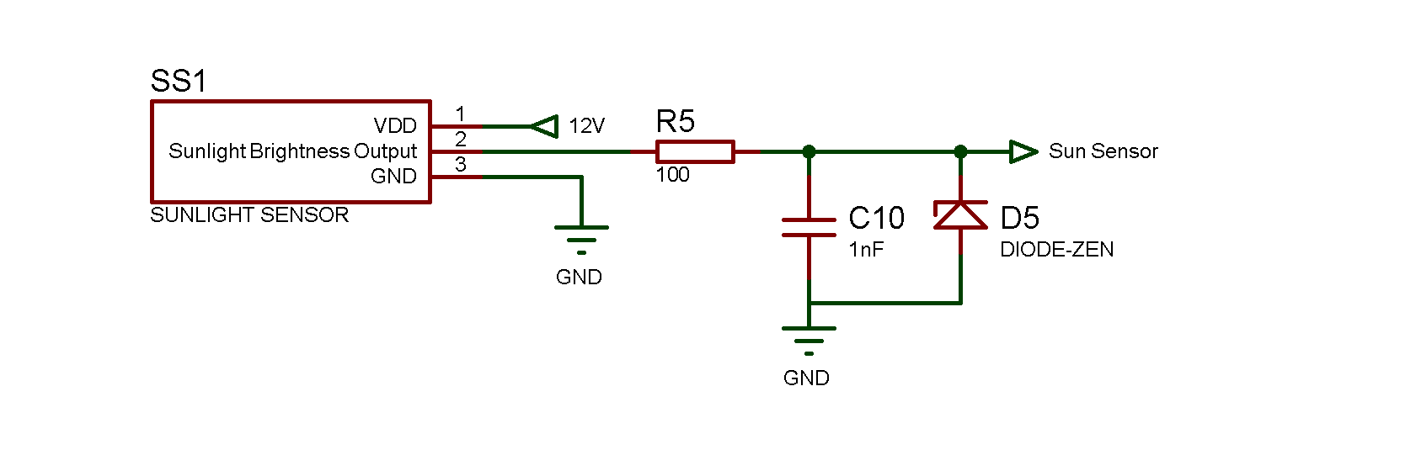

Figure 39: Proteus Sunlight Brightness Sensor Schematic

Figure 40: Easy PC Sunlight Brightness Sensor Schematic

The Proteus design in Figure 39 and the Easy PC Schematic in Figure 40 shows how the Sunlight Brightness Sensor will interface with the PIC Microcontroller.

SD Card Circuit Schematic

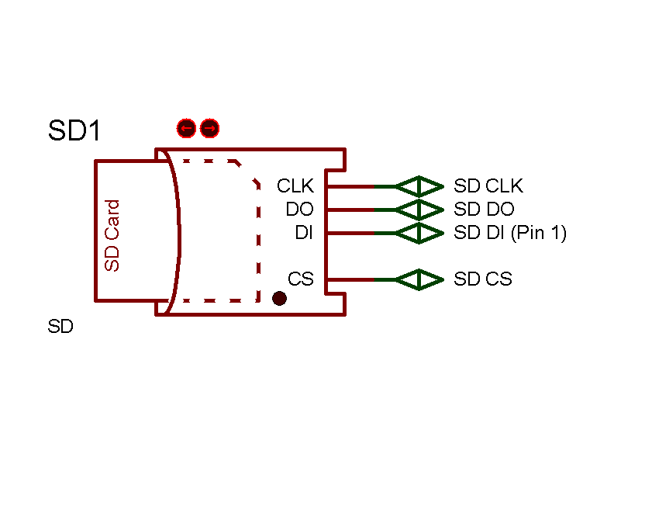

Figure 41: Proteus SD Card Schematic

Figure 42: Easy PC SD Card Schematic

The Proteus design in Figure 41 and the Easy PC Schematic in Figure 42 shows how the SD Card Module will interface with the PIC Microcontroller.

USB Circuit Schematic

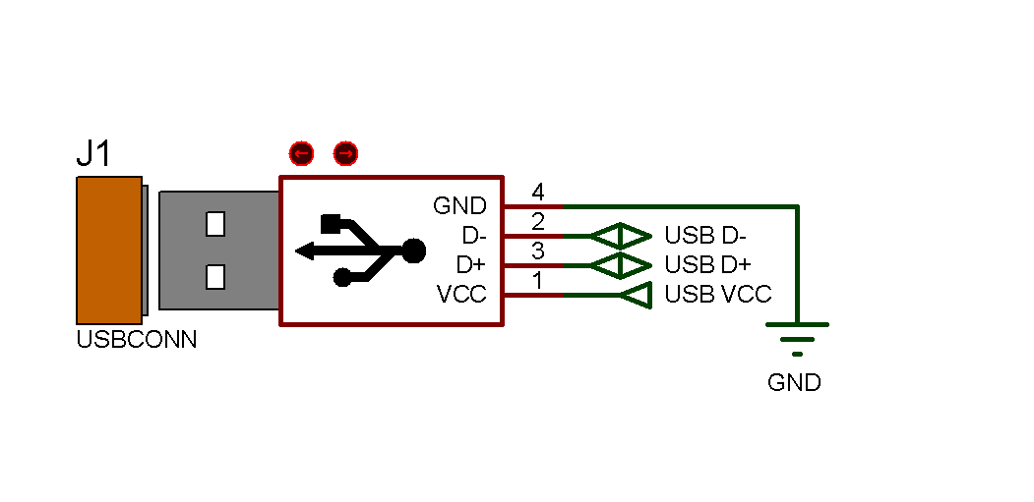

Figure 43: Proteus USB Module Schematic

Figure 44: Easy PC USB Module Schematic

The Proteus design in Figure 43 and the Easy PC Schematic in Figure 44 shows how the USB Module will interface with the PIC Microcontroller.

PIC Microcontroller Schematic
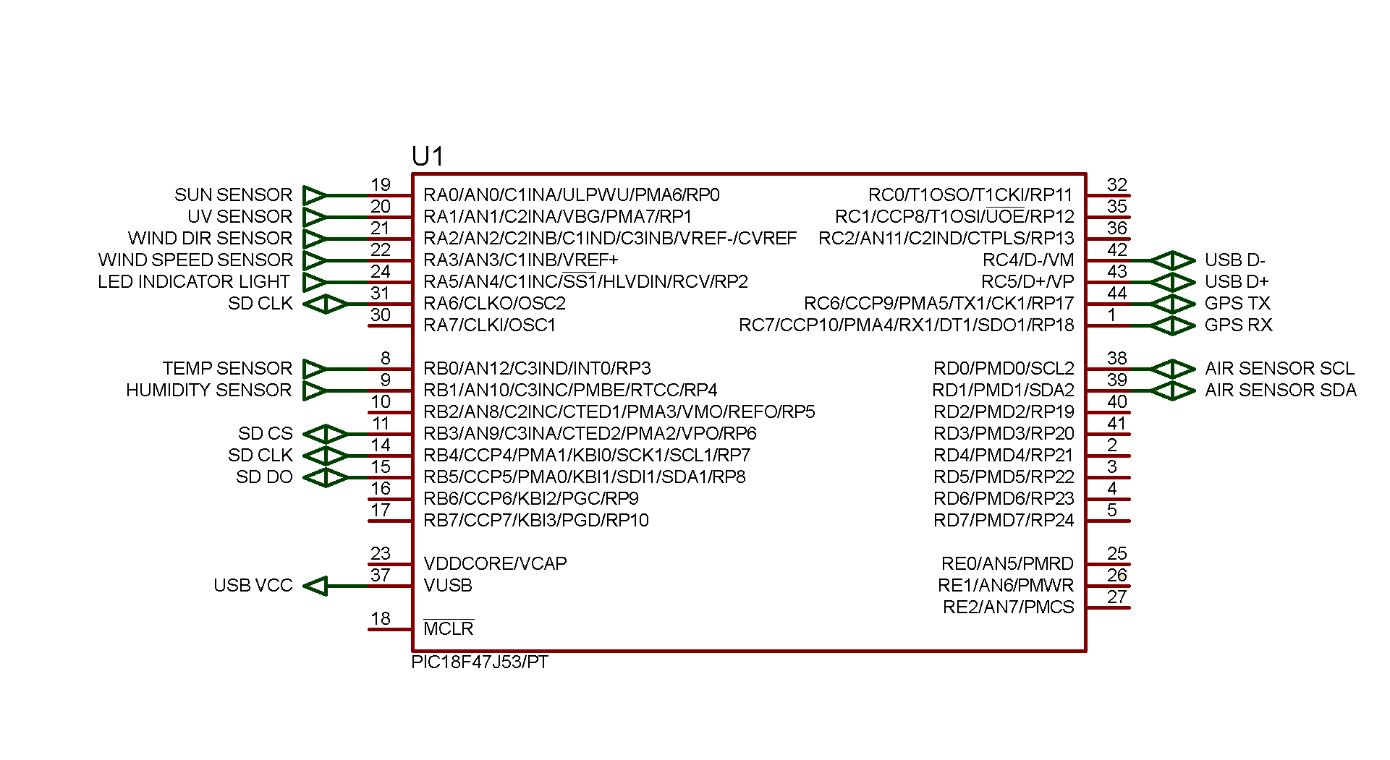
Figure 45: Proteus PIC Microcontroller Schematic

PIC Decoupler & PIC MCLR Schematic

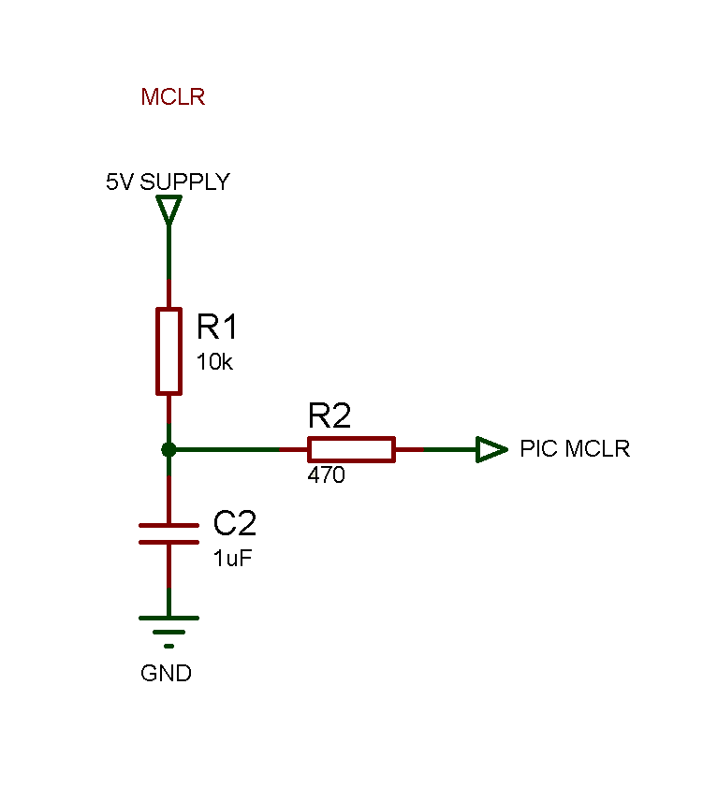
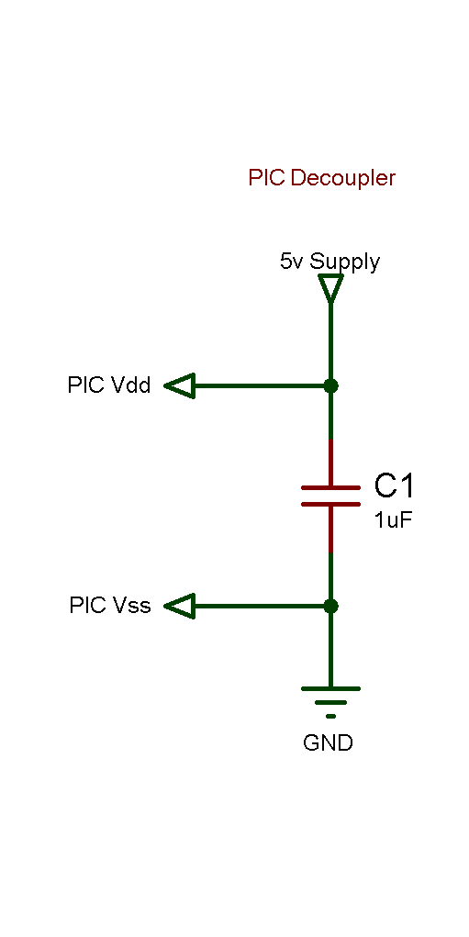

Figure 46: Proteus MCLR Schematic
Figure 47: Proteus PIC Decoupler

Figure 48: Easy PC PIC Microcontroller Schematic

The Proteus design in Figures 45 and the Easy PC Schematic in Figure 48 shows the interfacing of the PIC 18F47J53 Microcontroller to the peripherals and sensors. Note the Filter connected as well as the decoupling capacitors. All values and connections are as per datasheet.

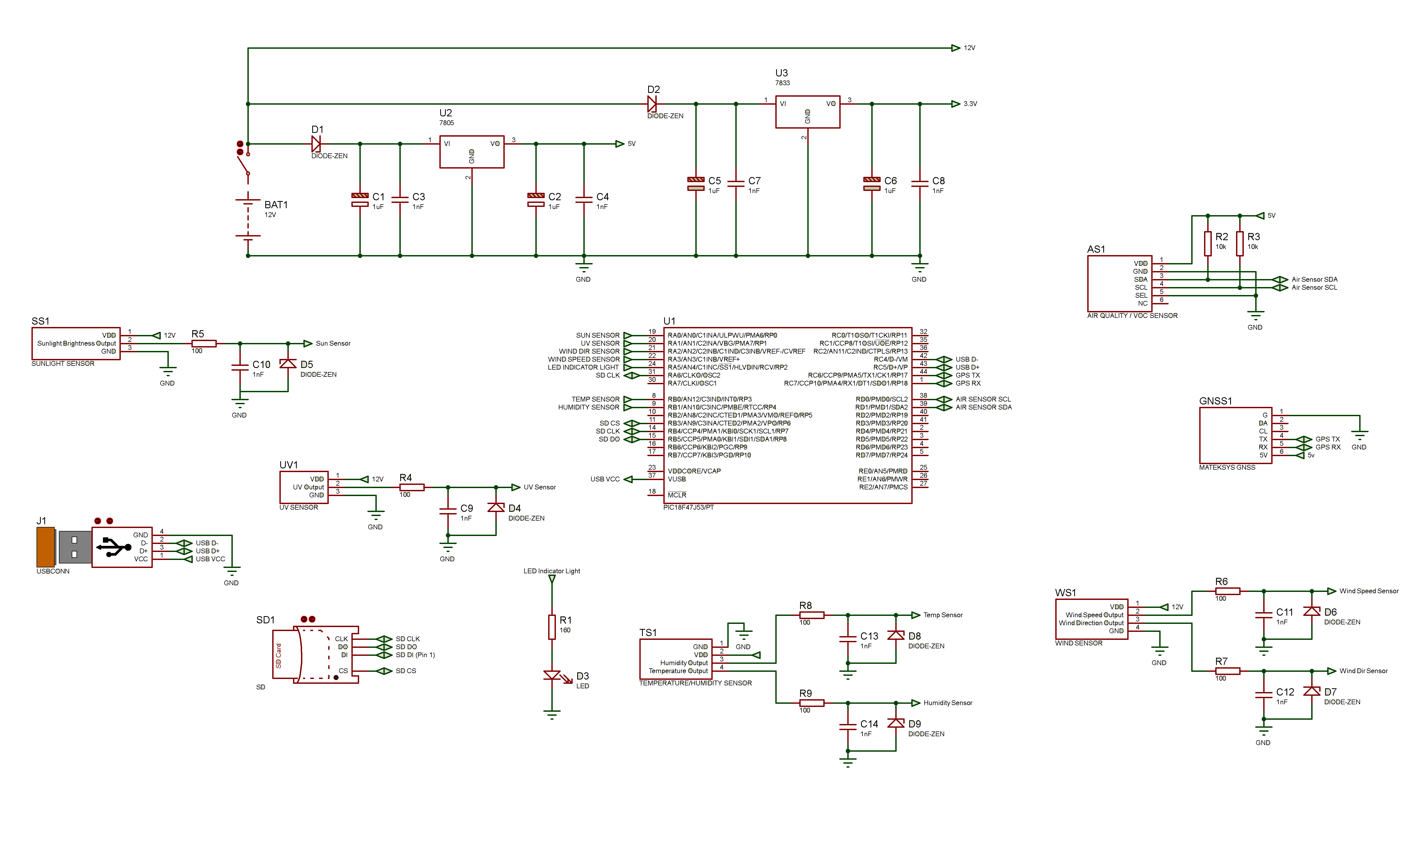
Figure 49: Proteus Schematic

Figure 50: Easy PC Schematic

PCB Schematic

Figure 51: Easy PC PCB Schematic

PCB Schematic (with Copper Pour)

Figure 52: Easy PC PCB Schematic (Copper Pour)

PCB Schematic 3D View (Top)

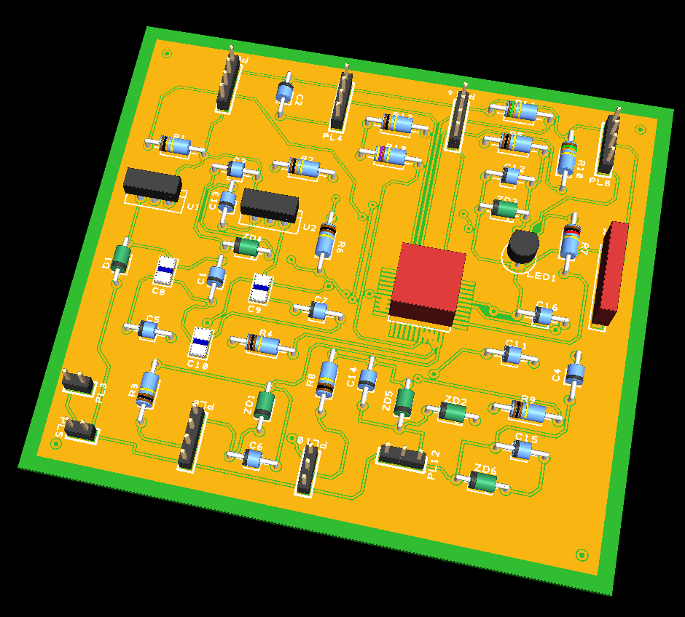
Figure 53: Easy PC PCB 3D View (Top)

PCB Schematic 3D View (Bottom)

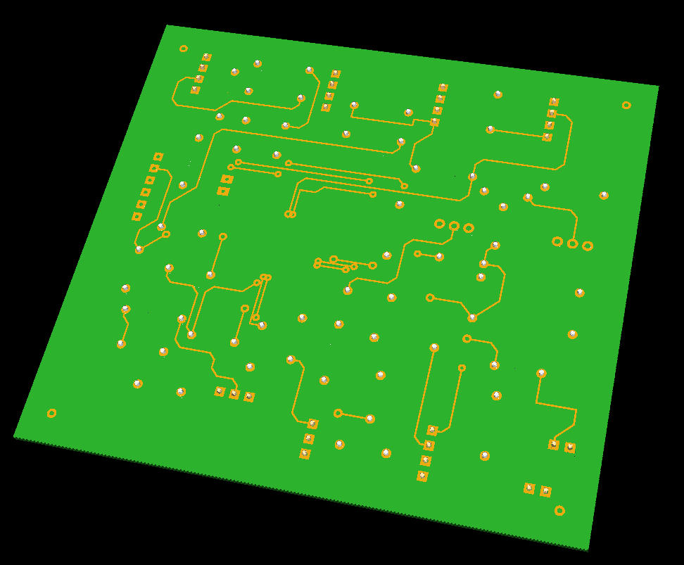
Figure 54: Easy PC PCB 3D View (Bottom)

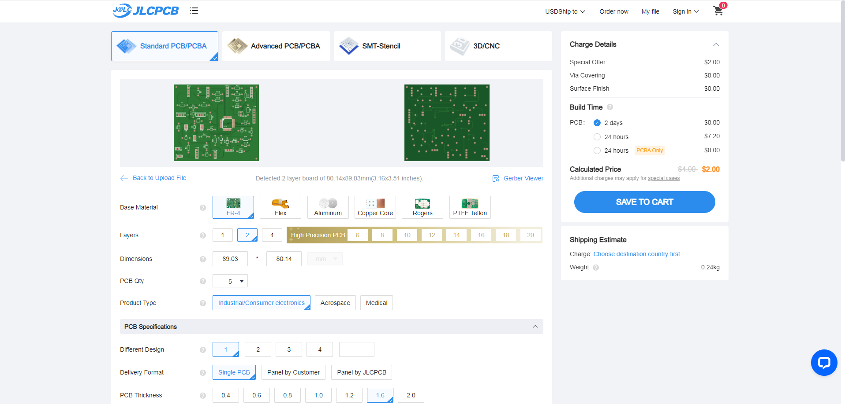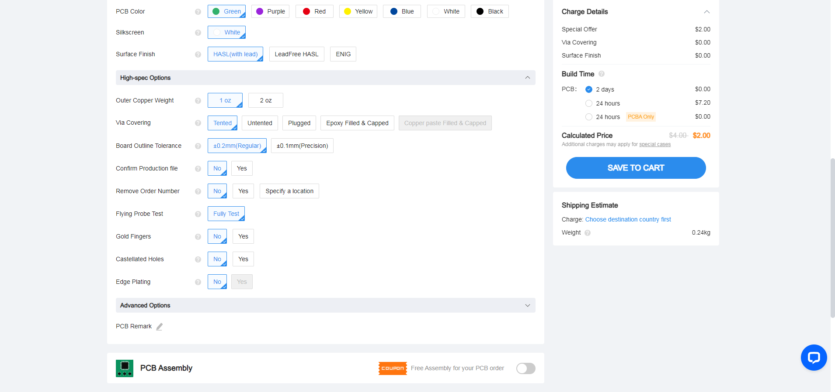

Figure 55: JLCPCB Website



Figure 56: PCB Build Costs

The Software

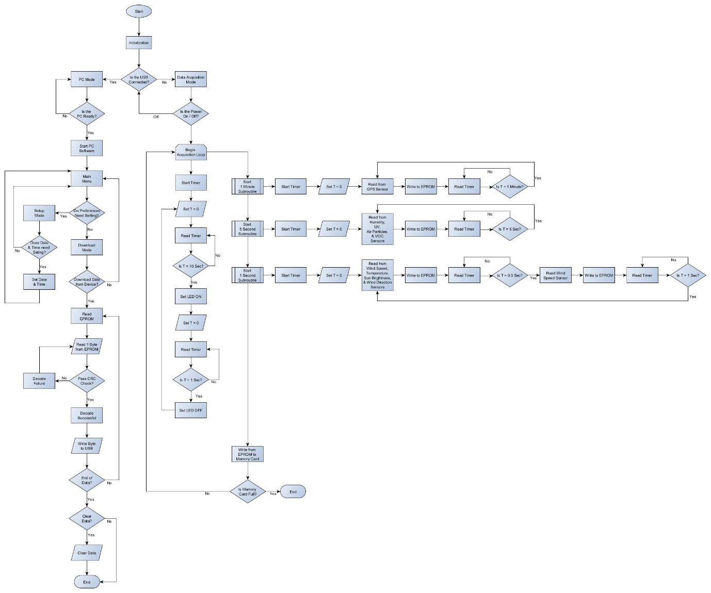
Figure 57: Software Flowchart
The block drawing in Figure 57 shows the complete software layout. A copy of the yEd file is included in the Appendix of this report for ease of view.
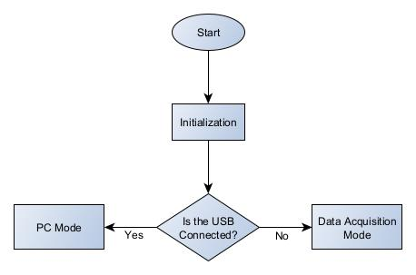

Figure 58: The Start of the Software

Figure 58 is the Start of the Software
Figure 59: Data Acquisition Mode
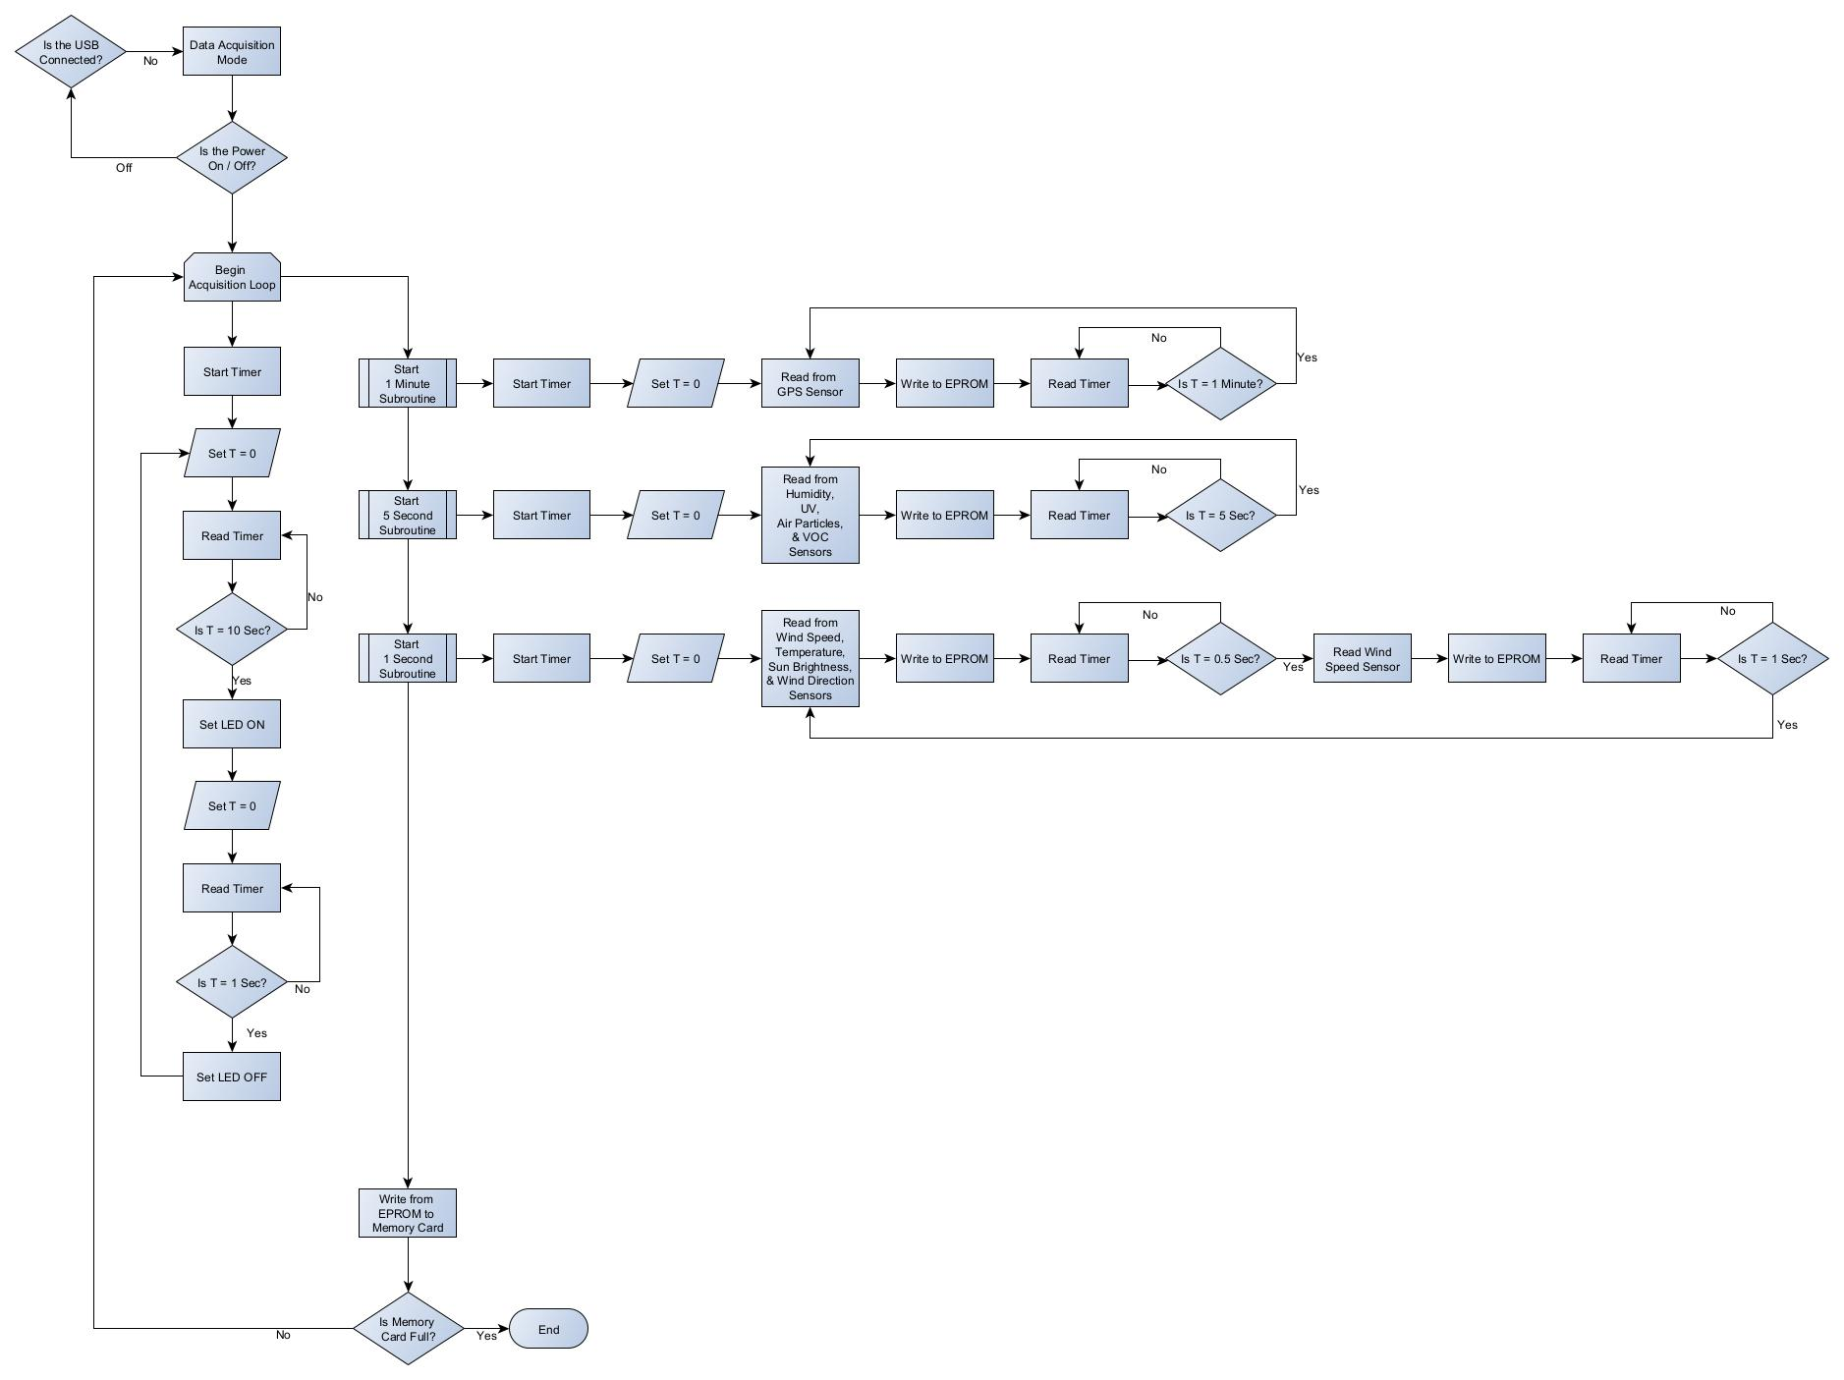
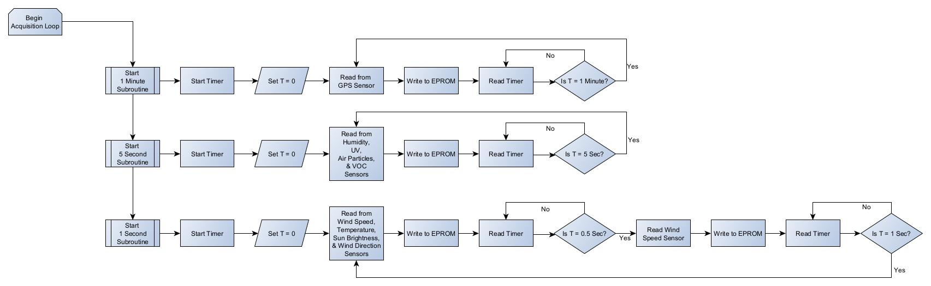
Figure 60: Acquisition Sub-Routines

Figures 59 and Figure 60 is the Weather Station Acquisition Mode, where Data is collected. Fig 59 shows the whole section, where Figure 60 concentrates on the subroutines. This method was decided on as the sensors collect data at different frequencies.

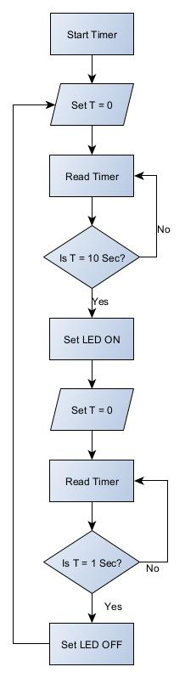

Figure 61: Flashing LED Indicator

The Output Requirement of this task requires the flashing LED indicator light to flash for 1 second every 10 seconds as shown in Figure 61. This part of the program runs simultaneously with the sub routines collecting data.

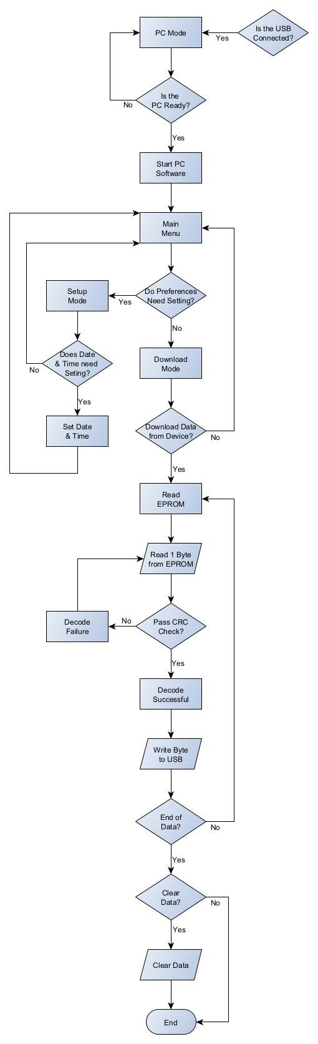

Figure 62: PC Download Mode

Figure 62 shows the software part that downloads the data from our Non Volatile Memory to the PC.

Costs and Figures

Component | Price/Item | Qty Required | Total Cost | Notes
Hardware Parts
TE Connectivity - HPP809A031 Temperature & Humidity Sensor | £93.23 | 1 | £93.23 | Temp. & Humid. Sensor
Gill - WindSonic 75 Anemometer | £1,443.00 | 1 | £1,443.00 | Wind Speed & Dir. Sensor
Sensirion - SEN54-SDN-T | £27.32 | 1 | £27.32 | Air Part & VOC Level Sensor
Campbell Scientific - CS320 | £265.00 | 1 | £265.00 | Sunlight Sensor
Solar Light - PMA1107 Analog Non-Weighted UVA+B Sensor | £425.00 | 1 | £425.00 | UV Sensor
MATEKSYS - M10Q-5883 GNSS | £31.10 | 1 | £31.10 | GPS Pos Sensor
PIC18F47J53 - Microcontroller | £4.63 | 1 | £4.63 | PIC  Microcontroller
RS PRO - Green Panel Mount Indicator | £15.36 | 1 | £15.36 | LED Indicator
Everything Smart - CH340 | £5.00 | 1 | £5.00 | USB Module
Components 101 - Diligent 410-380 | £6.96 | 1 | £6.96 | SD Card  Module
Pro Elec - PELR0233 | £0.86 | 1 | £0.86 | 12V Panel Switch
Varta - LED240 | £262.29 | 1 | £262.29 | Battery
NANUK - 960 Case | £332.43 | 1 | £332.43 | Battery Enclosure
Blue Sea Systems - Terminal Fuse Block | £34.99 | 1 | £34.99 | Terminal Fuse Block
Blue Sea Systems - Battery Fuse 30A | £22.60 | 1 | £22.60 | Battery Fuse
LotFancy - 3M-9MQF-X7LI | £31.67 | 2 | £63.34 | 4 Gauge Battery Wire
Ampper - Am-CBS01 | £12.99 | 1 | £12.99 | Battery Cut-Off Switch
Huazu - Fuse Block | £19.60 | 1 | £19.60 | Fuse Block
Nilight - 12 Volt Socket | £9.99 | 1 | £9.99 | 12 Volt Socket
Davis - Tripod | £172.30 | 1 | £172.30 | Tripod
Davis - Mounting Pole Kit | £60.00 | 1 | £60.00 | Mounting Pole
Evatron - Cabinet Enclosure | £31.13 | 1 | £31.13 | Enclosure
Shenzhen Technologies - Pole Bracket | £26.99 | 1 | £26.99 | Pole Bracket
Pro – Elec - SP 13 Series (3 Pin, IP68) | £8.28 / pair | 2 | £16.56 | Panel Mount Connectors
Pro – Elec - SP 13 Series (4 Pin, IP68) | £8.28 / pair | 4 | £33.12 | Panel Mount Connectors
 | Sub Total (Hardware) |  | £3,415.79
Table 30: Hardware Costs

Circuitry Parts (from mouser.co.uk) | Price/Item | Qty Required | Total Cost | Notes
TE Connectivity - Fixed Terminal Block (2 Pin) | £0.78 | 1 | £0.78 | PCB  Connectors
TE Connectivity - Fixed Terminal Block (3 Pin) | £1.14 | 2 | £2.28 | PCB  Connectors
TE Connectivity - Fixed Terminal Block (4 Pin) | £1.44 | 4 | £5.76 | PCB  Connectors
STMICROELECTRONICS L7805CV-DG | £0.74 | 1 | £0.74 | Voltage  Regulator (5V)
Texas Instruments LM1085IT-3.3/NOPB | £1.59 | 1 | £1.59 | Voltage  Regulator (5V)
STMicroelectronics 1N6263 | £0.35 | 2 | £0.70 | Schottky  Diode
Panasonic 20SEP150M+T | £1.39 | 2 | £2.78 | Capacitor -  150μF
KEMET ESS105M050AB2AA | £0.17 | 4 | £0.68 | Capacitor -  0.1μF
Vishay / BC Components K102J15C0GF53L2 | £0.34 | 10 | £3.40 | Capacitor -  1nF
Zener Diodes 5.1 Volt 0.5W 10% | £0.15 | 6 | £0.90 | Zener Diode -  5.1V
TE Connectivity / Neohm EP10WSS100RJBB | £1.81 | 6 | £10.86 | Resistor -  100 Ω
TE Connectivity / Neohm EP10WSS160RJBB | £0.85 | 1 | £0.85 | Resistor -  160 Ω
TE Connectivity / Neohm EP10WSS470RJBB | £1.43 | 1 | £1.43 | Resistor -  470 Ω
TE Connectivity / Neohm EP10WSS10KJBB | £1.36 | 3 | £4.08 | Resistor -  10 kΩ
TE Connectivity / Holsworthy EP9W15KJ | £0.80 | 2 | £1.60 | Resistor -  15 kΩ
PCB Board from JLCBCB.com | 2.54 | 1 | £2.54 | PCB Board
 | Sub Total (Circuitry) |  | £40.97
Table 31: Circuitry Costs

Miscellaneous Parts | Price/Item | Qty Required | Total Cost | Notes
SD Memory Card, 2GB - INSD2GV2 | £4.85 | 1 | £4.85 | SD Card
Irzaki - IR-EC-A08 | £15.99 | 1 | £15.99 | 12V Cord
 | Sub Total (Miscellaneous) |  | £20.84
Table 32: Miscellaneous Costs

Sub Total (Hardware) | £3,415.79
Sub Total (Circuitry) | £40.97
Sub Total (Miscellaneous) | £20.84
TOTAL PPROTOTYPE COST | £3,477.60
Table 33: Total Weather Station Build Costs

Please Note
The above costs do not include engineer’s time.

Summary
The project has been successful. Knowledge of Weather Stations, Data Acquisition, Microprocessors and Electronic Designs has been gained.

Conclusions
Did it meet the design specification?
The task requested that we design a simple microcontroller based Weather and Air Quality Monitoring Station. The Weather Station is designed to be fully portable and adaptable for any reasonable site it may be located at. It has enough power and memory storage in order to monitor and take measurements for a 14 day period.
Our Weather Station has been designed in a way that it is capable of obtaining the following data:
- Temperature
- Humidity
- Wind Speed
- Wind Direction
- Air borne particle count
- Sunlight brightness
- UV levels
- GPS position
- VOC level

Given the above, I conclude that the design meets the requirements and is therefore successful.

Recommendations for Improvements
Even though the system meets the design specification, if I was to replicate this project again, there are more features that could be added to the system in the future. The system could be improved by making component and software changes:
Component Changes:
- Wireless connectivity via 4G/5G technology for real time data transfer
- Replacing sensors for Electronic Micro Sensors. These would lower the cost and power requirement considerably. Also these would reduce the hardware setup. I chose not to use them during this project as it would rewire a lot of modifications to enclosure in order to maintain IP rating of the hardware.

Software Changes:
- The software could include a diagnostic option
- The software could include a program that warns the user via Mobile Device when weather conditions are above certain levels. I.e. Storm Warning

References

[1] | CPC, “Weather Meter / Weather Station Kit - SEN-15901,” 2024. [Online]. Available: https://cpc.farnell.com/sparkfun-electronics/sen-15901/weather-meter-kit/dp/MK00988. [Accessed 8 March 2024].
[2] | Weather Shop, “Davis Vantage Vue 6250UK - Highly Accurate & Robust, Optional Mobile Phone App/Web/PC Connectivity,” Weather Shop, 2024. [Online]. Available: https://www.weathershop.co.uk/davis-vantage-vue-weather-station. [Accessed 8 March 2024].
[3] | Farm Marketplace Ltd, “Sencrop Weather station - Irrigation stations + Pro plan subsc.,” Extra Digital, 2024. [Online]. Available: https://www.marketplace.farm/grain-storage/testing-and-monitoring/sencrop-irricrop-weather-station/. [Accessed 8 March 2024].
[4] | SB-Components, “BME280 Breakout - Temperature, Pressure, Humidity Sensor,” SB-Components, 2024. [Online]. Available: https://shop.sb-components.co.uk/products/bme280-breakout-temperature-pressure-humidity-sensor. [Accessed 8 March 2024].
[5] | RS Components Ltd, “TE Connectivity Temperature & Humidity Sensor,” RS Components Ltd, 2024. [Online]. Available: https://uk.rs-online.com/web/p/temperature-humidity-sensor-ics/8937373?gb=s. [Accessed 8 March 2024].
[6] | Farnell Limited, “OMEGA HX93BC, TEMPERATURE/HUMIDITY TRANSMITTER, 9-30V,” Premier Farnell Limited, 2024. [Online]. Available: https://uk.farnell.com/omega/hx93bc/temperature-humidity-transmitter/dp/3410282?st=omega%20hx93bc. [Accessed 8 March 2024].
[7] | Kempston Controls, “SCHNEIDER - TM1SHC4 HUMIDITY SENSOR,” Midland Automation Ltd, 2024. [Online]. Available: https://www.kempstoncontrols.com/TM1SHC4/Schneider/sku/1830029. [Accessed 8 March 2024].
[8] | Seeed Technology Co.,Ltd, “Grove - Temperature & Humidity Sensor,” Seeed Technology Co.,Ltd, 2024. [Online]. Available: https://www.seeedstudio.com/Grove-Temperature-Humidity-Sensor-V2-0-DHT20-p-4967.html?queryID=2d79ea30cb5f5094f53e29364264c23c&objectID=4967&indexName=bazaar_retailer_products. [Accessed 8 March 2024].
[9] | Vector Instruments, “Anemometers,” Windspeed Limited, 2024. [Online]. Available: https://www.windspeed.co.uk/ws/index.php?option=news&task=viewarticle&sid=5. [Accessed 8 March 2024].
[10] | Omni instruments, “WindMaster 3D Ultrasonic Anemometer,” Omni instruments, 2018. [Online]. Available: https://www.omniinstruments.co.uk/windmaster-3d-ultrasonic-anemometer.html. [Accessed 8 March 2024].
[11] | Richard Paul Russell Ltd, “Gill WindSonic 75 Anemometer,” Richard Paul Russell Ltd, 2024. [Online]. Available: https://r-p-r.co.uk/product/gill-windsonic-75-anemometer/. [Accessed 8 March 2024].
[12] | Distrelec, “101991044 - SenseCAP S200 Wind Speed and Direction Weather Sensor, Seeed Studio,” Distrelec Schweiz, 2024. [Online]. Available: https://www.distrelec.be/en/sensecap-s200-wind-speed-and-direction-weather-sensor-seeed-studio-101991044/p/30386206. [Accessed 8 March 2024].
[13] | Vector Instruments, “W200P/FC Potentiometer Windvane,” Windspeed Limited, 2024. [Online]. Available: https://www.windspeed.co.uk/ws/index.php?option=displaypage&op=page&Itemid=143. [Accessed 8 March 2024].
[14] | Alpha Controls & Instrumentation Inc, “IsoAir Pro-Plus Remote Particle Counter,” Alpha Controls & Instrumentation Inc, 2024. [Online]. Available: https://www.alphacontrols.com/IsoAir-Pro-Plus-Remote-Particle-Counter/model/7085. [Accessed 8 March 2024].
[15] | RS Components Ltd, “TERA Sensor Next-PM, Particle Matter / Dust Air Quality Sensor,” RS Components Ltd, 2024. [Online]. Available: https://uk.rs-online.com/web/p/environmental-sensor-ics/1953770?searchId=4b0398ca-2525-42ae-ac3c-da5b807a35e0&gb=s. [Accessed 8 March 2024].
[16] | Premier Farnell Limited, “SENSIRION SEN54-SDN-T,” Premier Farnell Limited, 2024. [Online]. Available: https://uk.farnell.com/sensirion/sen54-sdn-t/particle-sensor-dust-digital-5v/dp/3924519. [Accessed 8 March 2024].
[17] | Omni Instruments, “SP Lite2 Silicon Pyranometer,” Domain Design Agency, 2018. [Online]. Available: https://www.omniinstruments.co.uk/weather-stations-and-instruments/pyranometers-solar-irradiance/sp-lite2-silicon-pyranometer.html. [Accessed 8 March 2024].
[18] | Switch Electronics, “Photosensitive LDR Resistor Module,” Switch Electronics, 2024. [Online]. Available: https://www.switchelectronics.co.uk/products/photosensitive-ldr-resistor-module. [Accessed 8 March 2024].
[19] | Campbell Scientific, Inc, “CS320,” Campbell Scientific, Inc, 2024. [Online]. Available: https://www.campbellsci.com/cs320. [Accessed 8 March 2024].
[20] | Adafruit, “Adafruit VEML6075 UVA UVB and UV Index Sensor Breakout,” Adafruit, 2024. [Online]. Available: https://www.adafruit.com/product/3964. [Accessed 8 March 2024].
[21] | Solar Light, “Model PMA1107 Analog Non-Weighted UVA+B Sensor,” Solar Light Company, 2022. [Online]. Available: https://solarlight.com/product/uvauvbsensorpma1107/. [Accessed 8 March 2024].
[22] | BLET-ATMOS, “Precision UV Radiometer,” BLET-ATMOS, 2024. [Online]. Available: https://www.atmos-meteo.com/sensors/precision-uv-radiometer.html. [Accessed 8 March 2024].
[23] | PIMORONI LTD, “PA1010D GPS Breakout,” PIMORONI LTD, 2024. [Online]. Available: https://shop.pimoroni.com/products/pa1010d-gps-breakout?variant=32257258881107. [Accessed 8 March 2024].
[24] | YourFPV, “MATEKSYS M10Q-5883 GNSS & Compass,” YourFPV, 2024. [Online]. Available: https://yourfpv.co.uk/product/mateksys-m10q-5883-gnss-compass/. [Accessed 8 March 2024].
[25] | ESG-JETI-FIALA UK, “MAV Sense GPS sensor and logger,” ESG-JETI-FIALA UK, 2024. [Online]. Available: https://esoaringgadgets.co.uk/mavsence-gps-sensor-and-logger.html. [Accessed 8 March 2024].
[26] | Measurement Systems Ltd, “AQDTF Duct Air Quality VOC Sensor,” Measurement Systems Ltd, 2024. [Online]. Available: https://www.measurementsystems.co.uk/sensors_and_meters/air_quality_and_gas_sensors/aqdtf-duct-air-quality-voc-sensor. [Accessed 8 March 2024].
[27] | Cool Components, “SGP30 Air Quality Sensor Breakout - VOC and eCO2 (ID: 2458),” Cool Components, 2024. [Online]. Available: https://coolcomponents.co.uk/products/sgp30-air-quality-sensor-breakout-voc-and-eco2. [Accessed 8 March 2024].
[28] | Microchip, “Microchip Advanced Part Selector,” Microchip, 21 November 2023. [Online]. Available: https://www.microchip.com/maps/microcontroller.aspx. [Accessed 2023 November 2023].
[29] | Climates to travel, “Climate - Siberia,” Climates to travel, 2024. [Online]. Available: https://www.climatestotravel.com/climate/siberia. [Accessed 9 March 2024].
[30] | Arizona State University, “World: Highest Temperature,” Arizona State University, 2024. [Online]. Available: https://wmo.asu.edu/content/world-highest-temperature. [Accessed 9 March 2024].
[31] | World Population Review, “Most Humid Cities in the World 2024,” World Population Review, 2024. [Online]. Available: https://worldpopulationreview.com/world-city-rankings/most-humid-cities-in-the-world. [Accessed 9 March 2024].
[32] | National Hurricane Centre and Central Pacific Hurricane Centre, “Saffir-Simpson Hurricane Wind Scale,” National Hurricane Centre and Central Pacific Hurricane Centre, 2024. [Online]. Available: https://www.nhc.noaa.gov/aboutsshws.php. [Accessed 9 March 2024].
[33] | Breeze Technologies, “Air pollution – How to convert between mg/m3, µg/m3 and ppm, ppb,” Breeze Technologies, 20 August 2021. [Online]. Available: https://www.breeze-technologies.de/blog/air-pollution-how-to-convert-between-mgm3-%C2%B5gm3-ppm-ppb/. [Accessed 9 March 2024].
[34] | H. Junaidi, “All you need to know about Solar Radiation,” Synergy Files, 2021. [Online]. Available: http://synergyfiles.com/2016/05/solar-radiation/#:~:text=The%20maximum%20recorded%20direct%20solar,recorded%20is%201120%20W%2Fm2.. [Accessed 9 March 2024].
[35] | United States Enviromental Protection Agency, “Learn About the UV Index,” United States Enviromental Protection Agency, 5 February 2024. [Online]. Available: https://www.epa.gov/sunsafety/learn-about-uv-index. [Accessed 9 March 2024].
[36] | E. Gakstatter, “https://www.gpsworld.com/what-exactly-is-gps-nmea-data/,” GPS World, 4 February 2015. [Online]. Available: https://www.gpsworld.com/what-exactly-is-gps-nmea-data/. [Accessed 9 March 2024].
[37] | T. Knudsen, “The Air Quality Index (AQI) Basics & Beyond,” Lane Regional Air Protection Agency, 27 October 2022. [Online]. Available: https://www.lrapa.org/aqi101/. [Accessed 9 March 2024].
[38] | RS Components Ltd, “RS PRO Green Panel Mount Indicator, 1.8 → 3.3V dc, 14mm Mounting Hole Size, Lead Wires Termination, IP67,” RS Components Ltd, 2024. [Online]. Available: https://uk.rs-online.com/web/p/panel-mount-indicators/1301096?gb=s. [Accessed 9 March 2024].
[39] | Everything Smart Technology, “USB-C To UART Serial Adapter - CH340,” Everything Smart Technology, 2024. [Online]. Available: https://shop.everythingsmart.io/products/usb-c-to-serial-adapter. [Accessed 9 March 2024].
[40] | RS Components Ltd, “Development Kit Pmod MicroSD Card Slot for use with Store and Access On System Board,” RS Components Ltd, 2024. [Online]. Available: https://uk.rs-online.com/web/p/memory-development-tools/1840482?gb=s. [Accessed 9 March 2024].
[41] | Premier Farnell Limited, “Panel Mount Rocker Switch, Red, On / Off, SPDT, Green, 250V AC, 6A - PELR0233,” Avnet, 2024. [Online]. Available: https://cpc.farnell.com/unbranded/abrr016/switch-rocker-spst-green-250vac/dp/SW02923?ost=panel+mount+rocker+switch%2C+red%2C+on+%2F+off%2C+spdt%2C+green%2C+250v+ac%2C+6a+-&cfm=true&pm=true. [Accessed 9 March 2024].
[42] | Powerland, “VARTA LED240 PROFESSIONAL DUAL PURPOSE EFB LEISURE BATTERY 240AH (LFD230) (930240120),” Shopify, 2024. [Online]. Available: https://www.powerland.co.uk/collections/marine-batteries/products/varta-led240-professional-dual-purpose-efb-leisure-battery-240ah-lfd230-930240120-1. [Accessed 9 March 2024].
[43] | Roamer Batteries, “24-230SMART3,” Roamer Batteries, 2024. [Online]. Available: https://roamer.com/products/24-230smart?_pos=1&_sid=a28ebb3eb&_ss=r. [Accessed 9 March 2024].
[44] | Alpha Batteries Limited, “12V 250AH Expedition Plus Lead Carbon Gel Ultra Deep Cycle Battery (EXP12-250C),” Alpha Batteries Limited, 2024. [Online]. Available: https://www.alpha-batteries.co.uk/12v-250ah-expedition-plus-lead-carbon-gel-ultra-deep-cycle-battery-exp12-250c/. [Accessed 9 March 2024].
[45] | Cases UK, “NANUK 960 Case,” SAM Cases Ltd, 2024. [Online]. Available: https://www.casesuk.com/nanuk-cases/nanuk-960-case.html. [Accessed 9 March 2024].
[46] | MetCheck, “MetSpec M14 Mini Polycarbonate Stevenson Screen,” MetCheck, 2024. [Online]. Available: https://www.metcheck.co.uk/products/metspec-m14-mini-polycarbonate-stevenson-screen. [Accessed 9 March 2024].
[47] | Protective Cases, “SKB 3I-2424-10B-C Case With Cubed Foam,” Protective Cases, 2024. [Online]. Available: https://www.protective-cases.co.uk/product/skb-3i-2424-10b-c-case-with-cubed-foam_3901. [Accessed 9 March 2024].
[48] | Amazon.com, “Blue Sea Systems MRBF Terminal Fuse Blocks,” Amazon.com, 2024. [Online]. Available: https://www.amazon.co.uk/Blue-Systems-MRBF-Terminal-Blocks/dp/B0019ZBTV4?th=1. [Accessed 2024 March 2024].
[49] | Amazon.com, “Blue Sea Systems Terminal Fuses,” Amazon.com, 2024. [Online]. Available: https://www.amazon.co.uk/Blue-Sea-Systems-5187-Terminal/dp/B00198FP8Y/ref=pd_lpo_sccl_2/258-6860703-1721369?pd_rd_w=Xgbyx&content-id=amzn1.sym.448aab69-6fff-42b9-9d7a-f6325052a6f6&pf_rd_p=448aab69-6fff-42b9-9d7a-f6325052a6f6&pf_rd_r=7K7B16KG6RGYMPBVM0SZ&p. [Accessed 9 March 2024].
[50] | Amazon.com, “LotFancy 4 AWG Battery Cables 5/16" in Lugs, 24 Inch Power Inverter Cables with Terminals for Car Marine Solar ATV Lawn Mower Motorcycle, (Positive and Negative),” Amazon.com, 2024. [Online]. Available: https://www.amazon.co.uk/LotFancy-Inverter-Terminals-Motorcycle-Positive/dp/B07YD4V5ZW?th=1. [Accessed 9 March 2024].
[51] | Amazon.com, “Ampper Battery Switch, 12-48 V Battery Power Cut Master Switch Disconnect Isolator for Car, Vehicle, RV and Boat (On/Off),” Amazon.com, 2024. [Online]. Available: https://www.amazon.co.uk/Ampper-Battery-Switches-12-Disconnect/dp/B07413JWLD/ref=asc_df_B07413JWLD/?tag=googshopuk-21&linkCode=df0&hvadid=534929732553&hvpos=&hvnetw=g&hvrand=6170642811496463557&hvpone=&hvptwo=&hvqmt=&hvdev=c&hvdvcmdl=&hvlocint=&hvlocphy=1. [Accessed 9 March 2024].
[52] | Amazon.com, “Fuse Block, Huazu 12V Fuse Box with LED Indicator Waterproof Cover 6 Circuits with Negative Bus Fuse Panel for DC 12V/24V Car Marine Boat RV Trailer Truck Van Vehicle,” Amazon.com, 2024. [Online]. Available: https://www.amazon.co.uk/Huazu-Indicator-Waterproof-Circuits-Negative/dp/B09VGCCD9R. [Accessed 9 March 2024].
[53] | Amazon.com, “Nilight 2 Pack Car Cigarette Lighter Socket DC 12V Waterproof Power Outlet Adapter Replacement with Terminals Wires and Screws for Marine Boat Motorcycle, Boat, Car,Truck, RV, ATV,2 Years Warranty,” Amazon.com, 2024. [Online]. Available: https://www.amazon.co.uk/Nilight-50054B-Waterproof-Replacement-Motorcycle/dp/B082D8WKNW. [Accessed 9 March 2024].
[54] | Amazon.com, “26FT 12V-24V Car Cigarette Lighter Extension Cord Heavy Duty 15A Fuse Extension Cable Plug to Socket for Air Compressor Pump 16AWG Male to Female Socket,” Amazon.com, 2024. [Online]. Available: https://www.amazon.co.uk/12V-24V-Cigarette-Lighter-Extension-Compressor/dp/B0C61F1V98/ref=sr_1_2?dib=eyJ2IjoiMSJ9.rstfy8PKCBeMBzT_c0O65WcLX5YSuOp1mDKckyKNgJcZl0wdTyhz4LarD1MHH33svmiRhjFMPJXCZ17irrrnSaiQTTKAJCmN0aANmBVqcxRMiO7LDrI6TJP4BO3vWUK4LdhWibKJAtgZ7. [Accessed 9 March 2024].
[55] | Weather Shop, “Davis EZ-Mount Tripod with Lag Bolts (for in-ground mounting),” Weather Shop, 2024. [Online]. Available: https://www.weathershop.co.uk/davis-7716a-tripod-with-lag-bolts. [Accessed 9 March 2024].
[56] | Weather Shop, “Davis Mounting Pole Kit,” Weather Shop, 2024. [Online]. Available: https://www.weathershop.co.uk/accessories/spares-by-brands/davis-spare-parts-accessories/davis-7717-mounting-pole-kit. [Accessed 9 March 2024].
[57] | Evatron Plastic Enclosures Ltd, “DED001 – Cabinet Enclosure,” Evatron Plastic Enclosures Ltd, 2024. [Online]. Available: https://evatron.com/enclosures/ip-rated-enclosures/ip65-enclosures/ded001-cabinet-enclosure/?gad_source=1&gclid=CjwKCAiAi6uvBhADEiwAWiyRdomocI_G3FUUfu9i4-Q8F79cuZOwCXz05qOv8EK7T8NCcOKpN5iXdxoCT_IQAvD_BwE. [Accessed 9 March 2024].
[58] | Amazon.com, “WiTi 2PACK Vertical Pole Mount for Security Camera, Stainless Steel Mounting Corner Bracket with 3 Loop Pipe Clamps, Suitable for CCTV Cameras LED Wall/Stage Lights, Solar Panels (small size),” Amazon.com, 2024. [Online]. Available: https://www.amazon.co.uk/dp/B0C3LPVFVF/ref=sspa_dk_detail_3?psc=1&pd_rd_i=B0C3LPVFVF&pd_rd_w=x25Go&content-id=amzn1.sym.84ea1bf1-65a8-4363-b8f5-f0df58cbb686&pf_rd_p=84ea1bf1-65a8-4363-b8f5-f0df58cbb686&pf_rd_r=405NP0TXF0MQM1YV0375&pd_rd_wg=Dw7ui&pd_rd_r=a. [Accessed 9 March 2024].
[59] | Component Buddy, “SP2912/S Series,” Component Buddy, 2024. [Online]. Available: https://componentbuddy.com/product/sp29-panel-mount-connectors-female/. [Accessed 9 March 2024].
[60] | Premier Farnell Limited, “XLR Socket, 3 Pole, PCB, Vertical - NC3FAAV2,” Avnet, 2024. [Online]. Available: https://cpc.farnell.com/neutrik/nc3faav2/xlr-socket-3p-pcb-vert/dp/AV15739?st=3%20pole%20xlr%20socket. [Accessed 9 March 2024].
[61] | Premier Farnell Limited, “Circular Threaded Panel Mount Connector Socket, 3-Pole, IP68 - PELR0192,” Avnet, 2024. [Online]. Available: https://cpc.farnell.com/mbs-connect/sp2112-s3-1c/circular-panel-socket-3-pole/dp/CN21385?st=pro%20elec%20sp%2013%20series. [Accessed 9 March 2024].
[62] | reichelt elektronik GmbH, “PS 25/10W BR PCB connector angled, brown, 10-pin,” reichelt elektronik GmbH, 2024. [Online]. Available: https://www.reichelt.com/at/en/pcb-connector-angled-brown-10-pin-ps-25-10w-br-p47229.html?&trstct=pos_2&nbc=1. [Accessed 9 March 2024].
[63] | Premier Farnell Limited, “MOLEX 26-60-4043,” Avnet, 2024. [Online]. Available: https://uk.farnell.com/molex/26-60-4043/connector-header-4pos-1row-3-96mm/dp/3049003?st=molex%20pin%20header. [Accessed 9 March 2024].
[64] | Mouser Electronics, “282851-4,” Mouser Electronics, 2024. [Online]. Available: https://www.mouser.co.uk/ProductDetail/TE-Connectivity/282851-4?qs=qTrdGJE%2F%252BQz%252BSpIukU4Srg%3D%3D. [Accessed 9 March 2024].

Appendix

Appendix 1 – yEd Software File

Appendix 2 – Links to all Components

Component | Link
TE Connectivity - HPP809A031 Temperature & Humidity Sensor | https://uk.rs-online.com/web/p/temperature-humidity-sensor-ics/8937373?gb=s
Gill - WindSonic 75 Anemometer | https://r-p-r.co.uk/product/gill-windsonic-75-anemometer/
Sensirion - SEN54-SDN-T | https://uk.farnell.com/sensirion/sen54-sdn-t/particle-sensor-dust-digital-5v/dp/3924519
Campbell Scientific - CS320 | https://www.campbellsci.com/cs320
Solar Light - PMA1107 Analog Non-Weighted UVA+B Sensor | https://solarlight.com/product/uvauvbsensorpma1107/
MATEKSYS - M10Q-5883 GNSS | www.yourfpv.co.uk/product/mateksys-m10q-5883-gnss-compass/
PIC18F47J53 - Microcontroller | https://www.mouser.co.uk/ProductDetail/Microchip-Technology/PIC18F47J53-I-PT?qs=jecpP1bYcZSkJi3F6cR9zw%3D%3D
RS PRO - Green Panel Mount Indicator | https://uk.rs-online.com/web/p/panel-mount-indicators/1301096?gb=s
Everything Smart - CH340 | https://shop.everythingsmart.io/products/usb-c-to-serial-adapter
Components 101 - Diligent 410-380 | https://uk.rs-online.com/web/p/memory-development-tools/1840482?gb=s
Pro Elec - PELR0233 | https://cpc.farnell.com/unbranded/abrr016/switch-rocker-spst-green-250vac/dp/SW02923?ost=pelr0233
Varta - LED240 | https://www.powerland.co.uk/collections/marine-batteries/products/varta-led240-professional-dual-purpose-efb-leisure-battery-240ah-lfd230-930240120-1
NANUK - 960 Case | https://www.casesuk.com/nanuk-cases/nanuk-960-case.html
Blue Sea Systems - Terminal Fuse Block | https://www.amazon.co.uk/AUTOHAUX-250A-Battery-Terminal-Block/dp/B0BBFQ3W2H/ref=sr_1_58?crid=D9WZ26PGSLNP&dib=eyJ2IjoiMSJ9.1MBpac3Cke9Ap_LjhoZlJWCIpeMRMzHqmmRj84rFpks9fzKdHKemySwUDVCBQb0JnbxvD5mvtHE5hFMqTH5IS_-AAIRRS93tlO2xKG0kfey41DqvWxiMs2HcU05ftPqi5bDoR6StdKcv3iGSM1puOJdWkFtKwTcr-FXucuxOXv-RwvMUo15CRdRMPv_hJeAHBOiIAoLh3zPd3g5_ouPW8n-kiJvGgp1HFUdhaG89mAmw8weJwDbK1M8xZIKZBcF1TROtd2tQRT5hRd-5oZdj8VNcZ3ID8d2063MXRaDDpMs.7B94T3gD0FEq3D0EQHj9vdwFeEsp1JCtOeuCA55wLoc&dib_tag=se&keywords=Blue%2BSea%2BSystems%2Bterminal%2Bfuse%2Bblock&qid=1710674734&sprefix=blue%2Bsea%2Bsystems%2Bterminal%2Bfuse%2Bblock%2Caps%2C99&sr=8-58&th=1
Blue Sea Systems - Battery Fuse 30A | https://www.amazon.co.uk/BLUE-SEA-5186-FUSE-TERMINAL/dp/B00198FP8Y/ref=sr_1_7?crid=1IY1QCBC1QAYM&dib=eyJ2IjoiMSJ9.1MBpac3Cke9Ap_LjhoZlJWCIpeMRMzHqmmRj84rFpks9fzKdHKemySwUDVCBQb0JnbxvD5mvtHE5hFMqTH5IS_-AAIRRS93tlO2xKG0kfey41DqvWxiMs2HcU05ftPqi5bDoR6StdKcv3iGSM1puOJdWkFtKwTcr-FXucuxOXv-RwvMUo15CRdRMPv_hJeAHBOiIAoLh3zPd3g5_ouPW8n-kiJvGgp1HFUdhaG89mAmw8weJwDbK1M8xZIKZBcF1TROtd2tQRT5hRd-5oZdj8VNcZ3ID8d2063MXRaDDpMs.7B94T3gD0FEq3D0EQHj9vdwFeEsp1JCtOeuCA55wLoc&dib_tag=se&keywords=Blue%2BSea%2BSystems%2BTerminal%2BFuse%2BBlock&qid=1710674642&sprefix=blue%2Bsea%2Bsystems%2Bterminal%2Bfuse%2Bblock%2Caps%2C103&sr=8-7&th=1
LotFancy - 3M-9MQF-X7LI | https://www.amazon.co.uk/LotFancy-Inverter-Terminals-Motorcycle-Positive/dp/B07YD4V5ZW/?_encoding=UTF8&pd_rd_w=sfo2Z&content-id=amzn1.sym.f4bf6248-c25e-4846-ab32-07f8b3e1cc4d%3Aamzn1.symc.afd86303-4a72-4e34-8f6b-19828329e602&pf_rd_p=f4bf6248-c25e-4846-ab32-07f8b3e1cc4d&pf_rd_r=PRP1H6BWHTB3G1XPP60M&pd_rd_wg=z5VId&pd_rd_r=538c41a5-247e-4c2f-9f1c-58bb874acba2&ref_=pd_gw_ci_mcx_mr_hp_atf_m&th=1
Ampper - Am-CBS01 | https://www.amazon.co.uk/Ampper-Battery-Switches-12-Disconnect/dp/B07413JWLD/ref=sr_1_12_sspa?crid=3K5F1TUOT9R4&dib=eyJ2IjoiMSJ9.LJvkofHxt-xYxu7II-egx5yi0hyOfkOCNCaW0WA0oLK2vsfNYjr3rSgNg9XZMzPI1m0vASR3nfEeL6NL7mX1y0P4cexT38g76tkO6ZtUOEGg0Ru0Q9dOZ28jWtQX19tvFsFz7M2YlKsVK1tAUkpYN_0oOrcm1LK1W99D6zum6fdYX6n9DY9oZEo26ue6sv9eh6YJ7Iox_gOPeXGe4m7mnwYSXAkx2NIdkkhH9NwO5EaLs30DUUqtikCDDLjRuaWRAlbdFn_qRuch_bd-CCbUGccjNDsJbG7RlZCTGcY47XA.rPn8R3yIjjXptrp7sNMT_wPP99XXWRW5egZIdU7-7MI&dib_tag=se&keywords=Blue+Sea+Systems&qid=1710674487&sprefix=blue+sea+systems%2Caps%2C172&sr=8-12-spons&sp_csd=d2lkZ2V0TmFtZT1zcF9tdGY&psc=1
Huazu - Fuse Block | https://www.amazon.co.uk/KAOLALI-Negative-Indicator-Damp-Proof-Automotive/dp/B08HYD3JL7/ref=sr_1_12?crid=J2CILERSMNKH&dib=eyJ2IjoiMSJ9.5zXkeKAIJiHBSEQwQMfX3GBlxjQJ9RxZ-omImw-kggM1XgkU6SCr7IdXZz7XtlnQsZOPrOO-JPAYfrExIEM8JTCbBUVyid-Pnhd7LHlvsXQq2Va0pFVsMSjfhJ2sC8JktXpMNUfAUiFiGA58Dyy_FqV4MYtFe2mJiFguFzsIIZnMOVeu96_6nxt8A3Is6tOiZ4g7kSqKkhlNdlbvLPK09fdKBLnMft1fyP0Q_7o7OVI3D62jtaQv_CL-TfaKwxmEHDYYL3fLMbXJK9_frOVTmcbL1kh7JjmMrIRnVuGBIzg.e4VLZ3Iv-7ZXjSilCs3aI2qxOPLPXq-3pKx2F12ewWQ&dib_tag=se&keywords=Huazu%2B-%2BFuse%2BBlock&qid=1710674828&s=automotive&sprefix=huazu%2B-%2Bfuse%2Bblock%2Cautomotive%2C90&sr=1-12&th=1
Nilight - 12 Volt Socket | https://www.amazon.co.uk/Digit-Tail-Cigarette-Lighter-Socket-Waterproof/dp/B08H1465P1/ref=sr_1_9?crid=9L7Y9N3MX9MI&dib=eyJ2IjoiMSJ9.Nl7TY-w0qYnubxJwziPulaOsJffIY-xkeFrsJCE1jepm8jiZPXWsy_LvUfnsUMPmp2znMvZQXP-zA2AQFuzijoZz_lunPfEnP0-rVLDsXylKcbZP0V0oATfRkUztSpJrceDRCAIGazHHP4gFM21RdipSQnd5HMezovY_WL1MjRkhSQ-S3Mi8qAkh0EJpLaC4sTHfptoxFZ3iVnW6K-QKDJfjWO71xlNnkqcUY-F8ll5Rh65bJBFUU-dWn8HbF1sO8ohn86b5-ZotdCnbWjKNVNmidXSZbE6xAgahE1H0Q-U.hI7rcTgkOggwr3aolqROj6ehovUuaCnfX2jiuMP7VDg&dib_tag=se&keywords=12v+socket&qid=1710674980&s=automotive&sprefix=12v+socket%2Cautomotive%2C92&sr=1-9
Davis - Tripod | https://www.weathershop.co.uk/davis-7716a-tripod-with-lag-bolts
Davis - Mounting Pole Kit | https://www.weathershop.co.uk/accessories/spares-by-brands/davis-spare-parts-accessories/davis-7717-mounting-pole-kit
Evatron - Cabinet Enclosure | https://evatron.com/enclosures/ip-rated-enclosures/ip65-enclosures/ded001-cabinet-enclosure/
Shenzhen Technologies - Pole Bracket | https://www.amazon.co.uk/WiTi-Vertical-Security-Stainless-Mounting/dp/B0C3LPVFVF/ref=sr_1_9?crid=2LH5CFE2JEUVV&dib=eyJ2IjoiMSJ9.Pavu3A_nO1sFsbl5f_g3iqj0t3ggIbN_b-ibOLzFbVBPENKl5_9xWvj89DV8UMIs9qNLwjkx1htbTLl6BeEVycdaHtnr7M9kTyF5pI-kdMtlJsQhZgcuD2ZK-qy7SjWId4ujVW1H4s2W8raXvClhQPri_d5iJ3IpFG31a0ouASDWivFTcH8j9XcYNXUgSDr4-YjlXG3A8-meCsd69eYwQmvjrPqkglMwCWT40Qw2j8c.N-rlPc8ezz_EC18lFychZrrWNqxyDp0XpmbM-BVyUG4&dib_tag=se&keywords=SHENZHEN+TECHNOLOGIES+Pole+Bracket&qid=1710675413&sprefix=shenzhen+technologies+pole+bracket%2Caps%2C89&sr=8-9
Pro – Elec - SP 13 Series (3 Pin, IP68) | https://cpc.farnell.com/mbs-connect/sp2112-s3-1c/circular-panel-socket-3-pole/dp/CN21385?st=pro%20elec%20sp%2013%20series
Pro – Elec - SP 13 Series (4 Pin, IP68) | https://cpc.farnell.com/mbs-connect/sp2112-s4-1c/circular-panel-socket-4-pole/dp/CN21386
Circuitry Parts
TE Connectivity - Fixed Terminal Block (2 Pin) | https://www.mouser.co.uk/ProductDetail/TE-Connectivity/282851-2?qs=qTrdGJE%2F%252BQwtK31S4gQKCQ%3D%3D
TE Connectivity - Fixed Terminal Block (3 Pin) | https://www.mouser.co.uk/ProductDetail/TE-Connectivity/282851-3?qs=qTrdGJE%2F%252BQygMkRDYDA4Uw%3D%3D
TE Connectivity - Fixed Terminal Block (4 Pin) | https://www.mouser.co.uk/ProductDetail/TE-Connectivity/282851-4?qs=qTrdGJE%2F%252BQz%252BSpIukU4Srg%3D%3D
STMICROELECTRONICS L7805CV-DG | https://www.mouser.co.uk/ProductDetail/STMicroelectronics/L7805CV-DG?qs=T%2FOtf55vL7c3O0as9P9fAw%3D%3D
Texas Instruments LM1085IT-3.3/NOPB | https://www.mouser.co.uk/ProductDetail/Texas-Instruments/LM1085IT-3.3-NOPB?qs=X1J7HmVL2ZHhXlc9GKCtqg%3D%3D
STMicroelectronics 1N6263 | https://www.mouser.co.uk/ProductDetail/STMicroelectronics/1N6263?qs=JV7lzlMm3yLnNWyC0f3Ojg%3D%3D
Panasonic 20SEP150M+T | https://www.mouser.co.uk/ProductDetail/Panasonic/20SEP150M%2bT?qs=OE1iw1LrrPERx7mXD5ZOgg%3D%3D
KEMET ESS105M050AB2AA | https://www.mouser.co.uk/ProductDetail/KEMET/ESS105M050AB2AA?qs=gt1LBUVyoHk47Kt2aLnHUQ%3D%3D
Vishay / BC Components K102J15C0GF53L2 | https://www.mouser.co.uk/ProductDetail/Vishay-BC-Components/K102J15C0GF53L2?qs=Mig2RDu1Bfp2x8pA52uzng%3D%3D
Zener Diodes 5.1 Volt 0.5W 10% | https://www.mouser.co.uk/ProductDetail/Vishay-Semiconductors/TZX5V1A-TR?qs=8Acm1RElxHJj95m7pOkYpg%3D%3D
TE Connectivity / Neohm EP10WSS100RJBB | https://www.mouser.co.uk/ProductDetail/TE-Connectivity-Neohm/EP10WSS100RJBB?qs=1Kr7Jg1SGW%2FT7P4Od60McQ%3D%3D
TE Connectivity / Neohm EP10WSS160RJBB | https://www.mouser.co.uk/ProductDetail/TE-Connectivity-Neohm/EP10WSS160RJBB?qs=HoCaDK9Nz5dOoiL4b18keA%3D%3D
TE Connectivity / Neohm EP10WSS470RJBB | https://www.mouser.co.uk/ProductDetail/TE-Connectivity-Neohm/EP10WSS470RJBB?qs=HoCaDK9Nz5f4Acc3ieTFZA%3D%3D
TE Connectivity / Neohm EP10WSS10KJBB | https://www.mouser.co.uk/ProductDetail/TE-Connectivity-Neohm/EP10WSS10KJBB?qs=HoCaDK9Nz5dV2DYUSjFZAQ%3D%3D
TE Connectivity / Holsworthy EP9W15KJ | https://www.mouser.co.uk/ProductDetail/TE-Connectivity-Holsworthy/EP9W15KJ?qs=gt1LBUVyoHkslqI78SgZVw%3D%3D
Miscellanious Parts
SD Memory Card, 2GB - INSD2GV2 | https://www.farnell.com/datasheets/3110845.pdf
Irzaki - IR-EC-A08 | https://www.amazon.co.uk/12V-24V-Cigarette-Lighter-Extension-Compressor/dp/B0C61FVSDD/ref=sr_1_1?crid=3REPTH7XH8SCM&dib=eyJ2IjoiMSJ9.Cib41AI_EeXKGxaPYX48enpV95lLLXokjbojbEpcNYFJRW_KxQHHT2yR8t7QnKL2zGXUgytWs3jzbPS6fgzZ9Q.E0VQl_oy2eTDD0Xr4sakRGcsgyJrqLU4i3blKnm0bHk&dib_tag=se&keywords=Irzaki%2B12v&qid=1710675037&sprefix=irzaki%2B12v%2B%2Caps%2C117&sr=8-1&th=1

