Engine Characteristics

University of Wales Trinity Saint David
Engineering Academic Discipline
Jason Taberner
2404389
BEng, Motorsport Engineering
25/3/2025
Motorsport Technology, ACHA4004
Word Count: 1531 words

Contents
1 Introduction 3
2 Description 4
2.1 Brief Description of Alternate Methods 4
2.1.1 Manual 4
2.1.2 Test Sequencing 4
2.1.3 P Curve (Step) 5
2.2 Method Used 5
3 Data 6
4 Graphs 8
4.1 SFC vs Engine speed 8
5 Conclusions 11
6 Evaluation 12
7 References 13
8 Appendix 14
8.1 Formulas 14
8.1.1 Symbols 14

Introduction
The aims of the engine dynamometer test are to measure an engine’s performance by collecting data such as the load on the engine, the fuel flow rate, and the engine speed. These values can then be used to calculate the power, torque, specific fuel consumption, and thermal efficiency of the engine. The data can then be analysed to determine the safety and performance of the engine as well as highlighting any issues.

Description
The engine being tested is a Honda 1.6l Vtec D16 Model. The sensors on the engine are a coolant temperature sensor, and a lambda sensor. The dynamometer being used is a Schenck WS230 eddy current dyno with limits of 10000rpm and 230kW. The engine is connected to the dyno by the driveshaft which is bolted directly to the crankshaft. This means that the engine speed is the same as the dyno speed. The engine is also connected to the fuel supply board and the sensor recording modules. The fuel supply board is fed from the fuel safe where the fuel is stored. The fuel runs to the engine through the fuel supply board which filters the fuel and measures the fuel flow rate before running to the regulator. The regulator allows the system to be useable for both fuel injected and non-injected engines.
(UWTSD WISA Workshops, 2020 a)
The dyno has an inner core that is connected to the driveshaft and can rotate as the engine runs. The outer shell can rotate and is fed a current which produces an electromagnetic field. This field means that as the inner core spins it will be resisted by the magnetic field. Because of this resistance the outer shell will try to rotate but is prevented by a strain gauge. This strain gauge is calibrated using calibration arms. At weight is attached to the end arm on the opposite side of the dyno to the strain gauge at a radius of 815.776mm. using this known radius and known weight allow the voltage of the strain gauge to be calibrated so that the voltage measured can be converted to torque produced by the dyno.
(UWTSD WISA Workshops, 2020 a)
For all the tests there are three screens, the left shows the dyno torque, lambda which is the oxygen content of the exhaust, fuel flow rate, and some other numerical data. The right hand screen shows the dyno speed, components such as the fuel and coolant pumps, displaying whether they are on or off, as well as more numerical values. The central screen displays what is happening with the dyno, plotting it throughout the test.
(Wilmink Engine Parts, 2025) (UWTSD WISA Workshops, 2020b)

Brief Description of Alternate Methods
For all tests the Engine mode is direct.

Manual
For the manual test the dyno mode is set to torque and then the dyno and engine dials are turned as desired to increase and decrease the rpm and the current. The more current the more resistance to the engine. (UWTSD WISA Workshops, 2020 b)

Test Sequencing
Test sequencing allows the system to run the test. After you fill out all the parameters you press start and the test will automatically run and hold the rpm for a time as to your programmed specifications. This test can be looped to test things like drive cycles and other tests.(UWTSD WISA Workshops, 2020b)

P Curve (Step)
The P curve step test is good for targeting specific things. Set the start and finish rpm as well as the steps of rpm. Set the dyno mode to speed on the computer and then turn the engine dial until the throttle is fully open, then press start test. The system will change the current to hold the engine at each step of rpm and record the force required to hold the engine at the rpm. At the end of the test, it returns to 0. (UWTSD WISA Workshops, 2020b)

Method Used
The method used to collect the data shown in section 3 was a P curve sweep test. This test has the same setup as the step test but with the added setup of the ramp time which is the time from start to finish rpm. The start rpm was set to 1000 and the finish at 5500rpm with a step of 50rpm and a ramp time of 15s. Next set the end test throttle position to 0 and the rpm to idle (1000rpm) and the end test ramp time to 5s. Set the throttle position to 100 and start the test, the dyno will then run from 1000-5500rpm and take a reading every 50rpm as well as for the start and finish rpm. This test is less accurate compared to the step test because the sensors have a much shorter time to record the data, but it is less stress intensive on the engine because it isn’t being held at specific rpm while the throttle is fully open.
(UWTSD WISA Workshops, 2020b)

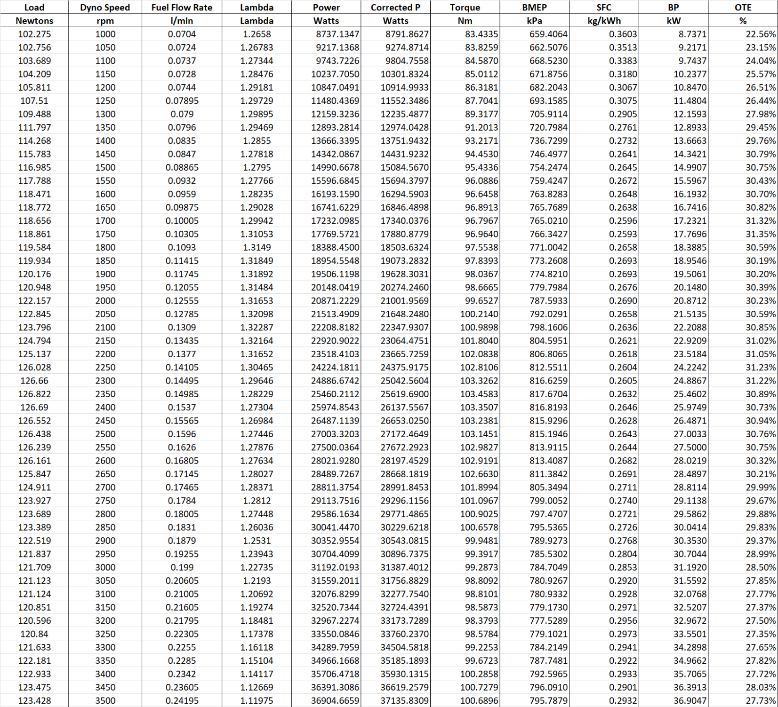
Data
Table 1 Dataset with calculated values
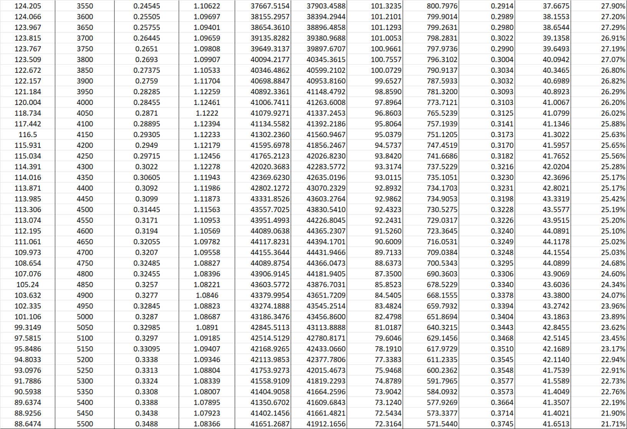
(Honda Motor Co. LTD)
Table 3 Fixed values
Table 2 Dataset continued
Table 4 Fixed values continued
(World Nuclear Association, 2020) (BP Australia, 2021) (Honda Motor Co. LTD)

Graphs

SFC vs Engine speed
Figure 1 SFC vs Engine speed
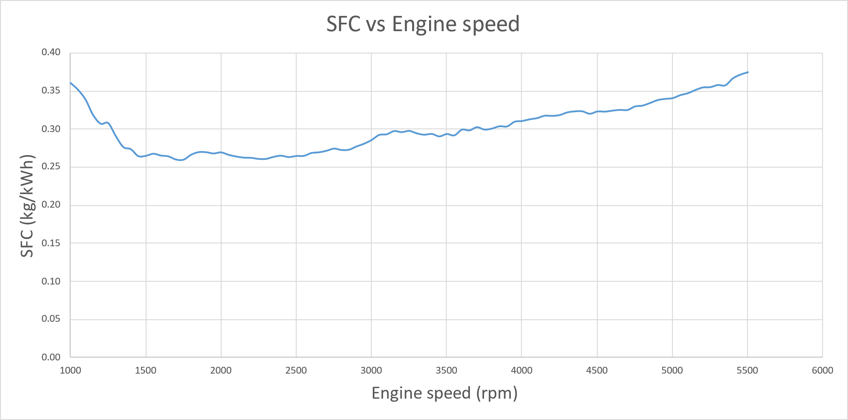
Looking at figure 1 it can be seen that the specific fuel consumption has a u-shaped curve. This means that at the lower rpm there was a higher fuel consumption, in the middle range of engine speed from about 1500-3000rpm, the SFC is stable, and between 3000rpm and 5500rpm it climbs up again. The reason for this could be because of incomplete combustion (Irawan, B. and Winoko, Y. A. and Puspitasari, E. and Dwiyono, T., 2021). This is when the fuel can’t combust, often due to insufficient oxygen in the combustion chamber which can be caused by the valves not having enough time open before ignition at higher rpm.
(Speight, James G., 2011, p281-323).
The high initial SFC could also be because the engine has to overcome the rolling resistance.
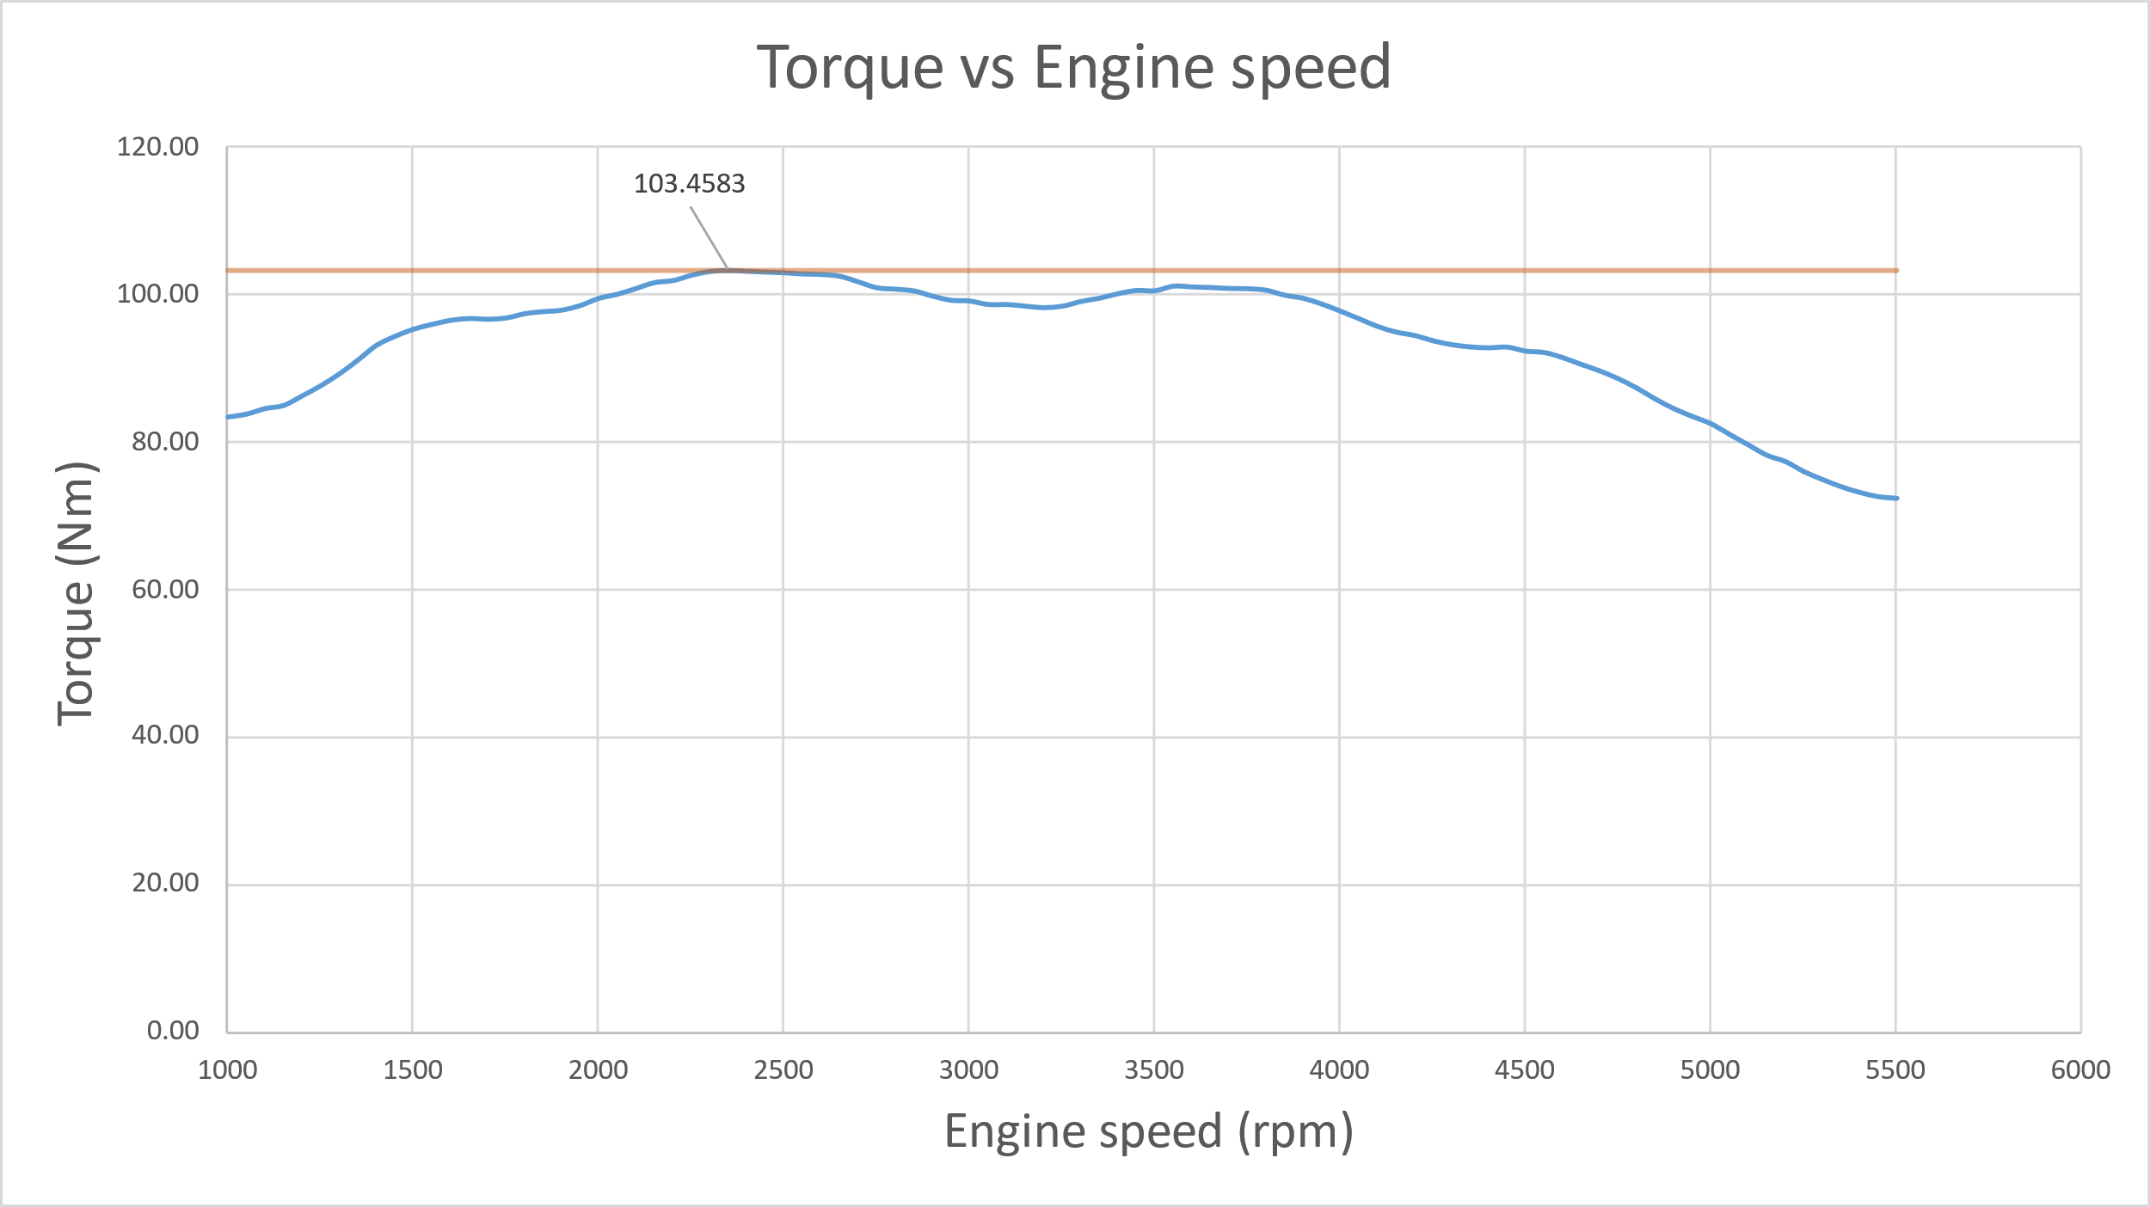
Figure 2 shows the torque curve of the engine; the torque rises initially with the rpm until it reaches its maximum of 103.4583Nm and is indicated by the orange line. After the maximum torque is reached the curve flattens off until around 3900rpm where it starts to drop off. It does this because at higher rpm there isnt enough time for full combustion as well as there being less airflow in the combustion chamber. When the engine reaches a certain rpm, the piston is moving too fast to allow enough air into the engine to complete the combustion, causing the torque to drop off.(Bite-Sized Science, 2020)(driving 4 answers, 2022)
Figure 2 Torque vs Engine speed

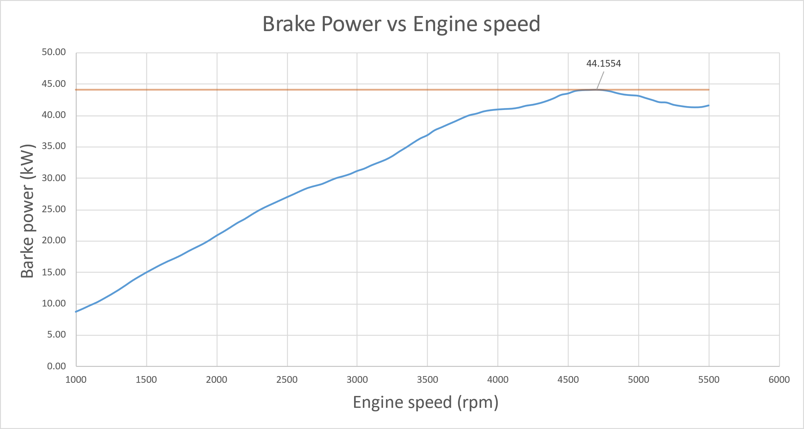
Figure 3 shows that as the rpm of the engine increases, so does the brake power. However, at around 4600rpm the power starts to drop off. This is because the power of the engine is related to the torque. $P=\frac{2π*N*T}{60}$ with P being power and T being torque. The lower the torque the lower the power. When looking at figure 2 it can be seen that the torque starts to fall off earlier than the power, but this could be because power is also related to the engine speed (N). So, while the torque drops the speed of the engine keeps rising which offsets the fall of the brake power. Like with torque, at higher rpm the engine can’t take in enough air for complete combustion because the piston is moving too fast. This causes the power to drop off at the high rpm. (driving 4 answers, 2022)
Figure 3 Brake Power vs Engine speed

Conclusions
Looking at figure 1 it is clear that the engine tested is the most fuel efficient between 1500rpm and 2500rpm this is because that area of the graph is at the lowest point and remains flat. We can also conclude that the engine requires more fuel at lower and higher rpm because two of the highest points on the graph are at 1000rpm and 5500rpm. This range where the fuel consumption is lowest is good because that is around the rpm range that a road car would be at when cruising at a constant speed.
Figure 2 shows that the torque is at its highest between 2400rpm and 3900rpm which is slightly after the engine speed that has the lowest SFC. This indicates that the engine is producing the most torque as it starts increasing the fuel consumption past its optimum fuel efficiency rpm range. This is important because in your average road car, as you accelerate your rpm increases and thus provides more torque. The higher the torque the more easily the car can overcome the inertia of its mass. When you are just cruising at a constant speed you can drop the rpm back into the fuel efficient range because the extra torque is no longer needed to overcome the resistance to acceleration.
Figure 3 shows that the power steadily climbs as the rpm increases and that there are no significant spikes in power. This suggests that the engine is in good condition and has no major problems or timing issues which could result in an uneven curve. Figure 3 also shows that the max power is 44.1554kW and is at around 4700rpm.

Evaluation
As students were not able to run the test due to equipment failure a major improvement would be to fix the issue with the equipment and have the students run the test. Because of this a personal evaluation is not possible as the test was not able to be run. Looking at the data analysis side of the investigation I feel like I performed well and have accurately calculated the required values and displayed them appropriately. If I were to run the test it would be done following the health and safety guidelines and following the correct procedure to ensure accurate results acquired in a safe manner.

References
Bite-Sized Science (2020) (59) TORQUE - and why it reduces at high revs - YouTube. Available at: https://www.youtube.com/watch?v=TTbqp7FcWQE&t=226s (Accessed: 23 March 2025).
BP Australia (2021) ‘SAFETY DATA SHEET GHS product identifier Section 1. Identification’, p. 8. Available at: www.bp.com.au (Accessed: 22 March 2025).
driving 4 answers (2022) WHY are HORSEPOWER and TORQUE CURVED? Available at: https://www.youtube.com/watch?v=Nbev14oIH6I (Accessed: 25 March 2025).
Honda Motor Co. LTD (unknown date), Civic Coupe CRX Chassis Maintenance and Repair.
Irawan, B. and Winoko, Y. and Puspitasari, E. and Dwiyono, T. (2021). ‘Analysis of fuel pressure on the performance of motorcycle engine with ethanol fuel’. IOP Conference Series: Materials Science and Engineering,1073. 012081. 10.1088/1757-899X/1073/1/012081. Available at: https://www.researchgate.net/publication/349656199_Analysis_of_fuel_pressure_on_the_performance_of_motorcycle_engine_with_ethanol_fuel
Speight, James G (2011) Handbook of Industrial Hydrocarbon Processes. Gulf Professional Publishing
UWTSD WISA Workshops (2020a) (38) Engine Dynamometer Overview - YouTube. Available at: https://www.youtube.com/watch?v=-WajOAp2LUE (Accessed: 21 March 2025).
UWTSD WISA Workshops (2020b) (38) Engine Dynamometer testing - YouTube. Available at: https://www.youtube.com/watch?v=VD9OPoaAcJU (Accessed: 21 March 2025).
Wilmink Engine Parts (2025) Lambda sensors - Wilmink Engine Parts. Available at: https://www.wilminkengineparts.com/en/products/lambda-sensors#!sorting=11&limit=&view=rows (Accessed: 21 March 2025).
World Nuclear Association (2020) Heat Values of Various Fuels - World Nuclear Association. Available at: https://world-nuclear.org/information-library/facts-and-figures/heat-values-of-various-fuels (Accessed: 22 March 2025).

Appendix

Formulas
$$T=WR$$
$$\frac{Ps}{P}=\frac{1.01325}{Pa}*\frac{\sqrt{Ta}}{293}$$
$$SFC=\frac{V*0.75*3600}{t*1000*Ps}$$
$$BMEP=\frac{2π*n*T}{D}$$
$$η=\frac{BP}{fuel mass flow rate*CV}$$

Symbols
T=Torque
W=Engine load
R=Torque radius
V=Volume of fuel
0.75=Mass density of fuel
t=Time taken
Ps=Corrected Power
P=Power
$η$=Overall thermal efficiency
n= Number of revolutions per power stroke
D=Displacement
CV=Calorific value of the fuel
Pa=Ambient pressure
Ta=Ambient temperature

