Chapter 8
Foreign Exchange Rate Determination
Learning Objectives
- Examine how the supply and demand for any currency can be viewed as an asset choice issue within the portfolio of investors
- Explore how the three major approaches to exchange rate determination—parity conditions, the balance of payments, and the asset approach—combine to explain, in part, numerous emerging market currency crises
- Detail how direct and indirect foreign exchange market intervention is conducted by central banks
- Observe how forecasters combine technical analysis with the three major theoretical approaches to forecasting exchange rates

Chapter Outline
- Exchange Rate Determination: The Theoretical Thread
- Purchasing Power Parity Approaches
- Balance of Payments (Flows) Approaches
- Monetary Approaches
- Asset Market Approach (Relative Price of Bonds)
- Technical Analysis
- The Asset Market Approach to Forecasting
- Currency Market Intervention
- Motivations for Intervention
- Intervention Methods
- Direct Intervention
- Indirect Intervention
- Turkish Crisis of 2014
- Capital Controls
- Disequilibrium: Exchange Rates in Emerging Markets
- The Asian Crisis of 1997
- Currency Collapse
- Casual Complexities
- The Russian Crisis of 1998
- The August Collapse
- The Aftermath
- The Argentine Crisis of 2002
- The Currency Board
- Economic Crisis of 2001
- The Currency Board and Monetary Policy
- Devaluation
- Forecasting in Practice
- Technical Analysis
- Cross-Rate Consistency in Forecasting
- Forecasting: What to Think?
- Exchange Rate Dynamics: Making Sense of Market Movements

Questions

1. Term Forecasting. What are the major differences between short-term and long-term forecasts for a fixed exchange rate versus a floating exchange rate?

Short-term forecasts are typically motivated by a desire to hedge a receivable, payable, or dividend for perhaps a period of three months. In this case, the long-run economic fundamentals may not be as important as technical factors in the marketplace, government intervention, news, and passing whims of traders and investors. Accuracy of the forecast is critical because most of the exchange rate changes are relatively small even though the day-to-day volatility may be high.

Long-run forecasts may be motivated by a multinational firm’s desire to initiate a foreign investment, or perhaps to raise long-term funds denominated in a foreign currency. Or a portfolio manager may be considering diversifying for the long-term in foreign securities. The longer the time horizon of the forecast, the more inaccurate but also the less critical the forecast is likely to be. The forecaster will typically use annual data to display long-run trends in such economic fundamentals as foreign inflation, growth, and the balance of payments (BOP).

Exhibit 8.6 summarizes the various forecasting periods, regimes, and the authors’ suggested methodologies.

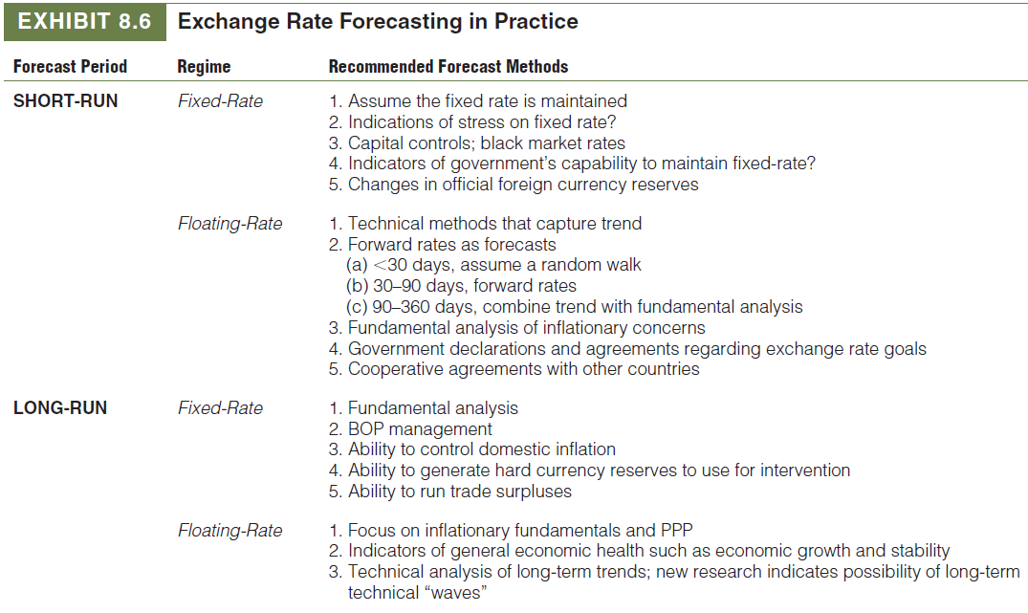

2. Exchange Rate Dynamics. What is meant by the term “overshooting?” What causes it and how is it corrected?

Assume that the current spot rate between the dollar and the euro, as illustrated in Exhibit 8.8, is S₀. The U.S. Federal Reserve announces an expansionary monetary policy that cuts U.S. dollar interest rates. If euro-denominated interest rates remain unchanged, the new spot rate expected by the exchange markets on the basis of interest differentials is S₁. This immediate change in the exchange rate is typical of how the markets react to news, distinct economic and political events, which are observable. The immediate change in the value of the dollar/euro is, therefore, based on interest differentials.

As time passes, however, the price impacts of the monetary policy change start working their way through the economy. As price changes occur over the medium to long term, purchasing power parity forces drive the market dynamics, and the spot rate moves from S₁ toward S₂. Although both S₁ and S₂ were rates determined by the market, they reflect the dominance of different theoretical principles. As a result, the initial lower value of the dollar of S₁ is often explained as an overshooting of the longer-term equilibrium value of S₂.

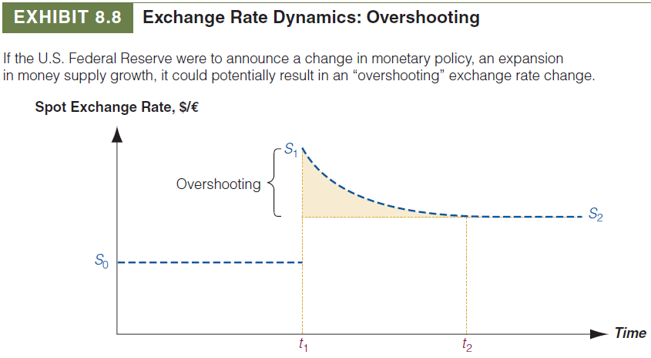

3. Fundamental Equilibrium. What is meant by the term “fundamental equilibrium path” for a currency value? What is “noise?”

It appears from decades of theoretical and empirical studies that exchange rates do adhere to the fundamental principles and theories. Fundamentals do apply in the long term. There is, therefore, something of a fundamental equilibrium path for a currency’s value. It also seems that in the short term, a variety of random events, institutional frictions, and technical factors may cause currency values to deviate significantly from their long-term fundamental path. This is sometimes referred to as noise. Clearly, therefore, one might expect deviations from the long-term path not only to occur, but also to occur with some regularity and relative longevity. Exhibit 8.7 illustrates this synthesis of forecasting thought. The long-term equilibrium path of the currency—although relatively well defined in retrospect—is not always apparent in the short term. The exchange rate itself may deviate in something of a cycle or wave about the long-term path.

4. Asset Market Approach to Forecasting. Explain how the asset market approach can be used to forecast future spot exchange rates. How does the asset market approach differ from the BOP approach to forecasting?

The asset market approach, sometimes called the relative price of bonds or portfolio balance approach, argues that exchange rates are determined by the supply and demand for financial assets. Shifts in the supply and demand for financial assets alter exchange rates. Changes in monetary and fiscal policy alter expected returns and perceived relative risks of financial assets, which in turn alter rates. This differs from the balance of payments approach argument that the equilibrium exchange rate is found when the net inflow (outflow) of foreign exchange arising from current account activities matches the net outflow (inflow) of foreign exchange arising from financial account activities.

The asset market approach assumes that whether foreigners are willing to hold claims in monetary form depends on an extensive set of investment considerations or drivers. These drivers include the following:
• Relative real interest rates are a major consideration for investors in foreign bonds and short-term money market instruments.
• Prospects for economic growth and profitability are an important determinant of cross-border equity investment in both securities and foreign direct investment.
• Capital market liquidity is particularly important to foreign institutional investors. Cross-border investors are not only interested in the ease of buying assets, but also in the ease of selling those assets quickly for fair market value if desired.
• A country’s economic and social infrastructure is an important indicator of that country’s ability to survive unexpected external shocks and to prosper in a rapidly changing world economic environment.
• Political safety is exceptionally important to both foreign portfolio and direct investors. The outlook for political safety is usually reflected in political risk premiums for a country’s securities and for purposes of evaluating foreign direct investment in that country.
• The credibility of corporate governance practices is important to cross-border portfolio investors. A firm’s poor corporate governance practices can reduce foreign investors’ influence and cause subsequent loss of the firm’s focus on shareholder wealth objectives.
• Contagion is defined as the spread of a crisis in one country to its neighboring countries and other countries that have similar characteristics—at least in the eyes of cross-border investors. Contagion can cause an “innocent” country to experience capital flight with a resulting depreciation of its currency.
• Speculation can cause both a foreign exchange crisis or make an existing crisis worse. We will observe this effect through the three illustrative cases that follow shortly.

5. Technical Analysis. Explain how technical analysis can be used to forecast future spot exchange rates. How does technical analysis differ from the BOP and asset market approaches to forecasting?

Technical analysis is the belief that the study of past price behavior provides insights into future price movements. The primary feature of technical analysis is the assumption that exchange rates, or for that matter any market-driven price, follows trends. Technical analysts, traditionally referred to as chartists, focus on price and volume data to determine past trends that are expected to continue into the future. The single most important element of technical analysis is that future exchange rates are based on the current exchange rate. Exchange rate movements, similar to equity price movements, can be subdivided into three periods: (1) day-to-day movement, which is seemingly random; (2) short-term movements extending from several days to trends lasting several months; and (3) long-term movements, which are characterized by up and down long-term trends. Long-term technical analysis has gained new popularity as a result of recent research into the possibility that long-term “waves” in currency movements exist under floating exchange rates.

This differs from the balance of payments approach argument that the equilibrium exchange rate is found when the net inflow (outflow) of foreign exchange arising from current account activities matches the net outflow (inflow) of foreign exchange arising from financial account activities.

6. Forecasting Services. Numerous exchange rate forecasting services exist. Trident’s CFO Maria Gonzalez is considering whether to subscribe to one of these services at a cost of $20,000 per year. The price includes online access to the forecasting services’ computerized econometric exchange rate prediction model. What factors should Maria consider when deciding whether or not to subscribe?

Numerous foreign exchange forecasting services exist, many of which are provided by banks and independent consultants. Predictions can be based on elaborate econometric models, technical analysis of charts and trends, intuition, and a certain measure of gall. Whether any of the forecasting services are worth their cost depends partly on the motive for forecasting as well as the required accuracy of the forecast. If nothing else, a variety of opinions is generally useful when attempting to predict the future. In addition, a CFO might also use a forecasting service because “it exists.” If the CFO does not use it, and guesses wrong on an exchange rate, the CFO could be criticized for not using available “expert advice.”

7. Cross-Rate Consistency in Forecasting. Explain the meaning of “cross-rate consistency” as used by multinational enterprises (MNEs). How do MNEs use a check of cross-rate consistency in practice?

International financial managers must often forecast their home currency exchange rates for the set of countries in which the firm operates, not only to decide whether to hedge or to make an investment, but also as part of preparing multicountry operating budgets in the home country’s currency. These are the operating budgets against which the performance of foreign subsidiary managers will be judged. Checking the reasonableness of the cross-rates implicit in individual forecasts acts as a reality check to the original forecasts.

To illustrate, assume the U.S. parent home office forecasts the yen-to-dollar exchange rate a year hence to be ¥120/$ and the UK pound sterling rate to be $1.50/£. This creates an implied spot rate one year hence of ¥180/£. However, both the Japanese and the British financial managers, with good reason, have forecast a spot rate one year hence of ¥150/£. Obviously, the two foreign subsidiary managers (forecasting ¥150/£) and the home office (with an implicit forecast of ¥180/£) cannot both be correct. The time to reconcile these conflicting forecasts is the present, not one year hence when managers in Japan or the United Kingdom claim that their performance against budget is better than measured by the U.S. parent. In addition, checking the reasonableness of implied cross rates is an exercise in improving the accuracy of the forecasting process.

8. Infrastructure Weakness. Infrastructure weakness was one of the causes of the emerging market crisis in Thailand in 1997. Define infrastructure weakness and explain how it could affect a country’s exchange rate.

Infrastructure weakness refers to situations where public services (roads, railroads, electric power, impartial judicial system, minimum corruption by politicians, adequate police and fire services, reasonable health-care systems, etc.) are dysfunctional. Lack of quality services increases the difficulty and risk of operating a business in that country, which in turn means domestic investment funds will tend to escape from the country and foreign investment funds will not enter. The flight of domestic currencies and the lack of foreign demand for the domestic currency force the exchange rate down (floating regime) or force the government to devalue (fixed exchange rate regime).

9. Speculation. The emerging market crises of 1997–2002 were worsened because of rampant speculation. Do speculators cause such a crisis or do they simply respond to market signals of weakness? How can a government manage foreign exchange speculation?

Speculation contributed greatly to the emerging market crises. Some characteristics of speculation are hot money flowing into and out of currencies, securities, real estate, and commodities. (“Hot money” is a term used to describe funds held in one country’s currency that will move very quickly to another currency as soon as it is deemed weak.) Uncovered interest arbitrage caused by exceptionally low borrowing interest rates in Japan coupled with high real interest rates in the United States was a problem in much of the 1990s. Borrowing yen to invest in safe U.S. government securities, hoping that the exchange rate did not change, was popular. Governments can attempt to manage foreign exchange speculation by either direct intervention (buying or selling the domestic currency against a foreign currency) or indirect intervention (the alteration of economic or financial fundamentals, which are thought to be drivers of capital to flow in and out of specific currencies, i.e., interest rates).

10. Foreign Direct Investment. Swings in foreign direct investment flows into and out of emerging markets contribute to exchange rate volatility. Describe one concrete historical example of this phenomenon during the last 10 years.

Cross-border investment flows are of two types: direct and portfolio. Investment flows into a country mean that foreigners are buying the local currency, which will drive up the value of that local currency. Such flows also give local entities, either private individuals and corporations or the central bank, foreign exchange balances that can be used to import goods and services or held as foreign exchange reserves. Together the investment inflows and their usage influence the country’s exchange rate.

Although it was not in the last 10 years, in the case of Thailand, investment flows went into the country before the 1997 crisis because Thai interest rates and expected returns on direct investments were high, because the outside world believed the Thai government would continue to support its currency, and because the outside world did not pay attention to the infrastructure weaknesses in Thailand. When Thailand devalued its baht, the outside world suddenly became aware of structural weaknesses, and new investment inflows stopped at once. This precipitated the devaluation of the baht and the beginning of devaluation in neighboring countries.

11. Thailand’s Crisis of 1997. What were the main causes of Thailand’s crisis of 1997? What lessons were learned and what steps were eventually taken to normalize Thailand’s economy?

The most visible roots of the crisis were in the excesses of capital inflows into Thailand in 1996 and early 1997. With rapid economic growth and rising profits forming the backdrop, Thai firms, banks, and finance companies had ready access to capital on the international markets, finding U.S. dollar debt cheap offshore. Thai banks continued to raise capital internationally, extending credit to a variety of domestic investments and enterprises beyond what the Thai economy could support. As capital flows into the Thai market hit record rates, financial flows poured into investments of all kinds, including manufacturing, real estate, and even equity market margin-lending. As the investment “bubble” expanded, some participants raised questions about the economy’s ability to repay the rising debt. The baht came under attack.

In May and June 1997, rumors circulated throughout the globe’s currency traders that the Thai baht was weak, and that a number of major investors were now speculating on its fall. The Thai government and central bank quickly intervened in the foreign exchange markets directly (using up precious hard currency reserves) and indirectly (by raising interest rates to attempt to stop the continual outflow). Thai investment ground quickly to a halt. Foreign capital, which had flowed into Thailand freely in the months and years previously, stopped. A second round of speculative attacks in late June and early July proved too much for the Thai authorities. On July 2, 1997, the Thai central bank finally allowed the baht to float (or sink in this case). In late October 1997, Taiwan caught the markets off balance with a surprise competitive devaluation of 15%. The Taiwanese devaluation seemed only to renew the momentum of the crisis.

Once the crisis was apparent, financial managers of multinational entities should have rationally stopped expansion of local facilities and tried to repatriate cash balances in local currencies, if possible. This would cause the financial component of the balance of payments to worsen for the countries involved. For companies manufacturing for local consumption, a drop in local demand, possibly caused by an increase in costs if imported components were needed, would lead to cutbacks in production and unemployment, worsening the crisis-caused depression.

12. Russia’s Crisis of 1998. What were the main causes of Russia’s crisis of 1998? What lessons were learned and what steps were taken to normalize Russia’s economy?

The Russian crisis of 1998 was the culmination of a continuing deterioration in general economic conditions in Russia. During the period from 1995 to 1998, Russian borrowers had borrowed heavily on the international capital markets. Servicing this debt soon became a growing problem, as servicing dollar debt requires earning dollars. The Russian current account, a surprisingly healthy surplus, was not finding its way into internal investment and external debt service. Capital flight accelerated, as hard-currency earnings flowed out as fast as they found their way in. Finally, in the spring of 1998, even Russian export earnings began to decline. Russian exports were predominantly commodity-based, and global commodity prices had been falling since the start of the Asian crisis in 1997.

The Russian currency, the ruble, operated under a managed float. Automatically, the central bank announced an official exchange rate each day at which it was willing to buy and sell rubles, always within an official band. In the event that the ruble’s rate came under pressure at the limits of the band, the central bank intervened in the market by buying and selling rubles, usually buying, using the country’s foreign exchange reserves. On August 7, 1998, the Russian central bank announced that its currency reserves had fallen by $800 million in the last week of July. The ruble, however, continued to trade within a very narrow range. On August 10, Russian stocks fell more than 5% as investors feared a Chinese currency devaluation. Devaluation would aid Chinese exports in cutting into Russian export sales. The government stated that the “panic” was psychological, not fiscal, and repeated, as it had in recent days, that it had money to meet its obligations through the fall of the year.

On Monday, August 17, the floodgates were released. The Russian central bank announced that the ruble would be allowed to fall by 34%. The government then announced a 90-day moratorium on all repayment of foreign debt, debt owed by Russian banks and all private borrowers, in order to avert a banking collapse. The central bank of Russia, in an attempt to defray criticism of its management of the ruble’s devaluation, disclosed that it had expended $8.8 billion in the preceding eight weeks defending the ruble’s value. On August 28, the Moscow currency exchange closed after 10 minutes of trading as the ruble continued to fall. For many, the collapse of the ruble and the loss of Russia’s access to the international capital markets brought into question the benefits of a free-market economy, long championed by the advocates of Western-style democracy.

13. Argentina’s Crisis of 2001–2002. What were the main causes of Argentina’s crisis of 2001–2002? What lessons were learned and what steps were taken to normalize Argentina’s economy?

By 2001, crisis conditions had revealed three very important underlying problems with Argentina’s economy: (1) the Argentine peso was overvalued; (2) the currency board regime had eliminated monetary policy alternatives for macroeconomic policy; and (3) the Argentine government budget deficit, and deficit spending, was out of control. The peso had indeed been stabilized. But inflation had not been eliminated, and the other factors that are important in the global market’s evaluation of a currency’s value—economic growth, corporate profitability, and so forth—had not necessarily always been positive. The inability of the peso’s value to change with market forces led many to believe increasingly that it was overvalued, and that the overvaluation gap was rising as time passed.

Argentina’s neighbor, Brazil, had also suffered many of the economic ills of hyperinflation and international indebtedness in the 1980s and early 1990s. Brazil’s response, the Real Plan, was introduced in July 1994. The real plan worked, for a while, but eventually collapsed in January 1999 as a result of the rising gap between the real’s official value and the market’s assessment of its true value. Brazil was by far Argentina’s largest trading partner. With the fall of the Brazilian real, however, Brazilian consumers could no longer afford Argentine exports. It simply took too many real to purchase a peso. In fact, Argentine exports became some of the most expensive in all of South America as other countries saw their currencies slide marginally against the dollar over the decade. But not the Argentine peso.

On January 6, 2002, in the first act of his presidency, President Eduardo Duhalde devalued the peso from ARS1.00/USD to ARS1.40. But the economic pain continued. Banks were closed. Most of the state governments outside of Buenos Aires, basically broke and without access to financing resources, began printing their own money. The provincial governments were left with little choice as the economy of Argentina was nearing complete collapse because people and businesses could not obtain money to conduct the day-to-day commercial transactions of life. On February 3, 2002, the Argentine government announced that the peso would be floated. The government would no longer attempt to fix or manage its value to any specific level, allowing the market to find or set the exchange rate. The value of the peso then began a slow but gradual depreciation.

