MARKETING MANAGEMENT

Executive summery
Present report has shed light on that managing the marketing environment is developed by employees' ability and problem solving factors. Industrial marketing management is focusing on future ability and can manage organizational performance. Literature skills depend on the ability and that can be enhancing the risk tolerance factors of the business. . Potential outcomes of the business are essential and can focus on the principles of the business and trying to minimize organizational challenges. Marketing planning is focusing on innovative sales that can manage organizational performance. Tactics are potential and can be managed competitive advantages of the business. Industrial marketing management has potential and that can be enhancing future opportunities for the business.

Table of Contents
Introduction 4
1. Knowledge and understanding skills 4
2. Engagement with literature skills 9
3. Cognitive and intellectual skills 10
4. Practical skills 12
5. Transferable skills for professional practice 16
Conclusion 18
Reference list 19

Introduction
Knowledge and understanding skills are essential and that can be enhancing critical awareness of current difficulties. The aim of the report is knowledge, understanding, as well as intellectual skills, which are developed by professional practice. The importance of the study is a comprehensive understanding of individual techniques that can demonstrate a structural understanding of knowledge. Practical skills are potential and that can be originally developed in new planning methods in Tesco Plc. Tesco has always focused on problem solving factors and an efficient decision making process and that is able to manage difficult situations in every circumstance.

1. Knowledge and understanding skills
Learning platform of Tesco Plc
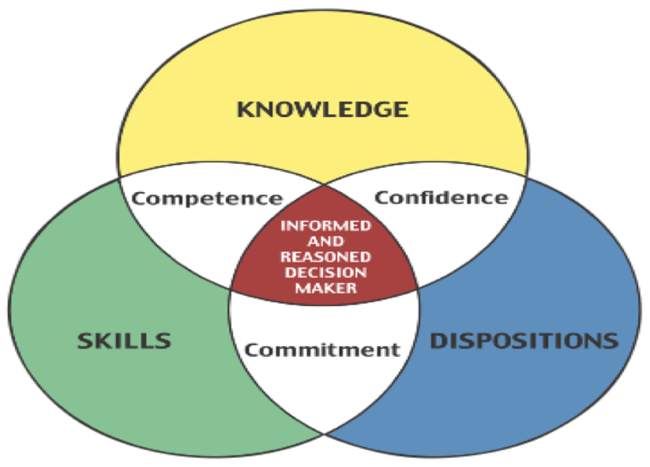
Figure 1: Knowledge and understanding skills
(Source: Nasirin and Lionardo, 2020)
- Employees are able to understand the gaps between skills and knowledge
- Training helps to support business growth
- Identify personal and professional skills by methodical understanding
Future opportunity makes positive support to the individual business organization and that is able to demonstrate the administrative system of Tesco Plc. Structural understanding has potential and can make oriented solutions for the business. Critical awareness is a major factor in the business and that can be methodically analyzed in the critical situation of the business. Critical solutions are able to demonstrate a basic understanding that can manage current challenges in the business. Contemporary concepts are a major principle that can explain the business issues of Tesco Plc (Tescoplc.com, 2022). Individual employees are enhancing their motivational level by improving the administrative system and are able to manage internal as well as external problems of the business. Training and learning process helps to effectively develop correct knowledge and understanding power of individual employees. Financial resources play a major role to demonstrate the personal and professional skills of individual employees.
Knowledge and understanding skills play major roles and that is able to maintain work life balances through professional practice. Comprehensive understanding is important and one is able to manage current difficulties with the help of professional practice. Critical understanding plays a chief role in ideally managing problems by the contemporary concept (Chang et al. 2018). Computational marketing management has a major impact on the business performance of Tesco Plc and is able to resolve organizational problems. The key element of the marketing activities such as best deals at low prices as well as a huge collection or variety of the product can engage potential customers in the business. The key elements are important and can be managed through organizational difficulties. The competitive advantages of sustainable performance are involved in maximizing customer satisfaction through contemporary concepts.
Critically appraise marketing management
- The variety of manufacturing product capture the marketplace
- Strategic management analysis of Tesco enhancing marketing environment
- An appropriate supply chain process can able to demonstrate marketing strength
Marketing management strategically analyzes the basic capabilities and is able to manage the market position of the business. The competitive position of Tesco Plc is dependent on the sufficient information process and that can be managed by strategic analysis. Around 28.6% market shares are established and that can strategically maintain work life balances of Tesco Plc. Customer satisfaction are an effective strategy that can manage the basic workforce of the company. Huge customer base organizations are focusing on the effective strategy to develop and demonstrate the business of multinational retailers. The relationship between network and marketing management can be enhancing future opportunities in the market (Naudé and Sutton-Brady, 2019). Strategic planning is potential and that can be examined through strategic analysis of the business. Oriented performance is the best way and that is able to manage basic difficulties of marketing management.
Industrial marketing management has potential and that can be enhancing future opportunities for the business. Innovative performance is involved in the digital innovation process and can manage organizational resources. Continuously increasing brand awareness is potential and that can be managed proportionally to the value of the market (Adams et al. 2019). Strategic marketing planning has potential and can effectively manage the business environment of Tesco Plc. Maximizing customer satisfaction is a competitive advantage for individual business organizations and that can methodically achieve a sustainable performance of a business. The basic challenges of the business organization are enhanced by managing the reputation of the business. The competitive marketplace is continuously rising with digitalization and that can manage customer satisfaction and maximize income returns for the business. The efficient marketing system is the efficient process that can maximize the marketing opportunities of Tesco Plc.
Critically appraise key activities of the marketing
Key activities | Description
Research | Market research is the best way and can control different types of activities of the company. Strategic planning involves innovative pricing as well as the design of the product and that can be enhanced by the advertisement process. The specific method can fulfil the positioning requirements of the business (Krings et al. 2021). The methodical performance of the business is important and that can be able to achieve marketing targets of individual business organizations. The digital innovation process completes the market research and that can be suitable for B2B business. Market research can analyze the current market situation of the business and individual employees can realize the marketing position of the company.
Strategy | The mission, vision, and goals of the business stand for business strategy and that can manage new possibilities of the business. Market analysis is potential and is able to manage organizational planning. Financial planning has potential and can realistically manage the strategic planning of the market. Multiple competitors are able to manage business strategy through the strategic planning of the business (Benedetto and Lindgreen, 2018). Business strategy is potential and that can be managed by the potential outputs of the business.
Planning | Marketing planning is focusing on innovative sales that can manage organizational performance. In order to achieve long term business goals, it is measured by the planning that can manage the basic planning of the business (Chonko and Hunt, 2018). The ethical business issues are potential and can be managed through industrial marketing management of the business. Strategic planning has potential and that can be enhancing basic opportunities of the business. A strategic plan is methodically enhancing future opportunities as well as the communication strategy of the business.
Tactics | Tactics happen after the planning stage and that can be managed through business planning of the business. Tactics are potential and can be managed competitive advantages of the business. Potential business output can be enhanced by marketing planning and that can be raising organizational revenue (Kouropalatis et al. 2019). Basic capabilities have an impact on organizational development and that can be enhancing basic opportunities of the business. Marketing management has potential and that can be enhancing future opportunities for Tesco Plc.
Table 1: Key element of the business
(Source: Self created)

2. Engagement with literature skills
Enhancing brand awareness is important and that can raise brand awareness of Tesco Plc. Literature skills have potential and can enhance basic business opportunities. The credibility of the financial sources is potential and that can consider knowledge and understanding of detailed knowledge (Lindgreen and Di Benedetto, 2018). Industrial marketing management is focusing on future ability and can manage organizational performance. Literature skills depend on the ability and that can be enhancing the risk tolerance factors of the business. Technological factors of the business are potential and can be managed by organizational opportunities in the business. Business elements are potential and can minimize organizational challenges. Sometimes technological factors are essential and that can enhance the reputation of the business organization.
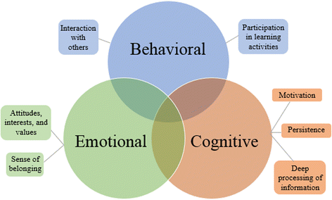
Figure 2: Engagement of the literature skills
(Source: Lindgreen and Di Benedetto, 2018)
Sometimes long-time business opportunities are enhanced by technological skills and that can put a major impact on the macro environment variables. Potential outcomes of the business are essential and can focus on the principles of the business and trying to minimize organizational challenges (Dončić et al. 2019). An economic analysis is applied in marketing management to identify the future abilities of the business. Several products of Tesco Plc are focused on the technological factors that can engage more consumers in the business. Tesco has been trying to develop business by individual financial sources that can systematically enhance basic business processes. The electronic fund transfer system is involved in the digital innovation process and that can be enhancing more opportunities for Tesco. Digital innovation systems are trying to develop organizational; performance by engaging more customers in the business. The electronic point of sales can improve stock activities of the business and can develop product distribution techniques of Tesco Plc.
Labour market theory
Tesco Plc has tried to resolve organizational difficulties through positive financial sources and that can be managed numerous difficulties of the business. Labour market theory is focused by Tesco Plc and that has demonstrated problem solving skills of individual employees. Individual investors are focusing on the business by identifying the financial position of Tesco Plc and that has a positive impact on the business performance. The ideal performance of the business is potential and that can be managed by organizational performance (Petrunia et al. 2019). Problem solving factors are potential in the business and can develop basic outcomes in the international marketplace. Professional and personal skills are essential during the time of the Coved 19 situation and can be used to manage organizational performance during a pandemic situation. Unemployment and poor financial sources are facing the Coved 19 situation and that can be managed by organizational performance in the business.

3. Cognitive and intellectual skills
- Enhancing supply chain management of the business
- Raising the managerial performance of the business
- Developing marketing strategy of the business.
Cognitive and intellectual skills are potential that can enhance the basic ability of a performance development plan. The cognitive skills are able to resolve hidden problems and can approve positive financial sources into the business. Intellectual skills enhance problem solving factors of individual employees and that can be achieved in the future as well as objectives (Tanasiichuk et al. 2020). Future abilities, as well as problem solving factors of the business, its potential, and that, can be enhancing the diversifications of marketing management systems. In order to enhance basic opportunities of the business, intellectual skills are essential and that can be enhancing problem solving factors in the business. The intellectual and cognitive skills are the potential that can minimize future threats to the business. The potential skills are essential and can manage organizational resources in the business.
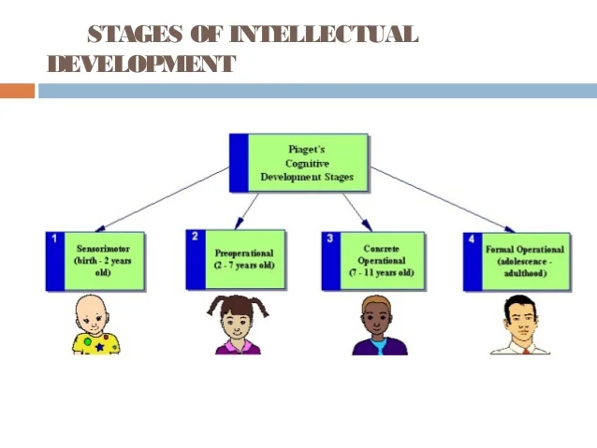
Figure 3: Cognitive skills
(Source: Lindgreen and Di Benedetto, 2018)
Intellectual skills are potential and can enhance the basic opportunity of the business. In order to mental functions of the individual organization, it depends on the business and that can be enhancing organizational business processes. Intellectual skills are potential and can be managed by organizational resources. Knowledge and understanding are potential that can manage the dynamic business process of the organization (Reddy and Karimikonda, 2019). The supply chain of the business process is potential and that can be managed by the organizational resources of the business. Critically evaluate the managerial information that can manage prominent marketing factors of the business. The relationship of the business can be enhancing the organizational resources of the business. Supply chain management can be enhancing the basic business process of the organization. The basic performance of the organization is enhancing the business process of Tesco Plc.
Knowledge development has potential and that can be managed by organizational resources in the business. Formal as well as concentration operational stages are important and can accommodate new learning processes of the business. As a British multinational business organization, Tesco Plc has focused on the appropriate product quality that can be enhancing the basic business process of the organization (Ellram and Murfield, 2019). The critical analytical process has potential and can manage the industrial performance of the business. The problem solving factor of the business is potential and that can be enhancing the basic performance of the business. Organizational performance is based on problem solving factors and managed by intellectual skills. The implementation strategy is potential and can be managed by organizational financial resources. The intellectual skills are potential and can be managed by organizational resources.

4. Practical skills
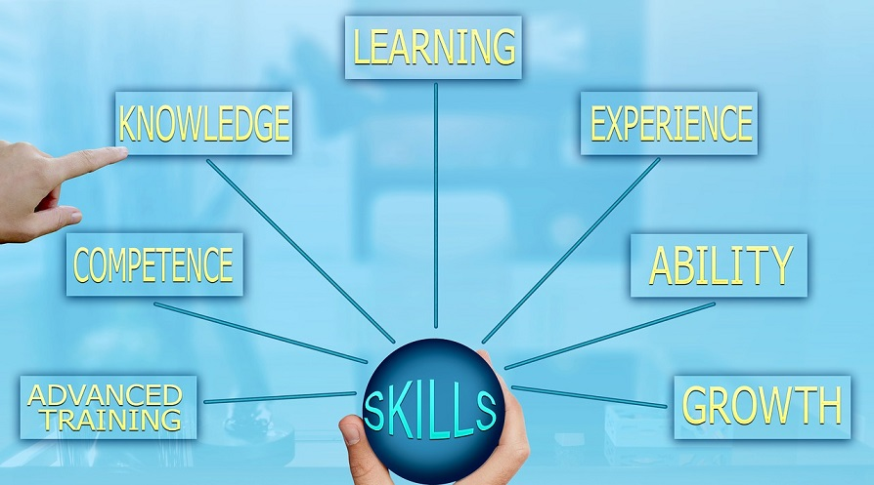
Figure 4: Practical skills
(Source: Lindgreen and Di Benedetto, 2018)
Practical skills | Description
Knowledge | Knowledge is the primary subject that is important in business. The key performance of the business is enhancing business values and that can improve potential outcomes of the business. Meaningful performance of the business is measured by the key elements of the business and that can be eligible for racing organizational ability. Knowledge is important, that can be enhanced by the advanced training process.
Learning | Learning is the process of acquiring innovative knowledge and that can be raising mission, and vision as well as achieving professional goals. Learning and experience have potential and can improve the ability of problem solving factors. Problem solving factors are enhancing the basic abilities of the business and that can reduce the basic difficulties of the business. New and innovative learning methods are being used to manage contemporary issues of Tesco Plc.
Experience | Experience is an important factor that can involve managerial resources in the business. Experience is the ability to observe human behaviour which is important in every organization. Knowledge and understanding are important and can develop numerous skills as well as human nature (Johnsen, 2018). Employees experience potential and that can be enhancing basic opportunities in the business.
Ability | Physically and mentally ability is involved by the knowledge and problem solving factors of the business and that can be managed by Tesco Plc. Ability is the key element of the business and that can enhance the marketing capability of an individual business organization. The structural performance of Tesco Plc is focusing on the supply chain and management and that can be the initial stage of the business.
Growth | Growth indicates the increasing future opportunity as well as strength of the business organization. Efficient planning is needed to manage organizational growth and that can be enhancing future opportunities for the business (Gölgeci and Kuivalainen, 2020). Capital budgeting, as well as organizational opportunity, is enhanced by the efficient decision making process.
Advance training | Advance training always has potential for the business as well as individual employees and that can be managed efficiently by problem solving factors in the business. Efficient planning is essential and can enhance basic performance and future opportunities. Innovative market ideas have potential and that can be managed by organizational difficulties (Lindgreen et al. 2021). Developing organizational performance advance training is required for individual employees and that could involve appreciative roles in the business.
Table 2: Practical skills
(Source: Self created)
Knowledge and understanding have potential in the business and established new techniques for the business. Practical skills are the potential and that can be enhancing the business process of the organization (Olson et al. 2018). The managerial resources are potential and that can be managed potential business opportunities of Tesco Plc. Decision making process has the potential that can enhance the basic performance of the business. Practical skills are beneficial to the business and that can be enhancing the basic problem solving factors of a business. Communicational skills are the potential to enhance future opportunities in the business. Practical skills are enhancing the business of Tesco Plc. Practical business skills are important and can be managed through organizational opportunities. Profit and loss statements play a meaningful role for Tesco. Enhancing the competitive advantages of the business is potential and can be managed by potential difficulties of the business.

5. Transferable skills for professional practice
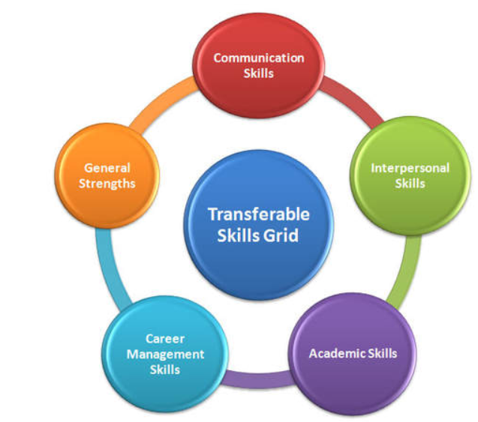
Figure 5: Practical skills
(Source: Varadarajan, 2018)
Ability to concentrate
An environmental performance management system is essential and can analyze the managerial information process of Tesco Plc. Transferable skills are conducted by advanced training and that can potentially resolve numerous problems in the business (Varadarajan, 2018). Transferable skills are potential and can develop new and innovative careers for individual employees. Advanced training and learning process is potential for every industry and Tesco Plc has tried to develop transferable skills through the advanced training and development process. Transferable skills are involving abilities that can be raising critical thinking processes as well as problem solving factors. Systematic information processes have potential and can develop strong analytical processes in the business. Individual business industries are following transferable skills that can manage the critical thinking process of an individual industry.
In order to conduct transferable skills, involved the analytical thinking process and can develop problem solving factors. Responsibility is the appropriate way and that can be managed with transferable skills and Tesco Plc has been trying to conduct research to develop transferable skills of individual employees (Tescoplc.com, 2022). Intent exercise can raise basic awareness and that can develop the basic relationship between skills and problem solving factors. Determine the information needed as well as identify basic consequences of implications that can be managed by the transferable skills. The connection between skills and problems is managed by the problem solving factors and that can be managed by organizational performance. Hiring a new committee that can improve the decision making process. The decision making process is important and can be managed by individual problems in the business.
Advance training and learning process
A typical conversation is potential and that can be enhancing problem solving factors of numerous employees. Knowledge and experience are potential and that can be managed by potential techniques of the individual employees (Lacka et al. 2020). Technological advancement is an important process that can enhance the basic ability of the business. An artificial intelligence technique has potential and can systematically enhance the knowledge framework of individual business employees. The new learning process has the potential and that can be enhancing the basic abilities of the business and that can manage organizational benefits. The training and learning process has potential and that can be managed by the training and learning process of individual employees. A comprehensive action plan is potential that can manage the organizational learning process of the business. New and learning principles are potential and that can be managed by the training and learning process of Tesco Plc.
Training and development for future opportunity
Demand is necessary and that can be managed by the organizational opportunity of the business. Production concern is the ability of future opportunities that can be enhancing the new business process and future opportunities can be enhanced by the training and development of the employees (Bag et al. 2021). Artificial intelligence is an important technique that can enhance the business opportunities of the organization. Individual employees are focusing on the B2B marketing techniques that can manage organizational opportunities as well as improve the basic performance of the business. The sustainable performance of the business is potential and that can be enhancing the basic abilities of the business. Marketing sustainability is the potential factor that can enhance the new learning process of the organization. A sustainable business strategy has potential and that can be enhancing new abilities of problem solving factors of new employees.
Improves employees ability
Individual employees are trying to develop new learning processes that can manage different types of problems. The ability of problem solving factors are enhancing basic ability by managing numerous problem solving factors of Tesco Plc. Individual business organizations are trying to focus on the training and learning process and that can be raising the basic abilities of the business (Cristobal-Fransi et al. 2020). Training and development trends are essential for each employee to enhance the basic ability of problem solving factors, as well as that, can be focusing on the new abilities of performance. An efficient training and learning process has potential and can develop future opportunities as well as individual employees are motivated by the training and development process.
Techniques, as well as leadership skills, are important to enhance each employee's ability and that can be appropriately communicated between expectation and performance. In order to fulfil basic requirements of the business employees' ability is potential and that can be systematically managed by the new learning process of individual employees. Tesco Plc has been trying to improve employee empowerment and can utilize technological development in the business. Employee flexibility is important for individual business organizations and that can enhance the basic ability of problem solving factors of each employee.

Conclusion
Based on the above discussion it can be concluded that managing the marketing environment is developed by employees' ability and problem solving factors. Employee performance is the best way and that can be managed by a critical thinking process. Individual employees are trying to improve the base level production of the business by enhancing basic abilities such as problem solving factors, training and learning process as well as their knowledge. Sometimes initiative benefits, as well as active administration, can enhance the motivational level of individual employees and that can manage work life balances of individual employees. Active listening, as well as dependability, describes the ability of the potential factors that can resolve numerous conflicts between organizational employees as well as their organization.

Reference list
Adams, P., Freitas, I.M.B. and Fontana, R., 2019. Strategic orientation, innovation performance and the moderating influence of marketing management. Journal of Business Research, 97, pp.129-140.
Al-Surmi, A., Cao, G. and Duan, Y., 2020. The impact of aligning business, IT, and marketing strategies on firm performance. Industrial marketing management, 84, pp.39-49.
Bag, S., Gupta, S., Kumar, A. and Sivarajah, U., 2021. An integrated artificial intelligence framework for knowledge creation and B2B marketing rational decision making for improving firm performance. Industrial Marketing Management, 92, pp.178-189.
Casanoves-Boix, J. and Pérez-Sánchez, M., 2021. Digital marketing management applied to the tourism sector: vueling airlines case study. Journal of Tourism and Heritage Research, 4(2), pp.9-30.
Chang, C.L., McAleer, M. and Wong, W.K., 2018. Big data, computational science, economics, finance, marketing, management, and psychology: connections. Journal of Risk and Financial Management, 11(1), p.15.
Chonko, L.B. and Hunt, S.D., 2018. Reflections on ethical issues in marketing management: An empirical examination. Journal of Global Scholars of Marketing Science, 28(1), pp.86-95.
Cristobal-Fransi, E., Daries, N., Ferrer-Rosell, B., Marine-Roig, E. and Martin-Fuentes, E., 2020. Sustainable tourism marketing. Sustainability, 12(5), p.1865.
Di Benedetto, C.A. and Lindgreen, A., 2018. The emergence of Industrial Marketing Management as the leading academic journal in business-to-business marketing. Industrial Marketing Management, 69, pp.5-12.
Dončić, D., Popović, V., Lakić, Ž., Popović, D. and Petković, Z., 2019. Economic analysis of wheat production and applied marketing management. Agriculture & Forestry, 65(4), pp.91-100.
Ellram, L.M. and Murfield, M.L.U., 2019. Supply chain management in industrial marketing–Relationships matter. Industrial Marketing Management, 79, pp.36-45.
Gölgeci, I. and Kuivalainen, O., 2020. Does social capital matter for supply chain resilience? The role of absorptive capacity and marketing-supply chain management alignment. Industrial Marketing Management, 84, pp.63-74.
Herhausen, D., Miočević, D., Morgan, R.E. and Kleijnen, M.H., 2020. The digital marketing capabilities gap. Industrial Marketing Management, 90, pp.276-290.
Iankova, S., Davies, I., Archer-Brown, C., Marder, B. and Yau, A., 2019. A comparison of social media marketing between B2B, B2C and mixed business models. Industrial Marketing Management, 81, pp.169-179.
Johnsen, T.E., 2018. Purchasing and supply management in an industrial marketing perspective. Industrial Marketing Management, 69, pp.91-97.
Kouropalatis, Y., Giudici, A. and Acar, O.A., 2019. Business capabilities for industrial firms: A bibliometric analysis of research diffusion and impact within and beyond Industrial Marketing Management. Industrial Marketing Management, 83, pp.8-20.
Krings, W., Palmer, R. and Inversini, A., 2021. Industrial marketing management digital media optimization for B2B marketing. Industrial Marketing Management, 93, pp.174-186.
Kukartsev, V.V., Khramkov, V.V., Fedorova, N.V., Rozhkova, A.V., Tynchenko, V.S. and Bashmur, K.A., 2020. Features of evaluating the effectiveness of industrial enterprise marketing activities. In IOP Conference Series: Materials Science and Engineering (Vol. 734, No. 1, p. 012081). IOP Publishing.
Lacka, E., Chan, H.K. and Wang, X., 2020. Technological advancements and B2B international trade: A bibliometric analysis and review of industrial marketing research. Industrial Marketing Management, 88, pp.1-11.
Lindgreen, A. and Di Benedetto, C.A., 2018. Citation classics from Industrial Marketing Management: Celebrating forty-seven years of publications on business-to-business marketing management. Industrial Marketing Management, 73, pp.1-6.
Lindgreen, A., Di Benedetto, C.A. and Kock, F., 2021. How to develop original, courageous ideas in business marketing research. Industrial Marketing Management, 95, pp.A1-A4.
Mero, J., Tarkiainen, A. and Tobon, J., 2020. Effectual and causal reasoning in the adoption of marketing automation. Industrial Marketing Management, 86, pp.212-222.
Nasirin, C. and Lionardo, A., 2020. Effective Implementation of Marketing Management of Hospital Pharmacy: A Study on the Impact of Hospital Service Quality Improvement in Enhancing the of Patients' Satisfaction and Loyalty. Systematic Reviews in Pharmacy, 11(5), pp.705-712.
Naudé, P. and Sutton-Brady, C., 2019. Relationships and networks as examined in Industrial Marketing Management. Industrial Marketing Management, 79, pp.27-35.
Olson, E.M., Slater, S.F., Hult, G.T.M. and Olson, K.M., 2018. The application of human resource management policies within the marketing organization: The impact on business and marketing strategy implementation. Industrial Marketing Management, 69, pp.62-73.
Petrunia, Y., Chentsov, V., Życzyński, N. and Petrunia, V., 2019. Marketing environment and marketing management of universities in Ukraine: national and regional dominants. Innovative Marketing, 15(1), pp.1-12.
Reddy, G.D. and Karimikonda, H., 2019. Social Media as a Prominent Marketing Management Tool: A Literature Review. SSRG International Journal of Economics and Management Studies, 6(11), pp.112-117.
Saura, J.R., Ribeiro-Soriano, D. and Palacios-Marqués, D., 2021. Setting B2B digital marketing in artificial intelligence-based CRMs: A review and directions for future research. Industrial Marketing Management, 98, pp.161-178.
Tanasiichuk, A., Hromova, O., Kovalchuk, S., Perevozova, I. and Khmelevskyi, O., 2020. Scientific and methodological approaches to the evaluation of marketing management of enterprises in the context of international diversification. European journal of sustainable development, 9(3), pp.349-349.
Tescoplc.com, 2022, Financial reports, Available at: https://www.tescoplc.com/ [Accessed on: 2nd April, 2022]
Varadarajan, R., 2018. Advances in strategic marketing and the advancement of the marketing discipline: The promise of theory. Journal of Marketing Management, 34(1-2), pp.71-85.
Varadarajan, R., 2020. Customer information resources advantage, marketing strategy and business performance: A market resources based view. Industrial Marketing Management, 89, pp.89-97.

