https://youtu.be/7nHx8BTNbQM
Within this assignment I will reflect upon the progress made in the development of personal language for oracy, reading and writing whilst on Professional Teaching Experience (PTE).
Rationale
The school I have been teaching at is a community school that is based in the heart of Carmarthen. The pupils come from the near surroundings of the town and villages within Carmarthen. The school identifies that 50% of it’s pupils have additional learning needs which is considerably over the local and national average. English is the main language spoken by the pupils at home with very few Welsh speaking families. 15% of pupils come from ethnic minority groups and 11% come from homes where neither English or Welsh is the main language.
The placement class was a reception class of 22 children with 21 present on the day. Within the class, 2 of the children have English as an additional language (EAL) and around 12 of the children have additional support involving either Speech and Language, emotional or social needs. The children within the class can confidently speak Welsh using basic greetings, simple sentences, answering questions and understand instructions. On assessment the children have confidently progressed between Outcome 1 or 2 within the Foundation Phase framework. This is due to the class teacher who fully immerses them with Welsh commands and instructions in every Area of Learning Experiences (AOLEs) and introduces subject specific language within the classroom which Estyn (2013) believe is the most effective practice for language acquisition.
The class teacher is a first language Welsh speaker and ensures every opportunity to provide the children with hearing the Welsh language both in and out of the classroom. Using incidental and subject specific vocabulary is a target area that I have been fully aware from the start of my teaching experiences in Year 1. Using Welsh within the classroom is something I have struggled with including within certain activities (appendix1), however I have appreciated working with my class mentor as she provides a range of opportunities to ensure I speak Welsh within the classroom and has built up my confidence in speaking Welsh both at home and on placement.
Whilst on PTE the theme chosen for the Welsh Development session was based around Flic a Flac’s story of Dau Gi Bach. The children were within their mixed ability groups for the activities. The theme was presented throughout the day with a carousel of five different activities. The activities revolved through the course of the day with the activities lasting around 40 minutes each. The scheme of work is based upon Flic a Flac but is a scheme that the class teacher has created over the past year which was shared to myself (appendix2) to ensure consistency and effective planning.
Disappointingly, I have not had the opportunity to previously teach the class a focused Welsh lesson or observed a Welsh lesson whilst on practice due to the timetable not planned for a Welsh Development timeslot. Unfortunately, my class teacher was out in the morning which was not previously planned and my (LSA) Learning Support Assistant was in a meeting therefore I had to film the majority of activities myself, as the lesson could not be scheduled until the last day of term due to events in the school’s calendar.
Reflection
Oracy Skill: listen and respond simply to what they hear in familiar circumstances, with growing attention and concentration (Welsh Government, 2015).
The children had not previously been introduced to the story of Dau Gi Bach from the Flic a Flac scheme of work, therefore, the children watched the DVD of Flic a Flac to introduce the new vocabulary and topic for the focused activities. It is unfortunate that it was not videoed due to staffing issues as I stopped the DVD at times to ensure the children understood the questions and vocabulary (appendix 3). Although, reflecting on how engaging the introduction was, I feel that the introduction could for future development be refined by having a more practical approach which promotes hands on, experiential learning (Dewey, 1938; Montessori, 1996). However, due to the nature of the new vocabulary, book and skills, using the DVD allowed the children to engage and become more independent with their learning in the main activities. Furthermore, DCELLS (2008) agree that structured opportunities such as the DVD allowed the children to explore the Welsh story of Dau Gi Bach which is also advocated within the Foundation Phase Framework (Welsh Government, 2015). It is apparent in the video that the children were engaged whilst watching the DVD as it was interactive and suitable to their language level. The WJEC (1998) further agree with the suitability of the language spoken by myself and the children within the vocabulary suggestions available from the Everyday Language Grids.
After this I ensured I modelled all the different carousel activities to the children and explicitly explained the tasks to ensure clarity of the activities; this enabled me to use teaching strategies such as drilling the vocabulary of the pictures to support their independent bingo activity. Ensuring this repetition of vocabulary allowed the learners to take control of their learning and become independent within the task which allowed me to work with another group (Bowlby, 1956). Skehan (1998) and Schmidt and Frota (1986) note that repetition of a language develops automaticity and scaffolds the language learnt (Vygotsky, 1978). The Flic a Flac puppets developed engagement and imagination to introduce the story of Dau Gi Bach, on reflection I would use the puppets again in further teaching approaches as I can see the benefits from using an additional resource. Estyn (2013) suggest that using puppets within the classroom can increase concentration, imagination and encourages the use of the Welsh language within activities.
Activity Ipads
Oracy Range: experience a range of stimuli including media and ICT texts (Welsh Government, 2015).
As you can see from the video the first activity was an independent activity of the children using the app Cyw on the ipads. The children rarely get a chance to use the ipads on Cyw independently and all enjoy working on them. To extend their learning, if there was enough staff available, I would have used the application Jit for the children to use to create their own drawings and import pictures to mark make writing mawr and bach. The children can confidently use Jit, however due to the time wasted getting the children logged in this was unable to happen. While there was independent learning, I ensured I questioned the children by asking ‘Wyt ti’n hoffi?’ and ‘Beth wyt ti’n gwneud?’ which are questions that are commonly used by the class teacher within the classroom. This type of questioning allows consolidation that the children are on task, engaged and understand the learning (Black, 2001). It is important to incorporate a range of digital technologies within language acquisition as the children find this a fun and engaging way to work and promotes the new curriculums cross-curricular responsibilities of ensuring our children are digitally and bilingually literate (Williams, 2017).
Continuous provision
Oracy Skill: show that they understand basic instructions (Welsh Government; 2015).
Next in the video you can see the children sorting a range of pictures linked to the story and other objects into two groups mawr and bach (appendix4). Lots of questioning and oracy was used by myself to the children and as you can see some independent learning and memory recall can be seen as one boy said ‘Pili pala’ when asked ‘Beth yw hwn?’. Within language learning there is an importance of ensuring an emphasis of oracy than reading or writing as the WJEC (2012) suggests that the weighting of oracy should be 70% whilst reading and writing should be 15% each. It can be surmised from these findings that oracy is the basis of language acquisition. The importance of continuous provision is essential within the pedagogy of the Foundation Phase (FP) as these areas allow children to consolidate and master the skills/vocabulary (DfE, 2017). This activity can be further improved by having a child-initiated activity where the children would have to find resources from the classroom to sort into the two groups as this would benefit the children’s understanding in a wider context and be applicable to the classroom environment. A target would be after the half term to introduce this as a tuff tray continuous provision activity and observe the child-initiated learning.
Activity Bingo
Oracy Skill: speak using correct pronunciation and appropriate intonation (Welsh Government, 2015).
The next activity is an independent vocabulary consolidation from a bingo game with pictures that are related to the book and the DVD from Flic a Flac. The resources were handmade by myself to ensure that the children were focusing on the vocabulary from the book which consolidated the learning for the plenary (appendix 5). To ensure the children were able to confidently use the bingo resources, within the introduction (which was not videoed as mentioned previously) the repetition of the vocabulary was developed, and children were able to use this vocabulary and speak audibly. On reflection, I was apprehensive whether this activity would work due to the children being so young, however on observation the children were speaking welsh to their appropriate level and were able to recall confidently some of the newly learnt vocabulary. Using this bingo game also worked well as the children knew how to use the resources independently due to repeating this activity in a variety of tasks in different AOLEs from previous lessons. This allowed myself and the LSA to concentrate on our focus tasks.
LSA Activity
Writing Skill: communicate by producing emergent writing (Welsh Government, 2015).
This activity was led by the LSA where there were 2 sets of 2 different pictures that the children needed to cut out and then stick to another piece of paper. The children then had to write the correct words underneath the right picture such as cutting and gluing the bocs bach and writing underneath ‘bocs bach’ with support from LSA. From LSA feedback this activity was interesting as some children were independently able to cut out the pictures but a lot of them struggled however the pieces of written work were clear and coherent. The children were able to use their oracy skills to talk about which picture they thought was mawr and which was bach using vocabulary that they are continuing to learn within the carousel of activities.
Teacher Focus
Reading Skill: Re-read extracts that have been enjoyed and memorise passages (Welsh Government, 2015).
The last activity in the carousel was the teacher focus where the children created their story map of Dau Gi Bach on the board and then created their own set of actions to memorise the first part of the story. This method mirrors the style of Pie Corbett and the Talk for Writing approach which he believes can inspire language development through the medium of storytelling (Corbett and Strong, 2016). As you can see from the video the children were able to join in with the actions, but I believe with further work and repetition this could have been refined where the children would independently use the correct vocabulary to recite the story. This method of reinforcing the language learnt is useful when learning new vocabulary as it strengthens and consolidates the pronunciation, understanding and accuracy (Skinner, 1957). The children all enjoyed using the actions that they had compiled to then perform as a group individually. Using the actions allowed the children to remember what came next in the story. Due to timing and introducing the new topic the children were only able to perform the first 4 sentences of the story, however they enjoyed the performance in the plenary.
Plenary
To showcase their hard work and dedication we decided to perform the story of Dau Gi Bach along with the learnt actions to the class teacher as she had been out for the day. The children were easily excited and engaged as they wished to show the Headteacher also what they had been learning. This observation of the children taking pride in their learning was wonderful to see as this builds their confidence and ensures they become ethical and informed citizens of Wales (Donaldson, 2015). Allowing the children to showcase their work develops their self-esteem and confidence which will benefit their learning of the language (Dunne, 2015).
Conclusion and Recommendations
To conclude the experience overall went well, the children were able to become independent learners. The children enjoyed the activities and on observation a lot of oracy was promoted within the class. Due to this being my first Welsh lesson within the school it was encouraging to see that the activities were not pitched too high or low. I also feel that my intonation was implemented well within the class to provide a stimulating and engaging atmosphere. Further recommendations include using the outdoor environment, however I was unable to implement this due to staffing and availability of the outdoor provision. A personal target would be to continually try to improve my Welsh in and outside the classroom to support the challenging effort to achieve a million Welsh speakers for a ‘living language for all’. (Welsh Government, 2017:3).

Reference List
Black, S. (2001) ‘Ask me a question: How teachers use inquiry in the classroom’, American School Board Journal, 188(5), pp. 43–45.
Bowlby, J. (1956) ‘The growth of independence in the young child’, Royal Society of Health Journal, 76, pp. 587-591.
Corbett, P. and Strong, J. (2016) Talk for Writing in the Early Years. How to teach story and rhyme, involving families 2-5 years.Oxford: Open University Press.
DCELLS. Department for Children, Education, Lifelong Learning and Skills. (2008) Welsh Language Development. Cardiff: DCELLS.
Dewey, J. (1938) Experience and Education. New York: Free Press.
DfE. Department for Education. (2017) Study of Early Year Education and Development: Good Practice in Early Education. Research Report. Available at: https://www.foundationyears.org.uk/files/2017/01/SEED-Good-Practice-in-Early-Education.pdf (Accessed: 28th May 2019).
Donaldson, G. (2015) Successful Futures. An independent review of the Curriculum and Assessment Arrangements in Wales. Cardiff: Welsh Government.
Dunne, D. (2015) Children’s work: Visibility leads to Value. Available at: http://www.educationworld.com/a_curr/curr274.shtml (Accessed 28th May 2019).
Estyn. (2013) Welsh Language Development in the Foundation Phase. Cardiff: Estyn.
Montessori, M. (1996) The Secret of Childhood. New York: Random House Inc.
Schmidt, R. and Frota, S. (1986) Developing basic conversational ability in a second language: A case study of an adult learner. In R. Day (Ed.) Talking to learn: Conversation in second language acquisition. Rowley: Newbury House.
Skehan, P. (1998) A Cognitive Approach to Language Learning. Oxford: Oxford University Press.
Skinner, B. (1957) Verbal Behavior. Massachusetts: Copley Publishing Group.
Vygotsky, L. (1978) Mind in society. The development of higher psychological processes. Cambridge: Harvard University Press.
Welsh Government. (2015) Foundation Phase Framework. (Revised 2015) Cardiff: Department for Education and Skills.
Welsh Government. (2017) Cymraeg 2050. A million Welsh speakers. Cardiff: Welsh Language Division.
Williams, K. (2017) Education in Wales: Our National Mission. Cardiff: Welsh Assembly Government.
WJEC. (1998) Aspects of Teaching Welsh Second Language Key Stages 1 and 2. Developing Everyday Welsh in the Primary School. Cardiff: WJEC.
WJEC. (2012) Support team for the Welsh language in education. Welsh second language. Moving learners from Level 4 to Level 5. Available at: https://www.wjec.co.uk/uploads/publications/17407.pdf?language_id=1 (Accessed: 28th May 2019).

Appendices
Appendix 1 – Targets from SWWCTE
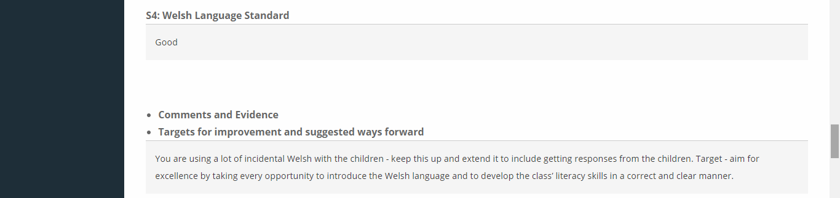
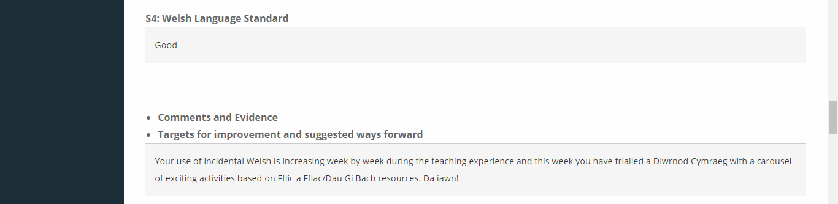
Appendix 2 – Scheme of work
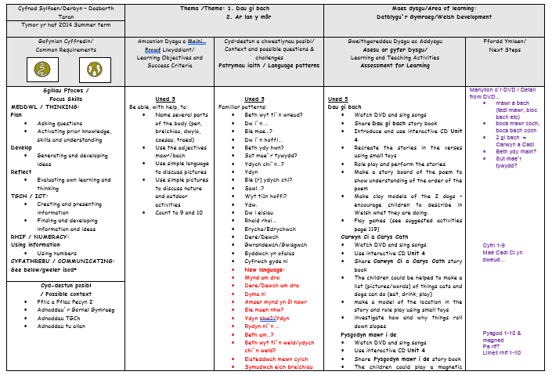

Appendix 3 – lesson plan
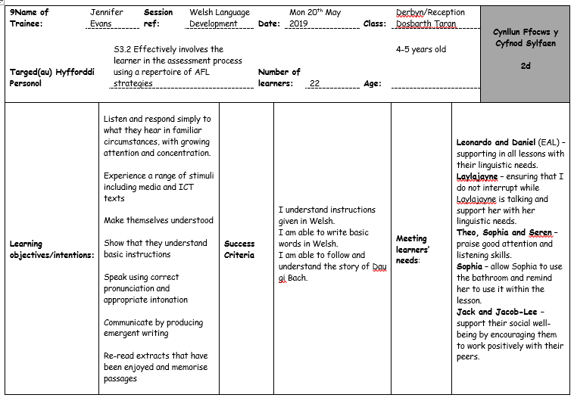
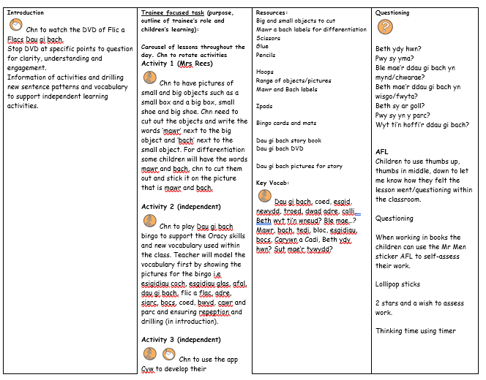
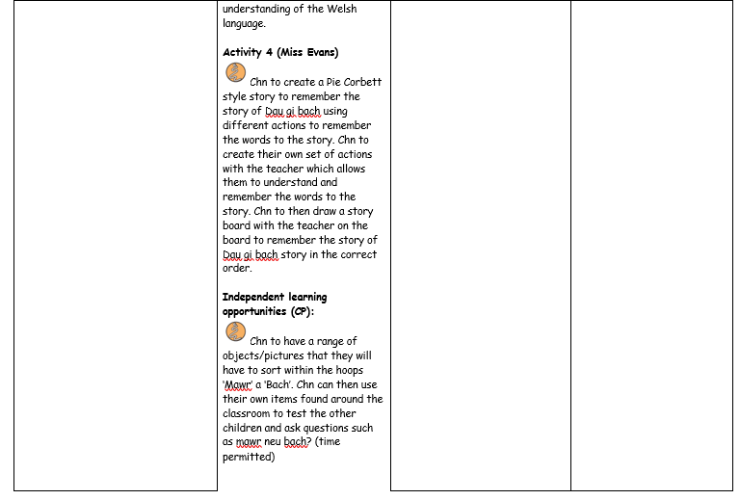

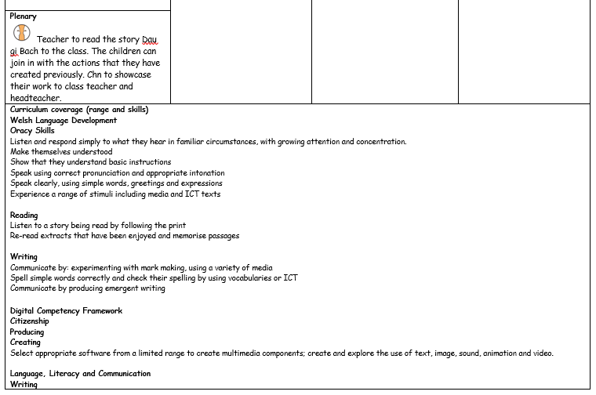
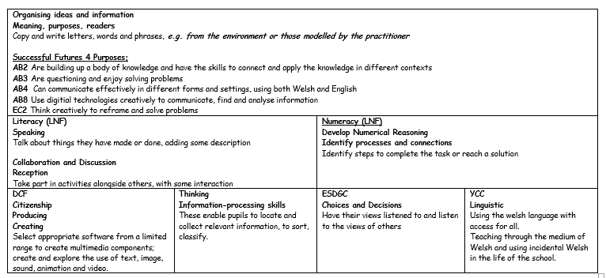

Appendix 4 – resource of mawr a bach
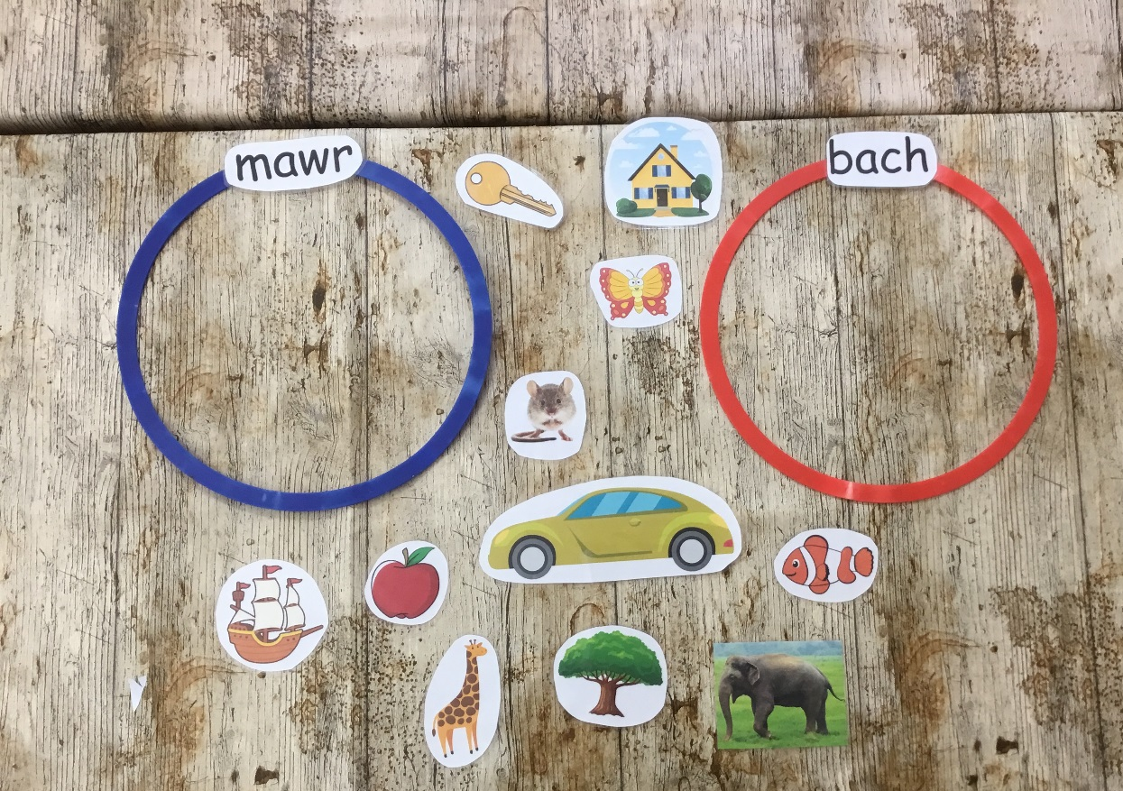

Appendix 5 – Bingo


