Name: Petrica-Lucian Ionesi
Student ID: 1813705
Module code: BMSK4002_LON
Assignment Name: Effective Team Working and Communication
Lecturer’s Name: Richard Small

Table of Contents
❖ Introduction 2
❖ Definition of Effective Communication 3
❖ What are Models of communication? 3
• The types of models are as follows: 4
❖ Communication Models 4
❖ Shannon and Weaver’s Informational Theory Model: 5
❖ Berlo’s S-M-C-R Model: 5
❖ Types of communication 6
• Five Types of Communication 6
❖ Theories of communication 7
✓ Critical Theory 7
✓ Information Theory 8
✓ Groupware Theory 8
❖ Types of communication skills at the workplace 8
✓ Verbal (In-Person) Communication 8
✓ Body Language & Facial Expressions 8
✓ Phone Conversation 9
✓ Written Communication 9
Managing conflict through effective communication at the workplace 9
❖ Communication styles 10
❖ Communication styles to be used within the workplace 10
❖ Recommendations for improvement 10
❖ Conclusion 11
❖ References 11

Introduction

- In this task, I will be talking and describing what communication means, what effective communication is, the importance of effective communication at the workplace, the theories and models of communication, how to solve problems and conflicts at the workplace through effective communication.

Definition of Effective Communication

- Communication is the procedure of sharing information, thoughts and feelings between persons through speaking, writing or body language. Effective communication extends the perception to involve that transmitted content is received and understood by someone in the way it was proposed. The goals of effective communication include producing a common perception, changing behaviors and obtaining information. Communication takes place when one person transmits ideas or feelings to another person or group of people. Its effectiveness is measured by the similarity between the idea transmitted and the idea received (BROWN, n.d.).

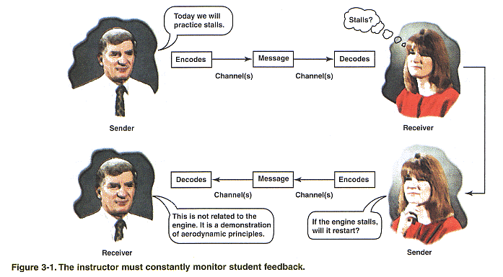
- Effective communication is defined as verbal speech or other methods of relaying information that get a point across.
- An example of effective communication is when you talk in clear and simple terms.
- An example of effective communication is when the person who you are talking to listens actively, absorbs your point and understands it.

What are Models of communication?

- Communication models are methodical representations of the procedure which assists in understanding how communication works can be completed. Models display the process emblematically and in symbols. They method general perceptions on communication by breaking communication from complex to simple and conserves the components in demand. Communication models can sometimes encourage traditional thinking and stereotyping but can also omit some major aspects of human communication. Methods and channels of communication to be used and the determination of communication must be considered before selecting a specific communication model. Models are used by business companies and other firms to foster their communication, explore their options and to evaluate their own situations. It is also used to cognise how the receivers will interpret the message (Businesstopia, 2018).

The types of models are as follows:
- Linear Model- This model includes a single speaker and listener where the ideas flow in one particular direction.
- Transactional model- This model helps to flow the ideas in both the ways where both the participants can present their feedbacks.
- Interactional model- This model can also help to share ideas and values in both the directions but in this instance, speakers and listeners can be more than one person.

Communication Models

Shannon and Weaver’s Informational Theory Model:

- In 1949 an engineer and researcher at Bell Laboratories, named Shannon, founded an information theory based on mathematical theories which was about signal transmission with maximum telephone line capacity and minimum distortion. For the first time, he introduced the qualitative and quantitative model of communication as a statistical process underlying information theory. The aim of Shannon was signal transmission from source to destination through transmitter and receiver across the channel with minimal interference or error. The information theory initially developed to separate noise from the signals carrying the information. Later on, Weaver extended and applied Shannon's information theory for different kinds of communication. While Shannon was focused on engineering aspect of his theory, Weaver developed the philosophical aspects of this theory related to human communication. Shannon and Weaver model of communication has 7 main elements which are:
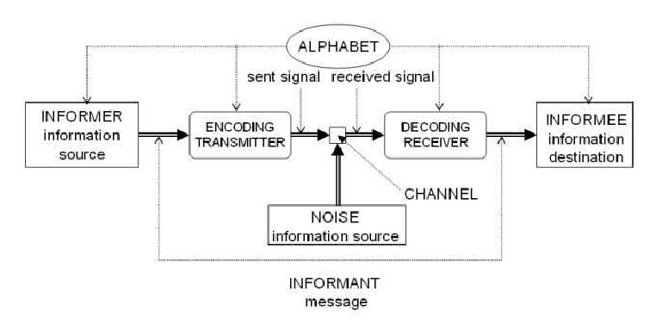
- This model shows the communication process between source and destination. The source creates the message which can be discrete or continuous. Based on Shannon and Weaver description which is quoted by Lossy (1999), a discrete source produces “the message, symbol by symbol. It will choose successive symbols according to certain probabilities depending, in general, on preceding choices as well as the particular symbols in question (Donohue, 2017).

Berlo’s S-M-C-R Model:
- In 1960, David Berlo postulated Berlo’s Sender-Message-Channel-Receiver (SMCR) Model of Communication from Shannon Weaver’s Model of Communication (1949). He described factors affecting the individual components in the communication making the communication more efficient. This model also focuses on encoding and decoding which happens before sender sends the message and before receiver receives the message respectively (ETECHMETHOD, 2016).



Types of communication

Five Types of Communication

- Communication is a precise basic and fundamental method for human beings. However, once a product wants to communicate with their customers, then the communication takes another form. Similarly, there is communication involved between teams as well. There are various types of communication between people as well as between teams. Research deep into the five types of communication detected between the group of people or an official team (Bhasin, n.d.).

- Verbal Communication:
- Verbal communication happens when we involve in speaking with others. It can be face-to-face, over the telephone, via Skype or Zoom plus many others. Some verbal engagements are informal, such as chatting with a friend over coffee or in the office kitchen, while others are more formal, such as a scheduled meeting (Goodwin, 2018).

- Non-verbal / Interpersonal communication:
- According to specialists, a considerable quantity of our communication is nonverbal. Every day, we answer to thousands on nonverbal cues and behaviors involving positions, facial expression, eye gaze, gestures, and tone of voice. From our handshakes to our hairstyles, nonverbal details reveal who we are and impact how we relate to other people (Cherry, 2019).

- Written Communications:
- The Written Communication mentions to the process of transmission a message across the written symbols. In other words, any message shared between two or more persons that make use of written words is called as written communication (Jargons, n.d.).

- Formal & Informal:
- Formal communication is one that passes through predefined channels of communication throughout the organization. On the contrary, Informal communication refers to the method of communication which currents in every direction, it attempts freely in the organization (S, 2015).

- Visual Communication:
- Visual communication is the transmission of information and concepts using figures and images. It is one of three principal types of communication, beside with verbal communication (speaking) and non-verbal communication (tone, body language). Visual communication is considered to be the style that people trust on greatest, and it includes symbols, graphic designs, films, typography, and countless other examples.

Theories of communication

- Communication theories approach from research and thought that describe how information is carried and received between two parties. These theories apply to verbal and written communication between people as well as form and transmission communications. Particular researchers apply the concepts to communication between animals and through computer networks. Lots of communication theories exist, but most collapse into several broader category. In determinations to progress the quality of communication, some researchers improve theories about what makes communication effective. These theories discover what goes right when viewpoints pass between two parties, and how to repeat that success more easily and reliably (Brick, 2018).

Critical Theory
- Critical Theory of Communication offers a vital set of new insights on how communication operates in the age of information, digital media and social media, arguing that we need to transcend the communication theory of Habermas by establishing a dialectical and cultural-materialist critical theory of communication (Fuchs, 2016).

Information Theory
- Information theory is the mathematical management of the perceptions, boundaries and procedures governing the transmission of messages through communication systems (Social & Sciences, 2001).

Groupware Theory
- The groupware theory proposes that old appearances of communication may change along with quick technological advances. Employees can communicate through computers and mobile devices so fast that information can extent throughout a company before management wants it to. Even affirmative information might stream from one department to another before management has time to notify all stakeholders of a change in policy or an initiative (Johnston, n.d.).

Types of communication skills at the workplace

- Words are only a minor percentage of how we communicate with one another. Yet the importance of other methods of communication is often supervised. Learn more about four different types of communication, and how using them effectively can improve performance, morale, teamwork and success in your business.

Verbal (In-Person) Communication
- When is possible, use face-to-face communication in the workplace to remove many of the confusions that can happen. Talking directly with someone in person permits both of you to see and hear the bigger picture. As you or your team member speak, you can see each other's facial expressions and body language.

Body Language & Facial Expressions
- As mentioned beyond, your body language and facial expressions play a vital part in how effective or ineffective you are at communicating with staff colleagues. Eye contact makes people feel acknowledged as they talk and listen. A relaxed stance with your arms by your sides encourages employees to feel comfortable in a meeting.

Phone Conversation
- Operating the phone is a common part of most every business day. Some people enjoy talking to team members by phone. Others dislike it so much that they put it off until the last minute. If the staff you lead is remote and spread out throughout the state, country or world, the phone will be a vital communication tool. You can definitely impact the efficiency of your phone communication by doing three simple things by smile while you talk, take notes before the conversation and finally, speak clearly and slowly so your words are understood.

Written Communication
- Emails, memos, and notes are mutual forms of written communication. Of all four communication styles, this is the one that can main to the most mistakes. People frequently read between the lines or feel that there are indirect messages or emotions in written forms of communication. In a workplace condition, this should and can be avoided. Before you send an email to your employees, distribute a note or post an important notice on the staff statement board, have an objective pair of eyes read it first. A business coach or mentor can look over your written communication and provide constructive criticism and helpful suggestions.

- Communication between you and your team will permanently be a work in progress. If communication between you and your staff has been difficult, you can zone in on the trouble spots and learn how to change them by working with a business trainer or coach (Miller, n.d.).

Managing conflict through effective communication at the workplace

- Keeping correct lines of communication can be the strategy to resolving differences in the workplace. Conflict in the workplace is certain to occur in an environment where people from different eternities, walks of life and working styles come together. Workplace conflict can inferior efficiency and lower confidence in the office. In order to contest workplace conflict, it’s important to find what’s producing the problem and then report the problem through proper communication techniques (Chan, n.d.).

Communication styles

- Decent communication skills demand a high level of self-awareness. Empathetic your own style of communicating will go a long way regarding assisting you to generate good and lasting impressions on others. By becoming more conscious of how others observe you, you can adapt more readily to their styles of communicating. This does not mean you have to be a butterfly, changing with every personality you meet. In its place, you can make another human more relaxed with you by choosing and highlighting assured behaviour’s that fit within your personality and resonate with another (Sherman, n.d.).
- There are three basic communication styles:
- Aggressive
- Passive
- Assertive

Communication styles to be used within the workplace

- An individual's communication style is seriously subjective by their personality and the way they learn. Knowledge what style, you lean toward can be an understanding tool to progress your performance at work. There are four common communication styles: analytical, intuitive, functional and personal. Each communication style displays strengths and weaknesses, and there are certain communication styles that conflict with one another. Everyone who has co-operated with colleagues on a group project recognises just how hard it can be to share and receive ideas. To transfer the project along, it is fundamental for everyone to communicate. The same holds true even when you’re sending an e-mail to one coworker: Say the incorrect thing, and you may damage or even expose a key professional relationship (NORTH, n.d.).

Recommendations for improvement

- Consider decent communication to be the underground ingredient in a successful, performing team. Communication plays a essential role in building reliable relationships, producing designs, and assisting a team overcome challenges and face difficult conversations.
- Create A Communication-Friendly Space
- Keep Communication Constant
- Hold Weekly Town Hall Meetings
- Ask for Your Employee’s Feedback
- Communicate Face to Face
- Master Your Body Language
- Don’t Over-Communicate
- Take Time to Listen
- Personalize Your Communications
- Be Authentic
- Incorporate Team Building Games
- Try the One Up, One Down Exercise
- Uncover communication problems
- In this report, I assign thirteen actionable guidelines to improve the quality and quantity of communication team (Robins, 2018).

Conclusion

- Effective communication and teamwork will assist a business support a positive work environment. Effective communication also permeates throughout all areas of business operations, because a confident workplace means happier employees are interacting with the public and with consumers. Effective communication among business teams begins with leadership that sets clear methods and values (Leonard & Thompson, 2019).

References

Bibliography
Bhasin, H., n.d. Five Types of Communication. [Online]
Available at: https://www.marketing91.com/five-types-of-communication/
[Accessed 12 05 2019].
Brick, B., 2018. Types of Communication Theories. [Online]
Available at: https://www.theclassroom.com/types-communication-theories-8117675.html
[Accessed 12 05 2019].
BROWN, B., n.d. What is Effective Communication?. [Online]
Available at: https://www.livestrong.com/article/69309-effective-communication/
[Accessed 12 05 2019].
Businesstopia, 2018. Models of Communication. [Online]
Available at: https://www.businesstopia.net/communication
[Accessed 12 05 2019].
Chan, C., n.d. Communication Techniques for Conflict Resolution in the Workplace. [Online]
Available at: https://woman.thenest.com/communication-techniques-conflict-resolution-workplace-8470.html
[Accessed 12 05 2019].
Cherry, K., 2019. Types of Nonverbal Communication. [Online]
Available at: https://www.verywellmind.com/types-of-nonverbal-communication-2795397
[Accessed 12 05 2019].
Donohue, M., 2017. Shannon-Weaver Model of Communication. [Online]
Available at: https://medium.com/design-theory-critical-thinking/shannon-weaver-model-of-communication-ce9ca9c14741
[Accessed 12 05 2019].
ETECHMETHOD, 2016. BERLO’S SMCR MODEL OF COMMUNICATION. [Online]
Available at: https://etechmethod.wordpress.com/2016/10/11/berlos-smcr-model-of-communication/
[Accessed 12 05 2019].
Fuchs, C., 2016. Critical Theory of Communication. [Online]
Available at: http://fuchs.uti.at/books/critical-theory-of-communication/
[Accessed 12 05 2019].
Goodwin, D., 2018. FIVE TYPES OF COMMUNICATION. [Online]
Available at: https://drexel.edu/goodwin/professional-studies-blog/overview/2018/July/Five-types-of-communication/
[Accessed 12 05 2019].
Jargons, B., n.d. Written Communication. [Online]
Available at: https://businessjargons.com/written-communication.html
[Accessed 12 05 2019].
Johnston, K., n.d. Theories on Communication in Organizations. [Online]
Available at: https://smallbusiness.chron.com/theories-communication-organizations-69478.html
[Accessed 12 05 2019].
Leonard, K. & Thompson, J., 2019. Effective Communication & Team Work. [Online]
Available at: https://smallbusiness.chron.com/effective-communication-team-work-3167.html
[Accessed 12 05 2019].
Miller, R., n.d. 4 Different Types of Workplace Communication and How to Improve in Each Area. [Online]
Available at: https://www.sandler.com/blog/4-different-types-workplace-communication-and-how-improve-each-area
[Accessed 12 05 2019].
NORTH, M., n.d. How to Communicate More Effectively in the Workplace. [Online]
Available at: https://www.extension.harvard.edu/professional-development/blog/how-communicate-more-effectively-workplace
[Accessed 12 05 2019].
Robins, A., 2018. 13 Ways To Improve Communication At Work. [Online]
Available at: https://www.officevibe.com/blog/improve-communication-at-work
[Accessed 12 05 2019].
Robinson, L., Segal, J. & Smith, P. a. M., 2018. [Online]
Available at: https://www.helpguide.org/articles/relationships-communication/effective-communication.htm/
Sherman, R., n.d. Understanding Your Communication Style. [Online]
Available at: http://www.au.af.mil/au/awc/awcgate/sba/comm_style.htm
[Accessed 12 05 2019].
Social, I. E. o. t. & Sciences, B., 2001. Information Theory. [Online]
Available at: https://www.sciencedirect.com/topics/neuroscience/information-theory
[Accessed 12 05 2019].
S, S., 2015. Difference Between Formal and Informal Communication. [Online]
Available at: https://keydifferences.com/difference-between-formal-and-informal-communication.html
[Accessed 12 05 2019].

