Title of work
University Students Attitudes Toward the use of AI tools such as ChatGPT in England.
Student name: saba badil
Student number: 2223131
Module code: LCLM6004
Module name: Research Methods for Business
Lecture name: Dr Koushik Das Sarma
Email: k.das-sarma@uwtsd.ac.uk

Contents
Abstract. 2
Introduction and identification. 3
Research aim, objectives, and questions. 4
Research questions. 4
Preliminary literature review: 4
Overview of AI in education. 4
AI Tools' Advantages for Students. 5
Concerns about Academic Integrity and Ethics: 6
Attitudes and Trends in Student Behaviour. 7
Conceptual framework. 7
Research gap. 7
Research Design and Methodology. 7
Interpretivism as a Research Philosophy. 8
Inductive Theory Development Method. 9
Selecting a Methodological Approach: Mono Qualitative. 9
Case Study as a Research Method. 9
Time Horizon Cross-sectional. 9
Data collection and analysis techniques. 9
Moral Points to Remember ethical consideration: 10
Restrictions limitation: 10
Gantt chart project timeline: 10
Practical implication: 10
Conclusion: 11
References: 11

Abstract.
This study investigates how universities students perceive and utilise ChatGPT and other AI learning technologies. It seeks to ascertain if students view these resources as immoral short cuts or as useful for enhancing academic success. Students from various classes will be surveyed and interviewed to gather data.

Introduction and identification.
This study aims to explore how universities students perceive and use ChatGPT and other AI technologies for their assignments. The Research Onion model, created by Saunders et al. (2016), is used in the study's design and justification of its methodological choices. The main objective is to comprehend the attitudes, benefits, challenges, and ethical quandaries around AI-assisted learning.
Over the years, the science of artificial intelligence has advanced significantly and is continuously moving away from the theoretical framework. AI is currently in its primary stage of becoming a reality and a tool for reality in modern life (Islam et al., 2024).
AI has completely changed how students’ study and finish their assignments. One such example is ChatGPT, a large language model that produces text and summaries. These features make AI technologies useful for students, but they also cause colleges to worry about academic integrity, plagiarism, and the growth of critical thinking skills.
Higher education institutions now face a business and managerial challenge in juggling innovation and quality control. Universities must address the administrative, ethical, and technological obstacles of adopting AI as education is increasingly run according to business principles, such as performance metrics, digital platforms, and student happiness. There are ethical issues with AI use in higher education that need to be resolved. Biassed algorithms are dangerous because they can have disastrous consequences for students, particularly when they are used to admissions or grading procedures. The replacement of human educators by AI systems is another problem, and as AI is more incorporated into decision-making processes, questions concerning accountability and transparency arise (Slimi and Carballido 2023).
Since companies in all sectors deal with the same issues of ethical AI governance, digital ethics, and employee training, the issue is pertinent to more general business practices. Universities may create equitable academic policies and better educate students for the AI-driven workforce by considering the opinions of their students. According to Singh and Pushpanadham (2024), AI has become a vital component of life in many different fields because to its extensive uses. AI has grown because of improvements in AI models, more access to large datasets, and the availability of computing power. Discussions and worries have been raised by the growing use of AI, especially in relation to its ethical implications. AI has the potential to define the current decade.
Considering this, this study explores how students view AI tools, the advantages they experience, the difficulties they encounter, and how they handle ethical dilemmas related to AI use.

Research aim, objectives, and questions.
Aim.
To investigate how college students feel about using AI tools (like ChatGPT) for research and assess the administrative, ethical, and educational ramifications for higher education.
Objectives.
To determine how students utilise AI study aids.

To evaluate the alleged advantages and difficulties of AI-assisted education.
To investigate students' concerns about academic integrity and ethical awareness.
To offer suggestions for the creation of responsible AI policies and practices in higher education.

Research questions.
1: What are university students’ attitudes toward using AI tools such as ChatGPT for studying?
2: What benefits and challenges are reported in existing research about student use of AI tools?
3: How do universities and students address the ethical and academic integrity issues of using AI in education?
The stated business problem is directly addressed by these SMART (specific, measurable, achievable, relevant, and time-bound) questions.

Preliminary literature review:

Overview of AI in education.
Our culture and way of life are undergoing significant change because to the quick development of artificial intelligence (AI) and intelligent robots like ChatGPT. Education is one of the many industries that is rapidly incorporating these cutting-edge technologies. Large-scale data processing and analysis capabilities of AI tools present special chances to enhance educational results and customise learning. They make learning more flexible and dynamic by giving students access to a wide range of resources and providing them with immediate solutions to their queries. But the use of new technologies also brings up important issues regarding how instruction and evaluation must change to be current and successful. Numerous projects and studies have already demonstrated how AI is affecting education.
Artificial intelligence (AI) has been a part of our lives for a very long time and has now permeated our daily lives so deeply that it is now necessary for us to function well in many ways. Outcome-based education systems have gradually replaced traditional educational systems in recent years. In outcome-based education, AI-based technologies make a substantial contribution by providing diverse teaching-learning groups with individualised experiences. Furthermore, in this COVID-19 era, when education is being delivered online all over the world, the process can be managed more successfully by incorporating the flavour of artificial intelligence. In this chapter, concentrate on the future of AI in education, its applications, and its reach (Bhise et al., 2022).
Giattino. et al (2023), claims that the amount of computing power required to train AI systems has increased dramatically, making it possible for programs like ChatGPT to carry out progressively difficult tasks. AI is becoming more widely available in educational settings because to this technical advancement, where students use it for research advice, writing assistance, and summarisation.
The UK government is aware of how generative AI might revolutionise education, especially in terms of improving individualised instruction and lightening the strain of teachers. With an emphasis on upholding academic integrity and protecting students, AI tools are being tested to assist feedback, marking, and resource production, according to Department for Education (2025).
It has been demonstrated that students can take practice exams repeatedly by choosing the right topics, difficulty levels, length of time, and other factors with the use of AI-driven systems. Ethical questions and concerns always accompany scientific and technological breakthroughs.

AI Tools' Advantages for Students.
It has been said that artificial intelligence (AI) will be the next big thing in research and education. Artificial Intelligence (AI) is a general term that describes computer systems that can carry out tasks that normally call for human intelligence. AI has the power to completely transform both research and the ways that we teach and learn (Kenchakkanavar 2023).
ChatGPT facilitates idea generation, translation, proofreading, and summarisation. Additionally, it makes learning more accessible for pupils with language or disability obstacles.
According to our World in Data students' access to and interaction with academic information has changed because of the rapid global integration of digital technology in education. AI tools are becoming increasingly integrated into educational settings, providing individualised assistance and enhancing resource accessibility, particularly in higher education (Roser., et al 2023).
According to a Jisc (2025) research, 61% of university students in the UK have used AI technologies for academic purposes, mostly to enhance their writing and comprehension of subjects. AI is guiding students through their studies by assisting them with research, writing, note-taking, editing, and presentation abilities.

Concerns about Academic Integrity and Ethics:
In addition to the many benefits that come with artificial intelligence in higher education, there are also risks to the core ideas, procedures, norms, morality, and academic integrity of both teaching and research. Therefore, the main emphasis should be on seizing the advantages and opportunities presented by this development while skilfully managing any possible risks and difficulties (Khatri and Karki 2023).
But there are also concerns about academic integrity when using AI. According to Bender et al. (2021), big language models could produce biassed or erroneous content.
While many UK individuals view AI as positive, worries about trust, transparency, and ethical use persist, according to a recent ONS poll (2023). These results reinforce the necessity of critically assessing AI tools in education, particularly about student data protection and fairness.
Algorithmic prejudice, a lack of transparency, and ambiguous accountability are among the ethical issues facing AI, according to Our World in Data. Since AI tools may have an impact on learning outcomes, feedback, or grading, these concerns are particularly important in the field of education. Such hazards have the potential to erode academic systems' credibility and fairness if they are not well addressed.

Attitudes and Trends in Student Behaviour.
While many students value AI for saving time, others are unsure of what constitutes appropriate use, according to Jisc (2025), Poor communication and uneven institution procedures are frequently the cause of this ambiguity.

Conceptual framework.
AI tool use. | Student perception. | Ethical awareness. | Institutional policy. | Learning outcome.

Research gap.
Many research focusses on AI's technological features or institutional reactions. Few qualitative studies have examined students' viewpoints and their comprehension of moral limits. This study closes that gap by using interpretivist analysis and a case study approach to investigate attitudes in an actual academic setting.

Research Design and Methodology.
I organised my research's methodological design using Saunders et al. (2016)'s Onion framework. The study aims to investigate how students view AI technologies like ChatGPT by analysing current academic and business literature, guided by an interpretivist philosophy and an inductive methodology. Using only secondary data from reliable sources, a qualitative case study design was used. The study adheres to ethical norms through precise reference and academic honesty, and it has a cross-sectional temporal horizon of 2024–2025.

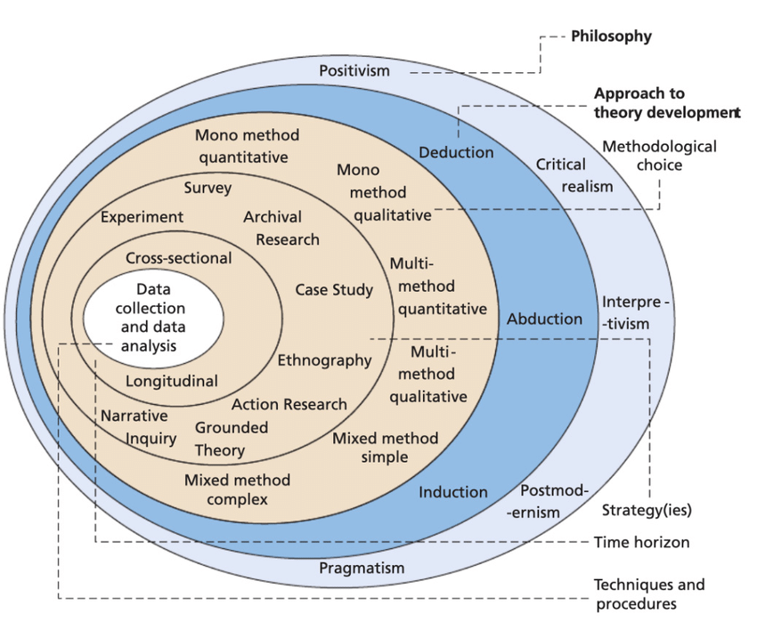
Fig 1: https://www.researchgate.net/publication/349514500/figure/download/fig1/AS:994190783705100@1614044962560/The-Research-Onion-Saunders-Lewis-2009.ppm

Interpretivism as a Research Philosophy.
To comprehend students' subjective experiences and views on AI tools, the study employs an interpretivist philosophy. Interpretivism works well for examining meaning and action in social settings, particularly when perceptions are shaped by personal values and educational settings.
according to Nickerson (2022), Interpretivism is a social science approach that holds that deciphering the meaning of the evidence that can be gathered about a phenomenon requires an understanding of the attitudes, motives, and reasoning of people in a social setting.
Limitation: Although the results will offer profound insights into individual views, they might not be applicable to other pupils.

Inductive Theory Development Method.
Theory is developed from known evidence using an inductive technique. This makes sense considering how AI in education is developing and the necessity of investigating new trends rather than testing preconceived notions.
Limitation: Results using inductive reasoning might be context-specific, necessitating additional study for wider validation.

Selecting a Methodological Approach: Mono Qualitative.

Utilising just secondary data, a mono-method qualitative approach is used. Academic journals, official publications, institutional reports, and internet databases are examples of sources. This eliminates the requirement for primary data collection and enables rich, contextual insights.

Case Study as a Research Method.
The study looks at real-world examples and the Jisc 2025 student survey using a case study methodology. This approach links educational research to real-world commercial and policy issues.

Time Horizon Cross-sectional.
To present a contemporary glimpse of student attitudes and institutional reactions, the study uses a cross-sectional time horizon, concentrating on data and trends from 2024–2025.

Data collection and analysis techniques.
Data collection:
Credible secondary sources will provide the data, such as academic literature, government and institutional reports, online surveys, and databases (such as Jisc and ONS).
Data Analysis:
To find trends in student attitudes, ethical issues, and institutional reactions, thematic analysis will be employed. To improve dependability, triangulation will be used by Journals, government publications, and internet sources are examples of secondary research.

Moral Points to Remember ethical consideration:
voluntary involvement, confidentiality, and informed consent.
No usage of personal identifiers or information produced by AI.

Restrictions limitation:
The study's reliance on secondary data, which might not accurately reflect student sentiment in real time, is one of its limitations. Furthermore, certain sources might be shallow or vague, and examining already-existing materials could lead to interpretation bias.

Gantt chart project timeline:

Practical implication:
Regarding Universities.
Create unambiguous, student-friendly AI usage guidelines.
Provide training courses on the moral and efficient application of AI.
Include a discussion of AI in workshops on academic integrity.

Conclusion:
Using the Research Onion technique, this research proposal offers a methodical strategy for examining students' perceptions of AI tools in the classroom. A thorough grasp of the moral and behavioural concerns surrounding the application of AI is provided by the interpretivist, inductive, qualitative, and case study designs.
By providing recommendations for AI training and policy that are backed by research, the project enhances scholarly literature and higher education policy.
increasing the professional level of ethical consciousness and digital accountability in the future.
The study provides insightful information for universities adjusting to the deployment of AI, despite its restricted generalisability.

References:

Bender, E., McMillan-Major, A., Shmitchell, S. and Gebru, T. (2021). On the Dangers of Stochastic Parrots: Can Language Models Be Too Big? FAccT ’21: Proceedings of the 2021 ACM Conference on Fairness, Accountability, and Transparency, pp.610–623. doi: https://doi.org/10.1145/3442188.3445922. [Accessed 25 October 2025].
Bhise, A., Munshi, A., Rodrigues, A. & Sawant, V. (2022). Overview of AI in education. In Artificial Intelligence in Higher Education, pp. 31–62. CRC Press. [Accessed 25 October 2025].
Department for Education (2025). Generative Artificial Intelligence (AI) in Education. [online] GOV.UK. Available at: https://www.gov.uk/government/publications/generative-artificial-intelligence-in-education/generative-artificial-intelligence-ai-in-education. [Accessed 25 October 2025].
Giattino, C., Mathieu, E., Samborska, V. and Roser, M. (2023). Artificial Intelligence. Our World in Data. [online] Available at: https://ourworldindata.org/artificial-intelligence. [Accessed 25 October 2025].
Islam, M.T., Al Mamun, M.A., Khan, O.U., Akeem, A.B., Mohammad, H., Hamdache, A. & Elmouki, I. (2024). Emerging trends in artificial intelligence learning methods: Deep learning and machine learning innovation in computer science. Nanotechnology Perceptions, pp. 1150–1173. [Accessed 25 October 2025].
Jisc. (2025). Student perceptions of AI 2025. Available at: https://www.jisc.ac.uk/reports/student-perceptions-of-ai-2025 [Accessed 25 October 2025].
Kenchakkanavar, A.Y. (2023). Exploring the artificial intelligence tools: Realizing the advantages in education and research. Journal of Advances in Library and Information Science, 12(4), pp. 218–224. [Accessed 25 October 2025].
Khatri, B.B. & Karki, P.D. (2023). Artificial intelligence (AI) in higher education: Growing academic integrity and ethical concerns. Nepalese Journal of Development and Rural Studies, 20(1), pp. 1–7. [Accessed 25 October 2025].
Nickerson, C. (2022). Interpretivism paradigm & research philosophy. *Simply Sociology*. https://www.simplysociology.com/interpretivism.html [Accessed 25 October 2025].
ONS. (2023). Public awareness, opinions and expectations about artificial intelligence – Office for National Statistics. [online] www.ons.gov.uk. Available at: https://www.ons.gov.uk/businessindustryandtrade/itandinternetindustry/articles/publicawarenessopinionsandexpectationsaboutartificialintelligence/julytooctober2023 [Accessed 25 October 2025].
Roser, M., Ortiz-Ospina, E., Ritchie, H., Samborska, V. & Ahuja, N. (2023). Global Education. [online] Our World in Data. Available at: https://ourworldindata.org/global-education [Accessed 25 October 2025].
Saunders, M., Lewis, P. & Thornhill, A. (2016). Research Methods for Business Students. 7th ed. Pearson Education. [Accessed 25 October 2025].
Singh, P. & Pushpanadham, K. (2024). AI ethics in higher education: Bridging the gap between principles and practices. In Generative Artificial Intelligence in Higher Education: A Handbook for Education Leaders, pp. 64–78. [Accessed 25 October 2025].
Slimi, Z. & Carballido, B.V. (2023). Navigating the ethical challenges of artificial intelligence in higher education: An analysis of seven global AI ethics policies. TEM Journal, 12(2), pp. 123–135. [Accessed 25 October 2025].

