

Dementia in Parkinson’s Disease F02.3
Group F00-F09 Organic, including symptomatology, mental disorder

Student name: Ramona Georgeta Marza
Student ID: 1919636
Module name: BMHP6006_LON
Lecturer name: Bianca Sanfilippo
Table of Contents
Dementia in Parkinson's Diseases 3
Dementia in Parkinson's Diseases within the ICD-10 Manual 4
Definition 5
Causes of Dementia in Parkinson's Diseases 6
Symptoms and signs 7
Diagnosis 8
Historical view and treatments for Dementia in Parkinson's Diseases 9
Current treatments (NHS) 10
Principles when working with people with Dementia in Parkinson's Diseases 11
Recommendations and Conclusion 12
Reference list 13

Dementia in Parkinson's Diseases

Parkinson's disease is found to be having a concerning amount of connection with Dementia. Parkinson’s disease is found to be leading to physical symptoms in the first place. Issues with cognitive functioning are found to be evident which is accompanied by forgetfulness and challenges regarding concentrating. With the passage of time, the disease gets worse and thus the person is found to be suffering from Dementia which leads to loss of memory thus maintaining relationships is found to be quite hard. However, it is evident that not every individual who is found to be suffering from Parkinson’s disease will eventually develop (Fiorenzatoet al., 2019). In Dementia it is found that individuals who have been diagnosed with Parkinson’s disease are also found to have started suffering from Dementia after a long period of time. There are also various forms of Dementia as well while the most common other than Parkinson’s disease is Alzheimer’s disease. Dementia in Parkinson’s disease is found to be having a wide range of factors which leads to mental condition, several signs and symptoms and diagnosis methods (Saredakiset al., 2019).

Dementia in Parkinson's Diseases within the ICD-10 Manual

The mental condition belongs to the group of neurotic disorder as several neurotic changes are found to be made among individuals suffering from it (Phull, 2021). Dementia in Parkinson’s Disease is found to be affecting in a manner which is dependent upon time. As the mental condition is progressing it is evident that the different parts of the brain which are leading to basic functioning are affected and thus the individual are suffering from loss of memory and inability to judge between things. Though, a person suffering from Dementia in Parkinson’s Disease does not die therefor the disease is not fatal. However, the condition is worsening as such individuals are not able to care for themselves and they are needed to supportive care to survive (Elsevier, 2022).

Definition

The term Dementia can be defined as a number of symptoms which are found to be worsening over time or in daily life. The symptoms of Dementia are evident due to the brain cells being impaired and die ultimately. A fall in the ability to think, reason, movement, is found to be a common issue that is faced by individuals who suffer from Dementia in Parkinson's Disease (Aarslandet al., 2021). Generally, Dementia in Parkinson's Disease is highly common among individuals who are aged above 50 years, however, the risk is found to be much higher for those individuals who are at and above the age of 60 years and this age is found to be average at most individuals suffer from Dementia in Parkinson's Diseases. It is evident from a report that, individuals who are aged between 30 to 59 years who are suffering from Dementia in the UK in 2018 were about 32,725. Individuals between 60 to 64 years suffering from Dementia were about 20,260, individuals between 65 to 69 years numbered 45,030 and individuals aged 70 years to 74 years were 103,649. Thus, a wide amount of the population is found to be suffering from Dementia in the UK (Statista, 2022).

Causes of Dementia in Parkinson's Diseases

The major causes of Dementia in Parkinson's Disease are caused due to the deterioration of brain cells or the degeneration of nerve cells and chemical moderation in the brain. Family background is another reason why various individuals are found to be suffering from Dementia in Parkinson's Disease. In addition to that, ageing is found to be the most common reason why older adults are found to be suffering from Dementia in Parkinson's Disease (Balestrino and Schapira, 2020). Individuals who have been diagnosed with Parkinson’s disease are at higher risk of suffering from Dementia. Individuals who have delusions and hallucinations in the early phases of their life are found to also have an increased risk of suffering from Dementia. Thus, there are factors or causes that have been leading to Dementia among older adults. Older adults are found to be more prone to these risks and thus they are found to be more vulnerable to suffering from Dementia in Parkinson’s disease (Bloemet al., 2021).

Symptoms and signs

There are specific signs and symptoms which are evident among individuals suffering from Dementia in Parkinson’s Disease. The major indicators are disturbances when sleeping, loss of memory and unable to think, moderation of appetite, and changes in mental health are some of the common symptoms of Dementia in Parkinson’s Disease. Older adults are found to be experiencing forgetfulness, loss of thinking capabilities, difficulty when concentrating, conversation with others and recalling something from memory such as names and words (Hayes, 2019). Moderation of energy levels and sleeping patterns are also major symptoms regarding individuals suffering from Dementia in Parkinson’s Disease. Changes in appetite, lack of activity and weakness and eating less are found to be also major indicators. Depression, anxiety, and agitation are found to be common among older adults suffering from Dementia in Parkinson’s Disease. Delusions, paranoia, and irrationality are also major signs and symptoms of Dementia in Parkinson’s Disease. Therefore, there are symptoms and signs which are found to be clear among older adults suffering from Dementia in Parkinson’s Disease (Sezginet al., 2021).

Diagnosis

There is a wide number of steps are to be adopted to diagnose Dementia in Parkinson’s Disease. At first, a GP or a Parkinson’s nurse is an appointment, however, in various cases, it is found that individuals have hired individuals who are close to them from their family and friends for their care and support. The medical history of individuals suffering from Dementia in Parkinson’s Disease is analysed by a trained or professional doctor or care provider, after that, the signs and symptoms are analysed as well as the examination of the physical as well as the neurological condition of the suffering individual (Smith et al., 2019). Therefore, a diagnosis is performed when is needed to be only done when the individual has been suffering from Dementia in Parkinson’s Disease for the past one year which is the least duration required to avail treatment or diagnosis under Dementia in Parkinson’s Disease. Thus, individuals who are suffering from Dementia in Parkinson’s Disease are needed to be provided with care in a quick and rapid manner as delay in care is found to be worsening the situation of the patient as further damage to brain cells is evident (Galtieret al., 2019).

Historical view and treatments for Dementia in Parkinson's Diseases

The history of Dementia in Parkinson’s Disease is found to be quite linked with therapeutic interventions which range from various observations which were serendipitous for the controlling of the trials in clinics which were particularly designed for the agents. In the past, Dementia in Parkinson’s Disease was treated by Dr Jean-Martin Charcot who used belladonna alkaloids which are the main agents with “anticholinergic” properties. In addition to that, products that are rye based named ergot were also employed for the treatment of Dementia in Parkinson’s Disease (Chia et al., 2020). Venesection which is mainly advocating of bloodletting from the neck is followed by vesicatory’s so that induction of the blisters and inflammation over the skin can be done and has been used as a method to treat Dementia in Parkinson’s Disease, this approach had been adopted by Parkinson. However, the method of Dr Charcot is found to have been widely employed in the past to deal with the issue (Rocca, 2018).

Current treatments (NHS)

Donepezil is being used in the treatment of Dementia in Parkinson’s Disease. NHS in the UK has made use of Donepezil which has brought about a concerning amount of help regarding the treatment of individuals suffering from the concerned mental health issue. In addition to that, “Acetylcholinesterase inhibitors” are also found to be used as these medicines are found to be leading to the prevention of enzymes for the resolving of a particular chemical in the brain named “acetylcholine” and thus communication between nerve cells is found to be supported (Sackleyet al., 2020). Memantine also known as Namenda is also employed to treat Dementia in Parkinson’s Disease, this medicine is found to be an alternative for those who are unable to consume “Acetylcholinesterase inhibitors”. It functions as an obstruction towards the rise in the amounts of glutamate in the brain. However, there are major side effects of this medicine which are fatigue, abnormal heart rhythm, dizziness, and headaches which are on a temporary basis. These medications have been widely adopted, which has provided enhancement of mental conditions (Nhs.uk, 2022).

Principles when working with people with Dementia in Parkinson's Diseases

There are certain measures that are needed to be adopted when dealing with individuals suffering from Dementia in Parkinson’s Disease. At first, avoiding environments and subjects that can be unfair to patients, as unfair situations are found to be leading to a rise in the levels of stress and confusion. Encouragement of the victim via keeping them engaged with their hobby and health interaction. Providing them support regarding their mealtime and medications (Liebermann et al., 2020). Listening carefully to what they speak, speaking clearly to them, and expressing respect while communicating with them, making use of body language such as being calm while communicating standing at a fair distance when communicating with them are some of the major principles that are needed to be adopted. These measures are found to be having positive influences or impacts on the mental health of individuals suffering from Dementia in Parkinson’s Disease. Individuals are needed to make sure that they are capable of these thighs so that they are able to effectively deal with issues and challenges faced when communicating with a patient with Dementia in Parkinson’s Disease (Schneider and Kortagere, 2022).

Recommendations and Conclusion

In conclusion, it can be said Dementia in Parkinson’s Disease is a major health issue. There has been a concerning number of factors that have been leading to Dementia in Parkinson’s Disease. In addition to that, there are several signs as well which are found to be leading individuals to suffer from Dementia in Parkinson’s Disease. Various diagnosis methods are available however, there is not a specific diagnosis method that can be used to state that a person is suffering from Dementia in Parkinson’s Disease. Lastly, individuals are needed to maintain principles in order to deal with patients in an effective manner. Compassion can be taken as a major recommendation and suggestion regarding individuals suffering from Dementia in Parkinson’s Disease which will widely bring about a fall in the cases of Dementia (Rashid, 2022).

Reference list
Aarsland, D., Batzu, L., Halliday, G.M., Geurtsen, G.J., Ballard, C., Ray Chaudhuri, K. and Weintraub, D., 2021. Parkinson disease-associated cognitive impairment. Nature Reviews Disease Primers, 7(1), pp.1-21.
Balestrino, R. and Schapira, A.H.V., 2020. Parkinson disease. European journal of neurology, 27(1), pp.27-42.
Bloem, B.R., Okun, M.S. and Klein, C., 2021. Parkinson's disease. The Lancet, 397(10291), pp.2284-2303.
Chia, S.J., Tan, E.K. and Chao, Y.X., 2020. Historical perspective: Models of Parkinson’s disease. International journal of molecular sciences, 21(7), p.2464.
Elsevier, 2022. Buck's 2023 ICD-10-CM for Hospitals-E-Book. Elsevier Health Sciences.
Fiorenzato, E., Strafella, A.P., Kim, J., Schifano, R., Weis, L., Antonini, A. and Biundo, R., 2019. Dynamic functional connectivity changes associated with dementia in Parkinson’s disease. Brain, 142(9), pp.2860-2872.
Galtier, I., Nieto, A., Lorenzo, J.N. and Barroso, J., 2019. Subjective cognitive decline and progression to dementia in Parkinson’s disease: a long-term follow-up study. Journal of neurology, 266(3), pp.745-754.
Hayes, M.T., 2019. Parkinson's disease and parkinsonism. The American journal of medicine, 132(7), pp.802-807.
Liebermann, J.D., Witte, O.W. and Prell, T., 2020. Association between different coping styles and health-related quality of life in people with Parkinson’s disease: A cross-sectional study. BMJ open, 10(7), p.e036870.
Nhs.uk. 2022. What are the treatments for dementia?NHS choices. NHS. Available at: <https://www.nhs.uk/conditions/dementia/treatment/#:~:text=Acetylcholinesterase%20inhibitors&text=Donepezil%20is%20also%20used%20to,Alzheimer's%20disease%20with%20vascular%20dementia/>[Accessed: 14 November 2022].
Phull, J., 2021. ICD 10 in Psychiatry: A Learning Guide. CRC Press.
Rashid, A., 2022. Yonder: Dementia friendliness, compassion fatigue, foundational science, and anal sex. British Journal of General Practice, 72(717), pp.173-173.
Rocca, W.A., 2018. The burden of Parkinson's disease: a worldwide perspective. The Lancet Neurology, 17(11), pp.928-929.
Sackley, C.M., Rick, C., Au, P., Brady, M.C., Beaton, G., Burton, C., Caulfield, M., Dickson, S., Dowling, F., Hughes, M. and Ives, N., 2020. A multicentre, randomised controlled trial to compare the clinical and cost-effectiveness of Lee Silverman Voice Treatment versus standard NHS Speech and Language Therapy versus control in Parkinson’s disease: a study protocol for a randomised controlled trial. Trials, 21(1), pp.1-13.
Saredakis, D., Collins-Praino, L.E., Gutteridge, D.S., Stephan, B.C. and Keage, H.A., 2019. Conversion to MCI and dementia in Parkinson's disease: a systematic review and meta-analysis. Parkinsonism & Related Disorders, 65, pp.20-31.
Schneider, J.S. and Kortagere, S., 2022. Current concepts in treating mild cognitive impairment in Parkinson's disease. Neuropharmacology, 203, p.108880.
Sezgin, M., Bilgic, B., Tinaz, S. and Emre, M., 2019, April. Parkinson's disease dementia and Lewy body disease. In seminars in neurology (Vol. 39, No. 02, pp. 274-282). Thieme Medical Publishers.
Smith, C., Malek, N., Grosset, K., Cullen, B., Gentleman, S. and Grosset, D.G., 2019. Neuropathology of dementia in patients with Parkinson’s disease: a systematic review of autopsy studies. Journal of Neurology, Neurosurgery & Psychiatry, 90(11), pp.1234-1243.
Statista. 2022. Prevalence of dementia in the United Kingdom 2018-2050, Statista. [online] Available at: <https://www.statista.com/statistics/1289608/prevalence-of-dementia-in-the-united-kingdom/> [Accessed: 14 Noveber 2022].

Appendix


Dementia in Parkinson’s Disease F02.3
Group: F00-F09 Organic, including symptomatology, mental disorder
Student name: Ramona Georgeta Marza
Student ID:1919636
Module: BMHP6006_LON
Lecturer: Bianca Sanfilippo

Dementia in Parkinson's Disease F02.3

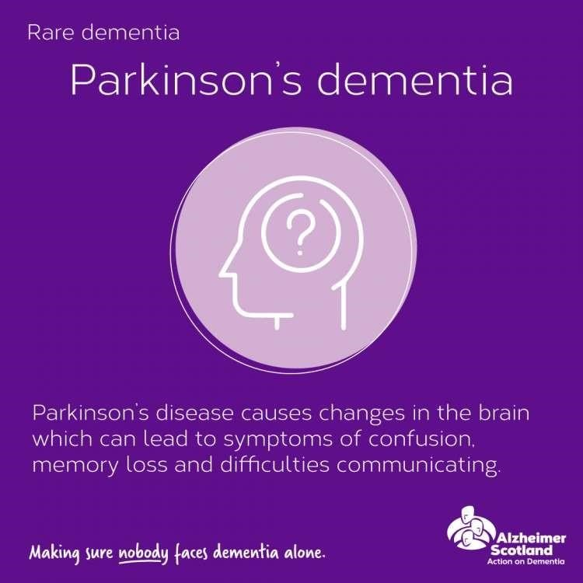
- Dementia in Parkinson’s Disease is found to be leading to a number of challenges among elderly
- Individuals that have been diagnosed with
Parkinson’s disease may suffer also from Dementia for a long time period (Fiorenzato et al., 2019)
- Loss of memory and forgetfulness are found to be major challenges among patients of Dementia in
Parkinson’s disease (Saredakis et al., 2019)
- There are a number of methods that are used to treat dementia and different symptoms as well

Dementia in Parkinson's Diseases within the ICD-10 Manual
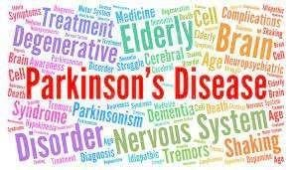
- Dementia in Parkinson’s disease liaise in the group of neurotic health issues and thus a number of neurotic changes are found to be evident among individuals suffering from it
(Phull, 2021)
- The severity of the disease is found to be proportional to time as time passes the mental health condition of the individual is found to be getting worse
- Such individuals are needed to provide
supportive care for their survival as they are not able to
function on their own (Elsevier,
2022)

Definition
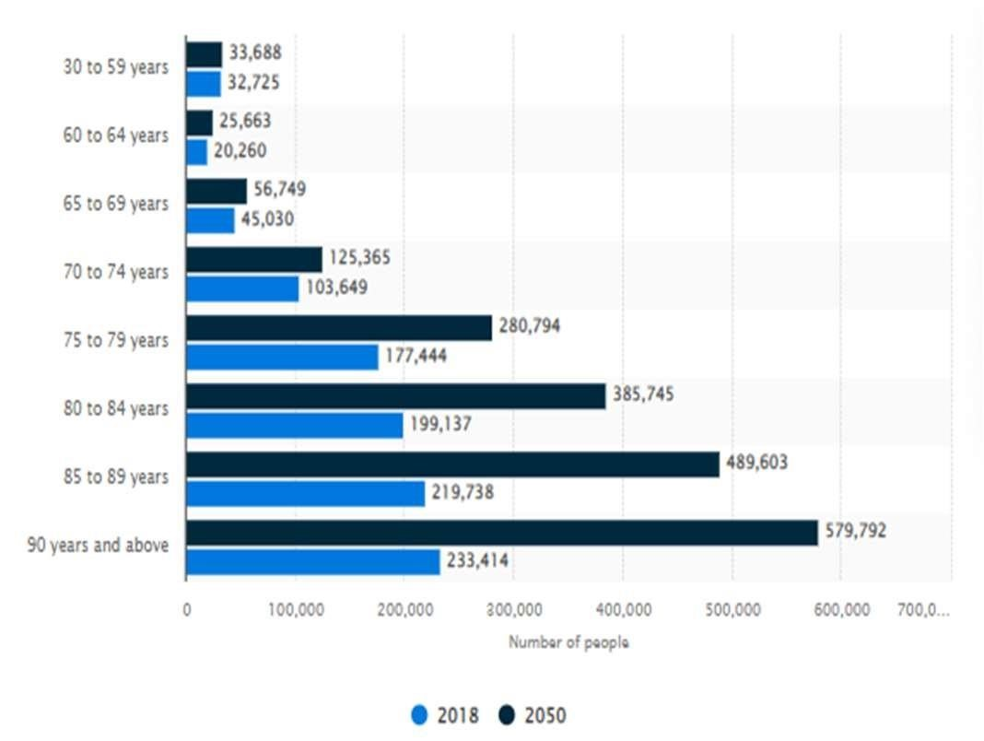
- Dementia in Parkinson’s Disease is a mental condition which is found to be worsening over time (Aarsland et al.,
2021)
- Individuals suffering from it are found to be unable to think, reason and a lack of locomotion is also evident
- It generally is found to be individuals above the age of 50 years, however, individuals above 60 years are more prone to Dementia in Parkinson’s Disease
- In the UK, there are 98,767 cases of Dementia in Parkinson’s Disease among
individuals aged between 30 to 74 years in 2018 and this number
is about to grow further (Statista,
2022)

Causes of Dementia in Parkinson's Diseases
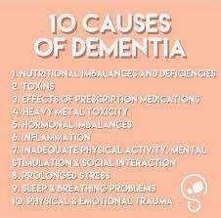
- There are numerous reasons which lead to Dementia in Parkinson’s disease
- Family background is a major factor that has been leading older adults to suffer from
Dementia
(Bloem et al., 2021)
- Ageing is found to be another significant reason that has been leading to Dementia among older adults
- Delusions and hallucinations also lead older adults to suffer from Dementia in Parkinson’s Disease
(Balestrino and Schapira, 2020)

Symptoms/signs
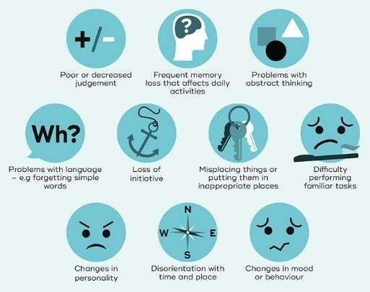
- Loss of memory, lack of sleep and unable to think are some major symptoms of Dementia in Parkinson’s Disease (Sezgin et al.,
2021)
- Moderation of food intake or appetite also indicates an older adult is suffering from Dementia in Parkinson’s Disease
- Unable to recall from memory also shows that an individual is suffering from Dementia (Hayes, 2019)
- Mental health issues such as depression, anxiety, delusions, paranoia and irrationality are major indicators as well

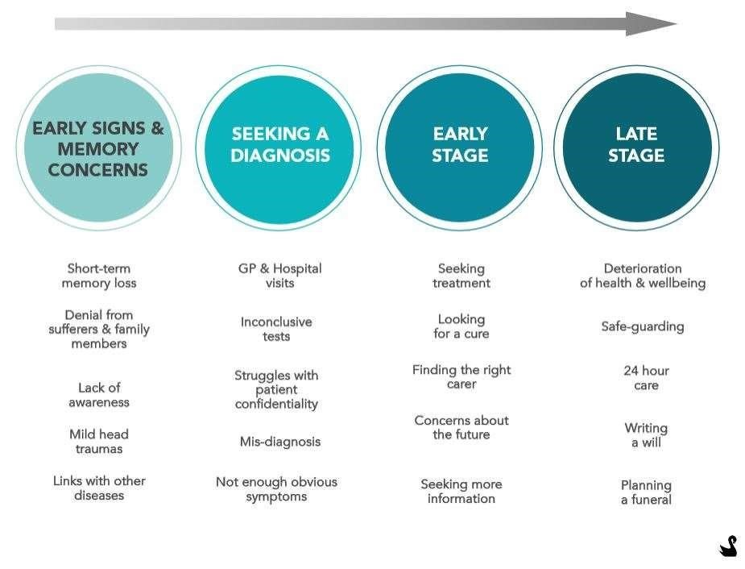
Diagnosis
- In order to diagnose Dementia in Parkinson’s
Disease a care provider generally a
Parkinson's nurse is needed to be allocated
- A doctor is there for the diagnosis of the person suffering from Dementia in Parkinson’s Disease (Galtier et al.,
2019)
- The medical history of the individual is to be analysed as well as physical and neurological examination is to be done
- Individuals who have been suffering from Dementia in Parkinson’s Disease for the past one year are to be diagnosed (Smith et al., 2019)

Historical view and treatments for Dementia in Parkinson's Diseases
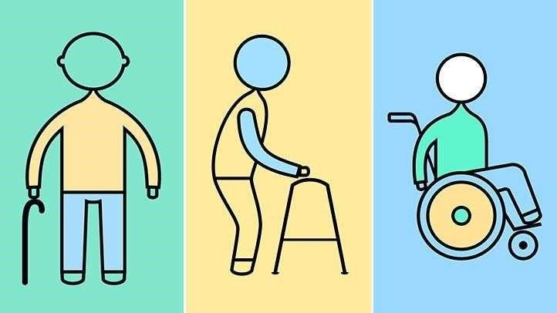
- Dementia in Parkinson’s Disease is found to be quite concerned with therapeutic interventions which are found to be done via a number of observations
- Jean-Martin Charcot was also employed in the treatment of Dementia in Parkinson’s Disease which was mainly belladonna alkaloids (Rocca, 2018)
- Rye based products that possessed “anticholinergic” attributes were used as well
- The advocating of bloodletting from the neck and induction of blisters and inflammation of the skin is also found to be employed (Chia et al., 2020).

Current treatments (NHS)
- Donepezil is used by NHS in the UK for the treatment of Dementia in Parkinson’s Disease (Sackley et al.,
2020)
- “Acetylcholinesterase inhibitors” is also taken as a medicine that is found to be preventing the formulation of “acetylcholine” which obstructs communication between nerve cells
- Memantine or Namenda is used as an alternative to “Acetylcholinesterase inhibitors” for those individuals that suffer from severe side effects (Nhs.uk, 2022).
- There are certain side effects such as dizziness, headache, seizures, abnormal heart rhythms, trouble sleeping, feeling tired.

Principles when working with people with Dementia in Parkinson's Diseases

- Avoiding harsh environments and subjects that can be stressful for the patient is an important principle
- Providing victims with support regarding their mealtimes and medications is also a significant measure (Liebermann et al.,
2020)
- Listening in a careful manner so that their issues and challenges are found to be met in an effective manner is significant as well
- Positive body language is found to be quite significant to provide effective care to victims of Dementia in Parkinson’s Disease (Schneider and Kortagere, 2022)

Recommendations and Conclusion
- Dementia in Parkinson’s Disease is a major health issue among elderly
- There are various factors that lead to Dementia in Parkinson’s Disease among the older population
- It can be recommended that dealing with victims of Dementia in Parkinson’s Disease is highly significant
- It is a means to improve the mental health of sufferer and for the reduction of cases of Dementia in Parkinson’s Disease
(Rashid, 2022)

References

- Aarsland, D., Batzu, cognitive impairment. Nature Reviews Disease Primers, 7(1), pp.121.L., Halliday, G.M., Geurtsen, G.J., Ballard, C., Ray Chaudhuri, K. and Weintraub, D., 2021. Parkinson disease-associated
- Balestrino, R. and Schapira, A.H.V., 2020. Parkinson disease. European journal of neurology, 27(1), pp.27-42.
- Bloem, B.R., Okun, M.S. and Klein, C., 2021. Parkinson's disease. The Lancet, 397(10291), pp.2284-2303.
- Chia, S.J., Tan, E.K. and Chao, Y.X., 2020. Historical perspective: Models of Parkinson’s disease. International journal of molecular sciences, 21(7), p.2464.
- Elsevier, 2022. Buck's 2023 ICD-10-CM for Hospitals-E-Book. Elsevier Health Sciences.
- Fiorenzato, E., Strafella, A.P., Kim, J., Schifano, R., Weis, L., Antonini, A. and Biundo, R., 2019. Dynamic functional connectivity changes associated with dementia in Parkinson’s disease. Brain, 142(9), pp.28602872.
- Galtier, I., Nieto, A., Lorenzo, J.N. and Barroso, J., 2019. Subjective cognitive decline and progression to dementia in Parkinson’s disease: a long-term follow-up study. Journal of neurology, 266(3), pp.745-754.
- Hayes, M.T., 2019. Parkinson's disease and parkinsonism. The American journal of medicine, 132(7), pp.802-807.
- Liebermann, J.D., Witte, O.W. and Prell, T., 2020. Association between different coping styles and health-related quality of life in people with Parkinson’s disease: A cross-sectional study. BMJ open, 10(7), p.e036870.
- Nhs.uk. 2022. What are the treatments for dementia? NHS choices. NHS. Available at:
<https://www.nhs.uk/conditions/dementia/treatment/#:~:text=Acetylcholinesterase%20inhibitors&text=Donepezil%20is%20also%20used%20to,Alzheimer's%20disease%20with%20vascular%20dementia/>[Acces sed: 14 November 2022].
- Phull, J., 2021. ICD 10 in Psychiatry: A Learning Guide. CRC Press.
- Rashid, A., 2022. Yonder: Dementia friendliness, compassion fatigue, foundational science, and anal sex. British Journal of General Practice, 72(717), pp.173-173.
- Rocca, W.A., 2018. The burden of Parkinson's disease: a worldwide perspective. The Lancet Neurology, 17(11), pp.928-929.
- Sackley, C.M., Rick, C., Au, P., Brady, M.C., Beaton, G., Burton, C., Caulfield, M., Dickson, S., Dowling, F., Hughes, M. and Ives, N., 2020. A multicentre, randomised controlled trial to compare the clinical and cost-effectiveness of Lee Silverman Voice Treatment versus standard NHS Speech and Language Therapy versus control in Parkinson’s disease: a study protocol for a randomised controlled trial. Trials, 21(1), pp.1-13.
- Saredakis, D., Collins-Praino, L.E., Gutteridge, D.S., Stephan, B.C. and Keage, H.A., 2019. Conversion to MCI and dementia in Parkinson's disease: a systematic review and meta-analysis. Parkinsonism & Related Disorders, 65, pp.20-31.
- Schneider, J.S. and Kortagere, S., 2022. Current concepts in treating mild cognitive impairment in Parkinson's disease. Neuropharmacology, 203, p.108880.
- Sezgin, M., Bilgic, B., Tinaz, S. and Emre, M., 2019, April. Parkinson's disease dementia and Lewy body disease. In seminars in neurology (Vol. 39, No. 02, pp. 274-282). Thieme Medical Publishers.
- Smith, C., Malek, N., Grosset, K., Cullen, B., Gentleman, S. and Grosset, D.G., 2019. Neuropathology of dementia in patients with Parkinson’s disease: a systematic review of autopsy studies. Journal of Neurology, Neurosurgery & Psychiatry, 90(11), pp.1234-1243.
- Statista. 2022. Prevalence of dementia in the United Kingdom 2018-2050, Statista. [online] Available at: <https://www.statista.com/statistics/1289608/prevalence-of-dementia-in-the-united-kingdom/> [Accessed: 14 November 2022].

