
FINANCIAL ANALYSIS OF PERFORMANCE AND FINANCIAL POSITION OF UNILEVER PLC AND BEARD PLC
FINANCE FOR BUSINSS MANAGER (BMMB7005) MOHD RAVISH

April 20, 2026
University of Wales Trinity Saint David

Executive Summary
This report combines a historical financial analysis of Unilever PLC with a forward-looking investment appraisal for Beard Plc. Part 1 analyzes the performance of Unilever in 2025 and 2024 based on profitability, liquidity, efficiency, gearing, and investor ratios, based on the annual report and calculations in Appendix B. The analysis indicates better reported margins and sustained EPS and inventory efficiency, which are offset by poor liquidity, increasing gearing, slower receivables collection, and working-capital impacts arising from supplier finance and demerger-related balances. Hence, Unilever is not in distress, but its financial management must focus on balance-sheet strength, better-quality liquidity, and disciplined shareholder payouts.
Part 2 assesses three four-year expansion options for Beard Plc using NPV, IRR and capital-rationing analysis. Option C, producing purses and wallets, is preferred because it generates the highest NPV, £91,226, and an approximate IRR of 8.57%, above the 5% cost of capital. Under divisible capital rationing, the optimal policy is 100% of Option C and 55.56% of Option B, producing total NPV of £132,311. Overall, the report shows that sound financial management requires both critical interpretation of past performance and disciplined, value-based evaluation of future investment choices under uncertainty and financial constraint.

Table of Contents
Executive Summary 1
1. Introduction 3
2. Main Findings [Part 1] 3
2.1 Basis of Analysis 3
2.2 Ratio Summary 4
2.3 Critical evaluation of the ratios 4
2.3.1 Profitability 4
2.3.2 Liquidity 5
2.3.3 Efficiency and working capital 6
2.3.4 Gearing and Investor Position 7
2.3.5 Limitations of Ratio Analysis 7
3. PART 2-Business Report to the Directors of Beard Plc 8
3.1 Requirement A: NPV evaluation of the three options 8
3.2 Requirement B: Approximate IRR of the selected option 10
3.3 Requirement C: Interpretation for management 10
3.3.1 Theoretical arguments for using NPV 10
3.4 WHY NON-DISCOUNTING TECHNIQUES ARE STILL POPULAR? 11
3.5 PRE-FINANCIAL INVESTMENT DECISION FACTORS 12
3.6 Requirement D: Capital rationing and optimal investment policy 12
3.7 FINANCING SUGGESTION 13
3.8 DECISION 14
4. Conclusion 15
5. Recommendation 16
6. References 17
7. Appendices 21

Introduction
This report evaluates financial management from two connected perspectives: the analysis of past corporate performance and the appraisal of future investment decisions. The first part examines the financial performance and position of Unilever PLC using ratio analysis based on the 2025 and 2024 annual reports. Profitability, liquidity, efficiency, gearing and investor ratios are used to assess how effectively the company converted sales into profit, managed working capital, maintained solvency and delivered returns to shareholders. However, ratio analysis is only useful when interpreted critically, especially where year-on-year comparability is affected by structural events such as disposals or demergers. In Unilever’s case, the Ice Cream demerger means some reported improvements must be interpreted with caution rather than accepted at face value (Unilever PLC, 2025; Unilever PLC, 2026a; Wang et al., 2024; Wang et al., 2024).
The second part shifts from historical analysis to forward-looking financial decision-making by assessing three expansion proposals for Beard Plc. This section applies investment appraisal techniques including NPV, IRR and capital-rationing analysis to determine which option is most likely to create shareholder value. NPV is given particular emphasis because it reflects the time value of money and directly measures the expected increase in firm value. However, sound financial management also requires strategic judgement, since even a financially positive project may underperform if assumptions about demand, cost, working capital or operational capacity prove unrealistic. Taken together, the two parts show that effective business finance depends not only on calculation, but also on critical interpretation, risk awareness and disciplined managerial judgement (Sureka et al., 2022; Mota and Moreira, 2023; Huikku et al., 2025).

Main Findings [Part 1]

Basis of Analysis
The ratios in this report are drawn from Unilever’s consolidated income statement, balance sheet and supporting notes. Income statement ratios are based on continuing operations because the 2025 annual report explicitly restates the 2024 and 2023 income statement comparatives to reflect the Ice Cream demerger. However, balance-sheet-based ratios must be treated more cautiously. Unilever separately discloses that 2024 net debt is not re-presented, and in its own ROIC bridge it had to adjust 2024 invested capital by €6.481 billion to create a comparable post-demerger base (Unilever PLC, 2025; Unilever PLC, 2026a). This is a major limitation and it matters because financial statement comparability improves users’ ability to assess risk and is associated with lower expected default risk (Wang et al., 2024). All amounts are in € million unless stated otherwise. Balance-sheet-based ratios are indicative because the 2024 closing balance sheet was not fully re-presented on the same post-demerger basis as 2025 (Appendix B, Table B1).

Ratio Summary

Category | Ratio | 2025 | 2024
Profitability | Gross profit margin | 46.9% | 46.7%
Profitability | Operating profit margin | 17.9% | 16.8%
Profitability | Net profit margin from continuing operations | 12.3% | 11.5%
Profitability | ROCE* | 18.5% | 16.2%
Liquidity | Current ratio* | 0.79x | 0.76x
Liquidity | Quick ratio* | 0.60x | 0.56x
Gearing / solvency | Gearing ratio* | 61.7% | 58.7%
Gearing / solvency | Interest cover | 8.83x | 8.88x
Efficiency | Inventory days* | 55.1 days | 67.5 days
Efficiency | Receivables days* | 35.1 days | 29.4 days
Efficiency | Payables days* | 149.8 days | 133.8 days
Efficiency | Cash conversion cycle* | -59.6 days | -36.9 days
Efficiency | Asset turnover* | 0.72x | 0.66x
Investor | Basic EPS from continuing operations | €2.60 | €2.45
Investor | Dividend cover | 1.28x | 1.26x
Investor | Dividend payout ratio | 78.4% | 79.6%

2.3 Critical evaluation of the ratios

2.3.1 Profitability
On initial inspection, Unilever’s profitability improved. Gross margin increased slightly from 46.7% to 46.9%, operating margin rose from 16.8% to 17.9%, and net profit margin from continuing operations rose from 11.5% to 12.3%. This suggests that the company managed input costs, overheads and pricing reasonably well. The 2025 results announcement supports that view such as underlying sales growth was 3.5%, but reported turnover fell 3.8% because adverse currency and net disposals more than offset operational growth (Unilever PLC, 2025; Unilever PLC, 2026a). The management also indicated that the underlying operating margin increased to 20.0% as compared to 19.4%, and this was due to structural gross margin improvement and overhead discipline. This means that Unilever protected margins even in a challenging external environment. Turnover and operating profit recorded in the consolidated income statement (Appendix A1) resulted in an increase in the operating margin to 17.9% in 2025 (Appendix B, Table B1).
Nevertheless, underlying operating profit decreased to €10,084 million compared to the previous level of €10,198 million, and underlying diluted EPS increased only to €3.08 as compared to €3.06. Meanwhile, non-underlying items in operating profit decreased by almost €1,369 million to €1,047 million. That is, some of the increase in reported operating margin and continuing EPS was due to a reduction in non-underlying charges and capital structure effects, rather than an apparent increase in underlying earnings power. This is precisely the reason why non-GAAP measures have to be adjusted to IFRS and not considered as alternatives to it (IFRS Foundation, 2023). Transparent reconciliation and quality of presentation are critical to the usefulness of adjusted earnings (Chen et al., 2021).
ROCE seems to increase to 18.5% as compared to 16.2%, though this ratio is not to be over-interpreted. The 2025 closing balance sheet is post-demerger, but 2024 balance-sheet amounts are not quite comparable. Unilever itself had adjusted underlying ROIC that explicitly eliminated the Ice Cream distortion in 2024 invested capital, resulting in 19.0% in 2025 compared to 19.1% in 2024. That provides a more cautious indication of performance. It means that the company did not significantly enhance its economic return on capital in 2025, despite the fact that the less complicated ROCE calculation is more promising (Appendix A6 and Appendix B1).

The total basic EPS increased to a high of €4.33, which is not a good predictor of future performance since it incorporates discontinued operations and a gain of €3,373 million on the Ice Cream demerger. In the evaluation of recurring performance, the board should thus consider continuing basic EPS and underlying EPS and not total EPS. The gearing deterioration should be reported together with the effects of the demerger which are reported in Appendix A7.

2.3.2 Liquidity
Unilever is not strong in terms of liquidity under the traditional ratio analysis. The current ratio has only increased marginally to 0.79x as compared to 0.76x, and the quick ratio has increased to 0.60x as compared to 0.56x. Both are less than 1.0, indicating that current liabilities are more than current assets even prior to any adverse shock. That would be a red flag in a textbook answer, and it should still be of concern to the directors as it means that Unilever relies on the constant generation of cash and on rolling access to funds as opposed to a robust liquid buffer (Appendix A2 and Appendix B1).
However, the company is not experiencing liquidity pressure at the moment. In 2025, Unilever produced a total of €10,772 million of cash flow under continuing operating activities and €5,921 million of free cash flow.
It also disclosed undrawn bilateral committed credit facilities of $5,200 million and €2,600 million and stated that its financing arrangements are adequate for short- and long-term cash requirements (Unilever PLC, 2026; Unilever PLC, 2025; Unilever PLC, 2026a). So the issue is not immediate solvency. The issue is quality and resilience of the liquidity position. The company can fund itself, but it is doing so from operating cash generation and capital-market access rather than from comfortable working-capital headroom. The working-capital discussion is supported by the receivables, payables and supplier-finance disclosures in Appendix A3 to A5.
Even the slight improvement in liquidity may overstate the underlying position. Unilever disclosed that trade and other current receivables included €2.1 billion due from TMICC at year-end, while trade payables and other current liabilities included €1.6 billion due to TMICC. On transition-adjusted basis, removing those disclosed balances would reduce the 2025 current ratio from 0.79x to about 0.75x.

2.3.3 Efficiency and working capital
There was an improvement in inventory management. The inventory days decreased to 55.1 days compared to 67.5 days, indicating that there was either better control of inventory, less slow-moving stock, or a more simplified portfolio following the demerger. It is among the most positive indications in the whole set of ratios. In comparison, the receivables days went up to 35.1 days from 29.4 days, and this suggests slower collection or a different sales mix. On its own, such an increase is not too bad, but it is heading in the wrong direction and cannot be overlooked (Appendix A3 and Appendix B1).

The payables days increased from 133.8 days to 149.8 days, and this moved the cash conversion cycle from -36.9 days to -59.6 days. At first glance, that is great since the working-capital cycle provides the business with cash prior to paying a large number of suppliers.
Research finds that a shorter cash conversion cycle is associated with better performance (Kiymaz et al., 2024). However, the board should be careful here. A more negative cash conversion cycle is not automatically evidence of better financial management.
That caution is especially important in Unilever’s case because €2.665 billion of trade payables were subject to supplier financing arrangements at 31 December 2025, up from €2.207 billion in 2024, and €2.065 billion of those balances had already been paid to suppliers by finance providers. Unilever states these balances remain classified as trade payables, and the IASB introduced new supplier-finance disclosures precisely because investors said such arrangements can materially affect liabilities, cash flows and liquidity risk. On an analytical adjustment, if the supplier-finance-exposed amount were removed from 2025 trade payables, payables days would fall from about 149.8 days to about 113.5 days, and the cash conversion cycle would move from about -59.6 days to about -23.3 days (Unilever PLC, 2026; Unilever PLC, 2025; Unilever PLC, 2026a).
Unilever’s 2024 supplier finance arrangements disclosure is positive for disclosure quality, however, it does not resolve the economic issue. Compliant disclosure is not the same as a strong working-capital structure. Under conditions of uncertainty, firms with weaker liquidity discipline are more exposed to pressure on operations and cash management (Tarkom & Ujah, 2023).

2.3.4 Gearing and Investor Position
The leverage illustration is mixed, but the overall signal is negative. Total financial liabilities fell from €32,053 million to €28,278 million and net debt fell from €24,519 million to €23,076 million. On that basis alone, leverage looks slightly better. But total equity fell much more sharply, from €22,555 million to €17,587 million, largely because the demerger reduced the asset and equity base. The gearing ratio worsened. The equity cushion is therefore thinner, even though absolute debt is lower. Capital structure research repeatedly finds that more borrowing is not value-enhancing indefinitely, beyond a threshold, leverage begins to reduce firm value (Karaca et al., 2025).
Investor ratios are also less favourable than the headline might suggest. Continuing basic EPS increased to €2.60 from €2.45, but dividend cover improved only marginally from 1.26x to 1.28x and the payout ratio remained very high at 78.4%. Unilever paid €4,453 million of dividends on ordinary capital during 2025 and completed a €1.5 billion share buyback. It also announced a further €1.5 billion buyback in 2026. That is an aggressive distribution stance for a business with weak liquidity ratios, heavier gearing and only marginal growth in underlying EPS. The conclusion is that shareholder distributions are currently being prioritised over balance-sheet reinforcement (Appendix A2, A5 and B1).

2.3.5 Limitations of Ratio Analysis
The first limitation is comparability as the 2025 income statement presents 2024 continuing-operations comparatives on a restated basis, but not all 2024 balance-sheet data are directly comparable after the demerger (Unilever PLC, 2026; Unilever PLC, 2025; Unilever PLC, 2026a). Unilever itself had to make a €6.481 billion adjustment to 2024 invested capital for ROIC, and it disclosed that 2024 net debt is not re-presented. This is exactly why careful analysts distinguish between accounting comparability and simple year-on-year arithmetic (Wang et al., 2024).
The second limitation is that year-end ratios are snapshots. They are especially vulnerable to distortion when transition balances, portfolio changes or supplier finance arrangements are material. In Unilever’s case, TMICC receivables and payables, along with supplier financing arrangements, materially affect the year-end picture. The IASB’s supplier finance disclosure changes were introduced precisely because investors need enough transparency to assess the effects of these arrangements on liabilities, cash flows and liquidity risk.
The board ought to reduce discretionary shareholder payments until leverage comes back to a normal level. Particularly, the 2026 buyback announced should be lower on the list of priorities than debt reduction. The retained TMICC stake proceeds, along with a greater portion of post-dividend free cash flow, should be channeled towards net debt reduction. An internal threshold that would be reasonable would be to avoid additional discretionary buybacks until net debt/equity is below 100% on a consistent basis and net debt/underlying EBITDA is below 1.8x. That is a more defensible and financially restrictive strategy than carrying on with buybacks at the moment, considering the thin liquidity buffer and high payout ratio (Unilever PLC, 2025; Unilever PLC, 2026a; Karaca et al., 2025).
The current ratio, quick ratio, and receivables exposure without TMICC transition balances should be reported monthly to the board. The existing statutory ratios are inadequate since they combine the core trading liquidity with temporary demerger-related balances.
A separate dashboard should show i.e. core current ratio excluding TMICC, core quick ratio excluding TMICC, TMICC net receivable exposure, and a timetable for unwinding Transitional Services Agreement balances. Without that, directors are judging short-term liquidity on contaminated numbers (Unilever PLC, 2026; Unilever PLC, 2025; Unilever PLC, 2026a).
Unilever should continue to manage working capital tightly, but it should stop using headline payables days as the main internal success indicator. The better metric is a supplier-finance-adjusted cash conversion cycle. A practical target would be to prevent trade payables subject to supplier finance from rising materially above the current proportion of trade payables and to bring supplier-finance-adjusted payables days closer to the low-100s rather than the reported 150-day level. This would improve the quality of liquidity and reduce dependence on supplier-funded cash flow. Working capital research supports focusing on the quality of the cash conversion cycle rather than simply maximising creditor days (Kiymaz et al., 2024).

PART 2-Business Report to the Directors of Beard Plc

Requirement A: NPV evaluation of the three options
The NPV method discounts future after-tax cash flows at the company’s cost of capital and deducts the initial investment. A positive NPV means that a project is expected to generate returns above the required rate of return. A negative NPV means that the project is expected to destroy value.
The detailed tax-adjusted cash-flow calculations are shown in Appendix C. The summary results are as follows:
Option | Project | Initial investment £000 | Present value of after-tax cash flows £000 | NPV £000 | Decision
A | Expand retail outlet | 600.000 | 596.737 | -3.263 | Reject
B | Develop internet sales | 900.000 | 973.952 | 73.952 | Accept if independent
C | Produce purses and wallets | 1,000.000 | 1,091.226 | 91.226 | Preferred option
Option A should be rejected. Its NPV is negative £3,263, meaning that it fails to recover the initial investment after allowing for tax and the 5% cost of capital. The project almost breaks even, but that is not enough. Option B is a viable option since it has a positive NPV of £73,952. Internet sales could also be appealing strategically since online retail is still significant in the UK retail market. According to the Office for National Statistics (2026), in 2025, internet sales constituted 27.4% of total retail sales, and this indicates that online retail is no longer a small sales channel. Nevertheless, the financial appraisal still ranks Option B as less attractive than Option C.
On the base-case figures, Option C is the best. It has the highest positive NPV, which is £91,226, and is hence the best option if the three projects are mutually exclusive. The recommendation must not be disregarded. The difference between the NPV of Option C and Option B is only £17,274, and it involves an extra investment of £100,000. That is, the financial advantage of Option C does exist, but it is not too strong. The board can only approve Option C when it is established that the forecast cash flows are realistic and that the risk of the project is not significantly greater than the risk reflected in the 5% discount rate.
The strategic rationale for Option C is plausible since purses and wallets are associated with handbags. Brand-extension research finds that parent brand equity and extension fit are important drivers of extension success (Peng et al., 2023). Nevertheless, line extensions may also cannibalize existing sales, particularly when the products are close substitutes (Sezen et al., 2024). This is significant to Beard Plc since purse and wallet sales can only be considered incremental when they do not significantly replace the sales of handbags or accessories.

3.2 Requirement B: Approximate IRR of the selected option
The selected option is Option C: produce purses and wallets. The IRR is the discount rate at which the project’s NPV equals zero. The full calculation is shown in Appendix D.
For Option C:
- NPV at 8% = +£13,746
- NPV at 9% = -£10,183
Using linear interpolation:
IRR = 8% + [13.746 / (13.746 + 10.183)] × 1%
IRR = 8% + 0.574%
IRR ≈ 8.57%
The cost of capital of Beard Plc is 5%, which is lower than the IRR of 8.57%, and therefore, Option C is acceptable under the IRR rule. This, however, should not be overemphasized. The premium over the cost of capital is not high, at 3.57 percentage points. Option C may soon be unattractive if the actual risk-adjusted cost of capital is greater than 5% or if forecast cash flows are lower by a significant margin.
This is the reason why NPV must be the first rule of decision. IRR is advantageous in that it provides a percentage of return to the management; however, it may not be as strong as NPV for comparing projects of varying sizes. Option B and Option C have varying initial investments; therefore, the Board must emphasize the absolute value created, rather than the percentage return.

3.3 Requirement C: Interpretation for management

3.3.1 Theoretical arguments for using NPV
The most appropriate appraisal technique in the given case is NPV since it is the only method that directly quantifies the anticipated value creation. It provides the answer to the key financial question of after taking into consideration tax, timing, and the amount of return required, what value will the project contribute?

To begin with, NPV acknowledges the time value of money. Cash received in Year 1 will be more valuable than cash received in Year 4 since the cash that was received earlier can be reinvested and the cash that will be received later is more uncertain. This is necessary in the case of Beard Plc since every project generates cash flows over a period of four years.
Second, NPV incorporates all the pertinent project cash flows. This is better than the simple payback, which can overlook the cash flows beyond the payback point. A project may recoup in a short period of time but still generate less overall value.
Third, NPV results in an absolute monetary value. Option C is not just profitable to look at, but it is likely to contribute to the value of the business to the tune of £91,226 once the necessary 5% return is obtained. This is a better foundation for decision-making by the Board than a percentage return.
Fourth, NPV is superior to IRR in the case of mutually exclusive projects of different magnitudes. A smaller project may have a higher IRR but generate less overall value. The NPV ranking is more credible since the projects of Beard Plc will need varying initial investments.
Lastly, NPV can be used with the profitability index and is therefore compatible with capital rationing. This is significant when there is a scarcity of funds and when projects can be divided as in Requirement D, but value-based discounted appraisal is at the core of disciplined investment selection (Sureka et al., 2022; Darmansyah et al., 2025).

3.4 WHY NON-DISCOUNTING TECHNIQUES ARE STILL POPULAR?
Regardless of the theoretical power of NPV, non-discounting approaches like payback are still popular due to their simplicity, intuitive nature, and liquidity screening. One of the questions that managers usually ask is how soon an investment can pay back the initial cash investment.
The approximate payback periods are calculated using the after-tax cash flows:
Option | Approximate after-tax payback
A | 3.63 years
B | 3.39 years
C | 3.35 years
These statistics describe the attractiveness of payback. It can be easily understood and conveys cash recovery risk in a short period of time. A shorter payback period would be safer than a longer payback period for a business with limited liquidity.
Payback is, however, perilous when it is employed as the primary decision rule. The first option (A) is nearly recovered in the fourth year, but the NPV is negative. As such, a payback-based decision might erroneously support a value-destroying project.
The empirical research justifies the occurrence of this in practice. Alles et al. (2021) discovered that the most commonly used capital budgeting method among the SMEs in their sample was the payback period and that the barriers to the use of more advanced methods were cost, time, and knowledge barriers. Mota and Moreira (2023) also discovered that payback is still preferred by some SMEs and that NPV with payback is used as an additional measure by others. Payback, therefore, should not be a decision rule but rather a secondary liquidity indicator that Beard Plc should use.

3.5 PRE-FINANCIAL INVESTMENT DECISION FACTORS
The Board cannot accept Option C simply because it is the one with the highest NPV and approve it as such. There are a number of other aspects that should be checked.
To begin with, the cash-flow predictions need to be put to the test. The NPV of Option C is just 9.1% of the initial investment. Assuming that the after-tax cash flows were to reduce by about 8.36%, the NPV would be zero. That is not a large margin of safety.
Second, cannibalisation has to be evaluated. Purses and wallets can be used to supplement handbags, but they can also take the place of some of the current accessory or handbag sales.
Third, Beard Plc ought to take into consideration working capital. New product lines normally entail inventory, packaging, storage, and supplier deposits, and possibly augmented receivables. The current NPV can be optimistic as these cash requirements are not included in the case data.
Fourth, the management will assess the operational capacity. The production of purses and wallets could include the incorporation of new suppliers, quality-control, product design expertise, and merchandising. Any failure in quality would be severe as Beard Plc is a quality manufacturer of handbags.
Fifth, there is a need for risk analysis. Huikku et al. (2025) explain that risk-analysis techniques such as sensitivity, scenario, and simulation analysis can help managers to understand the threats and opportunities in strategic investment proposals. Alpenberg et al. (2025) also show that in making decisions regarding capital investment, strategic, environmental, social, and behavioural factors should also be considered in addition to financial metrics. This would mean that sensitivity analysis, brand analysis, operational feasibility and management capacity must be taken into account in the ultimate decision in the case of Beard Plc, and not NPV alone.

3.6 Requirement D: Capital rationing and optimal investment policy
If funds are limited to £1.5 million and projects are divisible, Beard Plc should rank the projects by profitability index.
- Profitability index = Present value of cash inflows / Initial investment
The detailed calculation is shown in Appendix E.
Option | Present value of inflows £000 | Initial investment £000 | Profitability index | Rank
C | 1,091.226 | 1,000 | 1.0912 | 1
B | 973.952 | 900 | 1.0822 | 2
A | 596.737 | 600 | 0.9946 | 3
Option C gives the highest NPV per pound invested, followed by Option B. Option A has a profitability index below 1 and should not be undertaken.
The optimal policy is therefore:
Project | Investment £000 | Fraction undertaken | NPV generated £000
Option C | 1,000 | 100.00% | 91.226
Option B | 500 | 55.56% | 41.084
Option A | 0 | 0.00% | 0
Total | 1,500 |  | 132.311
Consequently, in case the projects are divisible, Beard Plc must take 100 percent of the Option C and 55.56 percent of the Option B and the resultant NPV would be about £132,311. This is more advantageous than investing in just Option C since the remaining £500,000 can be invested profitably in part of Option B.

3.7 FINANCING SUGGESTION
The decision to finance should be conservative since the decision of Option C is profitable but not very strong. The project should not be funded by the Board in a manner that increases the financial risk of the project to an extent that exceeds the returns of the project.
Retained earnings are attractive because they avoid interest payments, repayment schedules, security requirements and ownership dilution. Chit and Rizov (2024) find that financially unconstrained SMEs commonly specialise in retained earnings, while constrained SMEs often diversify financing sources. For Beard Plc, retained earnings should be used if sufficient cash exists after maintaining a prudent liquidity reserve. The disadvantage is opportunity cost: cash used for Option C cannot be used for dividends, debt reduction, working capital or other opportunities.
A medium-term bank loan could match the four-year project life and preserve shareholder control. Interest may also be tax-deductible. However, debt creates fixed obligations even if the project underperforms. Financing constraints and collateral availability can materially affect SME investment efficiency, and Martinez-Cillero et al. (2023) find that both internal and external finance sources help explain SME investment efficiency. Current survey evidence also shows that financing costs and collateral requirements can tighten for firms, so debt should not be assumed to be risk-free or cheap (European Central Bank, 2025) .
Asset finance or leasing may be suitable for equipment, fixtures, technology systems or production machinery. It spreads payments over time and may be easier to secure because the asset itself supports the finance. However, it is less suitable for marketing, staff training, product development and working capital.
Equity finance reduces insolvency risk because there are no mandatory interest or capital repayments. It may be appropriate if Beard Plc already has high gearing or wants to finance a wider growth strategy. However, equity dilutes existing shareholders and may be excessive for a project with only £91,226 of NPV. Santos et al. (2024) show that different financing sources affect innovation and growth differently, with equity associated with stronger turnover-growth additionality in their study; this supports considering equity for larger strategic expansion, but not necessarily for this single modest project.
Development or alternative finance that is supported by the government can also be considered in case the project promotes digital growth, employment or innovation. The 2025/2026 Investment Report by the EIB focuses on investment finance and how public financing can be used to finance digital and green transition, and the IFC/G20 MSME financing action plan highlights enabling conditions and mobilisation of private finance as key to smaller firms (IFC, 2024). These are possible sources, but they are not to be considered as a sure thing since the requirements of eligibility, time and compliance may be limiting.
Source | Suggested amount | Reason
Retained earnings | £400,000 | Reduces borrowing and shows internal commitment
Medium-term debt or asset finance | £600,000 | Matches funding to the project life
Total | £1,000,000 | Fully funds Option C
The same principle should be applied to the capital-rationed programme of £1.5 million: use a mixture of internal funds and medium-term debt or asset finance, but not too much gearing. An overdraft cannot be regarded as the primary source of funding since it is a short-term facility that might be repaid at any time and is not suitable for financing a four-year project.

3.8 DECISION
Beard Plc must not turn its back on expansion. Under the base-case assumptions, Option C: produce purses and wallets is financially viable since it has the highest NPV, of £91,226, and an approximate IRR of 8.57%, which exceeds the 5% cost of capital.
The recommendation is, however, not risk-free. The benefit of Option C over Option B is not significant and the NPV margin is not high. The Board must only accept Option C after considering sensitivity analysis, working capital requirements, capacity for operations, brand-extension risk, and potential cannibalisation.
Assuming that the projects are divisible and the funds available are not more than £1.5 million, the best policy will be to implement 100 percent of Option C and 55.56 percent of Option B, which will result in a total NPV of about £132,311.
The overall conclusion is thus: accept Option C, and reject Option A, and only perform a portion of Option B in the divisible capital-rationing case. Fund the programme on a conservative basis with retained earnings with the help of medium-term debt or asset finance.

Conclusion
In general, the report finds that the two companies need to be managed financially in a disciplined manner, albeit for different reasons. Unilever is still profitable and cash-generative, but the ratio analysis does not give reason to rest on its laurels. The reported margins are undermined by its poor underlying earnings momentum, poor current and quick ratios, increased gearing, and working-capital reliance on longer payables and supplier finance. The correct suggestion is thus to enhance the quality of liquidity, reduce leverage and be more careful about shareholder distributions. The appraisal of Beard Plc comes to a positive but cautious conclusion. Option C is the most appropriate choice since it has the highest NPV, £91,226, and an IRR of about 8.57, whereas Option A should be rejected. In case of capital rationing with divisible projects, Beard Plc ought to implement all of Option C and 55.56% of Option B. Sensitivity analysis, financing analysis, and operational analysis should still be considered in the final decision. This helps in value generation and minimizing unnecessary financial risk

Recommendation
For Unilever PLC, the main recommendation is that management should place greater priority on balance-sheet resilience and liquidity quality rather than continuing aggressive shareholder distributions. Although profitability and inventory efficiency improved in 2025, the company still shows weak current and quick ratios, rising gearing and growing dependence on extended payables and supplier-finance arrangements. This suggests that reported strength is supported partly by working-capital structure rather than by a comfortably liquid position. Therefore, Unilever should reduce discretionary buybacks, direct a larger share of post-dividend cash flow towards debt reduction, and monitor a core liquidity dashboard excluding TMICC transition balances and supplier-finance distortions. This would give directors a clearer view of underlying liquidity and strengthen financial flexibility if trading conditions worsen or financing becomes tighter (IFRS Foundation, 2023; Kiymaz et al., 2024; Karaca et al., 2025).

For Beard Plc, the recommended course of action is to approve Option C: produce purses and wallets, because it generates the highest NPV and an IRR above the firm’s 5% cost of capital. However, this should be presented as a cautious acceptance, not an unconditional approval, because the value advantage over Option B is relatively modest and the project’s margin of safety is not large. Before final commitment, the board should test the robustness of forecast cash flows through sensitivity analysis and assess possible cannibalisation, operational capability and additional working-capital needs. If projects are divisible under the capital rationing constraint, Beard Plc should undertake all of Option C and 55.56% of Option B to maximise total NPV. Financing should remain conservative, using retained earnings first and medium-term borrowing only where manageable (Peng et al., 2023; Sezen et al., 2024; Huikku et al., 2025).

References
Alles, L., Jayathilaka, R., Kumari, N., Malalathunga, T., Obeyesekera, H. and Sharmila, S. (2021). An investigation of the usage of capital budgeting techniques by small and medium enterprises: L. Alles et al. Quality & Quantity, 55(3), pp.993-1006.
Alpenberg, J., Hansson, F., Svensson, L. and Wnuk-Pel, T. (2025). Beyond financial metrics: An integrated framework for capital investment decisions in the Swedish forest industry. Forest Policy and Economics, 181, p.103660.
Chen, H.C., Lee, Y.J., Lo, S.Y. and Yu, Y. (2021). Qualitative characteristics of non-GAAP disclosures and non-GAAP earnings quality. Journal of Accounting and Economics, 72(1), p.101402.
Chit, M.M. and Rizov, M. (2024). SMEs' diversification of financing sources: Strategy or desperation?. International Journal of Finance & Economics, 29(3), pp.3123-3146.
Darmansyah, A., Ali, Q. and Parveen, S. (2025). Sophisticated capital budgeting decisions for financial performance and risk management—A tale of two business entities. Journal of Risk and Financial Management, 18(6), p.297.
European Central Bank (2025) Survey on the Access to Finance of Enterprises in the euro area: Third quarter of 2025. Frankfurt: European Central Bank
European Investment Bank (2026) Investment Report 2025/2026: Capitalising on Europe’s strengths. Luxembourg: European Investment Bank. https://www.eib.org/en/publications/20250379-investment-report-2025
Huikku, J., Karjalainen, J. and Seppälä, T. (2025). Strategic factors and the use of risk analysis techniques in strategic investment decisions. Accounting and Business Research, pp.1-29.
IFRS Foundation. (2023, May). Investor perspectives: Supplier finance, new disclosure requirements to aid investors. https://www.ifrs.org/content/dam/ifrs/project/supplier-finance-arrangements/ip-iasb-sfa-ias7-ifrs7-2023.pdf
International Finance Corporation (2024) Action Plan for Micro, Small, and Medium Enterprise Financing. Washington, DC: IFC. https://www.ifc.org/content/dam/ifc/doc/2025/gpfi-action-plan-for-msme-financing.pdf
Karaca, C., Mensi, W. and Gemici, E. (2025). Inverted U-shaped dynamics of capital structure and firm value: Evidence from an emerging market. Borsa Istanbul Review.
Kiymaz, H., Haque, S. and Choudhury, A.A. (2024). Working capital management and firm performance: A comparative analysis of developed and emerging economies. Borsa Istanbul Review, 24(3), pp.634-642.
MARQUES, N. and PHILIPPE, C. (2026). Europe's Long-Term Capital. How Liberal Ideas Can Orchestrate Europe's Economic Revolution, 7(1), p.67.
Martinez-Cillero, M., Lawless, M. and O'Toole, C. (2023). Analysing SME investment, financing constraints and its determinants. A stochastic frontier approach. International Review of Economics & Finance, 85, pp.578-588.
Mota, J. and Moreira, A.C. (2023). Capital Budgeting Practices: A Survey of Two Industries. Journal of Risk and Financial Management, 16(3), p.191.
Office for National Statistics (2026) Internet sales as a percentage of total retail sales: Retail Sales Index time series J4MC. London: ONS. https://www.ons.gov.uk/businessindustryandtrade/retailindustry/timeseries/j4mc/drsi
Peng, C., Bijmolt, T.H., Völckner, F. and Zhao, H. (2023). A meta-analysis of brand extension success: The effects of parent brand equity and extension fit. Journal of Marketing, 87(6), pp.906-927.
Santos, A.M., Cincera, M. and Cerulli, G. (2024). Sources of financing: Which ones are more effective in innovation–growth linkage?. Economic Systems, 48(2), p.101177.
Sezen, B., Pauwels, K. and Ataman, B. (2024). How do line extensions impact brand sales? The role of feature similarity and brand architecture. Journal of Marketing Analytics, 12(3), pp.537-550.
Sureka, R., Kumar, S., Colombage, S. and Abedin, M.Z. (2022). Five decades of research on capital budgeting–a systematic review and future research agenda. Research in International Business and Finance, 60, p.101609.
Tarkom, A. and Ujah, N.U. (2023). Global policy uncertainty and working capital management: Does national culture matter?. Technological Forecasting and Social Change, 196, p.122869.
Unilever PLC. (2026, February 12). Sharper focus and disciplined execution driving competitive performance. https://www.marketscreener.com/news/unilever-sharper-focus-and-disciplined-execution-driving-competitive-performance-ce7e5ad2dc8cf32c
Unilever PLC. (2025). Annual Report and Accounts 2024. https://www.unilever.com/files/unilever-annual-report-and-accounts-2024.pdf
Unilever PLC. (2026a). Annual Report and Accounts 2025. https://www.unilever.com/files/unilever-annual-report-and-accounts-2025.pdf
Wang, Y., Feng, Y., Zhu, Z., Liu, J. and Li, Y. (2024). Financial statement comparability and expected default risk. International Review of Financial Analysis, 95, p.103302.
Aktas, N., Croci, E. and Petmezas, D. (2015) ‘Is working capital management value-enhancing? Evidence from firm performance and investments’, Journal of Corporate Finance, 30, pp. 98–113.
Afrifa, G.A. (2016) ‘Net working capital, cash flow and performance of UK SMEs’, Review of Accounting and Finance, 15(1), pp. 21–44.
Afrifa, G.A., Tauringana, V. and Tingbani, I. (2015) ‘Working capital management and performance of listed SMEs’, Journal of Small Business & Entrepreneurship, 27(6), pp. 557–578.
Anolick, N., Batten, J.A., Kinateder, H. and Wagner, N. (2021) ‘Time for gift giving: Abnormal share repurchase returns and uncertainty’, Journal of Corporate Finance, 66, 101787.
Brunzell, T., Liljeblom, E. and Vaihekoski, M. (2013) ‘Determinants of capital budgeting methods and hurdle rates in Nordic firms’, Accounting and Finance, 53(1), pp. 85–110.
Chang, C.-C. (2018) ‘Cash conversion cycle and corporate performance: Global evidence’, International Review of Economics & Finance, 56, pp. 568–581.
Chiaramonte, L. and Casu, B. (2017) ‘Capital and liquidity ratios and financial distress: Evidence from the European banking industry’, The British Accounting Review, 49(2), pp. 138–161.
Deloof, M. (2003) ‘Does working capital management affect profitability of Belgian firms?’, Journal of Business Finance & Accounting, 30(3–4), pp. 573–588.
Enqvist, J., Graham, M. and Nikkinen, J. (2014) ‘The impact of working capital management on firm profitability in different business cycles: Evidence from Finland’, Research in International Business and Finance, 32, pp. 36–49.
Filbeck, G. and Krueger, T.M. (2005) ‘An analysis of working capital management results across industries’, American Journal of Business, 20(2), pp. 11–20.
Graham, J.R. and Harvey, C.R. (2001) ‘The theory and practice of corporate finance: Evidence from the field’, Journal of Financial Economics, 60(2–3), pp. 187–243.
Graham, J.R. and Harvey, C.R. (2002) ‘How do CFOs make capital budgeting and capital structure decisions?’, Journal of Applied Corporate Finance, 15(1), pp. 8–23.
Lazaridis, I. and Tryfonidis, D. (2006) ‘Relationship between working capital management and profitability of listed companies in the Athens Stock Exchange’, Journal of Financial Management and Analysis, 19(1), pp. 26–35.
Shin, H.H. and Soenen, L. (1998) ‘Efficiency of working capital management and corporate profitability’, Financial Practice and Education, 8(2), pp. 37–45.
Tauringana, V. and Afrifa, G.A. (2013) ‘The relative importance of working capital management and its components to SMEs’ profitability’, Journal of Small Business and Enterprise Development, 20(3), pp. 453–469.
Andor, G., Mohanty, S.K. and Toth, T. (2015) ‘Capital budgeting practices: A survey of Central and Eastern European firms’, Emerging Markets Review, 23, pp. 148–172.
Aurier, P. and Mejía, V.D. (2020) ‘The interplay of brand-line assortment size and alignability in the sales of brand-lines and line-extensions of frequently purchased products’, Journal of Business Research, 117, pp. 163–175.
Dens, N. and De Pelsmacker, P. (2010) ‘Attitudes toward the extension and parent brand in response to extension advertising’, Journal of Business Research, 63(11), pp. 1237–1244.
Hariharan, V.G., Bezawada, R. and Talukdar, D. (2015) ‘Aggregate impact of different brand development strategies’, Management Science, 61(5), pp. 1164–1182.
Hernández-Olalla, M.L., Valor Martínez, C. and Abril Barrie, C. (2023) ‘Organic line extensions: Do they make sense for brands?’, British Food Journal, 125(8), pp. 2785–2802.
Kadzima, M., Matemane, R., Machokoto, M. and Lemma, T. (2025) ‘Beyond the balance sheet: SME financing strategies for fixed assets amid constraints’, Finance Research Letters, 85, 107839.
Loken, B. and John, D.R. (1993) ‘Diluting brand beliefs: When do brand extensions have a negative impact?’, Journal of Marketing, 57(3), pp. 71–84.
Lomax, W. and McWilliam, G. (2001) ‘Consumer response to line extensions: Trial and cannibalisation effects’, Journal of Marketing Management, 17(3–4), pp. 391–406.
Martínez, E., Montaner, T. and Pina, J.M. (2009) ‘Brand extension feedback: The role of advertising’, Journal of Business Research, 62(3), pp. 305–313.
Milberg, S.J., Cuneo, A., Silva, M. and Goodstein, R.C. (2023) ‘Parent brand susceptibility to negative feedback effects from brand extensions: A meta-analysis of experimental consumer findings’, Journal of Consumer Psychology, 33(1), pp. 21–44.
Nijssen, E.J. (1999) ‘Success factors of line extensions of fast-moving consumer goods’, European Journal of Marketing, 33(5/6), pp. 450–474.
urnamasari, P. and Adriza (2024) ‘Capital budgeting techniques and financial performance: A comparison between SMEs and large listed firms’, Cogent Economics & Finance, 12(1), 2404707.
Royo-Vela, M. and Sánchez, M.P. (2022) ‘Downward price-based luxury brand line extension: Effects on premium luxury buyer’s perception and consequences on buying intention and brand loyalty’, European Research on Management and Business Economics, 28(3), 100198.
Shields, J.F., Bilsky, B.A. and Shelleman, J.M. (2024) SMEs, sustainability, and capital budgeting’, Small Business Institute Journal, 20(1).
Siziba, S. and Hall, J.H. (2021) ‘The evolution of the application of capital budgeting techniques in enterprises’, Global Finance Journal, 47, 100504.

Appendices
Appendix A: What to attach to your submission
Appendix A1-Consolidated income statement from Unilever Annual Report and Accounts 2025.
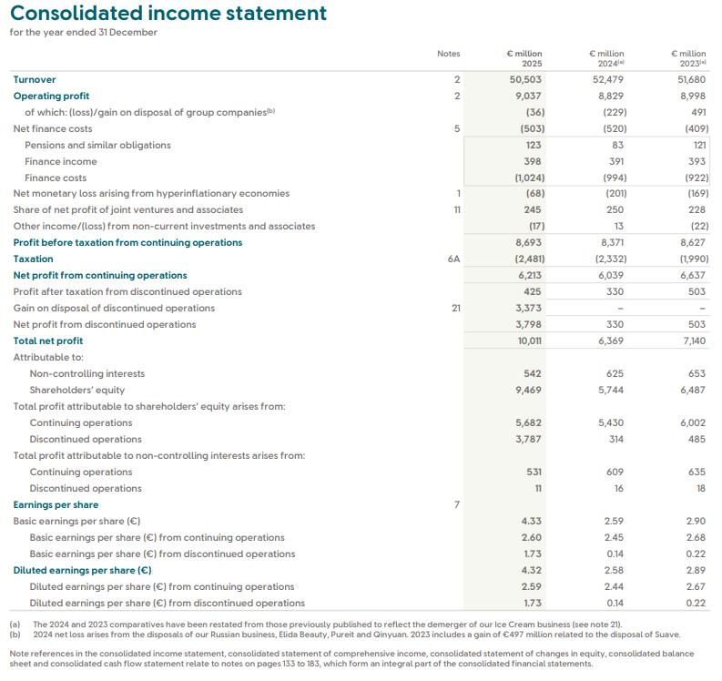
Appendix A2-Consolidated balance sheet from Unilever Annual Report and Accounts 2025.
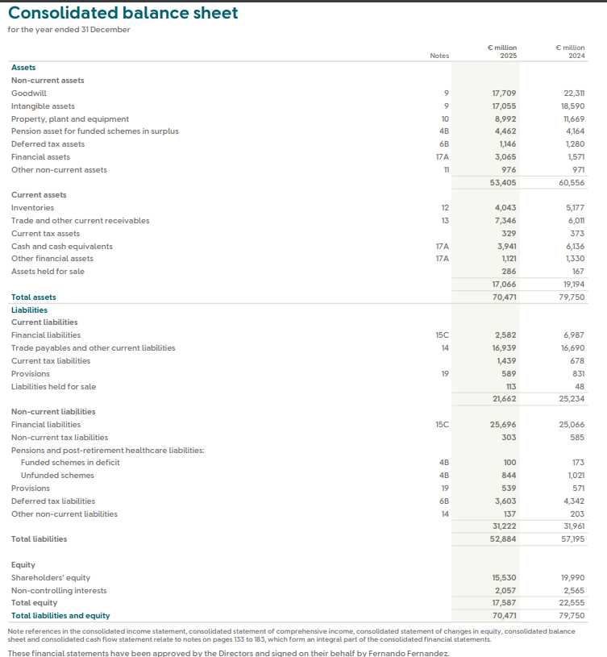
Appendix A3-Trade and other current receivables.
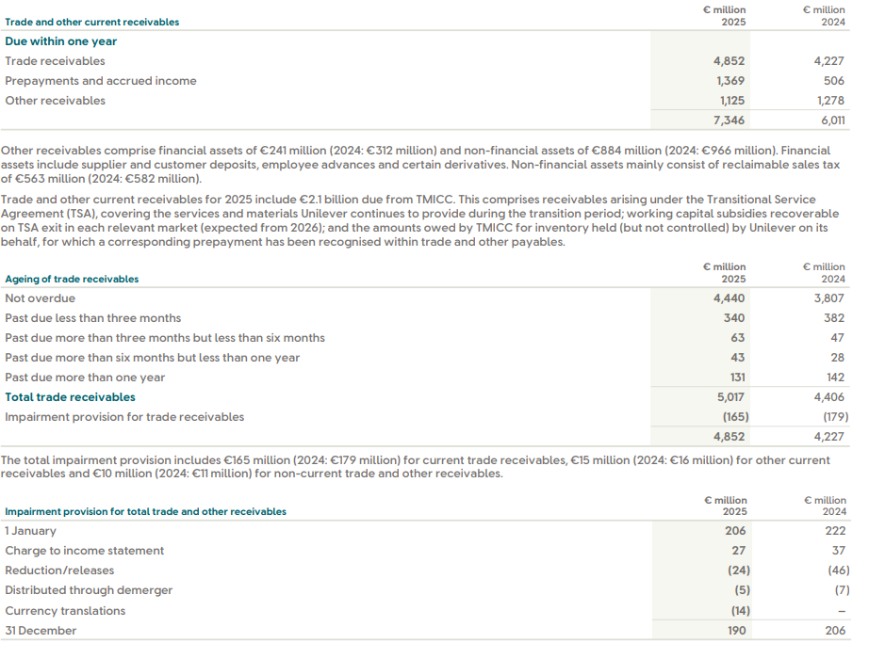.
Appendix A4-Trade payables and other liabilities.
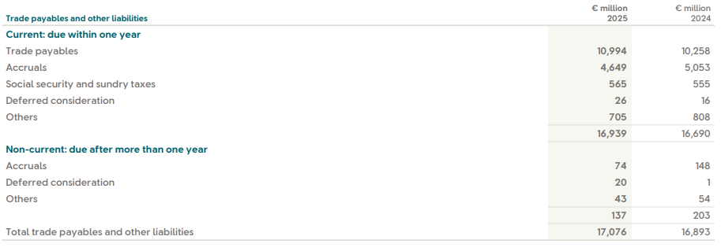.
Appendix A5-Supplier financing arrangements table
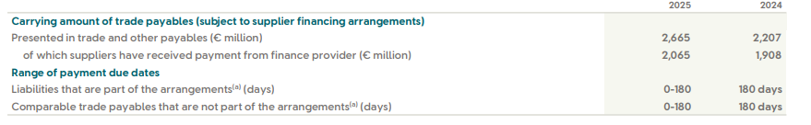.
Appendix A6-Financial liabilities.
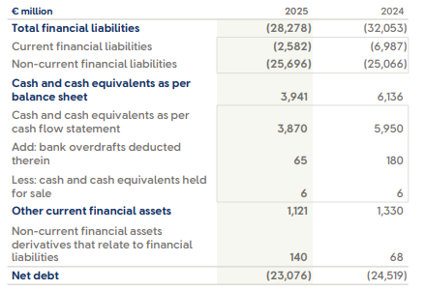.
Appendix A7-Demerger of the Ice Cream business.
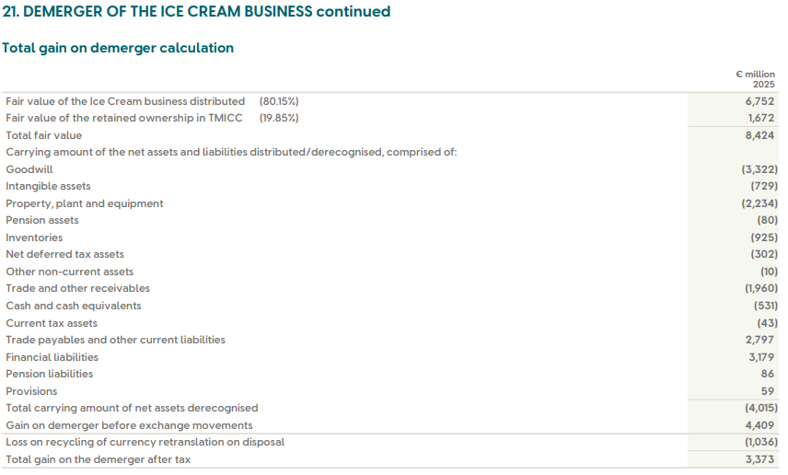.
Appendix B: Detailed ratio calculations
Table B1. Ratio workings
Ratio | Formula | 2025 calculation | 2024 calculation
Gross profit margin | Gross profit / turnover | 23,709 / 50,503 = 46.9% | 24,503 / 52,479 = 46.7%
Operating profit margin | Operating profit / turnover | 9,037 / 50,503 = 17.9% | 8,829 / 52,479 = 16.8%
Net profit margin, continuing operations | Net profit from continuing operations / turnover | 6,213 / 50,503 = 12.3% | 6,039 / 52,479 = 11.5%
ROCE* | Operating profit / (total assets - current liabilities) | 9,037 / (70,471 - 21,662) = 18.5% | 8,829 / (79,750 - 25,234) = 16.2%
Current ratio* | Current assets / current liabilities | 17,066 / 21,662 = 0.79x | 19,194 / 25,234 = 0.76x
Quick ratio* | (Current assets - inventory) / current liabilities | (17,066 - 4,043) / 21,662 = 0.60x | (19,194 - 5,177) / 25,234 = 0.56x
Gearing ratio* | Total financial liabilities / (total financial liabilities + total equity) | 28,278 / (28,278 + 17,587) = 61.7% | 32,053 / (32,053 + 22,555) = 58.7%
Interest cover | Operating profit / finance costs | 9,037 / 1,024 = 8.83x | 8,829 / 994 = 8.88x
Inventory days* | Inventory / cost of sales × 365 | 4,043 / 26,794 × 365 = 55.1 days | 5,177 / 27,976 × 365 = 67.5 days
Receivables days* | Trade receivables / turnover × 365 | 4,852 / 50,503 × 365 = 35.1 days | 4,227 / 52,479 × 365 = 29.4 days
Payables days* | Trade payables / cost of sales × 365 | 10,994 / 26,794 × 365 = 149.8 days | 10,258 / 27,976 × 365 = 133.8 days
Cash conversion cycle* | Inventory days + receivables days - payables days | 55.1 + 35.1 - 149.8 = -59.6 days | 67.5 + 29.4 - 133.8 = -36.9 days
Asset turnover* | Turnover / total assets | 50,503 / 70,471 = 0.72x | 52,479 / 79,750 = 0.66x
Basic EPS, continuing operations | As disclosed | €2.60 | €2.45
Dividend cover | Profit attributable to shareholders from continuing operations / dividends on ordinary capital | 5,682 / 4,453 = 1.28x | 5,430 / 4,320 = 1.26x
Dividend payout ratio | Dividends on ordinary capital / profit attributable to shareholders from continuing operations | 4,453 / 5,682 = 78.4% | 4,320 / 5,430 = 79.6%
Supplementary analytical adjustments for discussion in the main text
- Transition-adjusted current ratio, 2025
(17,066 - 2,100) / (21,662 - 1,600) = 0.75x
- Supplier-finance-adjusted payables days, 2025
(10,994 - 2,665) / 26,794 × 365 = 113.5 days
- Supplier-finance-adjusted cash conversion cycle, 2025
55.1 + 35.1 - 113.5 = -23.3 days
Appendix C: NPV Calculations for Beard Plc
Appendix C1: Initial investment and capital allowances
Option | Initial investment £000 | Capital allowance rate | Annual capital allowance £000
A | 600 | 20% | 120
B | 900 | 20% | 180
C | 1,000 | 20% | 200

Appendix C2: Tax-adjusted cash flows
Formulae:
Taxable profit = Operating cash flow − Capital allowance
Tax payable = Taxable profit × 25%
After-tax cash flow = Operating cash flow − Tax payable
Option A
Year | Operating cash flow £000 | Capital allowance £000 | Taxable profit £000 | Tax at 25% £000 | After-tax cash flow £000
1 | 100 | 120 | -20 | -5.0 | 105.0
2 | 180 | 120 | 60 | 15.0 | 165.0
3 | 210 | 120 | 90 | 22.5 | 187.5
4 | 260 | 120 | 140 | 35.0 | 225.0
Option B
Year | Operating cash flow £000 | Capital allowance £000 | Taxable profit £000 | Tax at 25% £000 | After-tax cash flow £000
1 | 220 | 180 | 40 | 10.0 | 210.0
2 | 270 | 180 | 90 | 22.5 | 247.5
3 | 350 | 180 | 170 | 42.5 | 307.5
4 | 400 | 180 | 220 | 55.0 | 345.0
Option C
Year | Operating cash flow £000 | Capital allowance £000 | Taxable profit £000 | Tax at 25% £000 | After-tax cash flow £000
1 | 250 | 200 | 50 | 12.5 | 237.5
2 | 310 | 200 | 110 | 27.5 | 282.5
3 | 400 | 200 | 200 | 50.0 | 350.0
4 | 430 | 200 | 230 | 57.5 | 372.5

Appendix C3: Discount factors at 5%
Year | Formula | Discount factor
1 | 1 / 1.05 | 0.9524
2 | 1 / 1.05² | 0.9070
3 | 1 / 1.05³ | 0.8638
4 | 1 / 1.05⁴ | 0.8227

Appendix C4: NPV schedules
Option A
Year | After-tax cash flow £000 | Discount factor | Present value £000
1 | 105.0 | 0.9524 | 100.000
2 | 165.0 | 0.9070 | 149.660
3 | 187.5 | 0.8638 | 161.970
4 | 225.0 | 0.8227 | 185.108
 |  | Total PV | 596.737
 |  | Initial investment | (600.000)
 |  | NPV | -3.263
Option B
Year | After-tax cash flow £000 | Discount factor | Present value £000
1 | 210.0 | 0.9524 | 200.000
2 | 247.5 | 0.9070 | 224.490
3 | 307.5 | 0.8638 | 265.630
4 | 345.0 | 0.8227 | 283.832
 |  | Total PV | 973.952
 |  | Initial investment | (900.000)
 |  | NPV | 73.952
Option C
Year | After-tax cash flow £000 | Discount factor | Present value £000
1 | 237.5 | 0.9524 | 226.190
2 | 282.5 | 0.9070 | 256.236
3 | 350.0 | 0.8638 | 302.343
4 | 372.5 | 0.8227 | 306.457
 |  | Total PV | 1,091.226
 |  | Initial investment | (1,000.000)
 |  | NPV | 91.226

Appendix D: IRR Calculation for Option C
Appendix D1: Cash flows for Option C
Year | Cash flow £000
0 | -1,000.0
1 | 237.5
2 | 282.5
3 | 350.0
4 | 372.5

Appendix D2: NPV at 8%
Year | Cash flow £000 | Discount factor at 8% | Present value £000
1 | 237.5 | 0.9259 | 219.907
2 | 282.5 | 0.8573 | 242.198
3 | 350.0 | 0.7938 | 277.841
4 | 372.5 | 0.7350 | 273.799
 |  | Total PV | 1,013.746
 |  | Initial investment | (1,000.000)
 |  | NPV at 8% | 13.746

Appendix D3: NPV at 9%
Year | Cash flow £000 | Discount factor at 9% | Present value £000
1 | 237.5 | 0.9174 | 217.890
2 | 282.5 | 0.8417 | 237.775
3 | 350.0 | 0.7722 | 270.264
4 | 372.5 | 0.7084 | 263.888
 |  | Total PV | 989.817
 |  | Initial investment | (1,000.000)
 |  | NPV at 9% | -10.183

Appendix D4: IRR interpolation
IRR = 8% + [13.746 / (13.746 + 10.183)] × 1%
IRR = 8% + 0.574%
IRR ≈ 8.57%

Appendix E: Capital Rationing Calculation
Appendix E1: Profitability index
Option | Present value of inflows £000 | Initial investment £000 | Profitability index
A | 596.737 | 600 | 0.9946
B | 973.952 | 900 | 1.0822
C | 1,091.226 | 1,000 | 1.0912

Appendix E2: Optimal investment policy
Project | Investment £000 | Fraction undertaken | NPV generated £000
Option C | 1,000 | 100.00% | 91.226
Option B | 500 | 55.56% | 41.084
Option A | 0 | 0.00% | 0
Total | 1,500 |  | 132.311

