Leah Williams (2005113) | Production Design & Animation
Art is Real Sorcery
For this assignment, I was tasked with designing and producing a scene within 3D animation/modelling software, based on a text extract of my choosing. The excerpt I chose to recreate is this conversation that takes between two members of the Italian mafia, which takes place within an Italian living room in 2001 (from the light novel Purple Haze Feedback):
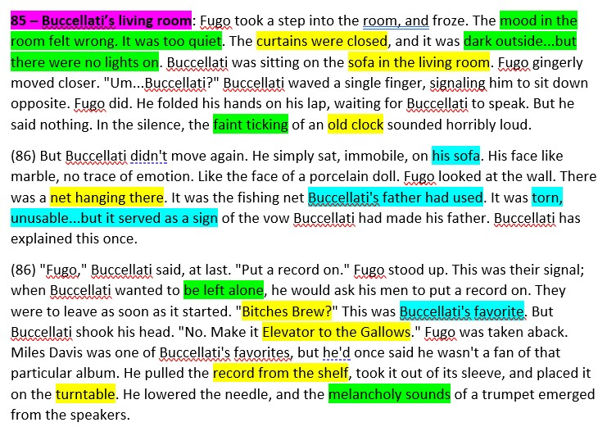
Colour code
Yellow = MATERIALISTIC CONTENT | Green = AURA/LIGHT
Blue = LOCATION HISTORY/CONTEXT
I picked this scene because compared to other scenes from my book of choice, this scene in particular had what I believe to be a very balanced content to aura to context ratio, and I thought that the aforementioned scene would be both plentiful in models to fill up a scene and to texture, as well as an abundance of context surrounding one object in particular; the fishing net, which I thought I could tie in with other clutter-like objects.
As the main theme of the book that I was basing the scene on was criminality, I decided to base the art style for this project on a video game which I had previously played beforehand and is focused on secret agents, due to how similar the mafia and spies can be in relation to their roles within popular media.

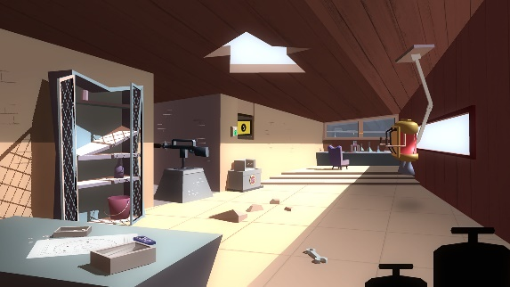
‘Agent A: A Puzzle in Disguise’ is a puzzle game for multiple systems, including mobile and Nintendo Switch, which follows a faceless character by the name of Agent A, who has been given the task of capturing his archnemesis and the supposed murderer of his boss, Ruby la Rouge. I was inspired by the art style of this game because it seems very geometrical in nature (which I am in favour of) and uses simpler shapes to create the many environments present. In using this art deco-esque style, I believed that it would make the process of production much more efficient, as well as aesthetically pleasing.

Conceptual sketches
To begin the creation process, I created a mood board full of examples of items that I had previously deemed essential for the purposes of following the source material. The following are the most important objects in the scene:

- A sofa
- A chair
- An old clock
- An old fishing net
- A ‘Bitches Brew’ vinyl case
- An ‘Elevator to the Gallows’ vinyl case
- A shelf with a stack of vinyl record cases
- A turntable

I labelled these items the necessities and prioritised them during the modelling and texturing phases. For the design of some of these objects, I used the images on the mood board as reference, most prominently seen in the fishing net and the shape of the room:
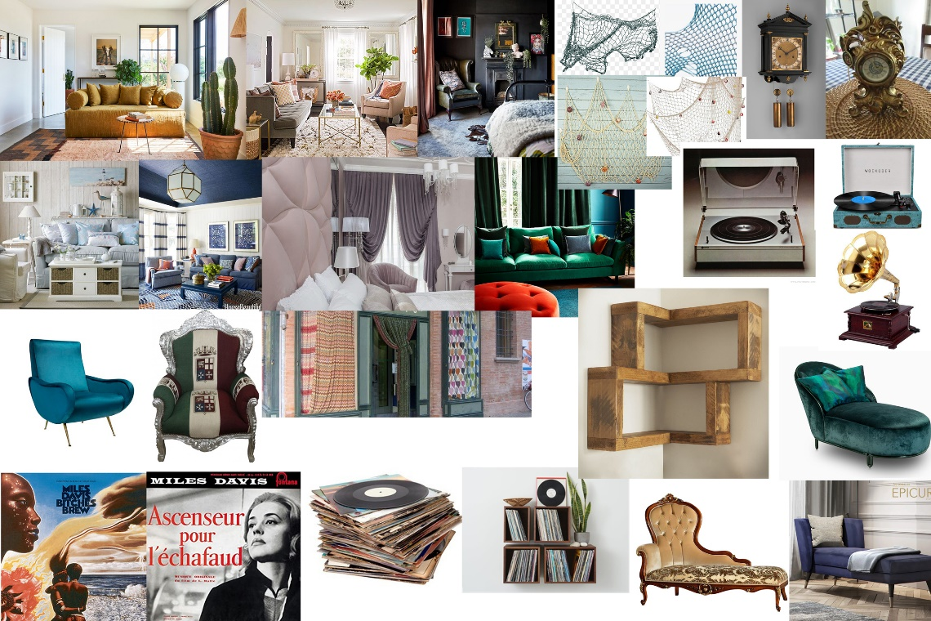
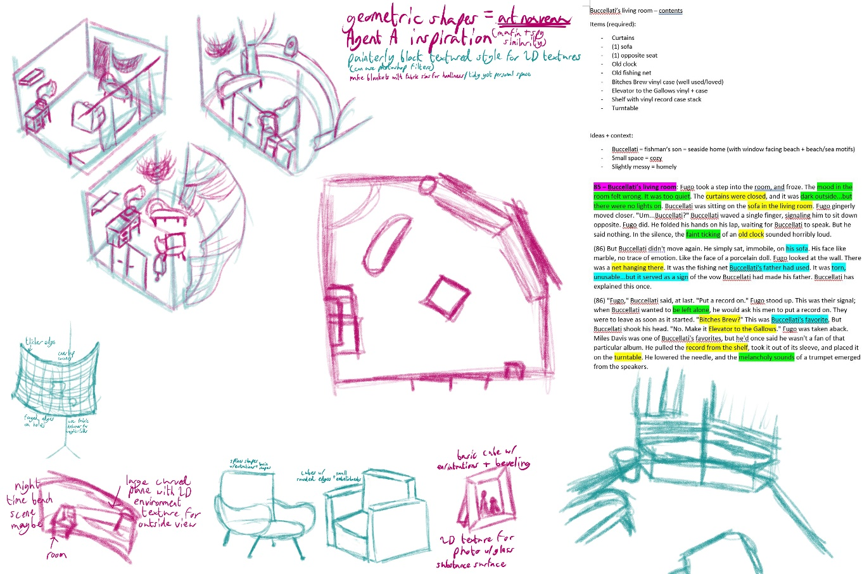
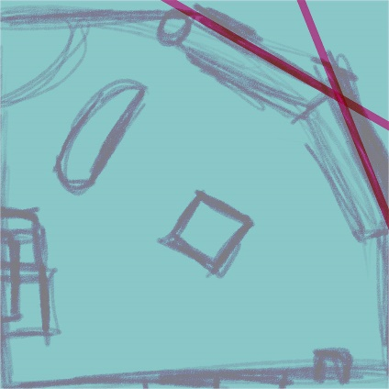
This (top) is the page of primary sketches that I drew for the purposes of planning the scene, as well as some of the objects that would be seen within it. The other image (left) is a basic adaption of the centre sketch, which I used in order to decide on the placing of larger scale furniture, in addition to the angling and other properties for a floor-to-ceiling window that took up the majority of space within the outermost corner. This was applied to a plane within the scene in earlier stages to help with construction and mismatched proportions.

Context
Small amounts of context about the homeowner’s history can be found within the selected passage, though most of it regards either a currently undergoing situation within his organization or his father, so I combined all of this with my previous knowledge of the character in question (from consumption of media from the same franchise) in order to portray a living room that suited his tastes and interests. One point that I focused on is that the character, Buccellati, is the son of a fisherman, which I portrayed with the sandy colour scheme that can be seen applied to objects like the walls and some instances of wood colourings and textures, but also in the fish ornament located on the short set of shelves. Due to the high volume of mention of Buccellati’s father, I decided to model a picture frame with an image of his father inside (which had been extracted from an episode of the main story’s animated show). Other uses of context are present within the placements of some objects, such as the record player on the table; the excerpt states ‘when [he] wanted to be left alone, he would ask his men to put a record on’, so I placed the table and short stack of shelves so that someone would have to slightly alter their exit course in order to gain access to it, but also not too out of the way so that the journey would take long enough to become awkward.
Testing
Throughout the process of this project, I experimented with test renders using Arnold so I could see how the geometry of an object was seen in a fully rendered scene or to test colours or materials for textures. Here are some examples:


