

Assessment 1 –
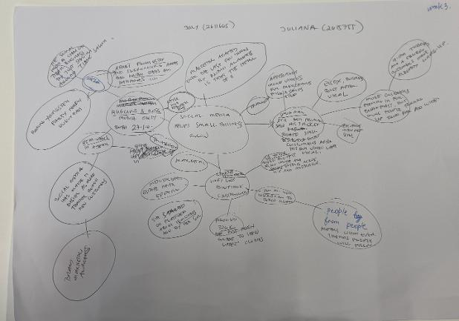

PART 2:

- What is the main idea of the whole text?

In my own understanding, the main idea of the whole text is that social media platforms such as Tiktok and Instagram are now widely used by traders and business owners in UK and worldwide in the marketing of their products, and they find it effective and are benefitting from it.

- What is one key point that supports the main idea, and which specific example from the text shows this?

According to figures shared by Tiktok, about 1.5 million UK businesses are using the Tiktok platform last year. Further, the government’s Business Academy also shared that more than 200 million businesses worldwide use Instagram to reach more customers.

As the text presented, some UK business owners have testimonials that when they posted videos in the social media, their businesses improved dramatically. Among them are: “Binley Mega Chippy” whose trade increased tenfold after posting a video; “Spudman” jacket demand increased and the stall besieged with customers after their video went viral; “Honywood Sandwich Shop” in Basildon that post videos on Tiktok experiences flurry of customers at early mornings from locals and customers who travelled from afar and wide to try their food.

- What is a different key point that supports the main idea, and which specific example from the text shows this?

Through social media, brand awareness among customers has become more prevalent. Social media has levelled the playing field in product marketing between and among the big business, small traders, and individual sellers because each of them have access to a common platform to highlight their brand authenticity and present how buyer-customers can relate to their product and buy it from them.
An example of this is the case of Krystals Boutique, a prom dress shop in Leigh-on-Sea and teenager customers from Channel Islands and even Cyprus just to pick out a frock after seeing their skirts online.

- Which part of the text do you think is most important, and why?
The data and information shared by Tiktok and Instagram on the number of businesses that use their platforms is the most important because it validates the main idea of the text.

Reflection:
- What did you find difficult in this task (including in-class components), and why was it difficult?

I find the determination of the proper main idea of the text difficult because the text has provided many experiences, points, and figures which can make you off-track of the main idea.

- What helped you with this difficulty, and how did it help you?

The Mind Map helped me in this difficulty because I was able to determine the main points and analyse their correlation, which helped me came up with the proper main idea of the text.

