LDE Assignment 1

E-Portfolio

´ESSENTIAL SKILLS FOR STUDY AND EMPLOYMENT IN COMPUTING´

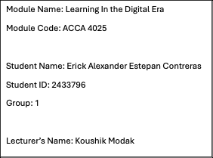

REFERENCING AND SUMMARY
The development of critical academic and professional abilities is crucial for computing students in today´s digital environment. These abilities include time management, digital literacy, problem solving, collaboration, and communication. They are helpful for future work as well as for education. Because it enables students to adequately explain concepts in assignments and presentations, communication is an essential ability.
Professionals in the computing industry frequently must explain technical concepts to non-technical individuals. Since many projects are conducted in groups using internet resources, teamwork is also crucial. Effective collaboration enhances learning and productivity. Critical thinking and problem-solving are necessary computer skills. Students must assess issues and come up with workable solutions, particularly when collaborating with technology.
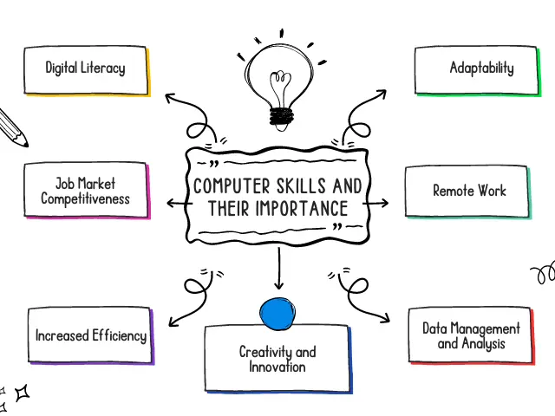

Furthermore, digital literacy is mandatory for the appropriate utilisation of software, platforms, and online resources in both academic and professional contexts. Developing these abilities will benefit my future profession since I will be more familiar working in groups, interacting with others, and addressing real-word challenges.
Employers place a high value on these skills, which will improve my prospects of finding work after graduation.
Overall, essential skills are important for both academic success and long-term career development in the computing field.

REFERENCES
- OpenAI ChatGPT, private communication, Mar. 2026.
- UK Government, “Essential Digital Skills Framework,” 2024. [Online]. Available: https://assets.publishing.service.gov.uk/media/5b9246d4e5274a4236952309/Essential_digital_skills_framework.pdf
- A. Brown, Digital Literacy in Higher Education, London: Pearson, 2022
- J. Smith, “Digital Skills for the Modern Workplace,” Journal of Computing, 2023.
- O’leary, T.J. and O’leary, L.I. (2008). Computing essentials 2008. Boston: Mcgraw-Hill/Irwin.

