MSc Digital Skills for Health and Care Professions
BMDS7001
1644
9 June 2022

Introduction
A heuristic approach to learning can be consolidated in a structured reflection of practical efforts. Jasper and Rolfe (2011) p.4-10 explain that mastery of critical reflection in a systematic and thorough approach allows deeper consideration of empirical evidenced based practice, alongside our personal epistemological development. Notably, they express that critical reflection must extend further than the acquisition of knowledge to a cyclical relationship between epistemology and practice adaption.
The Model of Structured Reflection by Driscoll (2007) (figure 1) emphasises the practical application of additional knowledge on subsequent practice. Therefore, I have chosen this model to reflect on my experience of engaging with the stakeholders for a recent digital task. The task being to elicit digital solutions to support National Institute for Health and Care Excellence NICE guidelines for antimicrobial resistance AMR (NG15) (2015) in the podiatry team, given their sociotechnical requirements and acquisition scope of suitable digital solutions.
Figure 1. Model of Structed Reflection (Driscoll, 2007)
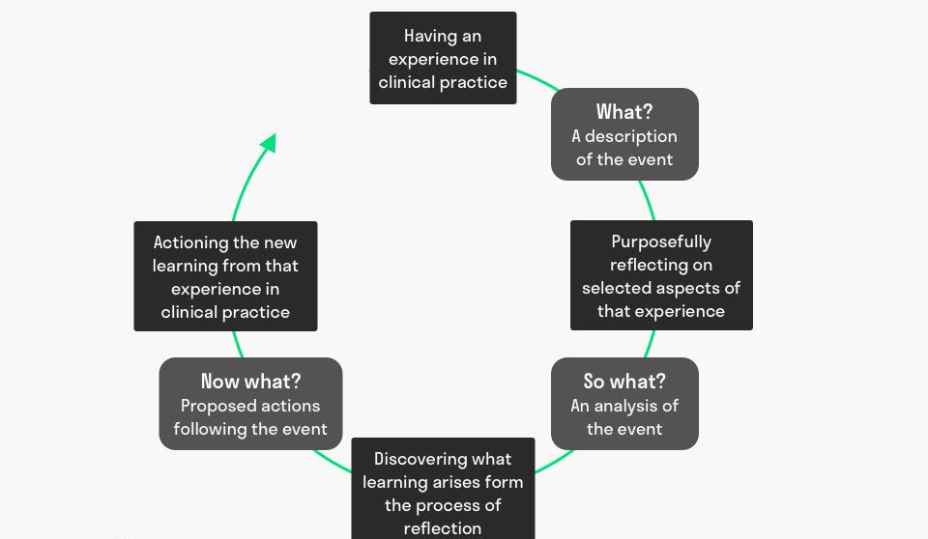

What? A description of the event
The stakeholders for the project are identified in the Power Interest grid (figure1). I did not involve the systems developers directly in the stakeholder meetings. However, indirectly, all proposed solutions had been discussed at a technical level with the developers and digital procurement teams previously by myself as clinical digital lead.
Stakeholder groups were separated into clinical staff and the senior podiatry leadership team (SPLT), with the former being engaged in the existing clinical process analysis and the latter being engaged in the more complex, governance and gap analysis/options appraisal processes. The stakeholder engagement involved a number of group workshops using Microsoft Teams, due to the pandemic restrictions of face-to-face group work.
I facilitated the meetings, explaining the overall purpose, objectives and each specific task to be completed using virtual tools. I set boundaries of respect and inclusivity at the beginning, advising staff how they could communicate, for example by freely speaking, creating a sticky note or adding comments to the chat. Once complete, the process maps were formatted in a visual context and issued both electronically and on paper for the clinicians to review. Follow-up meetings were used to validate and discuss improvements to the process. Digital solutions were not discussed at this point, rather, discussions on how best to support the NG15 guidance effectively and efficiently were discussed.
The SPLT attended further meetings to complete the gap analysis, linking a range of sociotechnical and digital requirements with the point-by-point NICE guidance. The gap analysis was used to record desired outcomes as either met, partial met or not met. At this point I was able to advise the SPLT of digital solutions that could support each desired outcome based on my knowledge of current and emerging digital solutions within the health board and Wales. Finally, the SPLT were engaged in an options appraisal based on pre-gathered technical, risk, functional and non-functional information.
So-what? An Analysis of the event
I was worried that this piece of work was an additional, poorly timed pressure for the wound team. My decision to only use focus groups was based on the work requiring group discussion, and because of time pressures. Usually, I would have chosen to do ethnographic work with individual staff first, to prepare the group work and to provide some data validation.
With previous experience, I felt confident to facilitate the stakeholder sessions but was concerned that I did not have the right stakeholders in correct sessions. For example, should I have had the developers in with the SPLT? With hindsight, consolidating the SPLT’s technical questions and liaising separately with the developers worked well. Furthermore, my experience was with face-to-face and not virtual group work. I was concerned that I would not be able to elicit views and a variety of data from all participants in a virtual meeting. In face-to-face stakeholder engagement it is much easier to be sensitively aware of quieter, less confident, or agitated/distressed stakeholders, using physical cues from body language and task engagement. I would usually employ small group work to elicit contributions from such stakeholders, spending time to reassure and encourage thoughts. Even though all staff were asked to leave their cameras on, I still felt a significant loss visuals clues to ensure all stakeholders had opportunity to express themselves. To compensate, I felt I had to intervene more and ask quieter members of staff for their thoughts, which may have felt too confrontational for them. The result was some quickly conformed to group agreement (group-think) rather than expressing concerns or alternative ideas which might have been debated by the rest of the group. My immediate thoughts were that the groups were too big for virtual group think. In general, I felt the stakeholders managed the virtual meetings well, with most contributing a variety of data and reasoning related to their practice and NG15 aims, to reach consensus on the tasks.
I felt the communication techniques used, including the collaborative documents on Office 365 were effective and informative for all stakeholders, although some struggled to use Teams through lack of training. Stakeholders liked the visual process maps which helped them consolidate and clarify their thinking. The SPLT used the gap analysis and options appraisal tools to develop their critical approach; I found them to be valuable and assistive in eliciting complex thinking and drawing consensus on decision making. Some stakeholders found the gap analysis tool complex and I agree; however, it was an organic document which developed to meet a number of needs. These including the identification of the key outcomes from the process mapping exercise, how they evidenced NG15 guidance, and how sociotechnical considerations of the AMR guidance would be met.
I did not anticipate the complexity of implementing the digital support of NG15 and was not expecting to uncover such an array of digitally supported outcomes. At the time I felt overwhelmed with the volume of work identified, which made me feel like I was losing focus on a single digital implementation. Now I realise the process helped me elicit a comprehensive approach to policy implementation, just as Lilford et al. (2010) anticipates should happen across the whole causal chain. Furthermore, understanding the complexity helped me focus the stakeholders on specific, achievable and measurable changes that could be sequenced in an acquisition strategy.
As the session were recorded for absent staff I was able to watch and reflect on my own technique. I noted that I tended to interrupt stakeholders on occasion, trying to interpret their points of view instead of leaving other stakeholders pick up on the points in a natural discussion. I also noted that being both a stakeholder (Clinical Digital Lead) and facilitator, I caused bias towards my point of views, which I failed to notice at the time.
Now what? Proposed actions following the event
Themes I have identified for improvement from my critical analysis are: stakeholder engagement (table 1), information gathering techniques (table 2) and focus group facilitation techniques (table 3). Each theme is explored in a tabulated format below.
My stakeholder engagement techniques are fundamentally good, but my expertise needs refining and remodelling to adapt to digital stakeholders, particularly the involvement of external stakeholders and the concept of dominant logic models and value creation. Additionally, I need to ensure I take full advantage of collaborative working in O365 Teams, bearing in mind that some stakeholders may need training.
Table 1: Stakeholder engagement
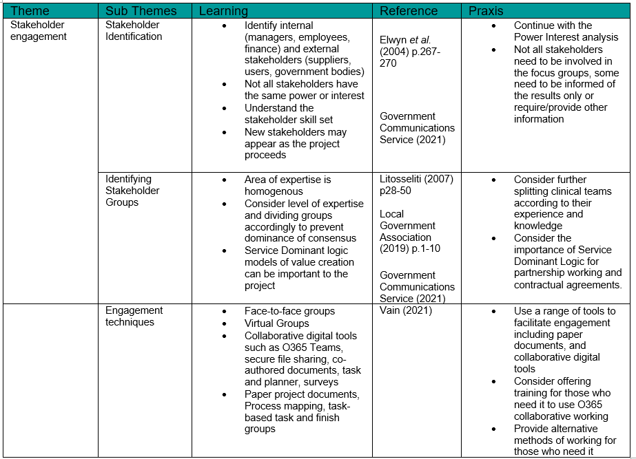
The second theme identified is information gathering techniques. My qualitative data collection skills require deeper learning and refinement of methodology. I need to work on these skills to improve data validity. I need to pay more attention to any bias and manipulation I might impose in my data collection which may lead to passive group-think. Particular learning has been around skills to elicit debate and a critical approach to reach a well-argued consensus. Time pressures should not compromise data triangulation efforts to improve data validity.
Table 2: Information elucidation techniques
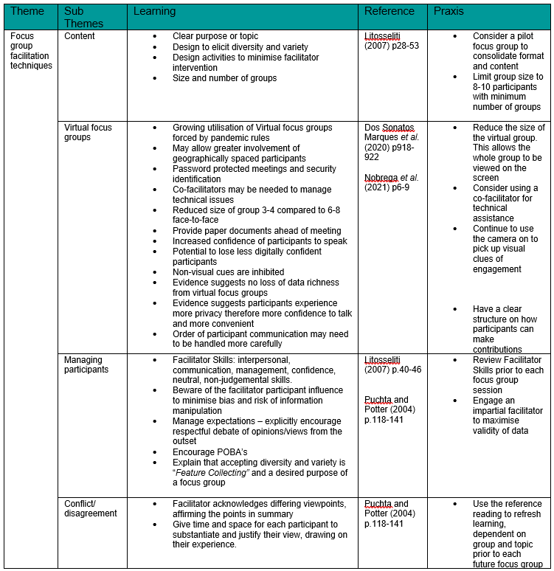

The third theme identified is focus group facilitation techniques. Key learning from this is the adaption of focus groups in the virtual environment. In particular, reducing the numbers of stakeholders per group, stratifying professions with greater homogeneity. This should assist with participant dominance and encourage greater participation from less assertive participants.
With previous learning from similar work I was aware of my own bias, but my position of lead on the topic may still have influenced the groups to conform, rather than produce useful debate, from which an agreed decision is made (consensus). Of importance is the recognition that I cannot be a stakeholder and facilitator and, elucidate balanced arguments without bias. Notwithstanding, I believe my engagement techniques largely met those suggested by J-squad (2015): provide the facts, offer alternative arguments to the group to discuss, and to encourage smaller working groups to discuss ideas. J-squad (2015) warn against interrupting and jumping into conversation, something I felt I did more of in the virtual group sessions and need to have future awareness of.
What did work well was the use of the collaborative working documents, which allowed SPLT staff to add ideas and thoughts to the gap analysis and options appraisal without the risk of direct confrontation, thus minimising the risk of group think.

Table 3. Focus group facilitation techniques
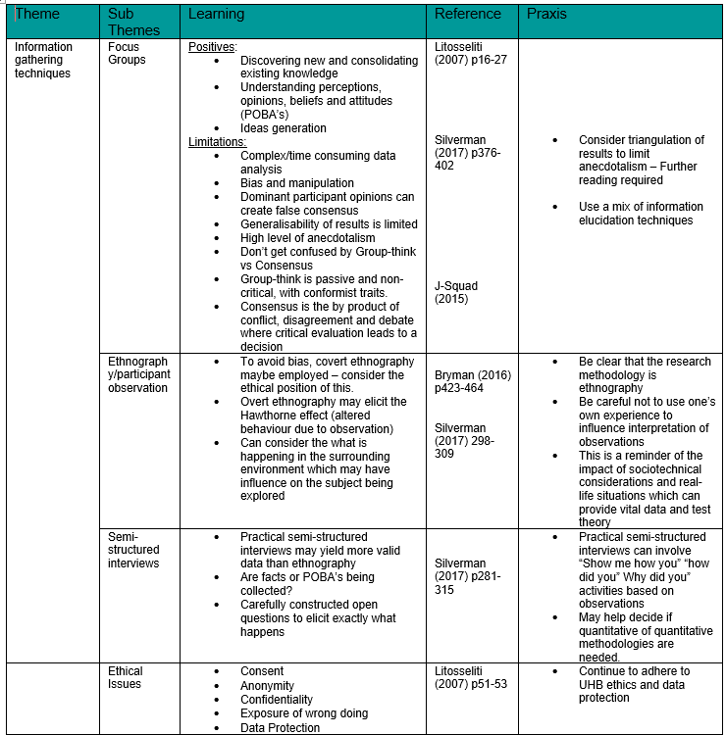
The learning points identified in my themes have acted both to reassure me about aspects of my practice and illustrated what I need to consider when engaging with stakeholders. In line with Jasper and Rolfe (2011) p.4-10, the concept of epistemological discourse and the practice of reflexivity have been summarised in the praxis. These are the changes I expect to implement in future engagement to build on my expertise and skill set. I intend to repeat the reflection of multi- and inter-disciplinary stakeholder engagement following further cycles, to recognise if my new knowledge, understanding and practices meet the learning points identified, or if further knowledge is required.

Reference
Bryman, A. (2016) Social Research Methods. 5th Edition. Oxford: Oxford University Press

Dos Santos Marques et al. (2020) ‘Implementation of virtual focus groups for qualitative data collection in a global pandemic’ The American Journal of Surgery, 221, pp. 918-922. doi.org/10.1016/j.amjsurg.2020.10.009

Driscoll, J.J. (2007) Practising Clinical Supervision: A Reflective Approach for Healthcare Professionals (2nd Edition) London: Bailliere Tindall. pp 27‐50

Elwyn, G., Greenhalgh, T. and Macfarlane, F. (2004) Groups: a guide to small group work in healthcare, management, education and research. London: Radcliffe Medical Press

Government Communications Service (2021) Ensuring Effective Stakeholder Engagement. Available at: Ensuring Effective Stakeholder Engagement - GCS (civilservice.gov.uk) (Accessed: 24/05/2022)

Jasper, M. and Rolfe, G. (2001) ‘Critical reflection and the emergence of professional knowledge’ in Rolfe, G., Jasper, M. and Freshwater, D. critical reflection in practice (2nd Edition) Basingstoke: Palgrave Mcmillan

J-SQUAD (2015) Group Think vs Consensus Available at: GroupThink vs Consensus | conflictmanagement (dlesniak3.wixsite.com) (Accessed: 27/05/2022)

Lilford, R. et al. (2010) ‘Evaluating policy and service interventions: framework to guide selection and interpretation of study end points’ BMJ 341:c4413. Available at: https://doi.org/10.1136/bmj.c4413 (Accessed: 09/04/2022)

Litosseliti, L. (2007) Using Focus Groups in Research. London: MPG Books
Local Government association (2019) Successful stakeholder management. Available at: Successful stakeholder management (local.gov.uk) (Accessed: 24/05/2022)

National Institute of Health and Care Excellence (NICE) (2015) Antimicrobial stewardship: systems and processes for effective antimicrobial medicine use. NG15. Available at: Overview | Antimicrobial stewardship: systems and processes for effective antimicrobial medicine use | Guidance | NICE (Accessed: 04/04/2022)

Nobrega, S., et al. (2021) ‘Feasibility of Virtual Focus Groups in Program Impact Evaluation’ International Journal of Qualitative Methods. 20, pp 1–10 journals.sagepub.com/home/ijq. DOI: 10.1177/16094069211019896

Puchta, C. and Potter, J. (2004) Focus Group Practice. London: Sage Publications Ltd
Silverman, D. (2017) Doing Qualitative Research. 5th Edition. London: Sage Publications Ltd

Vain, C. (2021) Tips for engaging with Stakeholders Available at: Tips for engaging with stakeholders | The common types of stakeholders (cpdonline.co.uk) (Accessed: 26/05/2022)

