MSc Data and Artificial Intelligence
Apply Data Security, Governance and Compliance principles to FinSure Bank (FSB)

1. Abstract
FinSure Bank (FSB) is a cloud-based financial services and bank provider that has a mobile device infrastructure and cloud-based infrastructure in multiple countries. It is also prone to many cybersecurity attacks such as data breaching, insider threat, mobile banking security, misconfigurations, and regulatory non-compliance policies and guidelines of cloud security. And the threat environment is evolving because of a host of factors such as those of advanced persistent threats, artificial intelligence-based attacks, and cloud ecosystem complexity. This requires a controlled and effective approach to governance and information security management systems as well as regulatory policies and guidelines, such as GDPR, PCI-DSS and financial conduct regulations, which highlights the nature of compliance and methodical attitude to the security of customer and financial data..
This report aims to analyze the most popular security standards, i.e., ISO 27001, NIST Cybersecurity Framework (CSF), and ITIL, in an attempt to create an integrated security architecture to be implemented in the governance of FSB. The security architecture will comprise the ISO 27001 standard in the governance aspect, the NIST CSF in the risk aspect, and the ITIL standard in the security aspect. The implementation of the security architecture will ensure the improvement of the current situation in the following areas: better identification of risks, better handling of security incidents, better data security, and better regulatory compliance.

Table of Contents
1. Abstract 2
2. Introduction 4
2.1 Background 4
2.2 Scenario Overview 4
2.3 Key Security Challenges 5
3. Literature Review: Security Frameworks and Models 5
3.1 Importance of Security Frameworks in Financial Institutions 5
3.2 ISO 27001 / ISO 27000 Framework 6
3.3 NIST Cybersecurity Framework 7
3.4 ITIL Security Management Framework 7
3.5 Comparative Analysis of Frameworks 8
4. Security Governance and Compliance Challenges at FSB 9
4.1 Data Protection Issues 9
4.2 BYOD Risks 9
4.3 Cloud Security Risks 10
4.4 Insider Threats 10
4.5 Regulatory Compliance 10
5. Proposed Security Governance Model for FinSure Bank 11
5.1 Assumptions 11
5.3 Security Governance Structure 12
5.4 Security Policies 13
5.5 Risk Management Framework 13
5.6 Protection Mechanisms 13
5.7 Contingency Planning 14
5.8 Service Level Agreements (SLAs) 14
6. Critical Discussion: Importance of Updating Regulations 14
7. Conclusion 15
8. References 17
Appendixes 20

2. Introduction

2.1 Background
Digitisation of the financial sector is occurring at a fast rate in the world with digital banking and cloud-based financial solution now becoming a key element of financial services. The introduction of digital banking in 2016 has caused financial services organisations to migrate their operations to the cloud in order to enjoy the benefits of scalability and cost reduction. Financial services organisations are also likely to allocate more budgets to cybersecurity to fight off new cybersecurity threats with 76% of financial services organisations likely to allocate more budgets to fight off new cybersecurity threats (Odumuwagun, 2023). Financial services organisations are noting cybersecurity threats in the cloud as one of the biggest cybersecurity challenges for them. On the other hand, there is an increase in cyber-attacks on financial services with the growth of online banking and reports from across the globe point to an increase in threats (Patil et al., 2025). The financial services organisations are experiencing AI-based malware, deep fake, and identity attacks on financial systems, indicating that they need to develop elaborate financial services organisations with risk, compliance and operational risk management competencies (Adegbite, 2025).

2.2 Scenario Overview
FinSure Bank (FSB) is a digital financial services provider operating in several countries, with a predominantly cloud-based infrastructure, hosting about 90% of the environment externally (Oyekunle et al., 2025). Banking Cyber Security market size has reached to $130.66 billion in 2025. Additionally, the organisation offers a Bring-Your-Own-Device (BYOD) policy, which allows the workforce to be flexible in the services they can access from the organisation. While the architecture allows the organisation to deliver services quickly, it has made the environment vulnerable to cyber threats, particularly in relation to devices, services, and datathird-party services, and distributed data environments are concerned.
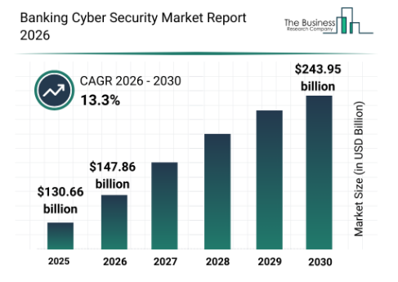
Figure 1: Banking Cyber Security Market
(Source: Thebusinessresearchcompany, 2024)

2.3 Key Security Challenges
The key security challenges for FSB are the absence of unified security governance, weak compliance model, insider threats, mobile and cloud security, and the complex data privacy challenges of GDPR (Sanjay et al., 2023). These challenges are present without a risk control, compliance and operational resilience model.

3. Literature Review: Security Frameworks and Models

3.1 Importance of Security Frameworks in Financial Institutions
The cyber attacks on banks are an excellent opportunity due to the nature of information they contain, transaction details and financial planning documents. In the US, the Federal Financial Institutions Examination Council (FFIEC) states that in 2023 the cost of cyber-attacks on US banking sector is over $7 billion because of an increase in the number of attacks on cloud computing and mobile banking apps (Alshar'e, 2023). Security standards like ISO, NIST, IEEE, and ITIL provide banks with guidelines to deal with security risks, to have security controls and to adhere to regulations in place. This helps banks to be active in addressing security threats and incorporating security, incident response and asset management in the bank operations (Saha et al., 2025). The implementation of a security framework plays a crucial role in the operations of the various countries, BYOD, and the use of cloud services, which minimizes the risk of data breach, regulatory compliance, and the establishment of confidence in the stakeholders in the case of FinSure Bank.

3.2 ISO 27001 / ISO 27000 Framework
ISO 27001 provides an Information Security Management System (ISMS) that provides a process for managing and protecting information. It includes risk assessment and management, security policy, information asset management, access control and incident management (Handayani, 2020). ISO 27001 uses the continuous improvement cycle (Plan-Do-Check-Act) to ensure consistency and improvement of security management and control. ISO 27001 is globally accepted and allows organisations to adhere to the GDPR, PCI DSS and other financial regulations. The implementation of ISO 27001 by FinSure Bank helps in terms of risk management and security, client data protection, and building trust among clients and regulators (Singh, 2025).
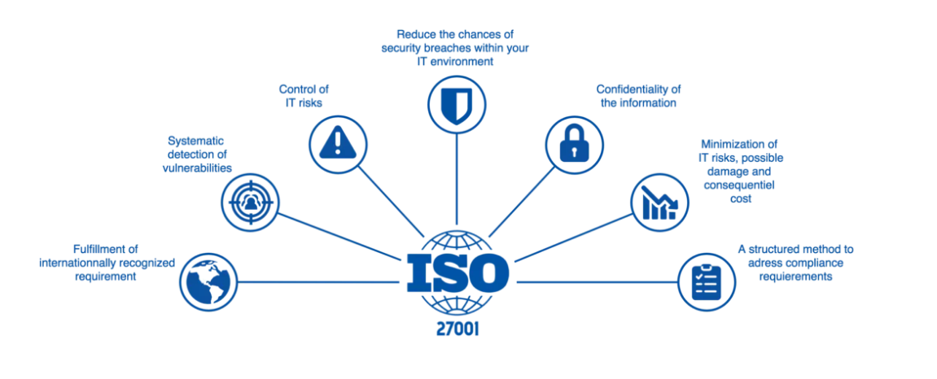
Figure 2: ISO 27000 Framework
(Source: Stewart, 2024)

3.3 NIST Cybersecurity Framework
The National Institute of Standards and Technology (NIST) Cybersecurity Framework (CSF) is a risk-based strategy that is flexible to improve cybersecurity. The NIST CSF consists of five main functions, which are Identify, Protect, Detect, Respond, and Recover (Sahiwala, 2026). The Identify function is the risk and asset understanding, the Protect function is the protection implementation, the Detect function is the identification of threats, the Respond function is the incident response and Recover function is the business recovery. NIST CSF would be beneficial to FinSure Bank and other financial institutions where risk management and business continuity would be improved, especially regarding cloud and BYOD (Uzougbo et al., 2024). The flexibility of NIST would assist financial institutions to adopt the existing policies and standards, and to customize security controls depending on risk. Although NIST Cybersecurity Framework is satisfactory regarding cyber resilience and monitoring, there must be governance that will guarantee the compliance with GDPR, PCI-DSS and other regulations (Luis Salas et al., 2025).
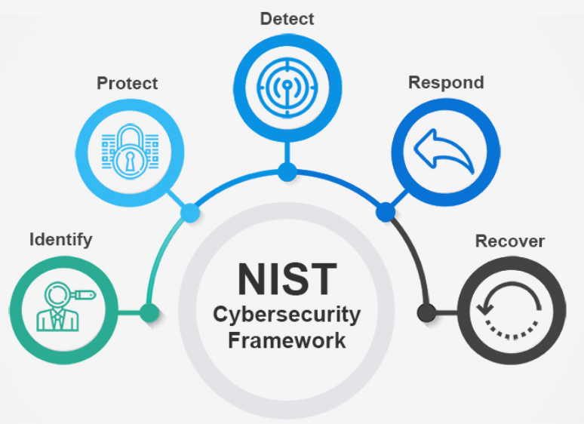
Figure 3: NIST Cybersecurity Framework
(Source: Cyberwatching, 2026)

3.4 ITIL Security Management Framework
The information technology infrastructure library (ITIL) security management framework is founded on the congruence of information technology service delivery and security goals in an organisation. It combines service life cycle management, incident management, change management and service level agreements (Ryanto and Tundjungsari, 2024). It provides safe, controlled and effective operations to an organisation. In the case of FinSure Bank, it will offer a framework that will enable it to successfully manage its cloud services, service level agreement and incident response. It will be used together with ISO 27001 and NIST CSF to ensure the balance between governance, risk and continuity (Azura et al., 2025).
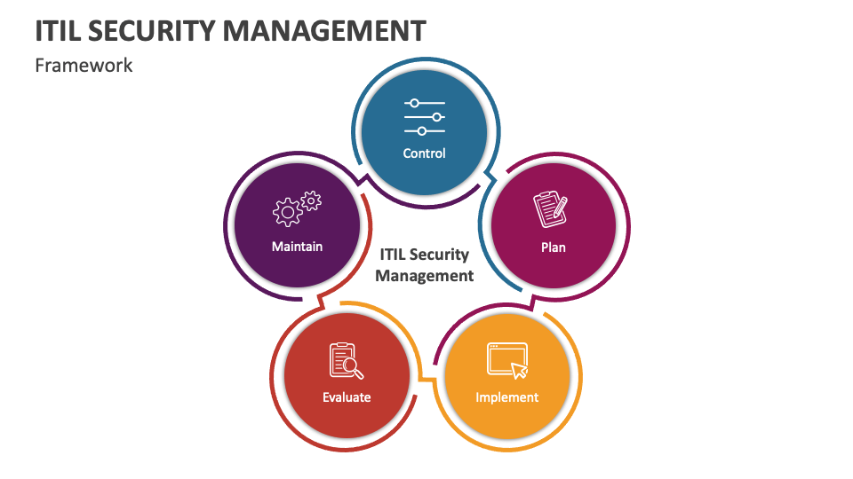
Figure 4: ITIL Security Management Framework
(Source: Collidu, 2023)

3.5 Comparative Analysis of Frameworks
The Literature review demonstrates that there is no single model that can be used to guarantee the security requirements of the FSB. The ISO 27001 standards offer a good governance framework to guarantee compliance and risk elimination (Folorunso et al., 2024). NIST CSF is a risk-based and flexible methodology of ensuring that cyber threats are identified, protected, and responded to, particularly to cloud and BYOD environments. ITIL is a business model that guarantees interconnection of service monitoring and incident management in order to maintain continuity of operations (Boyes and Higgins, 2024). In the case of FinSure bank, the security is holistic e.g. ISO, NIST and ITIL, which provide compliance, continuity of operation and risk reduction.
Framework | Primary Focus | Strength | Limitation | Relevance to FSB
ISO 27001 | Governance & Compliance | International standard; regulatory compliance | High implementation cost; requires organisational maturity | Provides structured ISMS; essential for GDPR compliance
NIST CSF | Risk & Resilience | Flexible; supports cyber resilience | Less prescriptive for regulatory compliance | Strong risk management tool; complements ISO governance
ITIL Security | Operational Security | Improves service delivery; SLA monitoring | Not inherently security-focused | Ensures cloud/vendor operations are secure and efficient

4. Security Governance and Compliance Challenges at FSB

4.1 Data Protection Issues
As a digital bank with a wide range of personal and financial information spanning various jurisdictions, FinSure Bank’s data protection is a significant concern. Adhering to the GDPR and other international regulations on data protection demands the safe storage, processing, and transmission of sensitive customer data (Olutimehin, 2025). Non-compliance with robust measures of data encryption and minimization would result in potential security breaches and regulatory fines. Poor data classification and divergent privacy policies could jeopardize customer confidence and cause significant losses to the digital banking firm’s reputation and bottom line.

4.2 BYOD Risks
However, the BYOD policy of the bank increases the risk of various vulnerabilities. Devices of the employees may not have standardised security settings, which could allow malware attacks, illegal access of the system, and disclosure of sensitive information (Djebbar and Nordström, 2023). Lack of proper MDM systems makes it difficult for the bank to track and secure devices, which increases the risk of non-compliance with internal policies and regulatory guidelines due to the presence of diverse devices in a multi-country scenario.

4.3 Cloud Security Risks
FSB's cloud infrastructure creates risk due to its dependence on third parties for security. There is a risk of data exposure if storage, access, or networking configurations are not properly set up. Additionally, data sovereignty laws pose a risk for operations that cross national boundaries. It is crucial to have regular audits, data encryption, and proper security designs (Radanliev, 2023). The multiple cloud infrastructure creates a high risk of human errors and configurations, which can cause significant security breaches if not monitored.

4.4 Insider Threats
The insider threat is considered a major challenge, especially because of the involvement of contract workers, partners, and privileged access users. The insider threat, whether malicious or negligent, can cause the unauthorized disclosure of data, bypass security controls, and manipulate financial data (Dimakopoulou and Rantos, 2024). In the case of the BYOD and cloud computing, privileged access and unusual behavior are hard to control without the help of identity and access management, as well as logging mechanisms. FSB must find the right balance between flexibility and access control to avoid being exploited by insiders.

4.5 Regulatory Compliance
In addition, FSB has to comply with GDPR, financial regulations, and cybersecurity regulations in different geographical areas. This has led to a lack of a proper governance structure, and compliance monitoring has also been a problem, leading to regulatory breaches and audit failures. With changing technological trends and new cyber risks, there is a need to update regulations and controls on a regular basis (Reuben-Owoh and Haig, 2025). This includes regular audits and automated compliance checks for cloud-based infrastructures and BYOD models.

5. Proposed Security Governance Model for FinSure Bank

5.1 Assumptions
The proposed model considers that the FSB functions in the EU and international market, servicing millions of retail and corporate customers. The bank's IT infrastructure is largely dependent on cloud services, using AWS and Azure, with 90% of the operations outsourced externally. The bank's budget is considered moderate to high for its cybersecurity, hence the ability to invest in state-of-the-art tools and personnel (Radanliev, 2023). The bank is also considered to be adhering to GDPR, PCI-DSS, and other local financial conduct regulations. The bank also considers the implementation of the BYOD policy, hence the need to ensure mobile security. All these are considered while designing an integrated governance structure.
5.2 Proposed Integrated Security Architecture
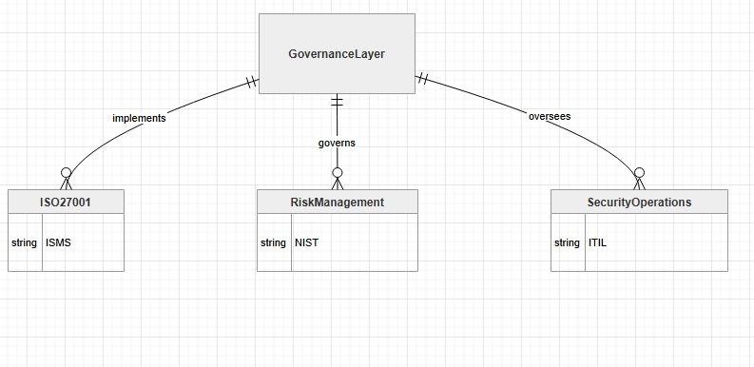
Figure 5: Integrated Security Architecture
(Source: Self-Created, From Draw.io, 2026)
The framework is an integration of ISO 27001, NIST CSF and ITIL, uniting these three in governance format. Governance is derived from ISO 27001 which sets the policies and ISMS. The NIST functions are used for risk management, enabling risk identification, assessment and mitigation for cloud computing and BYOD (Rofi’ah 2015). ITIL is used to implement these controls through service lifecycle, incident management and service level agreement monitoring. This brings a unified approach to ensuring compliance and security for the sensitive financial information through its multi-jurisdictional operations.

5.3 Security Governance Structure
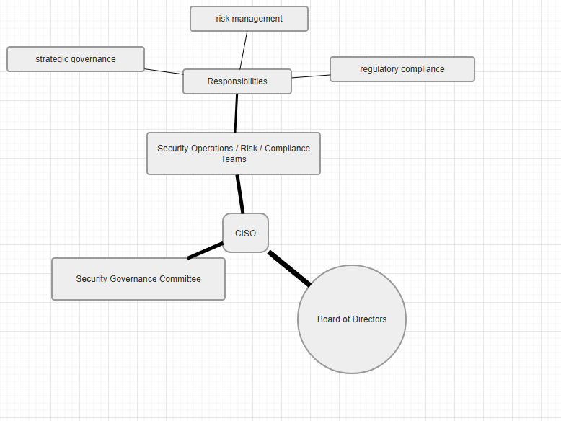
Figure 6: Security Governance Structure
(Source: Self-Created From Draw.io, 2026)
The hierarchy of FSB's governance structure begins with the Board of Directors, responsible for strategic direction and allocation of resources. The Chief Information Security Officer (CISO) is responsible for security strategy and policy implementation, and reports to the Board of Directors. The CISO is supported by the Security Governance Committee, responsible for cross-functional alignment and integration (Batte, 2025). The security operations, risk, and compliance teams are responsible for day-to-day operations, risk, and compliance. The hierarchy is complete with the inclusion of the strategic, tactical, and operational levels.

5.4 Security Policies
The FSB is governed on the basis of its policies. Information Security Policy gives the objectives, responsibilities and roles. The Access Control Policy will be used to implement the concept of role-based access control that is founded on the principle of least privilege access. BYOD Policy will guarantee the security, authentication, and monitoring of devices within the organization (Pamungkas et al., 2025). The Data Protection Policy guarantees not only the compliance of the organization with the GDPR but also with the cross-border requirements. Lastly, the Incident Response Policy defines the procedures to be adhered to in case of an incident that offers the mechanism to execute the integrated security architecture.

5.5 Risk Management Framework
FSB follows the NIST risk management process of risk identification and analysis, risk evaluation, risk treatment and risk monitoring. Data breaches, misuse and misconfiguration are threats to FSB. Risks are analyzed and evaluated to prioritise investments. A risk matrix is used to guide risk mitigation efforts:
Risk No | Risk Description | Risk Category | Likelihood | Impact | Risk Level | Mitigating Actions
R1 | Data breach of customer financial data | Data Security | High | Very High | Critical | Encryption, MFA, access control, continuous monitoring
R2 | Insider misuse of privileged access | Insider Threat | Medium | High | High | IAM controls, role-based access, audit logs, monitoring
R3 | Cloud misconfiguration exposure | Cloud Security | Medium | High | High | Regular audits, automated configuration checks, training
R4 | Malware infection via BYOD devices | Endpoint Security | High | Medium | High | MDM solutions, endpoint protection, BYOD policy enforcement
R5 | Regulatory non-compliance (GDPR/PCI DSS) | Compliance | Medium | Very High | Critical | Compliance audits, staff training, policy enforcement
R6 | Phishing and social engineering attacks | Cyber Threat | High | Medium | High | Employee awareness training, email filtering, MFA
R7 | Distributed Denial of Service (DDoS) | Network Security | Medium | High | High | Firewalls, DDoS protection services, traffic monitoring
R8 | Third-party vendor security failure | Third-Party Risk | Medium | High | High | Vendor risk assessment, SLA enforcement, security audits
R9 | Data loss due to system failure | Operational Risk | Low | High | Medium | Backup systems, disaster recovery planning
R10 | Delayed incident response | Operational Security | Medium | Medium | Medium | Incident response plan, regular drills, monitoring systems

5.6 Protection Mechanisms
Technical controls include multi-factor authentication, encryption of both data in transit and at rest, intrusion detection systems, firewalls, and endpoint devices. Operational controls include continuous employee security awareness programs, monitoring of suspicious activity, and the implementation of very stringent BYOD policies (Odumuwagun, 2025). These technical and operational controls will help to address both external and internal risks to the organization. In the cloud-based systems, real-time monitoring is also done to ensure that no unauthorized access is made (. Therefore, technical and operational controls will greatly improve the security posture of FSB.

5.7 Contingency Planning
FSB prepares incident response plans, disaster recovery and business continuity plans. The incident response plan involves processes of responding, eliminating and reporting security incidents (Patil et al., 2025). Disaster recovery plan contains the steps to restore the critical systems, data, and applications in case of the outages and security incidents. The business continuity plan has the steps of continuing service to the customers, and thus guaranteeing customer trust. Contingency Planning: It assists in creating resiliency to cyber attacks, cloud failure, and cross-country operations.

5.8 Service Level Agreements (SLAs)
SLAs involving cloud service providers cover the availability, security, and notification of data breach. The agreements entail adherence to laws of privacy of data, audit, and incident management. The SLAs stipulate that service providers adhere to the requirements of the governance of the bank in order to maintain business continuity and compliance (Adegbite, 2025). The SLA performance monitoring makes it possible to monitor the changes and accountability. The SLAs also deal with the needs of data sovereignty and encryption of a multi-jurisdictional business, and it is a tool of the contract that allows the bank to expand its security governance and risk management system to its service providers.

6. Critical Discussion: Importance of Updating Regulations
As cyber threats, technologies and AI-based attacks continue to evolve, the regulatory frameworks and guidelines for the financial sector are also being updated and upgraded. The financial service organisations are facing attacks from sophisticated cyber criminals, 76% of the financial service organisations plan to boost their cybersecurity budgets in 2015 (Adegbite, 2025). But the financial sector is still very much concerned about various threats such as cloud-based attacks, AI-based attacks (like AI-based malware, deepfake attacks, supply chain attacks) and so on. With the use of highly advanced and AI-based technologies such as cloud computing and AI-based technologies such as generative AI for customer service by organisations like FinSure Bank, the threat landscape is continuously growing and the financial sector is vulnerable to a range of potential risks and threats for its critical data and systems (Oyekunle et al., 2025). To combat these threats and challenges, regulatory policies and guidelines like the EU's Digital Operational Resilience Act (DORA), the EU's NIS2 and EU AI Act are being deployed and enforced in the sector. Data protection guidelines and regulations such as the GDPR are being continuously updated and amended and are levying fines of over €1.2 billion on organisations in 2025 for an increasing number of data breaches (Saha et al., 2025).
Despite this, however, there is a clear gap between the evolution of threats and the development of appropriate policy responses. The rapid pace of adoption of AI technologies, with the indication from financial firms that they have been quicker in adopting AI technologies than in seeking approval for their use highlights some of the regulatory gaps that leave the financial firms exposed and ill-prepared (Singh, 2025). The regulatory update process has been found to be linked with implementation challenges and compliance costs, with financial firms reporting that they spend significant percentages of their revenue on regulatory compliance, including the hiring of experts, tools and training. As well, complex and fragmented regulations can create compliance costs for financial firms, especially those that lack the size and economies of scale of larger financial institutions (Uzougbo et al., 2024). Therefore, there is a need for regulators to adopt flexible, technology-neutral standards that anticipate future risks, promote best practice adoption and enable harmonisation between jurisdictions, enabling banks like FinSure to flourish in a changing risk environment.

7. Conclusion
FinSure Bank is operating in a complicated cyber risk environment and cloud computing, BYOD, insider threats and global data management are only complicating the situation of the bank. The increased sophistication and complexity of cyber threats, including AI-based fraud and ransomware, underscore the need to roll out an efficient information security governance system. The bank must also adhere to major security requirements and regulations, including GDPR, PCI DSS, and future security provisions like those of AI security, and lack of an unified security system can subject the bank to financial, reputational, and legal losses.
The strategic alignment, risk management and security coordination in the organisation can be pursued using an integrated system of governance, which is based on ISO 27001, NIST CSF and ITIL. The formalization of an ISMS, NIST CSF risk assessment and management, and incident and service management under ITIL can be adopted on ISO 27001. The appropriate solution to all the challenges posed by the constantly changing environment, and deal with all the threats and risks, and earn the trust of stakeholders in the dynamic digital financial environment can make FinSure Bank successful.

8. References
Adegbite, M.A., (2025). Data Privacy And Data Security Challenges In Digital Finance. Journal of Digital Security and Forensics, 2(1), pp.6-19.
Aljumaiah, O., Jiang, W., Addula, S.R. and Almaiah, M.A., (2025). Analyzing cybersecurity risks and threats in IT infrastructure based on NIST framework. J. Cyber Secur. Risk Audit, 2025(2), pp.12-26.
Alshar'e, M., (2023). Cyber security framework selection: Comparision of NIST and ISO27001. Applied computing Journal, pp.245-255.
Azura, Y.T.Y., Azad, M.A. and Ahmed, Y., (2025). An integrated cyber security risk management framework for online banking systems. Journal of Banking and Financial Technology, 9(1), pp.85-104.
Batte, B., (2025). ISO 27001 and Alternative Frameworks for Managing Information Security Risks. Available at SSRN 5546398.
Boyes, H. and Higgins, M.D., (2024). An overview of information and cyber security standards. Journal of ICT Standardization, 12(1), pp.95-134.
Collidu (2023). ITIL Security Management. [online] Collidu.com. Available at: https://www.collidu.com/presentation-itil-security-management [Accessed 1 Apr. 2026].
Cyberwatching. (2026). NIST Cybersecurity Framework. [online] Available at: https://cyberwatching.eu/nist-cybersecurity-framework [Accessed 1 Apr. 2026].
Dimakopoulou, A. and Rantos, K., (2024). Comprehensive analysis of maritime cybersecurity landscape based on the NIST CSF v2. 0. Journal of Marine Science and Engineering, 12(6), p.919.
Djebbar, F. and Nordström, K., (2023). A comparative analysis of industrial cybersecurity standards. Ieee Access, 11, pp.85315-85332.
Draw.io (2024). Diagram Software and Flowchart Maker. [online] www.drawio.com. Available at: https://www.drawio.com/ [Accessed 1 Apr. 2026].
Folorunso, A., Mohammed, V., Wada, I. and Samuel, B., (2024). The impact of ISO security standards on enhancing cybersecurity posture in organizations. World Journal of Advanced Research and Reviews, 24(1), pp.2582-2595.
Handayani, F., (2020). Comparative analysis and design of cybersecurity maturity assessment methodology using nist csf, cobit, iso/iec 27002 and pci dss. JOIV: International Journal on Informatics Visualization.
Luis Salas-Riega, J., Riega-Virú, Y., Ninaquispe-Soto, M. and Miguel Salas-Riega, J., (2025). Cybersecurity and the NIST Framework: A Systematic Review of its Implementation and Effectiveness Against Cyber Threats. International Journal of Advanced Computer Science & Applications, 16(6).
Odumuwagun, O., (2025). Future of security in FinTech: Balancing user privacy, compliance, and technological advancements. International Journal of Research Publication and Reviews, 6(1), pp.1296-1310.
Olutimehin, A.T., (2025). Assessing the effectiveness of cybersecurity frameworks in mitigating cyberattacks in the banking sector and its applicability to decentralized finance (DeFi). Available at SSRN 5133050
Oyekunle, S.M., Popoola, A.D., Kolo, F.H.O., Ogunmolu, A.M. and Adesokan-Imran, T.O., (2025). Intelligent Fraud Prevention Information Banking: A Data Governance-Centric Approach Using Behavioural Biometrics. Asian Journal of Research in Computer Science, 18(5), pp.525-543.
Pamungkas, S.A., Widowati, A.S. and Amanullah, M.H., (2025). Cyber Security Risk Management in the Indonesian Capital Market. International Journal of Safety and Security Engineering, 15(12), pp.2603-2611.
Patil, A., Mishra, B., Chockalingam, S., Misra, S. and Kvalvik, P., (2025). Securing financial systems through data sovereignty: a systematic review of approaches and regulations: A. Patil et al. International Journal of Information Security, 24(4), p.159.
Radanliev, P., (2023). Review and comparison of US, EU, and UK regulations on cyber risk/security of the current blockchain technologies: viewpoint from 2023. The Review of Socionetwork Strategies, 17(2), pp.105-129.
Radanliev, P., (2023). Review and comparison of US, EU, and UK regulations on cyber risk/security of the current blockchain technologies: viewpoint from 2023. The Review of Socionetwork Strategies, 17(2), pp.105-129.
Reuben-Owoh, B. and Haig, E., (2025). A Systematic Review of Voluntary Cybersecurity Standards and Frameworks: B. Reuben-Owoh, E. Haig. International Journal of Information Security, 24(5), p.206
Rofi’ah, D.M.A., (2025). NIST Cybersecurity Framework in the Lens of Indonesian Internal Auditors. Indonesian Interdisciplinary Journal of Sharia Economics (IIJSE), 8(2), pp.3349-3367.
Ryanto, K. and Tundjungsari, V., (2024). Standardization of information security management in the banking sector using the iso 27001: 2022 framework. Journal La Multiapp, 5(4), pp.361-379.
Saha, S., Siddiki, M.S., Mondal, R.S., Bhuiyan, M.N.A. and Kamruzzaman, M., (2025). Risk assessment of cyber security in the banking sector. Journal of Business and Management Studies, 7(4), pp.208-218.
Sahiwala, F. (2026). An integrated risk management approach using the NIST CSF-2.0, NIST 800-82, and IEC 62443 frameworks.
Sanjay Shinde, I.P.S., Patil, Y. and Wadkar, P., (2023). Evolution of cybersecurity standards in financial sectors. Madhya Bharti-Humanities and Social Sciences UGC Care Group I Journal, 84(29), pp.118-123.
Singh, A., (2025). Evaluating the Effectiveness of Cybersecurity Measures: A Quantitative Analysis of Threat Types and Implementation of NIST and ISO 27001 Frameworks , pp.12-20
Stewart, A. (2024). ISO 27000: The International Standard for Cyber Security. [online] TechBrain. Available at: https://www.techbrain.com.au/understanding-iso-27000/ [Accessed 1 Apr. 2026].
Thebusinessresearchcompany (2024). Banking Cyber Security Global Market Report 2024. [online] Thebusinessresearchcompany.com. Available at: https://www.thebusinessresearchcompany.com/report/banking-cyber-security-global-market-report [Accessed 1 Apr. 2026].
Uzougbo, N.S., Ikegwu, C.G. and Adewusi, A.O., (2024). Cybersecurity compliance in financial institutions: A comparative analysis of global standards and regulations. International Journal of Science and Research Archive, 12(01), pp.533-548.

Appendixes
Appendix A: Risk Matrix for FinSure Bank
Risk | Likelihood | Impact | Priority | Mitigation
Data breach | High | Very High | Critical | Encryption, MFA, access control, monitoring
Insider threat | Medium | High | High | IAM, employee training, monitoring logs
Cloud misconfiguration | Medium | Medium | Moderate | Regular audits, configuration management
Mobile malware | High | Medium | High | BYOD policy, endpoint protection
Regulatory non-compliance | Medium | High | High | Compliance monitoring, audits, training
Appendix B: Comparative Analysis of Security Frameworks
Framework | Focus | Strength | Limitation
ISO 27001 | Governance & Compliance | Regulatory alignment, ISMS | High cost, requires maturity
NIST CSF | Risk & Resilience | Flexible, risk-based | Limited compliance focus
ITIL Security | Operational Security | Service efficiency, SLA support | Not security-specific
Appendix C: Cloud SLA Example for FSB Providers
SLA Component | Standard | Measurement
Uptime Guarantee | 99.95% | Monthly system availability
Security Obligations | Encryption, patch management | Quarterly audit compliance
Breach Reporting | <24 hours notification | Incident response time logs
Data Protection | GDPR & PCI DSS compliance | Annual third-party audit
Appendix D: Key Security Policies Summary
Policy | Purpose | Scope
Information Security Policy | Define governance, roles, responsibilities | All employees & contractors
Access Control Policy | Enforce role-based access and least privilege | IT systems & cloud environments
BYOD Policy | Manage device security and remote access | Employee-owned devices
Data Protection Policy | Ensure GDPR and cross-border compliance | Customer & financial data
Incident Response Policy | Guide response to security events and breaches | Operational & IT teams

