DEVELOPING RELATIONSHIPS AND WORKPLACE ACHIEVEMENT

Student Name : Olinda Raposo
Student No – 1605749
Modul name - BA Leadership and Management skills for the workplace
Module Tutor – ZE Zook

Table of Content
Introduction | 3
Critically assess the potential benefits to the organisation and the individual of personally developing individuals in the workplace. | 4
Critically evaluate development vehicles available to an organisation appropriate to the development needs of the individual. | 5
Develop a plan to meet the identified development needs and expectations of an individual. | 12
Evidence of wide reading and research, encompassing the application of relevant academic theories and models. | 15
Conclusion | 18
Reference | 19

Introduction
Personally developing individual improvement denotes to development in the set of abilities that needs achievement the needs at office and keeping the decent affairs with the persons in communal life. Individual improvement comprises talents like communal capabilities, performance, and understanding of persons. Career growth includes communication, information of process in attentive area, development and accurate management of time to attain the objectives and aims (Brian, 2001). This report developing relationships and workplace achievement would assess the methods of self-managed education that be able to be used for inspiring the education of ASDA workforce and suggest the methods of ultimate education in individual and specialised setting. This assignment would deliver the info about our individual present abilities and capabilities in contradiction of professional standard of business by way of an associate manager as well as grow the strategy for development in zones of missing. In the subsequent portion, this assignment would deliberate the procedures and actions obligatory to device the strategy and critically examine the education in contradiction of the unique goals and purposes. Furthermore, the report would offer the answers to overcoming the great turnover rate of workforce associates at ASDA and analyse the statement approaches and time management policy.
CASE STUDY – ASDA
ASDA is a faster growing business. The revenue of this business is increasing from 52.4M to 153.5m in the last decade. Market share of the ASDA is also growing in the last decade. There are more than 1500 employees directly involve with ASDA. But unfortunately it fell off of the Best Employer List completely. For the growth of the ASDA, the HR team knew it is needed to prevent crises like this from happening in the future, but they did not have a model or path to follow. Furthermore, the report would offer the answers to overcoming the great turnover rate of workforce associates at ASDA and analyse the statement approaches and time management policy.
Organization overview – ASDA
ASDA is private limited business that is functioning commercial with more than six thousand workforce associates to encounter the purposes of commercial as well fulfilled the requirements of businesses. The headquarters of the company is situated in London, United Kingdom.

Critically assess the potential benefits to the organisation and the individual of personally developing individuals in the workplace.
Today’s world is different than what was 10 or 100 years ago. It is hard and with more skills that are actuality spread through the world, it is becoming harder gradually. Chances for industries are growing but the degree of threats also increases. That is real for persons also. The marketplace required abilities in excess of ever. Individuals who are not continually improving by their own way or learning new abilities are harshly deterring their development. By this way the idea of individual growth comes in however before looking in the direction of the welfares of individual growth in the workplace, we need to recognize what this idea is.
Individual improvement means continually developing oneself toward improving work-life, well-being, individual life or all of these. Individual growth covers actions that progress consciousness and individuality, grow abilities as well as potential, create human wealth and simplify employability, improve the eminence of life expectancy as well as subsidise to the understanding of thoughts and ambitions (Allinson and Hayes, 1990).
In personally developing individuals take the initiatives so as to accomplish their knowledge. The personally developing individual has numerous optimistic effects for persons in addition to union. It is easy for individuals to apply our knowledge in the expert arena and reach the additional information from the applied knowledge.
Benefits to Individuals:
Personal Development: several colleges encourage the team work projects and performance. This aids them toward applying for the alike team work in the business and encourage the group task.
Presentation Skills: the professional training have a large part, for example, these skills. Skills, as well as understanding, increased about performance abilities in colleges be able to aid the persons toward becoming self-assured while providing performances in businesses as well as present the job toward upper administration in more operative system.
Communication Skills: personally developing individual aids the persons toward becoming robust in the communication abilities. This is maybe the greatest significant talent mandatory in the present specialised setting. Through achieving this, the persons are able to safeguard good situation and esteem in the company as well as increase more self-confidence in offering their job.

Benefits to Organization:
Policy: The business of the biosphere is changing their policy regularly to be settled down. Personal developing also helps ASDA to take several beneficial and effective policy within the business.
Better decision making: decision-making skills play an important role in the growth of ASDA as better decision-making skills to the employee’s leads to the success of the business. Personally developing individual can help the persons to acquire decision-making skills.
Becoming more ethical: personally developing individual benefits the person to develop more moral as well as offer ethical decisions. This is very helpful fora business as the individual functioning with them are very expert in their method (Allinson and Hayes, 1990).
Problem-solving approach: personal developing plan improves the ability to solve problem in persons that are important for ASDA general development and progress.
Having more flexible workforce: The flexible individuals are helpful toward the business like ASDA as persons with this quality are exposed for multi-tasking as well as are every time prepared to adopt all kind of business challenges. This flexibility is able to be effortlessly developed concluded personally developing learning.

Critically evaluate development vehicles available to an organisation appropriate to the development needs of the individual.
Personally, development individual process is a technique for persons to study diverse things from their backgrounds, civilization or workplace. It is associated with the objective situation for knowledge, classifying the determination of knowledge and dissimilar methods to attain those objectives. Personally developing individual provides chances toward persons for creating their individual policy in learning procedure. To handle the present trained as well as individual setting it is significant toward depending on personally learning methods.
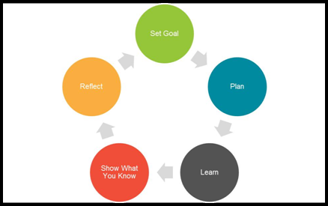
The different ways to self-managed learning (Source: Self-Study)
The dissimilar methods to personally learning individual are:
- Training / career development – an individual can learn new skill and knowledge by taking several training activities. The management team of the HR are responsible to identify the training needs of the staffs.
- Compensation (payroll and wages) – better compensation system can motivate all members of the business to perform well and develop themselves personally. ASDA offer better compensation for their employees.
- Recruitment – ASDA have an extensive way of recruitment process. They always tries to recruit effective and efficient human resources so that they will bring efficiency to the organization.
- Conferences and seminars –persons are able to advance numerous learning over the knowledge they achieve from meetings and discussions because these offer the chance toward offering their gained understanding toward others as well as likewise receiving from others. It aids in achieving the self-assurance in oral communication as well as performance abilities.
- Social Network–from social network a person can learn so many things now a day as everyone now a day prefer to share their experience as well as offer solution to the problems in a social media. By taking knowledge from social network an individual can easily transfer these skills toward their workplace.
- Organisational structure / Company Hierarchy- Corporate hierarchy is the process of chain of command. It describe organisation of persons within a business according to authority, rank, and job function.

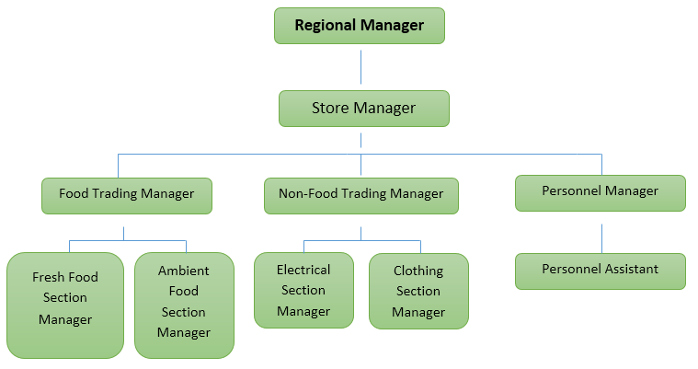
Figure: Hierarchical organisational structure of ASDA (Asda, 2019)

Through these approaches of self-managed learning, individuals can easily gain knowledge and increase their potential at workplace as well as in their personal development. We strongly support the self-managed techniques as they would help me to attain the required knowledge for our personal and professional growth.
Personally developing individual denotes to the constant training that would aid me in contributing toward our specialised as well as individual evolution. For this, we must have our individual valuation which offers our assets as well as flaw through SWOT study. SWOT examination is though, similarly valuable on an individual level as a method to classify areas for growth, besides a portion of occupation thoughts. Its modest arrangement, as well as easy to put on construction, mean that it be able to use very effortlessly without provision.
As per our SWOT study our weakness and strengths are:
Strengths
Strengths are area from where an individual has a benefit over others or some exclusive possessions toward exploit.
Professional knowledge and Technology Skills: the greatest significant power which an individual owns is the hypothetical and mechanical information about the specialised plus technology abilities. In the present day of commercial businesses, these two issues, which are approximately considered below the firm abilities are very significant for enlightening the enactment of the writer. This likewise aids in professional development. We have time management ability in an accurate way which is in effect in implementation an effort within the given period structure.
Time management and Self-management: we also consider myself to be very self-controls, self-motivated in addition to good at handling the work as well as the time. This also benefits in greater self-management for the individuals.
Communication skills: we have good communicational skills which are essential to place communication inside the group members.
As we are able to accomplish assignment with appropriate time scale as well as likewise accomplish the group members we have powers over organisation abilities.
We can arrange dissimilar efforts with accurate time management policies and representative jobs professionally
Weakness
Communication and Presentation Skills: Communication Skills is one of the greatest significant abilities which are obligatory in today's world businesses. Decent relational communication abilities not only aid the persons for functioning additional professionally plus efficiently in the groups as well as individuals but also aids in improving other compulsory talents over communication. For the case of me, the communication, as well as a consequence of the similar the performance abilities, are comparatively fragile for me as well as this leads to the situation in which we cannot be able to improve our skills (Brian, 2001).
Leadership Skills: Though there have been a slight chance of presenting management talents for me yet, it is predictable that because of an absence of the performance and oral skills, the management skill would not be according to the anticipation for me.
We tend to get stressed very early.
Problem-solving skills in different situations.
Opportunities
The opportunity which can be found by the performance of me in the ASDA is overtaking numerous programs as well as a workspace and over going to meetings and seminars where the skill of communication is necessary. In this kind of stage, the learnings collected can be applied for the upcoming efficiency through the beginner. Instead, these kinds of the stage also offer the chance for communal speaking as well as therefore being self-assured for the similar and grow essential abilities for the performance which is extremely appreciated in the contemporary world.
Guidance from the expertise of the ASDA within the business can also be beneficial in this situation.
Joining dissimilar courses would beneficial in enlightening the technological abilities.
Extensive access of the internet, as well as public networks, are likewise supportive because they are able to deliver dissimilar information with effective way.
Threats
The threats which happen for me comprises rivalry from the contemporaries and fellow scholars.
Financial inability can place hurdles in assembly advanced teaching or appropriate exercise.
Variations inside the present marketplace location can influence the present abilities and skills.
Absence in the attending and technical abilities be able to place barriers in the teaching and improvement periods.
As per the SWOT study as well as its assessment we can grow our individual developing plan by means of the tools like self-reflective knowledge as well as ongoing qualified growth. Variations inside the present marketplace location can influence the present abilities and skills. This is likewise significant for accepting our individual flaw and taking the educative stages to improve that (Allinson and Hayes, 1990).
Personal developing learning denotes to analysis of decision, views, movements and individual understanding that would be related to our professional growth. This would aid me toward study new activates at the organization also grow our individual abilities through receiving the work as well as accountability given to me.
The on-going professional growth mentions linking the methods, methods, and concepts that are beneficial in the growth of individual knowledge as well as professional development. It would safeguard our development over suitable assessment and preparation of our obligatory learning strategy (Brian, 2001).
Businesses safeguard that their purposes are positively attained. In the present commercial situation the purposes must be SMART:
S – Specific
M – Measurable
A – Achievable
R – Realistic
T – Time bound
The purposes can be attained by assessing the expectations in addition to the abilities they want from the persons they have employed. The persons the organization have employed essentially to have definite possible abilities similar time management, group player, good oral and written communication skills, management abilities etc. These aids are openly related to the purposes of an association.
As an employee of ASDA. The objectives of ASDA are:
- To deliver the complete facilities to individuals
- To form the facilities as per the person requirements as well as preferences of clients
- Responding to the individual requirements of clients
- Non-stop development in quality of facilities delivered
- Appreciating and supporting the employee (Furnham, 1996).
Our Personal skills and competencies against the ASDA objectives
Have decent spoken and written communication abilities, investigating abilities as well as listening skills. Our talents are supportive in encouraging the operational group work as well as pervading the inventive thoughts in business. Having the managing skills that are crucial for ASDA (Marzband, Sumper, Ruiz-Álvarez, Domínguez-García and Tomoiag, 2013).
Though it would be better for me to increase the commercial aids so as to me can put on them professionally to the ASDA as our chief impartial is toward become into the industry section of ASDA and deliver our facilities at planned level.
Identify own development needs and the activities required to meet them
The businesses need persons employed with them time IT skills, communication skills, and leadership skills. Inappropriately these are our flaw as well as it is necessary for me to try the effort in this zone besides having obvious toward involving me in these working out at our recent company. Having the management exercises and actual time organisation courses to growing these. This skills helps me to overcome our flaw through several preparation delivered our business.
Personal Strategy
We will grow the abilities of appropriate strategic organization over analysis the Harvard business evaluation as well as study about other businesses and their activities taken to develop the enactment in those businesses. We will focus on our individual growth through learning through investigating the online in addition to through assessing the commercial situation governmentally, economically, publically, and scientifically (PEST). These actions would aid to run into our growing requirements and we will grow the essential abilities for our specialized and individual development (Johnston, 2013).

CASE STUDY – Recommended Solutions: for overcoming the challenges out team members find out several developing needs. We are currently pursuing our requirement certificate courses in business. Our objective is to finish all the task within the set time structure so as to our consequences and record can be used through the College for registering us in the last year make an upgrade in bachelor of science in business. After fulfilling the current needs we have to focus on our future needs. Identify future needs and perform in a way to accomplish it is one of the best and suitable methods for our personal development. Our upcoming requirements are to grow professional abilities as well as achieve the degree of improved knowledge of our occupation and obligatory talents for our company. For the above reasons we need to endure with advanced teaching and advance the concentration in strategic management. Afterward completing the courses we have to join the numerous exercises that are obligatory for our specialized development (Goldstein and Bokoros, 1992). These exercises, as well as our courses, would aid me to express the actually planned tactics for our upcoming business.
We will grow the abilities of an appropriate strategic organization over analysis the Harvard business evaluation as well as study about other businesses and their activities taken to develop the enactment in those businesses. We will focus on our individual growth through learning through investigating the online in addition to through assessing the commercial situation governmentally, economically, publically, and scientifically (Furnham, 1996).

Develop a plan to meet the identified development needs and expectations of an individual.
Personally development individual is a basis which allows the persons to draw the strategy for their forthcoming individual and professional growth. Professionals inspire their groups to update their tactics for constant professional growth with the goal of upholding the business’s coming development and progress. Our personal growth strategy needs having a suitable preparation for our forthcoming growth.
ASDA Pyramid needs:
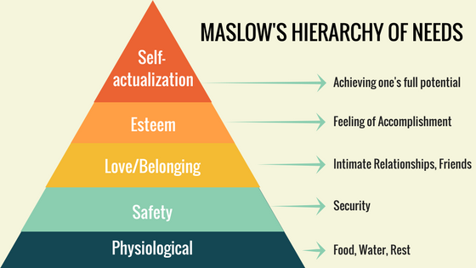
Figure: Pyramid Needs
The first stage of the pyramid is to meet with the basic needs of the employees. The next level of the pyramid is to ensure the safety of the employees. All individuals want security of their job and next level need love and belongings. ASDA ensure good workplace culture which is very effective to all individuals get a friendly environment. Job Promotional, reward and empowerment enhance the self-esteem of all individuals.
Herzberg two factor theory
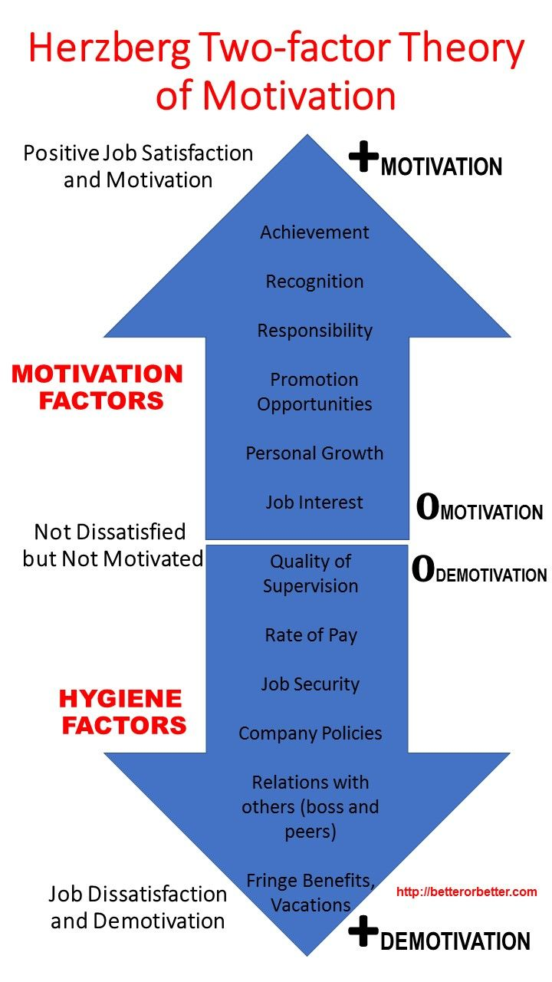
Figure: Herzberg two factor theory
The strategy necessity is flexible in regulating the altering goals as well as job necessities. Variations are the important portion of life as well as to preserve in step with the variations it is significant to have the flexible individual growth strategy. Our individual growth is as follows:
The main phase includes the improvement of curriculum vitae. This would provide a clear image of our educational abilities and improvement requirements
Documentation of short term aims – our short term aim is to have the whole emphasis on the advance learning necessities (Johnston, 2013).
Long term aim – This would cover the full strategy with times in the next six to seven years
SWOT study – We would keep the non-stop checking on our weakness, strengths, prospects, and threats
Describing the time structure –this would have specialised growth time structure from the period we started our occupation till the time we are forecasting to accomplish.
Our erudition strategies
Consistent evaluation of individual and professional improvement strategy
PERSONAL AND PROFESSIONAL DEVELOPMENT CHART
Action | Resource | When
Additional Educations | Discovery the colleges that could aid me in improving our occupation | From October 2019 till July 2020
IT Preparation | Short training from an organisation toward progress the IT abilities | To be finished in 3 months from now
Management skills, Decisional skills, and communication skills | Several preparations besides a project that would grow our management and decisional abilities and communication skills (Furnham, 1996). | To be finished in 6 months from now
Master’s in Business communication | Discovery the organisation for obtaining the information | To be finished in 1 or 1.5 year
Joining the ASDA | Discovery the chance for enrolling ASDA in their strategic section | After finishing the masters in business communication
Process with expert figure | Discovery the specialised form of planned organisation to subordinate with them | Throughout the sequence of service with ASDA

The procedures and actions essential to implement the improvement strategy
It is significant to create an appropriate process for attaining the individual improvement strategy. Our process for attaining the individual improvement strategy comprises:
Making the target time frame – time frame helps individual to evaluate the progress and growth of the individual. It is beneficial for an individual to create time frame that mainly emphasises the complementation of the objectives.
Self-assessment – in order to measure the progress, abilities, skills, as well as knowledge, it would be beneficial for me to do self-assessment. We can achieve our personal development target by doing our self-assessment. Self-assessment is the key to success (Johnston, 2013).
Learning Strategy – self managed learning is the most appropriate learning method for me as it ensures the personal as well as professional development within the business context. For enhancing our growth we have to take many strategies so that we can accomplish it with little effect.
Learning Resources– there are several resources that we can use as a resource for learning new skill such as online resources, reading Harvard business review, discussing with experience people, participating in conference as well as meeting, and so on (Furnham, 1996).
Getting the feedback – for implementation of this policy we have to gather feedback from upper management or expert as it serves as comments. We can develop our personal skills effectively within a short time if we get enough feedback. Hence, feedback is important for self-evaluation.

Evidence of wide reading and research, encompassing the application of relevant academic theories and models.
Undertake and document development activities as planned
The development actions as planned are based on the following arrangements:
Appropriate trainings – only proper and relevant training can help an individual to gain the skills that he or she were looking for. First, an individual need to find out the weakness of his performance then need to take a training programme which required to finish within a specific time frame. An individual becomes the assets of the organization by taking proper tanning. However some time management finds out what training is necessary for employees, it is also responsible for an individual to find out what training is necessary for his or her growth (Marzband, Sumper, Ruiz-Álvarez, Domínguez-García and Tomoiag, 2013).
Completion of education – It is very much urgent for me to complete our master's in business communication for enrolling myself in the marketing department of the ASDA (Furnham, 1996). Without having a degree WE will not be able to join myself in this department. WE have to take these courses in the future and complete them within a specific time frame. For effectively perform the duty this courses is essential for me.
For update our skills and various knowledge we have to take several courses. It will take more than six months to complete all of our planned training courses. We have to improve our decision-making skills, written as well as oral communication skills, leadership skills, and time management skills. But after evaluating our personally developing plans we found that it is very difficult for me to accomplish those type of skills within this short time. We have to update our plan to make it flexible. It is very much urgent for me to complete our master's in business communication for enrolling myself in the marketing department of the ASDA (Furnham, 1996). Without having a degree we will not be able to join myself in this department. We have to take these courses in the future and complete them within a specific time frame. For effectively perform the duty this courses is essential for me. All the courses that we planned to accomplish in the future need to have some practical experience also. We can accomplish these courses effectively if we get proper time to accomplish these tasks. If we consider the time frame then this plan has few drawbacks that needs to be updated. Based on the evaluation we have made an update development plan which is described in the next paragraph (Johnston, 2013).

Update the development plan based on feedback and evaluation
Based on the above feedback and evaluation the revise personal development will look like this:
Action | Resource | When
Additional Educations | Discovery the colleges that could aid me in improving our occupation (Goldstein and Bokoros, 1992). | From October 2019 till July 2020
IT Preparation | Short training from an organisation toward progress the IT abilities | After completing our graduation and need tree month to complete it
management skills, Decisional skills, and communication skills | several preparations besides a project that would grow our management and decisional abilities and communication skills | Need to be accomplished within eight months after successfully completing the above courses.
Master’s in Business communication | Discovery the organisation for obtaining the information | It will take more than one year.
Joining the ASDA | Discovery the chance for enrolling ASDA in their strategic section (Goldstein and Bokoros, 1992). | For joining this company WE have to complete all the above mention courses within a specific time period.
Process with the expert figure | Discovery the specialised form of planned organisation to subordinate with them | This success will depend on the performance of our effort and this is long term goal for me.

Conclusion
From the above assignment about the personal development, it is been measured that, individual and career development remains procedure that aids to increase the benefit over other persons besides advance the anticipated location. Assignment has clarified the self-managed education and continuous education methods and actions that might be used through me to keep the efficiency at ASDA. This assignment would deliver the info about our individual present abilities and capabilities in contradiction of professional standard of business by way of an associate manager as well as grow the strategy for development in zones of missing. In the subsequent portion, this assignment would deliberate the procedures and actions obligatory to device the strategy and critically examine the education in contradiction of the unique goals and purposes. Furthermore, the Assignment has offered the examination of individual skills and capabilities in contradiction of the structural and manager level average. At the conclusion, this assignment has advanced the strategy for development in the recognized talents to advance the upper position.

Reference
Argyris, C., Schon, D. (2008), Organizational Learning: A Theory of Action Perspective, Addison-Wesley, Reading, MA.
Armstrong, M. (2007) ‘Human resource management: a case of the emperor’s new clothes?’,Personnel Management. Vol. 19, No. 8, pp.30-35
Bagshaw M (2004) “Is diversity divisive? A positive training approach”, Industrial and Commercial Training 36, 4, 153-157
Beer, M., Spector, B., Lawrence, P. R., Mills, D.Q., Walton, R. E. (2004), A Conceptual View of HRM. inManaging Human Assets. Free Press, New York Chap.2
Bunderson, J.S. and Boumgarden, P., 2010. Structure and learning in self-managed teams: Why “bureaucratic” teams can be better learners.Organization Science, 21(3), pp.609-624.
Crookston, R. K. (2012). Working with Problem Faculty.John Wiley & Sons.
Dweck, C.S. (2013). Self Theories.Psychology Press.
Gallagher, K. (2013). Skills Development for Business and Management Studies. OUP Oxford
Gibbons, M. (2013).The self-directed learning Handbook.John Wiley & sons.
Hastings, J. (2015). Physical Asset Management.Springer.
Johnston, D.H., 2013. Practical applications of time-lapse seismic data.Distinguished Instructor Short Course, SEG, 16, p.270.
Kolb, A.Y. and Kolb, D.A., 2012. Experiential learning theory.InEncyclopaedia of the Sciences of Learning (pp. 1215-1219).Springer US.
Marzband, M., Sumper, A., Ruiz-Álvarez, A., Domínguez-García, J.L. and Tomoiag?, B., 2013.Experimental evaluation of a real time energy management system for stand-alone microgrids in day-ahead markets.Applied Energy, 106, pp.365-376.
Maslow, A.H. (2013). A theory of Human Motivation. Start Publishing LLC.
McLean, S. (2016). Six Step Approach to Problem Solving. [online available at:]. http://catalog.flatworldknowledge.com/bookhub/reader/16451?e=collins-ch06_s06 . (assessed on Allinson, C., & Hayes, J. (1990). Validating the Learning Style Questionnaire. Psychological Reports, 67, 859±866. Arneson, S., Millikin-Davies, M., & Hogan, J. (1993). Validation of personality and cognitive measures for insurance claims examiners. Journal of Business and Psychology, 7, 459±473.
Brian, M. (2001). Activists and difficult people, Social Anarchism, (27–47), nu.30.
Eysenck, H. (1996). Personality and the experimental study of education. European Journal of Personality, 10, 427± 439.
Furnham, A. (1996). The Myths of Management. London: Whurr.
Goldstein, M., & Bokoros, M. (1992). Tilting at windmills: comparing the Learning Style Inventory and the Learning Style Questionnaire. Educational and Psychological Measurement, 52, 701±708.
McLeod, J. (2007). Counselling Skills, Maidenhead, Open University Press.
Trevithick, P. (2003). ‘Effective relationship-based practice: a theoretical exploration’, Journal of Social Work Practice. 17(2), 163-176.
Zuckerman, M., Bernieri, F., Koestner, R., & Rosenthal, R. (1989). To predict some of the people some of the time: In search of moderators. Journal of Personality and Social Psychology, 57, 279-293. 23/7/16)

