Governance and Compliance based on CoffeeBlue information leakage

Abstract
With the development of Internet technology, networking+ is a major trend in recent years. More and more companies choose to combine products with the Internet. However, the integration process inevitably involves the information of users and enterprises. Without a complete information security model or system, once the information is attacked externally, it will bring huge losses to enterprises and customers. This paper discusses the related objectives of Information Technology Infrastructure Library (ITIL) and Security model example, International Organization for Standardization; ISO 27000, which is also applicable to the information security management of CoffeeBlue.
Keywords: Data Security, Governance and Compliance; information security management; ISO 27000; ITIL；Security model example
1.Introducation
In order to attract consumers' attention and promote the increase of actual sales, the company has adopted many ways. These include the recommendation of social media bloggers and the interaction between users and companies on the Internet, which has indeed brought huge customer traffic, but also caused the rapid expansion of Internet information processing. Information processing in Internet transactions includes many aspects. First, Internet transactions need to transfer offline paper content to the cloud service system, which contains the privacy information of the company and users. Compared with the traditional trading methods, the risk of information disclosure is greatly increased, which is also the core issue of common concern for companies and consumers. Secondly, the company has billions of intellectual property rights in coffee production technology and marketing model. As an important part of the core competitiveness, the information protection of intellectual property rights is also the focus of the company. Combined with the above two points, information security is undoubtedly the core issue of Internet transactions. But so far, the sorting of relevant problems has been very vague, and there is no systematic solution and mature technical support. Therefore, if the Internet economy wants to continue to develop well, we must first solve this core problem.
With the continuous development of the Internet industry, the construction of information security management systems is of great importance to the security management operations of companies and the significance of their development. First, building an information security management system raises employee information safety awareness, raises the level of corporate information safety management, and strengthens the ability of social organizations to prevent disaster-related incidents, which is important in corporate information construction. As a part, we will surely greatly improve the safety and reliability of information management work and make it serve better to the business development of the company. Next, through the construction of information security management system, we will effectively improve the management control ability for information security risk and make information security management more scientifically effective by connecting with work such as grade protection and risk assessment be able to.
Information security services refer to services that meet the needs of the whole security management and provide enterprises and governments with comprehensive or partial information security solutions. Information security services provide technical solutions ranging from high-end comprehensive security system to details.
Information security services have high requirements in management and technology. Enterprises must establish a perfect system disaster recovery and recovery system, which can respond continuously in 24 hours, ensure the timely and rapid response of the system, and ensure the safe storage of information data. In information technology, it must have certain monitoring technology, monitoring data analysis and processing technology, knowledge base or expert base to support emergency decision-making technology to protect enterprise information security. In the next chapter, we will explain and analyze the three network security frameworks and models, and compare their differences
2.Security Frameworks and Models
Here, we study and analyze the model frameworks of information technology infrastructure library, standardized information organization 27000 and information and related technology control objectives, and give their similarities, advantages and disadvantages.
2.1Information Technology Infrastructure Library (ITIL)
ITIL (Information Technology Infrastructure Library) is an abbreviation for Information Technology Infrastructure Library. ITIL is a best practice guide to IT service management published by the British Government Central Computer and Telecom Management Center (CCTA) in the early 1990s, aimed at resolving poor quality IT services. Since then, CCTA has put together a set of process-based IT service best practice experiences on the basis of recent practices and explorations by mainstream IT resource management software makers such as HP, IBM, BMC, CA and Peregrine. Formed the method and standardized the level of IT services. Later, CCTA merged with the UK Government's Department of Commerce (OGC), and ITIL is now copyrighted and published by OGC.
In 2001, the British Standards Association officially announced the British National Standard BS 15000 with ITIL at its core at the International IT Service Management Forum (itSMF). This is a serious event with historical significance in the field of IT service management.
It must be emphasized that ITIL is not a formal standard, but a "factual" standard that is generally practiced today.
2.1.1 ITIL standards
ITIL is a best practice guide to IT service management published by the British Government Central Computer and Telecom Management Center (CCTA) in the early 1990s, aimed at resolving poor quality IT services.
The core idea that ITIL emphasizes should be to understand IT service demand from the perspective of customers (business) rather than IT service providers (technology). In other words, when providing IT services, it is necessary to first consider the business needs and identify the IT needs according to the business needs. The business management module is the process by which business managers analyze IT problems with their own habitual thinking model, the IT infrastructure supports business processes, and IT service management provides end-to-end IT services. Helps you better understand your role in, better handle your relationships with service providers, and earn business benefits.
Therefore, the national standard for IT service management is ITIL, which is independent of any manufacturer and is basically the most important practice in the field of IT service management, regardless of the nature of the organization or the nature of the business. Only the parts are summarized. ITIL is nothing more than a "reasonable abstraction" of IT service management practices, clearly pointing out "what to do" but not "what to do". When companies and other organizations implement ITIL specifically, they can embody standards and establish their own methodologies. When a company manages internal IT services using ITIL-provided processes and best practices that include quality control concepts, it not only provides user-satisfying services and improves the customer experience, but this process is cost-effective. It can be ensured that it conforms to the principle of.
2.1.2 ITIL operation maintenance process management mode
ITIL's network management is currently embodied in several main areas:
The service desk is the only point of connection between you and your IT department, allowing you to find stakeholders to help you solve problems and make requests. The service desk not only handles accidents, problems, and customer inquiries, but also provides an interface to other activities and processes. Includes customer change requests, maintenance contracts, service level management, configuration management, availability management, sustainability management, and more.
Event management
Events are all failure reports related to IT infrastructure and applications within the scope of IT operational maintenance in the data center. This process is designed to help business and end customers return to normal operation as soon as possible. Adopting an event-driven model, we are interested in the speed of response to events and the rapid recovery of business.
Problem management
It has not yet been revealed that the accident has occurred. Before, because it is called a potential not; problem in response to an accident. Problem management emphasizes identifying the source of accidents and taking appropriate solutions and preventative measures to prevent recurrence. The main goal of problem management is to find problems existing in the user IT system, prevent the occurrence of incidents, increase the help desk / frontline incident / failure resolution rate of incident management, and improve the service quality and customer satisfaction of the entire enterprise. It is to increase the degree.
Change management
Changes are all activities of changes and changes in each element of the IT environment, such as network infrastructure, hosts, operating systems, databases, and applications. Change control includes processing change requests, approving changes, preparing changes, implementing changes, confirming or rejecting changes after they are implemented, recovery management, controlling and tracking changes, and issuing change results, and finally change management. A series of management processes and activities leading up to the formation of a report. The main purpose of change management is to evaluate, record and control risk of changes in all production environments.
Daily work management
Routine work management is to manage the daily operation maintenance work of the production system, and is the management of some periodic and relatively fixed daily operation maintenance work of the operation maintenance of the information system. Its main purpose is to standardize daily work plans, standardize daily work contents, standardize maintenance actions of maintenance personnel, and provide basic data for personnel evaluation.
Knowledge base management
The purpose of system construction should be to help improve the skill level of support personnel at each level and simplify IT service missions, as well as standardization, recording, dunning and automation management tasks. At the same time, it is a means of reducing dependence on a particular individual. These need to be achieved by accumulating and sharing knowledge and experience.
2.2Information Organization for Standardization 27000 (ISO)
ISO 27000 Information Security Management System Introduction The ISO / IEC 27000 series standard (also known as the ISO / IEC 27000 standard series, that is, the "Information Security Management System Standard Family", abbreviated as "ISO 27 K") is the International Organization for Standardization (ISO) and the International Organization for Standardization (ISO). It was jointly customized by the Society (IEC). The main series is ISO 27001.
2.2.1ISO27001 information security management system
ISO27001 information security management system, as an important part of an organization's complete management system, constitutes an active part of information security. Information security management is to guide and control the organization's coordinated activities on information security risks. Firstly, we should formulate the strategic policy of information security, which is the guidance and support of information security management. On this basis, we should select the control objectives and control methods. Enterprises and organizations also need to consider the principle of controlling cost and risk balance to reduce the risk to an acceptable level of the organization. The whole management process needs the participation of all staff and implement dynamic management. The implementation of security management should also follow the general mode of management - PDCA model.
2.2.2PDCA model
PDCA model, namely plan, do, check and act, is a management mode of continuous improvement, as shown in Figure 1. Action - take countermeasures against the inspection results to improve the safety situation; Plan - determine control objectives and control measures according to risk assessment results, laws and regulations and the needs of the organization's business operation; Do -- implement the selected safety control measures; Check - check the compliance of the implementation of safety measures according to policies, procedures, standards and regulations.
PDCA model is an abstract model. It abstracts the related resources and activities into processes for management, which is widely used。
2.2.3ISO27001 operational processes and activities of information security management
- Determine the organization's information security objectives and strategies; 2) Develop information security strategy; 3) Conduct risk assessment, clarify the organization's information security needs, Specifically, it includes: formulating a risk assessment plan (define the scope and responsibilities, collect relevant information

Fig 2. The model of PDCA
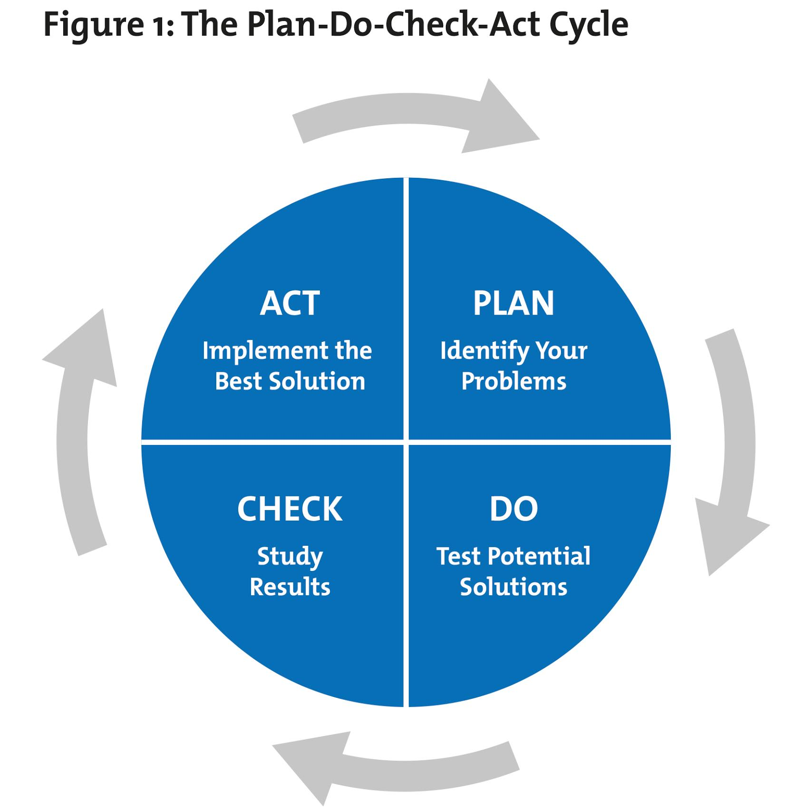
and describe the target system). Identify and evaluate information assets and understand the value and sensitivity of assets. Identify and evaluate threats and understand the
possibility of threat occurrence. Identify and evaluate weaknesses and understand the ease of vulnerability utilization. Assess risks, determine risk levels, assess and compare existing security measures, and find out objectives and current situations The gap between shapes. Recommend safety measures based on identified needs. 4) Carry out risk reduction. Specific activities include: determining risk reduction strategies in order to reduce risks. Select safety measures. Formulate safety plan, clarify the construction and implementation scheme of safety measures, and implement safety plan and strategy. Test and check the implementation results of security plan and strategy. 5) Carry out risk control, including: maintenance and operation of information system. Safety awareness training and education. Monitor the operation of information system and the effectiveness of security measures. Time response. Reassessment and certification. 6) Configuration management to ensure that changes in the system will not reduce the effectiveness of safety measures and the overall safety of the organization. 7) Change management identifies new security requirements when the information system changes. 8) Emergency plan, including business continuity plan, disaster recovery plan, etc.
2.3Control Objectives for Information and Related Technology (COBIT)
COBIT type is the bridge between enterprise strategic objectives and information technology strategic objectives, which enables the interaction between information technology objectives and enterprise strategic objectives.
The significance of this framework is that cobt plays a bridge role between enterprise objectives and it governance objectives. Firstly, COBIT considers the enterprise's own war path planning, analyzes and positions the business environment and the enterprise's overall business strategy, takes the objectives, policies and action plans generated by the war path planning as the key environment of information technology, and determines the IT standards.
It provides technology-based solutions for enterprise strategy and technologies and tools to meet business strategic needs. Under the guidance of it standards, using the control objective model, from planning and organization, acquisition and implementation, delivery and support, monitoring, etc
Process control and manage information resources. At the same time of IT management, audit guidelines are introduced to ensure the security, reliability and effectiveness of IT resource management.
COBIT realizes traceable performance measurement. Through the balanced scorecard, it can maintain a balance in Finance (Enterprise Resource Management), customers (Customer Relationship Management), process (intranet, workflow tools), learning (Knowledge Management), evaluate the achievement of enterprise objectives and it performance, adjust business objectives and it strategies, and carry out continuous IT management.
COBIT adopts the maturity model, which can locate the current position of its enterprise's IT management in the industry and the direction of its future efforts. Generally speaking, it "scores" it management. Cobt also provides the current best cases and key success factors (CSF) for the supervision of enterprises and organizations.
In terms of content, cobt covers the whole process from analysis and design to development and implementation to operation and maintenance. For analysis and design, the key objective is to meet the needs of it and business, refine the IT battle path according to the business objectives, and determine the IT system to be opened,
Carry out corresponding system analysis and design. In the process of analysis and design, it is much broader than the traditional analysis and design of information system. It emphasizes that the IT strategy should conform to the business strategy, and the development of any information system should be accurately calibrated with the business strategy. Analyze and design information system from the height of business war path. This stage is mainly to investigate the needs of the organization, design a reasonable resource portfolio and set a reasonable service level according to these needs
Objective to provide IT services to meet customer needs. At this stage, it application has risen to the stage of IT service management. It mainly solves the following problems: what resources are provided to meet the needs of customers, what is the cost between these resources, and how to achieve a satisfactory balance between service cost and service benefit. At the support level, it is mainly how to meet the it needs put forward by customers to support the needs of services. The upper layer of COBIT is to conduct external control and internal audit on it operation to ensure accurate calibration between it and business, and realize continuous application and improvement of IT applications. COBIT covers the whole life cycle of the whole information system, and its vision is the most open.The COBIT framework is shown in Figure 2.

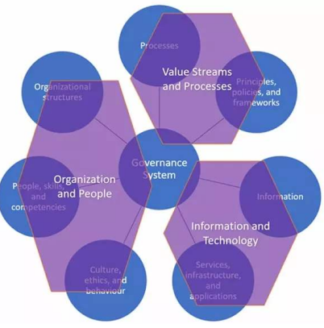
Fig 3. The framework of COBIT
3.Discussion and Comparison
ISO 27000 series focuses on Information security. The certification standard is ISO/IEC 27001. This standard helps an organization to define a framework for managing Information security more effectively. They have a guidance standard ISO/IEC 17799 which lists out the controls and interpretation for the same. This standard starts from the Board till the last employee within an organization
COBIT is restricted to IT Function. This lists out additional controls apart from ISO 17799. This document is used for implementing IT Governance within an organization.
ITIL is more towards achieving excellence in IT Service Management. You have ISO standards on these, ISO 20000-1 and ISO 20000-2. The former is the guideline and the latter is the certifiable standard. This framework helps more in aligning IT with business requirements.
4.Applying three security frameworks to solve the information security problem of CoffeeBlue
In order to attract consumers' attention and promote the increase of actual sales, the company has adopted many ways. These include the recommendation of social media bloggers and the interaction between users and companies on the Internet, which has indeed brought huge customer traffic, but also caused the rapid expansion of Internet information processing. Information processing in Internet transactions includes many aspects. First, Internet transactions need to transfer offline paper content to the cloud service system, which contains the privacy information of the company and users. Compared with the traditional trading methods, the risk of information disclosure is greatly increased, which is also the core issue of common concern for companies and consumers. Secondly, the company has billions of intellectual property rights in coffee production technology and marketing model. As an important part of the core competitiveness, the information protection of intellectual property rights is also the focus of the company. Combined with the above two points, information security is undoubtedly the core issue of Internet transactions. But so far, the sorting of relevant problems has been very vague, and there is no systematic solution and mature technical support. Therefore, if the Internet economy wants to continue to develop well, we must first solve this core problem. The security framework is shown in Figure 3.

ISO
ITIL
ISO

IT Operations
Service Management
COBIT
IT Security
Quality System

IT Planning
Project Management

Fig 4. The security framework for Caribbean coffee
The entire IT operation includes five operations, namely service management, IT security, project management, IT planning, and quality system.
4.1Service Management
We use project management when selling coffee online. In the design of ITIL framework application and service management, it specifically means that we formulate three different service operations according to the specific situation in reality. Service level management refers to dividing different levels according to customers' consumption ability or other consumption needs. Service financial management refers to our grading of capital services and contacting different service funds at different levels. In addition, service continuity management refers to the ability rating of employees and the timely replacement of employees who do not meet the post requirements, so as to ensure the service needs of customers and the company.
4.2 IT Security
ISO27000 framework is applied to the formulation of a series of measures in IT security. Several main measures are listed below: 1) asset security, set up an information security office in the company and arrange special personnel for information preservation. 2) For human resources security, special personnel shall be arranged in the human resources department to investigate personal information security vulnerabilities. 3) System development security: when the company is attacked by an online trojan virus, a series of plans should be set in advance to remove the Trojan virus in time and protect the privacy information and property security of the company, customers and employees. 4) Maintenance. Maintain and update the company's network platform on time, repair the security vulnerabilities of the firewall and other protection systems, prevent network attacks and realize the sustainability of system services.
4.3Quality System
It planning means that the company plans to carry out future business activities, such as pushing through the old and bringing forth the new of existing products, so as to obtain more customers and increase customer stickiness. Design the measures in the quality system under iso2700 standard, so as to ensure the stable and continuous operation of the whole online platform.
Because of the wide applicability of COBIT framework, the whole IT operation of the company is operated under its framework. In addition, the company can control it services, and the implementation methods include reasonable allocation of various resources and attributes.
5.Conclusions
By studying iso2700, ITIL and COBIT, this paper has a further understanding of the security framework. Through the construction of three network frameworks, the information security problems faced by CoffeeBlue company are solved, and the privacy and security of the company, employees and customers are better protected.

Reference


