Research Proposal
  - Design and Implementation of a Content Management System

  - Gabor Jonas
  - Web Development
  - Supervisor: James Williams
  - <Wordcount>

Table of Contents
1. Introduction 4
2. Industrial Context 4
3. Background Literature 5
4. Aims and Objectives 6
5. Research Methodology 6
6. Development Methodology 6
7. Risks 7
8. Analysis and Deliverables 7
9. Resources 8
9.1 Physical Resources 8
9.1 Human Resources 8
10. Timeline 8
11. References 8

Table of Figures
Figure 1 BRD Sports website 5
Figure 2 Agile-Scrum framework 7
Figure 3 Task List 8
Figure 4 Gantt Chart 8

Introduction
Today, website owners generally find it important to manage the content and even the structure of their website without any intervention by developers. Content management systems allow website owners to change text and image content on their pages without any programming knowledge or special software.

Industrial Context
Mountain Boarding and Gravity Centre was founded by Ben Room in 2008. To increase sales and customer satisfaction the company needs a new modern website with new features.
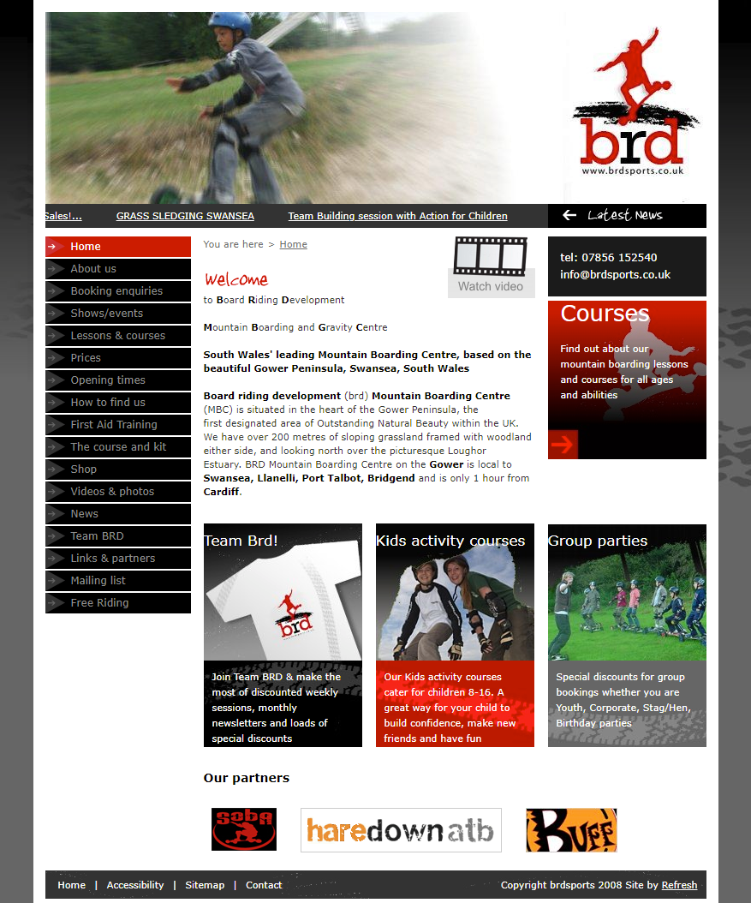
Figure 1 BRD Sports website

Aims and Objectives
The aim of the project is to design and develop a content management system application for Board Sports Development. In order to develop a complex application, the following objectives have to be achieved:
- Gather information of the required functions and features
- Write a software requirements specification document
- Design and develop the application
- Analyse and evaluate the application

Research Methodology
<Philosophy, Approach and 3 Strategies from the Research Wall. What have you chosen, why is it the right choice, what advantages does it give, how will you get around any problems it brings? In what way is your project reliable, valid and generalizable?>

Development Methodology
The chosen development methodology for the project is Agile Scrum.
Agile software development is a group of software development methods where software requirements and solutions developed together [2]. Jeff Sutherland and Ken Schwaber developed the scrum framework for the software industry in 1996 to help organizations struggling with development projects [1].
It is a step-by-step method. A new product or function, or an improved version of an old one, is created at a specific time interval. These so-called sprints can be used to work continuously and with realistic deadlines. This allows to plan the workflow in a more realistic way, because it can be seen what has to be done and how much time it takes. This will make the planning process predictable. In addition, risks can be managed more easily in short periods.
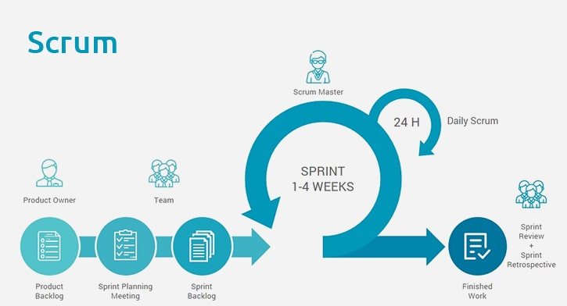
Figure 2 Agile-Scrum framework
Advantages
- Testing usually takes place at the same time as the actual development work, in the same iteration problems can be identified.
- The customer can try new features after each sprint and provide feedback about new features

Risks
Risk is a situation that may occur at any time during the lifetime of the project and has a harmful effect on the success by preventing achievement of the project's objectives and quality or keeping its schedule.
Identified risks in this project:
- The customer changes the requirements
- The scope of the project is too big, it’s impossible to deliver the project within the timeframe
- Choosing unsuitable programming language to develop the application
- Setting unrealistic timeframe for each sprint
- Not having the skill to develop a content management system

Resources

Physical Resources
To successfully deliver this project, the following physical resources needed:
- Books related to the subject
- Computer with operating system – to create required documentation and develop the application
- PhpStorm IDE – for development
- XAMPP package – to test the application
- Web server

Cost of resources
Books can be accessed via online and physical library. The project’s owner will use his personal PC to deliver the project with a Windows 10 operating system received from the university. The XAMPP package is free, so as PhpStorm student license.
The web server will be provided by the owner of Mountain Boarding and Gravity Centre.

Timeline
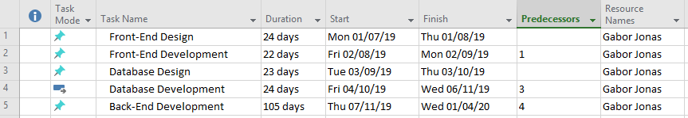
Figure 3 Task List
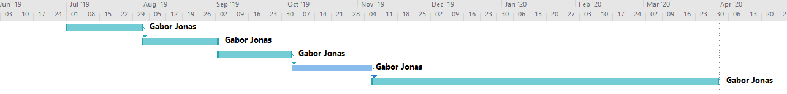
Figure 4 Gantt Chart

References

[1] | A. Aliance, “What is Agile?,” Aglie Aliance, [Online]. Available: https://www.agilealliance.org/agile101/. [Accessed 03 05 2019].
[2] | “Scrum.org,” Scrum.org, [Online]. Available: https://www.scrum.org/team/ken-schwaber. [Accessed 03 05 2019].
[3] | “Manifesto for Agile Software Development,” 2001. [Online]. Available: http://agilemanifesto.org/. [Accessed 03 05 2019].

