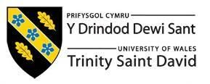

Programme: Master of Business Administration
Module: Human Capital Management
Module code: LCMB7023

Title: The influence of national and international labour markets on HRM and IHRM strategies.
Lecturer: Dr. Ejike Robert Udeogu
Student Name: Vaishnavi Vasantrao Patil
Student ID: 2504969
Submission Date: 17th October 2025

Table of Contents
1.Introduction 3
2.Technological Advancements and Labour Markets 3
3.Demographic and Geopolitical Factor: 5
4.Addressing Skills Gaps and Talent Shortage: 6
5. Capabilities in an International context 8
6. Conclusion 9
7.References 10

1.Introduction
Human capital management (HCM) is the strategic approach to recruiting, developing, retaining, and maximizing an organization's workforce to achieve long-term business success. HCM emphasizes people as assets whose skills, knowledge, and creativity can generate long-term competitive advantage, which is different from traditional personnel management. Companies that employ effective human capital management (HCM) techniques, such as succession planning, employee learning, and diversity initiatives, are better equipped to align human resources with strategic goals, which improves organizational performance, claims (Tucker, 2018). In today's fast-paced business environment, human capital management is evolving from a simple administrative function to a driving force behind creativity, adaptability, and resilience.
The global labour market is being significantly impacted by demographic changes, technological advancements, and geopolitical unpredictability. Rapid integration of digital platforms, automation, and artificial intelligence (AI) is altering the demand for skills and creating new job categories (Štaffenová, 2025). Concurrently, the dynamics of the labour supply and employee expectations are shifting due to demographic shifts, such as the aging of populations in developed countries and the arrival of Generation Z in the workforce (Snell, 2023). Furthermore, labour mobility and cross-border talent management have become more challenging due to geopolitical upheavals like Brexit, trade disputes, and regional conflicts (Review, 2024). When combined, these factors emphasize the need for flexible, evidence-based, and globally oriented HRM and IHRM programs.
The goal of this paper is to critically examine how demographic, technological, and geopolitical factors influence HRM and IHRM strategies in contemporary labour markets. It will also evaluate organizational approaches to address persistent skills shortages in critical industries and consider everyone’s readiness to work in a technologically sophisticated, globalized workplace. The paper uses current research and labour market facts to offer both personal reflection and analytical insights (Labour Market Dynamics, 2024).

2.Technological Advancements and Labour Markets
Technological innovation is one of the key elements affecting contemporary labour markets, particularly in the fields of automation, digital platforms, remote work, and artificial intelligence (AI). As a result of these developments, organizational structures, talent needs, and HR strategies are evolving across industries.
These days, workforce planning, personnel management, and predictive analytics all depend on artificial intelligence. AI, according to (Bositkhanova, 2025), aids businesses in more objective and efficient workforce planning as well as better strategic decision-making. To estimate staff attrition and talent shortages, for example, HR managers can use predictive analytics technologies to develop targeted interventions for retention and development (Popescu, 2025)Accenture's use of AI-driven recruitment platforms to screen a large number of applications has shown the strategic value of digital innovation in HR processes by reducing bias and raising hiring standards.
Additionally, labour markets are changing due to automation and robotics, especially in manufacturing and logistics. To reduce job instability, promote trust, and retrain employees for hybrid workplaces, (Arslan, 2022)highlight the need for novel HRM techniques in the interaction between human workers and AI-driven systems. The extensive deployment of robotics in Amazon's warehouses serves as an example of both the efficiency benefits of automation and the HR dilemma of reallocating employees to higher-value duties.
At the same time, the rise of remote work and global digital platforms has changed the HRM landscape globally. The COVID-19 pandemic has increased the use of virtual collaboration, and multinational companies now regularly employ global teams. According to ((2025), 2025), HR managers of cross-border virtual teams must manage concerns related to cultural diversity, data security, and global mobility. Therefore, IHRM initiatives must include regulations on cybersecurity, digital communication, and equitable remote work practices in addition to standard expatriate management.
These technological advancements highlight two issues: although they offer opportunities for innovation and efficiency, they also raise issues like workforce displacement, digital exclusion, and ethical dilemmas surrounding data protection. (MDPI, 2023)asserts that for individuals and companies to remain competitive in a technologically driven global labour market, lifelong learning and continuous reskilling are crucial.
The digital transformation has also altered performance management and employee engagement. Businesses are increasingly using AI-driven data and cloud-based HR systems to track productivity, measure employee well-being, and personalise training programs, according to (Fenwick, 2024) HR professionals can make data-driven decisions that align personnel capabilities with organisational objectives due to this technological connectivity. However, as (Priyashantha, 2023)points out, the success of such programs depends on cultivating a culture of learning and ensuring that staff members possess the requisite digital literacy skills. Moreover, (Bositkhanova, 2025) argue that predictive analytics not only enhances retention strategies but also fosters diversity and inclusion by lowering bias in decision-making. As automation increases, the HR function is changing from administrative oversight to strategic enablement, with a focus on reskilling and ethical governance. Future HRM frameworks must balance technological innovation with human-cantered principles to remain competitive in an increasingly digital global economy.

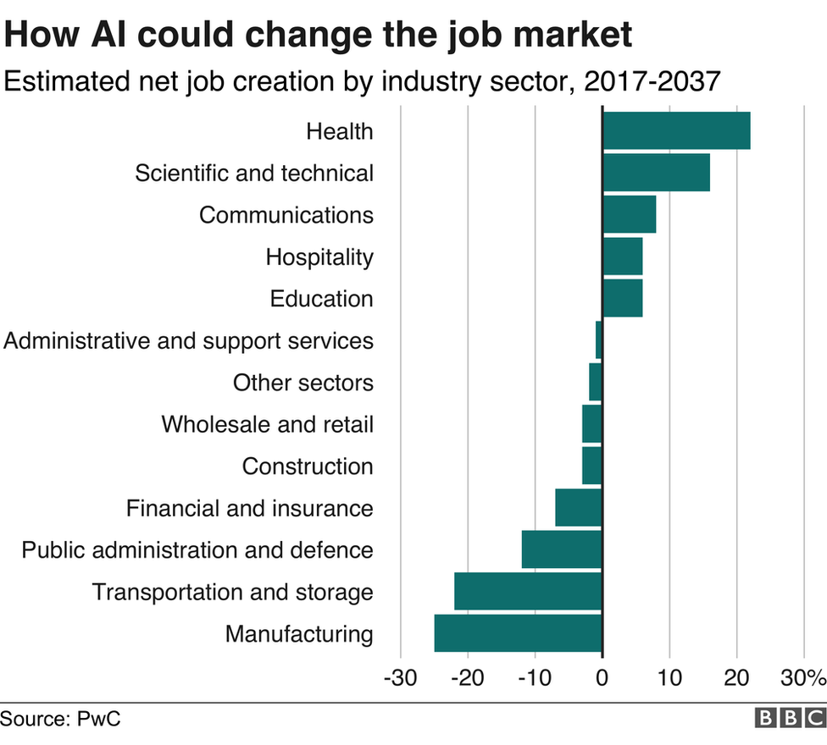
Figure-1 Source: PwC (Hawksworth & Ferti 1

3.Demographic and Geopolitical Factor:
Globally, demographic and geopolitical factors are increasingly influencing labour markets and HR management. The population's aging is a significant demographic trend that strains social welfare systems and results in a labour shortage, particularly in industrialized economies. For instance, the NHS in the UK is constantly understaffed, partly due to retirements and a shortage of skilled medical personnel (Costa-Font, 2025)HRM's workforce planning and retention strategies are essential because these shortages escalate workloads, stress levels, and burnout.
The arrival of the Generation Z workforce also creates new expectations. Gen Z employees place a high value on meaningful work, flexible scheduling, and real leadership. Organizations need to change their HR procedures to emphasize skill development, mental health support, and mentoring in order to attract and retain this group (M., 2022) (Robertson, 2023). Managing staff becomes even more challenging in multigenerational workplaces, requiring advanced engagement, incentive, and training strategies (arXiv, 2023).
Migration flows also influence labour markets. The United Kingdom's post-Brexit immigration policies have restricted the entry of skilled individuals, particularly in the technology and healthcare industries, leading to talent shortages (Financial Times, 2024; The Guardian, 2025). Geopolitical tensions such as the US-China trade disputes and the Russia-Ukraine war impact global supply chains and worker mobility, adding instability and uncertainty for multinational corporations.
These demographic and geopolitical factors also provide important HR issues, like lowering worker volatility, in addition to managing cultural diversity and ensuring local labour laws are followed. These days, effective HR strategies must include moral hiring practices, workforce planning foresight, and laws that support flexible, inclusive, and resilient workplaces. These trends have real-world implications for employee well-being and organizational effectiveness, as demonstrated by the NHS's staffing shortages and the IT sector's hiring difficulties after Brexit.
Organisations are being compelled by shifting demographics to adopt inclusive policies and flexible work schedules that meet the needs of a diverse workforce. Ageing populations are driving the need for phased retirement plans and lifelong learning programs to keep experienced employees on staff for longer (Costa-Font, 2025). At the same time, (Robertson, 2023) observes that businesses are being forced to reconsider leadership and communication strategies to enhance engagement due to Generation Z's emphasis on purpose-driven work. As per The Guardian (2025), HR professionals must strengthen international alliances and remote hiring frameworks to compete for international talent due to geopolitical factors like migration limits. Additionally, according to the (Review, 2024), labour mobility barriers are changing workforce planning and forcing multinational corporations to invest in regional skill development and localise their operations. Therefore, in a labour market that is globally interconnected, demographic awareness and geopolitical adaptability are now essential elements of sustainable human resource management.

4.Addressing Skills Gaps and Talent Shortage:
Critical industries like technology, hospitality, and healthcare continue to face talent shortages and skills gaps because of rapid technological advancement, changing customer demands, and demographic shifts. The quick development of technology necessitates upskilling in areas like cybersecurity, cloud computing, and artificial intelligence. The hospitality and healthcare sectors are experiencing a shortage of skilled workers because of high turnover rates, aging workforces, and growing service demands. To mitigate these challenges, effective HRM and IHRM strategies are required.
The primary goals of human resource management (HRM) strategies are training and development, international hiring, and employer branding. Companies like Google have implemented reskilling and upskilling initiatives to help employees adapt to new technology and future roles. Similarly, Marriott invests in training programs for the hospitality sector to improve employee skills, elevate service standards, and reduce attrition. Employer branding improves talent acquisition by positioning businesses as desirable workplaces, while global recruitment expands access to diverse talent pools and ensures that critical needs are met.
International human resource management (IHRM) strategies assist these efforts through collaborations with institutions, cross-cultural training, and expatriate management. Expatriate assignments facilitate knowledge transfer and the development of global leaders, while cross-cultural training fosters international cooperation and reduces adjustment challenges. Partnerships with universities help bridge the gap between academic preparation and industry demands by providing access to emerging talent and enabling work-integrated learning opportunities.
Models like the Talent Management Framework offer a methodical way to map skills gaps, identify critical jobs, and carry out development initiatives. To ensure that skill development is in line with business objectives, the Resource-Based View (RBV) places a strong emphasis on using internal human capital as a strategic asset. Proactive workforce planning is aided by tools such as PESTLE analysis, which predict external factors like economics, technology, and regulations that could worsen skill shortages.
To sum up, to address skills gaps and talent shortages, a combined HRM and IHRM approach is required. Through strategic training, employer branding, international hiring, expatriate management, and university partnerships, companies can develop a skilled, adaptable workforce. The case studies of Google and Marriott demonstrate the practicality of these strategies and how structured talent development can preserve competitive advantage in significant industries.
To further reduce the global skills gap, governments, academic institutions, and corporate executives need to collaborate more. According to (Priyashantha, 2023), organisations that integrate corporate training with academic curricula are better prepared to meet the needs of the workforce in the future. According to (Juqu, 2024), ignoring low-skilled employees puts the organization's long-term survival in danger in addition to widening the competency gap. Similarly, global corporations such as Google and Marriott demonstrate that investing in continuous education fosters innovation and employee retention. (Fenwick, 2024) emphasise the growing importance of human-cantered digital transformation, in which technology supports customised employee development rather than replaces human expertise. Additionally, virtual internships and exchange programs promote cross-border knowledge sharing and cultural competency. An HRM–IHRM strategy that combines reskilling, global partnerships, and inclusive growth ensures that companies stay adaptable in rapidly changing labour markets.

5. Capabilities in an International context
After looking at my development through the lens of (Kolb, 1984), I have identified both my primary areas of strength and those that require improvement in the areas of technology, communication, teamwork, leadership, and self-directed learning. I can better organize my professional development and learning in a global academic setting by using Kolb's paradigm, which consists of active experimentation, abstract conceptualization, reflective observation, and actual experience.
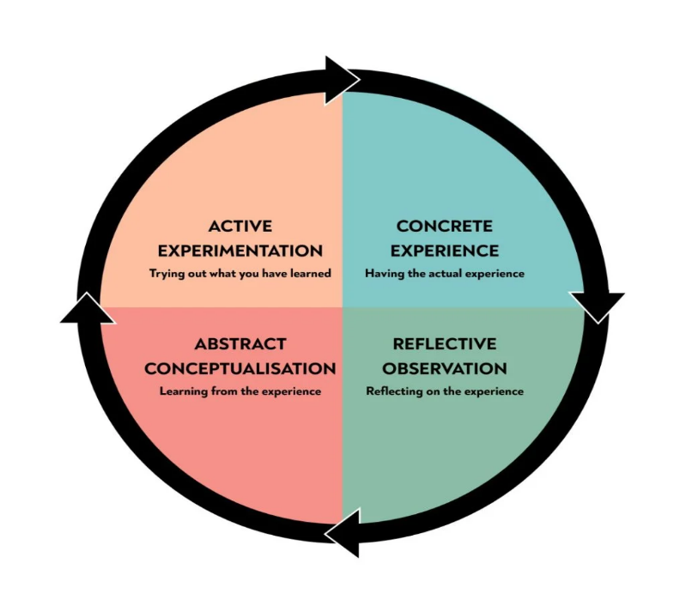
Figure 2- Kolb’s Learning Cycle- Adapted 1 (Kolb, 1984)
In terms of technology, my experience closely resembles the case study conducted by (Chan, 2025) on Hong Kong, which focused on enhancing digital literacy through course-based projects. Their research shows how information, technical, and socioemotional literacy are developed using digital platforms. Similarly, although I am comfortable using digital tools for research and collaboration, I am aware that I need to increase my photo-visual literacy to produce visually appealing academic presentations. After Kolb's cycle, I plan to try integrating graphic design software like Canva or Adobe Express into my coursework to improve my digital fluency.
Studying in a multicultural academic environment has increased my intercultural awareness and flexibility in terms of communication. Nonetheless, I am aware that I need to work on my academic and professional English. This bolsters the findings of (Tuti, 2022), who argue that although digital technology enhances English proficiency, users still need to regularly engage with real-world communication platforms. To get better, I want to use AI-assisted writing tools and participate more actively in academic discussions.
Working in a multicultural team environment has improved my ability to collaborate and solve problems. Multicultural teamwork promotes experiential learning and intercultural competence, according to (Méndez García, 2018). My group projects support this finding. However, I occasionally find it difficult to communicate with people who have different communication styles. I plan to address this by delegating more clearly and checking in frequently.
Although I still need to work on my confidence, I've started to take the initiative in group settings as a leader. Research by (Ang, 2020) shows that intercultural leadership development programs boost the competence and confidence of international students. I plan on taking on more leadership roles in group projects to put this ability into practice.
In summary, self-directed learning remains crucial. According to (Maphosa, 2024), time management and self-control are essential for effective digital learning. My ability to plan and monitor my work has improved, but I still want to create formal learning objectives to improve consistency.
In the end, ongoing reflection and adaptability are essential to my growth on both a personal and professional level. I can increase my effectiveness in international academic and professional contexts and develop my global competencies by implementing Kolb's reflective cycle and integrating research findings.

6. Conclusion
The practices of human resource management (HRM) and international HRM (IHRM) are evolving due to demographic changes, geographic shifts, and technological disruption. Innovations in digital platforms, automation, and artificial intelligence have altered how businesses manage talent. Alongside issues like labour displacement and digital inequality, these developments have also created opportunities for innovation. (Babashahi, 2024)assert that these shifts call for constant retraining and adaptability to remain employable in technologically sophisticated environments. According to (Fenwick, 2024)HR must adopt human-cantered strategies for digital transformation, placing a high premium on workforce inclusion and ethical integration.
To address persistent skills gaps, proactive investments in staff training and capability development are required. As demonstrated by (Juqu, 2024), organizations that do not upskill low-skilled workers risk long-term inefficiencies and talent loss. Furthermore, global demographic and geopolitical changes, such as aging workforces and trade disruptions, necessitate adaptable and globally coordinated HRM strategies (International Business Review, 2024). Effective adoption of disruptive technologies necessitates cultures of ongoing learning supported by strategic human resource frameworks, claims (Priyashantha, 2023).
Ultimately, to remain competitive in today's labor market, people and organizations must be committed to resilience, adaptability, and lifelong learning in a dynamic global setting.
Labor Market Dynamics (2024) Labour market dynamics in developing countries: analysis of employment transformation at the macro-level. Springer.

7.References
- (2025), J. o. I. B. S., 2025. Managing cross-border virtual teams: HRM challenges and strategies. Journal of International Business Studies, 56(3), pp. 123-139.
- Ang, S. e. a., 2020. ‘Intercultural leadership development among international students’. Journal of Global Leadership Studies,, 5(2), pp. 67-83.
- Arslan, M. e. a., 2022. Human-robot collaboration in manufacturing: Implications for HRM practices.. Journal of Manufacturing Technology Management, 33(4), pp. 567-584.
- Babashahi, A. R. L. a. H. F., 2024. ‘Reskilling for resilience: The future of HRM’. Human Resource Development Review, 23(1), pp. 78-95.
- Bositkhanova, N. &. D. A., 2025. Artificial intelligence in workforce planning: Enhancing HR decision-making through predictive analytics.. Journal of Human Resource Management, 42(1), pp. 45-62.
- Chan, A. a. S. W., 2025. Enhancing digital literacy in higher education: A case from Hong Kong’. Journal of Education and Learning, 14(1), pp. 22-34.
- Costa-Font, J., 2025. Aging populations and healthcare workforce shortages: Policy implications for HRM. Health Policy and Planning, 40(2), pp. 234-241.
- Fenwick, M. M. C. a. F. J., 2024. Human-Centred Digital Transformation in HRM, s.l.: Oxford University Press.
- Juqu, M. M. T. &. M. P., 2024. The consequences of neglecting low-skilled workers: A case for upskilling. Journal of Labour Economics, 42(2), pp. 112-127.
- Kolb, D., 1984. Experiential Learning: Experience as the Source of Learning and Development, Englewood Cliffs: NJ: Prentice Hall.
- M., B. M., 2022. Generation Z in the workplace: Expectations and HRM responses. Journal of Business Research, 75(1), pp. 102-110.
- Maphosa, C., 2024. ‘Time management and self-control in digital learning’. Educational Technology Journal,, 15(2), pp. 155-170.
- MDPI, 2023. The role of continuous learning in a digitally driven labour market. MDPI Human Resources Journal, 8(1), pp. 15-29.
- Méndez García, M. a. P. C. M., 2018. ‘Developing intercultural competence through team-based learning’. Innovation in Language Learning and Teaching,, 12(3), pp. 244-257.
- Popescu, M., 2025. Predictive analytics in HR: Forecasting employee turnover and talent shortages.. International Journal of Workforce Analytics, 19(2), pp. 88-104.
- Priyashantha, H., 2023. Cultivating a learning culture: HRM strategies for digital transformation. Human Resource Development International, 26(4), pp. 391-406.
- Review, I. B., 2024. Geopolitical influences on global HRM practices’. International Business Review, 33(5), pp. 799-815.
- Robertson, J., 2023. Engaging Generation Z employees: Strategies for retention and development.. Personnel Review, 52(3), pp. 456-470.
- Snell, S. B. G. a. M. S., 2023. Managing Human Resources. 19th edn, Boston: Cengage Learning. Available at- https://doi.org/10.1002/hrm.22158
- Štaffenová, D. K. A. a. F. L., 2025. Digital transformation and human capital: Labour market adaptation. Human Resource Management International Digest, 33(1), pp. 22-31. Available at- https://doi.org/10.1371/journal.pone.0320568
- Tucker, A., 2018. Strategic Human Capital Management Creating Value Through People, London: Routledge. Available at- https://doi.org/10.1108/SHR-05-2018-0034
- Tuti, N. a. S. A., 2022. ‘Digital technology and English language proficiency development’. International Journal of Education Research, 10(3), pp. 56-70.

