Digital Skills and Research Methods

Executive Summary
In this current situation of pandemic because of the COVID-19 the universities have implemented the use of VLE process of learning to effectively conduct the process of learning. This is the process which helps the students assess the studies even in this tough situation. The ways in which the students at the University of Wales Trinity Saint David London Campus have used this process has been explained in this report.

Table of Contents
1.0 Introduction 4
2.0 Research Methodology 6
2.1 Data Analysis 6
2.2 Data collection tools and techniques 6
2.3 Sample Size 6
2.4 Ethical Considerations 6
3.0 Data Analysis 8
3.1 Primary Data Analysis 8
3.2 Secondary Data Analysis 14
4.0 Reflection 17
5.0 Conclusion 19
6.0 References 20
6.1 Books and Journals 20
6.2 Website References 21
7.0 Appendix 22
List of figures
Figure 1 9
Figure 2 10
Figure 3 11
Figure 4 12
Figure 5 13
Figure 6 14
Figure 7 15
Figure 8 16

1.0 Introduction
The research report will be conducted to analyse the effect of the VLE on the learning experience of the student. Further, this is one of the most efficient ways which helps the student in enhancing their learning experience. Along with this, the data analysis would also be conducted by making the use of the primary and the secondary research methods. Based on the aim of the topic, the objectives of the report would also be derived.
Aim: To understand the consequence of VLE on the knowledge of the students at the University of Wales Trinity Saint David London Campus.
Objectives:
1. To demonstrate the potential benefits of VLE on the students at the University of Wales Trinity Saint David London.
2. To examine the challenges that the students face using the VLE.
3.To find the strategies which the students can implement to overcome the difficulties.
Research Questions:
1. What are the possible profits of using the VLE on the students at the University of Wales Trinity Saint David London?
2. What are the difficulties that the student face after using VLE?
3. What are the strategies which the students can implement to overcome the difficulties?
Rationale
Moodle is the abbreviated form of multiple object-oriented dynamic learning environments. Along with this, there are several learning courses in the moodle which is conducted on online platforms and with the help of VLE. Along with this, there are several issues that the student face while adapting this feature which has also been mentioned in this report. Moreover, the strategies which the students can implement to overcome the difficulties will also be examined.

2.0 Research Methodology

2.1 Data Analysis
The report will be including both the qualitative and the quantitative methods of data analysis. Further, both the method will be used to derive the accurate and the efficient outcome of the report (Munch, 2017). Along with this, the use of both these methods will help in representing the method in an appropriate manner.

2.2 Data collection tools and techniques
The primary analysis of the data will be including a survey that has been conducted with the help of online platforms. The link was shared among the individuals and the data was collected (Wang, 2019). Along with this, to accomplish the secondary data analysis, several books, articles, and journals related to the topic were used. This has helped in making the report more authentic using the relevant documents.

2.3 Sample Size
The report will be including the random sampling method where 10 students were taken as the sample and the online questionnaire was passed on to them. Further, the link was shared with them and then the data was collected (CFI, 2020).

2.4 Ethical Considerations
The research was done after following all the ethical rules and the regulations which are included in the data protection act. Along with this, permission was taken from the authorities of the Universities. Along with this, the data was kept in a secure way using all the safety measures (BRM, 2020).

Questionnaire
1. Are you using VLE learning process?
a) Yes
b) No
c) Maybe
2. What is the main outcome of using VLE?
a) Cost efficient
b) Improves time management
c) Ensure Effective Learning
3. Is the VLE process helpful for you?
a) Yes
b) No
c) Sometimes
4. What are the difficulties faced due to the use of VLE learning process?
a) Technical Issue
b) Communication Gap
c) Lack of Knowledge
5. What is the main impact of VLE learning process on students?
a) Enhanced Technological Knowledge
b) Improved self-studies abilities
c) Faster completion of syllabus
6. Will the problem-solving methods for the challenges be helpful in future?
a) Yes
b) No
c) Maybe

3.0 Data Analysis

3.1 Primary Data Analysis
1.Are you using VLE learning process?
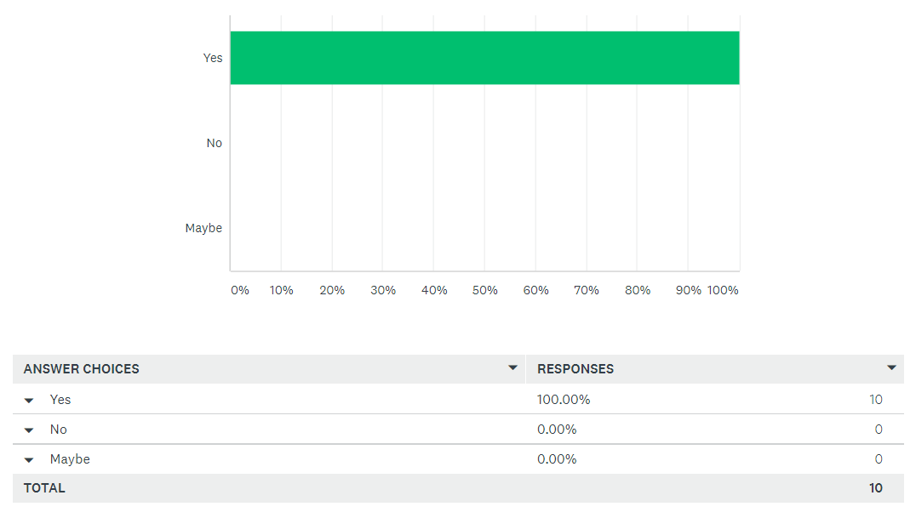
Figure 1
Source: (surveymonkey, 2021)
Analysis: The above data shows that VLE process is used by 100% students at the university. Every student at the University of Wales Trinity Saint David London Campus has taken part in this survey that was conducted.
2. What is the main outcome of using VLE?
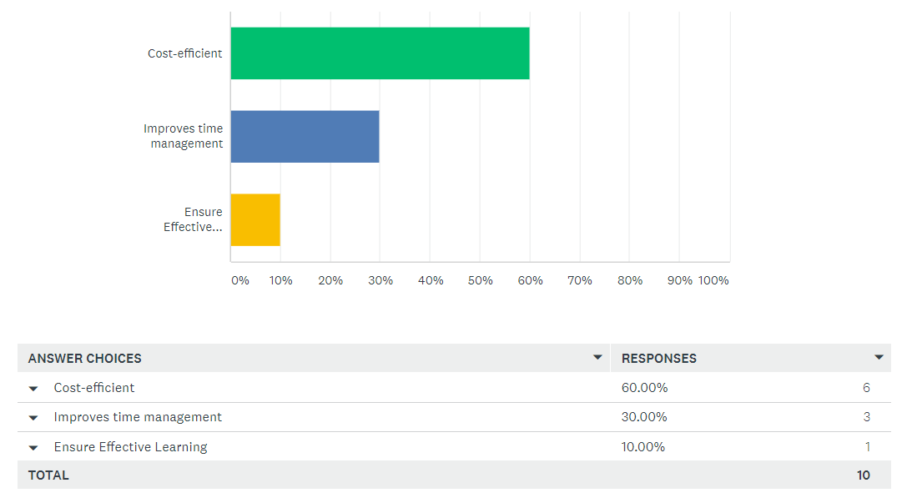
Figure 2
Source: (surveymonkey, 2021)
Analysis: From the above graph which was assessed from the survey conducted was taken part by all the students at the university. Through the report 60% students thought that VLE process is very cost-efficient. Besides that, 30% students thinks that this process has a huge contribution in proper time management. Whereas only 10% students stated that this process ensures effective method of learning.

3. Is the VLE process helpful for you?
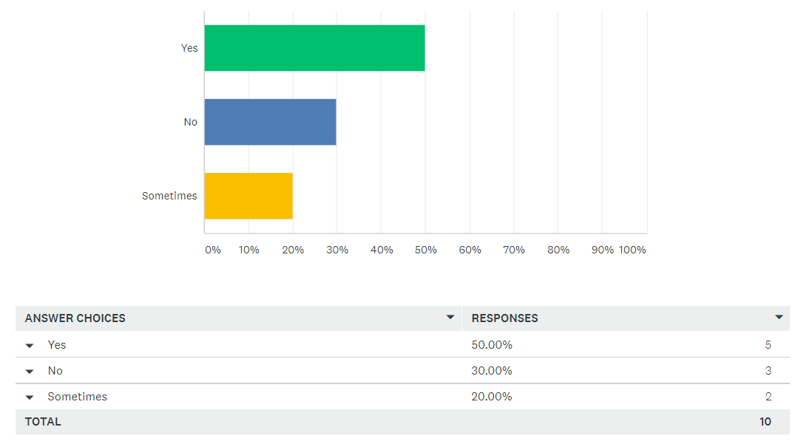
Figure 3
Source: (surveymonkey, 2021)
Analysis: From the survey conducted VLE process of learning has proven to be helpful for 50% of the students. Whereas 30% students think that the VLE process is no helpful for them in terms of proper learning. Furthermore, only 20% of students think that this VLE process is sometimes helpful and sometimes it is not that effective.

4. What are the difficulties faced due to the use of VLE learning process?
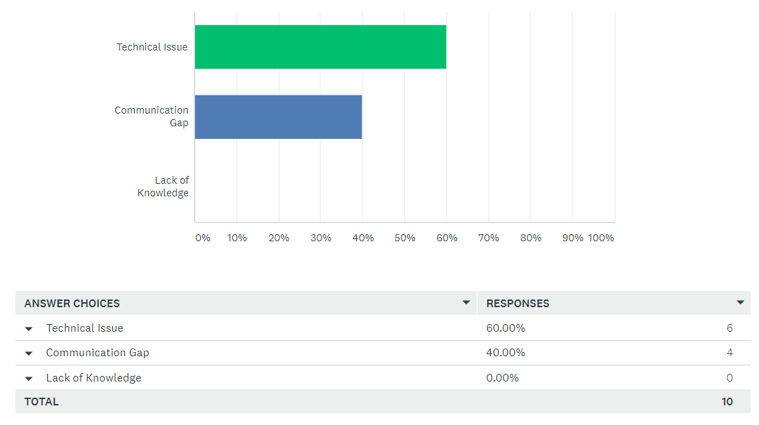
Figure 4
Source: (surveymonkey, 2021)
Analysis: Through the survey that was conducted it can be understood that there are certain problems which are faced by the students when they take part in VLE process of learning. From which 60% of the students face technical difficulties while they are accessing this process of learning. Another difficulty is the communication gap which was faced by 40% of the students. Where no one faced the lack of knowledge after the completion of this process.

5. What is the main impact of VLE learning process on students?
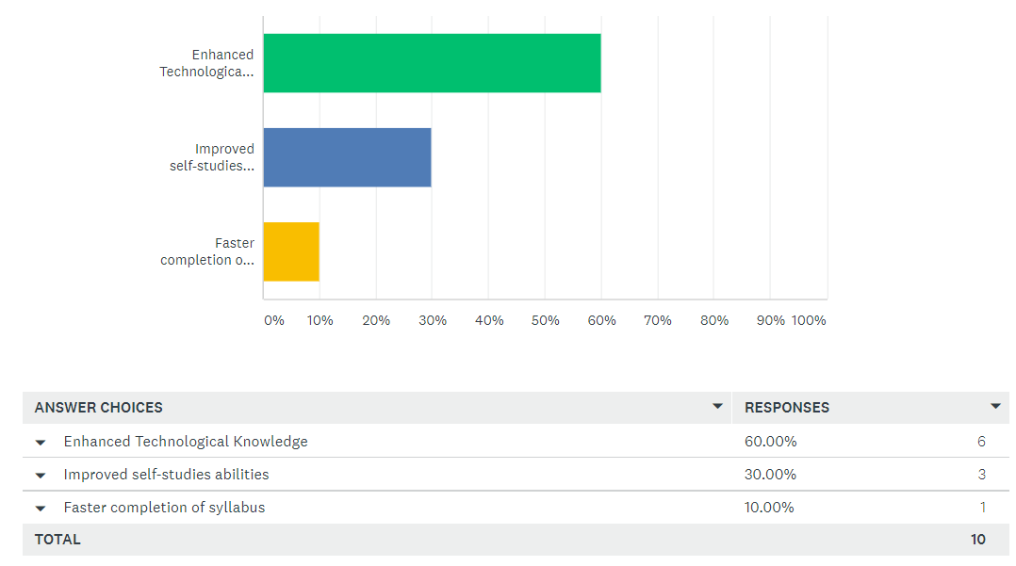
Figure 5
Source: (surveymonkey, 2021)
Analysis: The VLE process has a massive impact on the students at University of Wales Trinity Saint David London Campus. Some of which were witnessed with the help of the survey conducted. Enhancement of technological knowledge was one of the main factors which was witnessed by 60% students. Thirty percent of the students stated that this process has helped them improve self- studying abilities. Whereas only 10% students think this process helped in faster completion of the whole syllabus.

6. Will the problem-solving methods for the challenges be helpful in future?

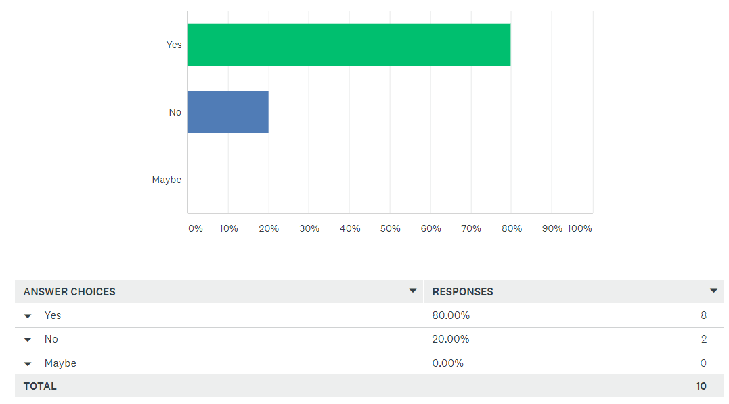
Figure 6

Source: (surveymonkey, 2021)
Analysis: The effectiveness of the problem-solving methods in the future has been described in the survey conducted. From which 80% stated that these methods will be helpful in future and 20% students thinks that it will not be helpful for them in future (surveymonkey, 2021).

3.2 Secondary Data Analysis
The reviews given by students at University of Wales Trinity Saint David London Campus has been used to conduct the secondary analysis. The benefits gained by the students and the difficulties has been explained in this analysis.

Figure 7
Source: (whatuni, 2021)
Benefits of VLE as per students’ feedback-
From the website of the University the above-mentioned feedback has been taken. The use of the VLE process to properly fulfil the educational requirements was a successful step taken by the University. During the pandemic situation, the guidelines set by the university to stay indoors and continue with the course proved to be an effective step. The contribution of the tutors to solve problems faced by the students was an amazingly effective step (Dillenbourg, 2019). It was also stated by some students that the teachers used different innovative methods to solve the problems. Interactive classes were also conducted to enhance the communication between the students and the teachers.
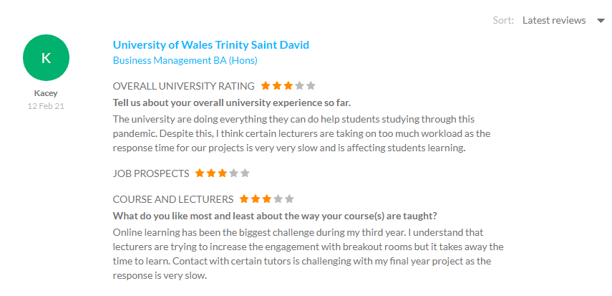
Figure 8
Source: (whatuni, 2021)
Challenges of VLE as per students’ feedback-
Since there were certain challenges faced by the students there were some negative feedbacks as well. Some difficulties with the connectivity were faced from both the teacher’s and student’s end. The proper feedbacks were not provided by the teachers in time by the teachers regarding the assignments submitted. Due to this student failed to correct the mistakes within the deadline (Bailey, 2020). All these factors collectively gave rise to certain problems such as time management and proper problem solving. The introduction of breakout rooms proved to be a problem for some students. Since breakout rooms were time consuming and this reduced the time for self-studies of the students (Puzhevich, 2020).
Methods to overcome the challenges of VLE that students face-
Overcome the technical difficulties faced by the students and the teachers, they can switch to a WIFI network with faster connection. The teachers can also record the classes and provide those recordings to the students after the class. Some students miss classes at times and this method will help them overcome their losses. The tutors must evaluate the assignments and provide formative feedbacks in time (Kerimbayev, 2016). The learning process gets a huge support by following this method. Session to solve queries must be conducted to improve the skills of the students. Promote time management, the time of breakout rooms must be decreased. This helps them to find more time for self-studies (Almeida, 2017). To promote the engagement of the students with the studies is increased in the process (Johnson, 2019).

4.0 Reflection
The use of Gibbs Reflective Cycle can be done to provide the knowledge I have gained from attending the VLE process (Rumson, 2018). This reflective model is the learning process which includes analysing the past experiences.
Topic: The encouragement provided by VLE to students at University of Wales Trinity Saint David London Campus
Description: The lessons taught in the classes was accessed by me with the use of VLE process. The virtual learning experience was quite satisfying. The cooperation that is received from my teachers in this process has helped me a lot in completing the syllabus in time.
Feelings: Since this process of learning was unknown to me, I was tensed regarding the syllabus completion. The excitement was also high since this was a new method that I would use to interact with my teachers and fellow mates. The technical advancement aspect related to this method made me more inclined towards this process.
Evaluation: I did face some difficulties with network at times. I gained appropriate knowledge in this process. The digital skills gained by me helped me develop certain technical skills within me. Due to the VLE process my communication skills were also increased.
Analysis: In this VLE process my proper research conducting skills were enhanced. Critical thinking skills also developed within me because of this process. Besides, technological knowledge has seen a huge development in this process.
Conclusion: With the proper use of VLE process I have gained huge development in my academics, and this will also help me once I am employed. Along with this, this process has a lot helped me focus more on my academics and future.
Action plan: I will focus more on increasing my technical skills as this will help me gain advantage in times of employment. My disciplinary skills will also be increased during the proper accessing of this VLE process.

5.0 Conclusion
The research report has kept its focus on the influence of the VLE on the learning experience of the students. Along with that, VLE is one of the web-based technology which increased the efficiency of online courses. Furthermore, there are different challenges that the students face while adopting this technology. These have been described in this report. Moreover, the strategies to lessen these challenges have also been described.

6.0 References

6.1 Books and Journals
Chapel, J.M. and Wang, G., 2019. Understanding cost data collection tools to improve economic evaluations of health interventions. Stroke and vascular neurology, 4(4).
Munch, E., 2017. A user’s guide to topological data analysis. Journal of Learning Analytics, 4(2), pp.47-61.
Kerimbayev, N., 2016. Virtual learning: Possibilities and realization. Education and Information Technologies, 21(6), pp.1521-1533.
Queirós, A., Faria, D. and Almeida, F., 2017. Strengths and limitations of qualitative and quantitative research methods. European Journal of Education Studies.
Hennink, M., Hutter, I. and Bailey, A., 2020. Qualitative research methods. Sage.
Dillenbourg, P. and Synteta, P., 2019, September. Virtual learning environments. In Proceedings of the 3rd Hellenic conference information & communication technologies in education (pp. 3-18).
Allen, M. ed., 2017. The SAGE encyclopedia of communication research methods. Sage Publications.
Byrd, R., 2020. Qualitative research methods.

6.2 Website References

BRM, 2020. Ethical Considerations. [Online]
Available at: https://research-methodology.net/research-methodology/ethical-considerations/
CFI, 2020. What is Random Sampling?. [Online]
Available at: https://corporatefinanceinstitute.com/resources/knowledge/other/random-sampling/
Johnson, S., 2019. Knowledge Anywhere. [Online]
Available at: https://www.knowledgeanywhere.com/resources/article-detail/the-advantages-and-disadvantages-of-a-virtual-learning-environment
Puzhevich, V., 2020. SCAND. [Online]
Available at: https://scand.com/company/blog/the-use-of-virtual-learning-environment-in-education/
Rumson, R., 2018. GIBBS – REFLECTIVE CYCLE MODEL (1988). [Online]
Available at: https://www.eln.io/blog/gibbs-reflective-cycle-model-1988
[Accessed 2 4 2021].
surveymonkey, 2021. SurveyMonkey. [Online]
Available at: https://www.surveymonkey.com/analyze/kKI6CyWYBDaiLwAiY0ptPdlkG5oRq6bFrQK4sDsrgpc_3D
whatuni, 2021. 1,681 University of Wales Trinity Saint David reviews. [Online]
Available at: https://www.whatuni.com/university-course-reviews/university-of-wales-trinity-saint-david/5225/
[Accessed 02 04 2021].

7.0 Appendix
Figure 1:
Figure 2:
Figure 3:
Figure 4:
Figure 5:
Figure 6:

